Cardiovascular Disease Prediction:

A Machine Learning Approach to Address Health Risks in Business Education
The prediction of cardiovascular disease (CVD) represents a critical intersection between healthcare innovation and business education. While traditional risk assessments focus on older demographics, work-related stressors such as job strain and long working hours are associated with a 10-40% elevated risk of coronary heart disease compared to individuals free of such stressors (Kivimäki, M., & Steptoe, A., 2017). This finding has relevance for business school students and professionals who often face demanding workloads, competitive environments, and high-pressure decision-making scenarios. More than half of young adults aged 18-24 show at least one risk factor for coronary heart disease, including obesity, hyperlipidaemia, and atherosclerosis, yet cardiovascular health screening remains underutilized in this demographic (Arts et al., 2014).
The dataset selected for this analysis originates from a multispecialty hospital in India and contains comprehensive health metrics from 1,000 subjects, including physiological measurements (blood pressure, cholesterol, heart rate) and lifestyle factors. This enables us to build a robust random forest classifier that provides both technical rigor and real-world applicability.

Analysing a Cardiovascular Disease Dataset with R
This code uses the Cardiovascular Disease Dataset to predict the risk of a person having a heart disease.

Preprocessing
Load the required Packages and read the uploaded .csv dataset
data <- read_csv("Cardiovascular_Disease_Dataset.csv",show_col_types = FALSE)

Basic variable plotting to further get insight into the data
Plot data distribution of Gender and Target Variable - Plot age distribution - Plot the slope variable
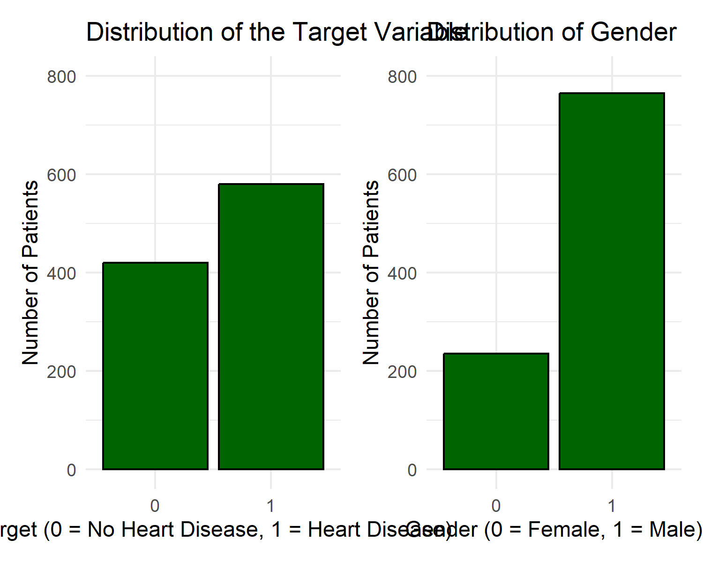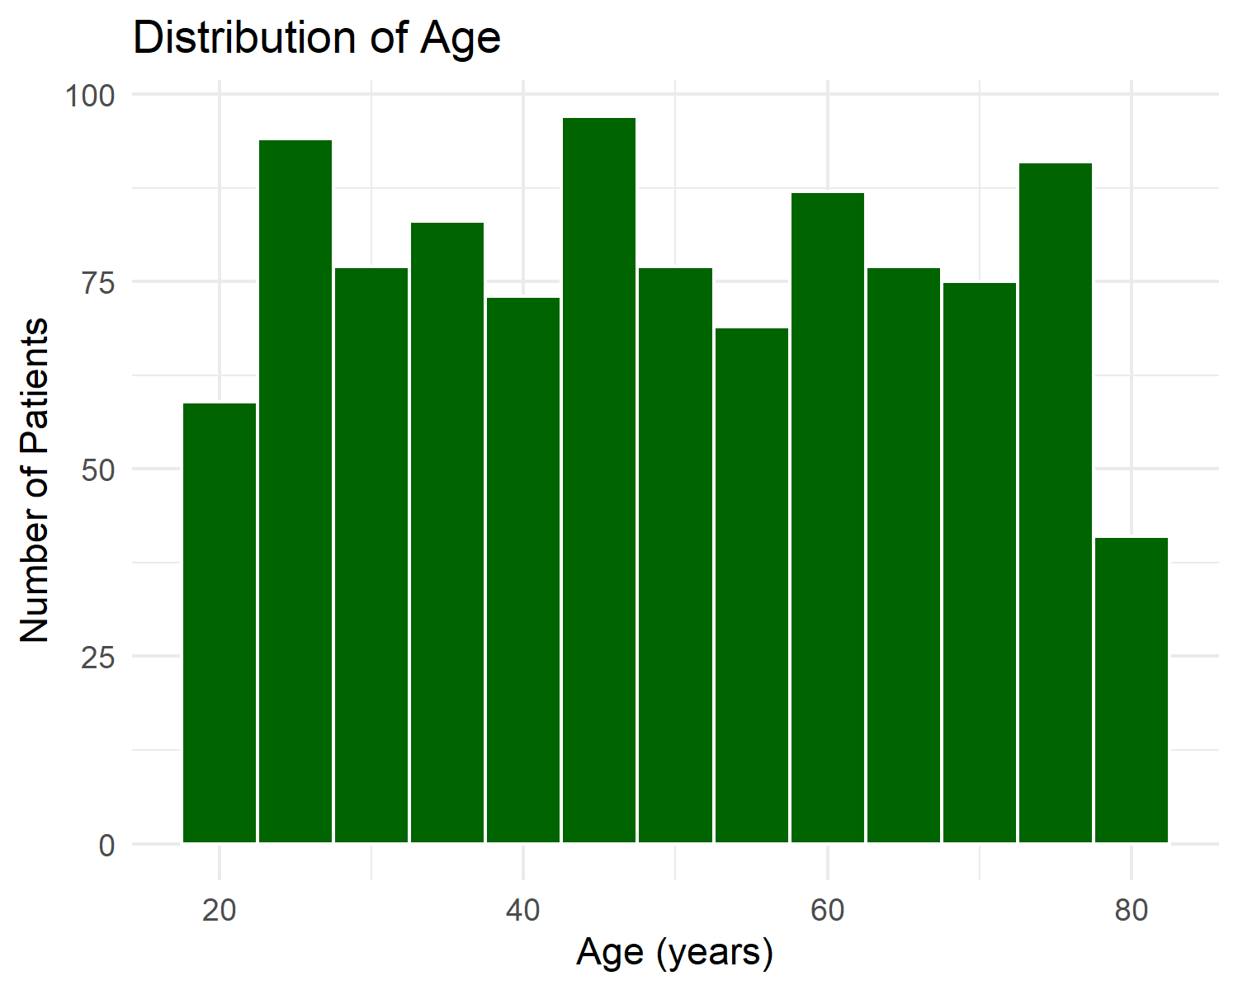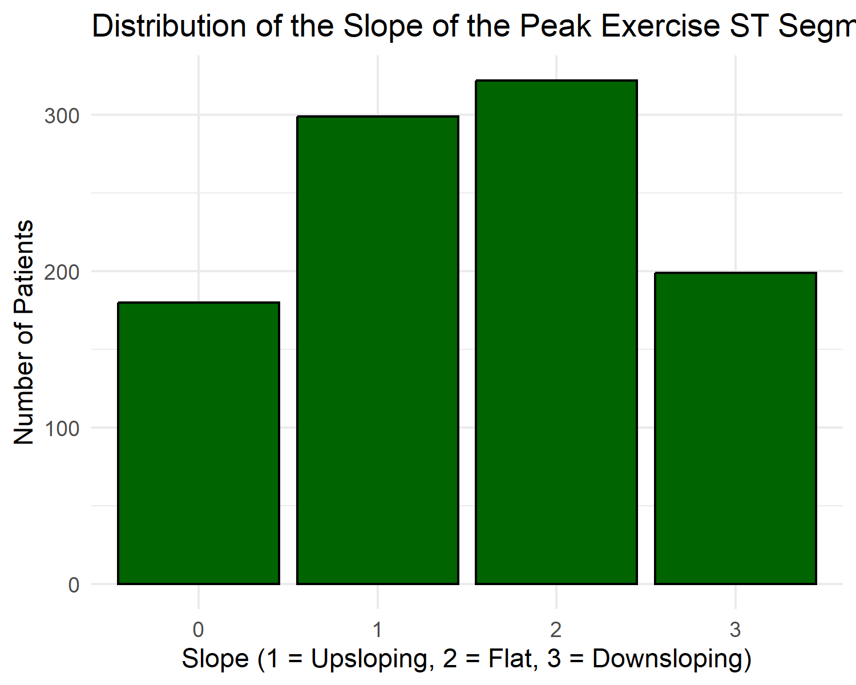
Check if there is any overlap between missing values in slope and serumcholestrol - Because there are 180 missing values in the column “slope” we drop this variable from the dataset - Check for correlation between independent variables
missing <- subset(data, serumcholestrol == 0 & slope == 0)
view(missing)
data <- subset(data, select = -slope)

Data split and variable imputation
Convert 0 to NA in serumcholestrol - Split data into Train / Test Sets - Calculate the median and impute the NA values - Drop ID column for modeling
data$serumcholestrol[data$serumcholestrol == 0] <- NA
set.seed(1234)
train <- data %>% sample_frac(., .66)
test <- anti_join(data, train, by = 'patientid')
median_train <- median(train$serumcholestrol, na.rm = TRUE)
train$serumcholestrol[is.na(train$serumcholestrol)] <- median_train
test$serumcholestrol[is.na(test$serumcholestrol)] <- median_train
train <- subset(train, select = -c(patientid))
test <- subset(test, select = -c(patientid))

Model training

Baseline Dummy Model
Create Majority class (0 or 1) - Predict majority class for test set - Evaluate baseline
train$target %>% table()
## .
## 0 1
## 264 396
dummy_class <- 1
predict_dummy <- rep(dummy_class, nrow(test))
confusion_matrix <- table(test$target, predict_dummy)
dummy_accuracy <- sum(diag(confusion_matrix)) / sum(confusion_matrix)
dummy_mmce <- 1 - sum(diag(confusion_matrix))/sum(confusion_matrix)
cat('Dummy MMCE:', (dummy_mmce),'-', 'Accuracy:', dummy_accuracy)
## Dummy MMCE: 0.5411765 - Accuracy: 0.4588235

Logistic Regression Model
Create Logistic Regression Model - Predict on test data - Evaluate Logistic Regression and compare to baseline
logistic_model <- glm(target ~ .,
data = train,
family = "binomial"
)
summary(logistic_model)
predict_reg <- predict(logistic_model,
newdata = test,
type = "response"
)
predict_reg <- ifelse(predict_reg > 0.5, 1, 0)
confusion_matrix <- table(test$target, predict_reg)
logreg_accuracy <- sum(diag(confusion_matrix)) / sum(confusion_matrix)
logreg_mmce <- 1 - sum(diag(confusion_matrix))/sum(confusion_matrix)
cat('LogReg MMCE:', logreg_mmce,'-', 'Accuracy:', logreg_accuracy)
## LogReg MMCE: 0.1117647 - Accuracy: 0.8882353
## MMCE ACC
## Baseline 0.5411765 0.4588235
## Logistic Regression 0.1117647 0.8882353

Decision Tree Model
Convert target variable into a factor - Create Decision Tree Model - Remove Patient ID from features - Set data split - Set up Imputer and Impute Missing Values in Training Data - Train the Decision Tree - Evaluate Decision Tree
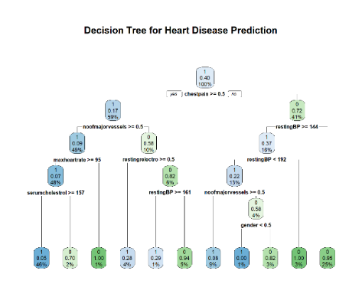
data$target <- as.factor(data$target)
task_data <- TaskClassif$new(
id = "data",
backend = data,
target = "target",
positive = "1")
task_data$col_roles$feature
task_data$set_col_roles("patientid", remove_from = "feature")
set.seed(1234)
splits <- partition(task_data, ratio = 0.66)
imputer = po("imputemedian")
dtree <- lrn("classif.rpart")
graph <- mlr3pipelines::`%>>%`(imputer, dtree)
tree_imp <- as_learner(graph)
tree_imp$train(task_data, splits$train)
prediction_tree <- tree_imp$predict(task_data, splits$test)
prediction_tree$confusion
rpart.plot(tree_imp$model$classif.rpart$model, main = "Decision Tree for Heart Disease Prediction")
mes <- msrs(c("classif.ce", "classif.acc"))
tree_perf <- prediction_tree$score(mes)
tree_perf
## classif.ce classif.acc
## 0.1117647 0.8882353

Random Forest
Create Random Forest Model with Imputation - Train the Model - Evaluate Random Forest - Introduce Cross Validation - Evaluate Random Forest with CV
rf <- lrn("classif.ranger", num.trees = 500, predict_type = "prob")
graphrf<- mlr3pipelines::`%>>%`(imputer, rf)
rf_imp <- as_learner(graphrf)
rf_imp$train(task_data, splits$train)
prediction_rf <- rf_imp$predict(task_data, splits$test)
prediction_rf$confusion
rf_perf <- prediction_rf$score(mes)
rf_perf
## classif.ce classif.acc
## 0.04705882 0.95294118
rdesc <- rsmp("cv", folds = 10)
res <- resample(task = task_data, learner = rf_imp, resampling = rdesc)
res$aggregate(mes)
## classif.ce classif.acc
## 0.049 0.951

Hyperparameter Tuning & Parallel Computing
detectCores()
## [1] 8
cores = detectCores() - 1
plan("multisession", workers = cores)
Define tuning Parameters - Create Graphlearner that performs tuning automatically - Evaluate Random Forest with Tuning
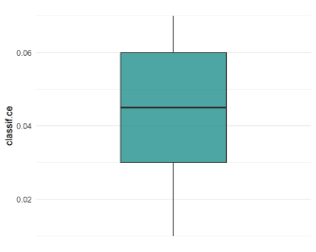
rf_ps <- ps(
`classif.ranger.mtry` = p_int(lower = 1, upper = 11),
`classif.ranger.min.node.size` = p_int(lower = 1, upper = 30))
res_inner = rsmp("cv", folds = 5)
mes_inner = msr("classif.mcc")
terminator = trm("evals", n_evals = 50)
tuner = mlr3tuning::tnr("random_search")
rf_at = AutoTuner$new(
learner = rf_imp,
resampling = res_inner,
measure = mes_inner,
search_space = rf_ps,
terminator = terminator,
tuner = tuner)
res_outer = rsmp("cv", folds = 10)
nested_res = resample(
task = task_data,
learner = rf_at,
resampling = res_outer)
plan("sequential")
nested_res$aggregate()
## classif.ce
## 0.044
autoplot(nested_res)

Benchmarking
Use Graphlearner to train all models with Imputation - Construct a Benchmark Grid - Run the Benchmark - Evaluate the Benchmark Results
plan("multisession", workers = cores)
logreg <- lrn("classif.log_reg")
tree <- lrn("classif.rpart", keep_model = TRUE)
rf <- lrn("classif.ranger", num.trees = 500, predict_type = "prob")
rf_tuned <- rf_at
baseline = lrn("classif.featureless")
graphlogreg<- mlr3pipelines::`%>>%`(imputer, logreg)
logreg_imp_bench = as_learner(graphlogreg)
graphtree<- mlr3pipelines::`%>>%`(imputer, tree)
tree_imp_bench = as_learner(graphtree)
graphrfbench<- mlr3pipelines::`%>>%`(imputer, rf)
rf_imp_bench = as_learner(graphrfbench)
graphbase<- mlr3pipelines::`%>>%`(imputer, baseline)
baseline_imp_bench = as_learner(graphbase)
design_class = benchmark_grid(
tasks = task_data,
learners = list( baseline_imp_bench, logreg_imp_bench, tree_imp_bench, rf_imp_bench, rf_tuned),
resamplings = rsmp("cv", folds = 10))
bm_class = benchmark(design_class)
plan("sequential")
mes_class = msrs(c("classif.ce", "classif.acc", "classif.precision"))
bmr_class = bm_class$aggregate(mes_class)
bmr_class[, c(4,7:9)]
## learner_id classif.ce classif.acc classif.precision
## <char> <num> <num> <num>
## 1: imputemedian.classif.featureless 0.420 0.580 0.5800000
## 2: imputemedian.classif.log_reg 0.123 0.877 0.8926310
## 3: imputemedian.classif.rpart 0.088 0.912 0.9187087
## 4: imputemedian.classif.ranger 0.045 0.955 0.9498937
## 5: imputemedian.classif.ranger.tuned 0.046 0.954 0.9465857
autoplot(bm_class, measure = msr("classif.ce"))

Variable Importance
Make a copy for variable importance Impute serumcholestrol and train Models again. Then plot variable importance measures.
data_vi <- data
med_sc <- median(data_vi$serumcholestrol, na.rm = TRUE)
data_vi$serumcholestrol[is.na(data_vi$serumcholestrol)] <- med_sc
data_vi$patientid <- NULL
task_vi <- TaskClassif$new(
id = "heart_vi",
backend = data_vi,
target = "target",
positive = "1")
logreg_vi <- lrn("classif.log_reg")
tree_vi <- lrn("classif.rpart", keep_model = TRUE)
rf_vi <- lrn("classif.ranger", num.trees = 500, predict_type = "prob")
logreg_model = logreg_vi$train(task_vi)
tree_model = tree_vi$train(task_vi)
rf_model = rf_vi$train(task_vi)
beta_weights <- coef(logreg_model$model)
beta_df <- subset(beta_df, Feature != "(Intercept)")
print(betas_plot)
rpart.plot(tree_model$model, main = "Decision Tree for Heart Disease Prediction")
y <- data_vi$target
X <- subset(data_vi, select = -c(target))
mod <- Predictor$new(rf_model, data = X, y = y)
importance = FeatureImp$new(mod, loss = "ce", n.repetitions = 10)
importance$plot()

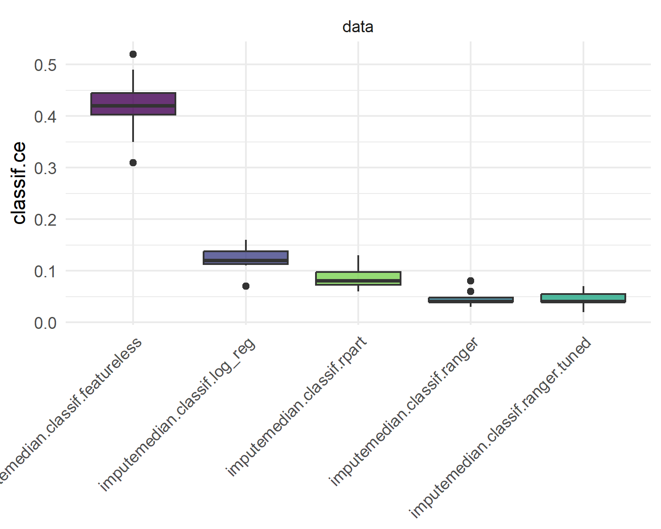
Final Comparison
The final comparison shows the improved performance of the Random Forest model against other models including the baseline, Logistic Regression, Decision Tree. Unfortunately the tuning does not improve the Random Forest performance further in this case.
mes_class = msrs(c("classif.ce", "classif.acc", "classif.precision"))
bmr_class = bm_class$aggregate(mes_class)
bmr_class[, c(4,7:9)]
autoplot(bm_class, measure = msr("classif.ce"))

  - Implications, Limitations, and Outlook
Our cardiovascular disease prediction model demonstrates the power of ensemble methods in handling complex medical data with multiple interacting risk factors. The model achieves high prediction accuracy while maintaining interpretability through feature importance rankings, allowing users to understand which factors most strongly influence their cardiovascular risk. From a business perspective, this project illustrates how machine learning can create value in healthcare analytics.
However, several limitations warrant acknowledgment. First, our model relies on cross-sectional data, capturing health status at a single point rather than tracking disease progression longitudinally. Second, the dataset originates from a specific geographic and demographic context (India), which may limit generalizability to other populations with different genetic backgrounds and dietary patterns. Third, while random forests achieve high predictive performance, the "black box" nature of ensemble methods makes explaining individual predictions challenging compared to simpler models.
Looking forward, the research approach employed by Doppala et al. (2022) in developing the original dataset offers valuable guidance for future enhancements. Their ensemble model combining naive Bayes, random forest, support vector machine, and XGBoost achieved 96.75% accuracy on this cardiovascular dataset through a voting classifier approach that aggregates predictions from multiple algorithms. Implementing such soft voting mechanisms that weight each algorithm's contribution based on individual performance represents a natural next step, potentially capturing complementary patterns that single models miss. Beyond algorithmic improvements, incorporating temporal data would enable survival analysis and time-to-event modeling. Integrating additional data sources—such as genetic markers, lifestyle tracking data from wearable devices, or psychosocial stress assessments—could enhance predictive power while providing more personalized risk profiles. The growing availability of electronic health records creates opportunities to validate models on larger, more diverse populations and implement continuous learning systems that update predictions as new data accumulates.

  - References
Kivimäki, M., & Steptoe, A. (2017). Effects of stress on the development and progression of cardiovascular disease. Nature Reviews Cardiology, 15(4), 215–229. https://doi.org/10.1038/nrcardio.2017.189
Arts, J., Fernandez, M. L., & Lofgren, I. E. (2014). Coronary heart disease risk factors in college students. Advances in Nutrition, 5(2), 177–187. https://doi.org/10.3945/an.113.005447
Doppala, B. P., Bhattacharyya, D., Janarthanan, M., & Baik, N. (2022). A reliable machine intelligence model for accurate identification of cardiovascular diseases using ensemble techniques. Journal of Healthcare Engineering, 2022, 1–13. https://doi.org/10.1155/2022/2585235

