JOB OPPORTUNITIES

206CDE-Real World Project

Google opening:

<https://careers.google.com/jobs/results/101128730773988038-staff-software-engineer-android-framework/?distance=50&hl=en_US&jlo=en_US&location=London,%20UK&q=Software>

Why did I choose this position?

I know it is somewhat a cliché to choose Google as a career option but I truly believe that if I put in the necessary work and just be myself, I could be accepted on such position, even though my current academic achievements do not give me a good prospect.

As a computer enthusiast I have followed Google’s evolution through the years, and applying to a position in the company seemed like a natural thing to do.

I am passionate about the technologies that Google uses and their tendency to always be one step ahead of the game and I would love to be part of the revolutionary work that they do.

Staff Software Engineer, Android Framework

Qualifications

Minimum qualifications:

* Experience with mobile application development or Android framework development.
* Experience in technical leadership, leading project teams, and setting technical direction.
* Experience in one or more programming languages, including Java, C++, Python.

Preferred qualifications:

* Experience developing APIs and integrating third-party services.
* Android Framework experience.
* Experience mentoring or managing junior engineers.
* Strong technical leadership, communication, and collaboration skills.

About the job

Google's software engineers develop the next-generation technologies that change how billions of users connect, explore, and interact with information and one another. Our products need to handle information at massive scale, and extend well beyond web search. We're looking for engineers who bring fresh ideas from all areas, including information retrieval, distributed computing, large-scale system design, networking and data storage, security, artificial intelligence, natural language processing, UI design and mobile; the list goes on and is growing every day. As a software engineer, you will work on a specific project critical to Google’s needs with opportunities to switch teams and projects as you and our fast-paced business grow and evolve. We need our engineers to be versatile, display leadership qualities and be enthusiastic to take on new problems across the full-stack as we continue to push technology forward.

The Android Framework team owns the infrastructures that powers innovation across the entire Android ecosystem and how manufacturers build devices. We aim to creating compelling APIs that allow developers to create great, powerful, and performant applications and a thriving ecosystem of applications.

Google is and always will be an engineering company. We hire people with a broad set of technical skills who are ready to take on some of technology's greatest challenges and make an impact on millions, if not billions, of users. At Google, engineers not only revolutionize search, they routinely work on massive scalability and storage solutions, large-scale applications and entirely new platforms for developers around the world. From Google Ads to Chrome, Android to YouTube, Social to Local, Google engineers are changing the world one technological achievement after another.

Responsibilities

* Work with engineers on operating systems, perform practical API design, and perform system design and implementation under the resource constraints of mobile device.

Location

[](https://www.google.com/maps/search/?api=1&query=51.533107,-0.125876)

## Google and Alphabet Research

Google LLC formerly Google Inc. (1998–2017), American search engine company, founded in 1998 by Sergey Brin and Larry Page, that is a subsidiary of the holding company Alphabet Inc. More than 70 percent of worldwide online search requests are handled by Google, placing it at the heart of most Internet users’ experience. Its headquarters are in Mountain View, California.

Google was founded in September 1998 by Larry Page and Sergey Brin while they were Ph.D. students at Stanford University in California. Together they own about 14% of its publicly-listed shares and control 56% of the stockholder voting power through super-voting stock. The company went public via an initial public offering (IPO) in 2004. In 2015, Google was reorganized as a wholly owned subsidiary of Alphabet Inc.. Google is Alphabet's largest subsidiary and is a holding company for Alphabet's Internet properties and interests. Sundar Pichai was appointed CEO of Google on October 24, 2015, replacing Larry Page, who became the CEO of Alphabet. On December 3, 2019, Pichai also became the CEO of Alphabet.

Business side:

Google has a diversified business model, primarily making money via its advertising networks that, in 2019, generated over 83% of its revenues, which also comprise YouTube Ads. Other revenue streams include Google Cloud, Hardware, Google Play store, and YouTube Premium content. In 2019 Google made over $161 billion in total revenues.

Graph representing the rapid and continuous growth of revenue hence the importance of the company as a major player on the global market:

[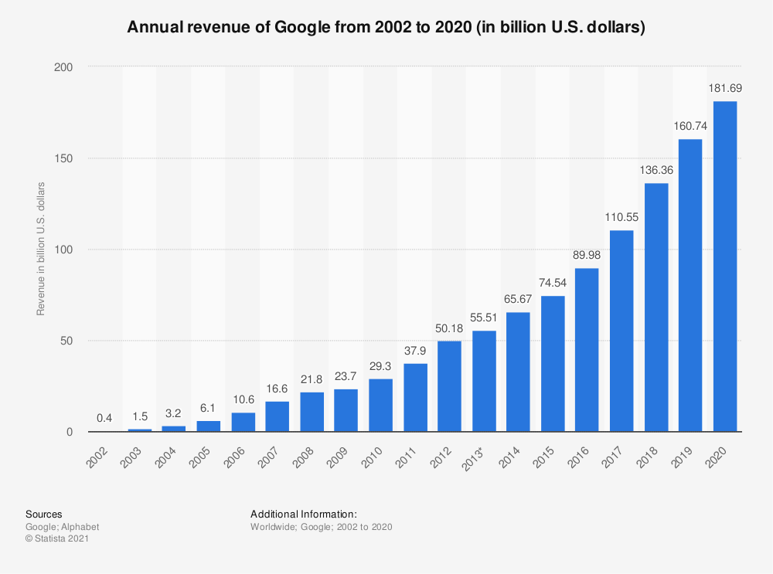](https://www.statista.com/statistics/266206/googles-annual-global-revenue/)

According to the Alphabet 10-K Annual Report from 2020:

The Internet is one of the world’s most powerful equalizers, capable of propelling new ideas and people forward. Our mission to organize the world’s information and make it universally accessible and useful is as relevant today as it was when we were founded in 1998. Since then, we’ve evolved from a company that helps people find answers to a company that helps you get things done. We’re focused on building an even more helpful Google for everyone, and we aspire to give everyone the tools they need to increase their knowledge, health, happiness and success.

(The long-term vision of the company has changed from the 2014 10-K Report, in which the main focus of the company was to make information accessible and relevant but now they have in scope the development on products and services that help individuals and businesses prosper, which is leading to “**invest heavily in talent**” as stated in this 10-K Form)

Across Alphabet, we're focused on continually innovating in areas where technology can have an impact on people’s lives. Every year, there are trillions of searches on Google, and we continue to invest deeply in AI and other technologies to ensure the most helpful Search experience possible. People come to YouTube for entertainment, information and opportunities to learn something new. And Google Assistant offers the best way to get things done seamlessly across different devices, providing intelligent help throughout your day, no matter where you are.

Company’s action base response for COVID-19:

Since the pandemic began, our teams have built new features to help users go about their daily lives, and to support businesses working to serve their customers during an uncertain time. In conjunction with Apple, we launched Exposure Notification apps that are being used by local governments globally. Our COVID-19 Community Mobility Reports are used by public health agencies and researchers around the globe, and we’ve committed hundreds of millions of dollars to help small businesses through a combination of small business loans, grants and ad credits. Importantly, we've made authoritative content a key focus area across both Google Search and YouTube to help users search for trusted public health information.

How big is Google:

Since recently Alphabet’s main bet was Google and its main subsidiaries such as YouTube, Double-Click, with their massive revenue solely based on ads, but new bets are being placed by developing and acquisitions or mergers with other companies. The number of companies rises above 240, for example from 2010 to 2011 more than a company per week was merged or acquired.

## Mission Statement

# A mission statement is a short statement of why an organization exists, what its overall goal is, identifying the goal of its operations: what kind of product or service it provides, its primary customers or market, and its geographical region of operation.

# Google’s Mission Statement from Google’s [Website](https://about.google/):

# Our mission is to organize the world’s information and make it universally accessible and useful.

Google is perhaps the most successful company to come up with a strategic approach to organize information for online users in the last two decades. With this company, it has become easier and better structured making it not only accessible but also useful. It is this influential role that the mission statement of the company emphasizes on. Based on this analysis, the following characteristics make up Google’s mission statement:

* Sharing of new ideas
* Global accessibility
* Boosting organization

## Google investing in the community:

“Since 2015, we've helped millions of people find a job, grow their career or business. Now, we are here to help accelerate economic recovery through our technology, tools and training; so that local businesses, communities and people can grow stronger, faster and more resilient.”

## Philosophy and Quotations

"We have a mantra: don't be evil, which is to do the best things we know how for our users, for our customers, for everyone. So I think if we were known for that, it would be a wonderful thing." - Larry Page

"The ultimate search engine would basically understand everything in the world, and it would always give you the right thing. And we're a long, long ways from that." - Larry Page

"As we go forward, I hope we're going to continue to use technology to make really big differences in how people live and work." - Sergey Brin

"Obviously everyone wants to be successful, but I want to be looked back on as being very innovative, very trusted and ethical and ultimately making a big difference in the world." - Sergey Brin

## Core Values

## Google Commitments

“Committed to significantly improving the lives of as many people as possible.”

2004 Founders’ IPO Letter

On the official website google has listed this under the Commitments category:

* Protecting users
* Expanding opportunity
* Including all voices
* Responding to crises
* Advancing sustainability

## How Google Keeps Its Employees Productive and Engaged?

## Exclusive perks

Today, employees want a job in a company that makes them love what they do. Never for financial benefit or intellectual recognition. Yet instead of chance to add to the common good.

The major differentiator is to make a real difference.

Google offers different perks to its employees to show them that they are not only investing in their overall health but their future as well.

* Chef-prepared free organic food (breakfast, lunch, and dinner);
* Free dental and health checkup;
* Free and unlimited dry cleaning;
* Subsidized massages;
* Several foosballs, ping pong, video games stations;
* On-site physicians;
* Gyms/swimming pools memberships;
* Free haircuts from professional hairdressers;
* In-house nap pods;
* Death benefits to deceased employees’ families, and;
* Hybrid car subsidies.

## Flexibility

Google has been one of the very first companies that had a vision of understanding the employees’ needs. It lets its workers have a flexible schedule so that they can work on their terms and enhance creativity and productivity. They have given their employees complete freedom to work in a way that is most suitable to them.

## Knowing the employees well

Google had gone through a series of laboratory tests to figure out the productivity of their employees. They had four different experiments that included 700 participants. All the employees were treated to free drinks, fruits, and chocolates or shown a comedy movie clip.

They also enquired some of the participants about the family tragedies as a part of their assessment. After this, they found that happiness is the reason for 12% more productivity.

## Culture

Google promotes an innovative and diverse organizational culture that has been a part of its employee’s life. A positive creative atmosphere and a safe working space offered by Google to its workers keep them comfortable and happy at work. The concept that being a part of Google is about being smart and wise encourages the employees to think openly and keeps them productive.

Nowadays, there are different creative coworking spaces which are known to be a perfect alternate to a workplace. These spaces are believed to deliver various advantages such as strong networking and increased engagement.

## Leadership

Google’s founders were researchers who had a belief in innovation and freedom of thinking. This is one of the main factors that influenced the style of Google’s leadership.

According to Brassfield, 2013, a positive leadership style stimulates inspiring and motivating employees to develop innovative ideas and inventions.

## Keeping people inspired

Future Workplace, in 2017, demonstrated in a study that one of the biggest threats to employees’ engagement is employee burnout. It has also been found out that many proficient workers are often overburdened with the tasks that lead to halted innovation, incomplete work, etc.

What does Google do about keeping its employees productive, inspired, or motivated? Google’s strategy for this is 20% time. Every employee devours up to 20% of his time at work each week on ventures that inspire him.

This concept inspires employees as it allows them to concentrate on things they love or are passionate about. It can prevent burnout, decrease turnover, increase engagement.

## Career Advancement at Google

At Google, 65% of 240 employees responded “Yes” when asked, “Does your current company provide you meaningful opportunities for career advancement?” More specifically, 70% of women and 64% of men think they're provided with sufficient career advancement opportunities. Additionally, employees who have some college or have Entry Level work experience answered “Yes” the most. Lastly, 83% of employees in Product answered “Yes”, while only 33% of employees in Finance provided the same answer.

## Recruitment process and preparation

Google, fortunately, is offering an abundance of tools to help you prepare and apply for a position there, this ranges from simple “How to” guides to YouTube channels, to complex learn-to-code websites that help you prepare for their challenging interviews.

Find connections between the job listing and your resume

First off, re-read your resume and the job description to help you draw lines between the two. Where do they connect? We want you to take every opportunity to set yourself up for success.

Focus on data

As you start to think about things you want to highlight in your interview, don’t forget to include data. This helps your interviewer understand not just your overall achievements, but how big of an impact you made.

Let’s put it this way: What data can you provide that tells the story of your experience in terms of the needs of this position? The “equation” we suggest goes a little something like this. Accomplished X as measured by Y doing Z. Here’s an example: “Increased tail wags of Dooglers by 75% over two days by placing dog treats outside of conference rooms.”

Look back at past work experiences

You should also go back through your own work history. That may not sound like something you need to prepare for, but most of us have done more than we think and it’s easy to forget some of our own wins (and lessons from mistakes). We want you to be calm and confident.

We’d also recommend you prepare examples of times you achieved something. Many of the questions we ask will be along the lines of “Tell me about a time when…” or “How would you approach this situation…?”

Come ready with questions

Next, come to the interview with your own questions. This not only shows you care about understanding Google and the position you’re applying for, but it’s also a testament to the research you’ve done by looking into our company. Besides, this is your opportunity to interview us as well. You hear that a lot, right? But honestly, it’s important to us.

Interview preparation:

I started with researching the methodology of preparing for a Google interview, starting with the job description. After thoroughly analyzing what the position requires from the candidate, I was able to learn what a hiring manager expects from me. With this said, I saw what tools skills, tools, technologies, knowledge and understanding of the mentioned above is required from me, so doing research and becoming familiarized with them was the next step. After I became more confident in my skills, I studied the organization’s mentality and culture, so I would know how to address the questions that I am asked.

Further studying , I analyzed what questions are asked and how. To be more specific, if I would be asked a question for which the answer implies a simple “yes” or “no”, I learned that I should always expand my answer with solid arguments to describe why I chose it. A question regarding whether I know of a specific skill , followed by a “yes”, would also involve me describing particular features or specifics of that skill that I am confident talking about. Also, replying with a “no” should be followed by my intention of wanting to know more about the skill, showing interest and being curious. I learned that Google interviews focus more on behavioral questions, which are not always targeting answering assuming something is “right” or “wrong”. They are made in such a way so that the interviewer can judge your reactions, whether you panic or get nervous and how you maintain your analytical thinking in such a situation. An example would be the following question:

“Who do you believe are Google’s main competitors? How does Google stand apart?”

This question gives the hiring manager an idea of how you see Google as a competitor in different areas and how its products are making a difference. Taking Google’s Cloud services in comparison to Amazon or Microsoft, also YouTube compared to other streaming services such as Netflix, and being able to highlight the advantages Google has against the competition. This emphasizes that you should have a fundamental knowledge of Google’s history and background, and also of the products and services that is offers, so you would know how to respond in any given situation.

Another source of information I used is YouTube, which offers many interview simulations and questions asked in previous interviews. Google Virtual Career Fair described in detail the necessary steps in order to create a strong resume.

Advice from Google for creating a strong resume, as presented in a video made by Google :

* Keeping a simple and consistent format
* Making the resume 1 page long for business and internships roles, and 2 pages for engineering and technology roles
* Relevant information based upon the position that I am applying for
* Education listed first as a Student
* Experience, the bulk of the resume
* Optional Final section to talk about myself, preferred if you are a student.

Using what I learned from these sources, I was able to create a CV that would comply with Google requirements in the following way:

* Starting from the top, I added my contact information, along with my email address
* Following up, I provided details about my Education, starting with the most recent one.
* I then provided my Experience, providing details about the skills I acquired. I also provided the projects I was involved into and what my roles were.
* I then continued with volunteering activities and concluded with an “About Me” section, respecting the Google Resume format.

Next, I followed a model which provided a fundamental view on how to create an effective cover letter. The following guidelines were used:

* A short, but respectful addressing means
* A brief introduction about myself
* Keeping everything short and on point, clearly stating my reasons
* Providing my career profile and experience in a different paragraph, showing that I am open to new opportunities and trying to be on point, so as to show that I respect the reader’s time

Following these guidelines, I was able to create a tailored CV and Cover letter based upon the job description and using the help of Google resources:

Second Job:

<https://careers.ibm.com/job/12986136/software-technical-architect-remote/?codes=IBM_CareerWebSite>

Software Technical Architect

Introduction

At IBM, work is more than a job – it’s a calling: To build. To design. To code. To consult. To think along with clients and sell. To make markets. To invent. To collaborate. Not just to do something better, but to attempt things you’ve never thought possible. Are you ready to lead in this new era of technology and solve some of the world’s most challenging problems? If so, lets talk.

Your Role and Responsibilities

A sought-after expert bringing the best of IBM’s portfolio of software offerings to drive client’s strategy. Deeply understands client environment, roadmap, business architecture and initiatives and their linkage to the client strategy. Educates and advises clients, influencing client strategy to drive SW renewals, upgrades and new solutions needs. Supports the achievement of business objectives through creation of opportunity pipeline. Produce a vision of the client’s path to gaining insight from their data and/or their journey to cloud. ​Advise client through their digital transformation and other disruptive initiatives and innovation agenda items, using client insight and knowledge of industry trends & market forces.​Serve as technical trusted advisor across the spectrum of the client roles e.g., CxO, LoB, Architects, Dev.​ Use innovative ways to progress opportunities and demonstrate client value. (e.g. Design Thinking, meetups, whiteboarding, prototyping, hands-on capabilities, MVP). Translate client business requirements into solution requirements, solution architecture and solution design. ​Compare, contrast, and integrate IBM SW solutions in the context of the customer’s existing software investments including competitive differentiation. ​Owns the software technical account plan.

IBMReferred_Europe

techsellers_uki

Required Technical and Professional Expertise

Industry knowledge, specifically around Banking.

Understanding of Hybrid Cloud, Data and AI.

Understanding of Solutions Requirements, Solution Architecture and Design.

Preferred Technical and Professional Expertise

Analytical Thinking.

Teamwork and Collaboration, Leadership.

Third Job;

# DevOps Engineer (CI/CD)

San Diego, California, United States

Software and Services

Add to Favorites DevOps Engineer (CI/CD)

Share DevOps Engineer (CI/CD)

## Summary

Posted: Jun 30, 2021

Weekly Hours: **40**

Role Number:**200254352**

Imagine what you could do here! At Apple, great ideas have a way of becoming great products, services, and customer experiences very quickly. Bring passion and dedication to your job and there's no telling what you could accomplish. Our team runs the CI/CD pipeline for Apple's applications which supports thousands of developers around the globe. We are passionate about continuously improving the way we enable the software development lifecycle and push the envelope to reimagine cutting edge solutions to engineering problems of scale. As a member of the team, you would develop applications and microservices to build and improve our next generation CI/CD pipeline.

## Key Qualifications

* Proficient in Python programming.
* Experience working on Unix/Linux based platforms.
* Experience with DevOps tools such as Chef, Docker, Kubernetes.
* Experience with software development processes such as building, unit testing, code analysis, release process, and code coverage.
* Experience with CI/CD process and platforms e.g. Jenkins
* Excellent written and oral communication skills and ability to work with large development teams.

## Description

Develop and maintain CI/CD pipeline for Application development teams. Collaborate across teams to improve build, integration & release process. Develop and maintain services and integrations for Apps Services CI/CD pipeline. Maintain and administrate dynamic K8s/Linux/Unix/macOS build farm. Ability to participate in an after hours on-call rotation schedule. We will also consider candidates located or willing to relocate to the following areas: - Culver City, CA - Austin, TX - Cary, NC - New York, NY - Pittsburgh, PA

## Education & Experience

B.S. in Computer Science or equivalent.

## Additional Requirements

* Preferred:
* Experience developing Python based microservices using Django/Flask.
* Experience with GitHub development workflow.
* Experience with Jenkins administration and scaling.
* Experience scaling CI/CD systems and microservices.
* Experience with Xcode and developing applications for iOS, macOS and other Apple platforms.

Referencing

Comparably. 2021. *Google Mission, Vision & Values*. [online] Available at: <https://www.comparably.com/companies/google/mission> [Accessed 5 May 2021].

2021. [online] Available at: <https://www.sec.gov/Archives/edgar/data/1652044/000165204421000010/goog-20201231.htm> [Accessed 5 May 2021].

Encyclopedia Britannica. 2021. *Google - Other services*. [online] Available at: <https://www.britannica.com/topic/Google-Inc/Other-services> [Accessed 11 June 2021].

Careers.google.com. 2021. *Staff Software Engineer, Android Framework - Google Careers*. [online] Available at: <https://careers.google.com/jobs/results/101128730773988038-staff-software-engineer-android-framework/?distance=50&hl=en_US&jlo=en_US&location=London,%20UK&q=Software> [Accessed 18 June 2021].

Statements, M., 2021. *Google Mission Statement 2021 | Google Mission & Vision Analysis*. [online] Mission-statement.com. Available at: <https://mission-statement.com/google/> [Accessed 18 June 2021].

Grow.google. 2021. *Grow with Google*. [online] Available at: <https://grow.google/intl/europe/> [Accessed 19 June 2021].

2021. [online] Available at: <https://medium.com/@valene.jouany/company-values-definition-importance-and-examples-e0b4b75d1be> [Accessed 19 June 2021].

The 6Q Blog. 2021. *Case Study: How Google Boosts its Employees' Engagement*. [online] Available at: <https://inside.6q.io/google-boosts-employees-engagement/> [Accessed 20 June 2021].

Comparably. 2021. *Career Advancement at Google*. [online] Available at: <https://www.comparably.com/companies/google/studies/career-advancement> [Accessed 21 June 2021].

Youtube.com. 2021. *Before you continue to YouTube*. [online] Available at: <https://www.youtube.com/watch?v=eIMR82oO2Dc> [Accessed 25 June 2021].

Youtube.com. 2021. *Before you continue to YouTube*. [online] Available at: <https://www.youtube.com/watch?v=BYUy1yvjHxE> [Accessed 25 June 2021].

Simpson, M. and Simpson, M., 2021. *Top 30 Google Interview Questions (Example Answers Included)*. [online] The Interview Guys - Get The Interview, Get The Job!. Available at: <https://theinterviewguys.com/google-interview-questions/> [Accessed 26 June 2021].

Youtube.com. 2021. *Before you continue to YouTube*. [online] Available at: <https://www.youtube.com/watch?v=ZfmVSFg_zSI> [Accessed 26 June 2021].

Growonair.withgoogle.com. 2021. *Grow with Google OnAir*. [online] Available at: <https://growonair.withgoogle.com/job-seekers> [Accessed 26 June 2021].