206CDE Real World Project – Showcase

Project introduction and final prototype:

The project consisted in working within a group of 5-7 students, creating a platform that leverages the chatbot technology, for a market of our choosing and to provide promotional materials for it. We used the Sprint Development Cycle in order to ease the process and increase efficiency. By using the five stages of Sprint development process; mapping, sketch, decide, prototype and test; we have been able to construct, deploy and increment our project in short periods of time, offering us a better view of our progress towards the end goal, eased our implementation of new features, and also gave us a sense of constant achievement. This development method requires a very well-defined role structure withing the group; I was assigned to be the facilitator, which involved maintaining the organisational part of the project such as: overseeing meetings, giving regular updates, making sure all the team members are aware of their given task and manage the group dynamics.

The main purpose of our chat-bot is to help people discover any irregularities with the contracts they are about to sign, meaning the bot will take in the T&C agreement, investigate it and surface any mischievous clauses. The initial targeted markets we chose where: finance, property, insurance, and social media.

Following the Sprint development led to a quick development of the project which led to multiple changes in order to improve its capabilities and structure it in an e

Final Prototype Features:

1. The users are able to upload documents of different formats for the to be analysed
2. A sneak-peak of the most frequently meet policies that are damaging the well-being of our users
3. 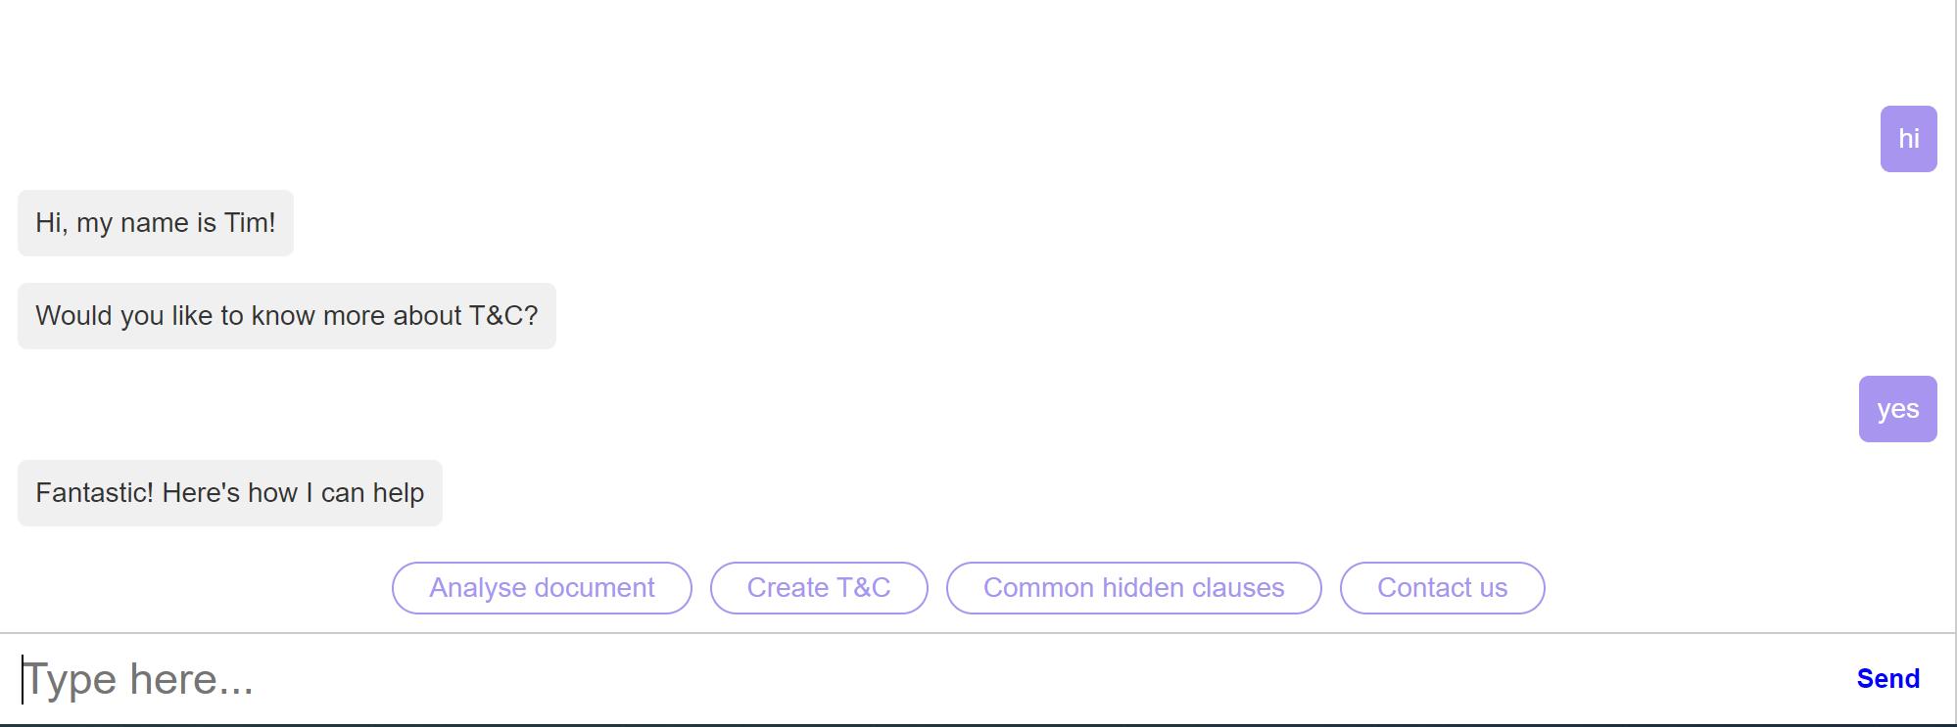Send the user to a specialised website which can help the create a professional and tailored T&C document for either a website a business so forth.

Figure 1. Working Prototype

Contribution:

I was assigned the position of facilitator which imposed a great responsibility. I was working closely with the team leader in the decision making and to assure the compliance of the team with the Sprint Development Process.

My role involved:

-creating different communication channels for our team and posting regular updates, so that everyone would be aware of the progress and the current stage of the project;

-organizing the weekly meetings and creating reports to in order to keep tracking of the progress made;

-created promotional materials such as the application mock-up and a prototype display of the working chatbot;

-offered support to my teammates when needed;

-maintained the group dynamics by creating and maintaining a visual presentation of the main project topics which involved the priority and status of each individual stage;

-creating and maintaining a Monday.com account, which is a Sprint based application, to create visual representation of the tasks at hand and current stages of the project;

-coding the chat-bot;

Throughout the project, I developed an understanding of the Sprint development cycle, I learned to work with Monday.com platform, enhanced communication skills and became aware of the responsibilities an individual has when working in a team.

Figure 2. Mock- Working Chatbot

Figure 3. Project Management Tool

Post-Mortem Project evaluation:

Ever since the beginning of the project, we worked together as a group and decided to have a clear vision regarding all aspects of the project and the steps necessary into achieving our goal, in order to avoid wasting precious time and resources.

The difference between our goal and the submitted project is not one that can be overlook but considering recent events and the lack of resources, I think we did a decent job.

From my perspective, as a whole, the project was successfully completed and for the most part of it, everything went as planned. As it is to be expected, any project has ups and downs, and for us, the challenge was the amount of work for the chatbot features to be completed. To comply with the terms and conditions of our project, we had difficulties searching for features and the ones we found were hard to implement with our current knowledge and understanding. Despite that, we overcame the impediments and, in the end, were able to deliver a market ready product.

As a team, all members were able to keep up with the given tasks, moreover, this strengthened our bonds and as a result, we had a strong communication and everyone achieved their individual goals.

Differences between initial goals and the outcome:

In the beginning we did set some unachievable goals but as the saying goes “shoot for the stars and settle with the moon”. The features that we wanted to implement are the following:

-The user could enter T&C from any company or industry and after a few moments of processing the bot to subtract the hidden clauses that raise concerns and can affect the well-being of the user.

-To have a database with the most common T&C from the most popular companies in the world.

-To have implemented a notification feature that keeps the user informed of any new “scamming” methods that some companies are fond of.

-To implement a “conversational path” that the bot should follow to make the user feel as it is having a conversation with a real person.

The goals we were able to achieve:

-We managed to create a scenario on which the bot to “behave” more naturally resembling a human.

-We managed to follow the agile development plan we did set in the beginning.

-We achieved our goal regarding promotional materials.

-We managed to bond as a team and support each other into learning new skills and develop professionally and personally.

Self-evaluation:

Throughout the project I had the chance not only to meet and work with new people, but also to get to know myself better. I have realised that some of my qualities are:

* Good Team-Player
* Organised
* Dedicated

My short-comings are:

* Bad time management skills
* Insecure
* Rushed
* Easily distracted

What I would do different is plan the application more thoroughly from the beginning and setting more reachable goals would be a must, as what we set out to do proved to be more complicated than expected, which brought the group moral down.