**WEEK 1:**

1. Ensure that development environment is working. Running ionic serve --platform android should open a browser that when in inspection mode looks like this:

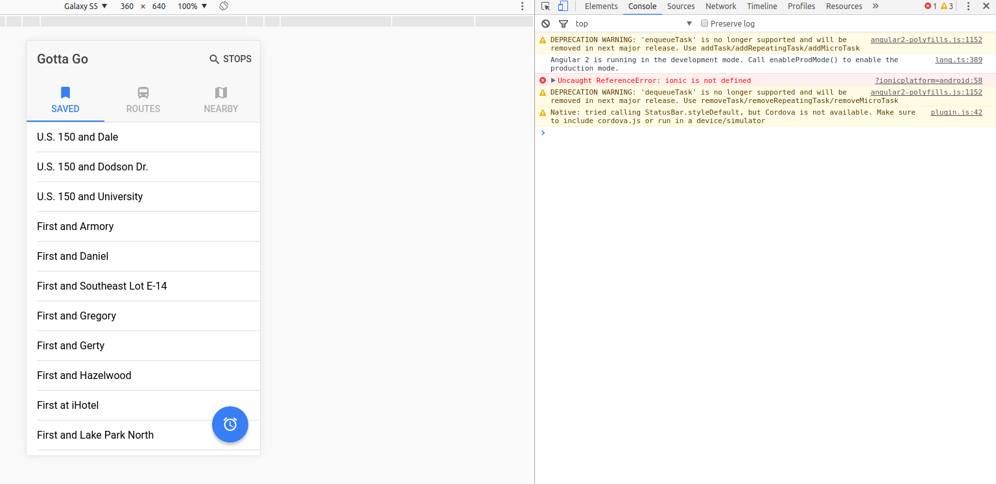

1. Ensure that other tabs work. They should look something like:

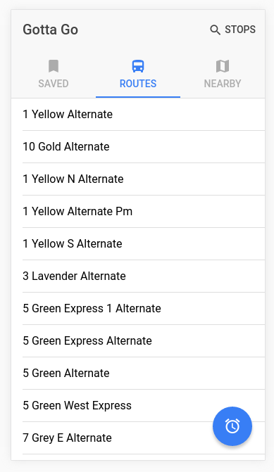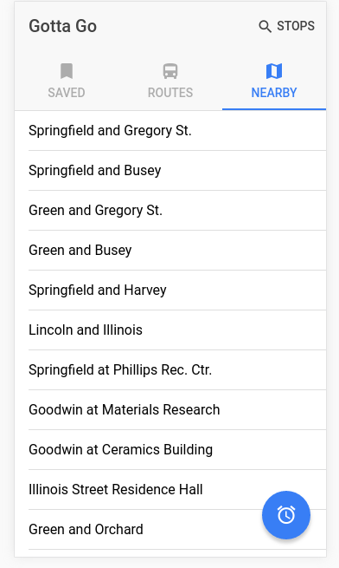

1. Click on a stop. Information like this should appear:

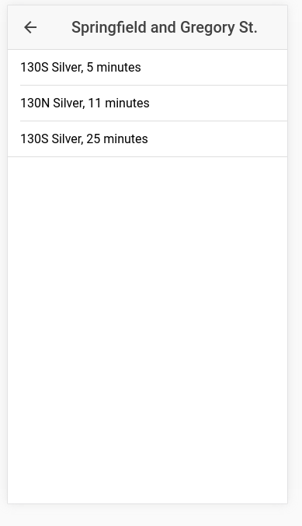

1. Assert that the data in each of these views makes sense