1. User

* CreateUser Request/Response

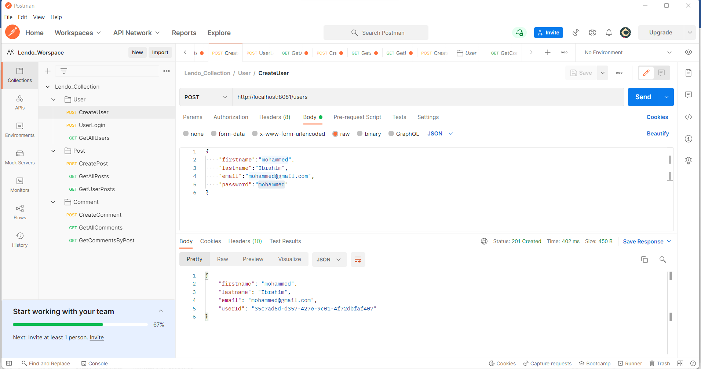

* UserLogin Request/Response (Getting the JWT Token in the response)

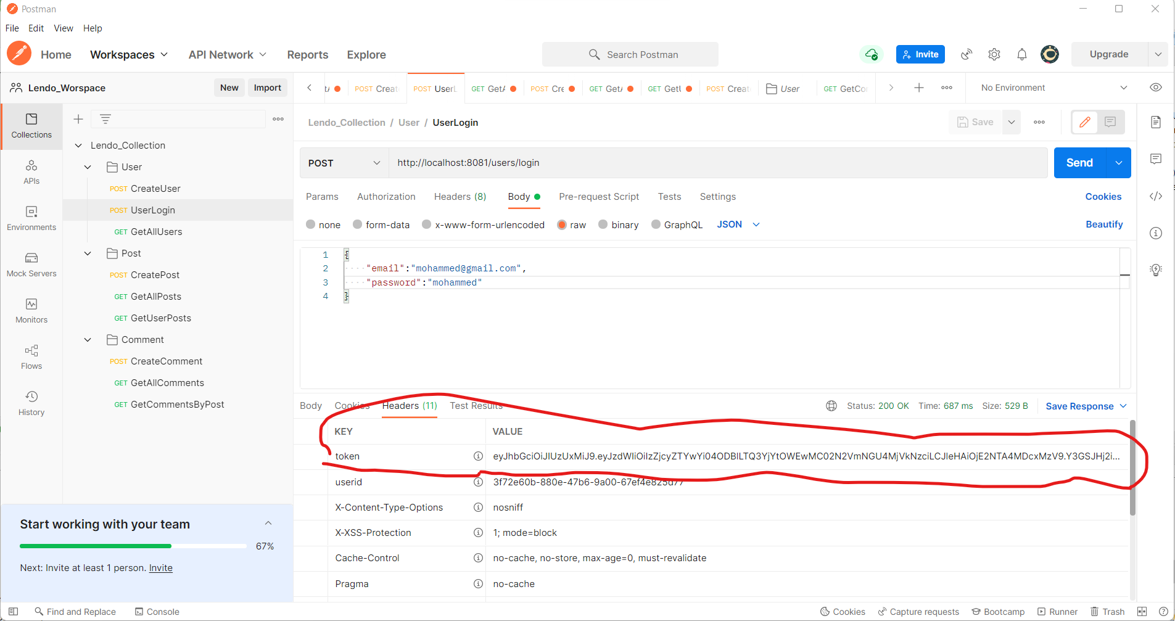

* GetUsers Request/Response (Without JWT token, request is **Forbidden**)

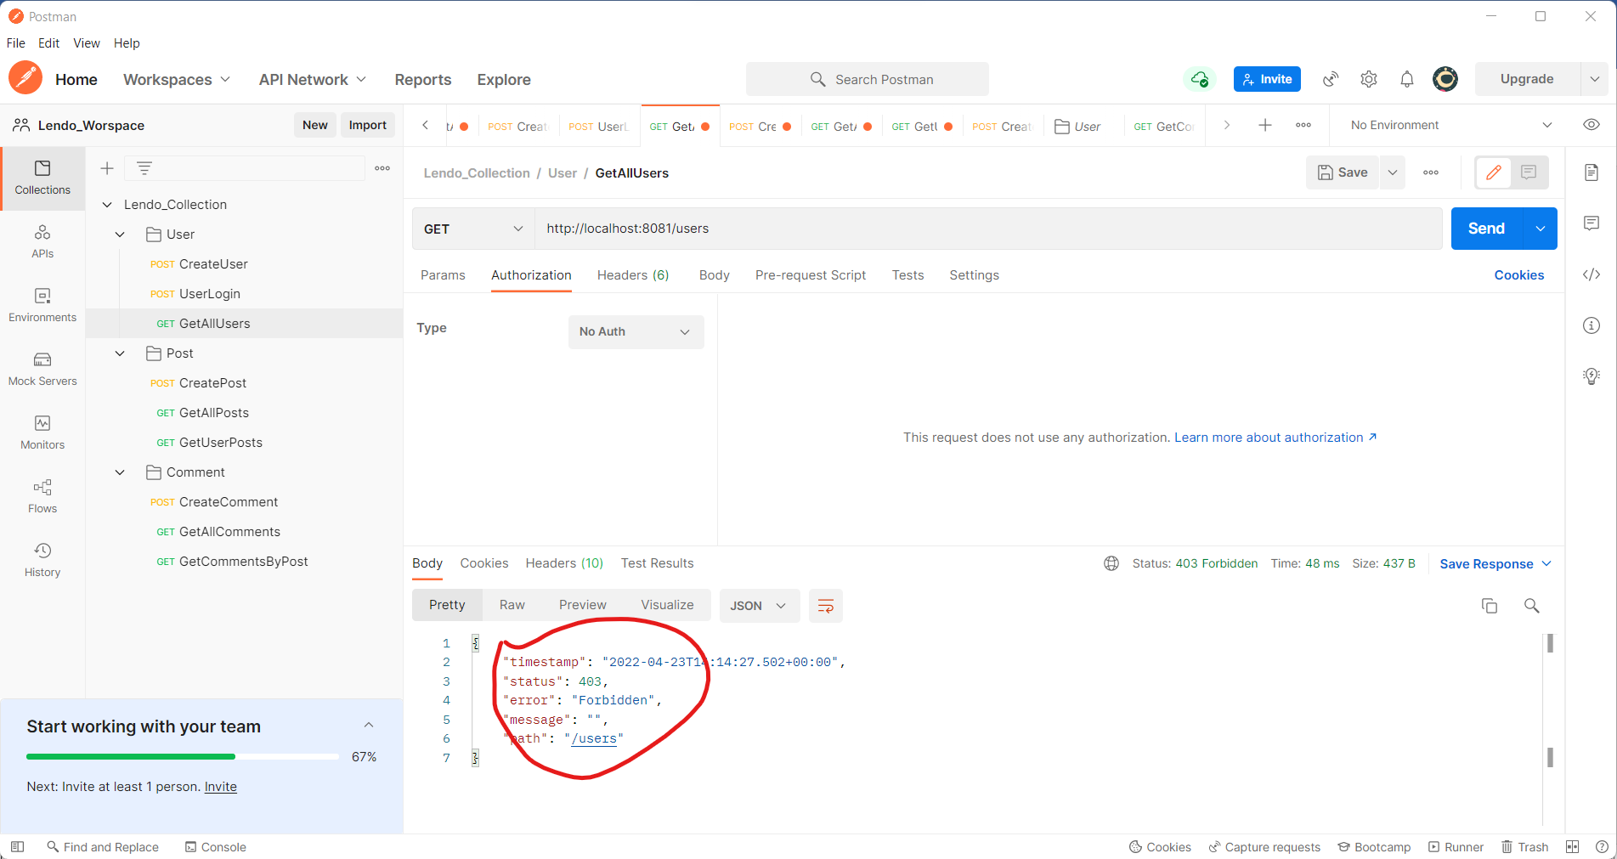

* GetUsers Request/Response (Passing JWT token in the authorization and getting the response)

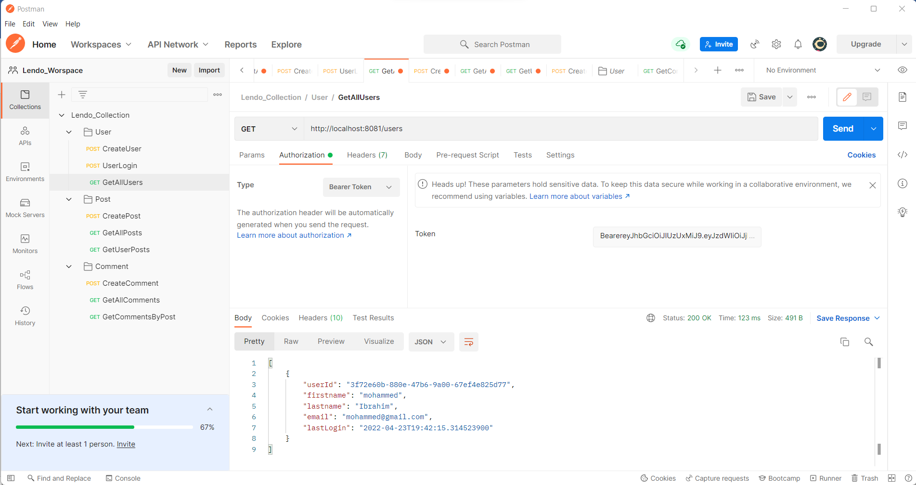

1. Post APIs

* Create Post Request/Response

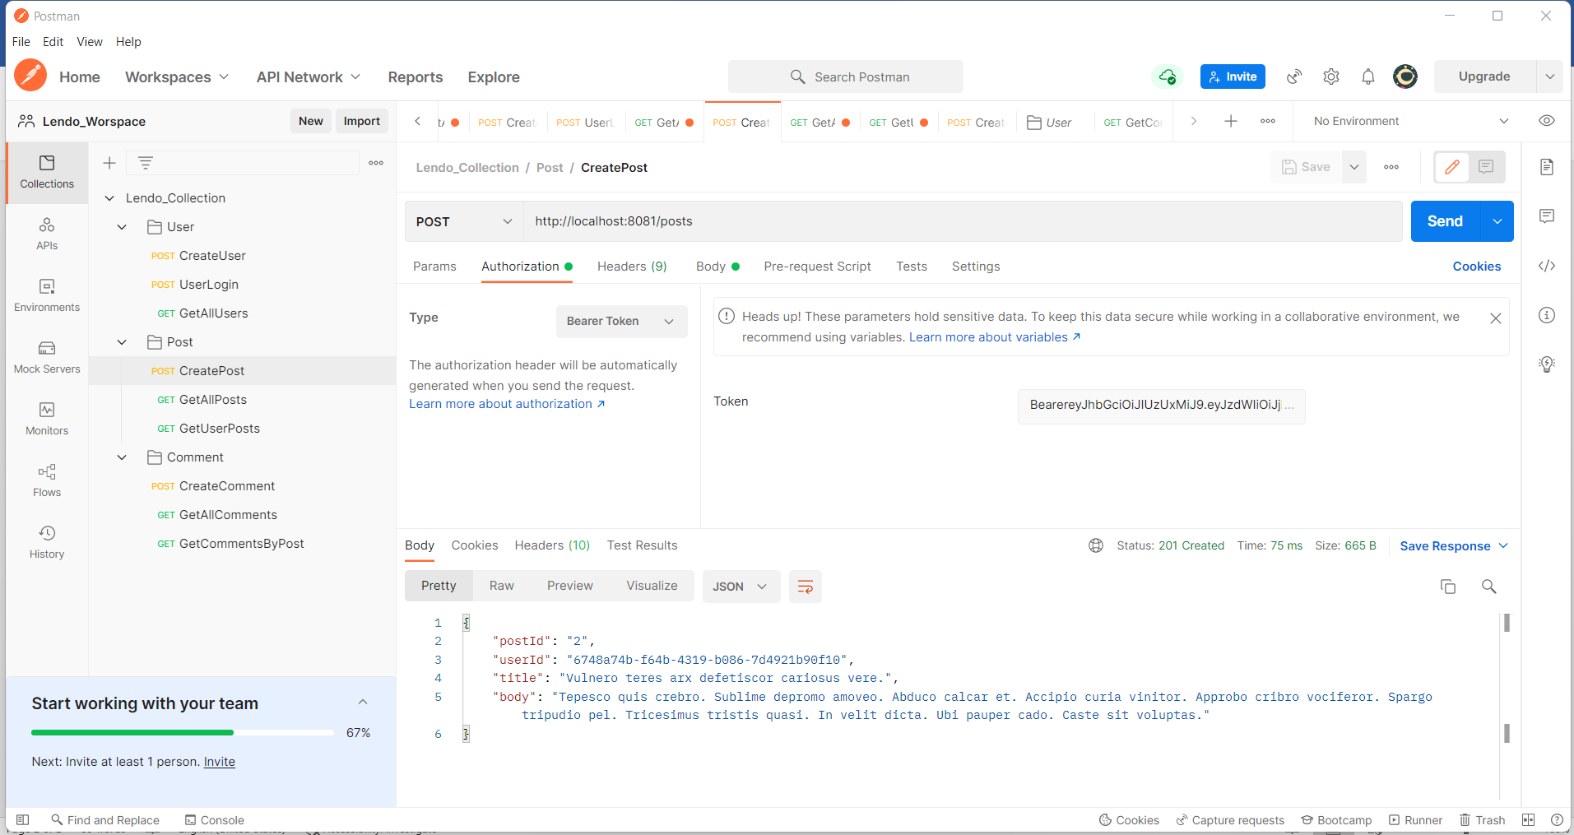

* Get All Posts Request /Response

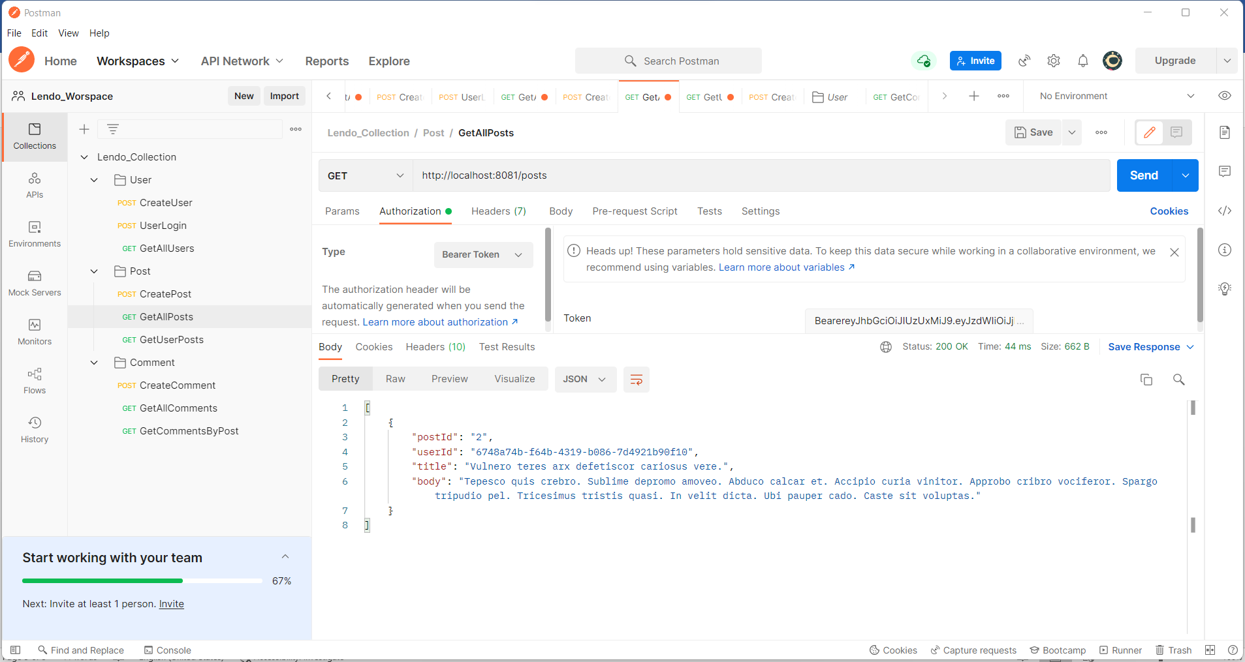

* GetUserPosts Request/Response

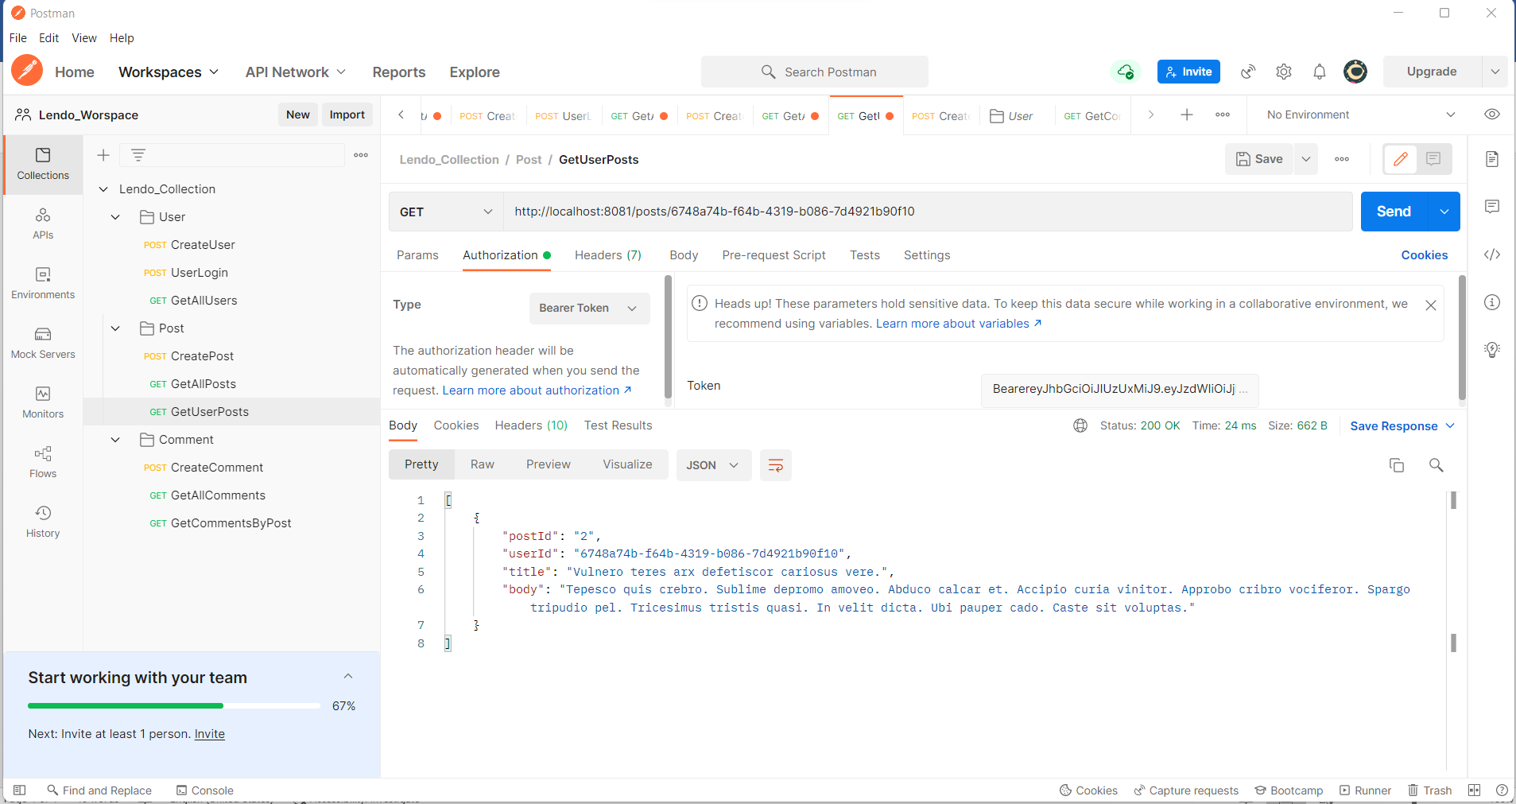

1. Comment API

* Create Comment Request/Resonse

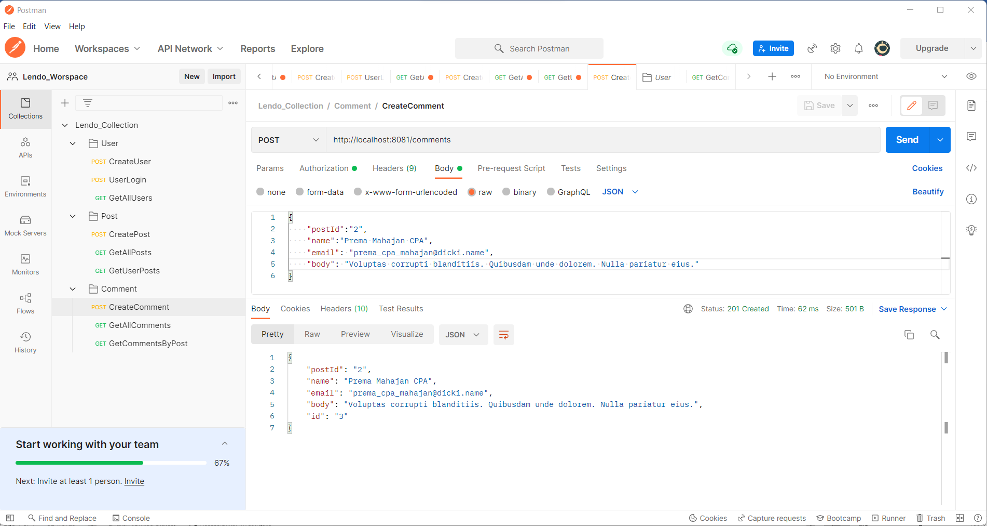

* GetAllComments Request/Response

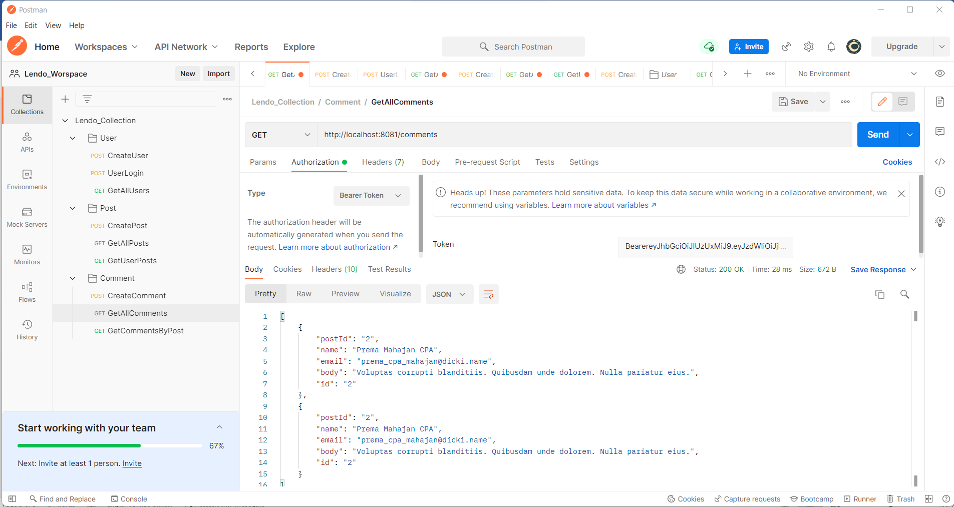

* GetCommentsByPost

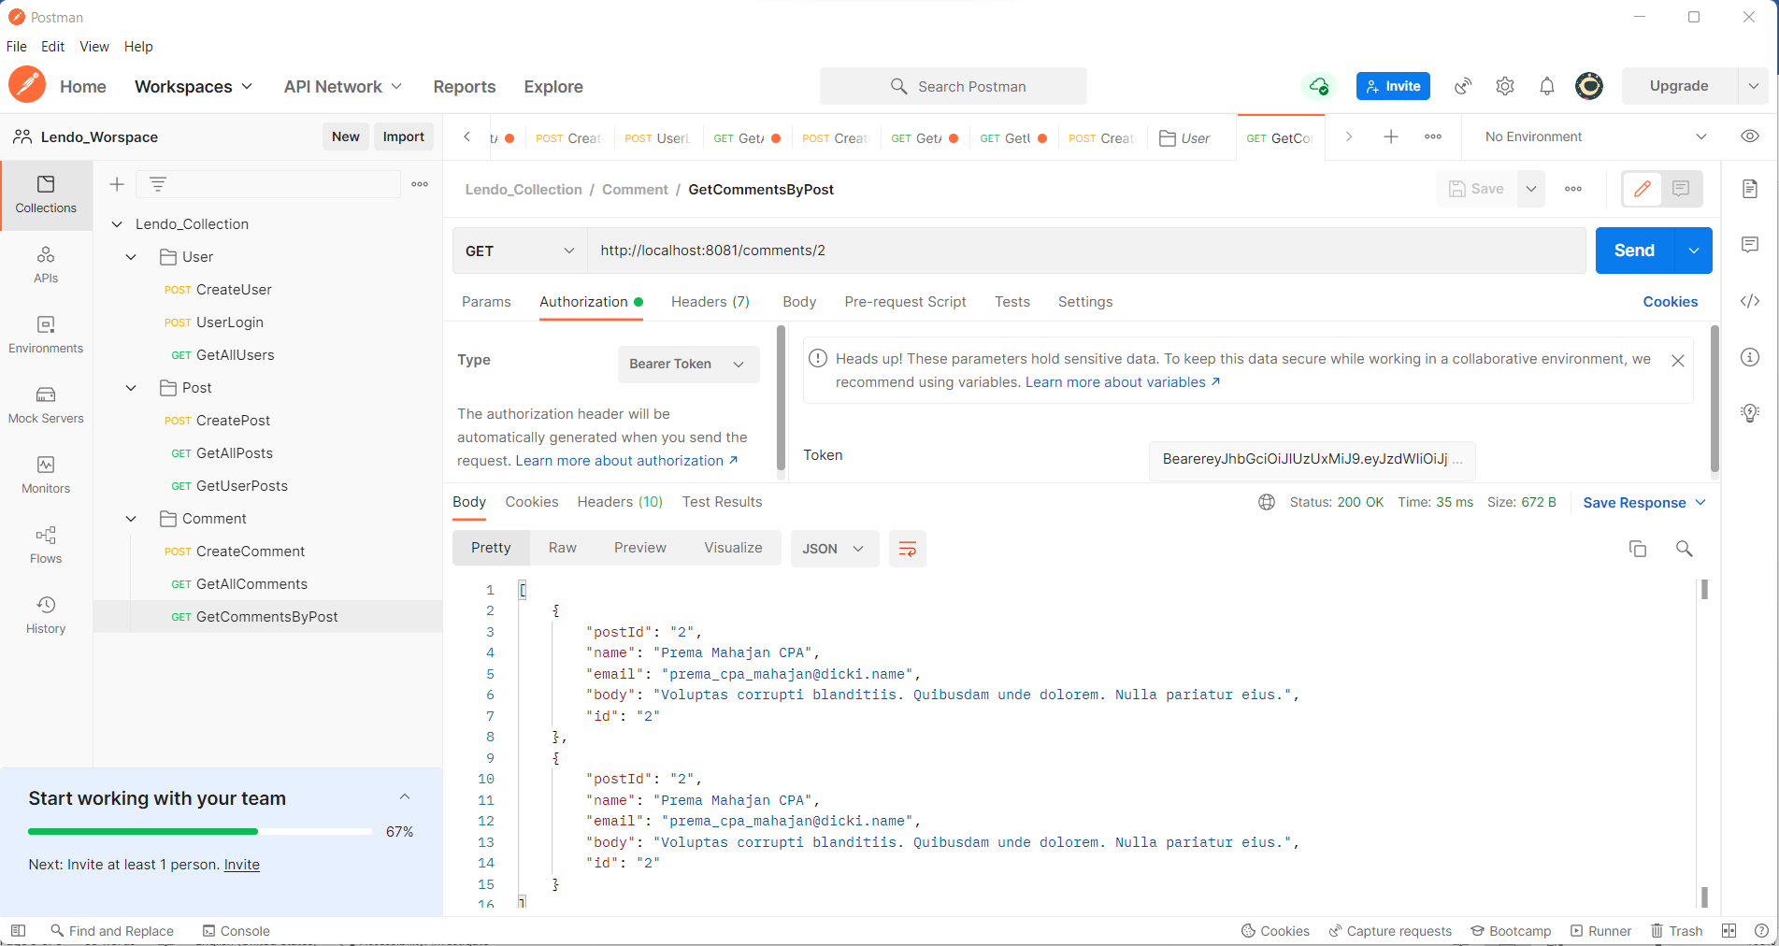

1. H2 In Memory DB

