* Output after each quantization step for same image
* Total loss of single VQ & RQ vs epochs for total number of codebooks
* Reconstruction of images
* EMA vs Without EMA for VQ and RQ both (2 plots)
* Total loss vs codebook size after fixed epoch

*Fig 1: Total loss vs Epoch for codebook size = 256, num of quantizer = 1*

**

*Fig 1: Reconstruction loss vs Epoch for codebook size = 256, num of quantizer = 1*

**

*With ema*

**

*With EMA*

**

*Without ema*

**

*Without EMA*

**

*Fig for comparison of RQ vs VQ for total loss with same number of total codebook*

**

*Fig for comparison of RQ vs VQ for reconstruction loss*

*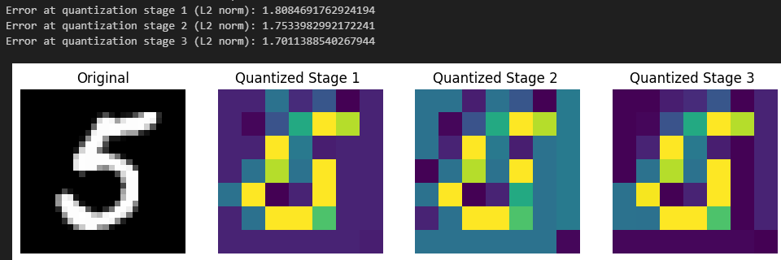*

**

*Fid score*

**