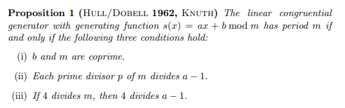

https://www.staff.uni-mainz.de/pommeren/Cryptology/Bitstream/1_Classic/Maxper.pdf

Hoeffdings confidence interval:

https://stats.stackexchange.com/questions/161303/how-to-use-hoeffdings-inequality-to-find-a-confidence-interval

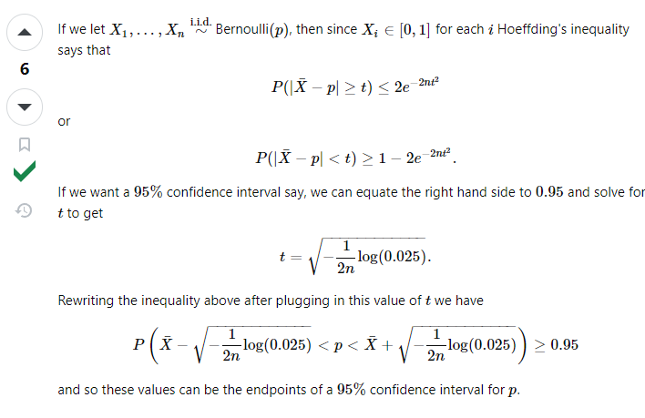

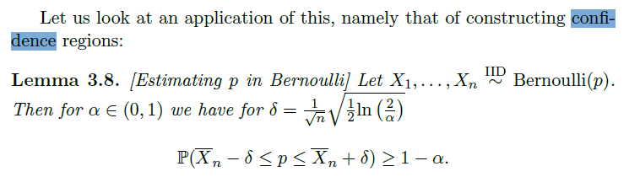

Bennett’s confidence interval (in **12-Regression.ipynb)**

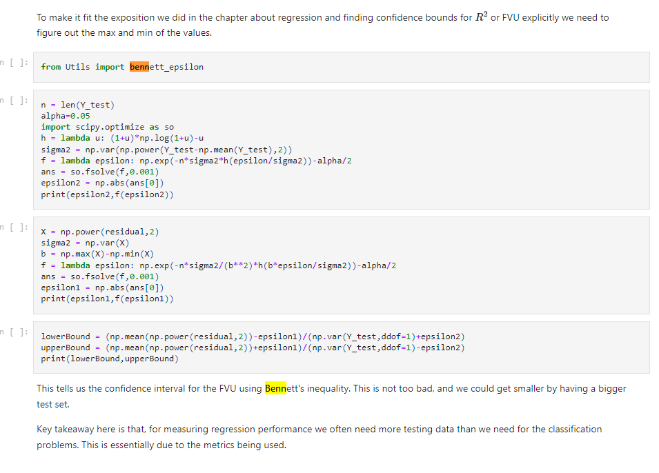

Joint density definition:

