
SAP
P_BTPA_2408 Exam SAP Certified Professional
Questions & Answers (Full Version)
Thank you for Purchasing P_BTPA_2408 Exam
www.certsland.com

Exam Dumps | 1/67
➢TOTAL QUESTIONS:120
Question: 1
You are a solution architect on a brownfield project where an SAP ECC 6.0 system is being migrated to SAP S/4HANA Cloud public edition. Two mission- critical legacy applications must be migrated to the new system. There is some debate on the project team as to the appropriate programming model to use:
• Application 1 was originally written using classic ABAP. The underlying SAP tables that the application originally relied on have been removed and the data now exists in a new simplified table in SAP S/4HANA Cloud public edition (to which table extensions are not permitted). Additional data needed for the application resides in SAP Ariba. Remote interfaces exist for both to select the data.
• Application 2 was originally written using Java and relied upon tables from the SAP ECC 6.0 system as well as SAP PLM 4.0. The PLM system will be retired; however, the SAP S/4HANA Cloud public edition instance has all the data needed for the application. No remote interfaces exist to select the data.
Which of the following approaches should the customer use? Note: There are 2 correct answers to this question.
A. Rewrite application 2 using the Cloud Application Programming Model
B. Rewrite application 1 using the Cloud Application Programming Model
C. Rewrite application 2 using the ABAP RESTful Application Programming Model D. Rewrite application 1 using the ABAP RESTful Application Programming Model
Answer: A, D
Explanation:
Option A is correct because rewriting Application 2 using the Cloud Application Programming Model (CAP) is suitable for modernizing the Java-based application. CAP is designed for developing cloud- native applications, allowing seamless integration with SAP S/4HANA Cloud, which contains all the necessary data for Application 2. This approach optimizes the application to leverage the cloud environment effectively.
Option D is correct because rewriting Application 1 using the ABAP RESTful Application Programming Model (RAP) is appropriate since this application was originally built using classic ABAP. RAP is tailored for developing applications in SAP S/4HANA using ABAP and is ideal for applications that require integration with S/4HANA data models. Since Application 1 relies on data from a new simplified table in S/4HANA, RAP provides the necessary framework to support this integration.
Option B is incorrect because rewriting Application 1 using the Cloud Application Programming Model is not optimal. CAP is primarily used for Java applications, whereas Application 1 is ABAP-based and would benefit more from RAP.
Option C is incorrect because rewriting Application 2 using the ABAP RESTful Application Programming Model is not suitable. Since Application 2 was developed in Java, leveraging RAP, which is designed for
www.certsland.com

Exam Dumps | 2/67
ABAP applications, would not align with its original architecture. CAP is a more fitting choice for Java applications.
References:
• SAP S/4HANA Migration Guide
• SAP Cloud Application Programming Model Documentation • SAP ABAP RESTful Application Programming Model Overview
Question: 2
In which phase of the SAP Integration Solution Advisory Methodology is a technology mapping of customer use cases and SAP BTP integration services produced (for an example of a solution architecture blueprint, see the attached diagram)?
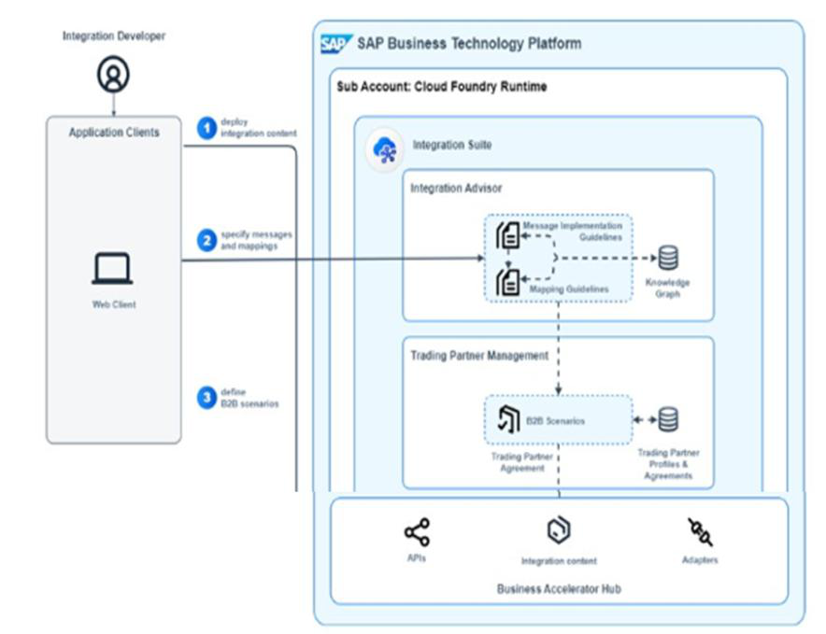
A. Enable a practice of empowerment
B. Define integration best practices
C. Design your hybrid integration platform
D. Assess your integration strategy
www.certsland.com

Exam Dumps | 3/67
Answer: C
Explanation:
Option C is correct because the phase "Design your hybrid integration platform" focuses on creating a comprehensive integration architecture that aligns customer use cases with the relevant SAP Business Technology Platform (BTP) integration services. During this phase, technology mapping is performed to identify which integration services will best support the specific use cases, resulting in a solution architecture blueprint that outlines how these services will be utilized within the customer's environment.
Option A is incorrect because "Enable a practice of empowerment" typically involves fostering a culture of innovation and self-sufficiency among teams but does not specifically address technology mapping or solution architecture.
Option B is incorrect because "Define integration best practices" focuses on establishing guidelines and standards for integration but does not involve the actual mapping of customer use cases to specific integration services.
Option D is incorrect because "Assess your integration strategy" involves evaluating the current integration landscape and identifying gaps or areas for improvement, but it does not produce the detailed technology mapping required for a solution architecture blueprint.
References:
• SAP Integration Solution Advisory Methodology Overview
• SAP Business Technology Platform Integration Services Documentation
Question: 3
A company is decommissioning its legacy ERP system in favor of adopting SAP solutions. The company is not sure which specific solutions to adopt. The company has three main business goals:
• Maintain several unique business processes.
• Maintain the solutions with a small budget, and limited time and resources. • Integrate several non-SAP solutions.
Which combination of solutions should the customer adopt?
A. SAP Lean IX | SAP S/4HANA on premise | SAP BTP
B. SAP Signavio | SAP S/4HANA public edition | SAP Process Orchestration C. SAP Signavio | SAP S/4HANA Cloud public edition | SAP BTP
D. SAP Lean IX | SAP S/4HANA Cloud private edition | SAP Process Orchestration
Answer: C
Explanation:
Option C is correct because adopting SAP Signavio, SAP S/4HANA Cloud public edition, and SAP BTP aligns well with the company's business goals:
1. Maintain several unique business processes:
o SAP Signavio offers business process management and modeling capabilities, allowing the company to document, visualize, and optimize its unique business processes effectively.
www.certsland.com

Exam Dumps | 4/67
o SAP S/4HANA Cloud public edition supports extensive customization and configuration options, enabling the company to tailor its operations while benefiting from the standard features of SAP.
2. Maintain the solutions with a small budget, and limited time and resources:
o The Cloud public edition typically has a lower total cost of ownership compared to on-premise solutions, as it reduces the need for extensive infrastructure and maintenance resources.
o Using SAP BTP allows for rapid development and integration capabilities, which can help streamline processes and reduce overall implementation time and resource consumption.
3. Integrate several non-SAP solutions:
o SAP BTP provides various tools and services for integration, enabling the company to connect and orchestrate data flows between SAP and non-SAP solutions easily.
Option A is incorrect because SAP S/4HANA on premise would require more resources for maintenance and integration, which conflicts with the company's goal of maintaining a small budget and limited resources.
Option B is incorrect because while SAP Signavio and SAP Process Orchestration can support business processes, the SAP S/4HANA public edition does not provide as many customization options as the Cloud public edition, potentially limiting the ability to maintain unique business processes.
Option D is incorrect as SAP Lean IX and SAP S/4HANA Cloud private edition typically require more investment and management resources compared to the public edition, which may not align with the company's limited budget and resource constraints.
References:
• SAP Signavio Documentation
• SAP S/4HANA Cloud Public Edition Overview
• SAP Business Technology Platform Integration Services
Question: 4
A customer wants to verify the feasibility of the attached "proof of concept" design. They would prefer a zero (or minimal) upfront investment but want to seamlessly transition to a different pricing model while preserving their SAP BTP investments if the design works.
As a solution architect, which pricing plan would you recommend to the customer?
www.certsland.com

Exam Dumps | 5/67
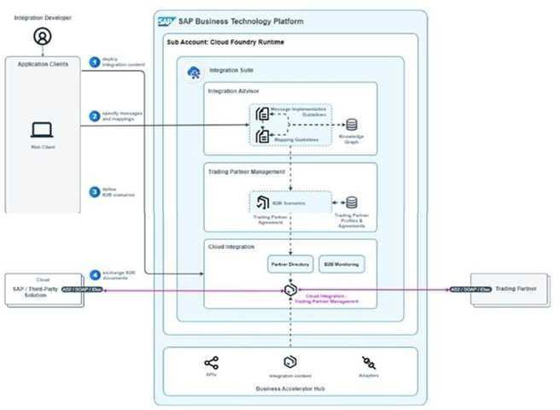
A. Subscription
B. Pay-As-You-Go for SAP BTP
C. SAP BTPEA
D. SAP BTP trial
Answer: B
Explanation:
Option B is correct because the Pay-As-You-Go for SAP BTP pricing model allows the customer to use SAP BTP services without a significant upfront investment. This model enables the customer to only pay for the resources and services they use, making it ideal for a proof of concept where costs need to be minimized initially. Additionally, if the design proves successful, the customer can continue to use the same services and seamlessly transition to a more extensive usage model without losing their investments in SAP BTP.
Option A is incorrect because the Subscription model typically requires a commitment to pay a fixed amount upfront for a specific duration, which does not align with the customer’s preference for minimal upfront investment during the proof of concept phase.
Option C is incorrect because SAP BTPEA (Business Technology Platform Enterprise Agreement) is designed for organizations with established usage patterns and does not cater to the need for zero upfront investment or flexibility in the early stages of a project.
Option D is incorrect because the SAP BTP trial is a temporary solution meant for evaluation purposes.
www.certsland.com

Exam Dumps | 6/67
While it offers free access to BTP services, it is not a sustainable option for transitioning to a full-scale implementation once the proof of concept is validated. The trial does not guarantee that investments will be preserved once moving to a paid model.
References:
• SAP BTP Pricing Models Documentation
• SAP Business Technology Platform Overview
Question: 5
You are a solution architect and your client has recently completed a merger and acquisition. Your client uses SAP S/4HANA Cloud Public Edition and the acquired company is using SAP ECC 6.0. For business and legal reasons, the users of the acquired company cannot yet be added to the global user directory. The acquired users still need access to the custom application.
Given the attached diagram, which solution would you recommend to your client in "1" to enable this access?
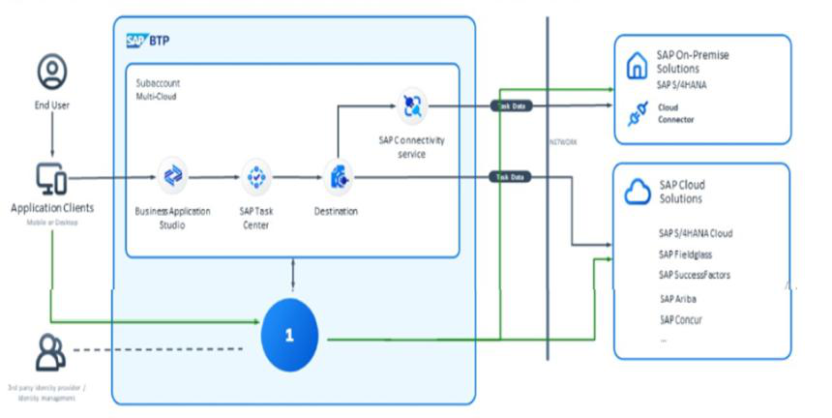
A. SAP Secure Login Service for SAP GUI
B. SAP Cloud Identity Services - Identity Provisioning C. SAP Authorization and Trust Management Service D. SAP Cloud Identity Services - Identity Authentication
Answer: D
Explanation:
Option D is correct because SAP Cloud Identity Services - Identity Authentication provides the necessary capabilities for managing user identities and enabling secure access to applications. This solution allows the acquired company’s users to authenticate themselves and access the custom application in the SAP S/4HANA Cloud Public Edition without needing to be added to the global user
www.certsland.com

Exam Dumps | 7/67
directory immediately. By leveraging identity authentication, the acquired users can gain access while complying with business and legal requirements.
Option A is incorrect because the SAP Secure Login Service for SAP GUI primarily focuses on enhancing the security of logins for SAP GUI applications but does not address the identity management needs for the acquired users who cannot be added to the global user directory.
Option B is incorrect because SAP Cloud Identity Services - Identity Provisioning is intended for provisioning user accounts and managing user access across different systems. However, since the acquired users cannot yet be added to the global user directory, this solution would not be feasible at this stage.
Option C is incorrect because the SAP Authorization and Trust Management Service deals with managing authorizations and trust relationships but does not directly provide a means for users to authenticate or access applications.
References:
• SAP Cloud Identity Services Overview
• SAP S/4HANA Cloud Security Guide
• SAP Identity Authentication Service Documentation
Question: 6
As a solution architect, you are asked for your opinion on an optimal integration. You are told that the data resides in two places, SAP S/4HANA (on- premise) and third party APIs. You are also told the following requirements:
• Periodically read the data from both systems, perform several transformations of the data, and forward the results to a business partner.
• Monitoring is to be done by a dedicated group from IT with SAP products.
• Maintenance of the integration part has a small budget, limited time, and limited resources.
Which of the following solutions would you recommend as optimal for the design?
A. A custom SAP Fiori App and Grafana
B. SAP Build Process Automation and SAP Solution Manager C. SAP Integration Suite and SAP Cloud ALM
D. SAP Build Apps and SAP Cloud ALM
Answer: C
Explanation:
Option C is correct because the SAP Integration Suite provides a comprehensive integration platform that can easily connect on-premise systems like SAP S/4HANA with third-party APIs. It supports various integration scenarios, including data reading, transformation, and forwarding results. Additionally, it offers pre-built connectors and templates that can accelerate development, aligning well with the requirement for limited time and resources.
Furthermore, SAP Cloud ALM is designed for application lifecycle management in the cloud and
www.certsland.com

Exam Dumps | 8/67
provides monitoring capabilities tailored for SAP environments. It allows the dedicated IT group to effectively monitor the integration processes and manage performance, which is critical for maintaining oversight with limited resources.
Option A is incorrect because while a custom SAP Fiori app could provide a user interface, it does not address the integration and transformation of data from multiple sources effectively. Grafana is primarily used for monitoring and visualization, which does not meet the integration requirements.
Option B is incorrect because SAP Build Process Automation is focused on automating business processes rather than integrating data across systems. While SAP Solution Manager is valuable for managing SAP landscapes, it does not provide the direct integration capabilities needed for the scenario.
Option D is incorrect because SAP Build Apps focuses on building applications rather than handling integration scenarios. Although SAP Cloud ALM is beneficial for monitoring, the integration capabilities needed to connect SAP S/4HANA with third-party APIs are lacking without the use of the SAP Integration Suite.
References:
• SAP Integration Suite Documentation
• SAP Cloud ALM Overview
• SAP S/4HANA Integration Scenarios Guide
Question: 7
The customer is looking to use an SAP BTP service to replicate master data objects across connected business applications. The service should be based off of the process integration style and the integration use case pattern as defined in the SAP Integration Solution Advisory Methodology. The customer wants to use an SAP BTP service to synchronize the workforce person master data object between SAP S/4HANA Cloud and SAP SuccessFactors HXM Suite as part of the Hire to Retire process (for cloud deployment). They prefer a service that uses a "hub and spoke" model to enable the synchronization.
Which of the following SAP solution should the customer use as the "Placeholder Icon" (see attached diagram)?
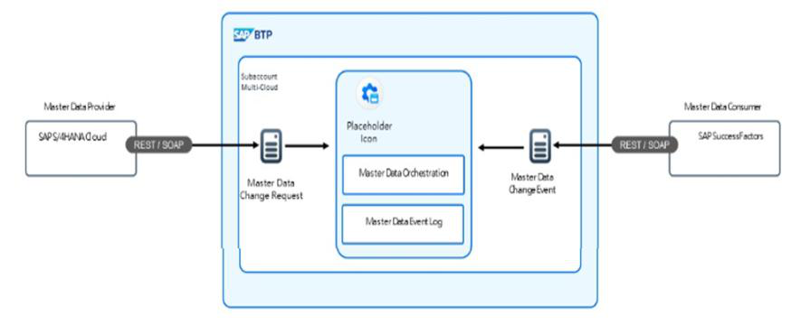
www.certsland.com

Exam Dumps |  | 9/67
A. | SAP NetWeaver Master Data Management
B. | SAP Master Data Governance
C. | SAP Cloud Integration
D. | SAP Master Data Integration
Answer: D
Explanation:
Option D is correct because SAP Master Data Integration is specifically designed for synchronizing master data across multiple systems in a "hub and spoke" model. This solution facilitates the integration of master data between different SAP and non-SAP systems, making it suitable for the scenario of synchronizing workforce person master data between SAP S/4HANA Cloud and SAP SuccessFactors HXM Suite.
• Hub and Spoke Model: This model allows the customer to centralize data management and synchronization processes, which aligns with the customer’s requirement for a service that enables effective replication and integration of master data objects.
Option A is incorrect because SAP NetWeaver Master Data Management (MDM) is an older solution that primarily focuses on data management rather than the modern integration capabilities required for cloud applications.
Option B is incorrect because SAP Master Data Governance (MDG) is focused on the governance of master data rather than direct replication and synchronization processes between cloud applications in a hub and spoke model.
Option C is incorrect because SAP Cloud Integration is generally used for integrating different cloud and on-premise applications but does not specifically address the master data replication and governance aspects needed for managing workforce person data in a centralized manner.
References:
• SAP Master Data Integration Overview
• SAP Integration Solution Advisory Methodology
• SAP SuccessFactors Integration Scenarios
Question: 8
A customer wants to establish connectivity between applications being executed by end users and the on-premise backend system (SAP S/4HANA).
Based on the attached diagram, which combination is necessary to establish the connectivity?
www.certsland.com

Exam Dumps | 10/67
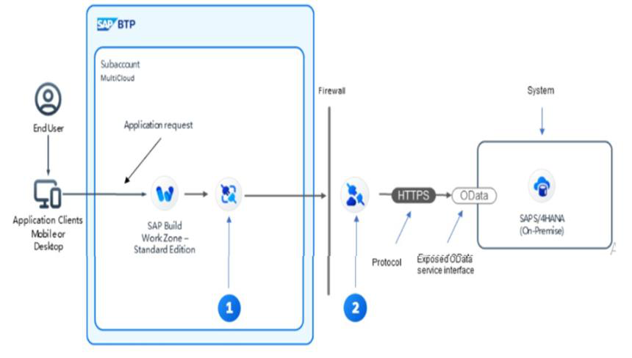
A. Cloud Connector for 1 and Destination Service for 2 B. Connectivity Service for 1 and Cloud Connector for 2 C. Custom Connector for 1 and Connectivity Service for 2 D. Destination Service for 1 and Connectivity Service for 2
Answer: B
Explanation:
Option B is correct because establishing connectivity between end-user applications and an on-premise backend system like SAP S/4HANA typically requires both the Connectivity Service and the Cloud Connector.
1. Connectivity Service (for 1): This service is essential for managing and routing requests from the cloud to on-premise systems. It allows the applications to connect to backend services securely and efficiently.
2. Cloud Connector (for 2): The Cloud Connector serves as a link between SAP Business Technology Platform (BTP) and the on-premise system. It enables secure communication by establishing a secure tunnel and managing access to on-premise resources from cloud applications.
The combination of these two services effectively enables a secure and manageable connectivity solution.
Option A is incorrect because while the Cloud Connector is essential for connecting to on-premise systems, the Destination Service alone does not provide the necessary connectivity without the underlying connectivity mechanism.
Option C is incorrect because a Custom Connector is typically not necessary for standard connectivity scenarios. Instead, using the provided services (Connectivity Service and Cloud Connector) is the best practice for integrating SAP systems.
www.certsland.com

Exam Dumps | 11/67
Option D is incorrect because although the Destination Service is useful for defining endpoints for applications, it does not directly establish connectivity to on-premise systems without the Cloud Connector.
References:
• SAP Cloud Connector Documentation
• SAP Connectivity Service Overview
• SAP Integration Guide for S/4HANA and Cloud Applications
Question: 9
Which part of the SAP Al architecture is responsible for providing the real-time, business-specific data to enable retrieval-augmented generation?
A. SAP HANA Cloud vector engine
B. SAP Joule
C. Generative Al hub
D. SAP AI Core
Answer: A
Explanation:
Option A is correct because the SAP HANA Cloud vector engine plays a critical role in providing real- time, business-specific data that is necessary for retrieval-augmented generation (RAG). This component is designed to handle vector embeddings, allowing for efficient searching and retrieval of relevant data based on business contexts. By leveraging this capability, organizations can enhance their generative AI applications with accurate and contextually relevant information.
Option B is incorrect because SAP Joule focuses on enabling intelligent automation and enhancing user experience but does not specifically handle the retrieval of real-time business data for generative processes.
Option C is incorrect because the Generative AI hub serves as a platform for managing generative AI models and workflows, but it relies on other components (like the vector engine) to supply the necessary data for retrieval-augmented generation.
Option D is incorrect because SAP AI Core provides foundational AI services and capabilities but is not solely responsible for retrieving real-time business-specific data needed for RAG. It supports various AI functionalities, while the vector engine is specifically tasked with data retrieval.
References:
• SAP AI Architecture Overview
• SAP HANA Cloud Documentation
• Retrieval-Augmented Generation Techniques in SAP AI
Question: 10
A manufacturer wants to discuss the design of a solution that tracks and manages stock availability and movement of goods within a warehouse. They want to ensure that movements are aggregated for www.certsland.com

Exam Dumps | 12/67
reporting purposes and that these reports can be used to optimize stock movements. They also want to use the newest solutions to build these reports.
Which of the following solutions can be used together to fulfill the requirements? Note: There are 3 correct answers to this question.
A. SAP Data Intelligence
B. SAP HANA Service (SAP Regions) for SAP BTP C. SAP Analytics Cloud
D. SAP Datasphere
E. SAP HANA Cloud
Answer: C, D, E
Explanation:
Option C is correct because SAP Analytics Cloud provides robust reporting and analytics capabilities. It allows users to create interactive reports and dashboards, enabling the manufacturer to visualize stock movements and availability, and optimize operations based on insights derived from aggregated data.
Option D is correct because SAP Datasphere (formerly known as SAP Data Warehouse Cloud) serves as a data management and integration solution. It allows for the integration of data from various sources, including warehouse management systems, enabling the aggregation and modeling of stock movement data for reporting purposes.
Option E is correct because SAP HANA Cloud serves as an in-memory database service that provides the high-performance data processing capabilities needed for real-time analytics. It can support the storage and processing of data related to stock availability and movements, which is essential for generating the required reports efficiently.
Option A is incorrect because SAP Data Intelligence focuses more on data integration and orchestration rather than direct reporting and analytics capabilities. While it can be beneficial in data management scenarios, it does not directly fulfill the reporting needs specified by the manufacturer.
Option B is incorrect because while SAP HANA Service provides database capabilities, it does not encompass the complete solution required for reporting and data aggregation as effectively as the combination of options C, D, and E.
References:
• SAP Analytics Cloud Overview
• SAP Datasphere Documentation
• SAP HANA Cloud Features and Benefits
Question: 11
As a solution architect, you are in a meeting about the design of a new application to manage the delivery process of goods or services. The extension will be maintained by the line of business (as opposed to IT).
The following application parameters/features are discussed:
• Tracking deliveries in real-time
www.certsland.com

Exam Dumps | 13/67
• Optimizing delivery routes
• Providing delivery notifications to customers.
• Scaling according to usage
• Maintenance downtime must be short.
Which extension type is best suited for this application?
A. Side-by-side
B. Classic
C. Key user
Answer: A
Explanation:
Option A is correct because a side-by-side extension architecture is best suited for the given application parameters. This type of extension allows the application to be developed and deployed independently from the core system, leveraging cloud capabilities. Key advantages include:
• Real-time Tracking: The side-by-side architecture enables integration with external services and APIs, facilitating real-time delivery tracking and notifications.
• Optimized Delivery Routes: This architecture allows for the integration of advanced routing algorithms and mapping services without altering the core application, making it easier to optimize delivery routes.
• Scalability: Side-by-side extensions can scale according to usage since they are hosted in the cloud and can utilize cloud resources dynamically.
• Short Maintenance Downtime: With a side-by-side architecture, maintenance can be performed independently, minimizing downtime for users.
Option B is incorrect because a classic extension is typically tightly integrated with the core application, making it less flexible and harder to scale according to usage. It may also lead to longer downtimes during maintenance.
Option C is incorrect because a key user extension is aimed at enhancing the core application’s functionality for specific users but does not provide the same level of scalability and independence as a side-by-side extension. It is more suitable for minor enhancements rather than comprehensive applications requiring real-time capabilities.
References:
• SAP Extension Suite Overview
• Side-by-Side Extension Architecture in SAP
• Best Practices for Application Design and Maintenance
Question: 12
A customer wants to design and build a mission critical application:
• The app will undergo frequent adjustments because business and legal changes will occur often. • The application must be always ready for deployment to production.
www.certsland.com

Exam Dumps | 14/67
• The deployment to production will be done manually by the IT department.
• Changes to the application code must be merged smoothly and easily so that the code remains stable.
As a solution architect, which SAP BTP solution best meets the customer requirements?
A. SAP Cloud ALM
B. SAP Continuous Integration and Delivery
C. SAP Cloud Management Service for SAP BTP
Answer: B
Explanation:
Option B is correct because SAP Continuous Integration and Delivery (CI/CD) provides the necessary tools and processes to automate the deployment pipeline, which is essential for applications that undergo frequent adjustments. This solution enables:
• Frequent Adjustments: CI/CD allows for regular integration and testing of code changes, facilitating rapid adaptation to business and legal requirements.
• Always Ready for Deployment: With CI/CD practices, the application can be kept in a state of readiness for production deployment, ensuring that the latest changes are always deployable.
• Manual Deployment by IT: While CI/CD automates much of the integration and testing process, it can be configured to allow manual deployment to production by the IT department, aligning with the customer's requirement.
• Smooth Merging of Code Changes: CI/CD pipelines include features for version control and automated testing, ensuring that changes are merged smoothly and that the application remains stable after updates.
Option A is incorrect because SAP Cloud ALM focuses on application lifecycle management and operational monitoring rather than on the specific continuous integration and delivery processes required for frequent code changes and deployments.
Option C is incorrect because SAP Cloud Management Service for SAP BTP primarily offers services for managing applications and environments but does not directly address the CI/CD processes necessary for continuous updates and stable code merging.
References:
• SAP Continuous Integration and Delivery Overview
• Best Practices for CI/CD in SAP BTP
• SAP Cloud ALM Documentation
Question: 13
A customer's sales department is having problems with governmental authorities dealing with transparency around logging events related to security and other compliance topics.
As an SAP Solution Architect, which SAP BTP service would you recommend for being compliant with regulations?
www.certsland.com

Exam Dumps |  | 15/67
A. | SAP Audit Log service
B. | SAP Cloud Management service for SAP BTP
C. | SAP Application Logging service for SAP BTP
D. | SAP Cloud Logging service
Answer: A
Explanation:
Option A is correct because the SAP Audit Log service is specifically designed to track and log events related to security and compliance. This service enables organizations to maintain a detailed audit trail of actions taken within applications, which is crucial for demonstrating compliance with governmental regulations and ensuring transparency regarding security practices. The audit logs provide the necessary documentation to satisfy regulatory requirements.
Option B is incorrect because the SAP Cloud Management service for SAP BTP focuses on managing and monitoring applications and resources in the cloud but does not specifically address the need for comprehensive logging and audit capabilities for compliance purposes.
Option C is incorrect because the SAP Application Logging service for SAP BTP is intended for logging application-specific events and messages. While useful for debugging and operational monitoring, it does not provide the regulatory compliance features necessary for managing audit logs related to security and compliance topics.
Option D is incorrect because the SAP Cloud Logging service primarily serves as a general-purpose logging solution for applications and services in the cloud. Although it can capture logs, it does not specifically focus on audit logging and compliance-related needs.
References:
• SAP Audit Log Service Overview
• SAP BTP Compliance and Security Documentation
• Best Practices for Audit Logging in SAP Solutions
Question: 14
You have been hired as a solution architect and it's your first day on the job. You participate in a meeting discussing the design and development of an extension to SAP S/4HANA Cloud. In the meeting, you are told:
"We have determined that the BusinessPartner (A2X) API in SAP S/4HANA Cloud is insufficient for our needs. Fortunately, the API is extendable via key user extensibility. We are currently creating a diagram with the technical building blocks of the extension".
In which SAP Application Extension Methodology phase is the project?
A. Assess Extension Technology
B. Define Extension Target Solution
C. Assess Extension Use Case
Answer: B
Explanation:
www.certsland.com

Exam Dumps | 16/67
Option B is correct because the project is in the Define Extension Target Solution phase of the SAP Application Extension Methodology. In this phase, the team is focused on outlining the specifics of the extension solution, including identifying the limitations of the existing API (BusinessPartner A2X) and determining how it can be extended through key user extensibility. The creation of a diagram with the technical building blocks further indicates that they are defining the architecture and components of the target solution.
Option A is incorrect because the Assess Extension Technology phase would involve evaluating the technologies available for the extension before defining the solution. Since the team has already decided on extending the existing API and is now outlining the solution, they have moved beyond this phase.
Option C is incorrect because the Assess Extension Use Case phase focuses on understanding and evaluating the specific business requirements and use cases for the extension. While the team is aware of the need for extension due to API limitations, the current discussion about creating technical diagrams indicates they are progressing toward defining the target solution rather than assessing use cases.
References:
• SAP Application Extension Methodology Documentation • Key User Extensibility in SAP S/4HANA Cloud
• API Management in SAP S/4HANA Cloud
Question: 15
A client's IT department has half a dozen subaccounts. They are having problems with the administration of the subaccounts as well as the corresponding global account.
Which SAP BTP service would you recommend to the customer, to design and develop a custom application to perform their administrative tasks?
A. SAP Monitoring service for SAP BTP
B. SAP Audit Log service
C. SAP Custom Domain service
D. SAP Cloud Management service for SAP BTP
Answer: D
Explanation:
Option D is correct because the SAP Cloud Management service for SAP BTP provides comprehensive capabilities for managing and monitoring cloud resources, including subaccounts. It allows
administrators to perform various administrative tasks, such as managing services, users, roles, and quotas across multiple subaccounts. This service is designed to streamline administration and provide insights into resource utilization, making it the best fit for the client's needs.
Option A is incorrect because the SAP Monitoring service for SAP BTP focuses primarily on monitoring the performance and health of applications and services rather than providing administrative capabilities for managing subaccounts.
Option B is incorrect because the SAP Audit Log service is intended for tracking and logging events related to security and compliance rather than for administrative management tasks.
www.certsland.com

Exam Dumps | 17/67
Option C is incorrect because the SAP Custom Domain service is used for managing custom domains within SAP BTP but does not provide the administrative features necessary to manage multiple subaccounts effectively.
References:
• SAP Cloud Management Service Overview
• SAP BTP Subaccount Administration Guide
• Best Practices for Managing SAP BTP Resources
Question: 16
A new application is to be developed to help manage production orders. About 8000 users will be using the app, about 1000 of them concurrently. The app must run on mobile devices and plant managers themselves will be maintaining the app.
Which solutions should be used for the placeholder "1" in the attached diagram? Note: There are 2 correct answers to this question.
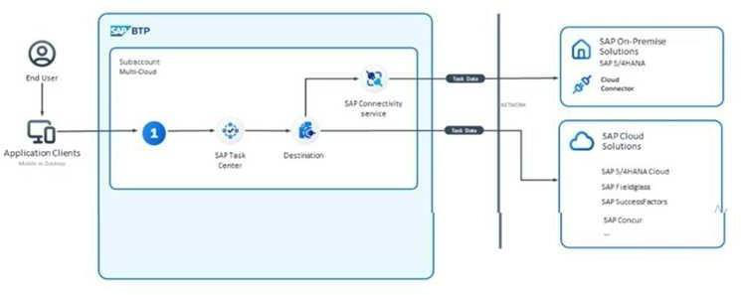
A. SAP Build Code
B. SAP Build Work Zone
C. SAP Build Apps
D. SAP Build Process Automation
Answer: C, D
Explanation:
Option C is correct because SAP Build Apps is specifically designed for building applications with a focus on low-code or no-code development environments. This makes it ideal for allowing plant managers, who may not have extensive programming knowledge, to maintain and update the app easily. It also supports mobile device compatibility, which is a requirement for this application.
Option D is correct because SAP Build Process Automation provides capabilities to automate business processes associated with production orders. This can help streamline workflows and ensure that the application functions efficiently for the users, especially given the expected volume of concurrent users.
Automation tools can enhance the app's functionality by integrating various processes seamlessly.
www.certsland.com

Exam Dumps | 18/67
Option A is incorrect because SAP Build Code is focused on providing developers with tools for custom coding, which may not align with the needs of plant managers who will maintain the application without heavy coding requirements.
Option B is incorrect because SAP Build Work Zone is a workspace solution designed for collaboration and content sharing rather than specifically for building mobile applications for production order management. It may not provide the necessary tools for the direct development and maintenance of the application.
References:
• SAP Build Apps Overview
• SAP Build Process Automation Features
• Mobile Development with SAP BTP Solutions
Question: 17
According to the attached diagram, which SAP Integration Suite capability can a customer use to monetize their APIs? Note: There are 2 correct answers to this question.
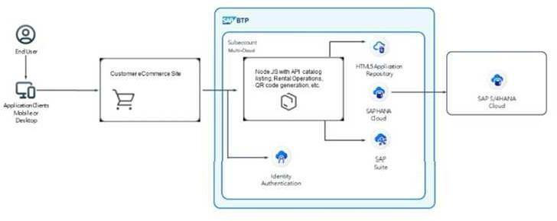
A. SAP API Business Hub Enterprise
B. SAP Business Accelerator Hub
C. SAP Market Rates Management, Bring Your Own Rates data option D. SAP API Management
Answer: A, D
Explanation:
Option A is correct because SAP API Business Hub Enterprise provides a platform where businesses can discover, manage, and consume APIs, allowing them to effectively showcase and potentially monetize their APIs. It serves as a marketplace for APIs, enabling organizations to create business value through their integrations.
Option D is correct because SAP API Management offers capabilities for managing the entire API lifecycle, including monetization strategies. It enables businesses to define pricing models, monitor API usage, and control access, making it an essential tool for effectively monetizing APIs.
www.certsland.com

Exam Dumps | 19/67
Option B is incorrect because the SAP Business Accelerator Hub primarily focuses on providing access to industry content and best practices rather than directly enabling the monetization of APIs.
Option C is incorrect because while SAP Market Rates Management can be useful for managing pricing information, it does not specifically relate to the monetization of APIs. Instead, it is more focused on handling market rates and pricing strategies within the broader context of SAP solutions.
References:
• SAP API Management Overview
• SAP API Business Hub Enterprise Features
• Monetization Strategies with SAP Integration Suite
Question: 18
A company is struggling with organizing and managing the immense amount of data generated by the business. They have been told about several possible solutions that SAP BTP offers; however, they are confused about which solutions they should use. A large amount of their historical and current data is in comma-separated values (CSV) and JavaScript Object Notation (JSON) documents. These documents need to be stored for reporting purposes. The client prefers to use the latest SAP solutions.
Which SAP BTP solution would you recommend?
A. SAP Datasphere
B. SAP HANA Cloud, data lake
C. SAP HANA Cloud
D. SAP Data Warehouse Cloud
Answer: B
Explanation:
Option A is incorrect because SAP Datasphere is designed primarily for data integration and management but is more focused on structured data rather than unstructured data like CSV and JSON documents. While it can handle data analytics, it may not be the best fit for storing large volumes of unstructured data for reporting purposes.
Option B is correct because SAP HANA Cloud, data lake is specifically built to manage large amounts of diverse data types, including unstructured data such as CSV and JSON files. It provides a scalable solution for storing and processing historical and current data, making it ideal for reporting and analytics.
Option C is incorrect because SAP HANA Cloud focuses on in-memory computing and structured data management. While it is a powerful database solution, it does not inherently offer the flexibility needed to store unstructured data in its native formats as efficiently as a data lake.
Option D is incorrect because SAP Data Warehouse Cloud is primarily focused on structured data warehousing. It is designed for data modeling and reporting but may not be as effective in handling unstructured data like CSV and JSON documents compared to a data lake.
References:
• SAP HANA Cloud, Data Lake Overview
www.certsland.com

Exam Dumps | 20/67
• SAP Datasphere Documentation
• SAP Data Warehouse Cloud Features
Question: 19
What are some activities in the "Assess your integration strategy" phase of the SAP Integration Solution Advisory Methodology? Note: There are 2 correct answers to this question.
A. To simplify landscapes after mergers and acquisitions B. To roll out solution architecture blueprints
C. To cover new integration patterns
D. To define and introduce integration roles
Answer: A, C
Explanation:
Option A is correct because one of the activities in the "Assess your integration strategy" phase involves evaluating and simplifying IT landscapes, especially following mergers and acquisitions. This activity helps organizations streamline their integration processes and consolidate systems, ensuring better efficiency and reduced complexity in their integration strategy.
Option B is incorrect because rolling out solution architecture blueprints is typically part of the "Define integration best practices" phase rather than the assessment phase. This phase focuses more on evaluating current strategies rather than implementing new architectures.
Option C is correct because covering new integration patterns is essential in the assessment phase. This activity involves identifying and evaluating emerging integration patterns and technologies that can enhance the organization's integration capabilities and align with current business needs.
Option D is incorrect because defining and introducing integration roles is more aligned with the implementation and governance phases of the methodology, focusing on operationalizing integration strategies rather than assessing existing ones.
References:
• SAP Integration Solution Advisory Methodology Overview • Best Practices for Integration Strategy Assessment
Question: 20
A customer has developed an application. This application crashes occasionally. They want to collect metrics and traces to fix the problems that cause the application to crash. They are particularly impressed with the OpenSearch specification from Apache and would like to use an SAP BTP solution based on it, if one is available.
Which SAP BTP services would you recommend? Note: There are 2 correct answers to this question.
A. SAP Audit Log service
B. SAP Cloud Management service for SAP BTP
www.certsland.com

Exam Dumps |  | 21/67
C. | SAP Cloud Logging service
D. | SAP Application Logging service for SAP BTP
Answer: C, D
Explanation:
Option C is correct because the SAP Cloud Logging service is designed to capture log data and metrics from applications running on SAP BTP. It allows users to collect and analyze log information, making it easier to diagnose issues and monitor application performance. Since the customer is interested in collecting metrics and traces, this service aligns well with their needs.
Option D is correct because the SAP Application Logging service for SAP BTP specifically focuses on logging application-specific events and errors. This service provides detailed logging capabilities that help developers understand application behavior and diagnose issues, such as crashes. It supports integration with various logging standards, including the OpenSearch specification from Apache, which the customer is interested in.
Option A is incorrect because the SAP Audit Log service is primarily focused on tracking security and compliance-related events rather than general application logging and tracing. It does not provide the necessary capabilities for diagnosing application crashes.
Option B is incorrect because the SAP Cloud Management service for SAP BTP focuses on managing and monitoring cloud resources but does not specifically provide logging or tracing features tailored for application development and debugging.
References:
• SAP Cloud Logging Service Overview
• SAP Application Logging Service Documentation
• Best Practices for Application Monitoring and Logging in SAP BTP
Question: 21
A project lead has the following requirements for a new design:
• When there is a deficit in the quantity of materials to be delivered by the supplier in a purchase order, an event will be triggered in S/4HANA Cloud by a periodic background job.
• The business event will be sent to SAP Event Mesh. A custom process will then be started in an on- premise system.
• The IT staff will have to set up several different scenarios using different on-premise systems. The project lead wants an SAP BTP solution that provides guided workflows with assignable tasks to members of the IT staff to help them set up the scenarios.
As the solution architect, which of the following do you recommend?
A. SAP Build Process Automation
B. Cloud Integration Automation Service
C. Intelligent Situation Automation
D. SAP Automation Pilot
www.certsland.com

Exam Dumps | 22/67
Answer: B
Explanation:
Option B is correct because the Cloud Integration Automation Service provides tools to automate and manage integration scenarios effectively. It allows IT staff to set up guided workflows that can help automate the process of connecting different on-premise systems with SAP S/4HANA Cloud and SAP Event Mesh. This service is particularly useful for creating and managing various integration scenarios while ensuring that tasks are clearly defined and assignable to team members.
Option A is incorrect because SAP Build Process Automation focuses on automating business processes and tasks within applications but may not specifically address the needs for guided workflows tailored for integration scenarios across multiple on-premise systems.
Option C is incorrect because Intelligent Situation Automation is geared towards automating responses to specific situations based on predefined criteria. While it can help manage incidents, it does not specifically provide the guided workflows and task assignment features required for setting up integration scenarios.
Option D is incorrect because SAP Automation Pilot is designed to facilitate automation through AI and machine learning capabilities but does not focus on the guided workflows and integration scenario management that the project lead is looking for.
References:
• SAP Cloud Integration Automation Service Documentation • SAP Build Process Automation Overview
• Intelligent Situation Automation Features
Question: 22
According to the SAP Integration Solution Advisory Methodology, the integration architect is responsible for which of the following activities?
A. Implementation and extension of prepackaged integration scenarios
B. Definition, communication, and continuous improvement of an integration reference architecture based on an overall IT strategy
C. Definition of technical integration architectures with a focus on specific integration technologies / services
D. Evaluation of new integration technologies / services
Answer: C
Explanation:
Option C is correct because, according to the SAP Integration Solution Advisory Methodology, the integration architect is responsible for the definition of technical integration architectures with a focus on specific integration technologies and services. This role involves designing how various systems will connect and interact using the appropriate integration tools and technologies.
Option A is incorrect because the responsibility for the implementation and extension of prepackaged
www.certsland.com

Exam Dumps | 23/67
integration scenarios typically falls under the domain of integration developers or engineers rather than the integration architect. The architect's role is more about the overall design and strategy.
Option B is incorrect because while the integration architect may contribute to the definition,
communication, and continuous improvement of an integration reference architecture, this is generally a broader responsibility that may involve collaboration with various stakeholders, including enterprise architects and IT leadership.
Option D is incorrect because the evaluation of new integration technologies/services is typically a responsibility of the integration team or innovation team rather than being solely assigned to the integration architect. The architect may participate in these evaluations, but they are not solely responsible for this activity.
References:
• SAP Integration Solution Advisory Methodology Overview • Role and Responsibilities of Integration Architects in SAP • Best Practices for Designing Integration Architectures
Question: 23
A customer is asking you to provide a pricing plan given the following parameters:
• Payment annual in advance
• Purchase of additional capacity such as memory or storage without penalty
• Use of additional SAP BTP services without penalty
Which pricing plan would you recommend?
A. Subscription
B. Trial
C. SAP BTPEA
D. Pay-As-You-Go for SAP BTP
Answer: C
Explanation:
Option C is correct because the SAP BTPEA (Business Technology Platform Enterprise Agreement) offers a flexible pricing plan that aligns with the customer’s requirements. This plan allows for annual payments in advance while providing the option to purchase additional capacity, such as memory or storage, without incurring penalties. It also enables the use of additional SAP BTP services without penalties, making it a suitable choice for customers needing scalability and flexibility in their SAP BTP usage.
Option A is incorrect because the Subscription model typically requires commitment to a specific level of service for the duration of the subscription. While it may allow for annual payments, it may not provide the same flexibility for additional capacity and services without penalties.
www.certsland.com

Exam Dumps | 24/67
Option B is incorrect because the Trial plan is intended for temporary usage and evaluation purposes, not for long-term commitments or additional capacity needs. It does not fit the customer's requirement for a paid plan.
Option D is incorrect because the Pay-As-You-Go for SAP BTP model allows for flexibility in usage but generally involves paying for resources as they are consumed. This model may not align with the request for annual payment in advance and does not provide the same level of commitment and capacity management as the BTPEA.
References:
• SAP BTPEA Overview
• SAP BTP Pricing Models
• Benefits of SAP Business Technology Platform Enterprise Agreement
Question: 24
Which part of the SAP Al architecture is responsible for handling text input from end users?
A. SAP AI Core
B. SAP AI Launchpad
C. Generative Al Hub
D. SAP Joule
Answer: D
Explanation:
Option D is correct because SAP Joule is specifically designed to handle text input from end users. It serves as a conversational AI interface that allows users to interact with AI applications through natural language processing. SAP Joule facilitates the understanding of user queries and manages text input effectively, making it an essential component of the SAP AI architecture for processing user interactions.
Option A is incorrect because SAP AI Core encompasses the foundational AI services and capabilities for developing AI applications but does not specifically focus on managing text input from users.
Option B is incorrect because SAP AI Launchpad provides a platform for managing and accessing various AI services and applications, but it is not primarily responsible for handling text input from users.
Option C is incorrect because the Generative AI Hub is focused on supporting generative AI models and their applications rather than directly processing text input from end users.
References:
• SAP Joule Overview
• SAP AI Core Features
• SAP AI Launchpad Documentation
Question: 25
A fit-to-standard analysis determined that the provided SAP Fiori App for SAP S/4HANA Cloud private edition was insufficient based on existing business requirements, and that a new front-end app must
www.certsland.com

Exam Dumps | 25/67
be built.
As a solution architect, you are asked to propose a solution and are told the following:
• The backend logic running on SAP S/4HANA Cloud private edition is sufficient and an appropriate remote API for create, read, update, and delete (CRUD) operations exists.
• The front-end app must be able to run on a variety of devices such as mobile phones and tablets.
• Front-end app instances must scale up or down automatically based on administrator- provided scaling parameters.
Which of the following runtimes would be optimal for the new front-end app? Note: There are 2 correct answers to this question.
A. SAP BTP, Cloud Foundry runtime
B. SAP BTP, Kyma runtime
C. SAP BTP, Neo environment
D. SAP BTP, ABAP environment
Answer: A, B
Explanation:
Option A is correct because SAP BTP, Cloud Foundry runtime is designed to support applications that can run on various devices, including mobile phones and tablets. It provides a platform-as-a-service (PaaS) environment that allows for the development of cloud-native applications, enabling automatic scaling based on demand, which aligns well with the requirement for the front-end app to scale up or down automatically.
Option B is correct because SAP BTP, Kyma runtime is another suitable option for developing applications that need to run on multiple devices. Kyma is designed for building microservices and serverless functions and supports automatic scaling. It allows developers to create flexible and responsive front-end applications, making it appropriate for the stated requirements.
Option C is incorrect because SAP BTP, Neo environment is an older environment that may not provide the same level of support for modern application development practices, particularly in terms of automatic scaling and cross-device compatibility.
Option D is incorrect because SAP BTP, ABAP environment is primarily focused on developing applications that run on the ABAP stack. While it is suitable for SAP-centric development, it may not offer the same level of flexibility and scalability for front-end applications designed to run on a variety of devices.
References:
• SAP BTP, Cloud Foundry Runtime Overview
• SAP BTP, Kyma Runtime Features
• SAP BTP, Neo Environment Documentation
www.certsland.com

Exam Dumps | 26/67

Question: 26
A company is implementing SAP S/4HANA Cloud along with SAP BTP. They need a customer-facing application for the general public. The application also needs to use its own unique SAP BTP subdomain. As a solution architect, you have been asked how a unique domain name can be accomplished.
Which of the following can serve as an option? Note: There are 2 correct answers to this question.
A. Create a new domain in a new global account
B. Create a new domain in a new subaccount
C. Create a new domain using the SAP Custom Domain Service D. Create a new domain in a new directory
Answer: B, C
Explanation:
Option B is correct because creating a new domain in a new subaccount allows the company to establish a unique SAP BTP subdomain for their customer-facing application. Each subaccount can have its own domain, providing the necessary isolation and identity for different applications or environments.
Option C is correct because using the SAP Custom Domain Service enables organizations to manage and configure custom domain names within their SAP BTP landscape. This service allows the company to map its own domain name to the application hosted on SAP BTP, ensuring that the application is accessible via a unique and user-friendly URL.
Option A is incorrect because creating a new domain in a new global account is not necessary for establishing a unique subdomain. Global accounts are typically used for overall management and do not specifically define domain names at the application level.
Option D is incorrect because creating a new domain in a new directory does not directly relate to SAP BTP’s domain management capabilities. Domains in SAP BTP are managed through subaccounts and the Custom Domain Service rather than through directories.
References:
• SAP BTP Domain Management Overview
• SAP Custom Domain Service Documentation
• SAP BTP Subaccount Configuration Guidelines
Question: 27
The DevOps / Site Reliability Team has a question for you. Over the course of the last month, several trust certificates have expired for several SAP BTP destinations, which has in turn occupied a significant portion of their time reinstalling. They wish to be informed before the certificate expires and to have a workflow triggered automatically.
As a solution architect, which SAP BTP service would you recommend (see attached diagram >)?
www.certsland.com

Exam Dumps | 27/67
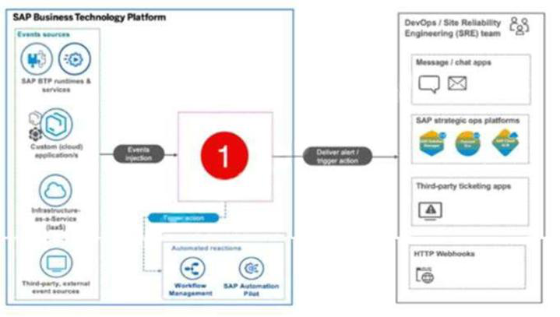
A. SAP Solution Manager
B. SAP Solution Lifecycle Management service for SAP BTP C. SAP Monitoring service for SAP BTP
D. SAP Alert Notification service for SAP BTP
Answer: D
Explanation:
Option D is correct because the SAP Alert Notification service for SAP BTP is specifically designed to provide notifications based on predefined events and conditions, including the expiration of trust certificates for SAP BTP destinations. This service allows the DevOps / Site Reliability Team to set up alerts that will inform them before a certificate expires, and it can also trigger automated workflows in response to these alerts, helping to streamline the certificate management process.
Option A is incorrect because SAP Solution Manager is primarily focused on application lifecycle management, monitoring, and incident management but does not directly address the specific needs for monitoring certificate expirations and triggering workflows for notifications.
Option B is incorrect because the SAP Solution Lifecycle Management service for SAP BTP helps manage the lifecycle of applications and services but does not provide specific functionalities for alerting on certificate expirations.
Option C is incorrect because while the SAP Monitoring service for SAP BTP provides capabilities to monitor the health and performance of applications, it does not have the focused functionality for managing alerts related to trust certificate expirations or automating workflows based on those alerts.
References:
• SAP Alert Notification Service Overview
www.certsland.com

Exam Dumps | 28/67
• SAP BTP Certificate Management Guidelines
• SAP Monitoring and Incident Management Best Practices
Question: 28
To comply with General Data Protection Regulation (GDPR), a company wants to build an application that allows their customers to delete their personal user information from the company's systems. Which SAP BTP service provides the APIs to build the application?
A. SAP Data Privacy Integration
B. SAP Credential Store
C. SAP Data Retention Manager
D. SAP Personal Data Manager
Answer: A
Explanation:
Option A is correct because SAP Data Privacy Integration provides the necessary APIs to help organizations comply with data protection regulations such as the General Data Protection Regulation (GDPR). This service allows companies to manage personal data effectively, including functionalities for data deletion, ensuring that customers can request the deletion of their personal user information from the company's systems.
Option B is incorrect because the SAP Credential Store is designed for managing credentials and secure storage of sensitive information, but it does not provide functionalities related to data privacy or the deletion of personal information.
Option C is incorrect because SAP Data Retention Manager is primarily focused on managing data retention policies and ensuring compliance with data retention regulations. It does not specifically provide APIs for enabling customers to delete their personal data.
Option D is incorrect because SAP Personal Data Manager offers functionalities for managing personal data but is not the service specifically designed for providing APIs for data deletion in compliance with GDPR.
References:
• SAP Data Privacy Integration Documentation
• GDPR Compliance with SAP Solutions
• SAP Data Retention and Privacy Management Overview
Question: 29
You are a solution architect and your client needs help in choosing the appropriate SAP solution to use for their application design. #
• SAP SuccessFactors will trigger an "event" when employees complete a variety of tasks such as changing their address or updating their W-4 information.
• The event will be caught by one of SAP's event solutions and it will trigger (via webhook) either SAP Integration Suite or SAP S/4HANA Cloud as needed.
www.certsland.com

Exam Dumps | 29/67
• The number of events processed is not expected to be high. • A cloud solution is preferred.
Which of the following could be used in place of the "Placeholder Icon" in the attached diagram? Note: There are 2 correct answers to this question.
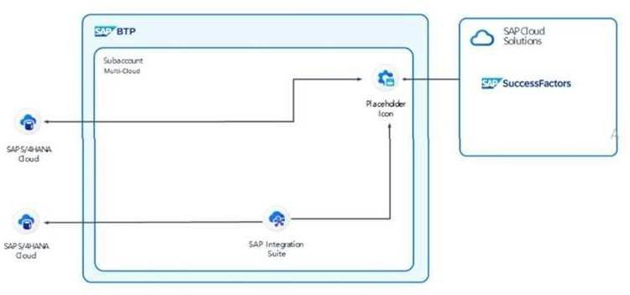
A. SAP Integration Suite, advanced event mesh
B. SAP Event Broker
C. SAP Event Mesh
D. SAP Process Orchestration
Answer: B, C
Explanation:
Option B is correct because SAP Event Broker is a suitable solution for handling events triggered by SAP SuccessFactors. It enables event-driven architectures and can manage the low volume of events effectively. The Event Broker can capture and route events to appropriate services such as SAP Integration Suite or SAP S/4HANA Cloud via webhooks, aligning well with the client's requirements for processing events from SuccessFactors.
Option C is correct because SAP Event Mesh is designed for enabling event-driven applications and can handle the events generated by SAP SuccessFactors. It provides a cloud-based solution that can seamlessly integrate with other SAP services, allowing events to be processed and routed efficiently to the necessary backend systems.
Option A is incorrect because while the SAP Integration Suite, advanced event mesh concept is beneficial for more complex and high-volume event processing scenarios, it may not be necessary for this client’s needs given that the number of events processed is not expected to be high.
Option D is incorrect because SAP Process Orchestration is focused on process integration and does not specialize in event-driven architectures like the Event Broker or Event Mesh, making it less suitable for handling events from SAP SuccessFactors in this context.
www.certsland.com

Exam Dumps | 30/67
References:
• SAP Event Mesh Documentation
• SAP Event Broker Overview
• Event-Driven Architecture with SAP Solutions
Question: 30
You are a solution architect helping to design a custom-built application for business users. You must follow these use case parameters:
• The application requires data solely from SAP S/4HANA Cloud public edition.
• The application supports create, read, update, and delete (CRUD) operations.
• If multiple backend protocols are applicable the one with the fastest performance is to be used.
Which of the following combinations would you recommend for the application design?
A.
• Frontend: SAP Fiori
• Backend: OData service binding on SAP S/4HANA Cloud B.
• Frontend: SAP Fiori
• Backend: RFC binding on SAP S/4HANA Cloud
C.
• Frontend: SAP Build Apps
• Backend: IDoc binding on SAP S/4HANA Cloud
D.
• Frontend: SAP Build Apps
• Backend: SOAP binding on SAP S/4HANA Cloud
Answer: A
Explanation:
Option A is correct because using SAP Fiori as the frontend in combination with OData service binding on SAP S/4HANA Cloud is the optimal choice for designing the application. OData services are specifically designed for CRUD operations and provide a lightweight, RESTful interface that ensures fast performance for data access from SAP S/4HANA. This combination leverages the user-friendly design capabilities of Fiori while maintaining efficient data interactions with the backend system.
Option B is incorrect because using RFC binding is typically associated with more traditional SAP interfaces and does not align with the modern architecture best practices for cloud applications. RFCs may also introduce additional complexity and potential performance overhead compared to OData services.
www.certsland.com

Exam Dumps | 31/67
Option C is incorrect because IDoc binding is mainly used for asynchronous communication and batch processing in SAP environments. It is not suited for real-time CRUD operations and is generally more complex to implement for direct user interactions.
Option D is incorrect because SOAP binding is considered a heavier protocol compared to OData. While it can perform CRUD operations, it typically has more overhead and is less efficient for cloud-based applications compared to the lightweight OData services.
References:
• SAP Fiori Design Guidelines
• OData Services in SAP S/4HANA
• Best Practices for Building Applications on SAP BTP
Question: 31
The finance department is creating a series of reports for their line of business (LOB) users and would like to integrate the reports in a front-end portal. They would like the LOB users to maintain the portal, as opposed to IT. As a solution architect, they come to you to recommend which SAP BTP service best fits their needs.
Which service would you recommend?
A. SAP Launchpad Service
B. SAP Build Work Zone, advanced edition
C. SAP Build Work Zone, standard edition
D. SAP Fiori Launchpad
Answer: B
Explanation:
Option B is correct because SAP Build Work Zone, advanced edition is designed for creating and managing personalized and integrated user experiences across applications and data sources. It allows line of business (LOB) users to maintain the portal themselves, enabling them to customize the interface, integrate reports, and manage content without heavy reliance on IT. This service provides the flexibility needed for the finance department to effectively deliver reports to users.
Option A is incorrect because while the SAP Launchpad Service provides a platform for deploying applications and content, it does not offer the same level of flexibility and ease of use for LOB users to manage and customize the portal independently. It is more geared towards IT-managed environments.
Option C is incorrect because SAP Build Work Zone, standard edition does not provide the advanced features and customization capabilities that the advanced edition offers. The standard edition may have limitations in terms of user management and integration of content that could hinder the finance department's objectives.
Option D is incorrect because SAP Fiori Launchpad primarily serves as a launchpad for Fiori applications and does not provide the comprehensive features for integrating reports and maintaining a broader portal experience that LOB users would need.
www.certsland.com

Exam Dumps | 32/67
References:
• SAP Build Work Zone, Advanced Edition Overview
• SAP Launchpad Service Documentation
• SAP Fiori Launchpad Features
Question: 32
The following design (see attached diagram) uses third-party REST APIs that are publicly available through the internet.
Which capability of the SAP Integration Suite can be used in place of "1" in the diagram?
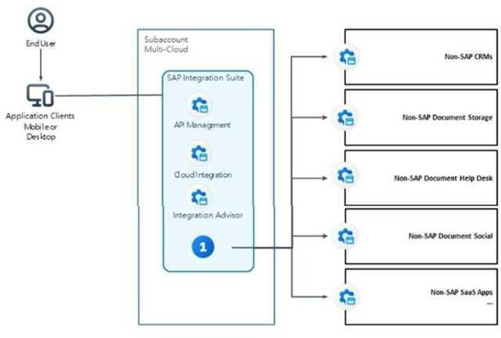
A. SAP Open Connectors
B. SAP Cloud Connector
C. SAP Business Connector
D. SAP Connectivity Service
Answer: A
Explanation:
Option A is correct because SAP Open Connectors provide a set of pre-built connectors for integrating third-party REST APIs, including those that are publicly available over the internet. This capability enables seamless connectivity and data exchange between SAP systems and external applications, making it suitable for the integration needs outlined in the design.
Option B is incorrect because the SAP Cloud Connector is primarily used to establish secure connections between on-premise systems and SAP BTP applications, rather than connecting to third- party public APIs.
www.certsland.com

Exam Dumps | 33/67
Option C is incorrect because the SAP Business Connector is an older integration technology that facilitates communication with various SAP and non-SAP systems but is not specifically focused on REST APIs or modern integration needs.
Option D is incorrect because the SAP Connectivity Service is more of a framework for managing connectivity within SAP environments, and while it supports various protocols, it does not specifically provide the out-of-the-box connectors that SAP Open Connectors offer for third-party REST APIs.
References:
• SAP Open Connectors Overview
• SAP Integration Suite Documentation
• SAP Connectivity Options and Best Practices
Question: 33
In which phase of the SAP Integration Solution Advisory Methodology does the project lead establish an integration architecture board and roll out a solution architecture blueprint, as shown in the attached diagram?
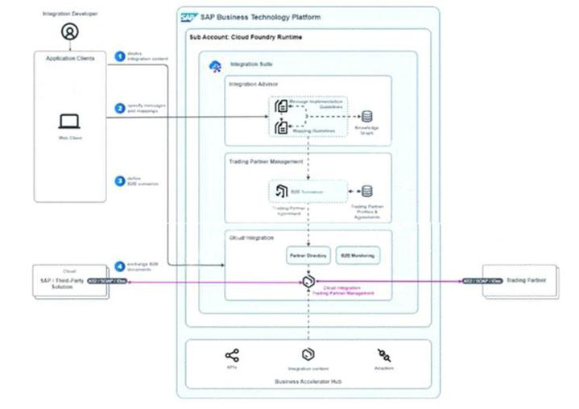
A. Define integration best practices
B. Assess your integration strategy
C. Enable a practice of empowerment
www.certsland.com

Exam Dumps |  | 34/67
D. | Design your Hybrid Integration Platform
Answer: D
Explanation:
Option D is correct because in the "Design your Hybrid Integration Platform" phase of the SAP Integration Solution Advisory Methodology, the project lead is responsible for establishing an integration architecture board and rolling out a solution architecture blueprint. This phase focuses on creating a comprehensive design for the integration landscape, including defining the roles and responsibilities of various stakeholders involved in integration and outlining the technical architecture needed to support the organization’s integration goals.
Option A is incorrect because the "Define integration best practices" phase focuses on establishing guidelines and standards for integration processes rather than the structural aspects of integration architecture and governance.
Option B is incorrect because the "Assess your integration strategy" phase is aimed at evaluating the current integration landscape and identifying areas for improvement, but it does not involve the formal establishment of architecture boards or the rollout of blueprints.
Option C is incorrect because "Enable a practice of empowerment" generally involves fostering a culture of self-sufficiency and innovation among teams, but it does not specifically pertain to the technical design and governance aspects related to integration architecture.
References:
• SAP Integration Solution Advisory Methodology Overview • Best Practices for Designing Integration Architectures
Question: 34
Which of the following are process steps in serving up a model in SAP AI Core? Note: There are 2 correct answers to this question.
A. Prepare the data
B. Register the Input Dataset
C. Make an inference
D. Create an Al Launchpad instance
Answer: C, D
Explanation:
Option C is correct because making an inference is a critical process step in serving up a model in SAP AI Core. This step involves using the trained model to generate predictions or insights based on new input data, which is the primary purpose of deploying a model.
Option D is correct because creating an AI Launchpad instance is necessary to serve models in SAP AI Core. The AI Launchpad provides the environment where AI models can be managed and accessed, facilitating the deployment and operationalization of AI solutions.
Option A is incorrect because preparing the data is a crucial step in the data preprocessing phase but
www.certsland.com

Exam Dumps | 35/67
does not directly relate to serving up a model once it is deployed. It typically occurs before model training rather than during the model serving process.
Option B is incorrect because registering the Input Dataset is part of the data management process, ensuring that the datasets used for inference are properly defined and available. However, it does not represent a step in the process of serving the model itself.
References:
• SAP AI Core Documentation
• Best Practices for Serving AI Models in SAP Solutions • AI Launchpad Overview
Question: 35
You are a solution architect assigned to a customer business transformation project.
Which solutions would you recommend the customers adopt to analyze and to optimize their procurement process to exceed industry benchmarks? Note: There are 2 correct answers to this question.
A. SAP Signavio Value Accelerators
B. SAP Signavio Process Transformation Manager C. SAP Signavio Process Intelligence
D. SAP Signavio Process Manager
Answer: B, C
Explanation:
Option B is correct because SAP Signavio Process Transformation Manager provides tools and methodologies for analyzing and transforming business processes. It helps organizations identify inefficiencies and areas for improvement, allowing them to optimize their procurement processes to exceed industry benchmarks. This solution focuses on aligning processes with best practices and improving overall process performance.
Option C is correct because SAP Signavio Process Intelligence offers advanced analytics and insights into business processes, enabling organizations to visualize and understand their procurement workflows in detail. By leveraging data-driven insights, companies can identify bottlenecks, measure performance against industry benchmarks, and implement optimizations effectively.
Option A is incorrect because SAP Signavio Value Accelerators are primarily focused on providing predefined templates and best practices for various industries but do not specifically address the detailed analysis and optimization of procurement processes.
Option D is incorrect because SAP Signavio Process Manager is focused on process modeling and documentation rather than advanced analytics and performance optimization. While it can support process design, it does not provide the analytical capabilities needed to optimize procurement processes against industry benchmarks.
www.certsland.com

Exam Dumps | 36/67
References:
• SAP Signavio Process Transformation Manager Overview • SAP Signavio Process Intelligence Features
• Best Practices for Procurement Process Optimization
Question: 36
A company is struggling with organizing and managing their data. Their data is distributed across many databases and datastores. The data structures are also very inconsistent. They need harmonized aggregated data to be used as the basis of advanced highly summarized reports for senior executives. They prefer to use the latest SAP solutions.
Which of the following solutions would you recommend?
A. SAP Datasphere
B. SAP HANA Cloud
C. SAP Analytics Cloud
D. SAP HANA Cloud, data lake
Answer: A
Explanation:
Option A is correct because SAP Datasphere is specifically designed to address the challenges of organizing and managing distributed data across multiple databases and datastores. It provides capabilities for data integration, harmonization, and aggregation, allowing organizations to create a unified view of their data. This is essential for generating advanced, highly summarized reports that senior executives can rely on for decision-making. SAP Datasphere supports modern data management practices and integrates well with other SAP solutions, making it a suitable choice for the company's needs.
Option B is incorrect because SAP HANA Cloud primarily focuses on in-memory computing and analytics. While it offers powerful data processing capabilities, it does not inherently provide the comprehensive data integration and harmonization features needed to manage inconsistent data structures across multiple sources effectively.
Option C is incorrect because SAP Analytics Cloud is primarily an analytics and business intelligence tool rather than a data management solution. It focuses on visualizing and analyzing data but does not address the foundational issues of data organization and harmonization.
Option D is incorrect because SAP HANA Cloud, data lake is designed for storing large volumes of unstructured and semi-structured data. While it offers scalability, it does not provide the same level of integration and data harmonization capabilities as SAP Datasphere, which is specifically built for creating a cohesive data environment for reporting and analytics.
References:
• SAP Datasphere Overview
• Data Integration and Management with SAP Solutions • SAP HANA Cloud and Analytics Solutions Comparison
www.certsland.com

Exam Dumps | 37/67

Question: 37
Company XYZ, a global firm with 25K+ employees across the geographic locations Europe
(headquarters), the USA (manufacturing), and South America (procurement), is migrating to SAP S/4HANA using SAP BTP. Each geographic location has dedicated IT staff managing access, authorizations, and SAP BTP resource quotas. For cost control, the company aims to analyze and optimize the usage and cost of SAP BTP resources both globally and by geographic location, intending to enhance their SAP BTP Account model structure.
Which of the following SAP BTP account models are appropriate? Note: There are 2 correct answers to this question.
A. One global account for each business function with a corresponding subaccount for that region B. One global account for each business function with a corresponding directory for that region C. One global account with one directory for each region
D. One global account with one subaccount for each region
Answer: C, D
Explanation:
Option C is correct because having one global account with one directory for each region allows Company XYZ to manage their resources effectively while providing a clear structure for access and authorizations based on geographic locations. This model enables centralized oversight of SAP BTP resources while still maintaining the ability to control access and quotas regionally, which is beneficial for analyzing and optimizing usage and costs.
Option D is correct because having one global account with one subaccount for each region also provides a structured approach to managing SAP BTP resources. This model allows each geographic location (Europe, USA, and South America) to have its dedicated subaccount, facilitating the
management of authorizations, access, and resource quotas while allowing for detailed tracking of costs and usage by region.
Option A is incorrect because having one global account for each business function with a corresponding subaccount for that region could lead to fragmentation and complexity in managing resources across multiple accounts. This structure may complicate cost analysis and optimization efforts due to the distribution of accounts.
Option B is incorrect because having one global account for each business function with a corresponding directory for that region does not align with the requirements for managing resource quotas and access efficiently. It introduces unnecessary complexity without the direct benefits seen in options C and D.
References:
• SAP BTP Account Management Documentation
• Best Practices for Managing SAP BTP Resources
• SAP BTP Structure and Governance Guidelines
Question: 38
www.certsland.com

Exam Dumps | 38/67
Given the following use case parameters:
• End users will need to restart messages in SAP S/4HANA using SAP AIF
• End users will need to change message payload in SAP S/4HANA using SAP AIF
• Clean core integration principles are to be applied.
Which of the following could be used as an "adapter" in the attached diagram? Note: There are 2 correct answers to this question.
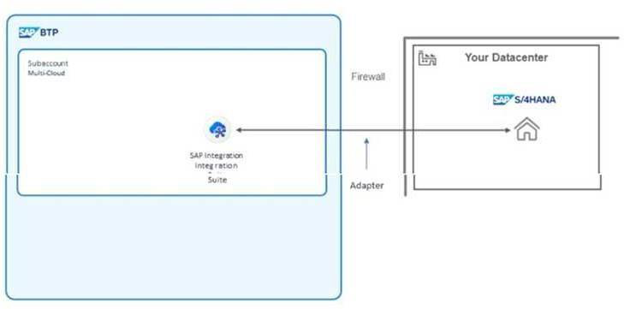
A. SOAP
B. ODATA
C. IDOC
D. HTTP
Answer: A, C
Explanation:
Option A is correct because SOAP (Simple Object Access Protocol) can be used as an adapter in SAP Application Interface Framework (AIF). SOAP is widely used for integrating with web services and supports operations like restarting messages and changing message payloads effectively within the SAP environment. It aligns well with the clean core integration principles by allowing structured, standardized messaging.
Option C is correct because IDOC (Intermediate Document) is a standard data structure used in SAP for electronic data interchange between SAP systems and external systems. It is also suitable for use as an adapter in SAP AIF, enabling the handling of messages and payloads while adhering to clean core integration principles.
Option B is incorrect because ODATA (Open Data Protocol) is primarily used for exposing and consuming RESTful APIs. While it is useful for accessing and manipulating data in SAP systems, it is not typically used as a direct adapter in AIF for message processing like restarting or changing payloads.
www.certsland.com

Exam Dumps | 39/67
Option D is incorrect because HTTP is a protocol for transferring data over the web, but it does not define a structured format for messages or payloads as SOAP or IDOC does. It is more of a transport layer rather than a specific integration adapter in the context of SAP AIF.
References:
• SAP Application Interface Framework Overview
• SAP IDOC Basics and Usage
• SOAP Web Services Integration in SAP
Question: 39
Applications on a customer's Marketing subaccount continuously crash due to insufficient memory. At the global account level, what can you use to allocate more memory to the Marketing subaccount?
A. Entitlement
B. Service Assignment
C. Entity Assignment
D. Quota
Answer: D
Explanation:
Option D is correct because Quota refers to the limits set on the resources allocated to a specific subaccount within a global account in SAP BTP. By adjusting the quota for the Marketing subaccount, you can allocate more memory resources to the applications running there, which can help resolve issues related to insufficient memory and prevent crashes.
Option A is incorrect because Entitlement defines what services and resources are available for a global account but does not directly manage the allocation of resources to specific subaccounts. It establishes the maximum available resources but does not dictate how they are allocated.
Option B is incorrect because Service Assignment refers to the assignment of specific services to subaccounts, but it does not directly pertain to memory allocation. It’s more about enabling access to specific services rather than managing resource quotas.
Option C is incorrect because Entity Assignment is not a recognized term in the context of SAP BTP resource management. It does not specifically relate to the allocation of memory or other resources within a global account.
References:
• SAP BTP Quotas and Resource Management Documentation • Managing Entitlements and Quotas in SAP BTP
• SAP Global Account Structure Overview
Question: 40
A customer is struggling with organizing and managing the immense amount of data generated by the business. They have been told about several possible solutions that SAP BTP offers; however, they are
www.certsland.com

Exam Dumps | 40/67
confused about which solutions they should use. Their data is highly structured and includes customers, sales orders, and purchase orders. The data needs to be stored for both transactional and reporting purposes in a vector database. The client prefers to use the latest SAP solutions.
Which of the following SAP BTP solutions would you recommend?
A. SAP HANA Cloud, data lake
B. SAP Datasphere
C. SAP HANA Cloud
D. SAP Analytics Cloud
Answer: C
Explanation:
Option C is correct because SAP HANA Cloud is a robust in-memory database solution that supports highly structured data, making it suitable for storing transactional data such as customers, sales orders, and purchase orders. It provides the necessary performance for both transactional processing and reporting. Additionally, SAP HANA Cloud can efficiently handle the requirements for a vector database, enabling advanced data analytics and retrieval capabilities.
Option A is incorrect because while SAP HANA Cloud, data lake is designed for managing large volumes of unstructured and semi-structured data, it is not specifically optimized for highly structured data. It is more suitable for scenarios where flexibility in data formats is required.
Option B is incorrect because SAP Datasphere focuses on data integration and management, providing tools for unifying and harmonizing data from various sources. While it can support analytics, it is not primarily a storage solution for highly structured transactional data.
Option D is incorrect because SAP Analytics Cloud is primarily an analytics and business intelligence tool rather than a data storage solution. It is used for visualizing and analyzing data but does not serve as a backend for storing transactional data.
References:
• SAP HANA Cloud Overview
• SAP HANA Cloud for Transactional and Analytical Use Cases • SAP Datasphere Documentation
Question: 41
In SAP's Intelligent Enterprise framework, which component leverages machine learning and AI to enable predictive analytics and automate processes?
A. SAP Data Hub
B. SAP Fiori
C. SAP Leonardo
D. SAP S/4HANA
Answer: C
www.certsland.com

Exam Dumps | 41/67
Explanation:
SAP Leonardo incorporates AI/ML to enable predictive analytics and process automation, essential for Intelligent Enterprise.
Question: 42
Which component of the SAP Intelligent Enterprise architecture is primarily used for real-time financial processing and management?
A. SAP S/4HANA
B. SAP Data Hub
C. SAP Leonardo
D. SAP Fiori
Answer: A
Explanation:
SAP S/4HANA is essential for real-time financial processing and management within the Intelligent Enterprise architecture.
www.certsland.com

Exam Dumps | 42/67

Question: 43
Which service in SAP BTP allows for real-time data processing and analytics, integrating data from
multiple sources?
A. SAP Analytics Cloud
B. SAP HANA Cloud
C. SAP Data Intelligence
D. SAP Data Warehouse Cloud
Answer: C
Explanation:
SAP Data Intelligence enables real-time data processing and analytics, integrating data from multiple
sources.
Question: 44
How does SAP Fiori support the Intelligent Enterprise framework?
A. Machine learning integration
B. User experience and interface
C. Financial management
D. Data integration
Answer: B
Explanation:
SAP Fiori enhances the Intelligent Enterprise framework by providing a consistent, intuitive user
experience across all SAP applications.
Question: 45
Which SAP BTP service offers a fully managed environment to develop, deploy, and manage
applications using multiple programming languages and frameworks?
A. SAP Cloud Application Programming (CAP)
B. SAP Kyma
C. SAP Business Application Studio
D. SAP Cloud Foundry
Answer: D
Explanation:
SAP Cloud Foundry offers a fully managed environment to develop, deploy, and manage applications
using multiple languages and frameworks.
www.certsland.com

Exam Dumps | 43/67

Question: 46
Which of the following describes the purpose of the SAP Business Technology Platform in the Intelligent
Enterprise framework?
A. Managing HR processes
B. Enhancing user experience
C. Handling financial transactions
D. Enabling data integration and application development
Answer: D
Explanation:
The SAP Business Technology Platform supports data integration, application development, and data
management within the Intelligent Enterprise framework.
Question: 47
How does SAP’s reference architecture for the Intelligent Enterprise integrate experience data and
operational data for better decision-making?
A. SAP HANA
B. SAP Qualtrics
C. SAP Business One
D. SAP Analytics Cloud
Answer: B
Explanation:
SAP Qualtrics is designed to combine experience data with operational data, enhancing decision-making
capabilities.
Question: 48
Which SAP solution focuses on integrating experience management within the Intelligent Enterprise
architecture?
A. SAP Concur
B. SAP SuccessFactors
C. SAP Qualtrics
D. SAP Ariba
Answer: C
Explanation:
SAP Qualtrics integrates experience management into the Intelligent Enterprise architecture, allowing
businesses to gather and act on feedback.
www.certsland.com

Exam Dumps | 44/67

Question: 49
For a predictable monthly cost, which SAP Integration Suite pricing plan is recommended?
A. Subscription
B. Pay-As-You-Go for SAP BTP
C. SAP BTPEA
D. SAP BTP trial
Answer: A
Explanation:
Subscription offers a predictable monthly cost, suitable for budget planning.
Question: 50
What does the HTML5 Application Repository service do in SAP CI/CD?
A. Manages HTML5 applications
B. Sends notifications
C. Manages transport of changes
D. Manages software lifecycle
Answer: A
Explanation:
HTML5 Application Repository manages and stores HTML5 applications in SAP CI/CD.
Question: 51
What is the main advantage of using SAP Business Technology Platform (BTP) for developing cloud-
native applications?
A. Scalability
B. Cost efficiency
C. Integrated services
D. Flexibility
Answer: C
Explanation:
SAP BTP provides a wide range of integrated services, making it ideal for developing cloud-native
applications.
Question: 52
What is a primary benefit of using SAP BTP's AI capabilities for businesses aiming to enhance their
www.certsland.com

Exam Dumps | 45/67
customer service?
A. Cost reduction
B. Speed
C. Data accuracy
D. Personalization
Answer: D
Explanation:
SAP BTP's AI capabilities enhance customer service by providing personalized, tailored interactions
based on customer data and behavior.
Question: 53
What is the principle of a "clean core" in SAP environments, and how does it benefit system
maintenance and upgrades?
A. Isolating customizations
B. Minimizing custom code in core
C. Frequent updates
D. Regular code review
Answer: B
Explanation:
The principle of a "clean core" involves minimizing custom code in the core system, which reduces
complexity and facilitates easier maintenance and upgrades.
Question: 54
Which pricing plan for SAP Integration Suite offers flexibility with costs based on actual usage?
A. SAP BTP trial
B. Subscription
C. SAP BTPEA
D. Pay-As-You-Go for SAP BTP
Answer: D
Explanation:
Pay-As-You-Go offers flexibility as charges are based on actual usage, making it ideal for unpredictable
workloads.
Question: 55
Identify the service that stores and manages HTML5 applications in SAP CI/CD pipelines.
www.certsland.com

Exam Dumps |  | 46/67
A. | HTML5 Application Repository
B. | Cloud Transport Management
C. | Alert Notification
D. | Solution Lifecycle Management
Answer: A
Explanation:
The HTML5 Application Repository is used for managing and storing HTML5 applications.
Question: 56
What is the main advantage of the SAP BTPEA plan for large enterprises?
A. Enterprise-level support
B. Tailored agreements
C. Cost savings
D. Customization
Answer: B
Explanation:
SAP BTPEA provides tailored agreements for large enterprises, accommodating their unique needs.
Question: 57
Which SAP CI/CD service can manage the transport of software changes?
A. Cloud Transport Management
B. Alert Notification
C. HTML5 Application Repository
D. Solution Lifecycle Management
Answer: A
Explanation:
Cloud Transport Management manages the transport of software changes in a cloud environment.
Question: 58
Which pricing plan provides the most control over monthly expenses for SAP Integration Suite?
A. Pay-As-You-Go for SAP BTP
B. Subscription
C. SAP BTP trial
D. SAP BTPEA
www.certsland.com

Exam Dumps | 47/67
Answer: B
Explanation:
Subscription plan provides a fixed monthly cost, allowing for better control over expenses.
Question: 59
Which component is essential for defining and implementing business logic in SAP ABAP RESTful
Application Programming model?
A. Core Data Services (CDS) views
B. ABAP Data Dictionary
C. SAP Fiori
D. Business Objects (BOs)
Answer: D
Explanation:
Business Objects (BOs) are crucial for defining and implementing business logic in the SAP ABAP
RESTful Application Programming model, providing the foundation for application behavior and rules.
Question: 60
Which SAP service allows the management of software changes in a cloud environment?
A. Solution Lifecycle Management
B. Alert Notification
C. Cloud Transport Management
D. HTML5 Application Repository
Answer: C
Explanation:
Cloud Transport Management is designed to handle the transportation of software changes in a cloud
environment.
Question: 61
What is a limitation of the SAP BTP trial plan for long-term projects?
A. Limited features
B. Free cost
C. Enterprise support
D. Customization
Answer: A
Explanation:
www.certsland.com

Exam Dumps | 48/67
SAP BTP trial has limited features and is not suitable for long-term projects.
Question: 62
Which service in SAP CI/CD helps in managing the lifecycle of software solutions?
A. Cloud Transport Management
B. Alert Notification
C. HTML5 Application Repository
D. Solution Lifecycle Management
Answer: D
Explanation:
Solution Lifecycle Management helps in managing the lifecycle of software solutions in SAP CI/CD.
Question: 63
Which quality of SAP BTP ensures that the platform can integrate seamlessly with existing SAP and
third-party applications, providing a unified environment?
A. Scalability
B. Flexibility
C. Interoperability
D. Security
Answer: C
Explanation:
Interoperability ensures SAP BTP can integrate seamlessly with existing SAP and third-party
applications, providing a unified environment.
Question: 64
When setting up a pipeline using the SAP Continuous Integration and Delivery service, which of the
following services can be triggered automatically after the build results finish?
A. Solution Lifecycle Management
B. Cloud Transport Management
C. Alert Notification
D. HTML5 Application Repository
Answer: B, D
Explanation:
The HTML5 Application Repository can manage web applications, and Cloud Transport Management
handles software change transports in the cloud.
www.certsland.com

Exam Dumps | 49/67

Question: 65
In the context of SAP BTP, what does extensibility refer to, and which type allows for custom
applications to be built on the platform?
A. API extensibility
B. In-app extensibility
C. Side-by-side extensibility
D. Key-user extensibility
Answer: C
Explanation:
Side-by-side extensibility allows custom applications to be built on the SAP BTP platform, running
alongside standard applications.
Question: 66
In SAP CI/CD, which service is responsible for sending notifications based on specific events?
A. Alert Notification
B. Solution Lifecycle Management
C. Cloud Transport Management
D. HTML5 Application Repository
Answer: A
Explanation:
Alert Notification service is used to send notifications based on specified events.
Question: 67
Which plan is suitable for initial testing and exploring SAP Integration Suite features?
A. Pay-As-You-Go for SAP BTP
B. Subscription
C. SAP BTPEA
D. SAP BTP trial
Answer: D
Explanation:
SAP BTP trial plan offers free access, ideal for testing and exploring features.
Question: 68
In the context of SAP BTP, what is the primary purpose of a subaccount within a global account?
www.certsland.com

Exam Dumps |  | 50/67
A. | To organize projects
B. | To allocate resources
C. | To manage user access
D. | To group services by function
Answer: A
Explanation:
Subaccounts within a global account help in organizing projects and allocating resources effectively.
Question: 69
In SAP BTP, which account model is used to structure and manage resources and services across
multiple projects and teams within an organization?
A. Subaccount
B. Global Account
C. Service Account
D. Directory
Answer: B
Explanation:
The global account is the top-level account used to structure and manage resources and services across
multiple projects and teams.
Question: 70
How does SAP BTP facilitate the creation and management of custom extensions for existing SAP
applications?
A. By using SAP Fiori
B. By providing APIs
C. Through SAP Extension Suite
D. Through SAP HANA Cloud
Answer: C
Explanation:
SAP Extension Suite provides tools and services for creating and managing custom extensions for SAP
applications.
Question: 71
For cost-effective scalability, which SAP Integration Suite pricing plan is recommended?
A. SAP BTPEA
www.certsland.com

Exam Dumps |  | 51/67
B. | Subscription
C. | SAP BTP trial
D. | Pay-As-You-Go for SAP BTP
Answer: D
Explanation:
Pay-As-You-Go scales with usage, making it cost-effective for varying workloads.
Question: 72
In SAP BTP, which component is essential for setting up automated workflows and managing business
processes across different systems?
A. SAP Intelligent Robotic Process Automation
B. SAP Cloud Integration
C. SAP Workflow Management
D. SAP Business Application Studio
Answer: C
Explanation:
SAP Workflow Management is essential for setting up automated workflows and managing business
processes across different systems.
Question: 73
What is a key capability of SAP BTP that enables the integration of various SAP and third-party
applications and services in a unified environment?
A. SAP Integration Suite
B. SAP Data Intelligence
C. SAP AI Core
D. SAP HANA Cloud
Answer: A
Explanation:
SAP Integration Suite enables integration of various SAP and third-party applications in a unified
environment.
Question: 74
A customer needs an agreement tailored to their specific business requirements. Which plan should they
choose?
A. SAP BTP trial
www.certsland.com

Exam Dumps |  | 52/67
B. | SAP BTPEA
C. | Subscription
D. | Pay-As-You-Go for SAP BTP
Answer: B
Explanation:
SAP BTPEA offers custom agreements tailored to specific business requirements.
Question: 75
In the context of SAP Intelligent Enterprise, what is the role of SAP S/4HANA?
A. UX/UI framework
B. Customer experience management
C. Core ERP suite
D. Data orchestration
Answer: C
Explanation:
SAP S/4HANA serves as the core ERP suite, providing real-time data processing and enterprise
resource management within the Intelligent Enterprise framework.
Question: 76
In SAP BTP, how does the platform support the concept of "clean core" while allowing for extensive
customization?
A. Through in-app extensibility
B. Using side-by-side extensibility
C. Via regular system updates
D. By isolating custom code
Answer: B
Explanation:
SAP BTP supports "clean core" by using side-by-side extensibility, allowing for extensive customization
without altering the core system.
Question: 77
What is a key AI capability of SAP BTP that allows businesses to automate and optimize their decision-
making processes through machine learning models?
A. SAP Conversational AI
B. SAP AI Core
www.certsland.com

Exam Dumps |  | 53/67
C. | SAP Intelligent Robotic Process Automation
D. | SAP AI Foundation
Answer: D
Explanation:
SAP AI Foundation offers tools for building and managing machine learning models, enabling
automation and optimization of decision-making processes.
Question: 78
When planning a migration to SAP S/4HANA, which approach involves starting from scratch and
reengineering business processes?
A. Brownfield migration
B. Bluefield migration
C. Hybrid migration
D. Greenfield migration
Answer: D
Explanation:
Greenfield migration involves starting from scratch and reengineering business processes for a fresh
implementation of SAP S/4HANA.
Question: 79
What is the significance of SAP Data Intelligence in the Intelligent Enterprise reference architecture?
A. Integrating and orchestrating data
B. Enhancing user interface
C. Managing HR processes
D. Financial transaction handling
Answer: A
Explanation:
SAP Data Intelligence plays a crucial role in integrating and orchestrating data from various sources,
facilitating better insights and decision-making.
Question: 80
What is the role of Cloud Transport Management in SAP CI/CD?
A. Sends notifications
B. Manages HTML5 applications
C. Manages the transport of software changes
www.certsland.com

Exam Dumps |  | 54/67
D. | Manages the lifecycle of solutions
Answer: C
Explanation:
Cloud Transport Management is designed to manage the transport of software changes in a cloud
environment.
Question: 81
How does the SAP Application Extension Methodology facilitate the extension of standard SAP
applications?
A. By providing a structured approach to development
B. By offering real-time data analytics
C. By enabling seamless integration of third-party systems
D. By managing user roles and permissions
Answer: A
Explanation:
The SAP Application Extension Methodology facilitates the extension of standard SAP applications by
providing a structured development approach.
Question: 82
What is the primary purpose of the SAP Cloud Application Programming (CAP) model in the SAP Cloud
Platform?
A. To enhance user interface design
B. To enable the development of cloud-native applications
C. To manage on-premise ERP systems
D. To handle database administration
Answer: B
Explanation:
The SAP Cloud Application Programming model is designed to facilitate the development of cloud-native
applications, providing frameworks and tools specific to cloud environments.
Question: 83
What is the purpose of the Data Modeling phase in SAP Data Analytics Methodology?
A. Creating data models
B. Visualizing data
C. Cleaning data
www.certsland.com

Exam Dumps |  | 55/67
D. | Defining business goals
Answer: A
Explanation:
The Data Modeling phase involves creating data models to structure data for analysis.
Question: 84
How does the SAP Cloud Application Programming model handle business logic development?
A. By using on-premise ABAP development tools
B. By using SAP HANA database procedures
C. By relying solely on SAP Fiori applications
D. Through JavaScript and Node.js
Answer: D
Explanation:
The SAP Cloud Application Programming model handles business logic development using modern
programming languages like JavaScript and Node.js, aligning with cloud-native development practices.
Question: 85
During the Data Exploration phase in SAP Data Analytics, what is the primary objective?
A. Building data models
B. Defining business goals
C. Identifying patterns and relationships
D. Cleaning data
Answer: C
Explanation:
The primary objective of Data Exploration is to identify patterns and relationships within the data.
Question: 86
What benefit does the SAP Cloud Application Programming model provide for developers working in a
cloud environment?
A. It simplifies on-premise data migration
B. It restricts development to SAP environments only
C. It offers on-premise integration tools
D. It provides frameworks and tools for cloud-native development
Answer: D
www.certsland.com

Exam Dumps | 56/67
Explanation:
The SAP Cloud Application Programming model benefits developers by offering frameworks and tools specifically designed for cloud-native application development, enhancing productivity and efficiency in cloud environments.
Question: 87
In the context of SAP Data Analytics Methodology, which phase involves defining business goals, data sources, and key performance indicators (KPIs)?
A. Data Modeling
B. Business Understanding
C. Data Exploration
D. Data Preparation
Answer: B
Explanation:
The Business Understanding phase involves defining business goals, data sources, and key performance indicators (KPIs).
Question: 88
Which of the following is a key component of the SAP Integration Solution Advisory Methodology?
A. Real-time data processing
B. Custom application templates
C. Governance model definition
D. User experience enhancement
Answer: C
Explanation:
A key component of ISA-M is defining governance models to ensure effective and consistent integration practices.
Question: 89
When recommending a solution design in SAP, what should be the primary consideration when weighing different requirements?
A. Cost
B. User experience
C. Compliance
D. Technical feasibility
www.certsland.com

Exam Dumps | 57/67
Answer: D
Explanation:
The primary consideration when recommending a solution design is technical feasibility to ensure that the solution can be effectively implemented.
Question: 90
What is the primary goal of the ABAP RESTful Application Programming Model (RAP) in SAP?
A. Enhance UI design
B. Optimize database performance
C. Simplify cloud-native application development
D. Improve data modeling
Answer: C
Explanation:
RAP's primary goal is to simplify the development of cloud-native applications in SAP environments.
Question: 91
When designing a solution in SAP, which commercial model focuses on a subscription-based approach with regular updates and support?
A. Subscription
B. Pay-As-You-Go
C. Perpetual License
D. On-Premise
Answer: A
Explanation:
The subscription model in SAP includes regular updates and support, aligning with a subscription-based approach.
Question: 92
How does the implementation of DevOps practices benefit SAP environments, particularly in the context of continuous integration and continuous deployment (CI/CD)?
A. Reduces deployment times
B. Increases code quality
C. Improves manual testing
D. Limits collaboration
Answer: B
www.certsland.com

Exam Dumps | 58/67
Explanation:
DevOps practices, especially CI/CD, benefit SAP environments by increasing code quality through
automated testing and integration.
Question: 93
In SAP Master Data Management, what is the primary purpose of data replication?
A. Ensuring data accuracy
B. Synchronizing data across systems
C. Migrating data
D. Archiving data
Answer: B
Explanation:
Data replication's primary purpose is to synchronize data across different systems to maintain
consistency.
Question: 94
What is the focus of the governance models in SAP Integration Solution Advisory Methodology?
A. User interface design
B. Structured development process
C. Managing integration practices and standards
D. Financial transaction management
Answer: C
Explanation:
The governance models in ISA-M focus on managing integration practices and standards to ensure
consistent and effective integration.
Question: 95
Which of the following is a core component of the SAP Cloud Application Programming model that helps
in building cloud-native services?
A. SAP Fiori
B. SAP HANA Cloud
C. SAP Data Intelligence
D. SAP Cloud SDK
Answer: D
Explanation:
www.certsland.com

Exam Dumps | 59/67
The SAP Cloud SDK is a core component of the SAP Cloud Application Programming model, providing
essential tools and libraries for building cloud-native services.
Question: 96
Which SAP compliance requirement ensures that data protection and privacy regulations are met?
A. Data Encryption
B. ISO 27001
C. SOX Compliance
D. GDPR
Answer: B
Explanation:
GDPR (General Data Protection Regulation) ensures that data protection and privacy regulations are
met.
Question: 97
How does RAP support the development of enterprise-grade services in SAP?
A. Through advanced AI integration
B. By focusing on UI enhancements
C. Via extensive documentation
D. By providing a consistent programming model
Answer: D
Explanation:
RAP supports enterprise-grade services by offering a consistent programming model for development.
Question: 98
How does the SAP Cloud Application Programming model support multi-cloud and hybrid cloud
environments?
A. Through integration capabilities and APIs
B. By providing native support for multiple cloud providers
C. By offering only on-premise solutions
D. By exclusively using SAP’s cloud services
Answer: A
Explanation:
The SAP Cloud Application Programming model supports multi-cloud and hybrid environments through
its robust integration capabilities and APIs, allowing seamless interaction with various cloud services.
www.certsland.com

Exam Dumps | 60/67

Question: 99
What is the key benefit of using a master data management (MDM) solution in an SAP environment?
A. Simplified user interfaces
B. Increased hardware requirements
C. Centralized data governance
D. Higher data redundancy
Answer: C
Explanation:
The key benefit of using an MDM solution is centralized data governance, which ensures consistent and
accurate data across the organization.
Question: 100
In the SAP Application Extension Methodology, what is the role of the extension project lifecycle?
A. To guide the structured development of application extensions
B. To enhance user interfaces
C. To manage financial operations
D. To handle integration of systems
Answer: A
Explanation:
The extension project lifecycle in the SAP Application Extension Methodology guides the structured
development and management of application extensions.
Question: 101
Which type of Identity and Access Management (IAM) solution in SAP provides centralized control over
user access and permissions across multiple systems and applications?
A. Role-Based Access Control (RBAC)
B. Central User Administration (CUA)
C. Identity Provisioning Service
D. Attribute-Based Access Control (ABAC)
Answer: B
Explanation:
CUA provides centralized control over user access and permissions across multiple systems and
applications.
Question: 102
www.certsland.com

Exam Dumps | 61/67
Which IAM solution in SAP automates the process of creating, managing, and deleting user accounts across different systems?
A. Central User Administration (CUA)
B. Role-Based Access Control (RBAC)
C. Identity Provisioning Service
D. Attribute-Based Access Control (ABAC)
Answer: C
Explanation:
Identity Provisioning Service automates the process of creating, managing, and deleting user accounts across different systems.
Question: 103
What is the primary objective of the SAP Integration Solution Advisory Methodology (ISA-M) in the context of enterprise integration?
A. To manage financial transactions in SAP systems
B. To enable seamless integration of applications and systems C. To define governance models for integration
D. To develop custom applications
Answer: B
Explanation:
The primary objective of ISA-M is to provide a structured approach for seamless integration of applications and systems within an enterprise.
Question: 104
What is the main advantage of using Attribute-Based Access Control (ABAC) in an SAP environment?
A. Speed
B. Simplicity
C. Cost-effectiveness
D. Flexibility
Answer: D
Explanation:
ABAC offers flexibility by providing granular control over permissions based on attributes.
Question: 105
In an SAP environment, which compliance requirement must be adhered to when handling sensitive
www.certsland.com

Exam Dumps | 62/67
financial data?
A. PCI-DSS
B. SOX
C. HIPAA
D. GDPR
Answer: B
Explanation:
The Sarbanes-Oxley Act (SOX) requires adherence to specific compliance measures when handling
sensitive financial data in SAP environments.
Question: 106
In SAP Cloud Application Programming, what is the purpose of the CDS (Core Data Services) layer?
A. To define and manage data models
B. To handle integration with external APIs
C. To support legacy system integration
D. To manage user interface design
Answer: A
Explanation:
The CDS (Core Data Services) layer in SAP Cloud Application Programming is used for defining and
managing data models, essential for structuring and accessing data in cloud applications.
Question: 107
What role does the SAP Cloud Application Programming model play in the SAP Business Technology
Platform?
A. It offers database management tools
B. It provides user interface customization
C. It facilitates the development of cloud-native applications
D. It manages on-premise ERP systems
Answer: C
Explanation:
The SAP Cloud Application Programming model plays a critical role in the SAP Business Technology
Platform by providing tools and frameworks for developing cloud-native applications.
Question: 108
How does Role-Based Access Control (RBAC) in SAP simplify user access management?
www.certsland.com

Exam Dumps |  | 63/67
A. | By automating provisioning
B. | By assigning permissions based on roles
C. | By using attributes
D. | By centralizing control
Answer: B
Explanation:
RBAC simplifies user access management by assigning permissions based on predefined roles.
Question: 109
How does the SAP Application Extension Methodology support custom application development?
A. By providing pre-built application templates
B. By defining a structured process for extending applications
C. By managing integration scenarios
D. By offering real-time financial processing
Answer: B
Explanation:
The SAP Application Extension Methodology supports custom application development by defining a
structured process for extending existing SAP applications.
Question: 110
What are the main environments where the ABAP RESTful Application Programming Model (RAP) can
be deployed?
A. All of the above
B. SAP Cloud Platform
C. Hybrid environments
D. On-premise SAP S/4HANA
Answer: A
Explanation:
RAP can be deployed in SAP Cloud Platform, on-premise SAP S/4HANA, and hybrid environments.
Question: 111
Which programming languages are commonly used with the SAP Cloud Application Programming model
for developing applications?
A. Java and ABAP
B. JavaScript and SQL
www.certsland.com

Exam Dumps |  | 64/67
C. | Python and PHP
D. | Java and Node.js
Answer: D
Explanation:
The SAP Cloud Application Programming model commonly uses Java and Node.js for application
development, providing flexibility and modern programming capabilities.
Question: 112
What does the SAP Integration Solution Advisory Methodology recommend for managing integration
complexity?
A. Real-time financial processing
B. Enhancing user experience
C. Defining integration governance models
D. Using pre-built application templates
Answer: C
Explanation:
ISA-M recommends defining integration governance models to manage integration complexity
effectively.
Question: 113
Which tool is used for defining and exposing data models in RAP?
A. Fiori Elements
B. CDS Views
C. BOPF
D. ALV Reports
Answer: B
Explanation:
CDS Views are used for defining and exposing data models in RAP.
Question: 114
Which runtime environment is essential for executing ABAP RESTful applications in SAP?
A. SAP Cloud Platform ABAP Environment
B. SAP HANA Database
C. SAP Fiori
D. SAP NetWeaver
www.certsland.com

Exam Dumps | 65/67
Answer: A
Explanation:
The SAP Cloud Platform ABAP Environment is essential for executing ABAP RESTful applications.
Question: 115
Which runtime environment is primarily used for executing applications built with the SAP ABAP RESTful
Application Programming model?
A. SAP Business Technology Platform
B. SAP NetWeaver Application Server
C. SAP HANA Cloud
D. SAP S/4HANA
Answer: B
Explanation:
The SAP NetWeaver Application Server is the primary runtime environment for executing applications
built with the SAP ABAP RESTful Application Programming model.
Question: 116
What is the main purpose of the SAP ABAP RESTful Application Programming (RAP) model?
A. To integrate with external APIs
B. To develop user interfaces using SAP Fiori
C. To manage database migrations
D. To enable the creation of RESTful services in ABAP
Answer: D
Explanation:
The SAP ABAP RESTful Application Programming model is designed to facilitate the creation of
RESTful services in ABAP, making it easier to build and maintain cloud-based applications.
Question: 117
Which component of RAP defines the business logic and transactional behavior of an application?
A. Projection View
B. Data Model
C. Service Definition
D. Behavior Definition
Answer: D
Explanation:
www.certsland.com

Exam Dumps | 66/67
The Behavior Definition component specifies the business logic and transactional behavior.
Question: 118
In RAP, what is the role of the service definition?
A. To specify service interfaces
B. To create UI elements
C. To handle database interactions
D. To define business logic
Answer: A
Explanation:
The service definition in RAP specifies the service interfaces for applications.
Question: 119
In the context of SAP methodologies, how does the SAP Application Extension Methodology ensure
quality and consistency in application extensions?
A. By integrating third-party applications
B. By defining a structured extension lifecycle
C. By managing financial transactions
D. By offering user experience templates
Answer: B
Explanation:
The SAP Application Extension Methodology ensures quality and consistency in application extensions
by defining a structured extension lifecycle.
Question: 120
In SAP Data Analytics Methodology, which phase involves cleaning and organizing raw data into a
structured format?
A. Data Analysis
B. Data Collection
C. Data Visualization
D. Data Preparation
Answer: D
Explanation:
The Data Preparation phase involves cleaning and organizing raw data into a structured format.%
www.certsland.com

Exam Dumps | 67/67

Thank You for Being Our Valued Customer We Hope You Enjoy Your Purchase

SAP P_BTPA_2408 Exam Question & Answers

SAP Certified Professional - Solution Architect - SAP BTP Exam
www.certsland.com

