|  |  |
| --- | --- |
| page | Topic |
| 2 | **1. Describing the project** |
| 2 | 1.1 Co |
| 2 | 1.2 Operating Instructions |
| 11 | * 1. Creating a KML file |
| 13 | **2. Software quality** |
| 13 | * 1. Saving the data |
| 14 | 2.2 Location Update |
| 14 | **3. Google earth** |
| 14 | * 1. KML file with a time line |
| 15 | * 1. KML file with just a rout |
| 15 | **4. Access to the original code** |

Blind Match Race

**Contents**:

**1. Describing the project**

* 1. **co**

This project is a race boaters app for people that have blindness

The name of the app is: blind match race

This app have some goals:

1. View the location speed / and the current direction while sailing.
2. View the location of the other boaters at that Participants in the race.
3. Set the location of the buoy while in the race they will also appear on a screen.
4. Creating KML file which contains the rout that the participants already passed.

The app inquires consistent connection to wireless or 3G, GPS.

Etch boater will have username and password for a certain event or race.

Important: one user can be connected for number of events.

**1.2 Operating Instructions**

First you need to make sure that the user internet connection and GPS are turned ON.

Unless the app will not work.

Now, in order to start and using the app lets define to main things:

1. Number of even / race
2. Location of the buoy on the map

Number of Event is the number that will set the difference between the current race and the other racers. That mean that one boater can log into the app for a race that his number is 123. The other boater can log to the app for a different race that his number will be 456 .

Important: in order that two boaters will compete against each other they most log in with the same number of event / race.

Now, after we define the event number and we know where we want to locate the buoy all we need to do is to set on the map the location of the buoys.

The location of the buoys can only be set by the admin, in order to do so we must log in to the app with the admin user. When we will first enter the app the first screen that will appear is the log in activity.

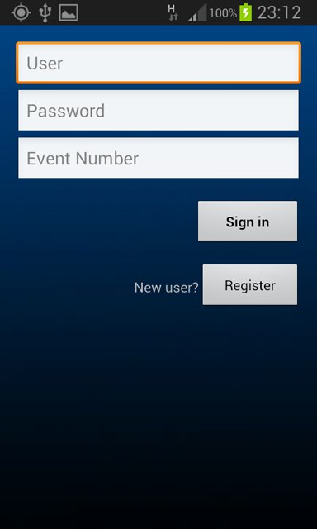

In that screen we will need to type the user box in the password box and the name of the next user admin.

Note: We can also type the admin name as the user and the password the system will allow this as well. in the event box we will type the number of race as we choose. After filling the text box we will sign in.

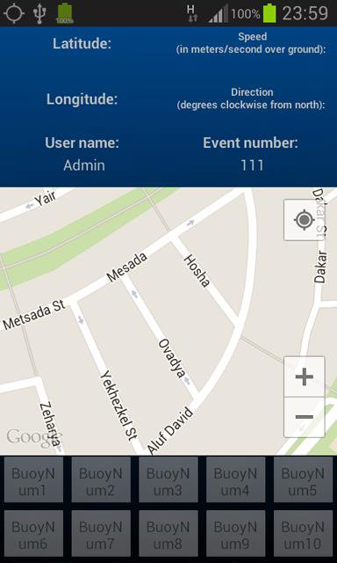

As you can see on the picture there are no information of location speed and Etc.

As well the buttons of the buoy location at the bottom of the screen are disabled that because the system is trying to connect to a System Satellites in order to get GPS coordination.

After a few seconds (mostly takes longer) there will be a connection.

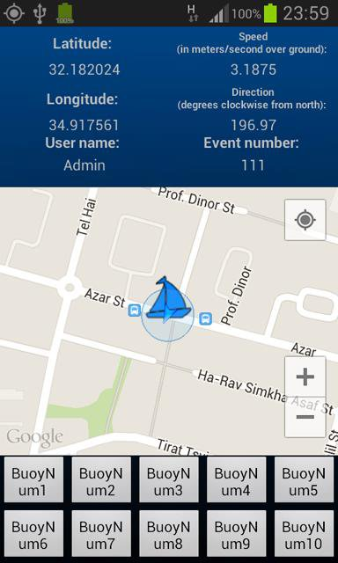

The screen that will appear contain the following:

1. Preview of the current location, current speed, direction of the current boater, user name that is logged in and the number of events / race that the user is connected.
2. A map that will contain three buttons
3. "-" - to focus
4. "+" – to focus
5. View the current location
6. The buoy buttons display while etch button belong to one buoy

the blue arrow marks the current location of the boater on the map. As well you can see a sign of a blue boat that representing the last location that was saved in the system at the moment we will move the blue arrow will move with us after a few matters the blue bout sign will appear at the new location.

Now all we need to do in order to locate the buoy on the map is to physically move with our Vessels towards the buoy that we want to locate on the map. Once we got to the buoy we will press the first button called buoyNum1

And then we will see the following screen:

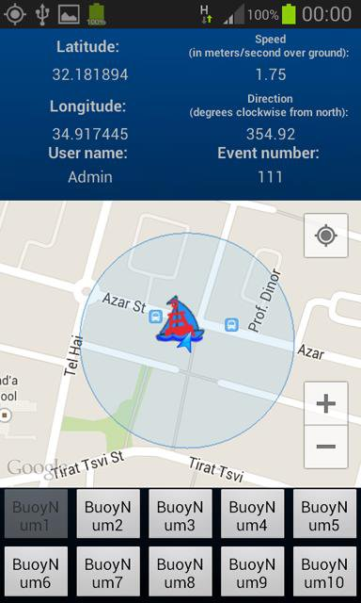

What is just happened is that buoyNum1 is located in:

Latitude: 31.181.894

Longitude: 34.917.445

That means that one's etch user will log in to the system to the number of event will view on his map the buoyNum1, like this you can continue and add buoys on the map as necessary.

Ones we are done locating our buoys on the map we no longer need to use the user admin for the next event. Once you press the back button the app will close. Now we got to the point were the boaters can start signing in the system.

The signing in screen will again appear and we will sign in for example the name: Ofir.

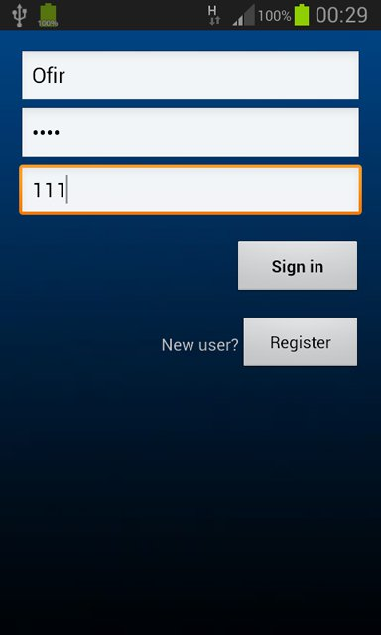

This time we will press the register number in order to create a new user in the system

Note: in case that we press the sign in button we will get note that the user is not existed. The screen that will appear in front of us is the menu activity.

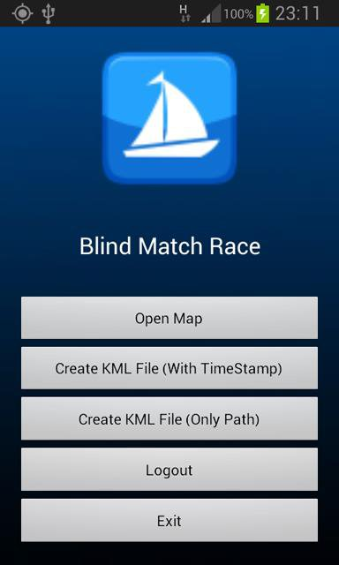

On the screen will appear five buttons:

1. Opening or upload a map.
2. Creating a KML file that will contain the rout the boater done including the timeline.
3. Creating a KML file that will contain the rout the boater did without a timeline.
4. Logging out from the current user and back to the main screen.
5. Logging out of the system.

Note: in order to create a KML file first you need to enter the map participate the race that your data location can be used and saved (at least two different location).

Note: while you log out of the system, the system doesn't deleting the user name, so the next time you will enter the system it will remember the last user.

Now at the menu screen first thing as we explained we open the map, the screen that will appears is the main activity

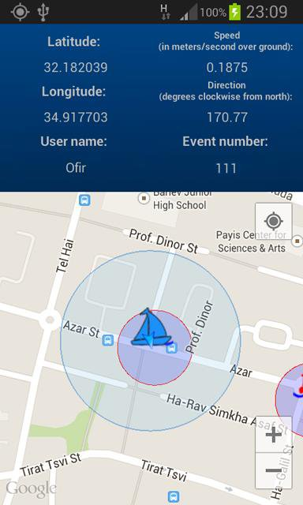

As you can see after connecting to the service our current location will appear and the system display on the map all the buoys and the other boaters that logged in to the same race.

The red circle symbolized the radios of the buoy

Ones you will be in that radios an alert notice will appear on the screen alerting us that the boater is next to a buoy as well there will be a warning sound.

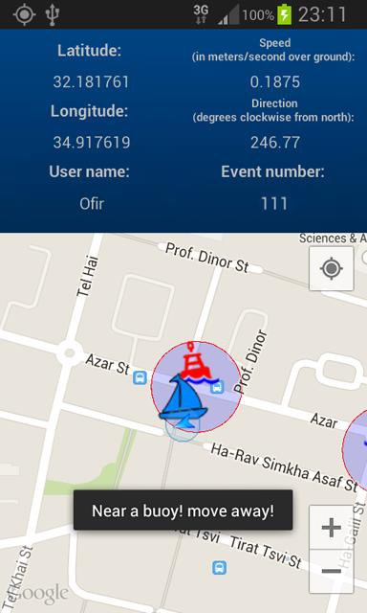

Ones we leave the red circle area the notice will disappear and the sound will stop.

The competitor will appear on the map on his last

location marked as an orange boat.

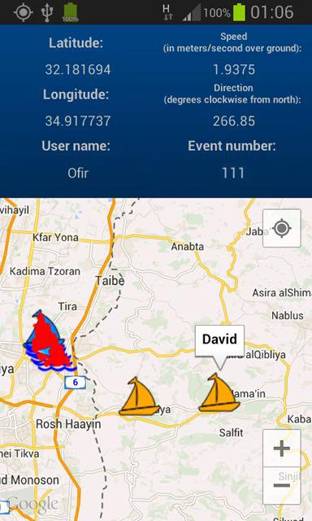

Pressing on one of the symbols will display a bubble of one of the competitor. Every few meters the system will update the boater location and according to that data we can create a KML file

That will contain the entire rout.

**1.3 Creating a KML file**

At the end of the race we would like to make a KML file this file contains the location data of the last race. In order to create this file we will press the back button and press on one of the create KML file by requirement. Then we will see a notice that will ask us to wait while the system is uploading the boaters data form the data base and creating a KML file.

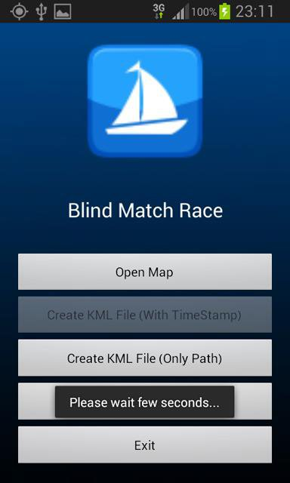

After the system is done we will get a notice that file was created successfully.

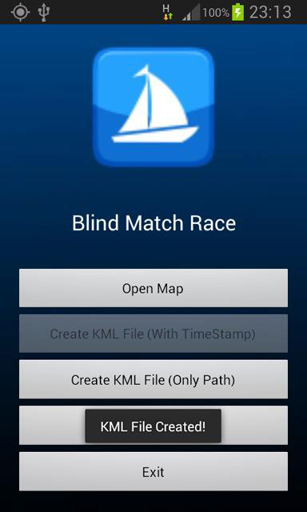

The KML files are saved on the device in the next file …\BlindMatchRace\KMLfiles

Note: in order to view the KML file out device will need to have google earth. In case we want to open another race all the users must do is log out of the current user from the main screen and register in with the different event number.

Note: you can resign in with the same username and password but with a different event number.

**2. Software quality**

**2.1 Saving the data**

Every user that sign in to the system add automatically to the data base in the server that’s why you can log in to everywhere in the world.

While singing in to the system it's add automatically to the user name the word sailor, adding this word to the username allows the system

Distinguish from all the users in the database as well the buoy location data are also saved in the name of buoyNum, by adding this we can select between the users that are boaters and the users that are buoys. In order to Distinguish between boaters that are competing in a certain race and boaters that are competing in a different race we give etch user an event number so the system can Distinguish them and show us in the map only the users that belong to the same event that we are. The full name of the user is being saved as:

Sailor UserName_Password_Event

That way we get all the information under the same database key.

**2.2 Location Update**

While being in the main screen that’s means in the map the system cheek if there where any changes to our current location. If there was a change the system refresh the map with new database that means our last location is marked as a blue bout will also change as well the system is updating on new location of the other boaters that’s why in case of one boater marked as an orange bout also moved. The system will refresh his current location. On the map beside the boaters the buoys will also appear on the location that was set by the admin. They are also been Removable from the database.

**3. Google earth**

**3.1 KML file with a time line**

KML file that was produce with a database of time will appear on GE With a time lone that shows the location where the boaters has sail throw the race

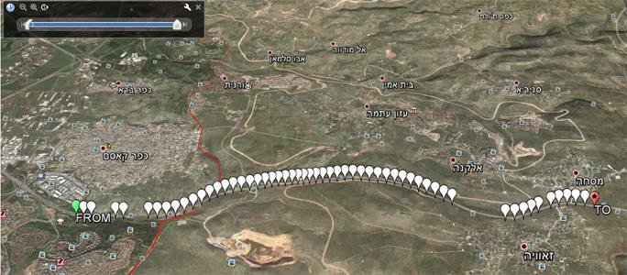

The marker sign that is in the color green marks the from point

The mark that is in the color red with a star marks the to point.

The marks that are in the color white represent the location that the boaters went from the begging of the race to the end.

**3.2 KML file with just a rout**

A KML file that was produce without a GE information will appear with a rout line that shows the entire rout that the boater passed throw the race.

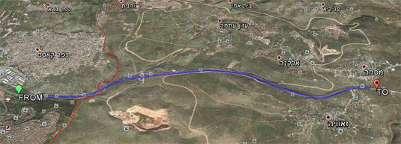

1. **Access to the original code**

The original code is added as an Android project, as well you can Accesses the original code that is stored in the [Github server](https://github.com/niso217/BlindMatchRace).