* Run the Code
* The following options will display

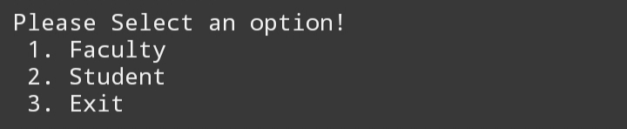

* Select if you are 1[FACULTY] , 2[STUDENT] or 3[EXIT] If you don't want to proceed.
* When you select [STUDENT] this will show.

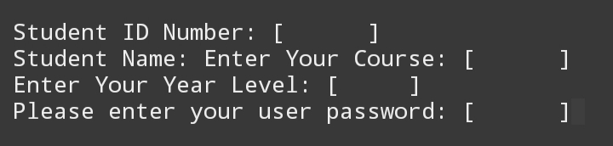

* Enter your [ STUDENT ID NUMBER, STUDENT NAME, COURSE, YEAR & LEVEL, PASSWORD] to proceed.
* ​After that, the following options will display [ DEMOGRAPHICS, GRADES, SCHEDULE, EXIT]

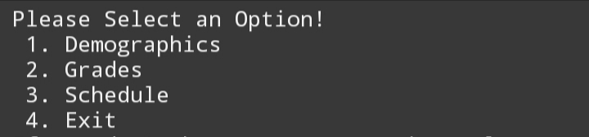

* If you select 1[ DEMOGRAPHICS] your personal information will display.
* ​If you select 2[GRADES] your grades in all subjects under your course will display.
* ​If you select 3[SCHEDULE] your list of classes will display.
* ​Select 4[EXIT] If you don't want to proceed or don't have any transactions.