BESTLINK COLLEGE OF THE PHILIPPINES BULACAN
CAMPUS - HOSPITAL MANAGEMENT SYSTEM
(PATIENT MANAGEMENT)

A Capstone
Presented to the Faculty of
The College of Computing Studies
Bestlink College of the Philippines - Bulacan Campus

In Partial Fulfillment of the
Requirements for the Degree
Bachelor of Science in Information System

MARIO L. BALANGATAN
JONEL CRISTIAN C. BALUTE
JHON ROBERT B. DELMIGUES
PRINCESS ANNE NORBIE A. SIKAT
EVELYN B. SUAREZ

February 2026

APPROVAL SHEET

ACKNOWLEDGEMENT
The researchers would like to express their heartfelt thanks and gratitude to the following persons who, in one way or another, has contributed much, and extended willingness and support needed to make this research possible:
Dr. Maria M. Vicente, President/CEO, Bestlink College of the Philippines, for her generosity and kind heart in establishing this institution and giving opportunities to those less fortunate students to continue their studies and pursue their dreams;
Ms. Edith M. Vicente, Executive Vice President, for providing the needed information to complete this research;
Dr. Ryan M. Ignacio, Vice President for Academic Affairs, for his support and encouragement to make this thesis writing possible;
Engr. Diosdado T. Lleno, Vice President for Administration and Finance, for his words of encouragement and motivation;
Dr. Joy Evelyn A. Ignacio, Director, Center for Research and Development, for her good heart to extend her help needed by the researchers;
Marimel A. Loya, LPT, MBA Campus School Directress of Bestlink College of the Philippines, for providing a guideline documentation in capstone project.
Mr. Phillip C. Arevalo, Research Coordinator, for helping us in improving our research and guiding us in completing this project.
Mr. David G. Jaurigue, Capstone Adviser, for giving us suggestions and ideas to improve our research and guiding us in completing this project.

Panelists, Ms. Cyrille Anne I. Nery, MSIT, Mr. Phillip C. Arevalo, MSIT, and Mr. Khristian M. Hoseña who extended their effort and time to be able to constructively criticize this thesis and share their knowledge with them to deepen and widen their needed information.

Families and Friends, for all the financial and moral support that have enabled the researchers to triumph all the challenges, especially during the lowest time that served as their inspiration to complete this study; and

Above all, to the Almighty God, for the strength and knowledge that were used for the accomplishment of this research journey.

THE RESEARCHERS

DEDICATION

This Research project is wholeheartedly dedicated first to our fellow researchers, whose passion, hard work, and collaboration made this study possible. This work is not only a product of individual effort but also of teamwork and shared dedication to the pursuit of knowledge.
To our beloved parents, whose unconditional love, sacrifices, and unwavering support have been our greatest source of strength and inspiration. Their guidance and encouragement have motivated us to persevere through challenges and pursue our goals with determination.
To the thesis adviser and professors, whose guidance, patience, and encouragement have been invaluable throughout the development of this study. Their expertise and dedication not only provided us with knowledge but also inspired us to persevere and strive for excellence.
This work stands as a reflection of their support and commitment, for which we will always be deeply grateful. And lastly, and most importantly, all glory and praise be to God, the source of all wisdom and strength, who has been our source of strength, wisdom, and guidance throughout the process of completing this research. Without his blessings, this journey would not have been possible.

THE RESEARCHER

ABSTRACT
Title: BESTLINK COLLEGE OF THE PHILIPPINES

BULACAN CAMPUS - HOSPITAL MANAGEMENT
SYSTEM (PATIENT MANAGEMENT)
Authors: MARIO L. BALANGATAN

JONEL CRISTIAN C. BALUTE

JHON ROBERT B. DELMIGUES

PRINCESS ANNE NORBIE A. SIKAT

EVELYN B. SUAREZ

Degree: Bachelor of Science in Information System

Date of Completion: FEBRUARY 2026

Healthcare institution continuously strive to improve efficiency and service quality through the use of digital technologies. Most hospital still use a manual processes including Dr. Eduardo V. Roquero Memorial Hospital, which relies on manual, paper-based processes for managing patient records. With the use of manual processes, it is prone to inefficiencies, errors, and data loss, creating operational challenges and hindering the quality of patient care. To address these issues, a centralized digital platform is proposed for creating, storing, managing, and instantly retrieving records, which does the Patient Management System for automating registration, scheduling, bed tracking and managing patient records. The core features of this system are digitalized patient records, automates appointment scheduling, and bed tracking. It is anticipated that the adoption of PMS will greatly simplify the working processes, decrease the load of administration on the workers of healthcare facilities, decrease the number of mistakes and unnecessary delays, and help access the correct information about patients easily. The system enables the healthcare professionals to spend more time attending to patients directly by automating their routine duties and this eventually improves the overall efficiency and quality of services offered by the hospital.

TABLE OF CONTENTS
APPROVAL SHEET ii
ACKNOWLEDGEMENT iii
DEDICATION v
ABSTRACT vi
TABLE OF CONTENTS viii
LISTS OF TABLES xvi
LISTS OF FIGURES xix
CHAPTER 1
INTRODUCTION 1
1.1 Background of the Capstone Project 3
1.2 Context and Scope 13
1.3 Problem and Statement 14
1.4 Objectives and Goals 17
1.5 Significance and Relevance 21
1.6 Structure of the Document 24
CHAPTER 2
RELATED STUDIES AND LITERATURE REVIEW 29
2.1 Agile Scrum Methodology Overview 30
2.2 Enterprise Architecture Concepts 32
2.3 Microservices Architecture 35
2.4 DevOps and CI/CD 39
2.5 Relevant Studies and Research 42
2.6 Integration of Information Systems in Enterprise Environment 47
CHAPTER 3
METHODOLOGY 49
3.1 Agile Scrum Methodology in the Project 52
3.2 Roles and Responsibilities 54
3.3 Sprint Cycles 56
3.4 Scrum Artifacts 59
3.5 Integration Approach for Information System 61
3.6 Microservices 62
3.7 Introduction to TOGAF and the four Architectural
Domains 64

LISTS OF TABLES
Table 1 Structure of the Document 25
Table 2 Roles and Responsibilities 56
Table 3 Sprint Planning 58
Table 4 Daily Standup 58
Table 5 Product Backlog 60
Table 6 Sprint Backlog 61
Table 7 User Stories and Use Cases 78
Table 8 Functional Requirements for Integration 83
Table 9 Components of Application Architecture 92
Table 10 Technology Stack and Infrastructure 107

LISTS OF FIGURES
Figure 1 Theoretical Framework 7
Figure 2 Conceptual Framework 9
Figure 3 BPA Level 1 26
Figure 4 BPA Level 2 27
Figure 5 Flowchart 28
Figure 6 Agile Scrum Methodology Overview 30
Figure 7 Enterprise Architecture 34
Figure 8 Microservices Architecture 35
Figure 9 DevOps and CI/CD 39
Figure 10 SDLC Methodology 49
Figure 11 Agile Scrum Methodology in the Project 52
Figure 12 Microservices 62
Figure 13 TOGAF Framework 64
Figure 14 Business Architecture 66
Figure 15 Data Architecture 67
Figure 16 Database Schema 68
Figure 17 Application Architecture 69
Figure 18 Technology Architecture 70
Figure 19 Identification of Business Processes 84
Figure 20 BPA Level 1 85
Figure 21 BPA Level 2 86
Figure 22 Application Architecture 89
Figure 23 Application Architecture Diagram 93
Figure 24 Data Architecture 97
Figure 25 Data Flow Diagram 100
Figure 26 Network Topology and Configuration 108
Figure 27 System Architecture 157
Figure 28 Illustration depicts the internal coordination of PMS components 168

CHAPTER 1

INTRODUCTION

References
Lists of Cited Sources and References
- Marion Rylan Q De Guzman, Jonn Louis N Ordoñez, Ronald O
Somocierra, Gloren S Fuentes
(2021) Online Scheduling System for Doctors and Patients in a Hospital. https://ieomsociety.org/proceedings/2021monterrey/277.pdf
- De Guzman, M. R. Q., Ordoñez, J. L. N., Somocierra, R. O., & Fuentes, G. S. (2021). Online Scheduling System for Doctors and Patients in a Hospital.) https://ieomsociety.org/proceedings/2021monterrey/277.pdf
- Rose Jean P. Bayot, Rona Jane L. Desoyo, and Gina A. Mangyao (2023) Dental Clinic Management System. https://www.scribd.com/document/638765050/Dental-Clinic-Management-System-Capstone-Project
- Anton Elepaño, Carol Stephanie Tan-Limp, Regine Ynez De
Mesa, Mia Rey, Josephine Sanchez, Leonila Dans, Antonio Miguel Dans (2025) Implementing Electronic Health Records.
https://pmc.ncbi.nlm.nih.gov/articles/PMC12283060/)
- Rogers Felix (July 2023) Patient Records Management System in Magomeni Hospital.
https://www.researchgate.net/publication/372131512_Patient_Records _ Management_System_in_Magomeni_Hospital
6. Tomas U. Ganiron Jr. Focuses on digitizing patient records, scheduling, and reporting to improve healthcare service delivery. (May 2023) Developing A Computer-Based Record Management System
https://www.researchgate.net/publication/370607649_Developing_A_Computer-Based_Record_Management_System
7. Enebeli Margaret Ifelunwa (2021) Electronic Patient Management.
https://www.scribd.com/document/517153335/Patient-Management-system

Appendices A
Detailed Technical Documentation

System Architecture
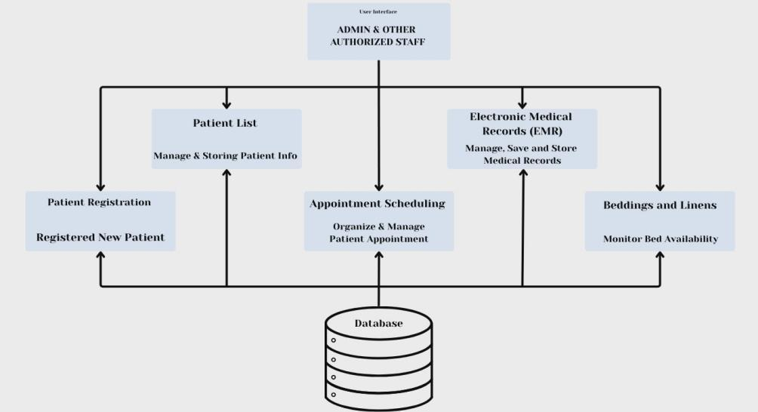
Figure 27 System Architecture

Overview Of The Overall System Architecture
The Patient Management System (PMS) is designed using a multi-tier, web-based system architecture that ensures scalability, security, maintainability, and efficient integration of hospital operations.
- Presentation Layer
The Presentation Layer acts as the user interface for the Patient Management System. Authorized users, including administrators, nurses, and front desk, access it via standard web browsers. The interface is designed to be user-friendly, responsive, and role-based, ensuring that each user only accesses functions relevant to their responsibilities.
- Patient registration forms
- Appointment scheduling interfaces
- Bed monitoring dashboards
- Electronic Medical Record (EMR) views
- Patient list and reporting screens
- Application Layer
The Application Layer encompasses the essential logic and features of the Patient Management System. It handles user requests, implements business rules, and manages communication between the Presentation Layer and the Data Layer. This layer is implemented using PHP with Object-Oriented Programming (OOP), allowing modular design, code reusability, and easier system maintenance. Each module operates independently but remains fully integrated within the system architecture, supporting scalability and future enhancements
- Patient Registration Module
- Appointment Scheduling Module
- Bed and Linen Management Module
- User Authentication and Authorization

- Data Layer
The Data Layer is responsible for secure storage, retrieval, and management of patient and hospital data. It uses a centralized relational database that stores. This centralized method removes data duplication, guarantees data uniformity, and enables immediate access throughout hospital departments. Data validation, backup, and access control systems are enacted to ensure data integrity, confidentiality, and adherence to healthcare standards.
- Patient demographic information
- Medical histories and EMRs
- Appointment records
- Bed availability and linen status
- System logs and audit trails
- Infrastructure and Technology Layer
The Infrastructure Layer provides the technical foundation that supports the PMS. The system can be implemented in either an on-site or cloud-based setting, providing adaptability according to hospital needs. Protective strategies like firewalls, encrypted messages, and role-specific access safeguard sensitive patient information

- Web server hosting the application
- Database server for data storage
- Network components (firewalls, routers, secure access controls)
- Backup and recovery mechanisms

Detailed Diagrams Illustrating System Components And Their Interaction
The overall architecture of the Patient Management System (PMS) developed for Dr. Eduardo V. Roquero Memorial Hospital. The diagram presents how users, system components, and the database interact to support efficient hospital operations. At the top layer, the users or actors consist of the Admin, Front desk, Nurse, and Patient. These authorized individuals gain access to the system via a web browser, enabling them to utilize the PMS at any time within the hospital network. Each role is assigned specific access rights according to their duties, thereby ensuring data security and appropriate system utilization. The middle layer represents the Web-Based Patient Management System, developed using PHP with Object-Oriented Programming (OOP). This layer serves as the core of the system and contains the main functional modules:
- Patient Registration Module – captures and stores patient demographic information digitally.
- Patient List Management – provides a centralized list of all registered and admitted patients.
- Electronic Medical Records (EMR) – manages patient medical history, diagnoses, prescriptions, and treatment records.
- Appointment Scheduling Module – organizes and manages patient-doctor appointments.
- Bed and Linen Tracking Module – monitors bed availability and linen readiness in real time.
- Reports and Dashboard – presents summarized data such as patient counts, appointments, and bed availability for management decision-making.
The bottom layer is the Database Server, which securely houses all system data within a centralized database. It comprises tables for patient details, medical records, appointment schedules, bed and linen availability, and user accounts. This centralized data storage removes the necessity for paper records and facilitates quick access, real-time updates, and consistent data across all departments.
This architecture addresses the hospital’s existing problems such as manual record-keeping, delayed data retrieval, incomplete records, and inefficient bed management. By digitizing and centralizing patient information, the system improves workflow efficiency, data accuracy, and the quality of patient care.

Explanation Of Component Responsibilities And Relationships
The Patient Management System (PMS) is composed of several interconnected components, each responsible for a specific hospital function. These components work together to ensure accurate data handling, efficient workflows, and improved patient care. The system follows a centralized and modular architecture, allowing seamless interaction between components while maintaining data integrity and security.
1. Authentication and User Management Component
Responsibilities:
- Manages user login and authentication.
- Enforces role-based access control (Admin, Receptionist, Nurse, Patient).
- Restricts access to sensitive patient data based on user roles.
- Ensures system security and accountability.
Relationships:
- Acts as the entry point to the system.
- Controls access to all other PMS components.
- Works closely with the Database Component to validate user credentials and permissions.
2. Patient Registration Component
Responsibilities:
- Records new patient demographic information such as name, address, contact details, and emergency contacts.
- Ensures required fields are completed to prevent incomplete records.
- Creates a unique patient profile for each individual.
Relationships:
- Sends patient data to the Patient List Component.
- Serves as the foundation for EMR, Appointment Scheduling, and Bed Management.
- Stores all patient information in the centralized database.

3. Patient List Management Component
Responsibilities:
- Displays all registered and admitted patients in a centralized list.
- Allows authorized users to search, view, and update patient information.
- Acts as the main access point for selecting patient records.
Relationships:
- Retrieves data from the Patient Registration Component.
- Provides patient records to the EMR, Appointment Scheduling, and Billing components.
4. Electronic Medical Records (EMR) Component
Responsibilities:
- Stores and manages patient medical history, diagnoses, prescriptions, and treatment plans.
- Allows nurses to update clinical information in real time.
- Ensures continuity of care by maintaining complete medical records.

Relationships:
- Receives patient identity data from the Patient List Component.
- Stores all clinical data securely in the Database Component.
- Restricted by Authentication and User Management for security.
5. Appointment Scheduling Component
Responsibilities:
- Manages patient appointments with doctors.
- Displays doctor availability and scheduled consultations.
- Prevents scheduling conflicts and double bookings.
Relationships:
- Uses patient data from the Patient List Component.
- Updates appointment data in the Database Component.
6. Bed and Linen Management Component
Responsibilities:
- Tracks hospital bed availability (occupied, vacant, under maintenance).
- Request Linen for new patients.
- Supports faster patient admission and room assignment.
Relationships:
- Receives patient admission details from Patient Registration and EMR.
- Updates real-time bed status for hospital staff.
- Stores bed and linen data in the Database Component.
- Helps reduce delays caused by manual bed checking.
7. Reporting and Dashboard Component
Responsibilities:
- Generates real-time summaries such as patient count, appointments, bed availability, and admissions.
- Provides hospital management with operational insights.
- Supports data-driven decision-making.
Relationships:
- Collects data from all PMS components.
- Retrieves aggregated data from the Database Component.
- Accessible mainly by Admin users through role-based access

Information Systems Integration

Description Of How The Class's Information Systems Were Integrated
The Patient Management System (PMS) is a system with several modules and connected to other systems of the hospital through RESTful APIs to ensure a smooth flow of data and real-time communication. The Patient Registration API receives the creation, retrieval, and update of the demographic information of the patients, as it forms the basis of the system. Patient Management API handles admissions, discharges, and update patient information, whereas the Appointment Scheduling API allows booking, rescheduling, and cancellations of appointments by communicating with Doctor and Nurse System API to check real-time doctor availability. EMR API is used to store the diagnoses, treatment plans, and notes of clinical nature, and it is linked directly to the Pharmacy API to transfer prescription data and the Laboratory API to request and obtain test results. For Inpatients, the Bed and Linen Management API follows the bed assignment and availability to provide adequate room assignment and resource monitoring. Moreover, the Billing API captures a history of billing, creates invoices and monitors payments and can be combined with services like laboratory tests and pharmacy histories to make sure that the charges are calculated accurately. Any APIs are also secured by the authentication procedure like role-based access control, which means that only authorized users like administrators, doctors, nurses and patients have access to the appropriate data. This integrated API structure helps the system to attain effective operations in the hospital, high accuracy of the data, and efficient communication among the departments.

Diagrams Showing The Integration Points And Data Flows
The Patient Management System (PMS) integrates its core modules and how data flows between internal components and external hospital systems. The diagrams emphasize data sharing, centralized storage, and system interoperability, consistent with the system architecture described in the uploaded document.
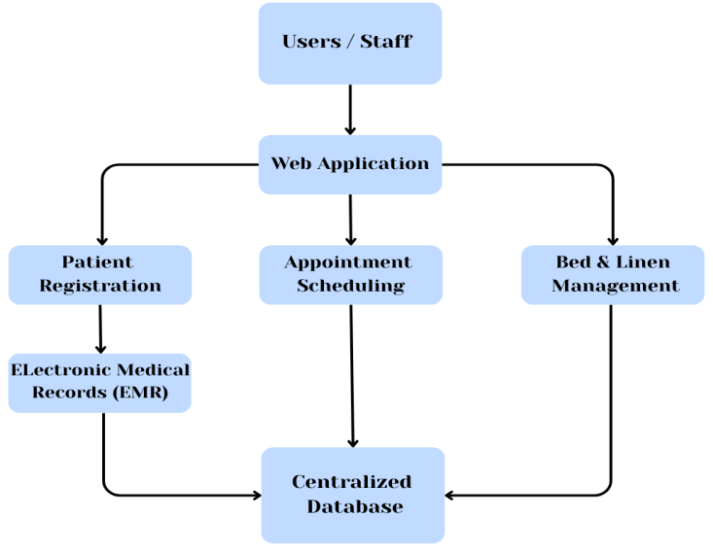
Figure 28 Illustration depicts the internal coordination of PMS components
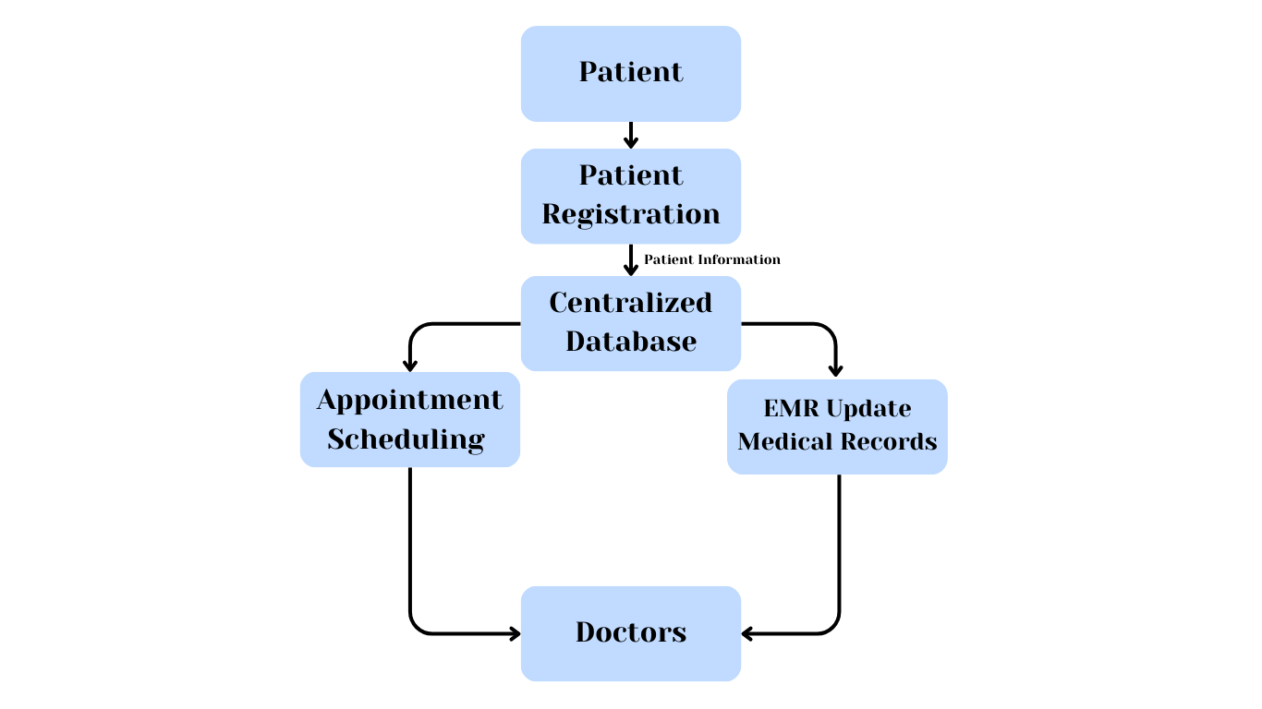
This illustration depicts the internal coordination of PMS components. Every functional module Patient Registration, Appointment Scheduling, EMR, and Bed & Line Management interconnects via the web application and utilizes a shared centralized database. This guarantees that after patient data is input, it is instantly accessible throughout all modules without any duplication or lag.

Figure 29 Illustrates how patient data moves

This data flow diagram illustrates how patient data moves through the system. Patient information is first captured during registration and stored in the database. The same data is reused for appointment scheduling and EMR updates, enabling healthcare professionals to access updated information in real time.
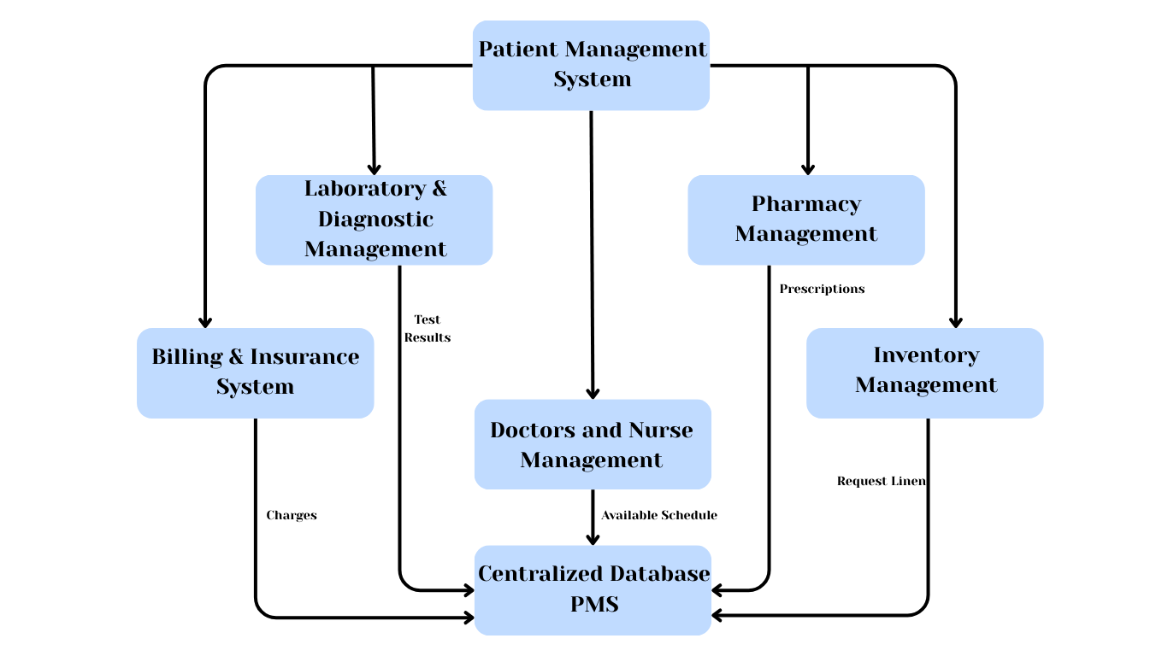
Figure 30 Integration points between PMS and other system

This diagram highlights integration points between PMS and other hospital systems. Laboratory results, pharmacy prescriptions, and billing information are exchanged through secure interfaces. The PMS acts as the central hub, ensuring synchronized data across departments and eliminating manual record transfers.

Data Transformation And Mapping Processes
In the Patient Management System (PMS), data transformation and mapping procedures outline the conversion of raw data gathered from different hospital sources into a uniform, organized, and functional format throughout the interconnected system modules. These processes guarantee consistency, accuracy, interoperability, and real-time accessibility of data between the PMS elements and other hospital information systems.
1. Data Sources in the PMS
The PMS receives data from multiple internal and external sources, including:
- Patient Registration Forms
- Appointment Scheduling Module
- Electronic Medical Records (EMR)
- Bed and Linen Management Module
- Laboratory and Diagnostic Systems
- Billing and Insurance Systems
- Pharmacy System
- Doctor and Nurse System
Each data source may use different data formats, naming conventions, or structures. Data transformation ensures that all incoming data follows a common system schema before being stored or shared.
2. Data Transformation Process
Data transformation is the process of converting raw input data into a standardized format suitable for processing and storage in the PMS database.
2.1 Input Data Normalization
- Patient details such as names, addresses, contact numbers, and dates are standardized.
- Date formats (e.g., appointment dates, admission dates) are converted into a uniform system format.
- Mandatory fields are validated to prevent incomplete records.
2.2 Data Validation and Cleansing
- Duplicate patient records are detected using unique identifiers (Patient ID).
- Invalid or missing values are flagged for correction.
- Data type validation ensures numeric, text, and date values are stored correctly.
This process supports the PMS objective of minimizing errors caused by rushed or manual data entry
3. Data Mapping Process
Data mapping defines how data elements from one module or external system correspond to fields in the PMS database.

3.1 Internal Module-to-Database Mapping
PMS Module | Source Data Field | Database Field
Patient Registration | Full Name | patient_name
Patient Registration | Date of Birth | patient_dob
Appointment Scheduling | Appointment Date | appointment date
EMR Module | Diagnosis | medical diagnosis
Bed Management | Bed Status | bed status
Table 28 Internal Module-to-Database Mapping

This mapping ensures all modules use consistent field definitions, allowing seamless data sharing across the system.
4. Data Transformation in System Integration
When integrating PMS with other hospital systems, data transformation ensures compatibility:
- Laboratory test results are converted into PMS-supported medical record formats
- Pharmacy prescriptions are mapped to patient treatment records
- Billing data is transformed into standardized charge and payment structures
- Doctors schedules are mapped to appointment scheduling for the availability of the doctors.
These transformations allow external systems to interact with the PMS through secure APIs while maintaining a single source of truth.
5. Security and Access Control in Data Mapping
During data transformation and mapping:
- Role-based access control determines who can view or modify mapped data
- Audit logs track data changes across modules
This ensures compliance with healthcare data protection requirements and safeguards patient confidentiality.
6. Importance of Data Transformation and Mapping
The implementation of data transformation and mapping processes in the PMS:
- Ensures data accuracy and consistency
- Eliminates redundancy and manual errors
- Enables seamless integration between hospital departments
- Supports real-time decision-making and patient care
These processes align with the enterprise integration and data architecture strategies defined in the uploaded Patient Management System documentation

Application Design and Development

Detailed Information About The Software Modules And Components
The Patient Management System (PMS) is a web-based application created with PHP utilizing Object-Oriented Programming (OOP). Its purpose is to digitize and centralize hospital operations concerning patient records, appointments, medical history, and bed management. The system features a modular design, enabling each component to execute a particular function while maintaining integration with the overall system via a centralized database.
- Authentication and User Management
This controls access to the system by validating user credentials and enforcing role-based permissions.
Functions
- User login and logout
- Role assignment (Admin, Front Desk, Nurse, Patient)
- Access control for sensitive data
Purpose
This module ensures that only authorized hospital staff can access the system and that each user can only perform tasks relevant to their role.
2. Patient Registration Module
Description
This module is responsible for collecting and storing patient demographic information during their first visit.
Functions
- Add new patient records
- Capture personal and contact information
- Store emergency contact details
- Validate required fields to prevent incomplete records
Purpose
Replaces manual index card recording and ensures complete, accurate, and digital patient records.
3. Patient List Management Module
Description
This module provides a centralized directory of all registered and admitted patients.
Functions
- Display all patient records
- Search and filter patients
- Update patient status (admitted, discharged)

Purpose
Allows healthcare staff to quickly retrieve patient information without searching through physical files.
4. Electronic Medical Records (EMR)
Description
Stores and manages the complete medical history of each patient.
Functions
- Maintain chronological medical history
- Restrict access to authorized users only
Purpose
Improves clinical decision-making by providing real-time access to accurate medical data.
5. Appointment Scheduling Module
Description
This module manages patient appointments and doctor availability.
Functions
- Create, update, and cancel appointments
- View doctor schedules
- Prevent scheduling conflicts

Purpose
Reduces waiting time and ensures efficient coordination between patients and doctors.
6. Bed and Linen Management Module
Description
This module tracks bed availability and linen readiness in real time.
Functions
- Monitor bed status (vacant, occupied, maintenance)
- Assign beds to admitted patients
- Update bed readiness automatically
- AI predicts the length of stay
Purpose
Eliminates manual bed checking and improves admission efficiency, especially during peak hours.
7. Reporting and Dashboard Module
Description
This module provides summarized and real-time operational data for hospital management.
Functions
- Generate patient statistics
- Display appointment counts
- Show bed availability rates
- Show overall overview and analytics
Purpose
Supports data-driven decision-making and hospital performance monitoring.
8. Database Management Component
Description
This component serves as the centralized repository for all PMS data.
Functions
- Data Stored
- Patient profiles
- Medical records
- Appointments
- Bed and linen status
- User accounts and roles

Purpose
Ensures data integrity, consistency, and fast retrieval, eliminating paper-based storage.

Figure 31 Software Modules and Components
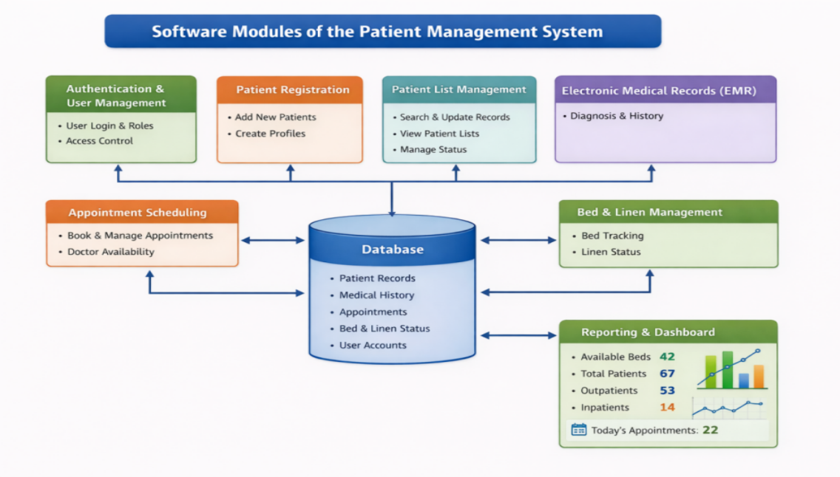

Code Snippets And Code Structure
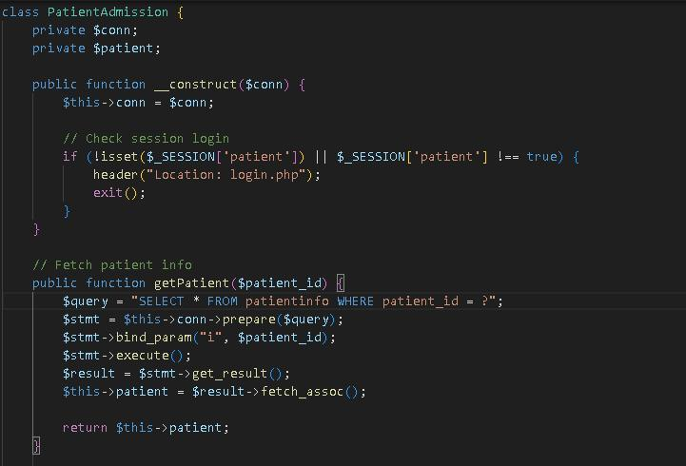
Figure 32 Code Snippet
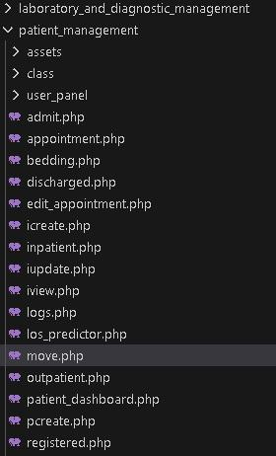
Figure 33 Code Structure

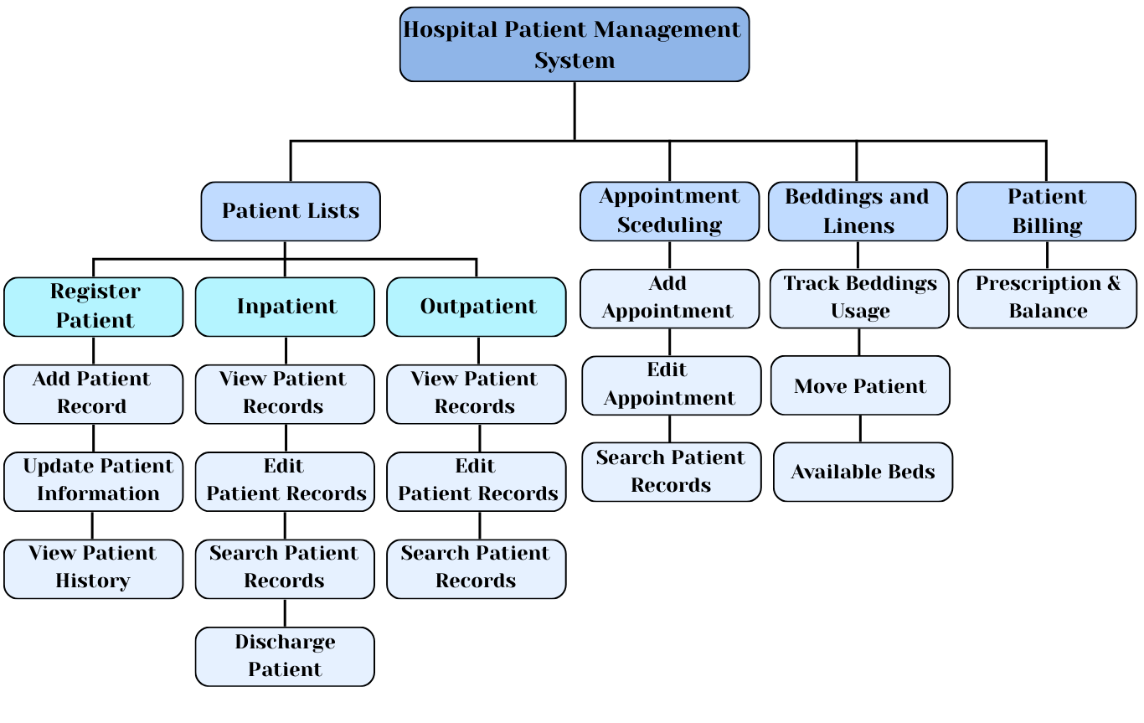
Algorithms And Data Structures Used
Figure 34 Algorithms and Data Structures Used

Libraries And Frameworks Utilized
FRAMEWORK / LIBRARY | DESCRIPTION | PURPOSE IN THE PMS  (TOGAF MICRO SERVICES CONTEXT) | BENEFITS
jQuery | A JavaScript library that simplifies client-side scripting and asynchronous interactions. | jQuery assists frontend components in communicating with backend services by handling asynchronous requests and dynamic data updates, supporting the integration layer between the presentation and application services defined in TOGAF. | Improves system responsiveness, reduces page reloads, and enhances user interaction.
Bootstrap | A front-end framework providing reusable UI components and responsive layouts. | As part of the presentation layer, Bootstrap ensures consistent user interface design across different system services while supporting the modular structure of the application architecture. | Speeds up development, ensures design consistency, and improves accessibility on different devices.
PHP | A server-side scripting language used for backend development and system processing. | In alignment with the TOGAF application architecture and microservices approach, PHP is used to build independent backend services such as user authentication, patient record handling, appointment scheduling, and billing processing. Each service communicates through APIs to ensure modularity and scalability. | Supports secure data processing, enables modular system design, and allows easy system expansion
HTML | The standard markup language used to structure web pages and application content. | HTML is used to define the structure of system pages such as login screens, patient registration forms, dashboards, and medical record views. | Provides clear content structure and ensures compatibility across web browsers.
CSS | A style sheet language used to control visual layout and appearance. | CSS is applied to enhance the visual presentation of the Patient Management System, ensuring readability, consistency, and a professional healthcare-oriented design | Improves user experience and maintains a clean and organized interface.
Font Awesome | An icon library that provides scalable vector icons | Font Awesome is used to visually represent system functions such as navigation menus, actions, and notifications, improving ease of use for medical staff and patients | Enhances usability, supports intuitive navigation, and improves visual clarity.
Table 29 Libraries And Frameworks Utilized

Database Schema and Data Management

Database Schema Design
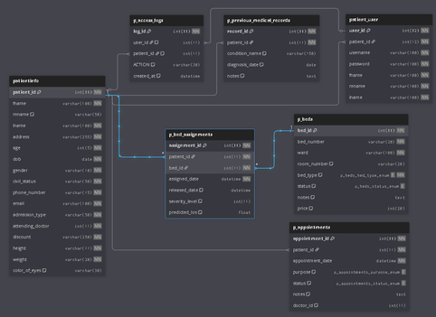
Figure 35 Database Schema Design

Entity-Relationship Diagrams (ERDs)
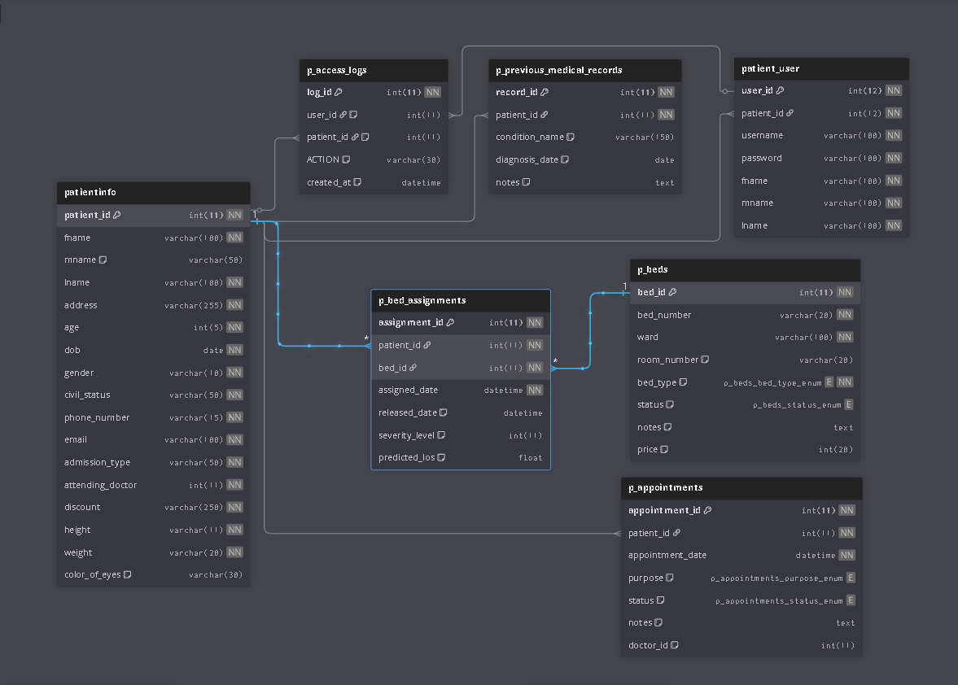
Figure 36 Entity- Relationship Diagrams (ERDs)

Data modeling and normalization
Data modeling for a patient management system is carried out through the creation of a systematic representation of healthcare data in a way that ensures accurate storage, retrieval, and management of patient information. It defines key entities like Patients, Appointments, Medical Records, Beds, and Billing along with their attributes and relationships. The well-designed data model will provide consistency of data, ensure system integration across different modules-Registration, EMR, Scheduling, and Billing-and offer easy reporting and decision-making.
Data normalization is the process of organizing the PMS database in such a way that data redundancy can be minimized, and data integrity is maintained. The application of the rules of normalization 1NF, 2NF, and 3NF will store the repeated details of a patient once in one table and refer them from other related tables. Normalization ensures accuracy in patient records, efficiency in data maintenance, and reliable system performance to meet secure and scalable healthcare operations.

CRUD (Create, Read, Update, Delete) operations
Create
In this function allows the authorize users (doctors, nurse and other healthcare staff) to register a new patient to the system. It is performed during the initial visit of a patient or as they being hospitalized. This also ensure that all patients are properly registered and can be tracked within the hospital system.
Process
- Collecting patient demographic information such as full name, date of birth, age, gender, and civil status.
- Generating a unique Patient ID to avoid duplication
- Saving patient data securely into the system database.
Read
Read allows authorized users to view the records of patients without modifying the records. This ensures that information is correct and individuals access information they require and provide healthcare staff quick access to accurate patient information for treatment and decision-making.
Process
- Viewing patient profile
- Searching patient records using Patient ID, and name
- Accessing medical history, diagnoses, or treatment records
Update
Update function allows authorized users to modify or update patient information when changes occur and keep patient information accurate and up to date throughout their hospital stay.
Process
- Updating patient information
- Updating patient admission status
Delete
Delete allows authorized users to remove or archived patient records from active use. It manage outdated or duplicate records.
Process
- Restricting deletion privileges to authorized administrators only
- Maintaining audit logs to track deleted or archived records

Network Configuration

Network Topology And Configuration Details
Network Topology and Connectivity
As a web-based platform, it specifically outlines how the system integrates across different hospital units to ensure a seamless flow of data:
- Centralized Integration: The PMS serves as a digital backbone, connecting various departments such as Laboratory (for test results), Pharmacy (for prescriptions), Inventory (for request linens), Billing (for billing history), and Doctors (for doctors schedules).
- API-Driven Communication: To avoid manual data entry and ensure real-time synchronization, the application uses APIs to share patient data automatically between these integrated systems.
System Configuration and Architecture
The system is built using a Microservices Architecture, which breaks the application into independent, modular services.
- Modular Services: Key modules like Patient Registration, Appointment Scheduling, and Beddings operate independently. This configuration allows the hospital to update or fix one service without taking the entire system offline.
- Scalability: The configuration is designed to be scalable, meaning it can handle increasing volumes of patient data and additional staff users as the hospital grows.
- Development Stack: The system is developed using PHP with Object-Oriented Programming (OOP) to ensure a structured, maintainable, and reusable codebase.
- Artificial Intelligence (AI) Integration: A specific configuration within the bed-linen management is designed to improve bed efficiency by predicting patient length of stay and supporting proactive bed allocation and discharge planning
Security and Governance Configuration
To protect sensitive patient information within the network, several security protocols are implemented:
- Role-Based Access Control (RBAC): Access is restricted to authorized personnel only, ensuring that staff members can only view or update data relevant to their specific roles.
- Data Protection: The system employs firewalls, encryption, and audit trails to secure data during transmission and storage.
- CI/CD Pipeline: The technical architecture includes Continuous Integration and Continuous Deployment (CI/CD) pipelines to automate testing and deployment, ensuring the system remains reliable with minimal downtime during updates.

Security Measures
The Patient Management System incorporates various security protocols to safeguard the confidentiality, integrity, and accessibility of patient information. These encompass network security through firewalls, data encryption during transmission and storage, role-based access management, secure authentication methods, database safeguarding techniques, routine encrypted backups, and monitoring of user activities. These precautions guarantee that only permitted individuals can reach sensitive medical records while averting data loss, unauthorized entry, and system exploitation, thus fostering secure and dependable hospital functions.
1. Network Security (Firewalls & Secure Access)
To protect the PMS from unauthorized external access, network-level security controls are implemented.
Firewall Protection
- A firewall is deployed between the PMS server and external networks to filter incoming and outgoing traffic.
- Only essential ports (e.x, HTTPS for web access, database ports restricted to internal use) are allowed.

2. Data Encryption (Protecting Patient Information)
Because the PMS handles sensitive patient data (EMR, diagnoses, appointments), encryption is critical.
Encryption in Transit
- All data exchanged between users (front desk, nurses, and admins)
- Prevents data interception during login, patient registration, and record updates.
- Patient records stored in the database (personal details, medical history, lab results) are encrypted.
3. Authentication and Authorization (Role-Based Access Control)
The PMS applies strict access control based on user roles.
User Authentication
- Every user must log in using a unique username and password.
- Passwords are hashed and not stored in plain text.
Role-Based Access Control (RBAC)
- Access is granted based on role.
4. Backup and Recovery Security
To prevent data loss from system failure or human error:

Regular Automated Backups
- Daily backups of patient records, appointments, and bedding data.
Secure Backup Storage
- Backup files are encrypted and stored separately from the main server.
Recovery Procedures
- Data can be restored quickly in case of system failure or accidental deletion.
5. Compliance and Privacy Protection
The PMS follows healthcare data protection principles.
Patient Data Confidentiality
- Only authorized users can view or modify patient records.
Regulatory Awareness
- System design aligns with healthcare data privacy principles (e.g., confidentiality, integrity, availability).

Protocols And Communication Methods Used
The Patient Management System uses a variety of standardized protocols and communication tools to ensure secure, reliable, and efficient system functioning for all its functional modules. Secure web connectivity is supported by HTTP and HTTPS, with HTTPS supporting encrypted communication to safeguard confidential patient and medical information from unauthorized access. The system is designed using RESTful APIs, which enable smooth and organized data transfer between the most important modules like patient registration, appointment scheduling, electronic medical records (EMR), beddings and linens, and patient billing. These APIs promote system interoperability, scalability, and easy integration with external healthcare applications while ensuring data consistency throughout the system.
Moreover, the system uses TCP/IP as the fundamental networking protocol to ensure stable and trustworthy communication between servers, client computers, and networked medical devices. This ensures that data packets are transmitted correctly and in the right order, reducing errors and losses. Database connectivity protocols are also used to facilitate real-time access to centralized and distributed databases, allowing reliable information exchange between departments.

Load Balancing And Failover Mechanisms
Load balancing and failover systems are crucial in ensuring the reliability and efficiency of the Patient Management System. Load balancing involves the distribution of system requests to a number of distributed servers, thus preventing any server from being overwhelmed with work. The system ensures optimal performance and faster response times by efficiently distributing workloads. This is particularly important in a healthcare setting where many users may be accessing patient information, making appointments, or updating medical information at the same time.
Failover systems also provide additional reliability to the Patient Management System by automatically switching operations to backup servers in the event of hardware or software failure of the primary server. The system ensures seamless continuity of critical healthcare services without requiring manual intervention. In emergency situations where uninterrupted access to patient information is critical, failover safeguards ensure that there is no loss of information or services. Load balancing and failover systems provide a comprehensive infrastructure that ensures high availability, the protection of confidential medical information, and the dependability of healthcare services.

Deployment and Infrastructure

Deployment Strategies
The Patient Management System may be deployed using, cloud-based, or hybrid deployment strategies depending on hospital requirements. Cloud-based deployment provides scalability and accessibility, while hybrid deployment combines both approaches to ensure security, reliability, and future growth. These deployment strategies support the system’s centralized architecture, secure data handling, and real-time access to patient records as defined in the proposed PMS design.
1. Cloud-Based Deployment
Description
In cloud deployment, the PMS is hosted on a cloud service provider’s infrastructure, allowing access through the internet using secure credentials.
How it works in the PMS:
- The PMS application and database are hosted on cloud servers.
- Authorized hospital staff access the system via secure web browsers.
- Cloud services handle scalability, backups, and uptime.

Advantages
- Scalable storage for long-term patient records
- Automatic backups and disaster recovery
- Accessible anytime for authorized staff
Limitations
- Dependence on stable internet connectivity
- Ongoing subscription costs
- Requires strict security controls
2. Hybrid Deployment
Description
Hybrid deployment combines on-premises and cloud
infrastructure, offering flexibility, security, and scalability.
How it works in the PMS:
- Critical patient data (EMR, diagnoses, treatment records) is stored on local servers.
- Non-critical data (reports, analytics, backups) is stored in the cloud.
- Secure APIs synchronize data between local and cloud systems.
Advantages
- Balances data security and scalability
- Ensures continuity even if internet access is disrupted
- Reduces storage pressure on local servers
Limitations
- More complex setup and management
3. Deployment Process
Staging Environment
- PMS is first deployed in a testing environment.
- Nurses, front desk receptionist and admin test features (registration, appointment scheduling, beds).
Production Deployment
- Final PMS version is deployed to live servers.
- Hospital staff begin real operations.
Training & Transition
- Staff are trained to use the new PMS.
- Manual systems are gradually phased out.
Maintenance & Updates
- Regular updates via CI/CD practices.
- Security patches and feature enhancements applied.

Hardware Specifications And Server Configurations
COMPONENENT | MINIMUM SPECIFICATION | RECOMMENDED SPECIFICATION
Processor | Dual – core Processor (e.g., Intel Core i3 or equivalent) | Dual – core Processor (e.g., Intel Core i5 or equivalent)
RAM | 8 GB | 16 GB
Storage | 256 GB | 512 GB SSD
Display Monitor | 15 – inch screen, HD Resolution | 24 – inch screen, HD Resolution
Operating System | Windows 10 | Windows 11
Web Browser | Latest version of Chrome, Microsoft Edge | Latest version of Chrome, Microsoft Edge
Network Interface | LAN/Wi-Fi | Stable LAN connection
Table 30 Hardware Specifications And Server Configurations

Configuration Management
Version Control Using GitHub: For effective collaboration, GitHub serves as the main platform for managing source code. It enables developers to track changes, review updates, and work together on features such as patient records, scheduling, and bedding without causing conflicts.
Local Server Setup with XAMPP: During development, a local server environment is created using XAMPP. This setup includes Apache for web hosting, MySQL for database management, and PHP for backend logic, allowing safe testing of system functions before deployment.
Automation and Development Tools in VS Code: As the primary coding environment, Visual Studio Code supports automation through extensions like GitHub integration. These tools simplify tasks such as code synchronization and version updates, ensuring smoother system integration and teamwork.
Modular Application Structure: By designing the application in a modular format using PHP and JavaScript, system components can be developed and updated independently. This structure makes it easier to enhance features such as login, patient registration, and medical records while supporting future scalability.
Project Documentation: Throughout the development process, detailed documentation is prepared to record system design, workflows, and technical decisions. This documentation helps ensure that the Patient Management System can be easily understood, maintained, and improved over time.

Scalability And Resource Optimization
The Patient Management System is built to be scalable and resource-efficient with a modular architecture, optimized database structure, automated processes, and a hybrid deployment approach. The PMS guarantees high performance, lower operational costs, and ongoing availability by enabling independent scaling of system modules and utilizing cloud resources for non-essential workloads. These methods are consistent with enterprise architecture principles and address the hospital's increasing needs for data, users, and services.
Modular system design
The Patient Management System is structured using a modular design approach implemented through PHP and JavaScript, where each core function operates as an independent module. These modules include Patient Registration, Appointment Scheduling, Electronic Medical Records (EMR), Bed Management, and Billing History in patient portal. This modular structure allows developers to update, maintain, or enhance individual components without affecting the entire system.
Load testing and performance evaluation
Load testing is performed to assess the performance of the Patient Management System under different usage scenarios, including peak hospital times, increased patient admissions, and numerous concurrent users. This guarantees that essential functions like patient registration, EMR access, and appointment scheduling stay effective and dependable even in times of high demand.
Database optimization
The PMS utilizes a MySQL database deployed through XAMPP, which is regularly optimized to ensure fast data retrieval and reliable storage of patient records.
Efficient front-end design
Front-end performance is enhanced through HTML and JavaScript to guarantee a seamless and responsive experience for hospital personnel. Methods like decreasing page reloads, enhancing form validations, and cutting down on unnecessary scripts aid in accelerating system interactions. Effective front-end design allows users to swiftly register patients, access medical records, manage appointments, and verify bed availability without interruptions, even during peak system usage.
Cloud deployment
To support future growth, the Patient Management System may be deployed using a cloud-based or hybrid deployment strategy. Cloud deployment allows the system to dynamically scale resources such as storage and processing power as user demand increases. This is particularly useful for handling large volumes of patient data, system backups, and reporting services.

Security Measures

Security Protocols And Measures Implemented
A patient management system uses a variety of security measures to ensure the confidentiality of sensitive health information, such as role-based security, multi-factor authentication to ensure that only authorized personnel have the ability to access the health information of patients, data/transaction encryption to ensure the health information of patients is not disclosed to unauthorized individuals, as well as auditing to monitor activities carried out by the healthcare software. The software is also complaint with healthcare legislation such as HIPAA or GDPR, as it adheres to the principles of consent, data minimization, and privacy, in addition to network security techniques such as the use of firewalls, IDS, as well as secure APIs.

Authentication And Authorization Mechanisms
The authentication and authorization of the Patient Management System are the security processes used to control access to the system that respond to the case of ensuring appropriate access to patient data and the appropriate use of system resources.
Authentication - verifies the identity of the user like nurses, admin, receptionist and patient before they can log in to the system. This is normally achieved by use of safe login identities; only registered and approved users can log in to the system.
- User Login Credentials – Users login their unique username and password to access the system.
- Multi-Factor authentication – Require users to provide two or more verification such as password, one-time password code, or biometric before logging in.
- Account Lockout – Automatically blocking an account after several failed login attempts, which require admin to unlock.
- Login Logs – Which records the track who logged in.
Authorization – after a user is authenticated, the system will check their assigned role and permissions to determine what features they can access. This ensure that users only access information relevant to their role, protecting patient confidentiality.
- Receptionist is authorized to register patients and view patient lists but cannot modify medical records.
- Nurses are allowed to update medical records.
- Hospital Admins can access all of the modules
- Patient has their own portal where they can view their information, billing history, medical records, and bed or room assign.

Encryption and Data Protection
ASPECT | DETAILS
Encrypted Data Storage | Patient information is stored in an encrypted format to protect sensitive medical and personal data.
Secure Data Transfer | Data sent between users and the system is protected using encrypted connections to prevent unauthorized access.
Controlled Data Access | Access to patient data is limited through user roles, ensuring that only authorized users can view or update information.
Protected Data Backups | System data is backed up regularly, and backup files are kept secure and encrypted to avoid data loss.
Hidden Sensitive Information | Sensitive patient details are hidden when used for testing or system development to maintain data privacy.
Table 31 Encryption And Data Protection

Incident Response and Mitigation Procedures
ASPECT | DETAILS
Incident Response Plan | The Patient Management System implements a comprehensive incident response plan that clearly defines the roles and responsibilities of system administrators, IT support staff, and hospital management. The plan outlines procedures for responding to security breaches, system failures, data inconsistencies, and unauthorized access to patient records.
Detection and Analysis | Monitoring tools and system logs are used to detect suspicious activities, system errors, or abnormal usage patterns within the PMS. Login attempts, database access, and transaction records are analyzed to assess the scope and impact of incidents.
Containment | Containment procedures are established to limit the impact of incidents and prevent further damage. These include temporarily disabling affected user accounts, isolating compromised system modules, restricting database access, and switching to backup services if necessary.
Eradication | Once the incident is contained, eradication measures are applied to eliminate the root cause of the problem. This may involve removing malicious code, fixing software bugs, applying security patches, correcting configuration errors, or updating access control policies.
Post-Incident Review | After resolving the incident, a post-incident review is conducted to evaluate the effectiveness of the response. Lessons learned are documented, and system policies, security controls, and monitoring mechanisms are improved accordingly. Using the Agile Scrum methodology,
Table 32 Incident Response And Mitigation Procedures

Testing and Quality Assurance

Detailed Test Cases And Scenarios
The test scenarios cover all critical aspects of the Patient Management System, ensuring that every feature functions as intended, data remains accurate, and security measures are properly enforced. These tests confirm that patient records are correctly created during registration, updated during consultations, and safely stored in the system. They also verify smooth integration with related modules, such as Doctor and Nurse, and Laboratory systems, ensuring seamless workflow and continuity of patient care. Furthermore, the system’s handling of unusual cases, error situations, and user access restrictions is carefully examined to guarantee reliability, data integrity, and compliance with privacy standards.

TEST SCENARIOS | TEST CASE ID | TEST CASE DESCRIPTION | TEST STEPS | EXPECTED RESULT | STATUS
Login Verification | TC- 01 | Ensure that only authorized users can access the system and are assigned the correct role-based dashboard. | 1. Open system login page  2. Enter username and password  3. Click login | User is authenticated and redirected to their proper dashboard | PASSED
Dashboard Accuracy | TC-02 | Validate that the dashboard displays real-time, accurate information for each user role (admin, doctor, nurse, staff). | 1. Log in as any role  2. Access dashboard  3. Review displayed data (appointments, notifications, patient count) | Dashboard data is accurate and role-specific | PASSED
Patient Record Creation | TC-03 | Verify that new patient profiles can be added with all required details. | 1. Log in as authorized staff  2. Open patient registration  3. Enter complete patient information  4. Save record | Patient profile is created and accessible in the system | PASSED
Patient Data Update | TC-04 | Ensure that existing patient information can be edited without data inconsistency | 1. Open an existing patient record  2. Edit necessary fields  3. Save changes | Updated patient details are reflected accurately across the system | PASSED
Appointment Booking | TC-05 | Test booking, rescheduling, and canceling appointments for patients. | 1. Access appointment module  2. Book, reschedule, or cancel an appointment  3. Save changes | Appointment records are updated correctly and synchronized | PASSED
Medical Record Entry | TC-06 | Validate creation, viewing, and editing of patient medical history and treatment notes. | 1. Open patient EMR  2. Add or update consultation details  3. Save record | Medical data is accurately stored and accessible by authorized personnel | PASSED
Bed Assignment & Monitoring | TC-07 | Test the process of assigning beds and linen to admitted patients and tracking availability. | 1. Admit patient  2. Assign bed and linen  3. Update status | Bed and linen are assigned properly and availability is updated | PASSED
Patient Transfer & Discharge | TC-08 | Ensure bed and linen status updates correctly when patients are moved or discharged. | 1. Transfer or discharge patient  2. Update bed status | Bed and linen are freed and reflected in system | PASSED
Service Charge Entry | TC-09 | Verify that patient services are recorded accurately for billing purposes. | 1. Open billing module  2. Add service charges  3. Save record | Charges are reflected correctly in patient billing | PASSED
Table 33 Detailed Test Cases And Scenarios

Test Data And Expected Outcomes
Login
TEST CASE NO. | TEST DATA | ACTION | EXPECTED OUTCOME
TC-1 | Successful Login | User provides the correct username and password. | ‎User is granted access to the Patient Management System and directed to the main dashboard.
TC-2 | Failed Login Attempt | ‎User enters an incorrect username or password. | ‎User enters an incorrect username or password.
TC-3 | Login with Multi-Factor Verification | ‎User tries to log in with multi-factor authentication enabled. | System prompts for additional verification and grants access only after correct validation.
Table 34 Test data(Login)

‎Patient Registration and Appointment Management
TEST CASE NO. | TEST DATA | ACTION | EXPECTED OUTCOME
TC-4 | Complete Patient Registration | ‎A new patient is registered with all required details provided. | Patient information is saved, and a unique patient ID is generated.
TC-5 | Incomplete Registration | ‎Some mandatory fields are missing or invalid during registration. | ‎System rejects the registration, logs the error, and notifies staff for correction.
TC-6 | Detecting Duplicate Patients | Patient with same details is attempted to be registered again. | ‎System identifies the duplicate entry and prevents it.
TC-7 | Scheduling an Appointment | Patient schedules an appointment through the system. | ‎System confirms the appointment, prevents scheduling conflicts, and updates the calendar.
Table 35 Test data (Patient Registration)

Electronic Medical Records (EMR)
TEST CASE NO. | TEST DATA | ACTION | EXPECTED OUTCOME
TC-8 | Adding New Medical Records | ‎Doctor or nurse enters patient diagnoses, prescriptions, or treatments. | System saves the records in the patient’s EMR with timestamp for tracking.
TC-9 | Viewing Patient History | ‎Authorized users or patients view medical history via dashboard or portal. | ‎System displays accurate historical data while maintaining privacy controls.
TC-10 | Editing Medical Records | ‎Authorized staff updates existing records. | System allows edits, logs changes for audit purposes, and preserves data integrity.
Table 36 Test data(EMR)

‎Beddings Management
TEST CASE NO. | TEST DATA | ACTION | EXPECTED OUTCOME
TC-11 | Assigning a Bed | ‎Patient is admitted and needs a bed assigned. | ‎System updates bed availability and assigns the patient to the selected bed.
TC-12 | Transferring a Patient to a Different Bed | Patient is moved to another bed. | ‎System updates bed allocation, frees the previous bed, and records the transfer.
Table 37 Test data (Beddings)

‎Patient Portal Access
TEST CASE NO. | TEST DATA | ACTION | EXPECTED OUTCOME
TC-13 | Portal Login and Data Access | Patient logs in to view personal medical records, appointments, billing history, and bed assign. | Expected Outcome:  ‎System displays relevant patient information securely and prevents unauthorized access.
Table 38 Test data (Patient Portal)

‎Security and Error Handling
TEST CASE NO. | TEST DATA | ACTION | EXPECTED OUTCOME
TC-14 | Unauthorized Data Access Attempt | ‎Unauthorized user tries to access patient records. | ‎System blocks access and records the attempt in audit logs.
TC-15 | Handling Data Transmission Errors | ‎Patient data fails to transmit due to network or system issues. | ‎System logs the error and retries transmission once the connection is restored.
Table 39 Test data(Security and error)

Test Results And Validation Against Requirements
‎After completing the testing of the Patient Management System, the following outcomes were confirmed:
- Patient Registration - tests were carried out to ensure the functionality of the system to enter new patients with their entire personal, as well as health, information. The system was able to store the valid information of the patients and identify duplicates.
- Appointment Scheduling - Testing included appointment bookings, with conflict detection, ensuring that no overlaps are created in appointments. All these worked as expected, with seamless processes, thus fulfilling the criterion.
- Electronic Medical Record (EMR) - This was evaluated for secure storage and retrieval of a patient’s medical history such as lab results, medications, and treatment history. The access control features allowed only authorized personnel to alter and view confidential information. The encryption process during storage and transfer confirmed compliance with privacy policies.
- Beddings and Linen – was thoroughly tested to ensure proper tracking of both beds and patient linen stock. Testing involved assigning beds to patients via ward, room, and bed numbers, tracking the issue of linen to individual patients, and making updates when discharged or when the linen is replaced. The system was able to manage live updates, including the automatic release of beds and patient linen once the patient was discharged, as well as flashing the stock alert when the stock level is low, and preventing conflicts such as assigning beds twice or assigning more patient linen than required.

Performance Testing And Optimization Efforts
Performance testing
- Load Testing - The system was subjected to rigorous load testing with the objective of simulating the expected level of traffic generated by users accessing the system at the same time expected in a hospital environment. This involved simulating various users accessing the system in a hospital environment, including receptionists, and nurses, at the same time accessing the system for activities related to patient registration, updates in the Electronic Medical Record, and checking the availability of beds in the system.
- Stress Testing - Stress testing was done to find the breaking point of the system. During stress testing, the system was subjected to data input that exceeds the expected limit. Stress testing helped the team understand the stability of the system when it is subjected to extreme conditions.
- Performance testing of database queries - Since the system uses a centralized database for records of up to 10 years, some specific tests were targeted at the Data Architecture. This included measuring response time for complex search queries, especially those of historical patient data retrieval or report generation.
Optimization Efforts
- Database Indexing & Schema Optimization - Database indexing has been implemented on frequently searched columns like Patient Name, Patient ID, and Appointment Dates to try to curtail the challenge of quick record retrieval. Such optimization greatly reduces the time the database engine spends finding specific records amongst the many, ensuring the instantaneous nature of the search function even when a large number of patients are archived.
- Implementation of Caching Mechanisms - In order to ease the server load and reduce the time needed to load the pages, caching systems were also employed. Data that is often accessed with minimal changes, like data of the various departments of a hospital, specializations of doctors, and basic medical codes, is cached.
- Code Optimization through Object-Oriented Programming (OOP) - The team has optimized the PHP code using good coding practices in Object-Oriented Programming. By unifying coded snippets in reusable classes and modules based on Microservices Architecture, code duplication has been removed.

System Monitoring and Maintenance

Tools And Techniques For Monitoring System Health
TOOL/  TECHNIQUE | PURPOSE | DESCRIPTION
Patient Process Performance Tool | Checks system speed | Monitors how fast the system handles patient registration, admission, discharge, and record viewing to avoid delays in hospital services.
Patient Data Monitoring Tool | Ensures data accuracy | Checks patient records, billing details, and bed assignments to make sure information is correct and updated.
User Activity Logging Tool | Records system actions | Tracks staff logins and system activities to support accountability and proper system use.
Data Backup Monitoring Tool | Protects important data | Confirms that patient records, billing information, and hospital data are regularly backed up to prevent data loss.
Security Access Monitoring Tool | Protects patient privacy | Monitors access to patient data and detects unauthorized access to keep information secure.
Bed and Linen Monitoring Tool | Tracks bed usage | Monitors bed availability and linen status to support proper patient accommodation.
Billing Monitoring Tool (Patient Portal) | Ensures correct billing | Reviews billing transactions and payments to reduce errors and maintain accurate hospital records.
System Availability Monitoring Tool | Ensures system uptime | Checks if the system is always available and working properly for hospital staff.
Table 40 Tools And Techniques For Monitoring System Health

Logging And Error Handling Mechanisms
The Patient Management System (PMS) utilizes a structured logging and error-handling framework that is integrated into its DevOps lifecycle and Microservices Architecture. These mechanisms are designed to move the hospital from prone-to-error manual processes to a reliable digital environment.
1. Automated Testing and CI Pipelines
The system uses Continuous Integration (CI) to catch errors during the development phase, preventing them from affecting live hospital operations.
- Automated Testing: Whenever code for modules is submitted, automated pipelines run unit, integration, and regression tests.
- Error Prevention: This prevents bugs or integration issues from reaching the live environment, which could otherwise compromise the accuracy of sensitive patient data.
2. Real-Time Monitoring and Alerting
Once the system is in production, it is under constant observation through a dedicated monitoring phase.
- Monitoring Dashboards: Dashboards track response times, resource utilization, and error rates across all modules.
- Log Management: A key activity involves regular log checking and resource adjustment to maintain system speed and reliability.
3. Resilience through Microservices
The system's architecture provides a level of fault isolation that serves as a structural error-handling mechanism.
- Fault Isolation: Because modules like registration and appointment scheduling function as independent microservices, an error in one module can be fixed or scaled without stopping the entire PMS.
- Independent Debugging: This modularity allows the team to maintain and debug specific components easily without impacting the overall application.

Scheduled Maintenance And Updates
The Patient Management System is regularly maintained to keep the system secure, stable, and easy to use. Scheduled maintenance helps prevent errors, protect patient information, and ensure that hospital operations run smoothly. These activities are done weekly, monthly, or quarterly based on system needs.
ACTIVITY | DESCRIPTION | SCHEDULE | RESPONSIBLE TEAM | PURPOSE
Appointment System Review | Checks appointment schedules for conflicts, overlaps, and outdated entries to avoid booking problems | Weekly | IT Support Team | Prevent scheduling errors and service delays
Beddings and Linen Status Check | Confirms bed availability and linen assignment after patient admission, transfer, and discharge | Weekly | Ward Management Team | Ensure proper patient accommodation and bed management
Billing Data Verification | Examines service charges, billing entries, and payment records to ensure correctness and consistency | Monthly | Billing Department | Reduce billing errors and financial disputes
Patient Portal Improvement | Enhances patient access to medical history, appointments, and personal health information | Quarterly | Development Team | Improve patient experience and system usability
User Access Review | Evaluates staff roles, permissions, and access levels to protect sensitive patient data | Quarterly | System Administrator | Strengthen data security and access control
System Data Backup Review | Confirms that patient, billing, and hospital data are regularly backed up and stored securely | Weekly | Database Administrator | Prevent data loss and ensure data recovery
System Performance Check | Monitors system speed, stability, and response time during peak hospital hours | Weekly | IT Support Team | Maintain smooth and reliable system operation
Table 41 Scheduled Maintenance And Update

Disaster Recovery And Backup Procedures
STEP / CATEGORY | ACTION | FREQUENCY / TOOL | SCOPE/  DESCRIPTION
Patient Information Backup | Create secure copies of patient data | Daily / Automated backup or SQL export | Protects patient profiles, appointments, billing details, bed records, and system users from data loss.
System File Preservation | Save application and configuration file | Weekly / Manual backup or Git repository | Allows the system to be rebuilt if files are deleted, corrupted, or damaged
Problem Detection | Identify errors or service interruption | When required | Helps the team quickly notice issues that may affect patient services or hospital workflows
System Impact Evaluation | Review affected modules and records | When required | Determines which system features such as registration, billing, or bed management need recovery
Data Restoration | Recover data from latest valid backup | When require | Brings patient and system data back to an operational state
Function Validation | Check system features after recovery | After recovery | Confirms that login, patient records, appointments, billing, and bed tracking work correctly
Security Review | Recheck user access and permissions | Monthly | Ensures patient data remains protected and accessible only to authorized hospital staff
System Monitoring | Observe system stability and performance | Weekly | Helps prevent recurring problems and supports continuous hospital operations
Table 42 Disaster Recovery And Backup Procedures

APIs and Integration Points

Documentation Of Apis Used For Integration
The Patient Management System (PMS) is a system with several modules and connected to other systems of the hospital through RESTful APIs to ensure a smooth flow of data and real-time communication. The Patient Registration API receives the creation, retrieval, and update of the demographic information of the patients, as it forms the basis of the system. Patient Management API handles admissions, discharges, and update patient information, whereas the Appointment Scheduling API allows booking, rescheduling, and cancellations of appointments by communicating with Doctor and Nurse System API to check real-time doctor availability. EMR API is used to store the diagnoses, treatment plans, and notes of clinical nature, and it is linked directly to the Pharmacy API to transfer prescription data and the Laboratory API to request and obtain test results. For Inpatients, the Bed and Linen Management API follows the bed assignment and availability to provide adequate room assignment and resource monitoring.
Moreover, the Billing API captures a history of billing, creates invoices and monitors payments and can be combined with services like laboratory tests and pharmacy histories to make sure that the charges are calculated accurately. Any APIs are also secured by the authentication procedure like role-based access control, which means that only authorized users like administrators, doctors, nurses and patients have access to the appropriate data. This integrated API structure helps the system to attain effective operations in the hospital, high accuracy of the data, and efficient communication among the departments.

Api Endpoints, Methods, And Data Formats
The Patient Management System (PMS) uses RESTful APIs to enable integration between core modules and hospital subsystems. Each API follows standard HTTP methods such as GET (retrieve data), POST (create data), PUT (update data), and DELETE (remove data). The endpoints are structured using resource-based URLs, and data is exchanged in JSON format for consistency and interoperability across systems.

MODULE | ENDPOINT | METHOD | PURPOSE | DATA FORMAT
Patient Registration | /api/patient | POST | Register new patient | patient_id, fname, lname, dob, gender, phone_number, address
 | /api/patient/{id} | PUT | Update patient information | updated demographic fields
 | /api/patient/{id} | DELETE | Remove patient records | patient_id
Patient List | /api/patient-list/admit | POST | Admit patient | patient_id, admission_date, ward, attending_doctor
 | /api/patient-list/discharge | POST | Discharge patient | patient_id, discharge_date, status
Appointment Scheduling | /api/appointment | POST | Book appointment | appointment_id, patient_id, doctor_id, appointment_date, status
 | /api/appointment | GET | View appointments | appointment details
Electronic Medical Records (EMR) | /api/emr/{patient_id} | GET | Retrieve medical history | record_id, patient_id, medical_records
 | /api/emr/{record_id} | PUT | Update medical records | updated clinical_notes
Bed and Linen | /api/bed-linen/available | GET | Check available beds | bed_id, status, bed_number, ward, room_number, bed_type
 | /api/bed-linen/assign | POST | Assign bed | patient_id, assignment_id, bed_id, assign_date, released_date, predicted_los
 | /api/bed-linen/release | POST | Release bed | bed_id, release_date
Table 43 Api Endpoints, Methods and Data Formats

How External Systems Interact With Your Project
External systems engage with the Patient Management System (PMS) mainly via an API-based architecture and a Microservices structure. This design guarantees that the PMS can effortlessly share data with other hospital departments and external services without needing manual data input.
Mechanisms of Interaction
The project aligns with external systems through the following integration methods:
- API-Driven Integration - The PMS utilizes Application Programming Interfaces (APIs) to communicate with other hospital information systems, such as HRIS (staff management), CRM (patient communication), and ERP (finance).
- Third-Party Interoperability - APIs also facilitate data sharing with external healthcare services, including laboratory systems, insurance platforms, and telemedicine tools.
- Modular Communication - Because the system is built on Microservices Architecture, individual modules (like registration or billing) can interact with external components independently. This allows for specific services to be updated or integrated with new external tools without affecting the entire system.
- Real-Time Data Exchange: The system is designed to provide real-time automated updates.
Integrated Modules within the Hospital Ecosystem
The PMS serves as the digital backbone that coordinates with several other departments:
- Laboratory: Test results are shared directly with the PMS and stored on the EMR.
- Pharmacy: The PMS received prescription information from this system.
- Billing: automatically receives service data then reflect to PMS the current billing status.
- Doctors and Nurse Management: provides real-time availability to the PMS to ensure proper scheduling.
- Inventory Management: this integrates to PMS for requesting linen for beddings.

User Documentation

User Manuals And Guides
This section provides an introduction to the Patient Management System, explaining its purpose and benefits. The system is designed to enhance patient care, streamline administrative processes, and efficiently manage hospital resources, including appointments, patient records, and bed allocations.
‎1. Getting Started‎
‎This part guides users on setting up and accessing the system while highlighting its advantages for smooth hospital operations.
‎Step-by-Step Setup
‎Account Creation: Instructions for registering a new user and setting up login credentials.
‎Logging In: How to securely access the system, recover forgotten passwords, and maintain account security.
‎User Roles and Permissions: Overview of roles such as Administrator, Nurse, and Patient, with details on what each role can access or modify.
‎System Requirements: Recommended hardware and software specifications to ensure the system runs efficiently and without errors.
‎2. Dashboard Navigation
‎This section explains how to navigate the main dashboard and utilize its features to monitor patient management activities and hospital operations effectively.
‎Key Dashboard Features:
‎Displays admitted patients, outpatients, total patients, number of appointments, for a quick reference. Also shows the real-time bed availability and occupancy status. Has a features of search patient, add patient, move patient, and add appointments for a quick actions. Also have a features of Analytics and Overview that generates insight on patient volumes, growth rate, and operational trends to support decision-making.

Instructions For System Users
Loggin In (General)
- Upon opening the web browser, the users will see the login page that need to enter the username and the password and any additional otp code if required. Healthcare personnel and patient who use this system has a different portals.
Patient List Module
Registering a New Patient
- In Patient Lists Module click “Add New Patient” for adding the patient who visit for the first time and fill all the mandatory fields such as name, gender, date of birth, age, phone number, weight and other more mandatory fields. Click save once done filling all fields.
Updating Patient Information
- If need to update the patient information, search the name or patient Id and click edit, update the correct fields, save the changes.
Searching for an Existing Patient
- Go to search and enter at least one of this; Patient Id, Name, or Phone Number then click search.

Appointment Scheduling
Booking a New Appointment
- Search and open the patient record, click the book appointment then select the appointment type (consultation, follow-up, procedure), and which doctor. Choose an available date and time and enter any notes or reason for the appointment type, then confirm the appointment details with the patient and click confirm.
Bedding and Linen
Admitting a Patient
- Before admitting the patient, required to fill up the form for diagnosis, and what room or bed, here will be based on what severity level and the AI will predict the length of stay of the patient.
Moving a Patient
- Select where bed or room to move the patient and tell the reason for the move.

Troubleshooting And FAQs
ISSUE | SOLUTION / ACTION
Can not Log in | Check username/password, check role permissions, check if the account is active, try password reset, and check server availability.
Slow System Performance | Clear browser cache, check network connectivity, reduce parallel active sessions, and schedule maintenance or optimize database performance.
Unable to access patient records | Confirm the role and permission of the user, verify network connection; check for system errors or database downtimes.
Data entry errors | This includes verifying that input fields are validated, the format is correct, and staff has been retrained in data entry procedures to confirm system updates have not affected forms.
Appointment scheduling errors | Refresh system, recheck calendar configuration, re-verify staff availability, and let synchronization with integrated systems be appropriately done.
Table 44 Troubleshooting and FAQs

Known Issues and Troubleshooting

List Of Known Issues And Their Status
PROBLEM | SOLUTION
Manual Incomplete Data Entry | Implemented compulsory digital input fields and validation checks that ensure all essential information has been entered before the record can be saved.
Inefficient of storing patient records | Implemented a computerized system that stores patient information in a centralized and searchable system that allows authorized user to instantly retrieve, and update records.
Manual Bed Preparation Verification | Introduced an AI-based Digital Bed Tracking that predict length of stay, which enables the staff to remotely update the status of the beds, thus offering real-time availability information on the readiness of the beds.
Delayed Processing of Results | Developed an automated real-time notification system for doctors and staff when results are ready or when records have been updated.
Table 45 List Of Known Issues And Their Status

Troubleshooting steps for common problems
Although the Patient Management System is built to function reliably, certain technical concerns may still arise during daily use. The guidelines below are intended to assist users in resolving frequent issues efficiently and maintaining continuous system operation.
PROBLEM | SOLUTION
Authentication and Login Errors | - Ensure that login credentials are typed correctly before submitting.  - Reset the account password using the recovery option when necessary.  - Reach out to the system administrator if access remains unavailable.
Unavailable Patient Records | - Verify the accuracy of the patient name or identification number entered.  - Reload the system page and attempt the search once more.  – Confirm that the patient has been properly registered in the system.
Patient Information Update Failures | - Review all input fields to confirm that information is correct and complete.  - Fill in all mandatory fields before saving changes.  - Forward the issue to technical support if errors continue.
System Navigation Difficulties | - Try clearing browser data or switching to a supported browser version.  - Check network stability to avoid loading issues.  - Inform the administrator if navigation problems persist
Report Generation Errors | - Confirm that all required patient details are available in the system.  - Generate the report again after refreshing the page.  - Request help from IT personnel if the report still fails to load
System Connection or Sync Issues | - Review system connections between internal modules.  - Validate configuration settings and user permissions.  - Escalate the concern to technical support if syncing does not work properly.
Table 46 Troubleshooting Steps For Common Problems

Contact Information For Technical Support
TEAM MEMBER | EMAIL / CONTACT
Princess Anne Norbie A. Sikat | princessannsikat@gmail.com
Jhon Robert B. Delmigues | jhonrobertdelmigues@gmail.com
Evelyn B. Suarez | evelyn37467@gmail.com
Mario L. Balangatan | mariobalangatan2@gmail.com
Jonel Cristian C. Balute | jonelcristianbalute@gmail.com
Table 47 Contact Information for Technical Support

Version Control and Source Code Repository

Description Of Version Control System
The version control system is a foundational part of the Technology Architecture of the PMS. It supports the Microservices Architecture by allowing each module (e.g., billing, pharmacy, and medical records) to be updated, maintained, and debugged independently. This modular approach ensures that a single code change in one service can be deployed without stopping the entire system.
Git is a free, open-source, distributed version control system (DVCS) used to track changes in source code and other files during software development. It allows individuals and teams to collaborate on projects, maintain a complete history of their work, and revert to previous versions if needed.
- Distributed Architecture: Unlike older, centralized systems, every developer has a full copy (or repository) of the project's history on their local machine. This means developers can work offline and independently, then sync their changes later with others.
- Branching and Merging: A core feature of Git is the ability to create branches, which are isolated lines of development. This allows developers to experiment with new features or bug fixes without affecting the main, stable code-base. Once the changes are complete and tested, they can be easily merged back into the main branch.
- Repositories: A Git repository is a folder that contains all the project files and the entire history of changes. Repositories can be local (on your computer) or remote (hosted online on platforms like GitHub, GitLab, or Bitbucket) for backup and team collaboration.

Repository Location And Access Details
The Patient Management System (PMS) source code and documentation is placed in a centralized version control repository such that it is quickly and securely accessed, that the version is properly tracked and that the team members are working efficiently. It is built on a cloud computing platform (like GitHub, GitLab or Bitbucket) and authorized users are able to access the project remotely with high security restrictions.
Only the approved personnel have access to the repository. The developers will have read and write access according to the role they are assigned, and project managers and stakeholders will have read-only access to see. Every access is achieved through verified user accounts, and the multi-factor authentication (MFA) is implemented to minimize the threats of unapproved access.
The repository is used with an organized approach to branches, whereby there are distinct branches of development, testing and production releases. This will ensure that live code is not accidentally modified and a controlled deployment process can be taken. It has regular commits and change logs to keep track of updates, fixes, and improvements and has transparency and accountability throughout the development life cycle. The hosting platform automatically performs backup of the repository, which helps hold against data loss and allows recovering data rather fast once the system fails or is deleted by accident.

Branching And Merging Strategies
The Patient Management System (PMS) utilizes DevOps and CI/CD pipelines to manage its code development, which inherently involves branching and merging strategies within a version control system.
- Feature-Based Development
The system is built using a Microservices Architecture, where each module (Patient Registration, Beddings, Appointment Scheduling) is an independent service.
- Independent Workstreams: This modular design allows developers to work on specific features or fixes independently without impacting the entire application.
- Isolation of Changes: Changes or updates can be applied to a single module, which suggests a branching strategy where each service or feature is developed in its own isolated environment before being integrated.
2. Continuous Integration (CI) and Automated Merging
The PMS employs a Continuous Integration (CI) pipeline as part of its technology architecture.
- Automated Testing on Commit: When a developer completes a task and commits (merges) their code, the CI pipeline automatically triggers unit, integration, and regression tests.
- Quality Gates: This process ensures that new code does not introduce bugs or break existing functionalities (like patient record retrieval) before it is permanently merged into the system.
3. Continuous Delivery (CD)
The integration of Continuous Delivery (CD) ensures that the merged code is ready for the live hospital environment.
- Reliable Releases: After the code passes all automated tests in the merging phase, it is deployed to production.
- Minimal Downtime: This automated workflow allows for frequent updates and bug fixes, ensuring healthcare staff always have the most stable and updated version of the system.
STRATEGY COMPONENT | ALIGNMENT IN PMS
Branching | Decentralized; organized by independent microservices (Registration, Beddings, etc.).
Merging | Automated through CI pipelines that run validation tests upon code submission.
Release Frequency | Continuous; enabled by CD to push small, tested updates frequently.
Table 48 Troubleshooting Steps For Common Problems

DevOps and Continuous Integration/Continuous Deployment (CI/CD)

CI/CD Pipeline Setup And Configurations
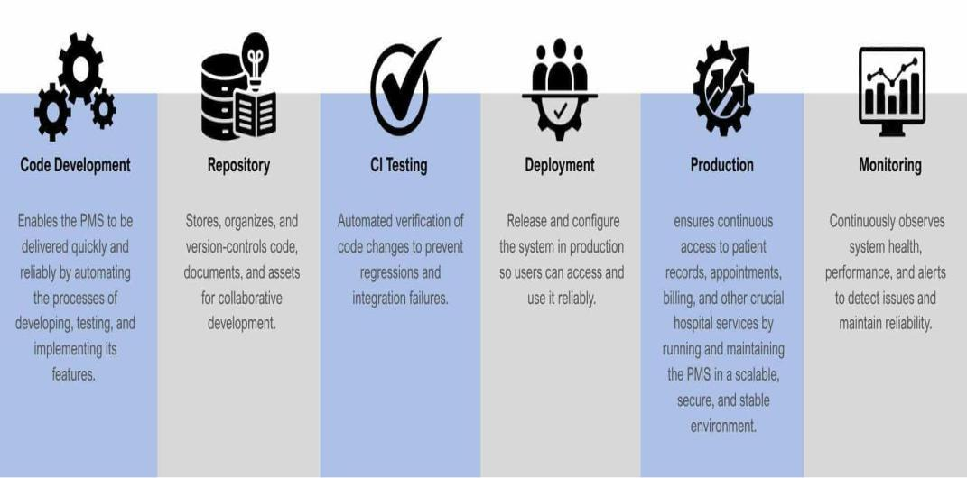
Figure 37 CI/CD Pipeline Setup And Configurations

The CI/CD (Continuous Integration/Continuous Delivery) pipeline is a core component of the project's DevOps strategy. It is designed to ensure that the web-based system is reliable, secure, and updated with minimal downtime.
CI/CD Pipeline Setup and Workflow
The system's pipeline follows a structured six-stage cycle to manage code updates and deployments :
- Code Development
What happen: Developers work with doctors, nurses, and administrative staff to create or improve parts of the Patient Management System (PMS), like patient registration, electronic medical records, scheduling appointments, and beddings.
Purpose: To make sure the PMS really helps hospitals with things like speeding up patient registration, admissions, making records more accurate, and retrieving information easier.
Key activity: Writing and updating code based on how things work in the hospital, feedback from staff, and changing hospital rules.

- Repository
What happen: A central repository (like GitHub, GitLab, or Bitbucket) stores and keeps track of all PMS source code, updates, and technical documentation.
Purpose: to make it possible for the development team to collaborate effectively, keep an accurate change history, and quickly roll back earlier iterations when necessary.
Key activity: Clear documentation management within the repository, including branching, merging, and committing.
- CI Testing
What happen: Automated pipelines test PMS modules (such as registration forms, patient records, appointment scheduling, and beddings) whenever developers submit code to the repository.
Purpose: to avoid bugs or integration issues that might compromise hospital workflows or the accuracy of patient data.
Key activity: setting up automated regression, integration, and unit tests for each of the PMS's essential features.
- Deployment
What happen: Updated PMS builds are made available to staging and production servers after passing testing, allowing hospital staff to use new features without interruption.
Purpose: To provide enhancements, like improved billing screens or quicker patient lookups, consistently and with the least amount of downtime possible.
Key activity: executing deployment scripts, setting up environments, and packaging builds for PMS servers.
- Production
What happen: Serving nurse, administrators, and patients, the live patient management system operates in a reliable and secure setting.
Purpose: to ensure that pharmacy orders, consultation notes, and patient registration are always correct and available.
Key activity: Maintaining database performance, applying security patches, and keeping an eye on uptime even during busy hospital hours.
- Monitoring
What happen: Monitoring dashboards, analytics, overview, and resource utilization allow for constant observation of the PMS.
Purpose: to keep staff and patients reliable and promptly identify problems.
Key activity: adjusting resources, checking logs, and setting up alerts to keep the system reliable and quick.

Automation Scripts And Tools Used
CATEGORY | TOOL / SCRIPT | PURPOSE
Development Environment | Visual Studio Code (Extensions: Live Server, Prettier) | Automates code formatting, live preview, and efficient development workflow
Database Automation | MySQL / SQLyog | Automates database queries, backups, data imports, and exports for patient records
Local Server | XAMPP (Apache, PHP, MySQL) | Automates setup and configuration of server-side environment for testing and deployment
Version Control | Git & GitHub | Automates version tracking, collaboration, and system backup
Front-End Automation | Bootstrap / Minified CSS & JavaScript | Automates responsive UI design and reduces manual styling
Form Validation | JavaScript Validation Scripts | Automates validation of patient information, appointments, and billing forms
Authentication Scripts | PHP Login & Session Scripts | Automates user authentication, role-based access, and session handling
Notification Automation | JavaScript / PHP Alert Scripts | Automates alerts for appointments, billing updates, and system notifications
Testing Automation | Custom PHP & JavaScript Scripts | Automates functional testing such as login, patient record management, and billing processes
Table 49 Automation Scripts and Tools Used

Deployment Strategies And Rollback Procedures
To make the Patient Management System reliable and stable even in the process of upgrading, the following deployment strategies are used:
1. Automated Deployment of CI/CD Pipeline - In accordance with the DevOps and CI/CD process, the deployment phase is automated via a Continuous Integration/Continuous Deployment pipeline. As soon as the developers commit any changes into the repository, automated tests are triggered to test the functionality of various modules such as Patient Registration, Appointment Scheduling, and Bed Tracking. In this way, only error-free code is pushed into the live server, with minimal chances of human errors.
2. Blue-Green deployment (Zero Downtime) - As the hospital stays open 24X7 and system downtime impacts the hospital severely, the project implements the Blue-Green Deployment technique. In this technique, the project uses two exactly similar production environments: the Blue Environment (current live environment) and the Green Environment (new environment with the update). They update the system in the dormant environment of the Green side. They check the functionality of the system only when the system analysts examine that the system functions completely in the new environment. They then redirect the system traffic to the new environment in a split second.
3. Staging Environment Validation - Before reaching the production-level server, an update is staged on a Staging Server. This staging server is essentially a replica of the production-level environment of the hospital. Such a staging allows testing of an application by the Product Owner along with certain members of the hospital to introduce functionality modifications. All potential bugs are addressed in this staging phase to not affect the production-level health service delivery by the hospital.
Rollback Procedures
In cases where critical bugs, instabilities, or data corruption are caused by a deployment, these following roll-back processes are invoked immediately:
- Migration to Reverse in the Database Structure
As PMS is totally dependent on its centralized database for Electronic Medical Records (EMR), it utilizes migration scripts for handling every single change that takes place in its structure. In case there is a mistake because of changes occurring in the database structure (like adding new tables or columns), the development team will run a down migration script. The script will backtrack its database structure to its former state instantaneously without eliminating or modifying the existing patient information.
2. Code Version Control Reversion
If a critical bug is identified within the application code (PHP) right after deployment, then the deployment team uses the version control system Git to revert changes. The team identifies the last stable Commit Hash before the failed deployment and executes a revert command. The CI/CD pipeline will re-deploy this previous stable version onto the server automatically, bringing back the system to work in a really short time.
3. Automated Backup Restoration (Contingency Plan)
As an additional level of protection, the whole system (application files and database) will be automatically backed up each day. As an unlikely last resort in either of the above reversals, the system will go temporarily offline. The IT team will then replace the system with the latest clean backup restored into the server. Prior to the system being brought back online, a full system check will take place for the Patient List and Appointment modules to ensure safe patient care activities are being carried out by the hospital.

Licensing And Open Source Libraries

Information About Licenses For Software And Libraries Used
Detailed Information on Licenses for Software and Libraries
The Patient Management System is built upon a specific technology stack where every software tool and library is governed by a license that dictates its usage, modification, and distribution. These licensing agreements are essential to ensure the system operates legally and effectively within the healthcare environment while supporting the management of patient records and hospital workflows.
1. Programming Language: PHP (Hypertext Preprocessor)
- Usage in Project: The core backend of the system is built using PHP with Object-Oriented Programming (OOP). This is used to handle server-side logic, database connections, and the management of patient records, appointments, and bed tracking.
- License Type: The PHP License (v3.01).
- License Details:
This is an open-source, BSD-style license.
It allows developers to use, copy, modify, and distribute the software freely.
- Restriction: The name "PHP" cannot be used to endorse products derived from this software without prior written permission.
2. Database Management: MySQL
- Usage in Project: The system uses MySQL as the Relational Database Management System (RDBMS) to store patient information, medical history (EMR), and appointment schedules.
- License Type: GNU General Public License (GPL) v2.
- License Details: MySQL is open-source software.
- Copyleft Clause: If the researchers distribute the Hospital Management System and it includes MySQL (or incorporates it), the entire system may need to be licensed under the GPL as well, meaning the source code of the system must remain open.
- Exception: If the system is used strictly internally by the hospital and not distributed commercially as a standalone product, the GPL restrictions are generally more lenient regarding the sharing of the hospital's own proprietary code.
3. Web Server Stack: XAMPP
- Usage in Project: Used as the local server environment to run the PHP and MySQL components during the development and testing phases (as mentioned in the Technology Architecture).
- License Type: GNU GPL (for Apache) & Mixed Licenses.
- License Details:
- XAMPP is a compilation of free software. The core component, the Apache HTTP Server, is licensed under the Apache License 2.0.
4. AI Integration (Beddings and Linens Module)
- Usage in Project: Embedding Artificial Intelligence (AI) within the Beddings and Linens module to predict patient length of stay.
- License Type: Dependent on Library Used (Likely MIT or Apache 2.0).
- License Details:
- While the specific library isn't named in the text, common libraries for AI/ML in PHP (or integrated via Python scripts) often use the MIT License or Apache License 2.0.
- MIT License: This is extremely permissive, only requiring that the original copyright and license notice be included in the code.
5. Development Tools: Visual Studio Code & GitHub
- Usage in Project:
Visual Studio Code: Used as the source code editor.
GitHub: Used for version control and repository management.
- License Type:
VS Code: MIT License (Microsoft). Free to use for any purpose.
GitHub: Proprietary (Terms of Service). The platform is free for public repositories, and often free for students/researchers via the GitHub Student Developer Pack.

Credits And Attributions For Open-Source Components
SOFTWARE / LIBRARY | PURPOSE / USAGE IN SYSTEM | LICENSE TYPE | LICENSE DESCRIPTION
PHP | Backend scripting language used to build the system’s core functionalities. | PHP License v3.01 | Permits use, modification, and redistribution of PHP source code with attribution.
HTML5 / CSS3 / JavaScript | Used for front-end design and interactive user interfaces. | Open Web Standards (W3C License) | Freely usable standards maintained by the World Wide Web Consortium (W3C).
Font Awesome | Provides scalable icons and visual enhancements in the user interface. | Creative Commons Attribution 4.0 (CC BY 4.0) | Allows free use with proper credit to the original author.
Bootstrap | Front-end framework used for responsive web design. | MIT License | Allows free use, modification, and distribution with attribution.
MySQL / SQLyog | Database system used for storing and managing hospital data. | GNU General Public License (GPL v2) | Allows free use and modification for educational and non-commercial purposes.
GitHub | Platform used for version control, collaboration, and CI/CD integration. | GitHub Terms of Service | Allows public repositories for educational and non-commercial projects.
Postman | Used for testing APIs and verifying backend communication. | Proprietary (Free Tier License) | Free version licensed for educational and testing purposes.
Swagger | Used for API documentation and visualization. | Apache License 2.0 | Permits usage, modification, and distribution for open and academic development.
ML.NET | Framework used for predictive analytics and machine learning integration. | MIT License | Open-source and free to use with attribution for academic and research projects.
Table 50 Credits and Attributes for Open Source Components

Credits and Attributions for Open-Source Components” means formally acknowledging and crediting the creators of open-source software used in a project, as required by their licenses.

Component Tools Reference Table
COMPONENT TOOL | DEVELOPER / ORGANIZATION | OFFICIAL WEBSITE / SOURCE
PHP | The PHP Group | https://www.php.net/
Bootstrap | Twitter Inc. | https://getbootstrap.com/
MySQL | Oracle Corporation | https://www.mysql.com/
SQLyog | Webyog / Idera Inc. | https://webyog.com/
XAMPP | Apache Friends | https://www.apachefriends.org/
GitHub | GitHub, Inc. | https://github.com/
Postman | Postman, Inc. | https://www.postman.com/
Swagger | SmartBear Software | https://swagger.io/
ML.NET | Microsoft Corporation | https://dotnet.microsoft.com/apps/machinelearning-ai/ml-dotnet
Table 51 Components Tools Reference Table

These tools were essential in enabling secure, scalable, and efficient system development for the Patient Management System (PMS), while ensuring compliance with ethical and legal software standards.

Performance Metrics And Monitoring

Metrics Collected And Monitored
The metrics collected and monitored for the Patient Management System (PMS), concentrate on digital transformation and optimizing hospital processes to enhance efficiency and patient services. The system shifts from a manual, paper-driven setting to an automated digital framework, gathering and tracking various essential operational sectors

Core Metrics and Monitored Areas
The system is designed to provide dashboards and reporting tools that track various metrics essential for hospital management:
- Patient Flow and Volume: The system monitors the total number of new patients, daily hospital visits, and ongoing registrations.
- Appointment Management: Real-time tracking of scheduled appointments, including doctor availability.
- Bed and Facility Utilization: Monitored metrics include real-time bed availability, patient-to-bed assignments, and the status of bed preparation.
- Clinical Outcomes and Accuracy: The system identifies and flags incomplete patient records such as missing medical histories or allergies ensuring critical information is captured even during emergencies.
Alignment with Strategic Goals
These metrics are designed to align with the hospital's operational efficiency and patient safety goals:
- Operational Efficiency: By automating routine tasks and tracking resource use, the PMS aims to reduce administrative burdens and operational costs.
- Data Accuracy: Mandatory fields and validation checks in digital forms ensure that patient records are complete and consistent, reducing the risk of medical errors.
- User Experience: Monitoring processing times for records and result generation allows the hospital to aim for reduced waiting times for patients.

Tools And Dashboards Used For Performance Analysis
- Key Performance Indicators (KPI) Summary Cards
Display quick statistics that helps admin quickly assess current system status.
- Inpatient
- Outpatient
- Total Patient
- Total Appointment
- Available Beds
- Data Visualization Charts
Help to identify peak days, and operational patterns.
- Bar Charts
- Line Graphs
- PHP (Backend Processing Tool)
Data Retrieval - retrieves raw data from table
- Patient records
- Appointments
- Beds
Data Processing - after retrieving, performs calculation
- Total number of inpatient
- Total number of outpatient
- Total of Appointments
- Bed Occupancy rate
4. MySQL (Database Tool)
- Stores patient information, appointment, bed information, and medical records.
- Filtering and grouping data

Actions Taken Based On Performance Data
The Patient Management System (PMS) performance data is continuously reviewed and utilized to make system improvements and operational decisions. The metrics can be used to identify the bottlenecks in the performance of the system, the rate of errors, the level of server load, and user activity trends and anticipate the vulnerabilities before they affect patient care.
Once there are performance problems that are identified, the IT staff examines logs and trend of usage to isolate the cause. They can be activities like optimization of database queries, tuning up server resources or even system configuration to enhance speed and reliability. Future upgrades also have performance data. To illustrate, in cases where the usage of the system continues to rise, then the hardware can be scaled, or the cloud resources can be expanded in order to maintain the stability. Whenever there are trends of under performance or violation of security or compliance measures are observed, corrective action is taken immediately, such as the deployment of patches or access controls. Every activity and result is recorded and analyzed in order to ensure that the improvements are working. This feedback mechanism makes sure that PMS is dynamic, consistent, and able to deliver clinical workflow uninterrupted.

APPENDICES B

APPENDIX A: Hospital Map

V334+P84, Dr. Eduardo V. Roquero Sr. Avenue
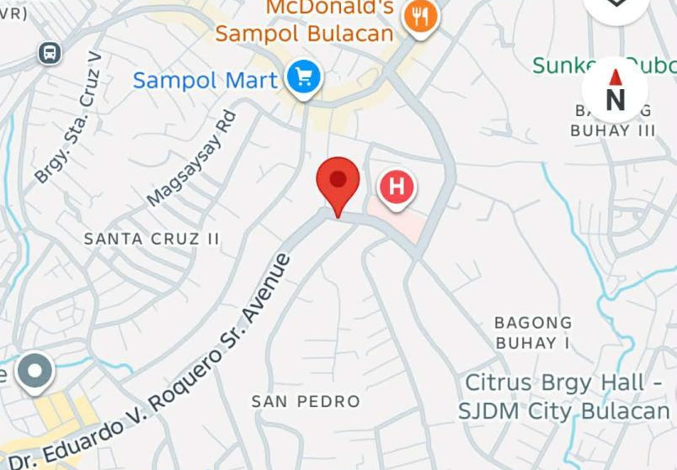
City of San Jose del Monte, Bulacan
Figure 38 Hospital Map

APPENDIX B: Interview
Questionnaire
- How do you currently register and track patient information — such as personal details, medical history, and demographics?
- What tools or systems (if any) do you use to manage patient records across multiple visits?
- Are there any challenges you face in keeping patient information up to date and accurate?
- How do you ensure that sensitive patient information is kept private and secure?
- Can you describe how appointments are scheduled in your facility? Do you use a manual logbook, spreadsheet, software, or another method?
- How do you handle appointment changes, like cancellations or rescheduling?
- Are patients notified of their appointments in any way (calls, texts, etc.)? If so, how?
- Do you ever face issues like double-booking or scheduling conflicts? How are those managed?
- How are patient medical records currently stored and accessed — paper, electronic files, a system, or a mix?
- How do you document important clinical information like lab results, prescriptions, or visit notes?
- Is retrieving a patient’s past medical records quick and easy? Why or why not?
- Have you considered or tried using an Electronic Medical Record (EMR) system? If so, what do you think are the pros and cons?
- How do you usually share patient information between departments (e.g., lab, pharmacy, billing, or radiology)?
- When referring a patient to another facility or specialist, how is their medical information shared — printed documents, emails, digital systems, etc.?
- Are there any challenges when transferring data between your hospital and external partners (like other hospitals, insurance providers, or government agencies)?

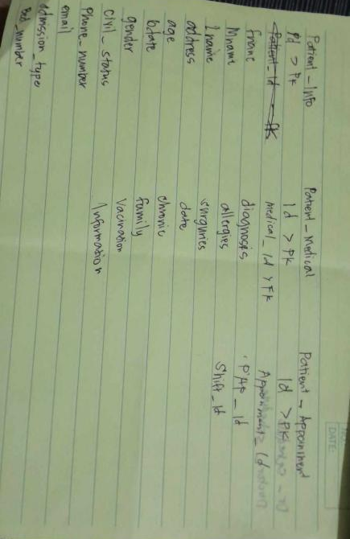
APPENDIX C: Discussion
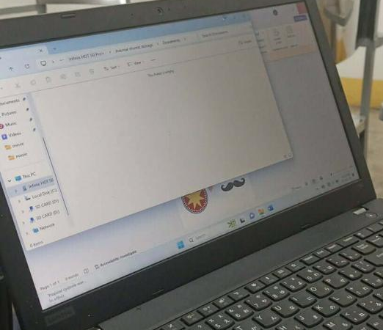
After the interview, we sort out what should be done and what is included in the system.

Figure 39 Discussion

APPENDIX D: Documentation



Figure 40 Documentation

Appendix E:

Technical Adviser’s Certification

This is to certify that the Undergraduate thesis entitled
BESTLINK COLLEGE OF THE PHILIPPINES BULACAN CAMPUS -
HOSPITAL MANAGEMENT SYSTEM
(PATIENT MANAGEMENT)

Submitted by its authors
MARIO L. BALANGATAN
JONEL CRISTIAN C. BALUTE
JHON ROBERT B. DELMIGUES
PRINCESS ANNE NORBIE A. SIKAT
EVELYN B. SUAREZ

has been technically advised for the proper software flowcharts, system design and schematic diagram

ENGR. JEAN LESTER M. CACHOLA
Technical Adviser

April 8, 2026

Appendix F:

Certificate of English Editing

This is to certify that the Undergraduate Thesis entitled
BESTLINK COLLEGE OF THE PHILIPPINES BULACAN CAMPUS -
HOSPITAL MANAGEMENT SYSTEM
(PATIENT MANAGEMENT)

Submitted by its authors
MARIO L. BALANGATAN
JONEL CRISTIAN C. BALUTE
JHON ROBERT B. DELMIGUES
PRINCESS ANNE NORBIE A. SIKAT
EVELYN B. SUAREZ

has been edited for language, grammar, punctuation, spelling, and overall style. Neither the research contents nor the author’s ideas we altered during the editing process.

APRIL MAY A. FERNANDEZ, LPT, MAT
Editor

April 8, 2026

APPENDIX G: Photo During Defense


Figure 41 Photo During Defense

CURRICULUM VITAE
Researcher’s Curriculum Vitae








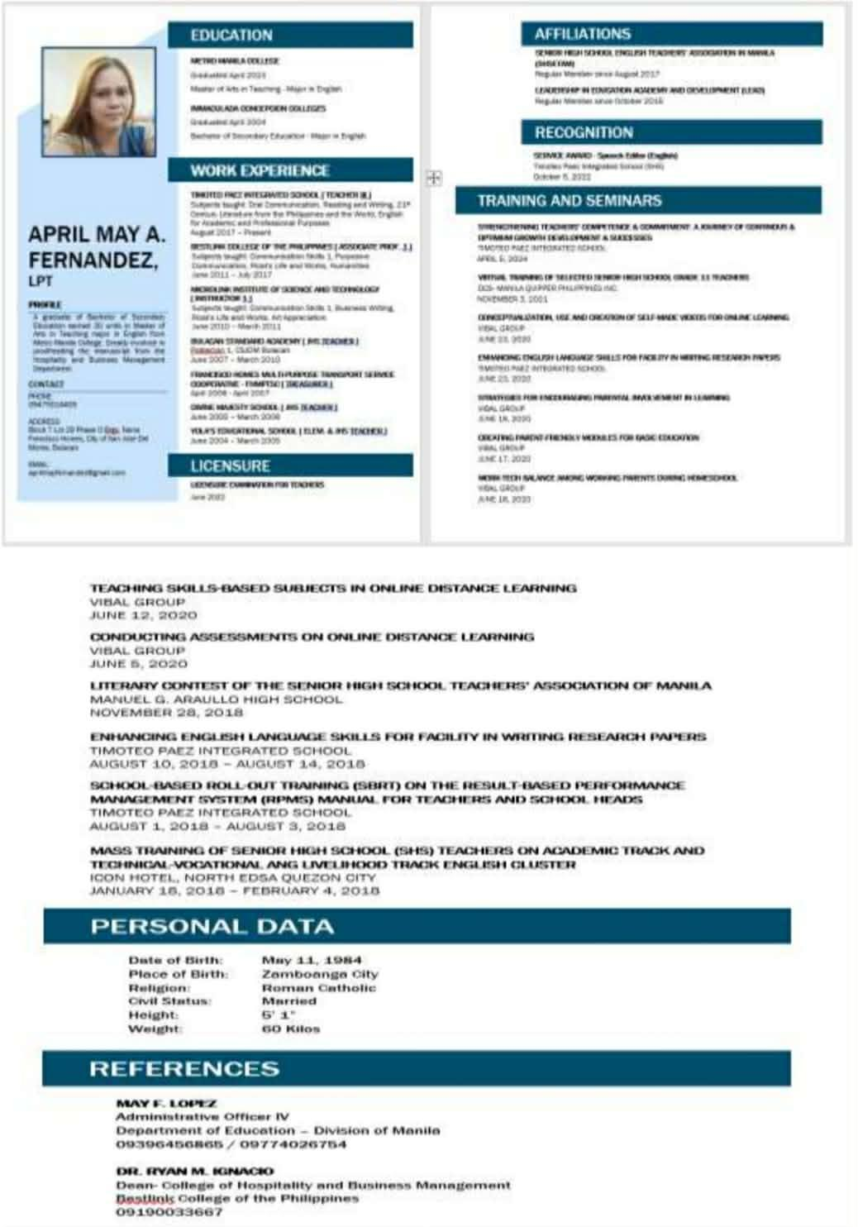
Grammarian Curriculum Vitae
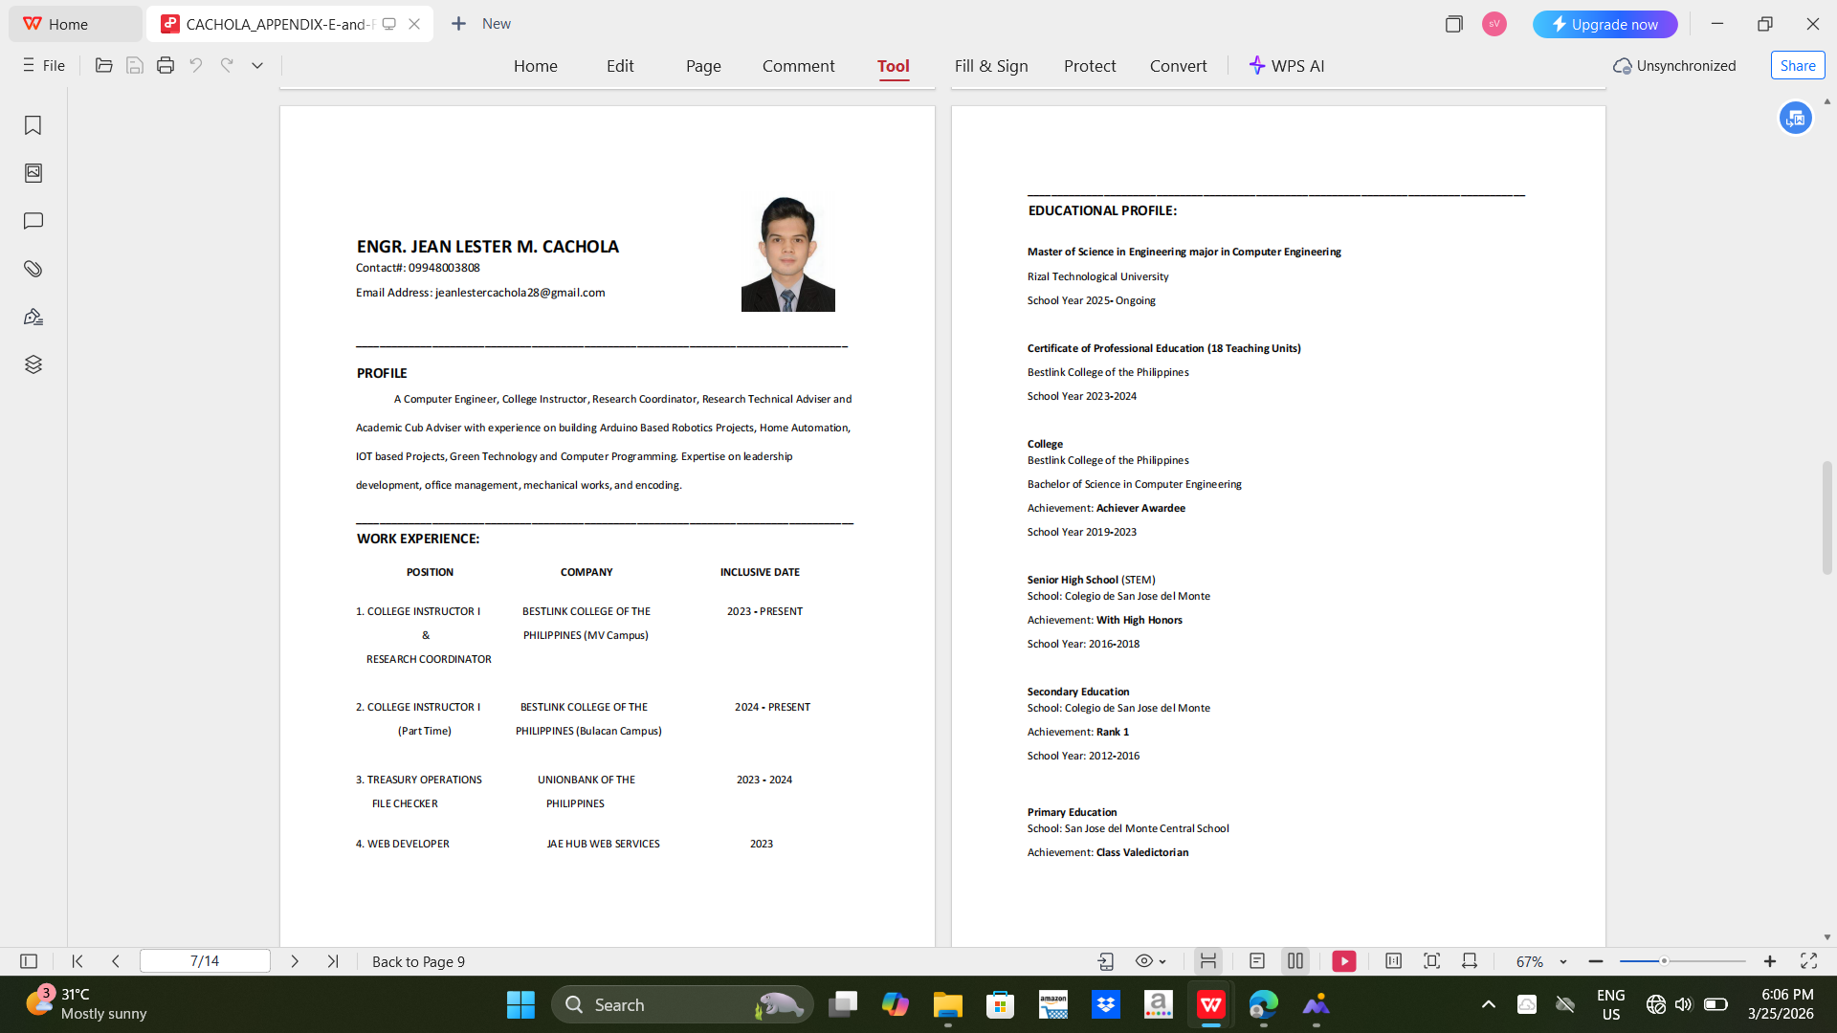
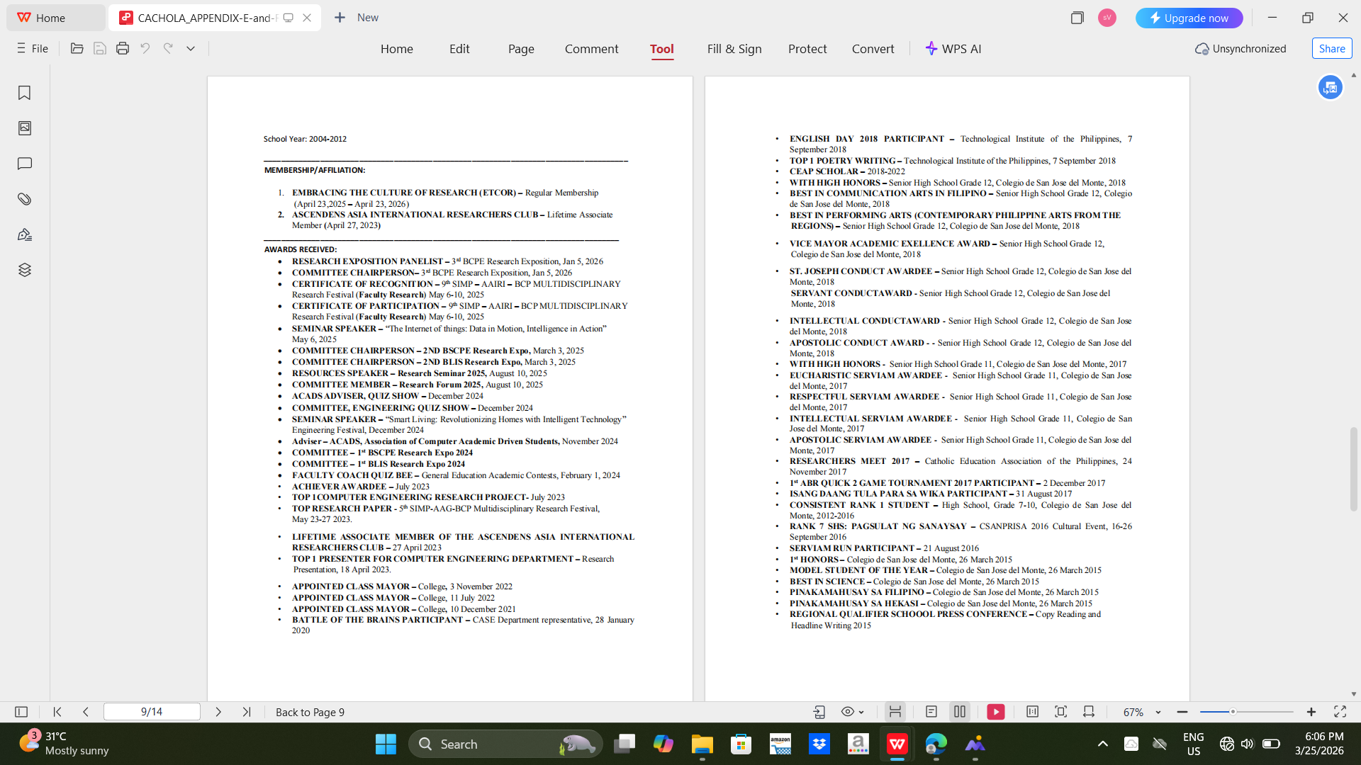
Technical Adviser Curriculum Vitae
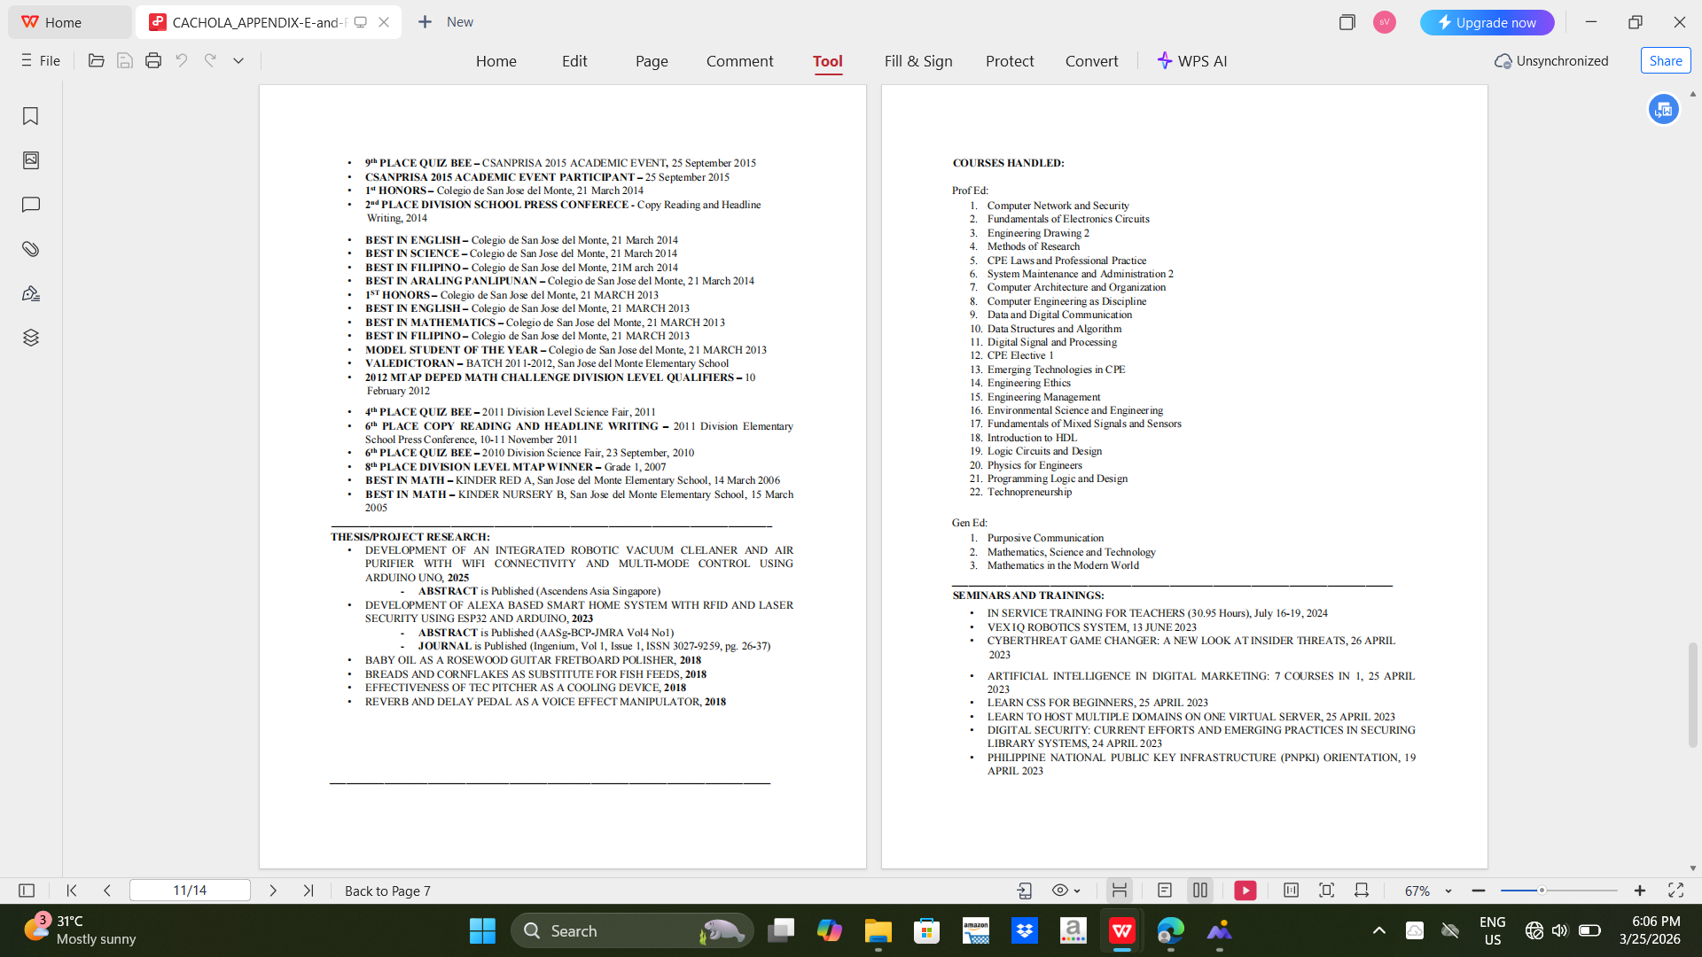
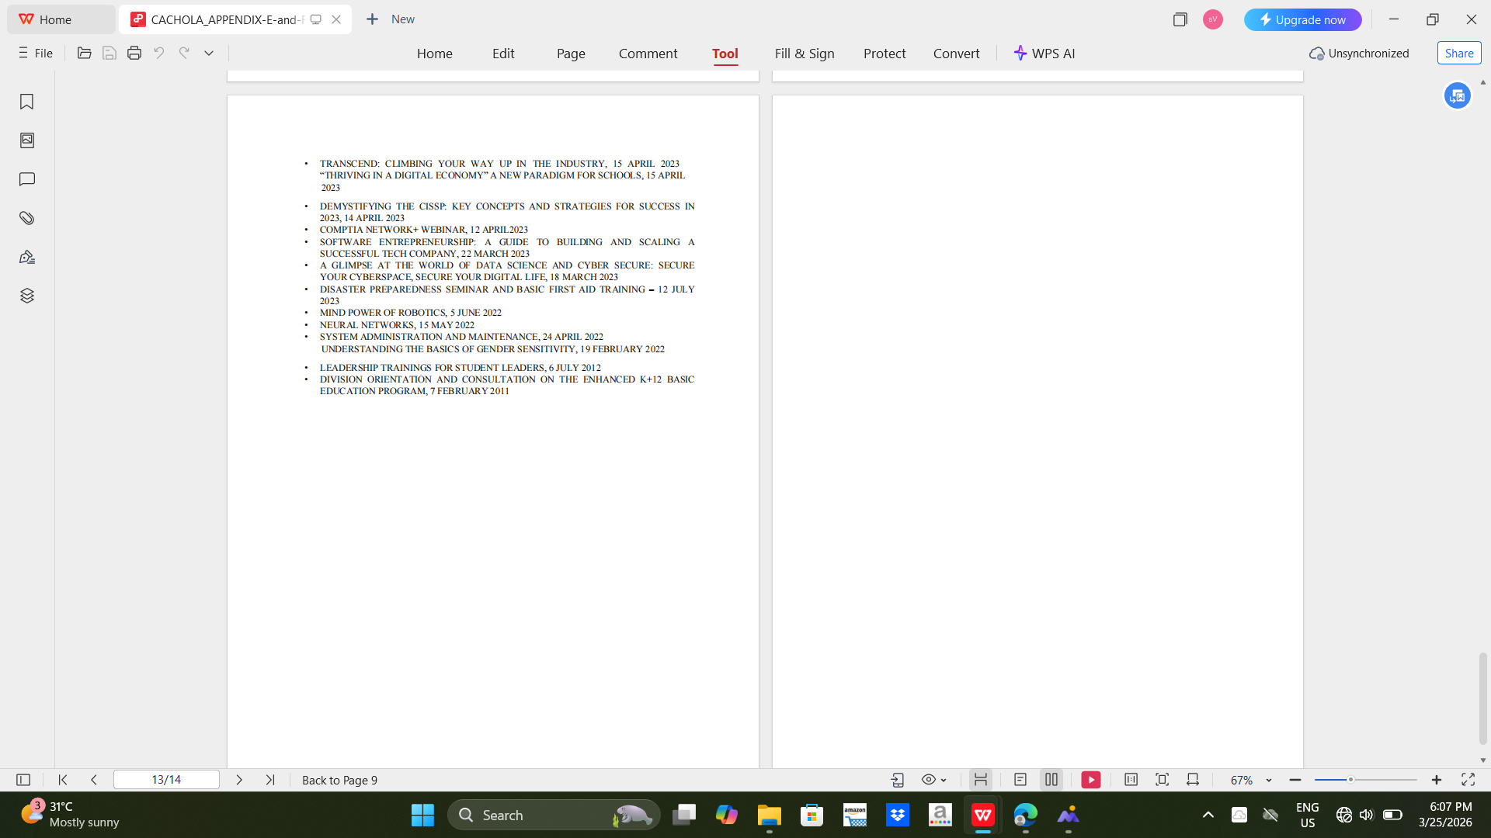

Research Adviser Curriculum Vitae

