**Lab Assignment 06:**

**pfSense Dev Setup IPv6**

Micah Flack

Department of Computer Science, Dakota State University

CSC 840 DT1, Cyber Operations I

Dr. Michael Ham

October 7, 2022

**A screenshot of the pfSense FRR BGP config. The default file location will be ./var/etc/frr/frr.conf**

**Screenshot showing SSH into both pfSense_dev and FreeBSD. Please include these in one screenshot.**

Used tmux to split the panes… you can see both of the SSH sessions started from the admin machine to FreeBSD and pfSense-Dev (172.16.1.1), and there are no prompts for passwds.

**Screenshot of remote access to FreeBSD file system from admin machine.**

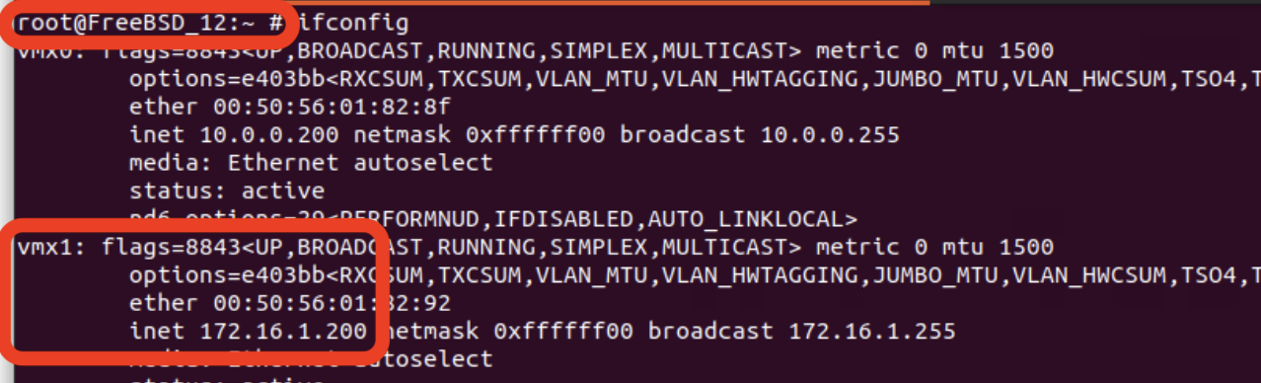

Screenshot showing the ip address belonging to the FreeBSD machine: 172.16.1.200

File structure within the shared SMB directory (note the “micahflack” folder)

Viewing the SMB network share from the explorer within the Ubuntu admin machine.

**Show output of the bgpd -h command after you have moved the patched binary over to pfSense-dev.**

After moving the work/stage/usr/local/sbin/bgpd via SCP as the user ‘root’ to pfSense-Dev.

**Upload your documented script to the dropbox also.**

