# Part 1 – Demodulate Audio

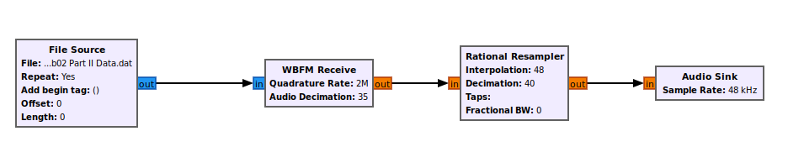

**Which age groups is the sweepstakes open to?**

South Dakota teens, ages 14-19

**In the commercial with the big-wig CEO, who is it or what is he the CEO of?**

Jay Farner, CEO of Rocket Mortgage

# Part 2 – Demodulate Digital Data

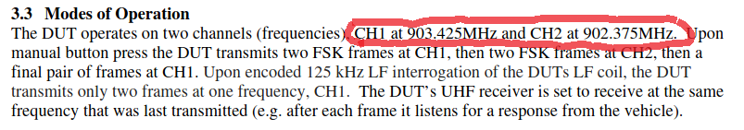

**What is the broadcasted frequency of the device?**

Looking at the testing documentation supplied by the filer, the interfering device should be visible at 903.425MHz or 902.375MHz.

**Signal broadcast within SDR#...**

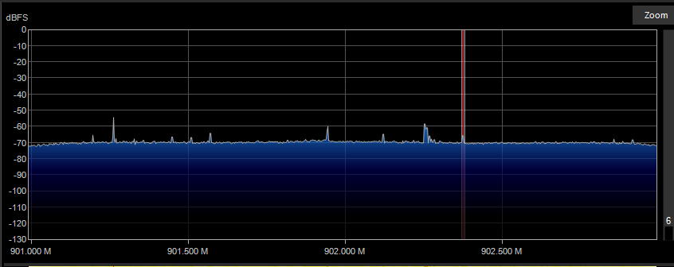

The signal shown centered in the previous image was broadcasting on the freq. 902.375MHz

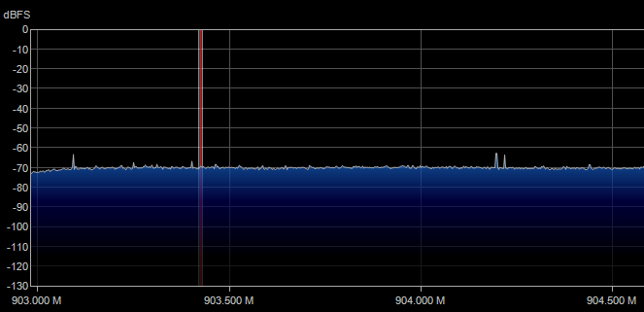

Reading the docs for the car key – there should have been another transmission over the second channel at frequency 903.425MHz… but there wasn’t anything visibly being broadcasted.

**What is the digital data sent in each transmission of part II?**

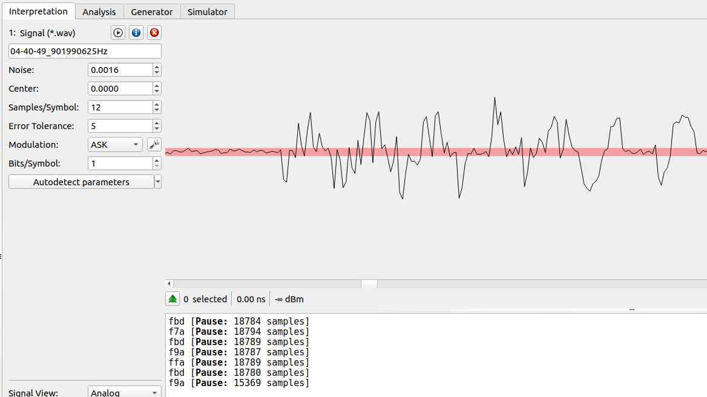

The above is the decoded transmission from the broadcast at 902.375MHz

fbd – f7a – fbd – f9a – ffa – fbd – f9a …. this doesn’t quite seem right though?

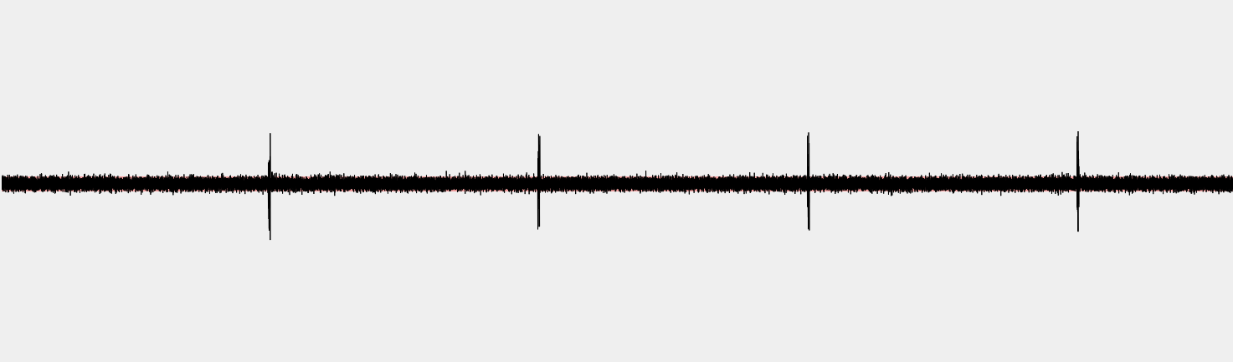

This is just a zoomed out screenshot of the previous interpretation shown in URH.

**Demodulating the Lab02 Part II Data file…**

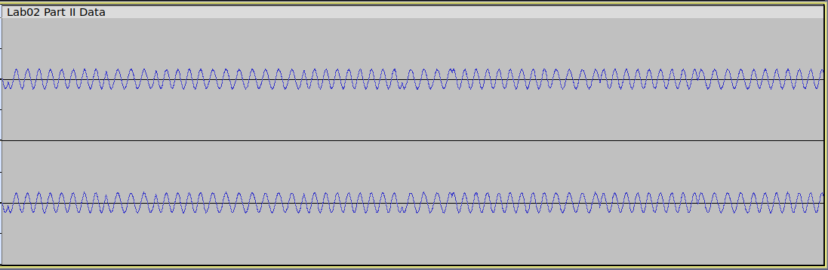

Audacity view of the raw file…

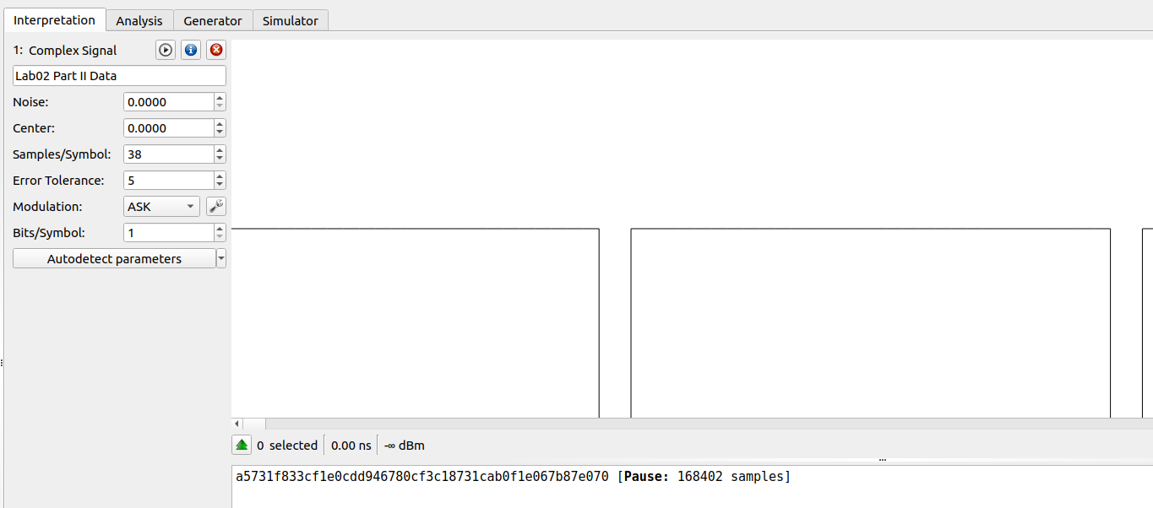

I guessed the samples/symbols by measuring the recurrent gap between the two amplitudes - ~38 samples.

The hex data: a5731f833cf1e0cdd946780cf3c18731cab0f1e067b87e070