Lab 12 – Layer 7 Inspection

# Client file upload

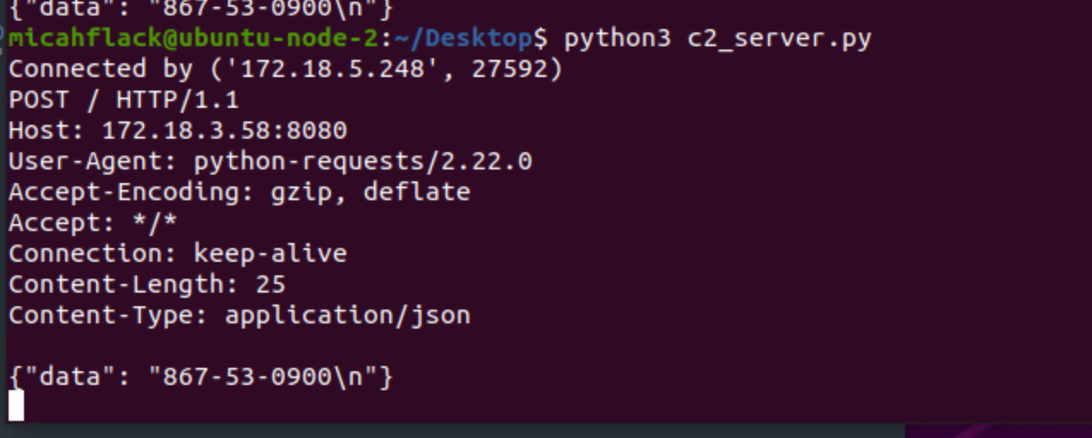

# IDS Captures HTTP Traffic

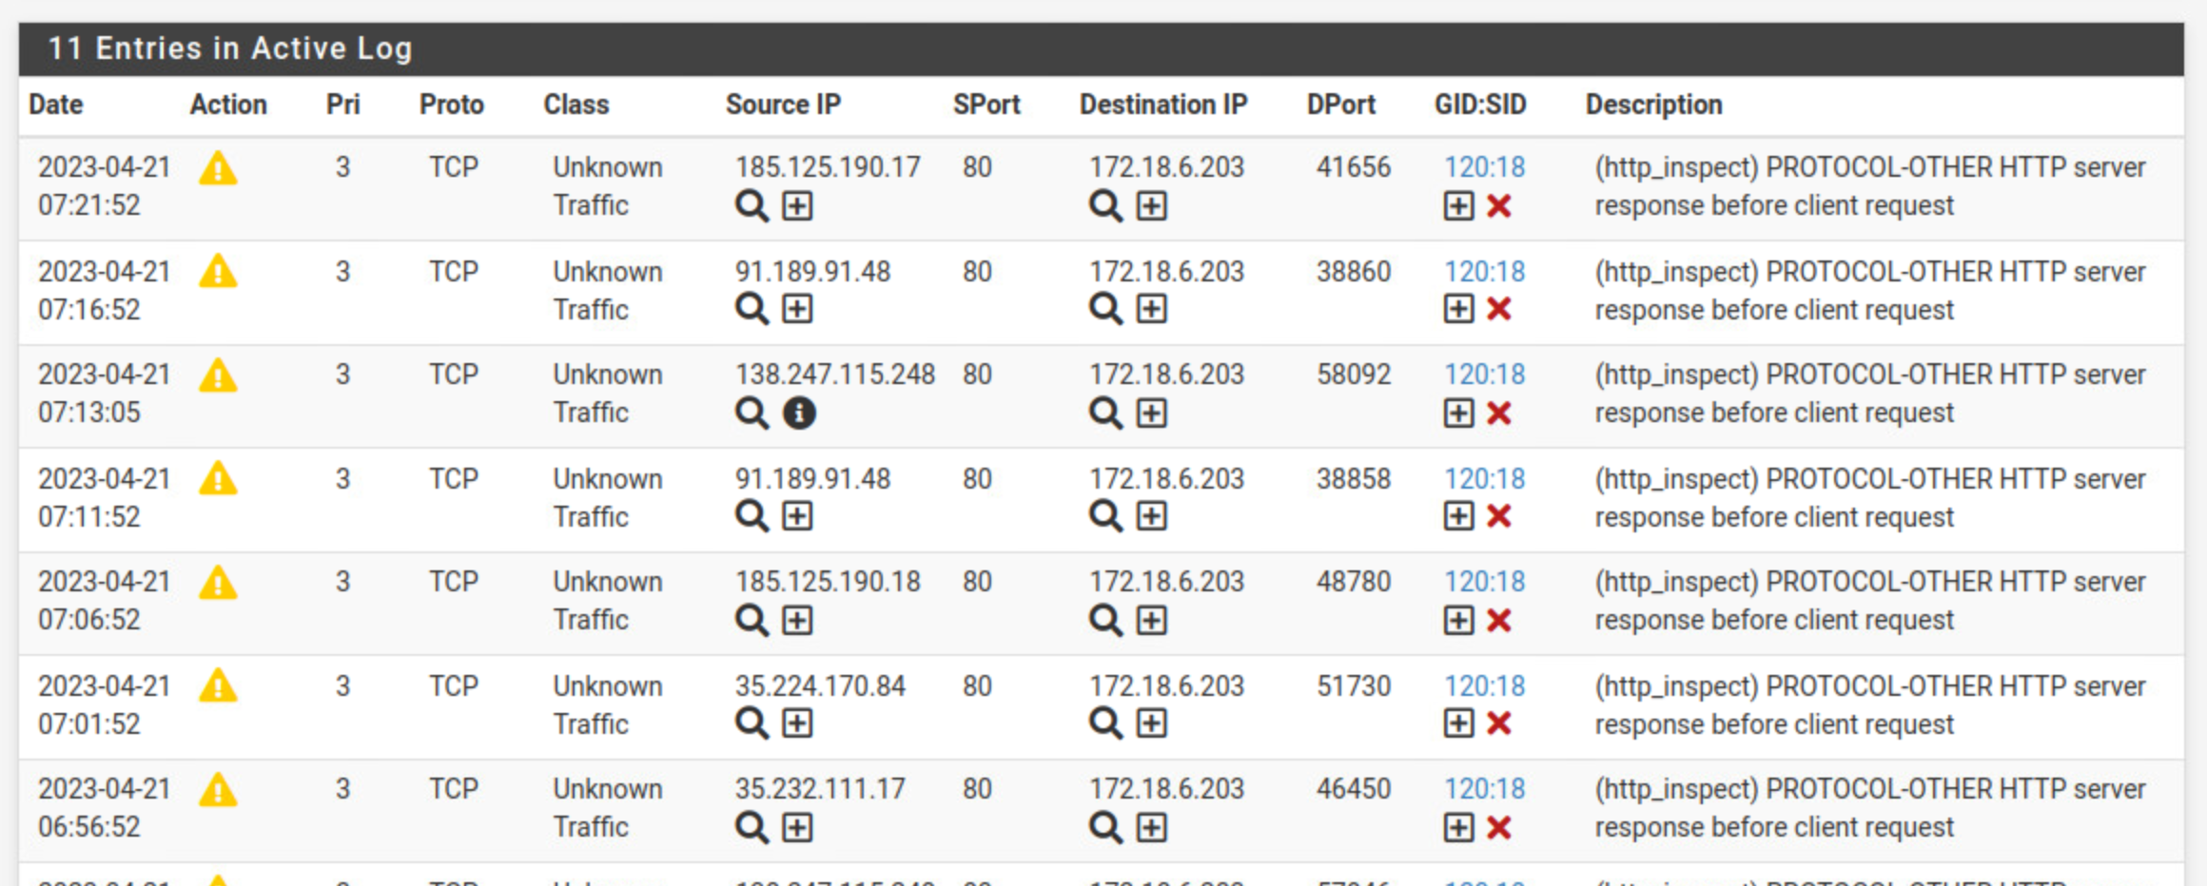

# IDS (Snort)

# SSN Rules

# Custom Rules

Forgot.