**Lab 1: Schematic Drawings and Software Install**

**Micah Galos - SID: 862082339**

**Joseph Ayala - SID: 862080244**

**Due: October 12th, 2020 - 11:59PM**

**Abstract [Joseph Ayala]**

Purpose of this lab is to get experience working with OrCAD in developing schematic models that will help us in modeling future circuits as well in developing appropriate documentation for use with the K64F Freedom Development Board Microcontroller.

**Objective & Accomplishments [Joseph Ayala]**

1. Loaded in the OrCAD successfully without issue and was able to move forward in designing the other circuits
2. Within this exercise we started with modeling a 555 Timer circuit with the OrCAD software in order to build and see where the parts where that have been used in prior electrical engineering courses
3. Within these exercises we will be modeling the K64F microcontroller within the orcad software.
   1. In this configuration the microcontroller is connected to an LED bar routed through port D and DIP switches
   2. This configuration is similar to the prior one however the main difference is that the LED bar is routed through Port C instead.

**Experiment System Specification [Joseph Ayala]**

In this lab, the tool used to create these three circuits is the OrCAD CIS Capture software with the appropriate Cadence libraries downloaded.

**Schematic Diagrams**

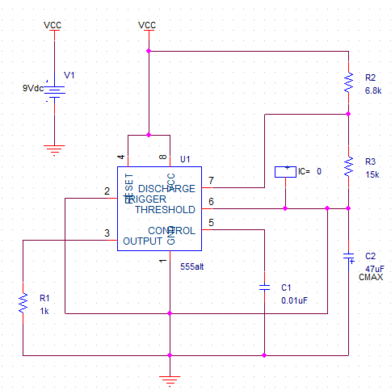

**Part 2 - 555alt timer circuit [Micah Galos]**

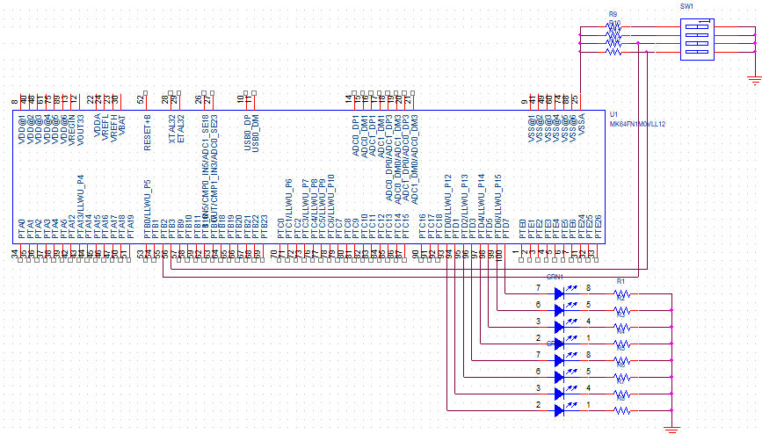

**Part 3A - microcontroller at PORTD [Micah Galos]**

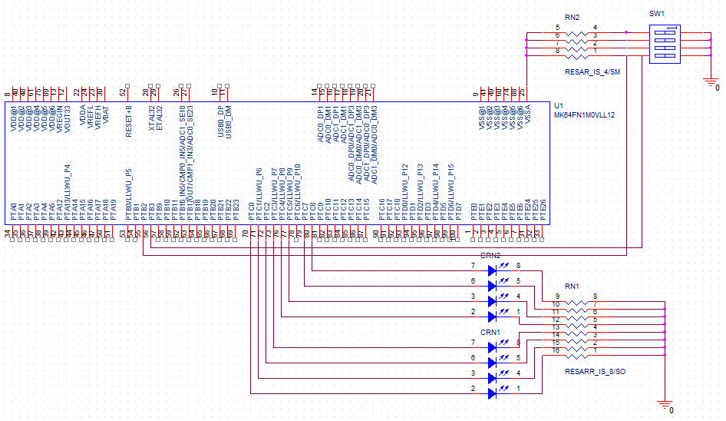

**Part 3B - microcontroller at PORTC [Joseph Ayala]**

**Technical Problems**

No conflicts in designing and implementing the OrCAD modeled circuits have occured.

**Conclusion [Joseph Ayala]**

In the course of these lab exercises, we were tasked with refreshing ourselves with the OrCAD software in modeling several different models of circuits. The first model was something more indicative of earlier electrical engineering courses with the modeling of a 555 Timer IC circuit, however the latter two would help bring to focus components that will be more readily used in this course. These two schematics are centered around the MK64 FRDM microcontroller and the different ways of connecting the LED bar. This allows us to further model the microcontroller and further hardware subsystems for future reports and professional documentation.