Guide to the PS-Cal Corrector Program

# Program Overview

The PS-Cal Corrector program “corrects” the following elements of the PS-Cal software, which are currently dysfunctional:

* Performs uncertainty budget lookups for Rho, Cal Factor, and Linearity, to ensure that PS-Cal does not report a smaller uncertainty than that which is reported in the company’s 17025 CMC
* Analyzes each uncertainty value and corrects it to two significant digits
* Performs interpolation for measured calibration factor values which lie in-between the calibration data associated with the power measurement standards used for calibration

On the first point, it is true that PS-Cal already allows the user to perform uncertainty budget lookups for Rho and Cal Factor measurements; though this is still a manual process that must be done separately for each measurement type. However, it does not yet provide the ability to do a linearity budget lookup. It was decided that if the user would have to run this program anyway, to do the linearity lookup, then the program might as well also perform the Rho and CF uncertainty lookup function. In this was the user does not have to tell PS-Cal to do the lookup for Rho manually, and then again for Cal Factors, and then run this program at the end of it all anyway.

On the second point, PS-Cal has no automatic provisions for ensuring that uncertainties are reported at the appropriate resolution. The 17025 standard requires that not more than two significant figure be present in an uncertainty value, and there is no way to accomplish this within PS-Cal for all resolution levels. The PS-Cal Corrector program analyzes each uncertainty value and strips away excessive significant figures to ensure that only two are ever present, regardless of the resolution of the uncertainty value.

On the third point, there are sometimes DUT sensors which need to be calibrated at frequency points which lie in-between the calibration data points provided in the power standard’s calibration data file. At this time PS-Cal provides no interpolation for these points, and when it encounters such a point it wildly miscalculates the calibration factor. The PS-Cal corrector program compares the measured calibration factor points of the DUT calibration to the calibration data used for the power measurement standard. Any frequency point found in the DUT calibration data which does not have a corresponding point in the standard’s calibration data file is automatically re-calculated using linear interpolation based upon surrounding cal factor points which do posses matching point in the standard’s calibration data. Uncertainties are correspondingly increased using, again, the associated uncertainties of the surrounding valid calibration factors.

All corrections are written to the DUT PS-Cal XML file (selected by the user at the program start).

# Step by step process

1. Perform a power sensor calibration using the PS-Cal software
   1. Perform the identical process that is normally performed within PS-Cal, except for step 1.d below
   2. Make note of the TEGAM standard XML data file which is used for the calibration, as this will be needed later
   3. As per the normal process, save the completed calibration file to the PS-Cal “CalResults” folder
   4. At this time do NOT create a PDF copy of the calibration data
   5. Within PS-Cal, close the DUT calibration run using the UUT menu; you do not need to re-save the data, if prompted to do so, because the data was already saved in step 1.c

**Note:**

* If calibrating a sensor which requires a cal factor sticker to be printed and adhered to the side of the DUT, do not print the sticker until the end of this process
* If calibrating an EEPROM sensor which requires interpolated Cal Factor data points, do not upload the new cal factor information until the end of this process

1. Double-click the PS-Cal Corrector program icon* on the desktop of the PS-Cal PC (circled in blue):

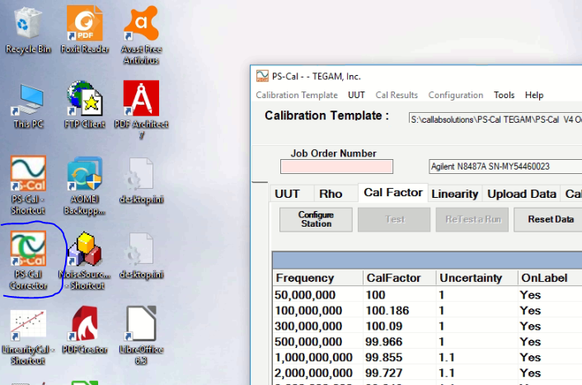

**\* Alternately, PS-Cal Corrector can be run manually by double-clicking the Python script, “PS-Cal_Corrector.py” which is located at “S:\Python\PS-Cal Correction\”.**

1. The PS-Cal Corrector program will launch:

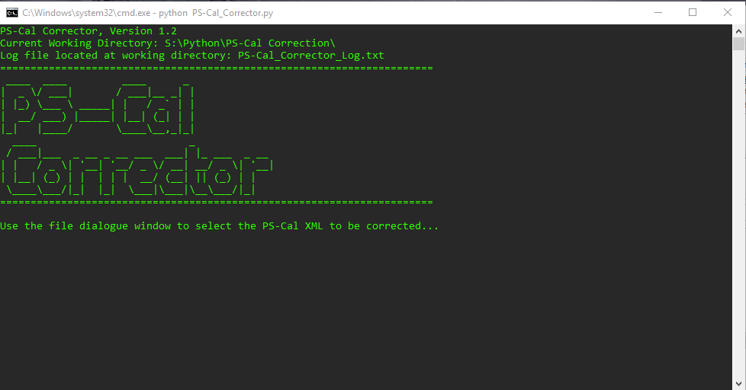

1. Almost immediately after program launch, a file dialogue window will open prompting the user to select the DUT PS-Cal XML calibration data file:

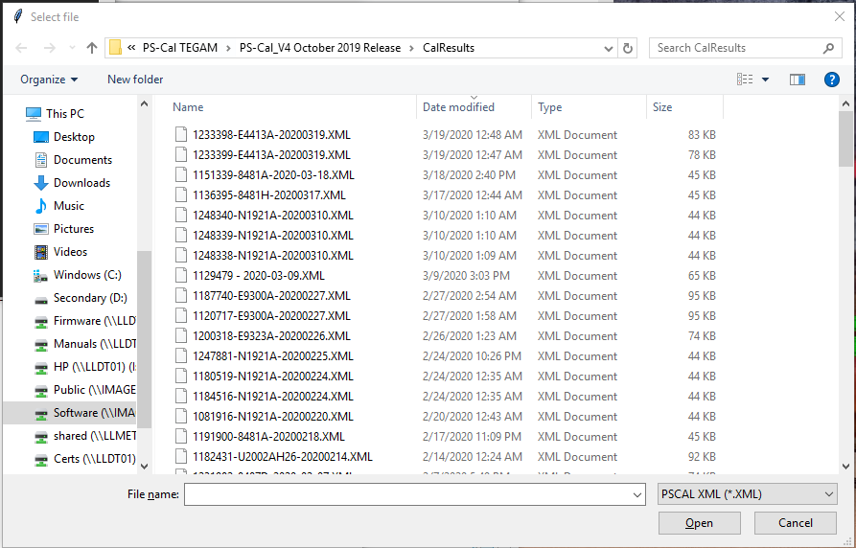

1. Select the DUT PS-Cal .XML calibration data file, which was previously saved in step 1.c (example show below):

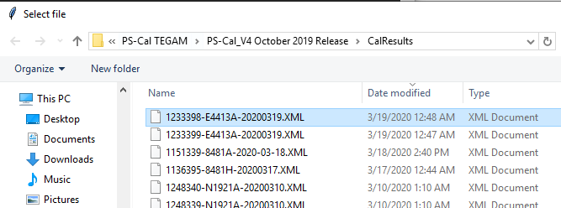

1. Click the “Open” button
2. The program will then prompt another file dialogue window. In the file dialogue window, locate and highlight the TEGAM standard data file used for the calibration of the DUT (noted in step 1.b above)
3. Click the “Open” button
4. At this time the program will perform all necessary operations. Upon completion you will see a screen similar to that shown below:

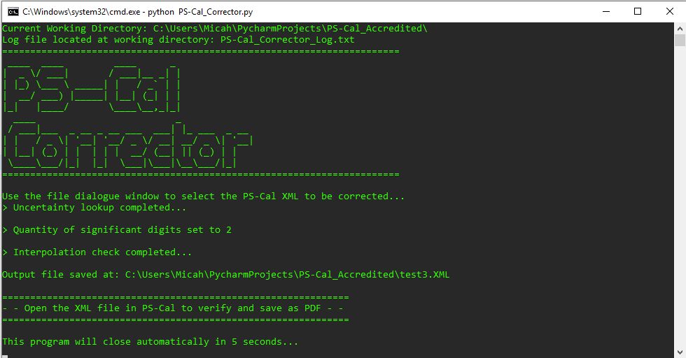

1. The program will automatically close in five seconds

**Note:** The corrected XML file will replace the original copy, saved in step 1.c above, and will be found at the same location as the original file (saved in step 1.c above)

1. Return to the PS-Cal program, and re-open the DUT PS-Cal XML calibration data file (previously saved in step 1.c above)
2. Briefly confirm that the data has been modified as required

**Note:** if the currently loaded XML file has been run through the PS-Cal Corrector program, the procedure name in the PS-Cal data will have been updated to read “PS-Cal Corrected”:

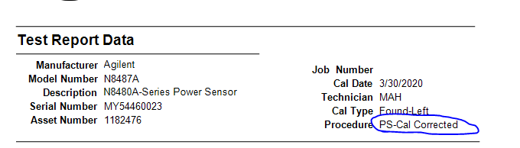

1. Save a PDF copy of the calibration data to the appropriate network folder location
2. Perform the following final steps, if applicable

* If the DUT requires the application of a printed cal factor sticker, print and apply the sticker at this time
* If the DUT is an EEPROM sensor which required cal factor points to be interpolated, perform sensor EEPROM download, backup, and upload process at this time

# Program Configuration

The PS-Cal corrector program provides a configuration file which can be modified to change certain parameters of the program’s operation. These are outlined below. Lines in the configuration file which start with the pound sign are ignored and treated as comments. The format of each configuration file parameter are as follows (also see the example below underlined in blue):

**Parameter_Name = Parameter_Value**

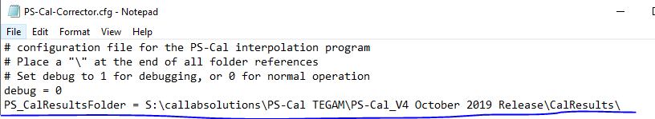

### Location of the configuration file

The configuration file is entitled “PS-Cal-Corrector.cfg” and is located within the same working folder as the Python program file. Normally this will be S:\Python\PS-Cal Correction\

### Debug

The debug line is used to streamline troubleshooting of the program. It should be set to zero except when operation of the program is being reviewed. When debug is set to one, the program will not prompt the user to select the DUT XML file or TEGAM standard data XML file

### PS_CalResultsFolder

This configuration line is used to set the default starting location of the file dialogue window used to select the DUT XML calibration data file. Normally it should be set to the path where all completed PS-Cal calibration data files are saved (e.g. S:\callabsolutions\PS-Cal TEGAM\PS-Cal_V4 October 2019 Release\CalResults\).

### archivePath

This configuration line is used to set the location where XML files backup are saved. At the beginning of the program operation, the program saves an original copy of the DUT XML calibration data to the folder location specified in this configuration line (e.g. S:\callabsolutions\PS-Cal TEGAM\PS-Cal_V4 October 2019 Release\CalResults\PS-Cal Pre-Correction Archive\). In this way, if a program error occurs, the original DUT calibration data can be retrieved safely.

### interpReferenceMethod

This configuration line sets the method of interpolation utilized by the program. If mode one is set, the software will use the XML data file Rho frequency points as the reference to determine which cal factor frequencies require interpolation according to the logic that: if a Rho frequency point exists for which a corresponding cal factor frequency point does not exist, the program will create and interpolate that missing cal factor point, and merge it into the XML data file. If mode two is set then the program will prompt the user to enter the PS-Cal standard data which was used for the calibration, and the PS-Cal standard data will be matched against the DUT XML file cal factor frequency points to determine which ones are absent from the standard data and therefore require interpolation. **Method two is the superior method and should always be used over method one**.

### standardsDataFolder

This configuration line sets the default starting location of the file dialogue window used to select the TEGAM standard data XML file. Normally this should be set to the PS-Cal location which contains the TEGAM standards data (e.g., S:\callabsolutions\PS-Cal TEGAM\PS-Cal_V4 October 2019 Release\Standards\).

### numberSigDigits

This configuration line tells the program how many significant digits to apply to each measurement uncertainty value. The appropriate quantity should be two, but the program does allow flexibility in case 17025 requirements change in the future.

### rhoBudgetTxtFile

This configuration line tells the program where to find the text file which contains the rho uncertainty data budget lookup values. The program parses the file into memory and uses it to correct reported uncertainty values, where necessary, to match the 17025 CMC.

**Note:** The structure of this file is explained in the next section.

### cfBudgetTxtFile

This configuration line tells the program where to find the text file which contains the cal factor uncertainty data budget lookup values. The program parses the file into memory and uses it to correct reported uncertainty values, where necessary, to match the 17025 CMC.

**Note:** The structure of this file is explained in the next section.

### linBudgetTxtFile

This configuration line tells the program where to find the text file which contains the linearity uncertainty data budget lookup values. The program parses the file into memory and uses it to correct reported uncertainty values, where necessary, to match the 17025 CMC.

**Note:** The structure of this file is explained in the next section.

# Uncertainty Budget Lookup File Structure

### Rho Lookup File

The rho budget lookup file is a comma separated values text file, an example of which can be seen below:

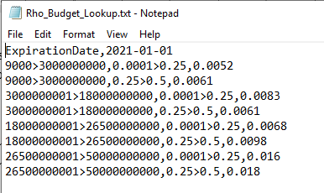

The expiration date is comprised of two comma separated columns, where the second column is the expiration date of the budget lookup file formatted as YYYY-MM-DD.

Each subsequent line contains three comma separated columns.

* Column one: The start and stop frequency range of the row. The value on the left side of the “>” operator is the start frequency, and the value on the right side is the stop frequency
* Column two: The power range of the row. The value on the left side of the “>” operator is the start of the power level range, and the value on the right side is the stop of the power level range
* Column three: The CMC specified uncertainty value. This is the value which the program will apply to any XML file uncertainty point which is found to be too small. Too small is defined as less than this value in column three

As seen in the example above, multiple power ranges can be applied by repeating the start and stop frequency column into the subsequent row.

### Linearity Lookup File

The linearity budget lookup file is a comma separated values text file, an example of which can be seen below:

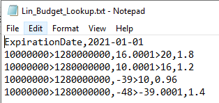

The expiration date is comprised of two comma separated columns, where the second column is the expiration date of the budget lookup file formatted as YYYY-MM-DD.

The linearity lookup file is formatted identically to the rho lookup file. Each line contains three comma separated columns.

* Column one: The start and stop frequency range of the row. The value on the left side of the “>” operator is the start frequency, and the value on the right side is the stop frequency
* Column two: The power range of the row. The value on the left side of the “>” operator is the start of the power level range, and the value on the right side is the stop of the power level range

***Note:*** *It is a good idea to pad the top and bottom end of the uncertainty budget power ranges, by a few dB to ensure the lookup does not fall outside the boundaries*

* Column three: The CMC specified uncertainty value. This is the value which the program will apply to any XML file uncertainty point which is found to be too small. Too small is defined as less than this value in column three

As seen in the example above, multiple power ranges can be applied by repeating the start and stop frequency column into the subsequent row.

### Cal Factor Lookup File

The cal factor budget lookup file is a comma separated values text file, an example of which can be seen below:

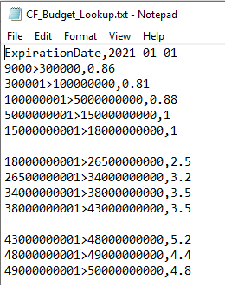

The expiration date is comprised of two comma separated columns, where the second column is the expiration date of the budget lookup file formatted as YYYY-MM-DD.

The cal factor lookup file is similar to the lookup file structure used for rho and linearity, with the only exception that a power level cannot be applied. Each line contains just two comma separated columns.

* Column one: The start and stop frequency range of the row. The value on the left side of the “>” operator is the start frequency, and the value on the right side is the stop frequency
* Column two: The CMC specified uncertainty value. This is the value which the program will apply to any XML file uncertainty point which is found to be too small. Too small is defined as less than this value in column three

As seen in the example above, power ranges are not applicable to the cal factor lookup file. It is additionally shown that the file may contain extra whitespace if desired, perhaps to aid in making the data contained within the file a little more viewable. Extra whitespace can be applied to all three of the different budget lookup files with no ill-effect on the operation of the program.

# Supporting Files

The PS-Cal corrector program is supported by four external text files, which it requires in order to function:

* PS-Cal-Corrector.cfg (this name is hard-coded in the program and cannot be changed)
* The Rho Budget Lookup File (this can be any filename or file location, and is set in the configuration file)
* The Cal Factor Budget Lookup File (this can be any filename or file location, and is set in the configuration file)
* The Linearity Budget Lookup File (this can be any filename or file location, and is set in the configuration file)

In the event that any one of these files becomes lost or corrupted, below are functional copies of each. By copying these, the user may easily re-create the required support files.

**Note:** PS-Cal-Corrector.cfg must always be placed within the same root folder as the PS-Cal_Corrector Python program script. However, the three budget lookup files can be named anything and located anywhere, so long as the file path of each is recorded in PS-Cal-Corrector.cfg.

### PS-Cal-Corrector.cfg

*/ Began Copying Below This Line /*

# configuration file for the PS-Cal interpolation program

# Place a "\" at the end of all folder references

# Set debug to 1 for debugging, or 0 for normal operation

debug = 0

PS_CalResultsFolder = S:\callabsolutions\PS-Cal TEGAM\PS-Cal_V4 October 2019 Release\CalResults\

archivePath = S:\callabsolutions\PS-Cal TEGAM\PS-Cal_V4 October 2019 Release\CalResults\PS-Cal Pre-Correction Archive\

# Interpolation method can be 1 or 2; if 1 then the software will use the

# Rho frequency as the reference to determine which cal factor frequencies require interpolation.

# if 2 then the program will prompt the user to enter the PS-Cal standard data which was used for

# the calibration, and then the PS-Cal standard data will be matched against the CF frequency

# points to determine which ones are absent from the standard data and therefore require interpolation.

interpReferenceMethod = 2

standardsDataFolder = S:\callabsolutions\PS-Cal TEGAM\PS-Cal_V4 October 2019 Release\Standards\

numberSigDigits = 2

rhoBudgetTxtFile = S:\callabsolutions\PS-Cal TEGAM\PS-Cal_V4 October 2019 Release\Uncertainty\Rho_Budget_Lookup.txt

cfBudgetTxtFile = S:\callabsolutions\PS-Cal TEGAM\PS-Cal_V4 October 2019 Release\Uncertainty\CF_Budget_Lookup.txt

linBudgetTxtFile = S:\callabsolutions\PS-Cal TEGAM\PS-Cal_V4 October 2019 Release\Uncertainty\Lin_Budget_Lookup.txt

*/ End Copying Above This Line /*

### Rho Lookup Budget

*/ Began Copying Below This Line /*

ExpirationDate,2021-01-01

9000>3000000000,0.0001>0.25,0.0052

9000>3000000000,0.25>0.5,0.0061

3000000001>18000000000,0.0001>0.25,0.0083

3000000001>18000000000,0.25>0.5,0.0061

18000000001>26500000000,0.0001>0.25,0.0068

18000000001>26500000000,0.25>0.5,0.0098

26500000001>50000000000,0.0001>0.25,0.016

26500000001>50000000000,0.25>0.5,0.018

*/ End Copying Above This Line /*

### Cal Factor Lookup Budget

*/ Began Copying Below This Line /*

ExpirationDate,2021-01-01

9000>300000,0.86

300001>100000000,0.81

100000001>5000000000,0.88

5000000001>15000000000,1

15000000001>18000000000,1

18000000001>26500000000,2.5

26500000001>34000000000,3.2

34000000001>38000000000,3.5

38000000001>43000000000,3.5

43000000001>48000000000,5.2

48000000001>49000000000,4.4

49000000001>50000000000,4.8

*/ End Copying Above This Line /*

### Linearity Lookup Budget

*/ Began Copying Below This Line /*

ExpirationDate,2021-01-01

10000000>1280000000,16.0001>20,1.8

10000000>1280000000,10.0001>16,1.2

10000000>1280000000,-39>10,0.96

10000000>1280000000,-48>-39.0001,1.4

*/ End Copying Above This Line /*