|  |  |
| --- | --- |
| data structures & algorithms  DSA | Abstract  To understand about Data Structure and Algorithm  Mr. Thihan Hein  Unit 34 |

Contents

Data Structure and Algorithm 3

Data Structure 3

Algorithm 3

Sorting Algorithm 3

Selecting Sort 3

Inserting Sort 5

Quick Sort 6

Merge Sort 9

Bubble Sort 11

Comparison for Sorting Algorithms 13

Search Algorithm 14

Linear Search 14

Binary Search 15

Jump Search 16

Sorting and Search for Assignment 17

Recursive Algorithm 18

When use Recursive Algorithm? 19

How to use Recursive Algorithm? 19

Why use recursive Algorithm? 20

Example Usage of Recursive Algorithm 20

Recursive in Merge sort 20

Recursive in Binary Search 21

Test Plan (2.3) 21

Add New Book 21

Add New Customer 22

Add New Staff 23

Search Book 23

Delete Book 23

Search Customer 24

String (3.1) 24

String Buffer Class 24

String Builder 25

Methods of String (3.2) 26

Int hashcode() 26

String replace (char oldChar, char newChar) 27

String replaceAll() 28

String [] split (String regax) 29

Int length() 30

String concat() 31

String matches() 32

String trim() 33

boolean equalsIgnoreCase(String another String) 33

boolean equals(Object an object) 34

String toUpperCase() 35

String toLowerCase() 35

String toString() 36

String format() 36

String join () 37

Preparation for Assignment (D1) 37

Problems I Met 38

What I’ve learnt 38

Schedule (D2) 39

# Data Structure and Algorithm

## Data Structure

Data structure is a kind of data type that announce the type of the variable such as integer, float, array and so on. Data structure can store the data. For example you can add data with an array. You can add data whatever you want. But how will you select those data. You can select the data. But the data will be like a trash and for a normal user can be confuse. Data must be need clear for the end user. For example, there are many search engines. Among them, Google search engine is most useful. So why Google engine is most useful? Because of the algorithm, it’s more powerful. Algorithm is to learn about the program to make more performance as a backend coding.

## Algorithm

Algorithm is a detailed step by step method for solving a problems. It is well developed and good approach to solving complex problems. For example, make sorting the data. Without algorithm you can also sort data. But it’s difference. It might be take more time to sort. So algorithm is to make a good performance program. As an example with Google Search engine. Why it is used by all people? Because of the search algorithm, it can make more performance of the search result. So Algorithm is to find the best way solution of the program performance. In easy way, every program has their own original design, color and structure. Like fast sorting, fast searching, fast saving and so on. So algorithm is one of the design, color structure of the program.

So for example with the video call application like Viber, Discord, Messenger and so on. Before inventing those application, we connect with the satellite connection to connect each other. In satellite, we have to wait a minute to hear the voice. When hearing voice, we can’t hear clearly the voice. It has some barriers noises. Because it through the satellite and at that time developer don’t know the better algorithm. So after that, developer think about the algorithm to clear the barriers noises. Viber, Discord, Messenger and such like application has different algorithm to prevent from the external voice barriers. So Algorithm is to make the application better with the better performance. That is why we learn about the algorithm.

# Sorting Algorithm

There are many type of algorithm such as sound clear algorithm, searching algorithm and so on. Among them I want to explain about the sorting algorithm. Sorting Algorithm is a kind of algorithm that find to make sort fast. You can make sort without algorithm. But sorting can make you to make better performance in sorting. There are many type of sorting algorithm and I want to explain their benefits and limitation.

## Selecting Sort

Selecting sort is to select a small number and put at the beginning. Selecting sort is easy for a junior programmer and easy to understand. For example there has an array room and all the room are unsorted. With selecting sort, it will select smallest number that has in that array and put it at the first index of the array and the first array will reach to the smallest number room. After that, the first index of the array will lock and it will start from the next room of the lock array index.

So it has the array 64,25,12,22,11. Now let’s sort with for low to high by using selecting. First select 64 and check with beside of the array room.

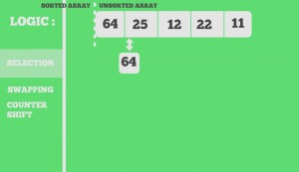

Now the select number is 25. And check the beside of 25 array room.

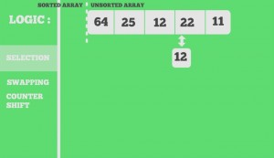

Now the select is 12. And check the beside number of array room. If the select number is less than beside of the array room. It doesn’t change and keep checking. Now the select number is 11. And it will swap 11 and 64 and the swap room was locked and continue selecting.

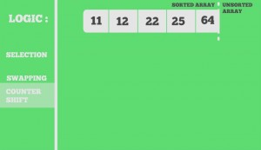

**As a real world example, it will use in student grade result in each classes. Assume that each class has 60 or 70 students. Sorting them according to ID is not an easy task. Here, we can simply use selection sort to sort these 60 or 70 students in no time. By swapping the IDs that came in front with respective to those who are not in order. Although it may seem confusing, it can make sorting easier for those who are supposed to sort this.**

|  |  |
| --- | --- |
| Benefits of Selecting Algorithm | Limitation of Selecting Algorithm |
| * The Sorting is very fast | * it will doesn’t effect in so many data |
| * It use less memory | * If the data is too much it can take much time |
| * It doesn’t need temporary storage to store an index | * It doesn’t match with a huge business |

Selecting sort is good for only if the data is less than 60 or 70. It can’t handle 100 of data. Because it can take much time to finish it in a short time. And it doesn’t support in a large business. In my example, it is suitable for a classroom grade of student. Because, it only have 60 or 70 students. In short, selecting sort is good for less data, if not it will take long time to make sort.

## Inserting Sort

Inserting Sort is a kind of algorithm that select an array index number and check with the right array indexes. And it will catch as a temporary memory after check with right index. If the right index is correct it will stop mark temporary and put a real number. If not it continue store temporary and check with the right index rooms.

So here is the number 7,8,5,2,4,6,3 array. So first it select one number and check with the front arrays. So 8. Check with the 7. If true, it doesn’t make any changes.

And now it’s 5. Check with the left side of the array room. Check with 8. False and 8 was place in 5 array room. But in 8 array room 5 was stay as a temp memory to check with the rest array room. So 5 check with 7 false so swap.

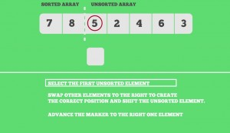

After that array count is plus one and another number will be selected as 2. It will check with the rest of the array room and stored as temporary memory until it’s true or nothing to check with other. The rest array room will check like this.

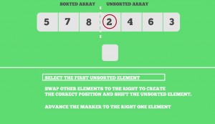

Finally, the array is sorted. As conclusion. Insertion sort is to select the number and check the front of the array room until it’s true. And if the array has need to check it will store temp to check with the rest.

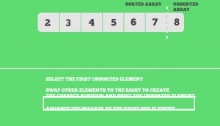

**With a real world example, a card games, poker as an Microsoft games. It will give you unsorted number and you need to make with minimum number to maximum number. It use Inserting sort to make an order. Inserting sort is also simple and it can easy to understand.**

|  |  |
| --- | --- |
| Benefits of Inserting Sort | Limitation of Inserting Sort |
| * It is simple to understand and easy to use | * It doesn’t perform as well as other sorting. Because it repeated again even the condition is true |
| * It comfortable with small business | * Doesn’t support for large business |
| ---------------- | * It store temporary data, so if a data is much it can damage and harm to hardware |

Inserting sort is also good for the small business and it is only good what to do exactly. For example, sorting poker (Cards) program game. So we know how many poker does it have and the selecting poker will little to play. So we can know the counter exactly. At that time, we can use inserting sort to sort the poker program. And it doesn’t support large amount of data and doesn’t know the total counter.

## Quick Sort

Quick sort is a divide and Conquer algorithm. It pick one of the number that has in the array index as pivot. After getting pivot it make partition into left and right. There may be different for quick sort for getting pivot. The pivot can get by the following statement. Be careful, if you choose one of those steps, the other steps should also same with the previous step.

1. The first element will always be set as pivot.
2. The last element will always be set as pivot.
3. A random element can be picked as pivot.
4. Median can be picked as pivot.

In this report, I want to choose the pivot as a last element. Here is an example with some number.

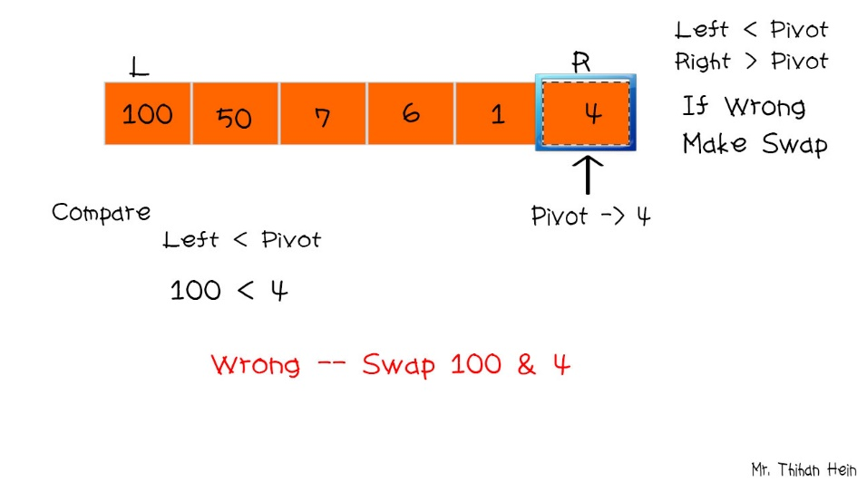

So I will take 4 as a pivot. In this statement it will have a condition. If the number of the array index is less than pivot, it will swap. If not it doesn’t change. So pivot is 4. And it will check with the first number of array index (100). 100 < pivot that is true. So both room will swap. And it will change as follow.

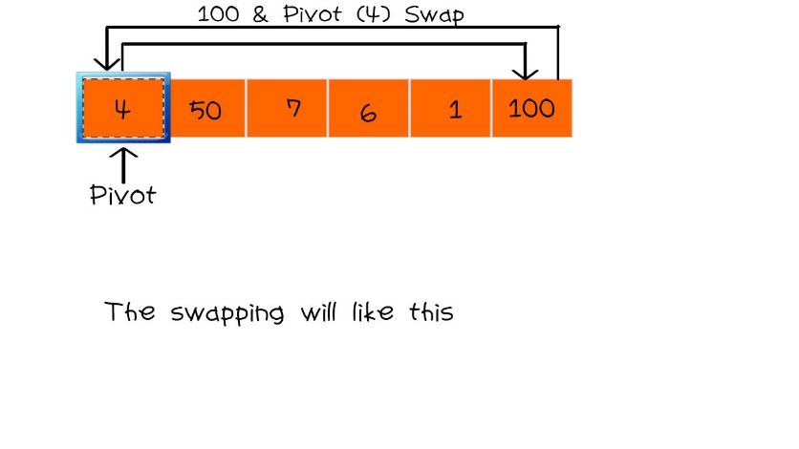

After swapping pivot and an array index room, it will check with Left and Right as define with pivot. Now 4 is pivot. 100 > pivot (4) is true, so it doesn’t change. 1 > pivot (4) is not true so, it will make swap with 1 and 4. So it will be as shown in figure.

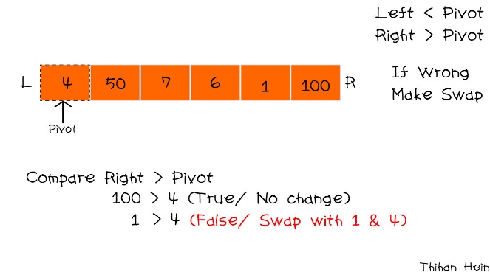

So swap like that. Now it’s also make partition again as Left and Right with same pivot (4). it will check both left and right. 1< pivot (4) is true so, it doesn’t change. And 50 < pivot (4), it doesn’t true. So 50 and pivot will swap. Now the sort will like this.

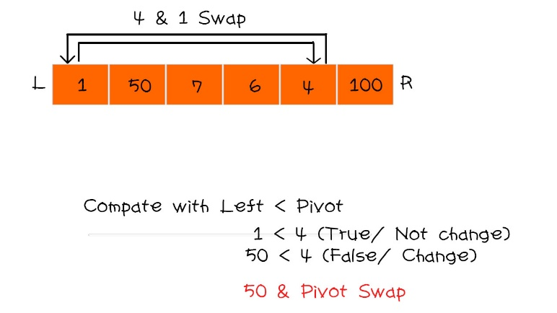

If the pivot is in the middle it should divided into two partition that has on the side with pivot. So the partition will be like this

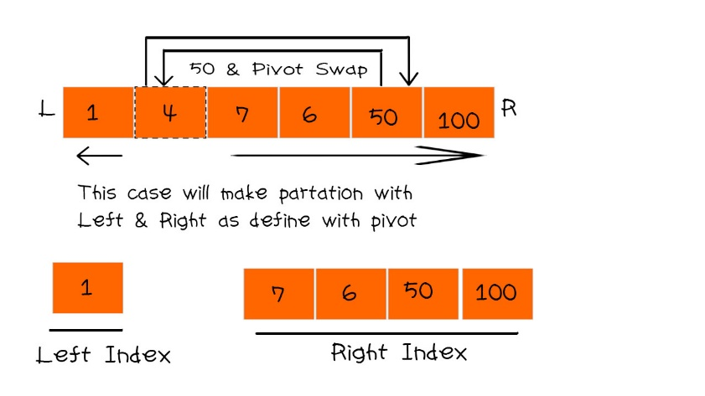

So the right side of the room will do with the last pivot and it will do same steps with uppercase.

7 < pivot (100) is true. So it doesn’t change. And the rest will also same it. if not found it the array will reduce from the right side. So at this time 50 will pivot.

7 < pivot (50) is true so doesn’t change anything and keep going. And 6 will take as pivot.

7 < pivot (6) is false, so swap those number as following

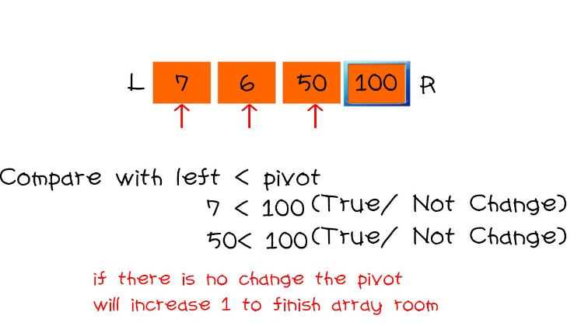

Now 6 is pivot and check again with right side. 100 > pivot (6) is true so doesn’t change nothing and the rest will same with. After that, the left index and right index will combine together as following.

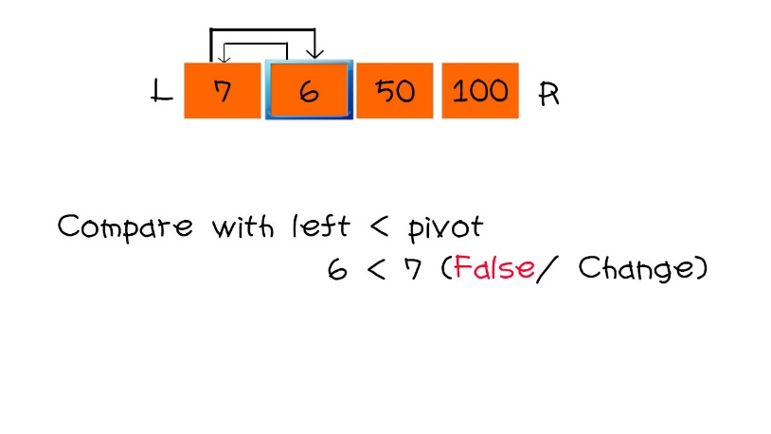

And it will also take pivot for last index (100). 1 < pivot (100) is true, so doesn’t change nothing and the rest will do like this and finally the array room will finally sorted.

Quick sort is an very effective sorting algorithm and mostly used in nowadays. Quick sort is to sort with pivot with left and right with adjustment for the sorting. Quick sort fast enough and good performance thank selection and inserting sort.

**As a real world example it use in the sorting that want to know the result of the order number by descending or ascending. It is mostly use in supermarket for sorting the buying or order process. Because of the data of the order, it can have more than 1000, quick sort can handle it and for the customer who doesn’t have patient is the best way with the quick sort.**

|  |  |
| --- | --- |
| Benefits of Quick Sort | Limitation of Quick Sort |
| * It is very effective in sorting and it is use widely | * It need more space to finish the sorting |
| * Effective on both small and huge business | * It need much knowledge of Sorting |
| * If a developer understand and can implement quick sort, he is really and certain to apply a job | * It use much memory because it need many steps to finish |
| -------- | * Some of the parts theory are difficult to understand |

## Merge Sort

Merge sort is a kind of sorting algorithm that is as efficient as quick. Merge sort is combine with Selecting that divide and conquer algorithm. It divide array room into two half until it get the last one. It is easy to understand for the merge sort. Here is an example of merge sort. The array is divided by 2 and separate the result. If the result is odd, it take as an even. And it will separate until the room is last 1 in separation. Here is an example.

100 50 7 6 1 4

This array room is divided by 2 and it will separate as shown in figure

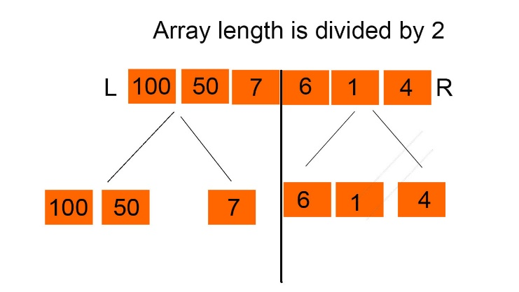

It doesn’t finish because the all the room is doesn’t last as a one. So it need to do same with first steps that divide by 2.

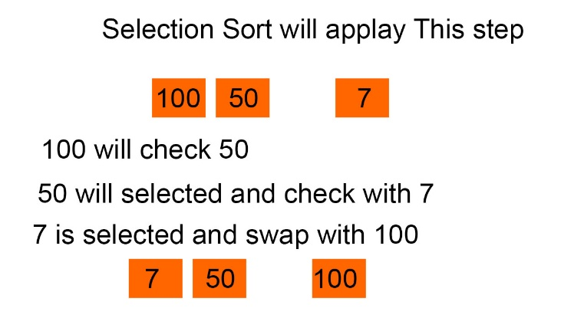

And it’s still need to finish so it also divide by 2.

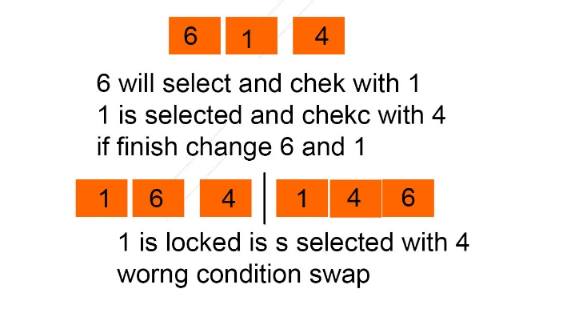

So all the array room are separated and there has no room to separate. So in this state, selection sort will do this process for each partition. For the left index, it will make selection sort for both left and right.

After making selecting sort, both left and right, it will make sort for both left and right,

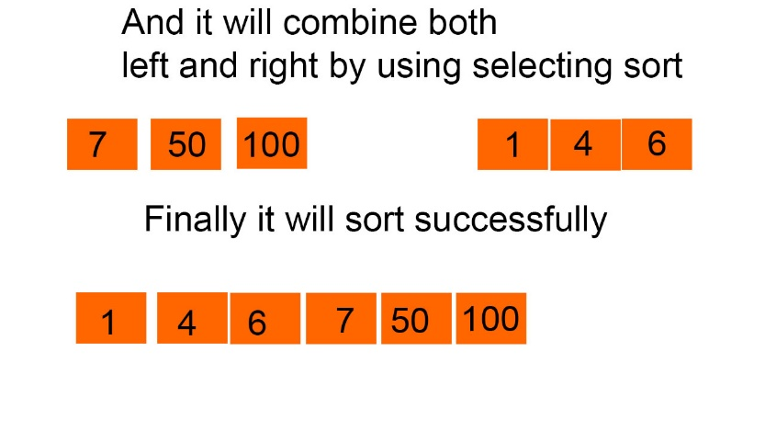

Now the array is sorted with faster.it is easy, isn’t it? Merge sort is combine with divide and selecting sort to complete Merge sort.

**As a real world example, merge sort is mostly use if the data is large and the sorting time is need to finish hurry. For example, A University Student Exam Result, It should use Merge sort. Because a university can have many student and it will have many grade. At that time, selecting sort is not suitable and quick sort is also. Even quick sort can take long time to finish. So merge sort is suitable for this process because it process is simple and very effective because combining divided and selecting sort. Here is benefits and Limitation of Merge Sort.**

|  |  |
| --- | --- |
| Benefits of Merge Sort | Limitation of Merge Sort |
| * Main benefits is that it can apply for huge data and can get fast processing | * It is less efficient than Quick sort |
| * Processing is very fast and comfortable with both huge business and small business | * It can have more memory usage |
| * It is easy to understand than quick sort | ----- |

## Bubble Sort

Bubble sort is the simplest sorting algorithm by swapping each other if they are not sorted. It can refereed to sinking sort which repeatedly steps through array. It can repeated until the list is sorted. It swap side of the room and it can repeat process until its finish. So here is a clear example. We have 5,1,4,2,8,9. And we will sort it by using bubble sort. Remember bubble sort is check the both side of each array room.

So first two array room will be 5 and 1. 5 will selected and check with the right side of array room. If the condition is false it will swap. So now it will make swap with 5 and 1.

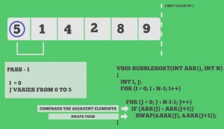

And now it again check the swapped number and right side of the room. It will be 5 and 4. 5 is swapped number with 1. So 5 and the right side of the 5 is 4. So it will check. False! Swap. So 5 and 4 ware swapped. And it will have as shown in figure.

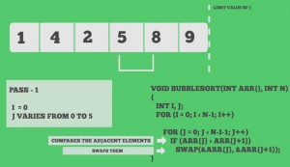

Now the swapped number (5) and right side of the swapped array room (8) will checked. If the condition is true it doesn’t change and the room will be next selected room. The selected room 8 and right side of the room were checked. If true it doesn’t change nothing and the array count will reduce. And it will repeat process form start.

So it will start with 1 and right side of the array room 4. If true doesn’t change and index will increase. So it will be 4 and right side of array number is 2. The condition is false so it swapped. So the swapped number (4) and right side of the array room 5 will check. The condition is true so doesn’t change nothing and index will increase. So 5 and 8 will check. Condition is true doesn’t change nothing and array count will reduce and lock. And it will start again until array count doesn’t finish. It seems it will sorted. But it doesn’t finish. It will continue the size of the array even all the room are sorted. Finally you will get sorted number.

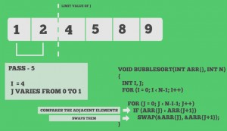

**As a real world example it is suitable use in school report number or office report number sorting in class. In class it only have 60 student each class in school. Because the number can be low or big. We can’t know exactly. Because of repeating process of the bubble sort it is suitable. If the big report number is insert in the middle, it can easily sort because it work until the array size is finish.**

|  |  |
| --- | --- |
| Benefits of Bubble Sort | Limitation of Bubble sort |
| * First is easy to understand | * It can use between the data is less than 300 because of the repetition process. |
| * Best performance than inserting and selection sort | * Sorting time is increase if the data is too much or the process is repeat again and again |
| * It doesn’t need temp memory to store so it doesn’t need much garbage | * It can have less efficient if the data is input again. |

# Comparison for Sorting Algorithms

|  |  |  |  |  |  |
| --- | --- | --- | --- | --- | --- |
| No | Selecting Sort | Inserting Sort | Bubble Sort | Quick Sort | Merge Sort |
|  | It is very fast sort if the data are less than 10. | It can be fast if the data is less than 25 | It might be fast when data is as same as inserting sort | It can take much time to sort but it is very effective for huge business | Can take much time in dividing array to sort if the data are too large |
|  | Easy but useless for huge business | It repeated until the sort is not finish so it can take long time |  | It can take pivot as different condition. So it can different some condition by getting different pivot | Combine with selecting sort. So after dividing, it do selecting sort. |
|  | Select the smallest number of the index and swap and lock | Take a number and check with the all left index rooms | Check the two index that is beside each other and swap | Take pivot and divide left and right to sort and combine and sort again | Separating all array room until it reach to one and make selecting sort. |
|  | Thinking flowchart is easy | Complex than selecting sort because it has temporary memory | Same as Inserting sort | Advance level of Programmer | Easy to understand to design merge sort |
|  | If the data are too much, it can have memory allocated | Memory allocation is also appear in inserting sort if the data is too much. Because it need temp file to check with other | It can be less memory allocated because it move room by one. | It can be less memory allocated because it check with pivot with the rest room | It can have a little bit allocated because it need to divide and make temp and do the selecting sort. Sometime it can have memory allocated but sometime it doesn’t make memory allocated. |

# Search Algorithm

Search algorithm is step by step which used to locate the exact data from the collection of data. it is a kind of computing. Search algorithm help to make faster searching. For example, there are many search engine. Among them Google is very famous. Because Google search algorithm is the best. That why searching algorithm is important. There are many type so search algorithm as following here.

## Linear Search

Linear search is a kind of searching algorithm which check with each array room until it reach correct keyword. It check each element of the list for the target value until a match is found or until all the element have been searched. For example, there are a number array room which has 1 to 10. If you enter 6 that you want to find. It will search all the array room. It will check from start of the array room until correct. And it will return array room number if found. Here is clear example for linear search.

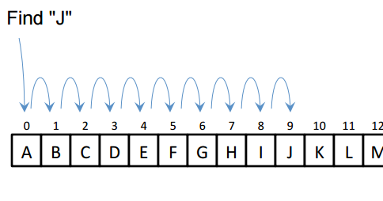

|  |  |
| --- | --- |
| Benefits of Linear search | Limitation of Linear Search |
| * If the data is less, searching is very fast. | * If the date is large more than 100 it can take time to search. Because it check the room by one. |
| * It doesn't need any temp file to memorize because it check the room by one. If it doesn’t match it skip. | * If the data are same like '3' in is array room of '4' and also '3' is in array room of '6' if the data found the first array room '4' is taken and it doesn't check the other room. So the data can't correct if the data are same. |
| * It is easy to understand for the programmer. |  |
| * It doesn't need sorting to search. |  |

**As a real world example, in a library to search old books or ancient books. It is very effective way to use linear search. Ancient books are not more than 100. So it can use linear search and it doesn’t need sorting and the ID of the books can’t same. So it can use in library to find ancient books. Not modern book.**

## Binary Search

Binary search is a kind of searching algorithm to search an item from a sorted list. The method of binary search is dividing for each portion of a list. The main point of binary search is it have to be sorted. The array must be sorted. If not it is difficult and it rule is only for the sorted. Binary need sorted because it check the number with greater or less than the find number. Here is a clear description.

It take the search number is greater than the middle and it’s true, it take right. If not take left. Here is 10 array room and you want to find 23 in that array. So first make tow partition with same half. And with the half number seem a middle number. Check is 23 is bigger than 16? Yes, so take right side of the array room.

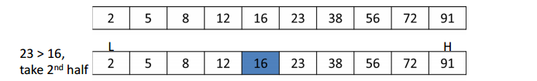

And make same partition with the first stage. So take middle number 56. Does 23 is greater than 56? No. so take the left side of the array.

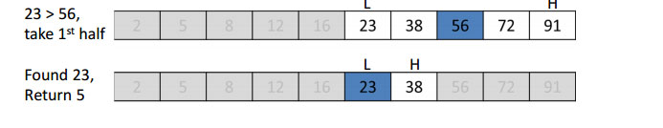

So it will have two array room. So also divide same with the first stage. And check. If the number doesn’t match check with the other room. If the data is match bingo. It will return the array number room. That is why this searching i=need sorting because it check divide and conquer like merge sort. If the data doesn’t match it won’t show nothing. But main point it must be sorted. If not you can’t find matches.

|  |  |
| --- | --- |
| Benefits of Binary Search | Limitation of Binary Search |
| * It is faster than linear search and it can use in the middle range of searching | * The array need sorted if not it can’t use |
| * It is fairly simple algorithm because easy to understand | * If the data is too much more than 1000 it can take time to finish. |
| * It doesn't have memory garbage because it check only greater or less | * It is more busy than the other searching because if the data is not sorted you have to sorted first and you have to decide the sorting algorithm to use binary search. So it can also take time to implement. |
|  |  |

**As a real world example, a good example is online ranking game. To find top players. They allow only 100 for top players. And a sponsor want to find not too high and not low rank. So if the input the score number. It will search by divide and conquer for the ranking point. If it’s match, it will show.**

## Jump Search

Jump search is also known as block search which represent to a search algorithm for a list. So it jump fro the block and find the matches by checking grather or less than the search number. It combine with linear search. It check with the square root of the array size and the result size is that it will jump. If the result size is 3 it will jump for three block for each size and check the jump room with search key. One main point is, the array must have been sorted. Because it skip other array room. Here is clear example.

Here is 16 array size. The square root of array size is 4. That number will jump number for each block. And you want to find 77. And this array size is sorted. So first it will jump four block. So 77 search number is greater than the jump number ‘2’. If true jump next four block. It will go until false.

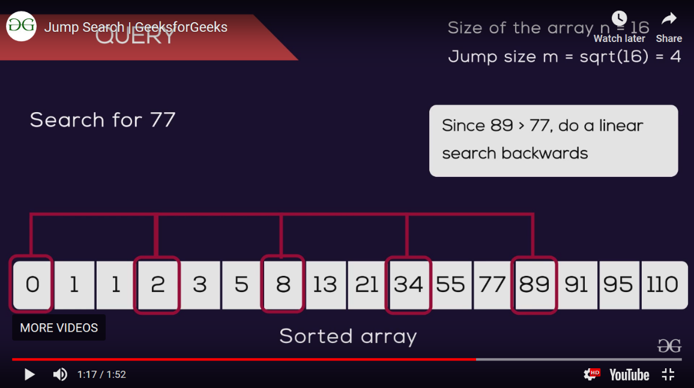

Now it reach to the jump block 89. Search key 77 doesn’t greater than 89. False. So it will apply linear search. It will reduce the back until it correct. So previous size of 89 is 77. If they are match bingo. You will find it successfully.

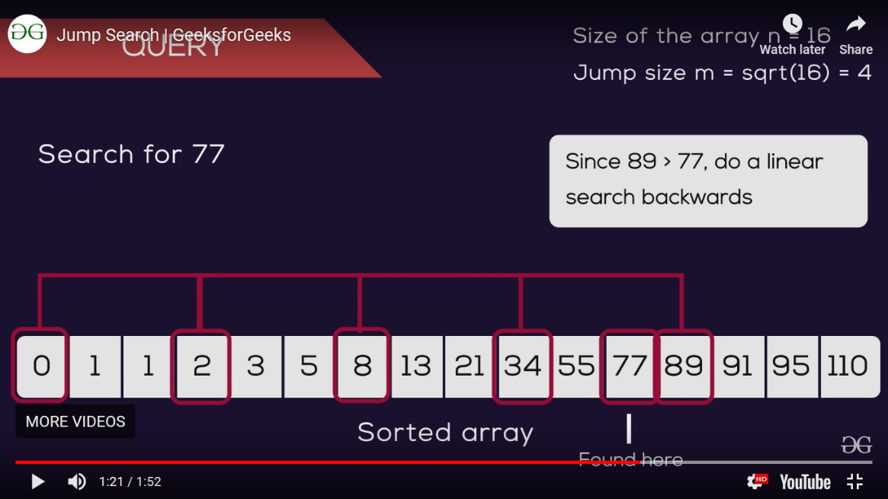

|  |  |
| --- | --- |
| Benefits of Jump Search | Limitation of Jump Search |
| * Doesn’t need any cache to find. | * Array need be sorted because of it’s rules |
| * Sorting is very effective and fast because it jump to other block. |  |
| * Easy to understand for newbie programmer | * If the data are the same it only show one time |
| * It can use in large process like finding over 1000 of data. |  |

**As a real world example, it can apply in finding staff list. Staff can only have less than 50 in a company. This can have very effective for finding in staff with id. Most staff search program of algorithm will use jump search. Because data is less and very effective than linear and binary search.**

## Sorting and Search for Assignment

|  |  |
| --- | --- |
| Sort and Search Algorithm Name | Description |
| Merge Sort | For the book data it will use merge. Books data must find quickly and books can have too many data in the text file. And merge sort can also handle the data. And it can have performance for sorting. We already know that selecting sort is fast in every sorting. So merge is to divide each part until it reach to last. And make selecting sort. So it is fast. And customers doesn’t wait much time while make sorting. Because merge sort can sort more than1000 of data. So books data can be also more than 1000. So they are match. So I use merger sort for the book sorting. |
| Bubble sort | For staff data, because it can have less data of staff in the text file. So for less data I will use bubble sort for the staff and if the new staff will add it doesn’t have any problem. It can sort easily. As staff can have only less than 30 in library bubble sort is suitable. Because of less data even new staff is arrived it can be 1 or 2. Not too much data. |
| Binary Search | For both books and customer data I will use jump search because it divide all the array with half and jump and use liner so. Performance is good enough for large data. Because it is suitable with both sort. It need sorting array to search. So quick sort and merge sort are sorted and easy to apply jump search. And jump search is divide the array and check the number less than or grater. So it can only have left and right data. So searching is fast enough both book list and customer data. |
| Linear Search | As staff data are less I want to use linear search. When data is less, linear search can search easily. Main reason is staff data is less. It doesn’t need any sorting data to search because it check with each room with keyword. And staff data is less so searching process is fast. |

------------------------------------------------------------------------------------------------------------------------------------------

# Recursive Algorithm

Recursive algorithm is a kind of method which calls itself directly or indirectly the corresponding is called as recursive algorithm. It make a small value of input value. It use to solve same problem with same solution. It is a kind of repeat process for the single process. It can use for a problem which can't solve with looping. Performance of recursive is slow because it called itself. Recursive algorithm is use in the complex process problem and it is easy to understand but the performance is not good enough. To use recursive it is very careful to use although it is easy to understand. Because if it wrong usage, it can happen memory stark over flow. Or if the base case is wrong it can have problem with the recursive algorithm.

In recursive algorithm it has direct recursive and indirect recursive which called itself directly or go through other methods. Direct recursion is a method which invokes itself and direct recursive is the expression is same in the first paragraph. So here is an example of direct recursive algorithm.

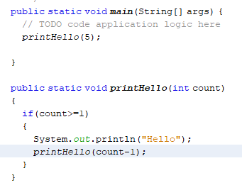

In photo, you will see printHello method with parameter. If the count is less than equal to 1 it will print “Hello”. You will see the count-1 in it’s method. It will reduce count until reach 1 which have the total count in main method. In printHello method. It call itself by reducing count. So it is a directly call is called direct recursive algorithm.

Indirect recursive opposite of direct recursive algorithm. Indirect recursion is when method called form a different method and its turn called the original method. It use more than one method. Indirect it only use one method itself. Indirect recursive called more than one method and use recursively.

A good example is directory traversal program. One method for navigating the hierarchy and one for processing the files. If the file turns out to be a directory then the original process folder method is called and so on.

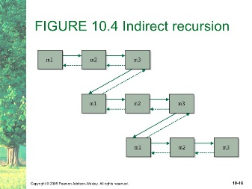

## When use Recursive Algorithm?

It use when the process is huge or big and to see the code clearly and not to have much tracking trace for the program. Like quick sort, merge sort. In quick sort, you have to make partition, swap process, and check condition process. So if you make one layer code, you will find too much nervous and you will have difficult in tracing. So generally recursive algorithm is used for complex and clear process. So to clear quick sort and easy to trace recursive algorithm can use in quick sort. Not only quick. It is up to the condition of the program. If you want to have clear and to solve complex condition. You should use quick sorting. But recursive code doesn’t use in every condition. If a program need to have clear to understand and complex condition, recursive algorithm can use.

So here is an example with quick sort. You can have code in one layer of quick sort. The main difference is too difficult track and very complex code and it is difficult to understand. First we have to make a partition of quick sort array and get pivot. So you will have a partition method for process. After partition you will get pivot and make quick sort. In this case I want to show how recursive work. So we will do quick sort for the recursively.

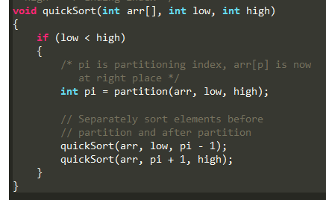

Recursive use parameter. So you will see a quick sort method. In this case you will see the calling method of quick sort. Parameter data in the quick sort method are recursively called. And data will be transmitted to itself. If other method called that method. Parameter data will be inserted. So in this case, you will clear and easy to find tracking.

## How to use Recursive Algorithm?

As I says recursive algorithm is use to solve for complex condition which can’t solve with looping. So it is use in complex case. So how to use it? Called it’s method in it’s scope. It is a little bit complex. Before you use recursive algorithm you should think about the data structure with steps by steps by using pseudo code or flow chat by thinking carefully and tracing each steps. Because if you make wrong recursive, it can have memory stack overflow and that problem is doesn’t same with other program problems, it can harm to your device or memory. To use recursive, you should have to think about the parameter, base state which make to stop the sequence or loop and call it’s method to do again and again. If you are wrong in base case, you will face with memory over flow or which relate with that problems. Think about the condition steps by steps to prevent from memory stack problem.

## Why use recursive Algorithm?

As I says, it is to solve for the complex problems. Recursion can typically allow to use with other concepts such as immutability. Mostly for the looping which is used to be altering a mutable data structure. Using immutable data structure can allow for things like simple parallelizing of your functions. So you can distribute the work among several CPU's without running the risk of corrupting your tasteful object. If you use recursive the performance is not good enough because of the memory over problems. It just need to use for the complex process for tracking easy for the programmer.

## Example Usage of Recursive Algorithm

So as an example, mostly use in algorithm process. It can be in hacking, hashing, encryption. Because they do repeat and repeat same process for all. In hacking to lock the hashing code they should use recursive algorithm to apply. So sometimes hacking apps are memory over problem for hackers. Because simply base case is wrong for hacking algorithm. Hacker can’t extract and doesn’t know about the Company A’s hashing. So they use that kind of recursive algorithm to think about the hashing design of the Company A. And to solve heavy problems to subs problems.

## Recursive in Merge sort

We already know that merge sort is divide until the room doesn’t reach to the last. And use selecting sort to make merge sort. So in merge it will have many steps if you write code in one layer, you will have difficult to trace of marge sort. So you have to use different methods and recursive algorithm to apply merge sort. So here is an example.

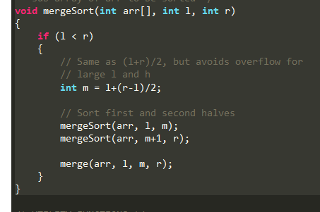

So you will see mergesort method and it’s called it’s self with parameter. That parameter form he main method and form partition method to put it. Those data will transfer to the partition method to make condition of the sorting. With the parameter, partition will take out and sort method will do sort in main method.

## Recursive in Binary Search

Binary also need to apply recursive algorithm. Binary is divided and make condition to get the data. It will have many steps to finish and it seem easy in outside. But with the code it can complex for the programmer. So recursive algorithm can help programmer to trace easily.

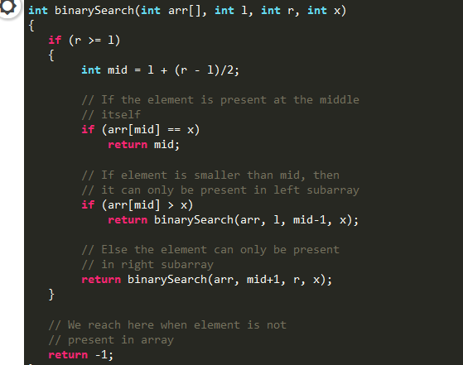

You will see binarySearch method and it’s called itself. it find middle number from left and right. Those left and right will get form the parameter. And parameter data will come from main method. This method is also called in main method to get data and make sort. And it returns it’s method and -1. If -1 it can’t find. Search data doesn’t have in the array list. If its returns it will make binary search up to the condition.

In those case, in merge sort and binary search. It can easily trace all the program. It doesn’t have any performance for the program. If the parameter is wrong, it can only have memory stack over flow problems. So think careful for the base to prevent from problems. I hope you will understand about recursive algorithm.

------------------------------------------------------------------------------------------------------------------------------------------

# Test Plan (2.3)

## Add New Book

|  |  |  |  |  |  |  |
| --- | --- | --- | --- | --- | --- | --- |
| No | Publisher Name | Book Title | Edition No | Author Name | Pass / Fail | Description |
| 1 | ---- | --- | --- | --- | Fail | If all the text box are blank, it can’t accept. |
| 2 | Thihan | Blank | Blank | Blank | Fail | It can’t accept blank so it fail. |
| 3 | Thihan | Titanic | Blank | Blank | Fail | It can’t accept blank so it fail. |
| 4 | Thihan | Titanic | First | Blank | Fail | It can’t accept blank so it fail. |
| 5 | Thihan | Titanic | First | James | Pass | If all the data is correct it can accept |
| 6 | 123 | Titanic | First | James | Fail | Name can’t accept numeric value |
| 7 | Thihan | 123 | First | James | Fail | Same also rest of the text field doesn’t accept numeric value |
| 8 | Thihan | 123 | 123 | James | Fail | Same also rest of the text field doesn’t accept numeric value |
| 9 | Thihan | 123 | 123 | !@#$%^& | Fail | Same also rest of the text field doesn’t accept Special Character |

## Add New Customer

|  |  |  |  |  |  |  |
| --- | --- | --- | --- | --- | --- | --- |
| No | Customer Name | Customer Phone | Customer Email | Customer NRC | Pass / Fail | Description |
| 1 | ---- | ---- | --- | --- | Fail | If there has blank, it can’t go next |
| 2 | bob |  |  |  | Fail | If there has blank, it can’t go next |
| 3 | bob | 09123456789 | [Bob123@gmail.com](mailto:Bob123@gmail.com) |  | Fail | If there has blank, it can’t go next |
| 4 | bob | 09123456789 | [Bob123@gmail.com](mailto:Bob123@gmail.com) | 12/YGN(n)123456 | Pass | If all the format are correct it Pass. |
| 5 | Bob | Ddjdj!@# | [Bob123@gmail.com](mailto:Bob123@gmail.com) | 12/YGN(n)123456 | Fail | Phone number doesn’t accept aspheric and special character |
| 6 | 213^&* | 0912345678892522 | #$%^&@gmail.com | 25/jg(v)23**9 | Fail | Same also rest of the text field doesn’t accept Special Character and it doesn’t have correct format. |

## Add New Staff

|  |  |  |  |  |  |  |
| --- | --- | --- | --- | --- | --- | --- |
| No | Staff Name | Staff Phone | Staff Email | Staff NRC | Pass / Fail | Description |
| 1 | ---- | ---- | --- | --- | Fail | If there has blank, it can’t go next |
| 2 | bob |  |  |  | Fail | If there has blank, it can’t go next |
| 3 | bob | 09123456789 | [Bob123@gmail.com](mailto:Bob123@gmail.com) |  | Fail | If there has blank, it can’t go next |
| 4 | bob | 09123456789 | [Bob123@gmail.com](mailto:Bob123@gmail.com) | 12/YGN(n)123456 | Pass | If all the format are correct it Pass. |
| 5 | Bob | ddjdj | [Bob123@gmail.com](mailto:Bob123@gmail.com) | 12/YGN(n)123456 | Fail | Phone number doesn’t accept aspheric and special character |
| 6 | 213^&* | 0912345678892522 | #$%^&@gmail.com | 25/jg(v)23**9 | Fail | Same also rest of the text field doesn’t accept Special Character and it doesn’t have correct format. |

## Search Book

|  |  |  |  |
| --- | --- | --- | --- |
| No | Book ID | Pass / Fail | Description |
| 1 | --- | fail | If the data is blank, it can’t find data and it doesn’t have any data. |
| 2 | 1 | Pass | Only accept numeric value. So it accept. |
| 3 | !@# | Fail | It can’t accept special character it only accept numeric value |
| 4 | Asdf | Fail | Because Text Field only accept numeric value |

## Delete Book

|  |  |  |  |
| --- | --- | --- | --- |
| No | Book ID | Pass / Fail | Description |
| 1 | --- | fail | If the data is blank, it can’t find data and it doesn’t have any data. |
| 2 | 1 | Pass | Only accept numeric value. So it accept. And it will delete with the relate ID number. |
| 3 | !@# | Fail | It can’t accept special character it only accept numeric value |
| 4 | Asdf | Fail | Because Text Field only accept numeric value |

## Search Customer

|  |  |  |  |
| --- | --- | --- | --- |
| No | Customer ID | Pass / Fail | Description |
| 1 | --- | fail | If the data is blank, it can’t find data and it doesn’t have any data. |
| 2 | 1 | Pass | Only accept numeric value. So it accept. |
| 3 | !@# | Fail | It can’t accept special character it only accept numeric value |
| 4 | Asdf | Fail | Because Text Field only accept numeric value |

Delete Customer

|  |  |  |  |
| --- | --- | --- | --- |
| No | Customer ID | Pass / Fail | Description |
| 1 | --- | fail | If the data is blank, it can’t find data and it doesn’t have any data. |
| 2 | 1 | Pass | Only accept numeric value. So it accept. |
| 3 | !@# | Fail | It can’t accept special character it only accept numeric value |
| 4 | Asdf | Fail | Because Text Field only accept numeric value |

------------------------------------------------------------------------------------------------------------------------------------------

## String (3.1)

String is a kind of data type which use in programming. It include decimal, integer, phrase, words, and special characters and so on. It represent text rather than the other. For example, "I do assignment for 2 hours.” It is a text. String is used to accept text. it can include 12345, or others specials characters. Strings are specified correctly. Strings can't combine each other and they can't fixed any more. So if you want to modified you have to use other classed called Buffer and Builder. They use string to make modified.

As a real world example, it used to represent text. It can be long words form the data base. So we can accept data from the database as string and we can show output. It the data is text you can use string variable to accept. It can also different data like float, decimal or others data.

## String Buffer Class

String are can't modified. If you want to modified you can you string buffer. String buffer is a class which used to create modifiable stings. String buffer has parameter. It is modified so it can save thread. So it doesn’t have thread but performance is not also good in string buffer class because of the thread, if you know how to use it. In string buffer class it can have none parameterize constructer and parameterize constructor. It can have characters or substrings in the middle or appended to the end.

In StringBuffer it has three constructor which none parameterize constructor, integer constructor and string value constructor.

|  |  |
| --- | --- |
| Constructor | Description |
| StringBuffer() | It create empty string buffer with the capacity of 16 |
| StringBuffer(String s) | Create String buffer with the specific string |
| StringBuffer(int i) | Creates an empty string buffer with the specified capacity as length. |

StringBuffer have slower because of the synchronizations. StringBuffer is used when a condition is need a mutable string between different thread, you can use StringBuffer. It is synchronized method which control access that is only one thread can assess a StringBuffer object synchronized code at a time. Thus, StringBuffer objects are generally safe to use in a multi-threaded environment.

As a real world example, it imagine you are manually building HTML for a page, where you do roughly 100 string appends. If you did this with immutable strings, the JAVA virtual machine would do quite a bit of memory allocation and deal location where with a StringBuffer it would do far less.

## String Builder

StringBuilder class is used to create mutable to modified string. StringBuilder is same as StringBuffer. It is a little bit difference it has non-synchronized. String builder like string objects which can be modified. Unlike StringBuffer, it doesn’t save thread. It can have thread if you use StringBuilder. But because of thread, the performance is better than StringBuffer. But you have to think about thread before you use. In StringBuilder it has three constructor same as StringBuffer.

|  |  |
| --- | --- |
| Constructor | Description |
| StringBuilder() | It create empty string builder with the capacity of 16 |
| StringBuilder(String s) | Create String builder with the specific string |
| StringBuilder(int i) | Creates an empty string builder with the specified capacity as length. |

As an real world example, it the data are dynamic change, you should use StringBuilder because there has multithread to use again and again. Like dollar rate. It change dynamically with time. So it can use string builder for the dynamical condition or program.

These are all about string, string buffer and string builder. I hope you will understand about those string.

------------------------------------------------------------------------------------------------------------------------------------------

# Methods of String (3.2)

Strings is a data type that use in programming. It represent the text rather than number. Include number, text, word and special characters. And also include white spaces. String can’t fixed. The original string can’t fix. String array was use if you want to store string data. So in string, it has many methods and types. Here is some method of strings and its functions with real world example.

## Int hashcode()

It has the return value a hash code for a string. It return a inter value using by hashing algorithm. Object which is equal length with different character must return different hash code. But same character and same length but different variable will also take the same return hash value of the string. Because of its hashing methods.



Because of that hashing method. Here is testing code.

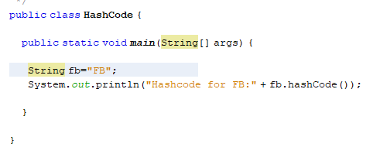

So I announce the string with data. And display output with the hash code of the announce string. If you run the output will see as an integer because, it returns integer value as shown in figure.



2236 is the hash code for FB. It is the return value of ‘FB’ as an integer. So I hope the working of the hash code. One more thing. It doesn’t need any parameter and return value.

As a real world example, it is only use in technical term. It is just to know that java has hashing function. Mostly it doesn’t use in programming. Because programs are using combine like database, eclipse and so on. That kind of program has their own authorization and their own encryption method. But if you can have an external security. You can try it. Even the database security is break out. Here is code sample.

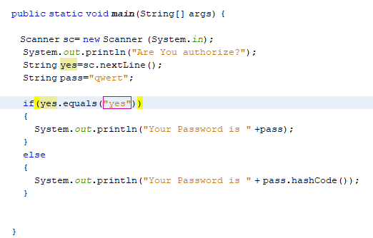

If you are authorize and type yes. You will see a password if not you can’t see the password, you will only see hash code of the password.

 

You will see here difference of authorize. I hope you understand about hash code of string.

## String replace (char oldChar, char newChar)

This method returns as a string which is replacing all the old character to new characcter. If the oldChar does not present in the character which represented by this String object, then a reference to this String object is returned. Or a new String object is created that symbolize a character to the new character represented by this String object, except that every occurrence of oldChar is replaced by an occurrence of newChar.

This method return new character to replace and it need parameter of old character and new character to replace.



Here is a sample of replace method.

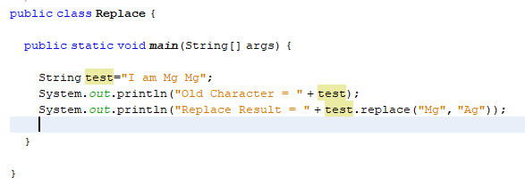

You will see a string that is announce “I am Mg Mg”. So that person want to change his name. so we don’t fix the original string. We just use replace method. So old character of the first is “Mg” to replace with a new character is “Ag”. If you run, you will see the changes as shown in figure.



“Mg” was replace by “Ag”. It is very simple to use. It return the the replacement new character as a string object and overwride it in the memory.

As an real world example microsoft word is the best example for using that method. So in microsoft word, in “Home” tab at “Editing“ place. You will find a “Replace” button. You will find a box. in that box you will see two input first is the old character second is the new character that you want to replace.



It is easy to use for the changes. For example an announcement of Gusto Institude. That announcement is too long and a owner want to fix the instutide to Collage. It is not possible to find and fix each word. So using replace method is the good way to solve the proble faster and very effective to use it. it can have less time and less worry. So I hope you will understand about the replace method.

## String replaceAll()

This method replace the character with all strings by checking with the regular expression. It return the new string of the replacement with the regax. It is the opposite of replace method. Here is a clear example.

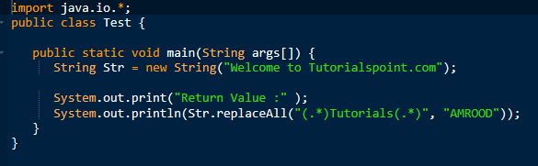

So a string is announce and it use the old character with the regax and the new character. If you run that the whole string is replaced with as shown in figure. Because of the regax.



So that will replaced instead of the old string.

As an real-world example, this is same with the replacement method (). It replace all with the regular expression. So I hope you will understand about the replaceAll method.

## String [] split (String regax)

This method is use to split the string into it sub strings which is based on the given parameter of regular expression. It return array of strings enusing splid as an input string on the regular expression. If the expression does not match any part of the string then the resulting array has just one element, namely this string. One more things we need to remember. We can’t make out put easily by using print. It will show you the memory address. Because it store in a array in a memory. So I hve to use moderanize loop to display out put. So here is clear example.

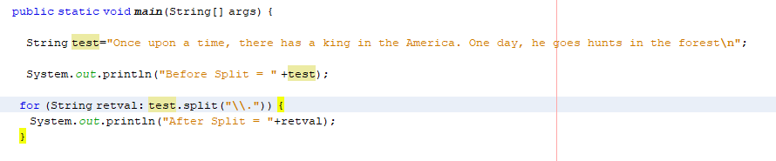

So here is a string that include with many texts that inclue full stop. So if you want to split you have to find a expression. In this case the expression will be full stop. So it will place in the regex in the split method by using modernize loop to deiplay instead of memory address. So it will split every full stop and display each sentences. So here is the out put of that expression.

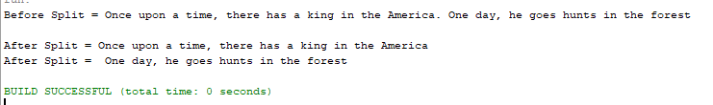

It will split the string as shown photos. The regex can use the regular expression like \\D,\\W and others regular expression.

As an realworld example, also with microsoft word. You will see the total word count on the left button. There is a word count to know for the user exactly.know the total. It is not possible to count each word by user. And we have to split the spaces in every words. So in the regular expression we have to place the “\s” to check the white space. It will split all word for each spaces. And we have to use string tonkenizer which is allow to break string into tokens. It return integer value for each words. So I use that object form split and it will add to count and display total coudt of words.

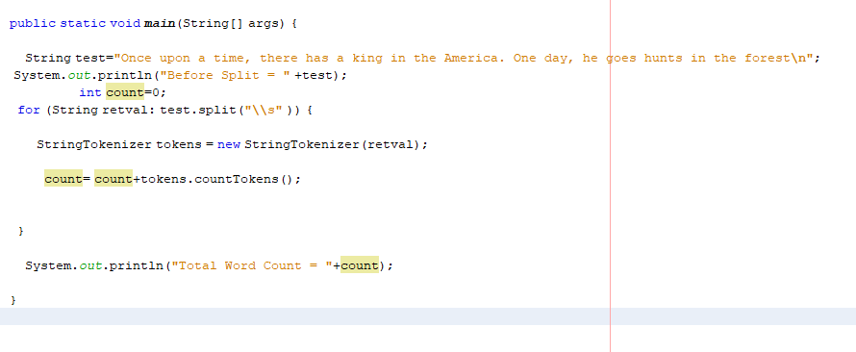

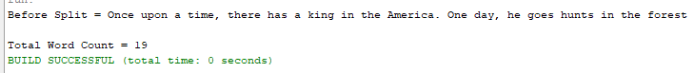

In Microsoft word it also ust that kind of logics to count word. I hope you will understand for split method of string.

## Int length()

It is a method which returns the length of string that is accept for string onjects of length and returns the integer or number of each character which has in string. It include white spaces which has in the string value. And also include the special character because they can accept as string in string value. So here is a example code.

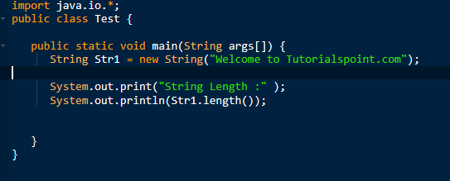

So you will see a string which is announce. So if you out put it with length(). It will show the total length of that string which will including with spaces.

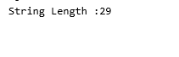

There is a out put of the string with return the integer value of the string length.

As a realworld example, it use to check the length of the string of the text box. We can assume that the tex box length is 0. There is no data. It means blank. If the length is 0 we have to assume it is blank. So user name can’t be blank in the realworld program. So if the staff skip it will save blank data of the user name. so it is a kind of technical term useage. But some of the text boxes have limitation. So it can show the limitation of text box data. For the limitation of the text box data it can show easily.

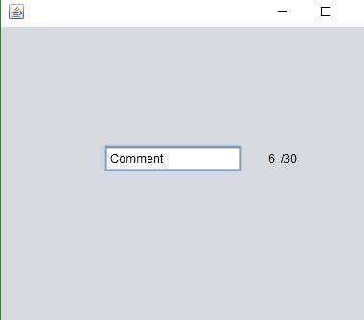

So user can know easily the limitation of letters. It can show the letter count to user if there has the limitaion of the letter. It use in comment session or the other place in the short description place.

## String concat()

This method is to combine the string value each other. And return the value of string with the value of string which placed in it's parameter to the end of the first string.

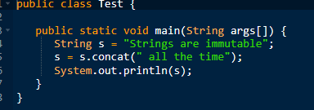

There is an example of code. You will see a first strin which announce with the variable. The string is doesn’t finish. So if you want to add use concat method to combine with the first string. If you use concat you need parameter of the string. And if you out put string with concat you will see combine of each string as shown in photo.



So if you want to combine each string you can use concat method.

As a realworld example, it can use with database. It is impossible of each string to combine from the database table in the program. It can use concat mentod to combine data from the database as a string. You can accept database data with string from the different table. So those data will combine as one strin with different database table. So it can combine database data in a progrma by using concat method.

## String matches()

It check the string value with the regular expression with will placed in the patameter. It returns the true of the the string is matches with regular expression. if not it return false. It use to check the string with the regular expression like for the name only accept alpabetic not for both numbers and special character. So here is an example.

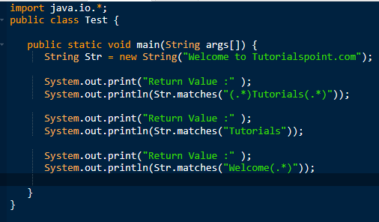

There is a string with include the matches method with the regax of (.*). That meanks it can match with the word with has in the regular expression. The parameter must contain regular expression in this match method. Because it need to check with the regex. If the String contain and match with the regular expression. It will return ture as shown in picture.



As a realworld example it use to check the input value of the test field in the program. For example NRC input text box. It can input number, characters and special character. It should be “12/YGN(n)123456” with the correct format. So it accept all format but it wrong. So we have to check with the real world format as I shown. So here is an example.

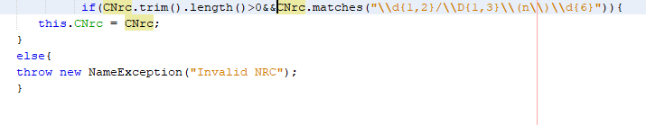

There is a regular expression in the parameter. If they did match with that it will show as shown in figure.

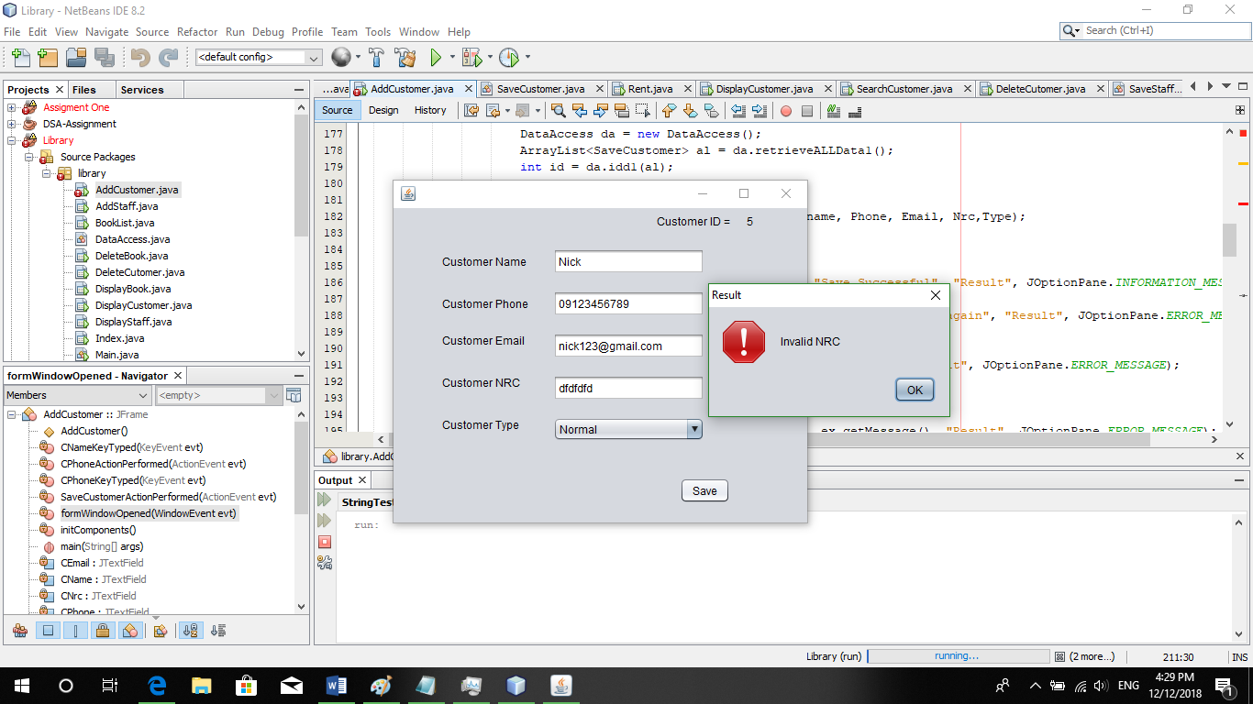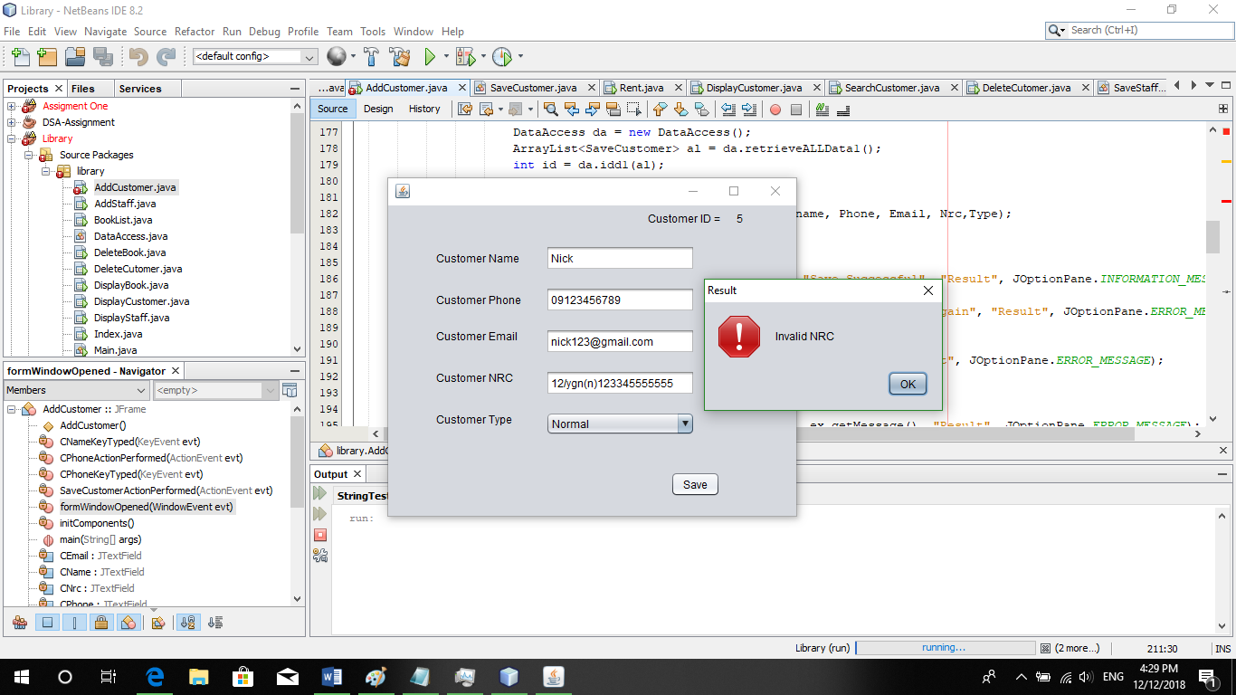

So if it’s match, it will save successfully. So it use to check the input with the realworld example. So I hope you will understand about the matches method.

## String trim()

This method delete the whitespaces form beginning of the string and the end of the string. It delete the whitespaces in the leading and endd of the string. So here is clear example.

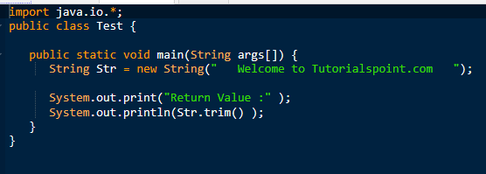

There is a white spaces in the beninning and at the end. So if you use that string with trim method. It will automtically delete the white spaces automatically and you will not see the whitespaces in the out put as shown in figure.



As a realworld example it can use to check the white spaces in the input value. The input value doesn’t contain spaces. For exampel in the name input text box. It shouldn’t contain whitespaces from the beginning and at the end. So if it placed spaces it shows errors.

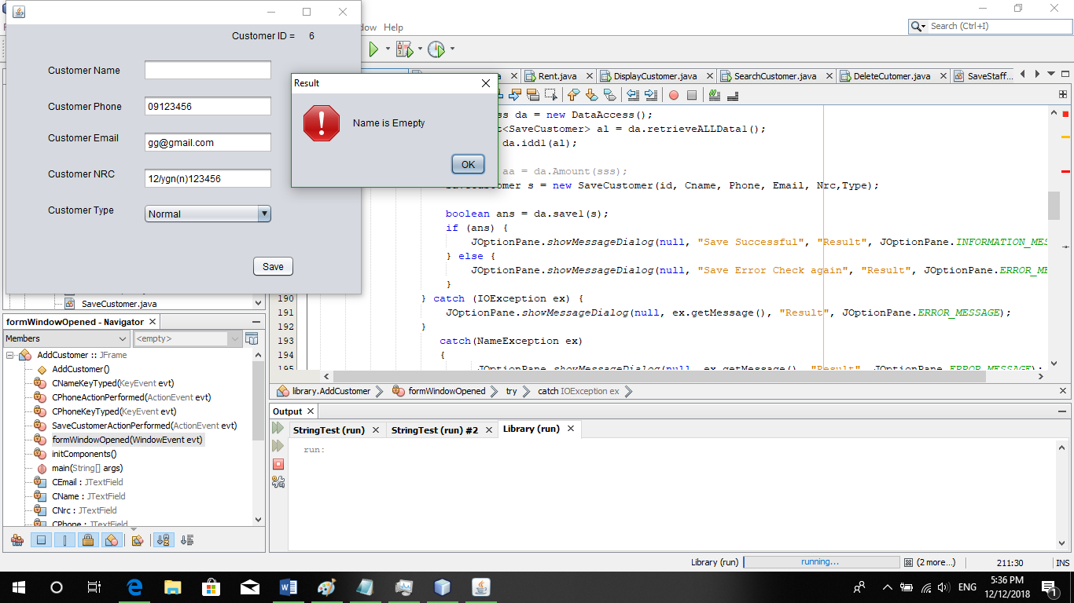

It is use to check the input values like name or others input values. So I hope you will understand about the trim method.

## boolean equalsIgnoreCase(String another String)

This method check the strin with another string by ignore the characters. It mean same length same character but only difference captical letter and small letters. i only ignore capital or small letter if the string is same length and same letter.

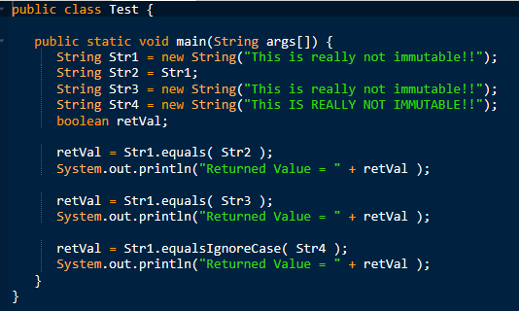

Here is an example for it’s method. It return true if the statement are correct. equalIgnoreCase is to check the same length but only ignore the string with the capital or small or letter.

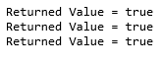

As the realworld example, in the searching place, it use. It select the data from the condition of the search box. The data can be the samll or capital. So staff or customer can’t know it easily. So in this case it can use equalIgnoreCase to check the data. It will ignore the small and capital letter of each letter. So user an type small or capitial to search.

## boolean equals(Object an object)

It check with the string with another string obje. It check same character, same length. It is the opposite of the equalIgnoreCase. it check with the capital and small petter. If all are correct it return ture if wrong, return false.

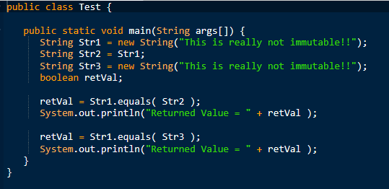

So there is an example, which contain the two strin with the letter. If it check the same length with the same letter condition as shown in upper fingure. If it’s true it return the true as shown in figure.



As an real world it use to match the password like retype- password or comfirm password. Those must have same length and same character. To idendify correct or not. So if you use equalIgnoreCase user can’t login any more. This case must use only equals method to check. It use password to check for the retype password.

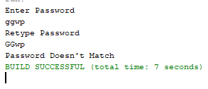 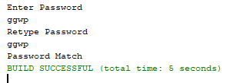

So I hope you will understand about the equals method.

## String toUpperCase()

This method is to change the all string value to the capital letter. It returns the strings by converting strings to the uppercase. It is easy to understand and use. Becaue it change the characters to the uppercase. Here is an coding example.

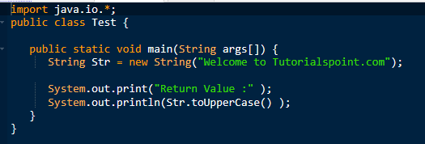

There is an example. A string is announce and it will used by toUpperCase method. So that that string will convert to the all uppercase character expect numberic and special character.



As an realworld example, if you want to change same data but for the capital letter, you can use this method. For example, NRC input. A policy change, from they use samll letter to reprresent their citizen. But now as a new policy, all business should change to upper case as a standard. So they don’t need to change all system. So with the program they select and accept as strings. And they can use toUpperCase and that new string will update in database. So they don’t need to change whole system with the new polocy.

## String toLowerCase()

This method is opposite of the toUpperCase method. Because it convert to the lowercase. And it returs a string by converting to lowercase. So here is an clear example.

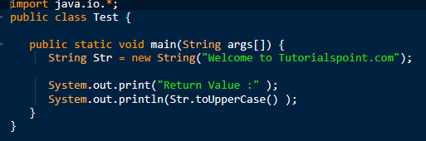

There is an example. A string is announce and it will used by toLowerCase method. So that that string will convert to the all lowercase character expect numberic and special character.



As an realworld example is with the toUppercase method example. As they convert string to lower case., so they will have same example in this session.

## String toString()

This method convert other variable to the string object. It doesn't have any parameter. It's return value is return string itself.

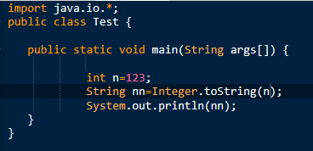

If you want to change integer value to string value. You can use toString. It will change integer to string object. So it can accept string value.

As an realworld example, you want to save data in the text file you ncan save data as a string. In your data, it might contain integer or other values like float, or boolean. In this case you can’t save data in save file. So by using toString method. All of the data are convert to the string value. So you can save it in the text file.

## String format()

It returns a string value as a format string with the agreement of their rules like \t,\d\n. It make the formatted output of the string. So here is a clear example with coding.

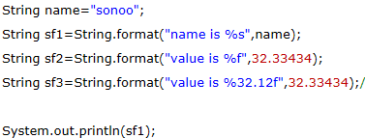

There are string with the formatted strings. Unlink print method. Print method can’t use that formatted sign. So if you want to use that signs. You should use format method.

As a real world example, it is a short form. You can use it to output with the formative like tabs, next line to clear to see the strings values. If you want to put the output with formatted, you can use format method.

## String join ()

It returns string value with join of each string in the parameter. It has parameter which will be a character to join each string value. The first parameter will be a character which make know that string is join. Here is clear code example.

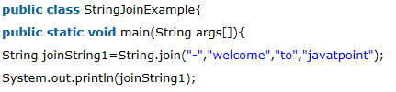

It will join which has in the parameter and separate with the first value of the parameter. If it’s output, it will join together. With using separating value of the parameter. As shown in photo.



As an real world example, it use to joint data from the database. It is same with concat method. But unlike method, it can easily know the separating because of the parameter. So it is a same example with the concat method.

These are all about strings and it’s method, I hope you will understand about that method.

------------------------------------------------------------------------------------------------------------------------------------------

## Preparation for Assignment (D1)

I have done the task 1 before the assignment. To explain about sorting and searching. But I can’t show it in the review session because of I haven’t add photos for the step by step of sorting. So I late review to teacher. But I can finish it before the review session. I do it because I know what will have in the assignment because teacher already told in class before. So I explain those types. But I haven’t prepare for the program. But I made it in time. I decided to choose sorting type and searching type. Because I have to think it and decide that I can do or not. So first I want to use quick sort in the program. But it is very difficult for me and I can’t catch it. I finish program in time because of all the code are done in module 1. So I don’t need to worry about the coding. And teacher said there will be also string class and string methods to evaluate in the assignment. And teacher also said to do in class with her. But unfortunately I can’t finish it even in the review session. So I tried to finish before dead line. Because that is fault. I bored in theory and I can’t finish it in time. Because it is very difficult to think about the real world example. And I have to learn about the strings because I don’t know. And I really don’t understand how they mean.

## Problems I Met

The main problems is that I can’t find real world example in internet. And the problems is I don’t know how to sort and delete txt fine data and how to sort by name. So for the program I asked help to internet. I test it many and many ways. It take a week to know about the delete. I know the process. But I don’t k now what code is applied to delete. And another problem is teacher doesn’t allow to draw flowchart after code. I only worry about sorting in flow chart might wrong. But I tried to draw it and trace. As my side it correct. I worry about wrong statement in the flow chart. And I applied coding in program unfortunately, my net beans is out of date and it can’t apply compare to method. So I find solution and I just need update to use it. I don’t know what the problem is. But when I update it, it comfortable with the program.

Unfortunately things is, my windows system was down. I think all data are gone because I did it from the problems and less sleep night. I was disappointed because about 2 days I can’t give time with all assignment including this assignment. And I have no idea about that. But after two days, I can recover my data. And I really happy. Because I did it very tired and less sleep night. And I met problems from choosing fifteen string methods. Because explaining theory is easy but evidence with real world example is very difficult. And some of the example are just for the technical term and some of the example are repeat with each other. So I take time for that and I continue with very comfort mind. But I finished it in time before dead line.

## What I’ve learnt

I’ve learnt about the sorting and how algorithm is important. It is important if I want high rank in a company. And I know how algorithm work and in a program the performance things is algorithm. It can make program better than the normal like in online call. They can clear noises. Because of the algorithm they can clear surrounding noises. So in a program I know how algorithm is important and I know how to implement algorithm. And also for the searching algorithm. Instead of checking data with each line and checking with other way can get more performance in searching that I know. And they are many searching algorithm by researching about the search algorithm for this assignment. But I have to choose easy and effective searching algorithm for this assignment although I want to choose all. Because of assignment rule, I forgave other searching algorithm. But I don’t give up. I try to research other type of algorithm after I finish this assignment.

All of I learnt are good point because they can help me to get a good job if I know about the algorithm. Is there any problem I don’t know about the algorithm. There has no problem. But you should know about the algorithm for the basically. If you know about the algorithm it is easy to think about the whole program. You can create own algorithm instead of using plug in algorithm. It seems that you are a professional programmer if you understand about the algorithm. That word is I heard from my class teacher. I have learnt many news things about this assignment and I met with many terrible problems. As I bored in theory, I don’t want to do DSA. But I have to pass this subject. So I have to do it and some of the parts are interesting for me.

------------------------------------------------------------------------------------------------------------------------------------------

## Schedule (D2)

|  |  |  |
| --- | --- | --- |
| No | Date | Description |
| 1 | 10 Nov 2018 | I start DSA assignment and researching about sorting algorithm |
| 2 | 12 Nov 2018 | Draw own step by step sorting of Quick sort and Merge sort |
| 3 | 15 Nov 2018 | Continue for sorting |
| 4 | 19 Nov 2018 | At that day I finish of sorting algorithm and continue to searching algorithm |
| 5 | 25 Nov 2018 | Start Implementation for the program |
| 6 | 27 Nov 2018 | Research for the recursive algorithm |
| 7 | 1 Dec 2018 | Apply for the flowchart and combine all task and send to teacher |
| 8 | 11 Dec 2018 | Continue implementation for the program and only left staff data |
| 9 | 12 Dec 2018 | Continue program and Do task 3.1 |
| 10 | 13 Dec 2018 | Continue task 3.2 and do D1 and D3 |

Time scales are very closed to me. But it can’t effort. I have to do even I bored. The problems are there that I met in D1 point. Because of the time, I bored and I don’t know what to do. And I didn’t some tasks in the review session. That is my error and that is my boring fault. Actually DSA subject is easiest subject in module 4. Because of theory, my schedule is very closed. So I have to worry about the pass point. But I did my best.

------------------------------------------------------------------------------------------------------------------------------------------