# How they tried for tank?

Tanks are famous in World War I. In that face, tanks are more bigger than this days and less performance. But tanks are become a mainstay of ground battlefield armies. Britain, France and Germany find out ways to build a tank. They think about the basic principle such as armour, firepower and mobility of the tank. As an initial tank by Britain, named Little Willie which was constructed by William Foster Company. They design a tank and named Mark I and it was test by British Army. They spend over one year to finish first tank.

They use many works and many electronic, construction engineers, designer to make a tank. At that time, there is no technology like now a days. They use many iron materials to make body, and Chains are also made by hand. And they think about the where to place engine, because engine is too hot so and they find how to make cooling system. They tried many ways to put the torrent. Torrent can only use for front. They can't turn around. And the materials which tank use is too thick and heavy so engine is too slow. After one year later, Mark I tank is finish and tested by British Army. At that time, that kind of tank is very useful for attack and defense. In that one years, they face with many problems, lacking ironing. And the torrent. They also think about the control direction. Because that days was only cars and they have to think the control direction. And the petrol state. Tank need more petrol than the others. But there is no digital technology. If they want to shoot the look outside of the tank. They use, any handmade workers to finish a tank.

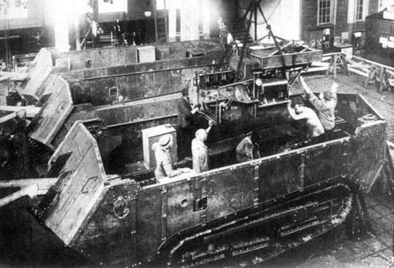

Tank construction

They tried many steps with several workers. They use handmade crane to carry heavy materials. Because there has no modern technology human only do all the work. Such as build a body, connect wire and so on. The problem is that they couldn’t finish in time all tanks. And they faced with the riot with the workers.

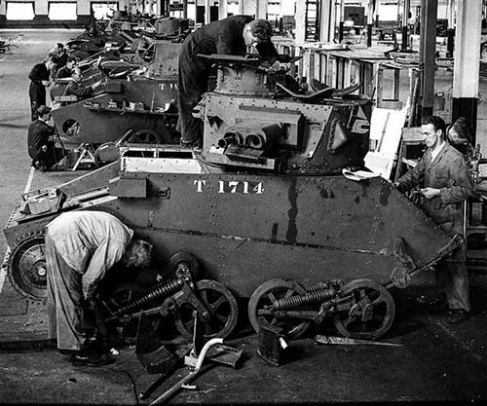

Build a tank without machine

Because of their power and policy workers can’t agree for over working. And country didn’t give worker salary enough and the economy of the country is very bad at that time. So sometimes lacking irons to continue build a tank. And workers also ran away from factory and other show their wish on the road. So riot appear and some of the tanks are doesn’t finish in WWI. Workers wants same freedom and they don’t want over working for that job even they didn’t give salary enough.

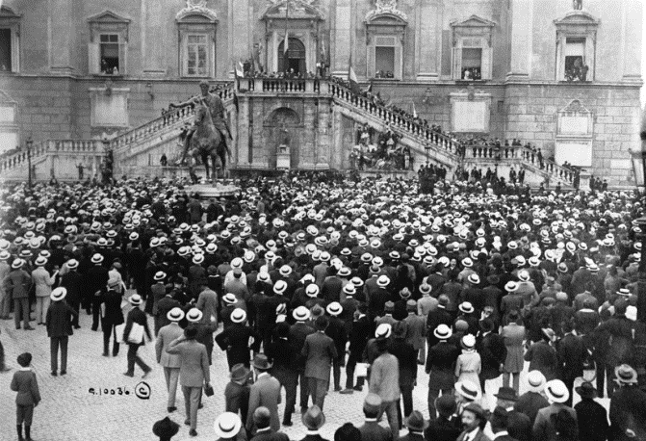

Workers riot

In 1914, WWI started. After finish WWI. They know how to modify for tanks and they invents crane and other machines that help to build tank. But one of the problem is that it is also need workers. One of the solution that they made is not to have over working for the workers. And if workers work in factory, they will have responsibility to have good attitude to workers like in lunch time, they will give lunch for workers. It is very effective way and the riot can reduce and tanks are finish in time before WWII.

In World War II They know about the fault and designs are very good and improved performance. In WWI some of the tanks are doesn’t finished in time because of the technology lacking of budget and materials. In WWI some technology are improved. Torrent can turn 360 degree and engine power also improved. And they finished all tanks in time for the battle. Before WWII Germany, France, British, Spain, China, Korea and many countries which take part in WWII already had tank industrials. And they invent rock, iron melting machine to get more materials for tanks. Designers, engineers are improve performance for tank. So these facts are the how they tried for tank. I hope you will understand of their work.