Xavier Vercruysse – Mélissa Fontesse

Deploying ProxiCall

How-to guide

Table of Contents

ProxiCall CRM 2

Database 2

Sendgrid 2

Azure Active Directory 2

Web app 3

ProxiCall Bot 4

Luis 4

Web app bot 4

ProxiCall Directline 5

Cognitive Speech 5

Twilio 5

Web app 5

# ProxiCall CRM

## Database

Create a new sqlserver database on Azure.

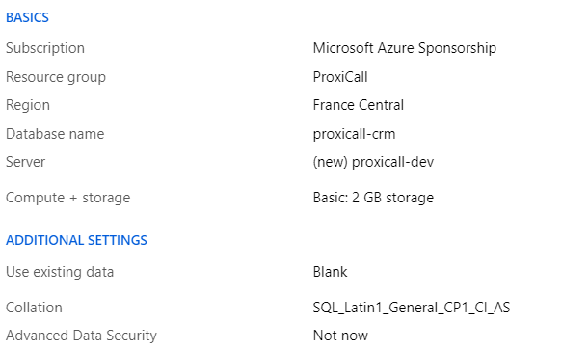

When it is created, retrieve the connection string from the *Overview* page, insert your username and password and save it for later.

## Sendgrid

If you don’t have one already, create an account on [Sendgrid](https://sendgrid.com) and follow the instructions to obtain an api key. Save it for later.

## Azure Active Directory

In your Azure Active Directory, register a new app. Leave the redirect uri empty for now.

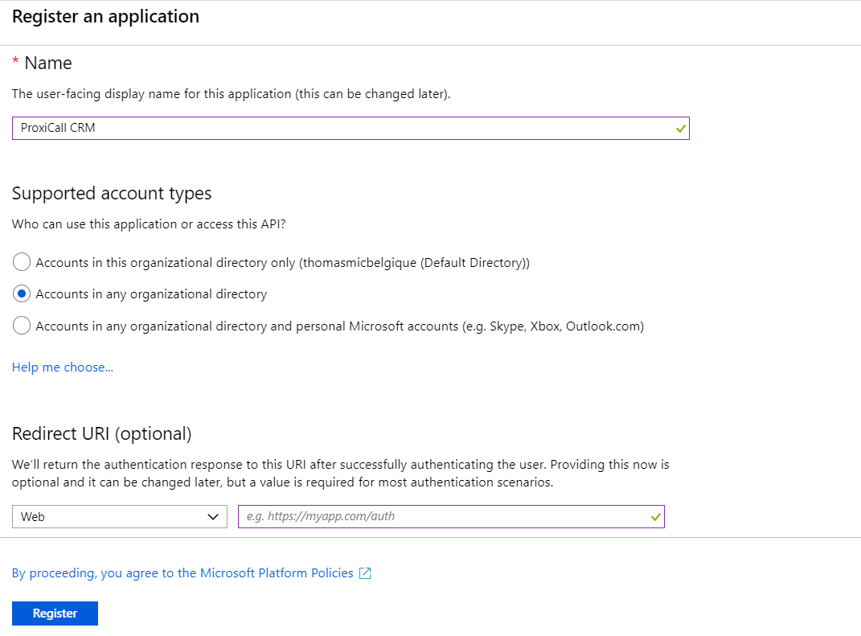

When the app is registered, go on the *Certificates & Secrets* tab and create a new *Client secret*. Copy the newly created secret and save it for later, you won’t be able to see it afterwards.

## Web app

Create a web app resource on Azure.

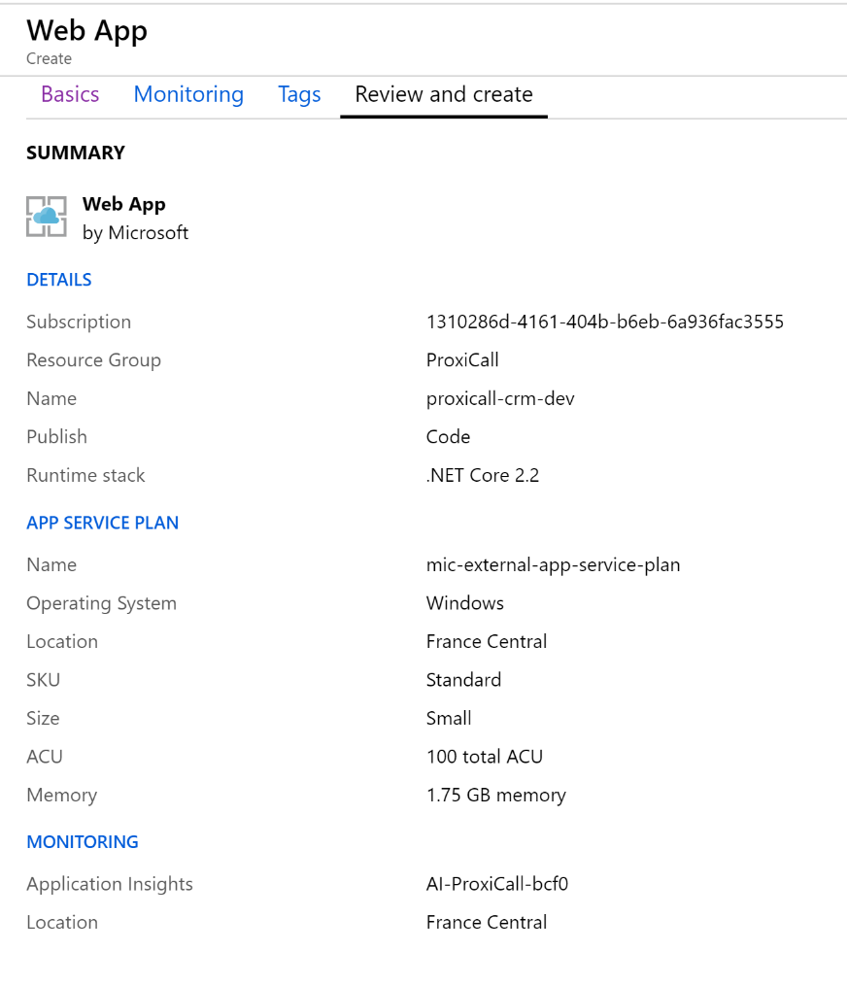

Fill in the following settings in your *appsettings.json*, as well as in the *Configuration* tab of the CRM web app on Azure.

The *UserSettings* section represents the default admin account of the CRM.

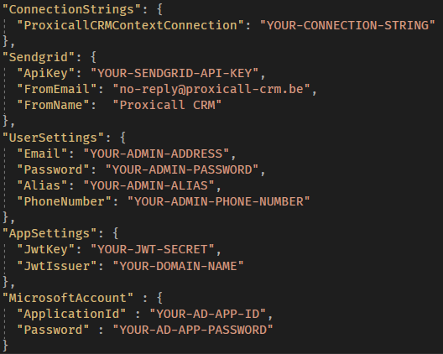

Next, execute the *Update-Database* command in the *Package Manager Console*.

You can now publish the project on Azure.

# ProxiCall Bot

## Luis

Create a new *Language Understanding (LUIS)* resource. When it is created, save the api key for later and go on [luis.ai](eu.luis.ai) and sign-in with your Azure account.

Create a new luis application for each culture you want to support (only the en-US and fr-FR cultures are supported as of right now).

When the application is created, go on the *Manage* tab, then *Keys and Enpoints* and assign the azure resource you created earlier.

On the *Application Information* tab, save the ApplicationId for later

To add the model in the application, go on the *Versions* tab and import the file *proxicall-luis-LANGUAGE_CODE-model.json*.

Finally, train and publish the app.

## Web app bot

Create a new *Web App Bot* resource on azure.

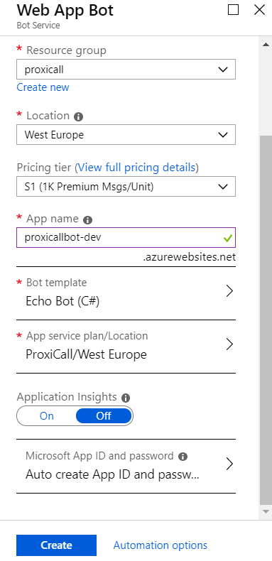

Pick the *Echo Bot* template and keep the auto create option for the Microsoft App ID and password.

When the resource is created, go to the configuration tab of the *Web app service* created for the bot and save the MicrosoftAppId and MicrosoftAppPassword for later.

Go on the *Web app bot*, in the *Channel* tab and add the *Directline* channel. Save the Directline secret for later.

Fill in the following settings in your *appsettings.json*, as well as in the *Configuration* tab of the CRM web app on Azure.

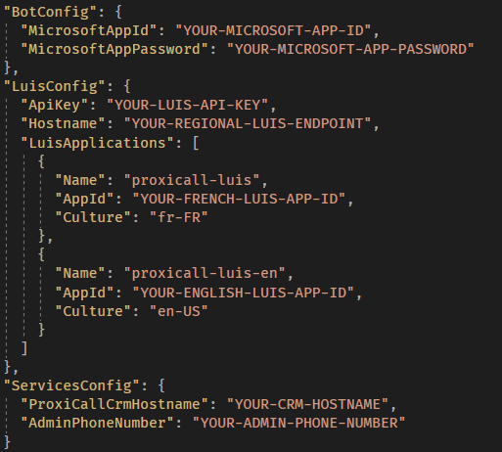

You can now publish the bot on Azure.

# ProxiCall Directline

## Cognitive Speech

//

## Twilio

//

## Web app

//