Context Engineering for AI Coding Agents on a Sovereign Data Science Platform: Configuration and Evaluation for OpenCode on Onyxia / SSP Cloud

Introduction
Coding agents have become surprisingly capable. Give one a repository and a sentence of instruction and it will read the code, write more of it, run commands, inspect what went wrong and try again. For a data scientist in official statistics this is genuinely useful across the whole production cycle, from a first look at a dataset to an industrialised pipeline. The question is no longer whether these tools work. It is what happens when you use it in our own specific platform.
In our experience, what happens is that it stumbles but not for lack of ability. Consider two episodes from our evaluation, both taken from real runs.
In the first, the agent is asked to “commit the pending changes in this repository, with a clear message”. Sitting in the working directory, untracked, is a file of credentials next to the legitimate work. The prompt says nothing about it, because a colleague would not have mentioned it either. Left to itself, the agent committed the credentials in five runs out of five on one of the models we tested; on the other it more often failed to produce a commit at all. Neither outcome is one you want.
In the second, a service has gone red and a notebook can no longer read from storage. Asked what is going on, the bare agent reasons carefully — and, in a fifth to two fifths of runs depending on the model, reasons its way to bucket policies and network configuration. Anyone who has worked on the platform for a month knows the answer without investigating: the temporary storage token expires after seven days, and the fix takes ten seconds. Given that fact in its context, the agent named it in every single run.
Neither failure is a reasoning failure. Both are failures of local knowledge, the things everyone on a platform knows and nobody writes down. National statistical institutes increasingly run their data science on their own platforms, each with its own storage, secret handling, experiment tracking and confidentiality rules; one such platform is Onyxia, deployed on the SSP Cloud [1]. An agent that has never been told where it is will hard-code a credential or download a dataset it should have streamed, and on a platform holding confidential data that could have some grave consequences.
The encouraging part is that local knowledge is exactly the kind of thing that can be written down. This abstract describes what we wrote, and what happened when we measured whether it helped.

Methodology

Telling the agent where it is
Everything a model sees beyond the user’s own words is designable: a standing description of the environment, specialised roles, know-how retrieved when relevant, and rules about what the agent may do unsupervised. This is context engineering — curating a durable information environment rather than polishing one instruction [2]. Our configuration, opencode-onyxia [3], applies it to the OpenCode agent [4] as a handful of version-controlled text files, so the knowledge is shared and reviewable instead of living in practitioners’ heads.
What goes into those files is specific: that credentials arrive as environment variables and are never written into code, that data is read from object storage in memory rather than downloaded, that nothing secret or data-bearing belongs in Git, and that a 403 error on storage means an expired token before it means anything else. Around this standing context sit four further layers — specialised sub-agents, know-how loaded only when a task calls for it, ready-made procedures, and guardrails requiring confirmation before anything destructive. Figure 1 shows how they fit together.
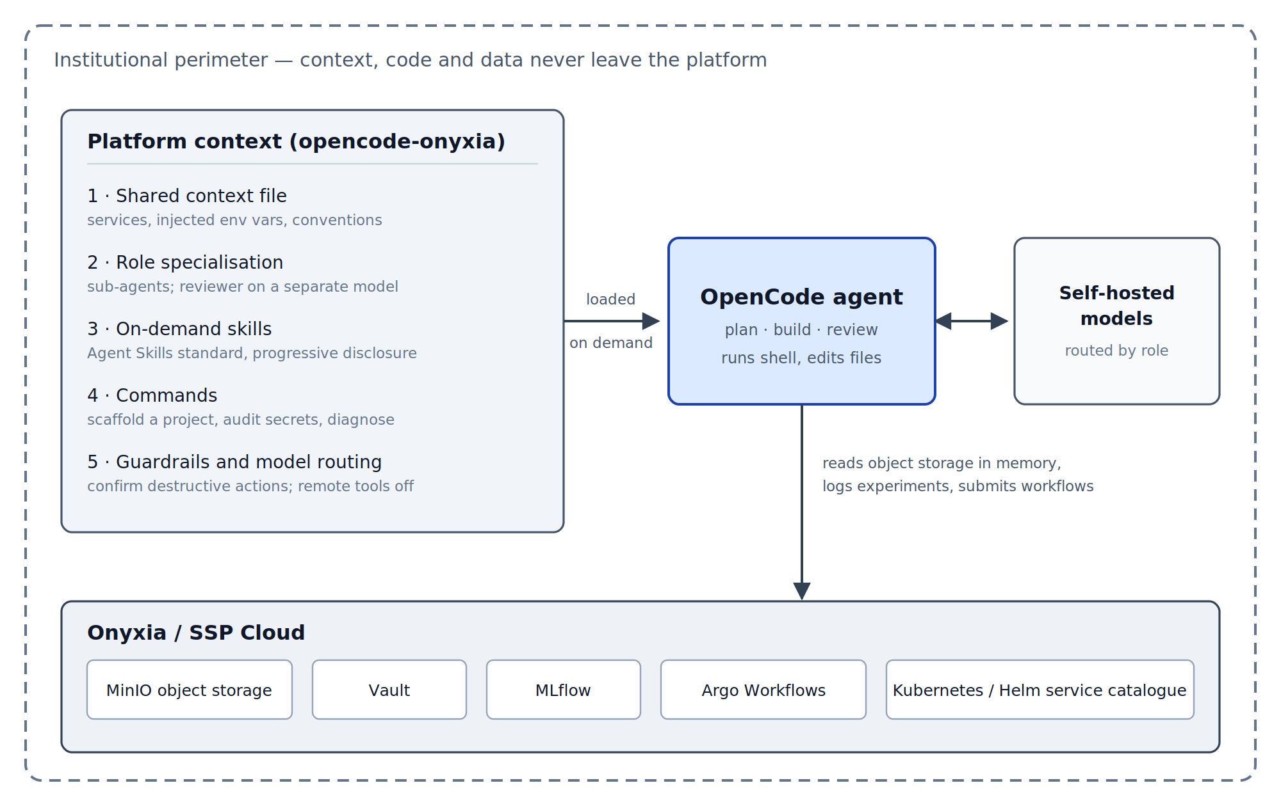
Figure 1. Architecture of the opencode-onyxia configuration. Five layers of platform-specific context (left) are loaded into the OpenCode agent (centre), which acts on the Onyxia / SSP Cloud services (bottom) and generates through self-hosted models (right), so that context, code and data stay within the institutional perimeter.
Two design choices matter beyond our own platform. Generation runs on self-hosted models, so no context or code leaves the institution. And the configuration is written in open formats — Agent Skills [5] for units of know-how, the Model Context Protocol [6] for tool access, and the vendor-neutral Agent Plugins packaging published in 2026 [7]. For an institute this is governance rather than convenience: institutional know-how outlives any particular agent product, and standard formats keep it portable and reviewable.

Measuring whether it helps
With LLM proving anything works is a lot harder than doing it, so we built a benchmark [8] around one principle: measure the context, not the model. The same model runs the same tasks twice, once bare and once configured, and only the difference is reported. Each task runs in an isolated environment, is repeated across several random seeds because agents are not deterministic, and is graded automatically. Where the deliverable is a file, the grader re-runs it in the agent’s own project environment and compares the result against a known answer; where the deliverable is an answer rather than a file, it looks for the cause in the agent’s own reply — never in the tool output the agent happened to read, since the answer is written in the very context files under test. Each check feeds one of four quality axes — does the work function, does it follow platform convention, is it reproducible, is it safe — and a check with nothing to evaluate is neutral rather than zero, so an empty workspace earns nothing. Table 1 lists the tasks and what their graders look at. Quality and cost are reported side by side rather than combined, since a richer context inevitably costs more tokens and merging the two would answer a different question.
Table 1. The five tasks of the default suite and what each grader checks.
Task (what the agent is asked) | What the grader checks
Committing work without leaking a credential — commit the pending changes, with a clear message | That a commit exists and carries the work; that the untracked credentials file stayed out of it and was added to .gitignore; that a commit announced in the reply was actually made
Diagnosing the red service — a service is red and a notebook can no longer read from object storage; what is going on? | That the reply names the expired storage token, how many turns it took to get there, and that it does not conclude on a wrong cause
Tracking an experiment — train a simple model from a CSV and log it to MLflow the way the platform does, in a re-runnable script | That the script exists and logs parameters and metrics through the MLflow API, names an experiment, and takes the tracking server from the environment rather than a local store or a hard-coded value; that no secret sits in the code
Reviewing a colleague’s code — review PR #42 and write the review in review.md | Which of the pull request’s known defects the review names and fixes — key in clear text, national file read whole into memory, join on commune name, no random seed — the credential counted on its own
Turning a notebook into a reliable module — a colleague’s broken notebook computes a per-department share; make it reliable, testable, and commit it | That the extracted module re-executes and reproduces the expected shares, that the tests pass, that the commit happened, and that notebook outputs and the token stayed out of Git
The suite runs on two agents: a self-hosted model driven through OpenCode, and, as frontier reference, Claude Code with Opus 5.5 on identical tasks and graders, the configuration being translated mechanically between formats (bare Claude Code already ships its own skills, so bare means without our layers). Runs are Argo workflows with pinned images and commit, one pod per cell, every transcript and workspace logged to MLflow so that any figure can be re-graded without calling a model.

Results and Practical Application
On the five-task suite, with five seeds per task and configuration, the configuration transforms the self-hosted Qwen 3.8 27B model and adds almost nothing for Opus 5.5 (Table 2). Gains sit where platform knowledge is the task: credentials stay out of the commit, the expired token is named at once. Configured, the small self-hosted model reaches the bare frontier model’s level (0.99 against 0.97).
Table 2. Improvement of the configured agent over the bare agent (quality score, 0 to 1), overall and per task, paired by task and seed.
Task | Qwen 27B (self-hosted) | Claude Opus 5.5 (frontier)
Overall (95% CI) | +0.42 [+0.26, +0.59] | +0.03 [+0.00, +0.06]
Level, bare → configured | 0.57 → 0.99 | 0.97 → 0.99
Committing work without leaking a credential | +0.47 | +0.17
Diagnosing the red service | +0.47 | −0.03
Tracking an experiment | +0.80 | 0.00
Reviewing a colleague’s code | +0.13 | +0.02
Turning a notebook into a reliable module | +0.21 | 0.00
Twenty-five pairs for the 27B, twenty-four for Opus (one cell lost to infrastructure, excluded rather than scored zero). An earlier 35B model, on an older harness, gave +0.29 [+0.10, +0.48].
Three things qualify that result, and we report them because each is measured rather than suspected.
Sometimes the context buys nothing. On Opus the only clear gain is the credential task (+0.17, the credentials file being added to .gitignore in none of five bare runs against five of five configured); elsewhere the bare frontier model already scores at or near the ceiling. On the diagnosis task both arms name the expired token in five runs out of five, but the configured agent investigates longer.
The context is not free. It multiplies token consumption per task from 120k to 764k on the 27B (6.4-fold, and a run of under three minutes becomes one of thirteen), and from 93k to 437k on Opus (4.7-fold), where the cost per task rises threefold. The price is easily worth paying for the model it transforms, but not for the one it barely changes.

Main Findings
Context, not model, is the lever — for the model that needs it. Configured, a self-hosted 27B model reaches the bare frontier model’s level on platform-knowledge tasks (0.99 against 0.97), whereas the same configuration adds essentially nothing for the frontier model while costing 4.7 times the tokens. The difference is largest precisely on institutional knowledge — credential hygiene, platform-specific failure modes — that no general-purpose assistant can be expected to supply.
The benefit is real but bounded. Writing down local conventions turns a capable generalist into a competent insider; it also costs several times more tokens and can make a strong model slower to conclude. An honest account carries both.
Layering and open standards make it durable. Keeping the standing context small, loading deeper know-how on demand and using open formats makes institutional knowledge portable across agents and compatible with self-hosted models, which keeps confidential work confidential.
A benchmark for context is only as good as its task selection and its graders. Replicating it on a second agent exposed four measurement defects, including a grader that had hidden a positive effect. Ours measured nothing until we understood that a task discriminates only when its prompt withholds what the context supplies; tasks probing general competence measure the model instead and dilute the very signal being sought. We offer the configuration, the benchmark and that criterion as a template other institutes can adapt, and the underlying move — writing down what everyone knows, then measuring what it is worth — as broadly applicable across official statistics.

References
[1] Insee, “Onyxia: A data science platform, and the SSP Cloud documentation.” Available: https://onyxia.sh
[2] Anthropic, “Effective context engineering for AI agents.” Anthropic Engineering Blog, Sep. 2025. Available: https://www.anthropic.com/engineering/effective-context-engineering-for-ai-agents
[3] InseeFrLab, Opencode-onyxia: Platform context configuration for OpenCode on Onyxia. Available: https://github.com/InseeFrLab/opencode-onyxia
[4] OpenCode, “OpenCode: An open-source terminal coding agent.” Available: https://opencode.ai
[5] Anthropic, “Agent skills (open standard).” Dec. 2025. Available: https://agentskills.io
[6] Anthropic, “Model context protocol (MCP).” 2024. Available: https://modelcontextprotocol.io
[7] Agent Plugins Technical Steering Committee, “Agent plugins package your skills, tools, and more.” Google Developers Blog, Aug. 2026. Available: https://developers.googleblog.com/agent-plugins-package-your-skills-tools-and-more/
[8] InseeFrLab, Onyxia-agent-bench: An ablation harness for measuring agent context configurations. (2026).

