Quickstart — from box to dashboard in ~10 minutes
This gets you capturing live Zigbee traffic with names, a routing map, and diagnostics. For the
full tour see the [User Guide](user-guide.md).
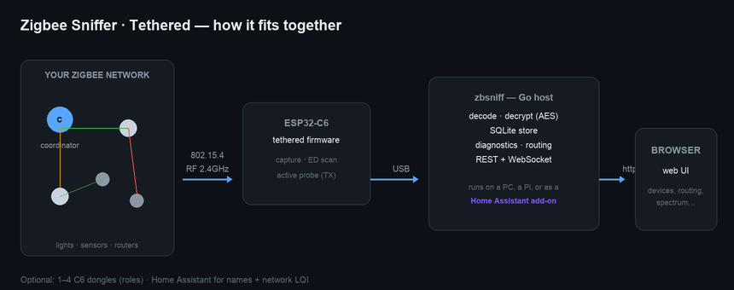

What you need
- An ESP32-C6 dev board (e.g. ESP32-C6-DevKitC-1). *Not* a C61 — that has no 802.15.4 radio.
- A USB-C cable and a computer (macOS/Linux/Windows, or a Raspberry Pi / Home Assistant host).
- [PlatformIO](https://platformio.org/) (VS Code extension) to flash the firmware, and Go 1.25+
to build the host — or use the prebuilt Home Assistant add-on (see step 4b).
- *(Optional but recommended)* a ZHA backup from Home Assistant — it carries your network
channel, PAN id, network key, and device names so everything auto-configures.
No hardware yet? Skip straight to ./zbsniff --demo (step 3) — a fully simulated network
(a home mesh, a Philips Hue network, and a foreign neighbor network on another channel) lets you
explore every tab with no C6 required. A DEMO MODE badge stays visible the whole time so it's
never mistaken for a real capture.
────────────────────────────────────────

1 · Flash the firmware onto the C6
Plug the C6 into USB, then:
cd firmware
pio run -e tethered -t upload
Use the board's USB port (the native-USB connector, not the UART one) if it has two. This same
command reflashes later — the on-board OTA partition table is installed on this first flash.

2 · (Optional) Grab your ZHA backup
In Home Assistant: Settings → Devices & Services → Zigbee Home Automation → ⋮ → Download backup.
Save the .json file. It's the easiest way to get names + the network key + channel.

3 · Build & run the host
cd tether
go build -o zbsniff ./cmd/zbsniff
./zbsniff --zha-backup "ZHA backup ….json" # auto: channel, PAN, key, names
No backup? Point it at your network manually:
./zbsniff --channel 20 --key 0123…ef # channel + network key (hex, optional)
zbsniff auto-detects the C6's USB port. It also remembers your settings in zbsniff.yaml
(secrets encrypted), so next time just run ./zbsniff.
No C6 at all? Run ./zbsniff --demo instead — no port, backup, or key needed. The same thing
happens automatically (after asking first) if zbsniff can't find a C6 within a few seconds; a
banner offers Retry or Enter Demo Mode, so a slow-to-enumerate real device is never
silently mistaken for "no hardware."

4 · Open the dashboard
Browse to http://localhost:8080. Within a few seconds you should see:
- top bar: ● receiving from device and ● capturing · ch N
- Overview tab: devices filling in, and a routing tree growing toward the coordinator
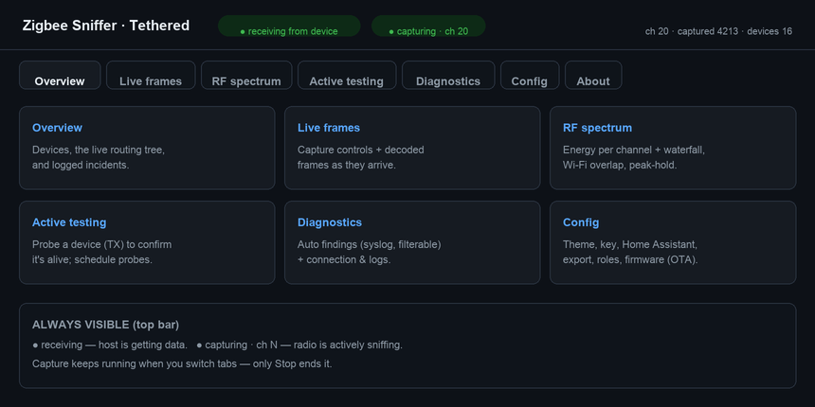

4b · Prefer to run it inside Home Assistant?
Install it as an add-on instead of running the binary — see [deployment-addon.md](deployment-addon.md).
The UI then appears as a sidebar panel; the C6 plugs into the HA host's USB.
────────────────────────────────────────

5 · First things to try
- Overview — click a device to open its detail drawer (signal, messages, a "Probe now" button).
- RF spectrum → Scan once — see energy per channel and where your Wi-Fi sits.
- Diagnostics — automatic findings; the Silent device category is your dropout radar.
- Config → Home Assistant — enter your HA host + a long-lived token to get friendly names and
the network's own Net LQI (see Two signal readings below).

Two signal readings (important!)
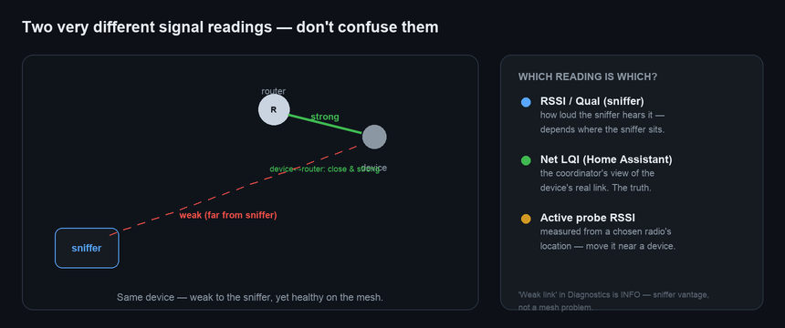
The RSSI/Qual ⌖ columns are what *your sniffer* hears from one spot — not the device's link
to its router. A device can look "weak" to the sniffer yet be perfectly healthy on the mesh. Connect
Home Assistant to see Net LQI (the coordinator's real view), or use Active testing to probe
from a radio placed near the device.
────────────────────────────────────────

If you see "host up — no device data"
If a no hardware found banner offers Retry/Demo Mode instead, your C6 just hasn't enumerated
yet — try Retry first. Otherwise, open Diagnostics → Connection & logs:
- 0 bytes → wrong USB connector (use the native-USB port), or another zbsniff is holding the
port. Hit ↻ Reconnect.
- bytes but 0 frames → firmware/protocol mismatch — reflash (step 1).
- captured stops climbing → reflash; older firmware had an RX-buffer stall (fixed).
More in [troubleshooting.md](troubleshooting.md) and the [User Guide](user-guide.md).

