User Guide
The complete guide to the Zigbee Sniffer & Diagnostics web interface. New here? Start with the
[Quickstart](quickstart.md), then come back for the details.
Contents
- What it is
- The interface at a glance
- The top bar
- Demo mode
- Overview tab
- Live frames tab
- RF spectrum tab
- Active testing tab
- Diagnostics tab
- Config tab
- About tab
- Key concept: sniffer vs network signal
- Key concept: radio roles & allocation
- Workflow: diagnosing dropouts
- Firmware updates (OTA)
- Configuration & security
- Troubleshooting
- Command-line reference
────────────────────────────────────────

What it is
A full 802.15.4 sniffer and diagnostics platform: an ESP32-C6 captures the air, a single-binary
Go host (zbsniff) decodes/decrypts/stores it and serves a web dashboard. Built to hunt down
the classic problem — *devices that go unresponsive until you power-cycle them.*
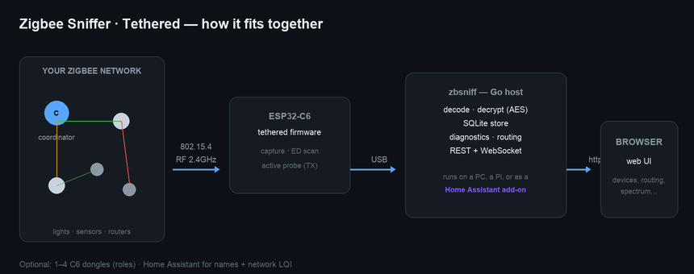
It runs anywhere the binary runs — a laptop, a Raspberry Pi, or **inside Home Assistant as an
add-on** (see deployment-addon.md).
────────────────────────────────────────

The interface at a glance
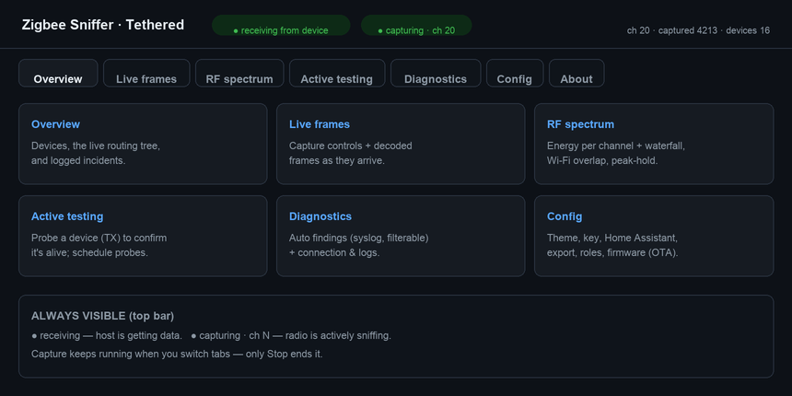
The app is organised into tabs. Capture runs on the device, so it keeps going when you switch
tabs — only Stop ends it.
────────────────────────────────────────

The top bar
Always visible, on every tab:
Indicator | Meaning
● receiving from device (green) | the host is getting data over USB. Grey/"host up — no device data" means the serial link is down — see Troubleshooting.
● capturing · ch N (green, pulsing) | the radio is actively sniffing. Amber "capture mode · no new frames" = quiet or stalled; "◐ ED sweep" = spectrum scanning; "■ idle/stopped".
ch · captured · dropped · devices | live counters. captured should climb steadily on an active network.
decrypting | the network key is loaded and payloads are being decoded.
────────────────────────────────────────

Demo mode
No C6 handy? ./zbsniff --demo runs the exact same dashboard against a fully simulated network —
useful for exploring the UI, taking screenshots, or a walkthrough with no hardware in the room.
It activates two ways:
- `--demo` on the command line — starts in demo mode immediately.
- Automatically offered if zbsniff can't find a C6 within a few seconds — a banner offers
Retry (keep searching for real hardware) or Enter Demo Mode, with a confirmation before
switching. It never silently substitutes simulated data for a real device that's just slow to
enumerate.
A purple DEMO MODE — simulated data badge stays in the top bar the entire time, so simulated
and real captures are never mistaken for one another.
What's simulated:
- A 13-device home mesh (coordinator, routers, and end devices spread across rooms) generating
realistic sensor reports and the occasional coordinator→device command, decrypted through the
same crypto pipeline real traffic uses.
- A Philips Hue network (a bridge + 3 bulbs) as a foreign network, plus a **second foreign
network** on a different channel — both populate the Networks tab and foreign-device list the
same way a real neighboring network would.
- Home Assistant and Hue integration data — friendly names and device counts, consistent across
refreshes rather than randomized each time.
- RF spectrum — Scan once and Continuous both work, with a realistic bursty energy pattern
(channels under the simulated networks read hot only some of the time, like real intermittent
Zigbee traffic, against a quiet noise floor elsewhere). Starting a continuous sweep takes over a
radio exactly like it would on real hardware — that radio stops "capturing" for the duration.
Device identities, PANs, and channels stay stable for the life of the process — only traffic counts
and RF readings vary — so it behaves like a consistent physical layout rather than re-randomizing on
every page load.
────────────────────────────────────────

Overview tab
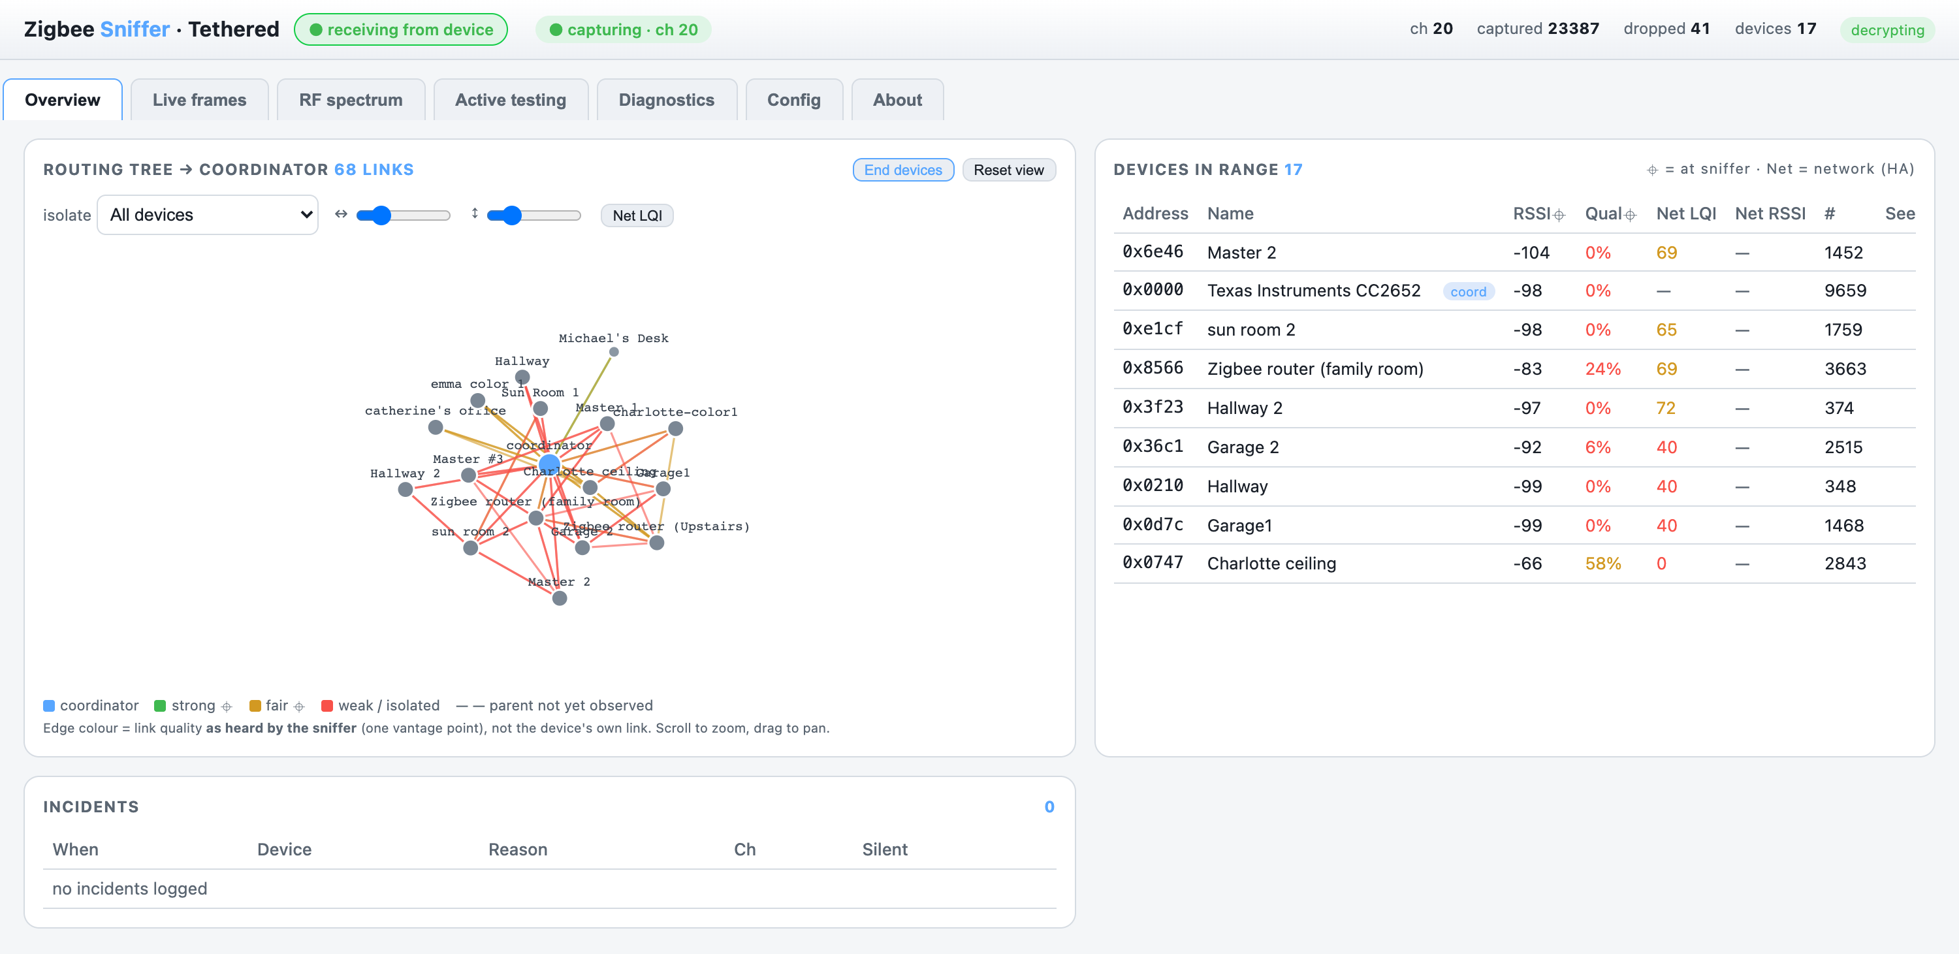
Your home base — three panels:
Devices in range. Every device the sniffer has heard, with:
- RSSI ⌖ / Qual ⌖ — signal *as heard by the sniffer* (the ⌖ marks "at the sniffer").
- Net LQI / Net RSSI — the coordinator's own view (needs Home Assistant; often only LQI is
reported). See sniffer vs network.
- # frames seen and Seen (age). Click a row to open the detail drawer — signal, recent
messages, and a Probe now button.
Routing tree. A live, physics-based map of how devices reach the coordinator.
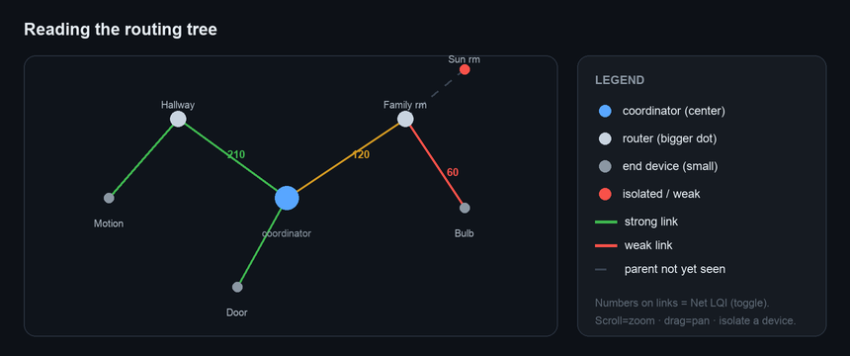
- Scroll to zoom, drag to pan. Labels stay readable as you zoom.
- ↔ / ↕ sliders spread the layout so names don't overlap.
- Isolate a device to show only its path back to the coordinator.
- Net LQI toggle prints the network LQI on each link.
- End devices toggle shows/hides leaf nodes (routing backbone only).
- Foreign toggle shows/hides devices on *other* networks (e.g. Philips Hue). Foreign nodes are
purple and labelled …/FGN:<channel>. They appear once you've heard that network — pin your
channel there or use the Monitor button on the Zigbee-networks panel; their names (from a
paired Hue bridge) and manufacturer are saved and survive restarts.
- Edge colour = link quality as heard by the sniffer; a dashed line means we haven't yet
observed that device's parent.
Device details (click a device). Beyond signal/messages, the drawer shows Capabilities
(endpoints + in/out clusters, manufacturer, model, power — pulled from the coordinator/ZHA, no
on-air interrogation; Re-interview re-pulls it on demand) and a Path from coordinator
button that plots the route to the device hop-by-hop with per-hop LQI (from ZHA's neighbour table,
or the sniffer's observed links). An Active interrogation section can transmit an encrypted
ZDO request (read bindings / query endpoints) directly to the device — gated behind a confirmation,
and needs firmware ≥ 0.28; the reply shows up in the device's Recent messages.
A ⚠ channel-hopping badge appears in the top bar whenever the radio is hopping (which only
captures your network part of the time) — click it to pin back to your channel.
Incidents. Timestamped dropout events the host flags automatically: a device that was
heard regularly then went silent past the threshold (with the channel's energy at that
moment), and a recovered entry when it returns. Tune the silence threshold in **Config →
Incident detection** (default 120 s). This is the log that catches devices dropping off.
────────────────────────────────────────

Live frames tab
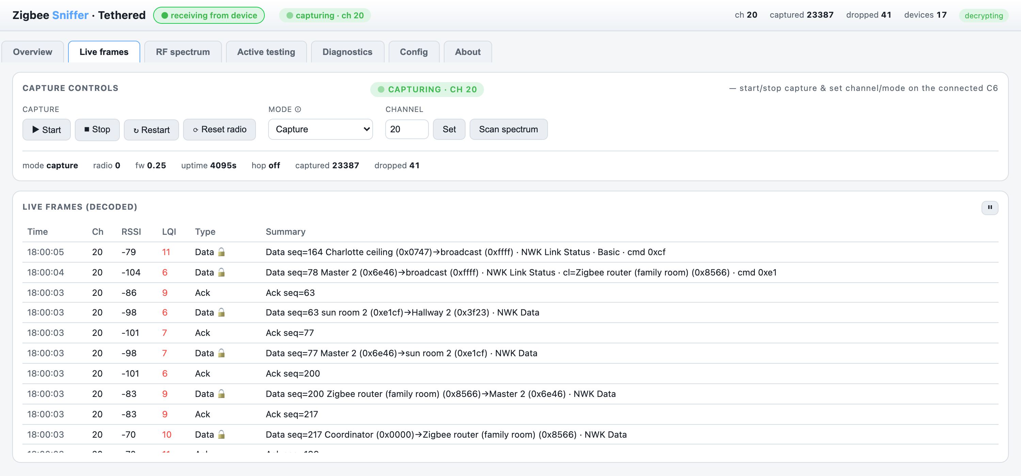
Capture controls (top): Start / Stop / Restart / Reset radio, the Mode selector, the
Channel + Scan spectrum. Below, Live frames shows decoded frames as they arrive,
newest-first, with friendly names in parentheses (e.g. Charlotte ceiling (0xcf67)).
- Click any frame to open the inspector: a layer-by-layer decode (MAC / NWK / APS / ZCL),
the resolved device name and IEEE address, and a raw hex dump. Copy hex or Export JSON
(the full decode + metadata) from the drawer.
- The table seeds from history on load, so you see recent frames even during a quiet moment.
- Mode: *Capture* = sniff frames; *ED spectrum sweep* = feed the spectrum tab (no capture);
*Capture + ED* = both on one radio (time-sliced); *Idle* = park it. With multiple radios, prefer
[roles](#key-concept-radio-roles--allocation) over changing mode.
- ⏸ pauses the live list (capture keeps running on the device).
────────────────────────────────────────

RF spectrum tab
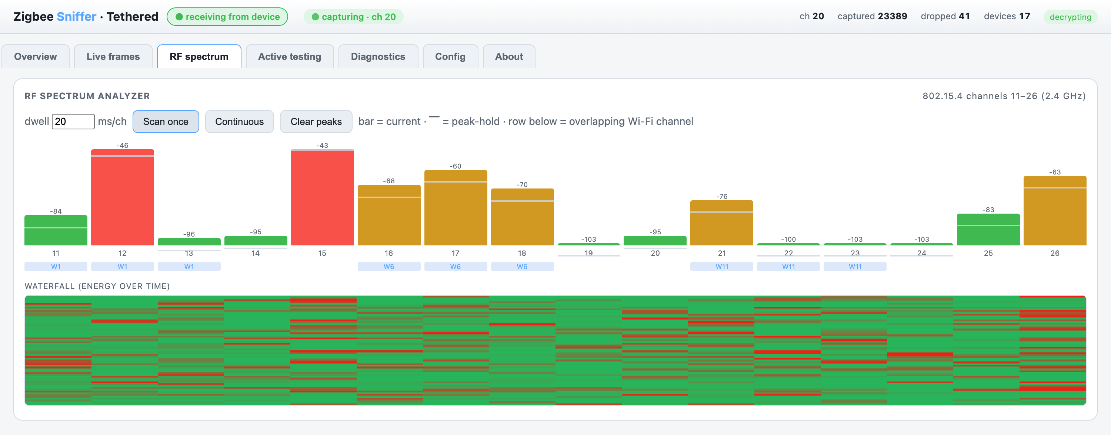
A spectrum analyzer built on the radio's energy-detect (ED):
- Scan once or Continuous; adjustable dwell (ms/channel); peak-hold markers.
- Per-channel bars + a Wi-Fi overlap row (which Wi-Fi channel sits on each Zigbee channel).
- A waterfall showing energy over time. Hatched-grey bars = "no reading" (not zero) — if you
see those, reflash the firmware.
Use it to find a quieter Zigbee channel and to spot Wi-Fi/interference.
On a single radio, a spectrum sweep pauses capture — the app asks before doing so, or blocks
it if a radio is dedicated to sniffing. Add a second radio with the spectrum role to run both.

Zigbee networks panel
Below the waterfall, the Zigbee networks panel lists every network (PAN id) the sniffer has
heard — tagged yours or foreign — with its channel, frame count, and last-seen. A foreign
network on your channel is a prime dropout suspect.
Because one radio hears only one channel, use a survey to see the rest of the band:
- Passive survey — hops channels 11–26 listening for networks that are actively transmitting.
- Active scan ⚡ — also transmits a *beacon request* on each channel so even idle networks
reply. Needs firmware ≥ 0.26; it TX's on-air (a standard Zigbee scan), so it's gated behind a
confirmation, like the active device probe.
A survey briefly pauses capture (~30 s) on a single radio, then restores your channel. Full
detail: networks.md.

Channel airtime panel
Below the networks table, Channel airtime answers the question the table can't: not just *who*
is on the air, but how much and how loudly. A loud neighbouring network physically close to
your coordinator can break your network without ever touching your channel (receiver
blocking/desense) — this panel makes that visible instead of "unplug things until it works".
- Stacked bars — frames per minute over a selectable window (15m / 1h / 6h / 24h), one
colour per network. Your PAN is always blue; foreign PANs keep a stable colour; grey collects
PAN-less frames (MAC ACKs). Hover a segment for the exact count and time slice.
- Per-channel totals — which channels actually carried traffic in the window.
- Per-network rows — total frames, ~frames/min, average RSSI ⌖, and an RSSI histogram
(8 bins, ≤−101 to ≥−40 dBm). A neighbour piling up frames at the loud end of the histogram is
*close* to your sniffer — if the sniffer sits near your coordinator, that's a prime suspect for
otherwise-unexplained NWK_NO_ROUTE storms, pairing failures, and mesh-wide dropouts.
Rates and RSSI carry the usual heard-at-sniffer caveat ⌖: a network on another channel is only
sampled while a radio is actually listening there (a hopper, a survey, or a dedicated
monitor/satellite radio — see multi-radio.md).
────────────────────────────────────────

Active testing tab
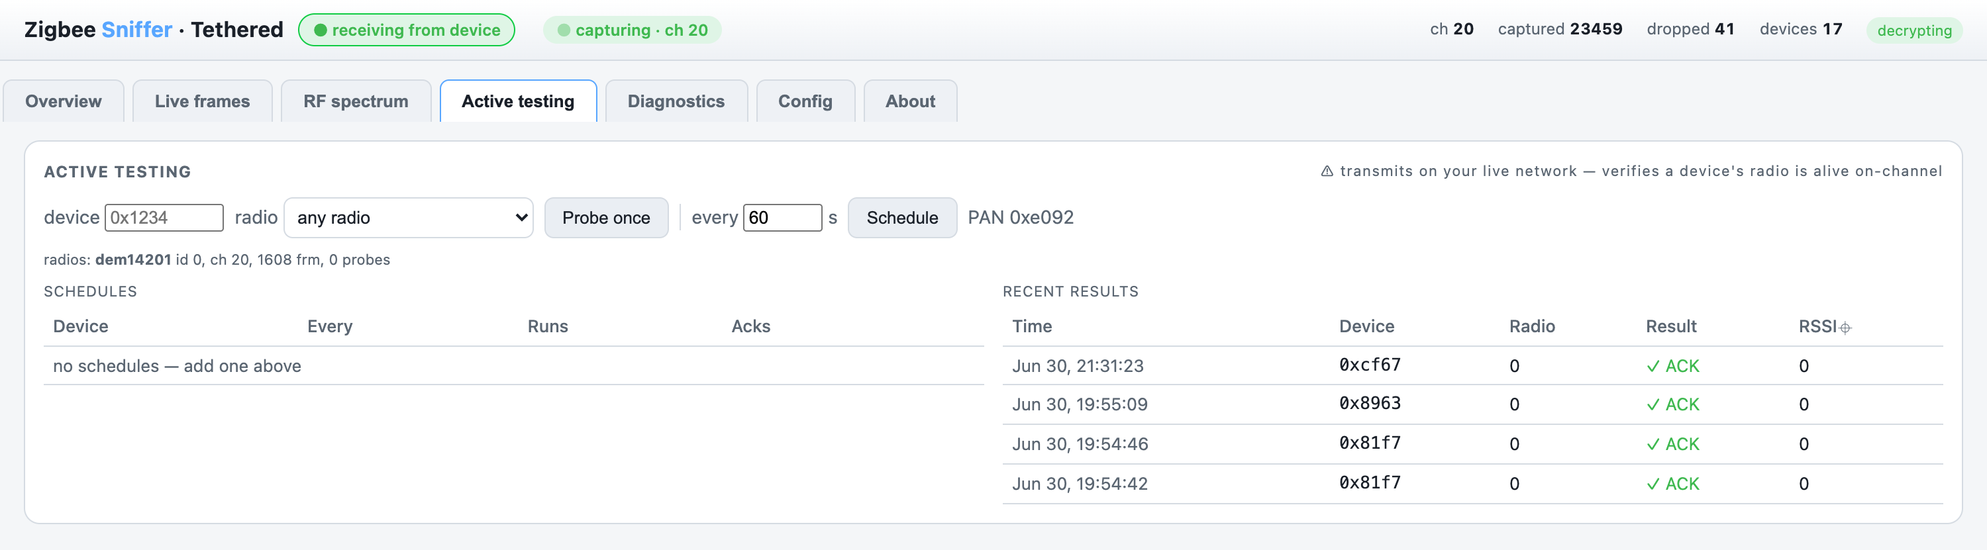
⚠ Transmits on your live network. It sends a MAC frame to a device and waits for an ACK — an
ACK proves the device's radio is alive and on-channel right now. Great for confirming a
"dropped" router.
- Enter a device short address (e.g. 0x1234), pick a radio, hit Probe once.
- Schedule a recurring probe (every N seconds) to watch a device's responsiveness over time —
the per-device ACK rate is your dropout signal.
- Recent results lists each probe with ACK / no-ACK and the ACK's RSSI.
- The PAN id (needed to address probes) comes from your ZHA backup.
Mainly verifies always-on routers/repeaters; sleepy end devices only ACK while polling.
────────────────────────────────────────

Diagnostics tab
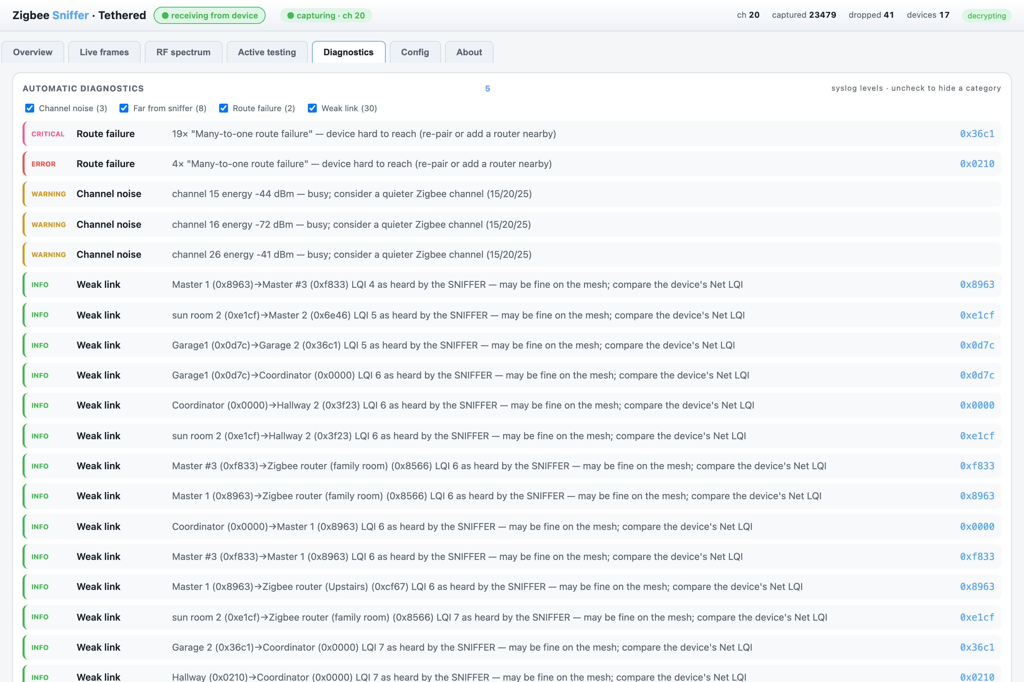
Automatic findings, using syslog severities (critical > error > warning > notice > info):
Category | Level | What it means
Route failure | error/critical | a device is hard to reach — the strongest dropout signal.
Silent device | notice/warning | a once-chatty device went quiet — a dropout candidate.
Coordinator | warning | no coordinator traffic — wrong channel or stalled capture.
Foreign network | notice | another Zigbee/Thread PAN sharing your channel (interference).
Channel noise | warning | a channel is energetically busy.
Weak link / Far from sniffer | info | the sniffer's vantage only — *not* a mesh fault.
Uncheck a category to hide it (e.g. the noisy sniffer-view "Weak link" items). Below sits
Connection & logs — port, bytes, frames, last-message age, and the host log, plus a
↻ Reconnect button to re-init the serial link.
────────────────────────────────────────

Config tab
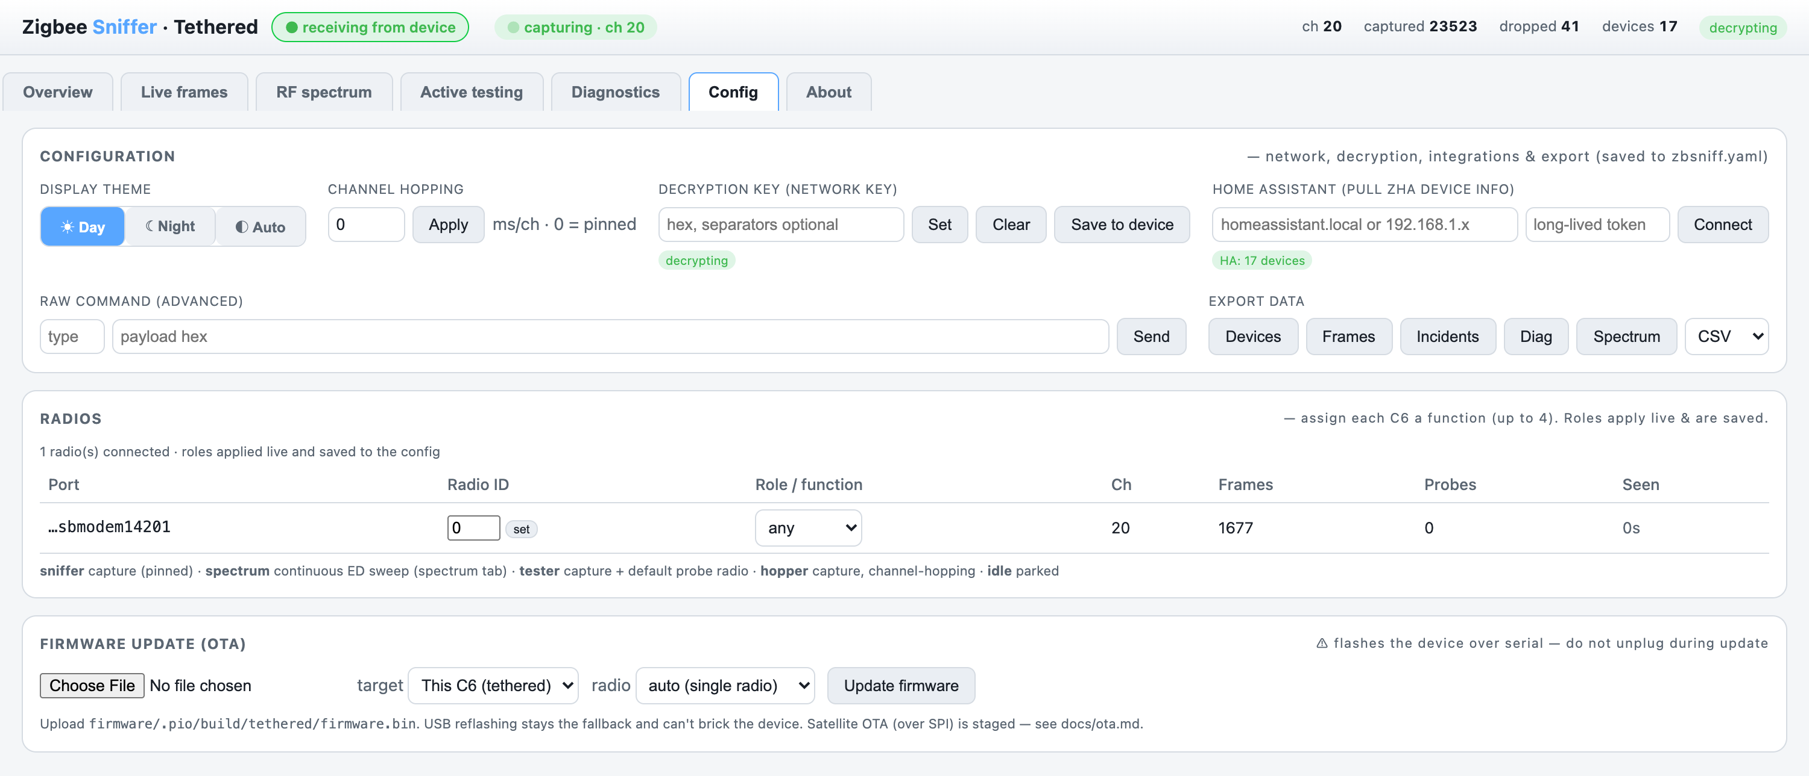
The ☀ Day · ☾ Night · ◐ Auto toggle (top-left of Config) restyles the whole UI — same data,
either look:
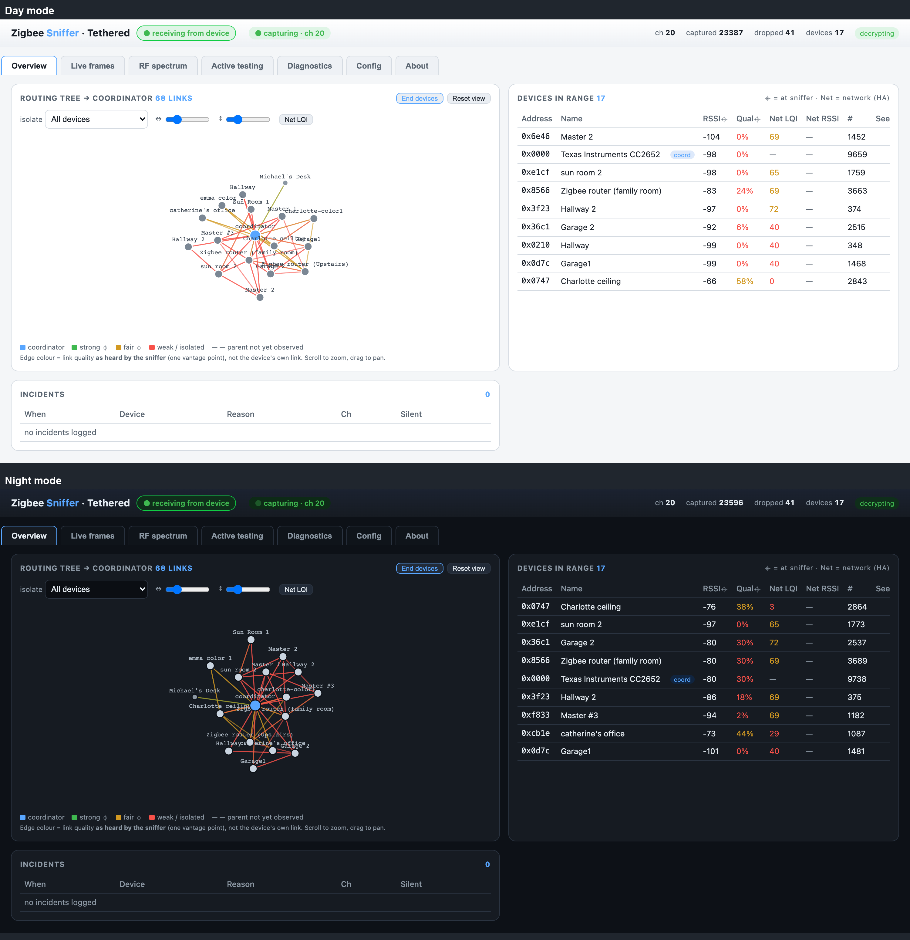
Everything that isn't live capture:
- Display theme — Day (light) / Night (dark) / Auto (follow the system). Remembered per browser.
- Channel hopping — dwell ms/channel (0 = pinned to one channel; hopping misses concurrent
traffic, so pin for diagnostics).
- Decryption key — paste the Zigbee network key (hex) to decode payloads; Save to device
stores it in the C6's NVS. Encrypted at rest in the config file.
- Home Assistant — enter just the host or IP + a long-lived token; the app builds the URL,
pulls friendly names and Net LQI, and reconnects automatically next run.
- Philips Hue bridge — enter the bridge IP, press its round link button, then click
Pair. Names Hue devices and helps identify the Hue network in *Zigbee networks*. Runs
alongside Home Assistant (both name sources at once). The key is stored encrypted.
- Raw command — advanced: send an arbitrary framed command.
- Export — download Devices / Frames / Incidents / Diagnostics / Spectrum as CSV or JSON, or
Frames → pcap for Wireshark (802.15.4 TAP encapsulation, with per-frame RSSI/LQI/channel).
- Radios — assign each connected C6 a role (see below), or set its radio-id.
- Firmware update (OTA) — see below.
────────────────────────────────────────

About tab
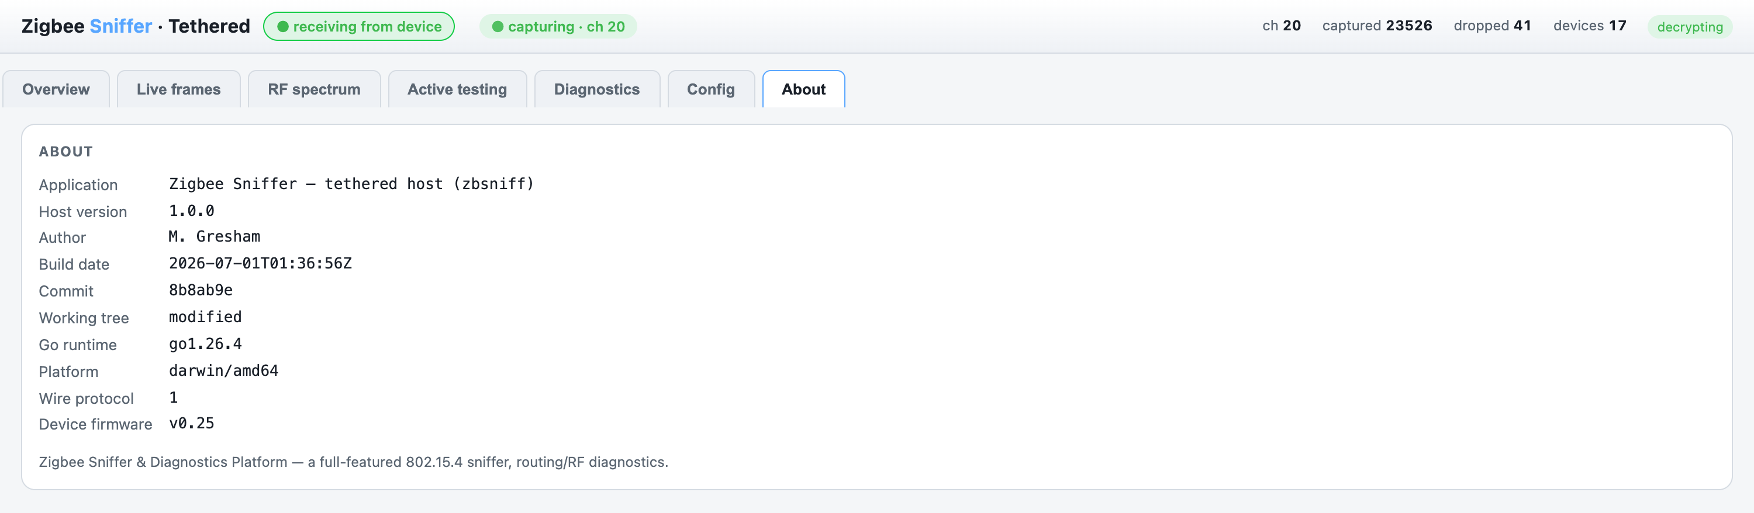
App name, host version, author, build date, Go/runtime info, wire-protocol version, and the
live device firmware version.
────────────────────────────────────────

Key concept: sniffer vs network signal
The single most important thing to understand:
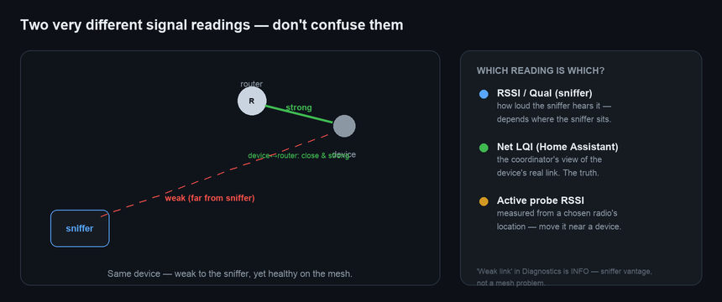
- RSSI ⌖ / Qual ⌖ = what *your sniffer* hears from its one location.
- Net LQI = the *coordinator's* view of the device's real link (from Home Assistant).
- Active-probe RSSI = measured from a *chosen radio's* location.
A device can be weak to the sniffer but fine on the mesh. That's why "Weak link" is only an
info — to judge a device's real health, use Net LQI or an active probe from nearby.
────────────────────────────────────────

Key concept: radio roles & allocation
With up to 4 C6 dongles plugged in, give each a role in Config → Radios:
Role | What it does
any *(default)* | the system tasks it to any function on demand
sniffer | passive capture, pinned to the channel
spectrum | continuous ED sweep — feeds the spectrum tab without pausing capture
tester | capture + the default radio for active probes
hopper | capture with channel-hopping
idle | parked
When you request a function (capture / spectrum / probe), the host allocates a radio — a
dedicated one first, else a free any radio. If the only radio is busy it asks to confirm; if
nothing is free it tells you exactly what each radio is doing. So one radio time-shares with
warnings; two-plus radios run everything at once with no prompts.
────────────────────────────────────────

Workflow: diagnosing dropouts
The reason this tool exists. When a device keeps going unresponsive:
- Pin the channel to your network's (auto from the ZHA backup). Don't hop.
- Leave it capturing for a while. Check the Diagnostics tab:
- Route failure on the device → it's genuinely hard to reach; add/relocate a router.
- Silent device → it stopped talking; note *when* relative to the dropout.
- Connect Home Assistant and compare Net LQI to the sniffer's RSSI ⌖. If Net LQI is fine,
the mesh link is healthy — look at the device/power, not RF.
- Schedule an active probe on the suspect device (e.g. every 30 s). Watch the ACK rate:
- ACKs keep coming through a "dropout" → the radio's fine; the problem is higher up (app/stack).
- ACKs stop exactly at the dropout → the device's radio/power is the culprit; power-cycle test.
- Check RF spectrum for interference (busy channel, Wi-Fi overlap, a Foreign network). If
the channel is noisy, move your Zigbee network to a quieter one (15 / 20 / 25 are common).
────────────────────────────────────────

Firmware updates (OTA)
Update the C6 over USB serial — no esptool needed. Config → Firmware update:
- Build the image: cd firmware && pio run -e tethered → firmware/.pio/build/tethered/firmware.bin.
- Choose the file, the target (This C6, or a Satellite), and the radio; click Update.
- A progress bar tracks *receiving → writing → verifying → complete (rebooting)*.
The device writes its inactive OTA slot, verifies, and reboots into it; the bootloader rolls back if
an image is bad, and USB reflashing is always the fallback. The very first flash (step 1 of the
quickstart) must be over USB because it installs the OTA partition table.
Satellite OTA (over SPI) works the same way — pick the satellite as the target and the tethered
C6 relays each chunk over the carrier's SPI link. The satellite briefly pauses capture during the
transfer and resumes it automatically once done. SPI is a lossier link than USB serial, so a
transfer can involve many chunk retries — the satellite tracks each chunk's byte offset and skips
any that already landed, so a resent chunk (from a lost acknowledgment, not lost data) can never be
double-applied and corrupt the image. Validated end-to-end on carrier hardware, including transfers
with heavy retry activity throughout. See ota.md for the wire-level design.
────────────────────────────────────────

Configuration & security
- Everything you set in the UI persists to `zbsniff.yaml` (override with --config) and reloads
next run: channel, network key, HA host/token, radio roles, channel-hopping dwell, **capture
mode, and the web-UI preferences** — theme, routing-tree X/Y spacing, End-devices and Net-LQI
toggles, spectrum dwell, diagnostics category filters, and export format (stored as ui.* lines).
An explicit CLI flag wins over the file; the startup log prints its absolute path.
- Secrets are encrypted at rest. The network key and HA token are stored as enc:…
(AES-256-GCM); the key lives in a sidecar zbsniff.yaml.key (mode 0600, gitignored). Copying or
committing the YAML alone never leaks the secrets.
- Only the network key is needed for decryption — the other keys in a ZHA backup are APS link
keys and aren't required.
────────────────────────────────────────

Troubleshooting
Symptom | Fix
host up — no device data | Diagnostics → Connection & logs. 0 bytes = wrong USB port / port held by another instance (↻ Reconnect); bytes but 0 frames = reflash.
captured stuck at ~20 | Old firmware RX-buffer stall — reflash the latest.
no new frames after a spectrum scan | Old firmware left the radio off-channel — reflash (fixed: the sweep restores the channel).
spectrum shows −128 / hatched grey | Reflash — the ED units fix is required.
probe does nothing | Enter a real device address; reflash (probe now wakes the radio even if capture is stopped).
link keeps dropping / device re-enumerates | The host auto-reconnects; use ↻ Reconnect to force it.
wrong chip | You need an ESP32-C6, not a C61 (no 802.15.4 radio).
────────────────────────────────────────

Command-line reference
zbsniff [flags]
--port <dev> serial port (repeatable; omit to auto-detect the C6)
--channel <11-26> capture channel to set on start (0 = from backup/leave as-is)
--key <hex> Zigbee network key for decryption (separators optional)
--zha-backup <f> ZHA backup JSON → channel, PAN, key, and device names
--ha-host <host> Home Assistant host/IP (URL built automatically)
--ha-token <tok> HA long-lived access token
--db <path> SQLite path (default zbsniff.sqlite)
--http-port <n> web UI port (default 8080)
--config <path> settings file (default zbsniff.yaml; secrets encrypted)
--baud <n> serial baud (default 921600; USB-CDC ignores it)
--demo start in demo mode with a simulated network (no hardware needed)
See also: Quickstart · HA add-on · OTA ·
protocol/framing.md.

