**[DELETE BEFORE SUBMISSION]**

**(1) A Cover Page**

§ Contain your group members’ ID and name. (Refer to the sample in last page

of this project write up.)

# Introduction

For our project, we developed an imaginative 3D World in Outer Space using the concepts we learned in Computer Graphics. The concepts we used include building models, simple animations (rotation, moving along certain axis), and rendering effects such as lighting, shading, and texturing.

# Documentation of virtual model

## Satellite

The model is built by dividing it into small parts, e.g. wing, top, body, bottom through using OpenGL primitives such as Quadrics objects, polygon. They are then combined, and a simple rotation animation is applied.

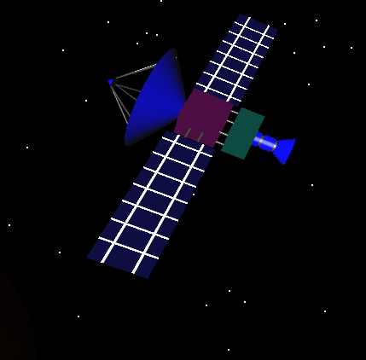

Figure 1: Satellite model

## Spaceship (Prometheus)

The model is built through the usage of MyModelLoader from CGLab01. The obj file of the model is obtained from free3d.com. Subsequently, the obj file is converted into ply file, and then loaded into our virtual world. A simple translation animation is applied to make it seem like it is moving to the left.

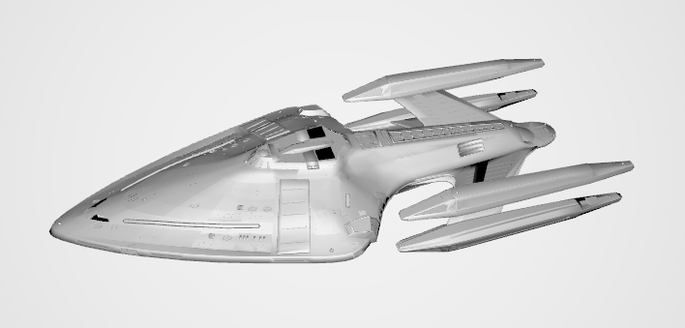

Figure 2: Prometheus model

## Capsule

Like the spaceship, the model is built through MyModelLoader obtained from CGLab01. There is no animation as it is stationed on the planet.

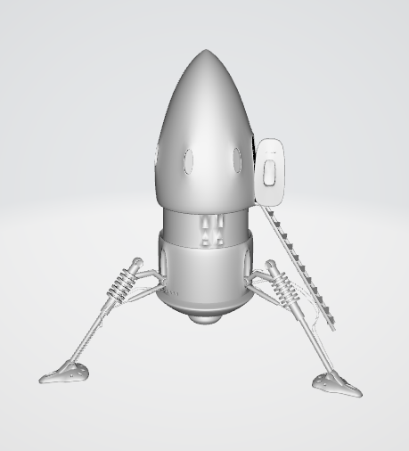

Figure 3: Capsule model

## Globe & Planet (same model scaled differently)

An example of a textured sphere is taken from www2.cs.duke.edu. We extracted the necessary codes and used them in our project. The model uses Quadrics object (glSphere), while the texture is applied using rgb image file.

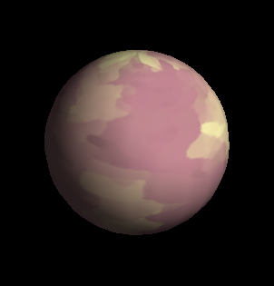

Figure 4: Globe model

## Star

Like the spaceship and capsule, the model is built through MyModelLoader obtained from CGLab01. Lighting is applied to the star; there are two stars, one with a yellow diffuse lighting while the other has a white diffuse lighting.



Figure 5: Star model

## Satellite (second)

The satellite model is loaded through MyModelLoader obtained from CGLab01. A rotation animation is applied to it.

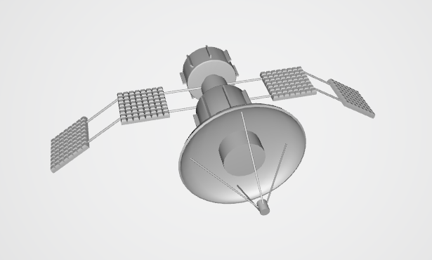

Figure 6: Satellite model

## Spaceship (Tyderium)

The spaceship is loaded through MyModelLoader obtained from CGLab01. It travels along the z-axis (towards positive z) at a greater speed than spaceship (Prometheus).

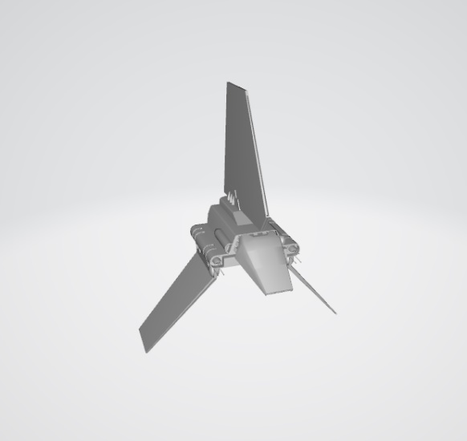

Figure 7: Spaceship model (Tyderium)

## Rocket

The model is built by dividing into three parts which are top, body and bottom by using Quadric objects.

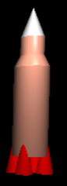

Figure 8: Rocket model

## Space Station

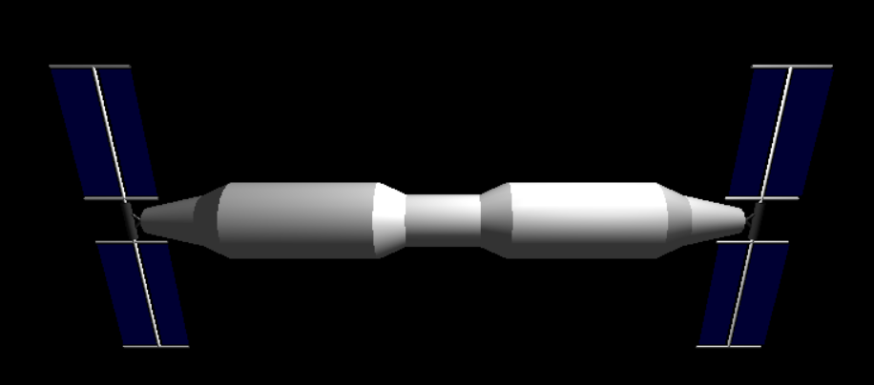The model is built by dividing into two parts which are body and solar panel by using Quadric objects and polygons. Rotation is applied on the solar panel.

Figure 9: Space Station

## Points

The code of the points is obtained from the CGLab03. The points are spread in the whole world to mimic the look of stars for our world.



Figure 10: Points

## Space Hotel

The model is divided into four parts, the outer ring which using glutSolidTorus, the inner cylinder, the connecters connect outer ring and inner cylinder and the blue half transparent sphere. The flat face of the cylinder is applied triangle fan method. This model will move in the space between the globe and the planet within a certain boundary.

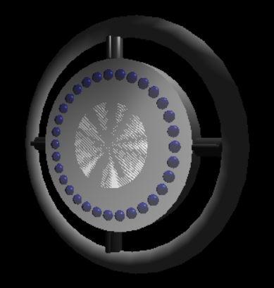

Figure 11: Space hotel

## UFO

The model is divided into three parts, the hemisphere by making a sphere and translate it so that it looks like a hemisphere, the disc part using glutSolidTorus and the yellow sphere. The model move from a point to the globe, when it reaches the globe, it will started to rotate.

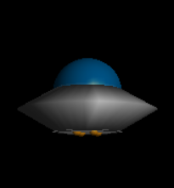

Figure 12: Space hotel

## MKII Station

The spaceship is loaded through MyModelLoader obtained from CGLab01. It rotates along the y-axis.

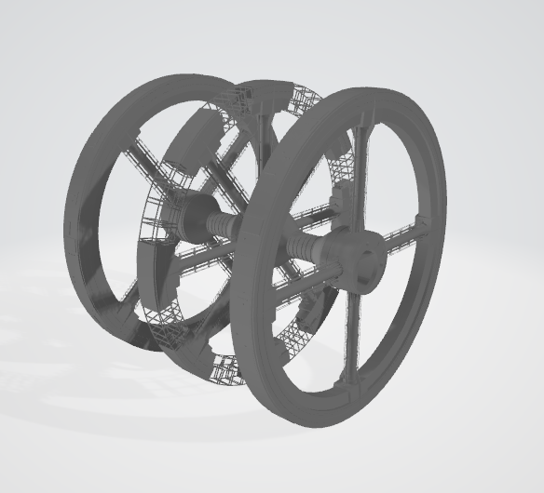

Figure 13: MKII Station

# User Manual / Instructions

### Keyboard Functions:

A, S, D, F, Q, E – Change the viewport

Left, Right, Up, Down arrows - Change the camera angle

### Mouse Functions:

Drag left, Drag right – Rotate the world

### Special Key Functions:

1. Home – restore defaults
2. Esc – exit
3. F1 – toggle shading/ wire-frame mode
4. F2 – toggle rendering of the axes
5. F3 – toggle lighting on or off
6. F4 – toggle object lighting on or off (LIGHT0)
7. F5 – toggle yellow star lighting on or off (LIGHT1)
8. F6 – toggle white star lighting on or off (LIGHT2)
9. F7 – toggle white points lighting on or off (LIGHT3)
10. F11 – toggle animation for all objects
11. F12 – toggle texture

# Screenshots

**(5) Screen Shots**

§ A few pictures of the project you created.

§ Provide short description for each picture.

# Reference List:

1. Prometheus model obtained from:

<https://free3d.com/3d-model/uss-prometheus-nx-59650-16091.html>

1. Capsule model obtained from:

<https://free3d.com/3d-model/mars-lander-space-capsule-3771.html>

1. Globe & Planet model obtained from:

<http://www2.cs.duke.edu/courses/fall00/cps124/resources/ds1/>

1. Star model obtained from:

<https://free3d.com/3d-model/star-mobile-ready-60-tris-49986.html>

1. Satellite model obtained from:

<https://free3d.com/3d-model/satellite-220624.html>

1. Tyderium model obtained from:

<https://free3d.com/3d-model/tyderium-t-16-shuttle-47589.html>