Contents

1. Introduction 2

1.1 Problem Statement 2

1.2 Objectives 2

2. Proposed Solution 3

2.2 Analysis on websites 3

2.3 Use-case diagram 9

2.4 Web app functions 9

3. Implementation 10

3.1 HTML 10

3.2 CSS 10

3.3 Final product 12

3.4 Screenshot 12

4. Plan for Assignment 2 13

5. Conclusion 14

6. Appendix – HTML validation 15

# Introduction

## Problem Statement

After analyzing a few restaurants’ websites, our group realized that the functionalities of these websites are severely limited and are usually used merely as a display of information about their companies, location, menu, careers, catering and more. To make it worst, Sakae Sushi do not even display the menu served in their website.

Other than that, the websites lack interactivity and do not retain the attention of users. For example, Rakuzen, Sakae Sushi and Sushi Zanmai have primitive website designs, which consists of a header photo, a nav bar, content and footer. In fact, Rakuzen and Sushi Zanmai shares a similar unattractive design layout, where the interface does not appeal to users visually.

## Objectives

1. To have useful functions that can attract and retain users
2. To have aesthetically pleasant interface and interactive elements

# Proposed Solution

## Analysis on websites

Since the nature of our restaurant is Japanese cuisine, our group have visited several websites of popular Japanese restaurants in Malaysia, such as Sakae Sushi, Rakuzen, Sushi Zanmai, and last but not least Sushi Mentai. A table that summarize our analysis is on the final page of this section.

* + 1. Sakae Sushi

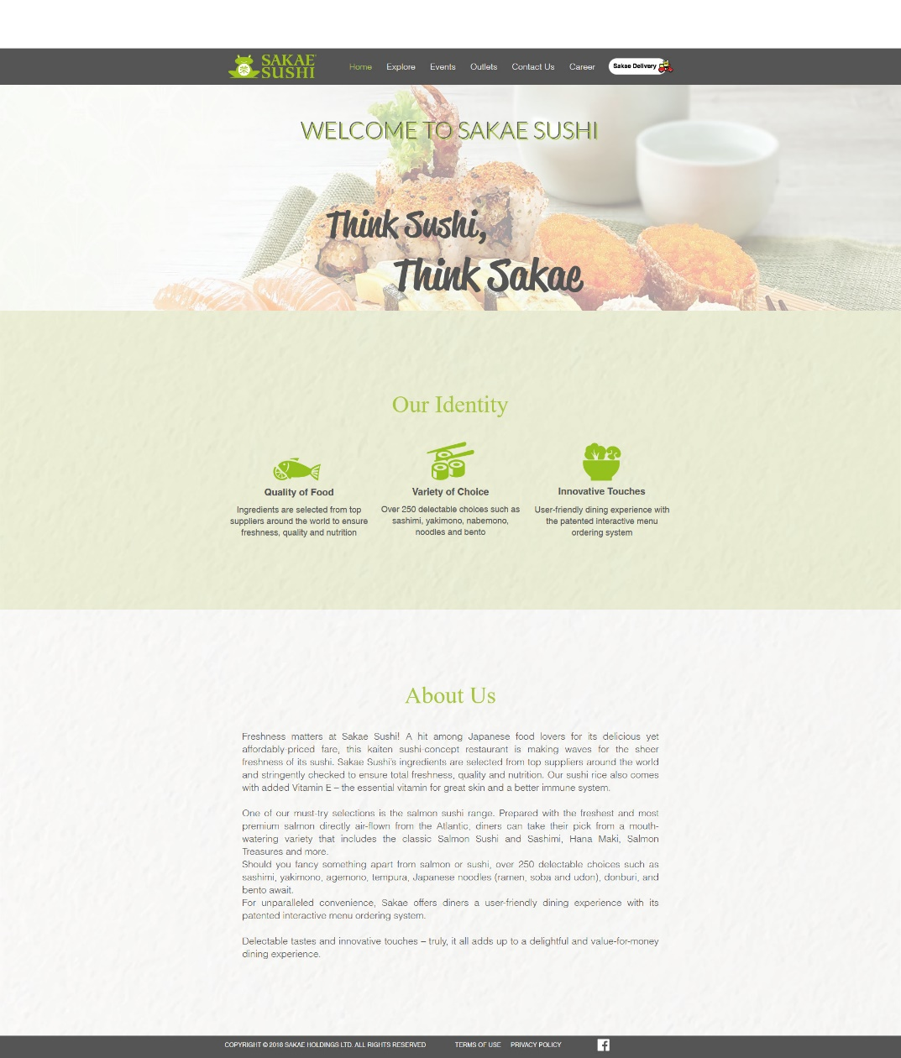

Figure 1: Screenshot of Sakae Sushi website

As you can see from the above figure, the website is plain and boring; The design layout is simple, the color palette is only Sakae Sushi’s signature green, white and black. The website also does not have a menu display.

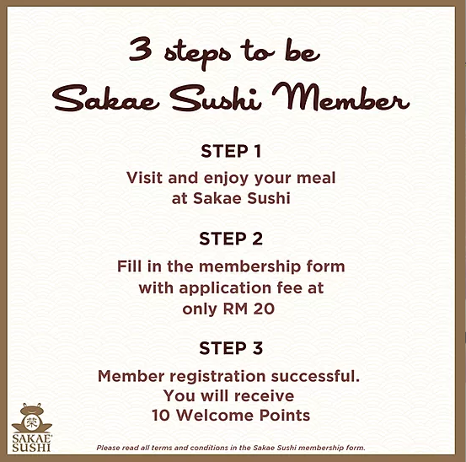

Figure 2: Pop up from Sakae Sushi website

When you first visit the website, a pop-up will appear; promoting the membership of Sakae Sushi as shown in Figure 2. However, the application of membership can not be done through online. When you click on the “Explore” -> “SAKAECard” on the navigation card, it displays the privilege of being a member, a link to its membership portal, and the terms and conditions of SAKAECard membership.

Other than that, when you click on the button for Sakae Delivery, it redirects you to another website, where it requires you to sign in with an Oddle Pass. It is a login mechanism that allows customers to log in to Oddle Shops with a single set of login credentials. The website is lacking in terms of functionality.

* + 1. Rakuzen (Super Dining)

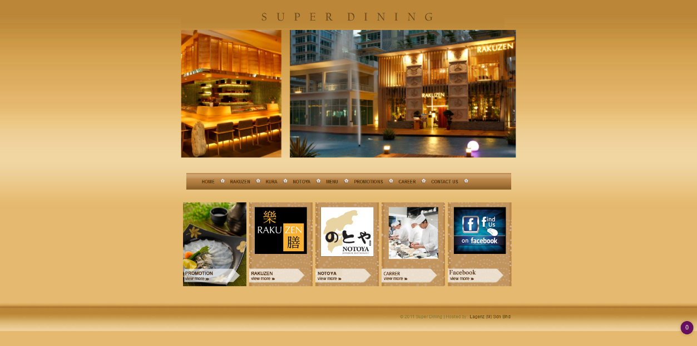

Figure 3: Screenshot of Rakuzen website

Super Dining is a group of Japanese restaurants, consisting of Rakuzen, Kura and Notoya. It is obvious from first sight that the website is not optimized for bigger screen size because of the left and right empty spaces. Among all the websites we analyzed, it has the simplest design and color theme. However, it has responsive design on both tablets and phones.

The website only displays information about its outlets, different menus, careers for the three different restaurants. The promotion page supported by promotion.php displays nothing. Other than displaying information, the website does nothing. In comparison to other modern websites, it is severely lacking in terms of functionality.

* + 1. Sushi Zanmai

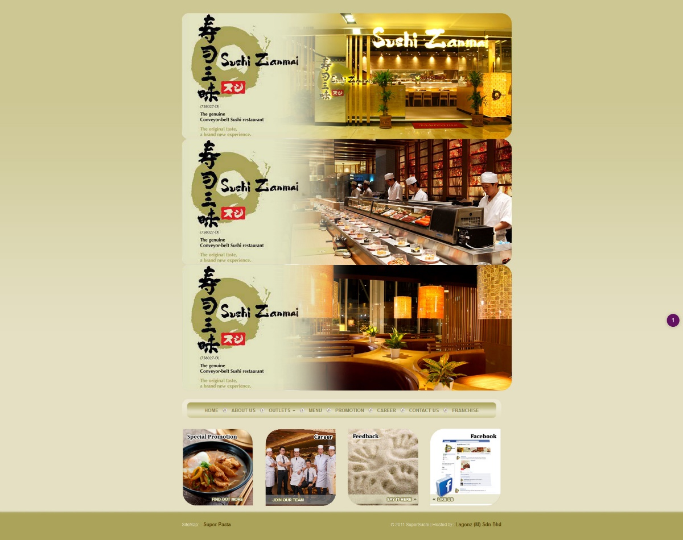

Figure 4: Screenshot of Sushi Zanmai website

During our analysis, we realized how similar Sushi Zanmai website look in comparison to Rakuzen’s. It is also hosted by the same company with the same copyright year. Most of the comments on Rakuzen website can be applied here as well; unattractive color theme and simple layout. Different from Rakuzen, it does not have a responsive design.

Other than that, while navigating through the website, the “Outlets” in the navigation bar is linked incorrectly to the index.php, which is the website’s home. As of 4th January 2020, the promotion page has yet to be updated to the most recent promotion offered in their restaurants. It can be seen from their Facebook post, but not on their website.

As compared to Rakuzen website, it allows users to apply for franchise through a form on their website. However, it still does not have enough functionalities to attract and retain users.

* + 1. Sushi Mentai

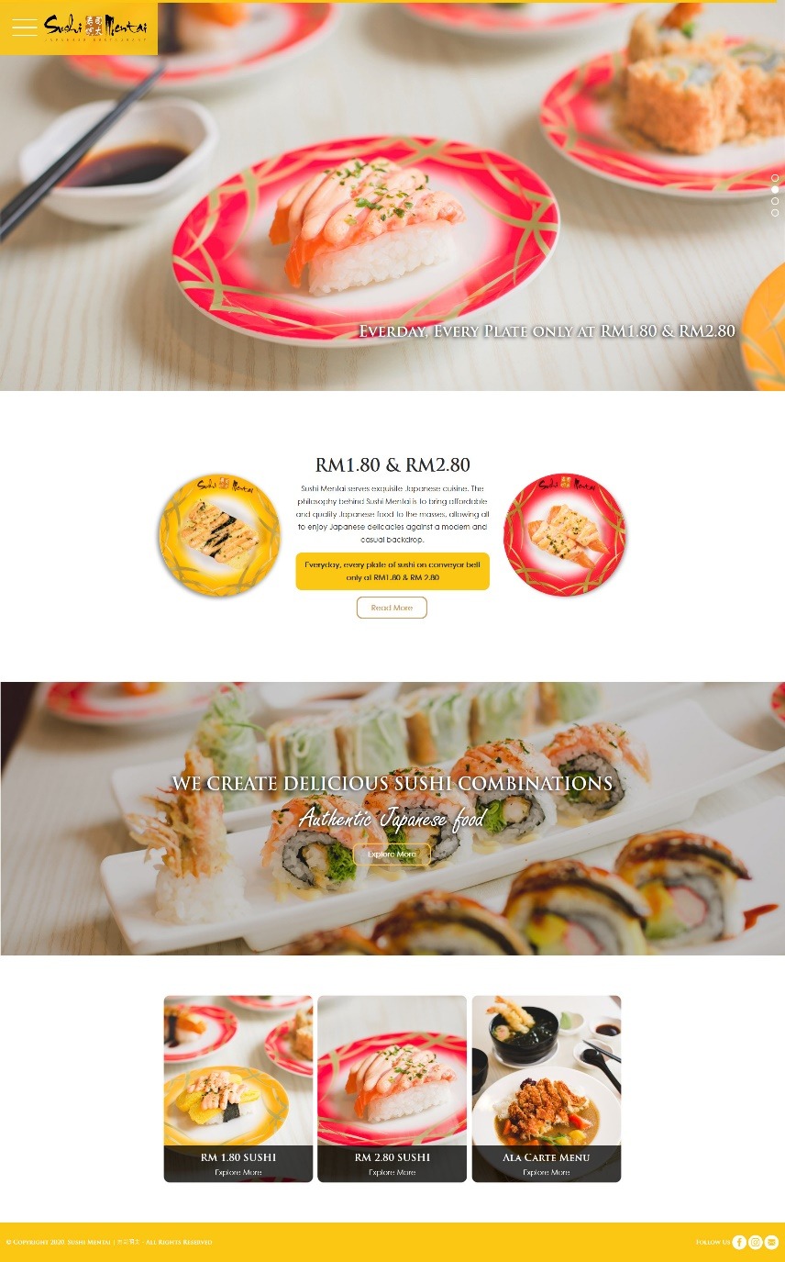

Figure 5: Screenshot of Sushi Mentai website

Sushi Mentai website offers a refreshing and enticing look, where the colors used complement the food pictures well and attracts your attention. It is not reflected in the still screenshot, but certain elements of the website have animation, such as pop-up effect, slight rotation when hovering over, fly-in effect and more. It also has a responsive design on both tablets and phones.

Despite the beautiful and appealing interface, the website does not offer many functionalities. It has the basic functionalities such as menu display, outlets display, career display and company information. Sushi Mentai offers lucky draw and customers can join the mentioned lucky draw through online. After clicking the button to join, it redirects you to a google form, where you can fill in your details. The Japanese restaurant is no longer accepting franchisees so we are not sure whether you can apply for franchise through online or not.

|  |  |  |  |  |
| --- | --- | --- | --- | --- |
| **Features** | **Sakae Sushi** | **Rakuzen** | **Sushi Zanmai** | **Sushi Mentai** |
| 1. Attractive design  (layout, color theme) | ✘ | ✘ | ✘ | ✔ |
| 2. Responsive design | ✘ | ✔ | ✘ | ✔ |
| 3. Profile management  (registration, login) | ✔ | ✘ | ✘ | ✘ |
| 4. Membership application | ✘ | Not offered | Not offered | Not offered |
| 5. Franchise application | ✘ | ✘ | ✔ | Closed |
| 6. Lucky draw application | ✘ | ✘ | ✘ | ✔ |
| 7. Information display  (menu, outlet location, company information, careers, promotions) | ✔ (Missing Menu) | ✔  (Missing Promotion) | ✔  (Missing outlets) | ✔ |
| 8. Food delivery | ✔  (Different website) | ✘ | ✘ | ✘ |
| 9. Order pick-up | ✘ | ✘ | ✘ | ✘ |
| 10. Reservation booking | ✘ | ✘ | ✘ | ✘ |

Table 1: Summary of website analysis

## Use-case diagram

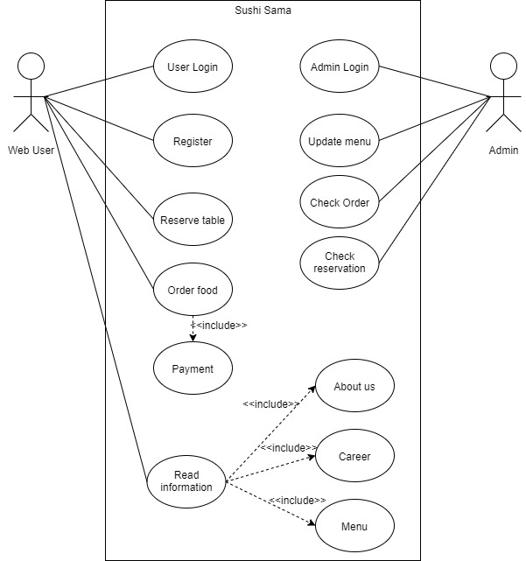

## Distribution of development / coding tasks

|  |  |  |  |  |  |
| --- | --- | --- | --- | --- | --- |
| **Tasks** | **Kar Sing** | **Guan Cheng** | **Yuan Jun** | **Michelle** | **Lucas** |
| Website design (navigational flow, layout, color palette, etc.) | ✔ | ✔ | ✔ | ✔ | ✔ |
| Homepage and other information display |  |  |  | ✔ | ✔ |
| Table reservation |  |  |  | ✔ |  |
| Profile management (login/register) | ✔ |  |  |  |  |
| Menu display/ Menu selection |  |  |  | ✔ |  |
| Order summary |  | ✔ |  |  |  |
| Discount calculation |  |  | ✔ |  |  |
| Payment processing |  |  | ✔ |  |  |
| Admin – Login | ✔ |  |  |  | ✔ |
| Admin – Menu update |  |  |  |  | ✔ |
| Admin – User List |  |  |  |  | ✔ |
| Admin – Check order | ✔ |  |  |  |  |
| Admin – Check reservation | ✔ |  |  |  |  |
| Documentation | ✔ | ✔ |  | ✔ |  |

# Implementation

## HTML

#### Description of elements used

We have used several HTML elements such as container, card, tables, navbar, custom form, where certain elements are only available thanks to the Bootstrap framework.

For every page, we use a combination of container, row and different sizes of column to create the multicolumn layout that will resize and fit automatically in response to different device width through the Bootstrap framework, which allows a simple process of creating responsive design.

Our menu includes the usage of bootstrap cards, which provide flexible and extensible content containers since the cards support a wide variety of content including the images, text and more.

We use bootstrap table to create our order summary because working with the bootstrap framework, we can easily improve the appearance of the table so that the user can have a greater experience.

The table reservation is made through a form so that we can receive information when the user submits, where processing will be done on the form data in Assignment 2.

#### Navigational flow design

A navigation bar is located top of our website. Since the navigation is generally the direction that takes the users where they want to go, setting it at the top allows user to navigate through our website quickly and easily.

Our utility navigation, i.e. login is on top of the website also. This allow us to have a user-friendly navigation and user will interact with the site because they are able to perform the actions at the first moment.

We have Call to Action (CTA) function for the table reservation, which users will automatically notice once they enter our homepage. Clicking it redirects users to the table reservation form at the bottom of homepage.

Our footer also provides some navigation so users can click on them when they reach the bottom of the page, without the need to scroll up to reach the nav bar.

#### Any tools used?

We used Bootstrap framework because it speeds up our website design process, and it is also compatible with all modern browsers.

We also used font awesome for the various icons displayed in our pages.

## CSS

### Description of CSS styles

@media query

### Responsive design?

Bootstrap allows us to split the website into grids of columns and rows. Based on the device’s width, these columns will arrange themselves appropriately. For certain cases, we also specify the properties of certain elements that we would like to display differently as opposed to the predefined rules, by using the @media notation.

### Any tools used?

Just as explained under 3.1.3, we used Bootstrap framework because it is one of the most popular HTML, CSS and Javascript framework directed at responsive, mobile-first web development.

Our group has also used the material design for bootstrap for (MDBootstrap), where it provides many user interface (UI) elements, such as animation, icons, plugins.

## Final product

## Screenshot

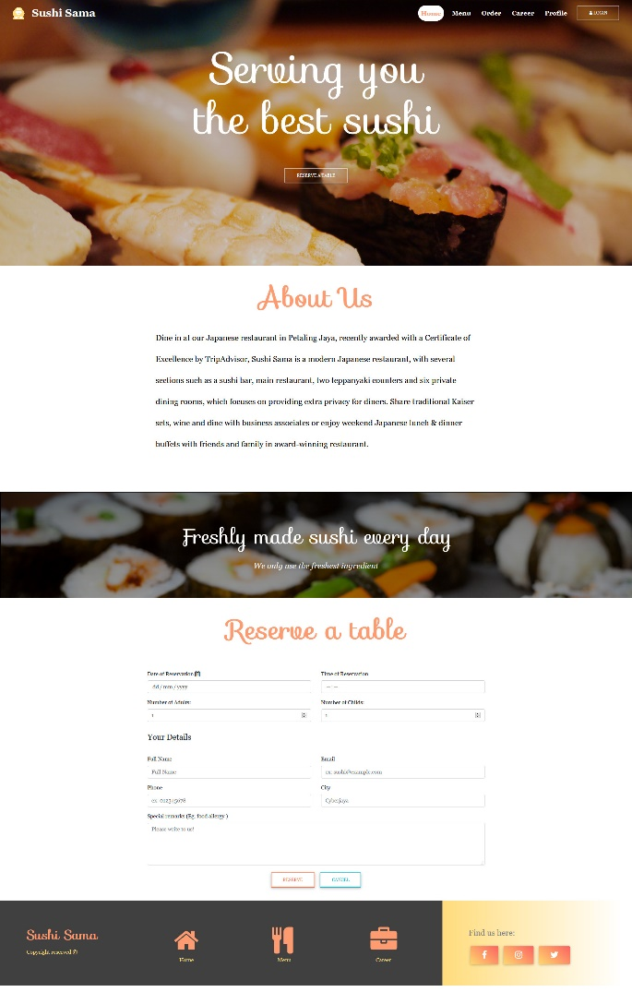 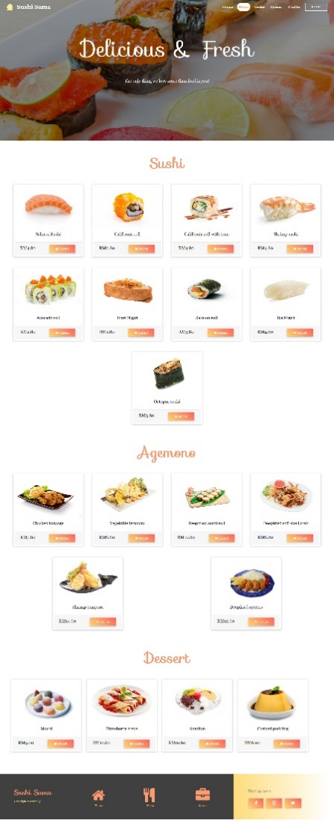

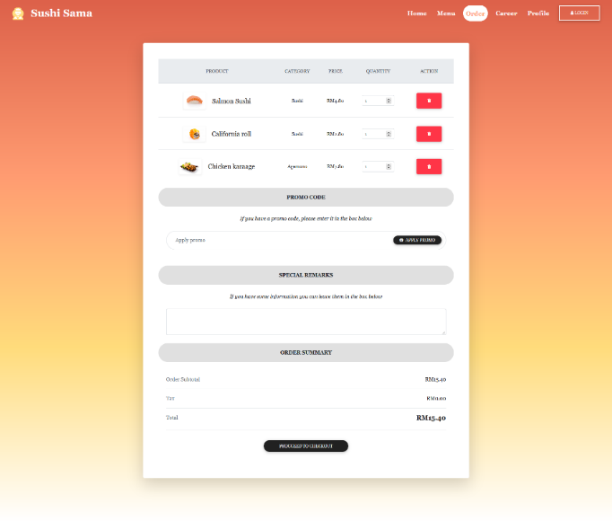 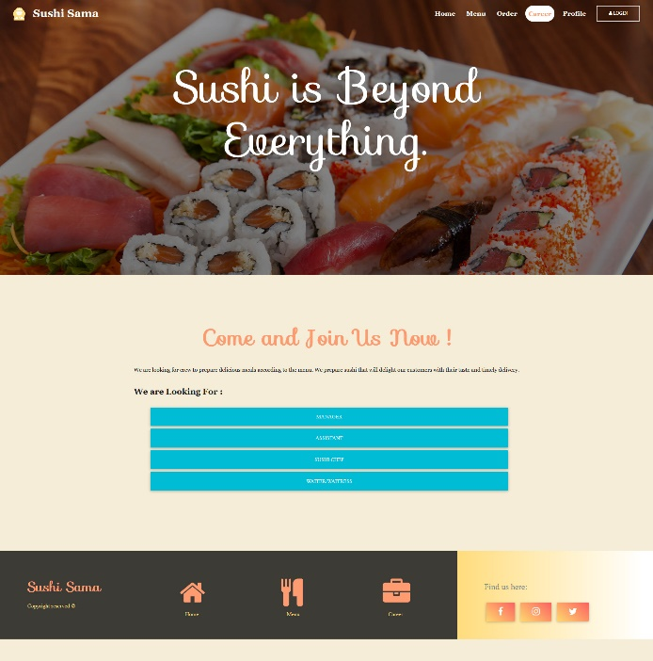

# Plan for Assignment 2

For our current website, our membership portal and profile page are static, and need to be linked to a database. Subsequently, we need to process the registration; check the availability of login name, the validity of email address etc. As for the login process, we need to process the login authentication and reset of passwords.

Other than that, our checkout/order summary page is static as well. We need a script for getting the order of our customer in terms of items, pricing and quantity. Other than that, we also need a script for totaling up the order and display the order summary to our users before proceeding with payment.

Furthermore, when the user submits data for their reservation of table, we need a script to process it and give the user feedback whether their selected time slot is available or not. We also need to send and highlight their special remarks, especially their food allergy to the waiters/waitresses and chefs.

For administrative functions, we need to allow administrators to login, to update the menu in terms of items, pricing and descriptions, to check the order summary and other functions.

In terms of design, we would like to make the website more interactive through placing animations that will only be triggered once the users scroll to that section. For example, the transparent nav bar will turn solid after user scroll down for a specific distance. Furthermore, if time permits, we would love to make our website more attractive and pleasing to users through both front-end and back-end development.

# Conclusion

Websites is playing important role in all kind of business. The eye capturing visual effects from dynamic and interactive website are commonly use on website. Many people are browsing website in order to get information. People are attracted by convenient and beautiful website.

In our Assignment 1, we have learned the basic of building website using HTML and CSS with bootstrap. We have examine few different website then take the good and keep away from bad. All of our group member pass different opinion to each other to improve our website so that it makes our website more user friendly. Other than that, we also develop responsive website so that the webpage is able to view on mobile phone. Mobile phone is commonly use to browse website so it is necessary and priority to make website that run on mobile phone.

For our future Assignment 2, we plan to add JavaScript and link our website to Database to store data. This will make our webpage not running on individual but link to other page so that it will make convenient to user.

For this website, we aim to achieve better user experience than others website and make our website become one of the best recommend reference to other developer.

# Appendix – HTML validation