Michael Miller

Akshay Shetty

CS 498 – HW4

3/1/16

**Problem 3.4**

**a)**

Iris data is plotted in a 2d scatterplot matrix (Figure 1).

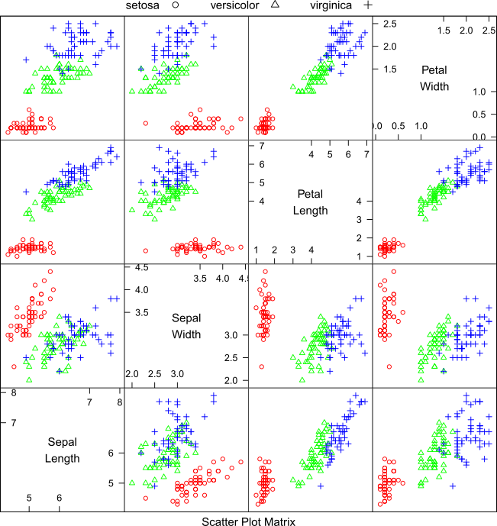

**Figure 1. Iris data potted in a two-dimensional scatter plot**

**b)**

Principle components were found using the R function prcomp() in the lattice package. The first two principle components are plotted blow (Figure 2). The data is significantly more varied along the first component than the second. This could be useful to reduce unnecessary dimensions.

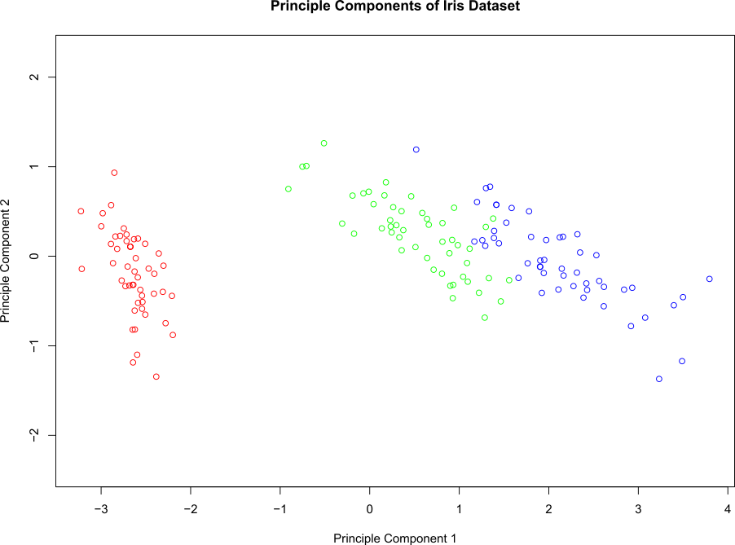

**Figure 2. First and second principle components of Iris data**

**c)**

Discriminative direction were calculated using the pls2_nipals function of the chemometrics R package. Figure 3 displays plots of the first and second Discriminative Direction. The plot looks slightly better than the plot in Figure 2 because the different data groups remain closer together. In the case that a dimension were removed, the grouping would be more or less preserved.

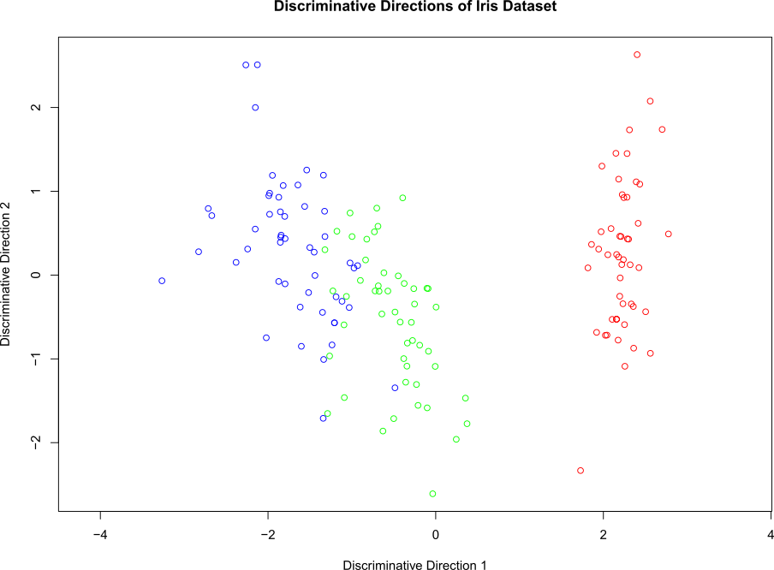

**Figure 3. Discriminative Directions of Iris data**