Michael Miller

Akshay Shetty

CS 498 – HW6

4/4/2016

Problem 2.

Classifiers were trained using α = 1, 0, and .5 to represent Lasso, Ridge, and Elastic Net schemes respectively. The misclassification error of these classifiers is displayed in Figures 1-3.

The three classifiers were trained using 70% of available data and 10 fold cross validation. Classifiers were trained using optimal lambdas. The remaining 30% of data was used to estimate the accuracy of the classifiers. Each classifier’s accuracy is displayed in Table 1. While the difference in accuracy between the various classifiers is negligible (less than 1% difference), a higher α seems to result in slightly better classification scores.

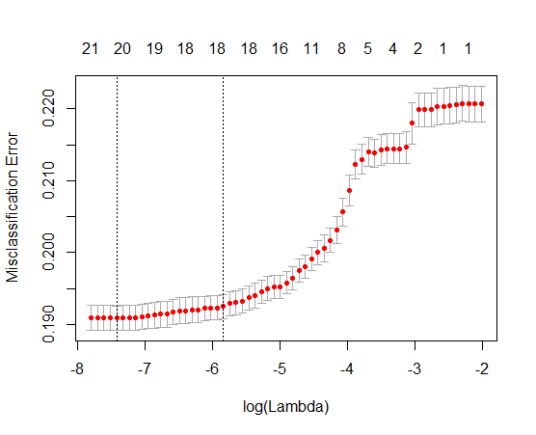

**Figure 1.** Misclassification Error vs. log(λ) for α = 1 (Lasso Scheme)

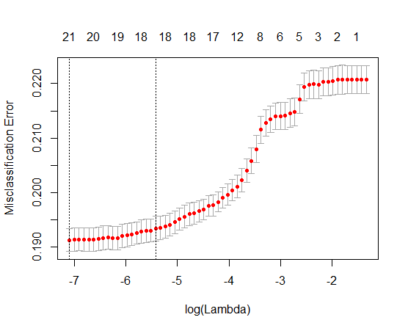

**Figure 2.** Misclassification Error vs. log(λ) for α = 0 (Ridge Scheme)

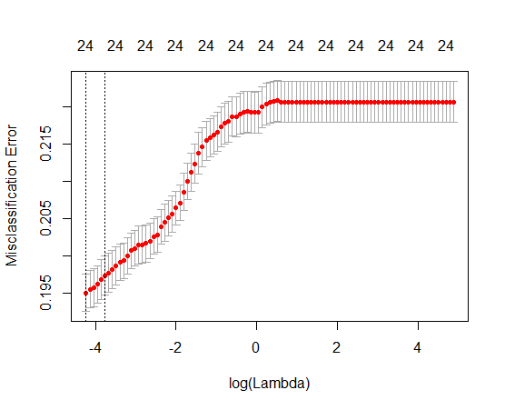

**Figure 3.** Misclassification Error vs. log(λ) for α = .5 (Elastic Net Scheme)

**Table 1. Accuracy of All Classifiers**

|  |  |
| --- | --- |
| **Classifier** | **Accuracy** |
| Lasso (α = 1) | 0.8133 |
| Ridge (α = 0) | 0.8092 |
| Elastic Net (α = .5) | 0.8132 |