Generating useful questions for assisted learning with optimised software

Author: Michael Stevens

Abstract:
Learning information is not commonly known to be a simple process. Generally it requires considerable effort listening, note taking, reading and finally doing revisions. This project aims to simplify the process of learning through an interface that enables the user to test himself on his markdown notes (with the .md extention). Specifically, this report focuses on the development of a program that initially reads the user’s notes, detects the styling, and stores the data in JSON files. It then utilizes the format of the JSON files to generate questions that are relevant to the content in the notes, facilitating an assisted learning interface. Additionally, the report will also discuss how I optimized the functionality of the code by leveraging the unique capabilities of the C programming language.

Table of Contents
Abstract: 2
Introduction: 3
The Background: 4
Markdown Files: 4
Contrast: 5
The Project’s structure: 8
Problem: 9
Specification 10
Setup: 10
execution: 11
Design 13
File_Handling.c 13
File_Processing.c 15
Learning_Interface.c 18
main.c 20
CJSON.c 20
Implementation 21
Learning C 21
Initial Steps: 21
CJSON: 22
Efficient File Handling 22
Efficient File Processing 22
User Interface 23
Results and Evaluation 24
Conclusion 24
Reflection 25
References: 25

Introduction:
Personal computers are ever more present to accompany individuals on their learning journey. Many take advantage of the opportunities to learn thanks to applications that have been developed to empower individuals to learn anything. One of the most remarkable application is called Anki(1).
The Anki app is open source, written in python and rust and made to be available on all the main operating systems with over 700 plugins. It allows the user to create organised playlists of Flashcards that each contain a question and answer. This app leverages the learning potential related to storing user defined questions. The questions, require the user to recall the information from the answer, this directly develops the user’s memorisation skills of that specific answer.
Indeed, questions play a special role in prompting users to engage their memory. However, the Anki app presents a limitation: users must invest significant effort to manually create each flashcard. My project aims to address this obstacle through question generation. Computers are increasingly relied upon for learning, and I will demonstrate how question generation is pivotal in developing a practical implementation within an assistive learning application. For my solution I will prioritize computational efficiency in the question generation process, considering the limited resources typically available on the average person's computer.
My implementation will be accessible to every person that owns a computer that can run the C programming language. The current functional version natively runs on Linux by using the bash terminal environment as the learning interface. However the implementation is highly extensible, allowing many features to develop upon the already existing implementation.
The outcome for my project is to prove its usefulness of question generation in an assistive learning app for the users that understand how to write their notes in the markdown format. My assumption is that many have started using the markdown format for its practicality, this will translate in a keen understanding of my implementation to be worthwhile using. Lastly the app’s simple yet efficient implementation is documented on GitHub, this allows for users to participate in the development of this project to make it better.

The Background:
Question generation often refers to complicated machine learning implementations for Natural Language Processing. However I would argue these implementations have many inconveniences. Firstly they are complicated software applications that don’t allow much collaboration from the general public. Secondly they require high levels of performance that make them incompatible with slower computers. Lastly these tools are often dependable on an internet connection to access the computation power on the cloud.
However the solution that I’ve implemented is a highly compact and efficient program that can be extensively improved through collaboration. Its only dependency is the usage of the markdown file format. Specifically for my current version users will also need to be familiar with the terminal interface. However for users to truly understand the extent of my program’s capacity’s they must also understand it’s implementation. That way users can refine the program in a way that suits their personal use.
In this section I will introduce the Markdown file and explain the advantages of using such a format. Then I will first thoroughly explain how this program distinguishes itself by comparing it to a previous implementation of mine without the question generation. Finally I will introduce the overarching modular structure of the code, so that users may truly understand how they can implement their own modifications.

Markdown Files:
To understand the scale and the personal uses of this application you must first familiarize yourself with Markdown. Markdown is a lightweight markup language that is simply implemented in common text files. It was inspired by pre-existing conventions for marking up plain text in emails and its predecessor, ATX. In 2004, Aaron Swartz and John Gruber invented Markdown and referred to its uses as: "to write using an easy-to-read and easy-to-write plain text format, optionally convert it to structurally valid XHTML (or HTML)." Indeed, Markdown was designed not only to be easy to write but also easy to read. This forms the basis of what allows my application to conveniently use Markdown files for writing and reading purposes. This technology is already utilized in many well-known applications such as GitHub, GitLab, Reddit, and Stack Overflow. Additionally, it has been the basis for purposely designed text editors such as Obsidian. The Markdown file format is not only simpler and more efficient to use for storing information but also allows it to be input for automation processes, such as its conversion to HTML or, as we shall see in my implementation, into JSON.

To understand how Markdown works, here is an infographic explaining the simple syntax required to use it:
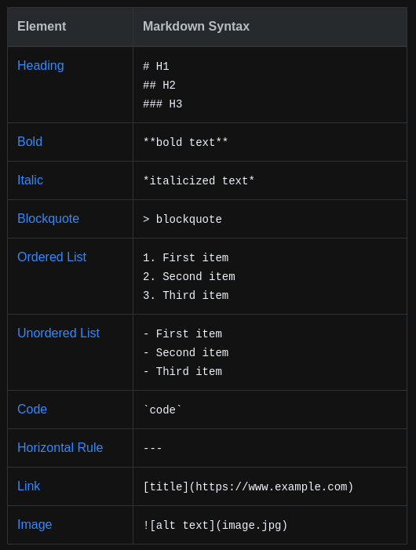

T

Contrast:
To understand the usefulness obtained by the question generation we must first understand the contrast between a version that would not include question generation with a model that does. Before the implementation of this solution I had developed another kind of learning app that I coded in python. This learning app was called PyAssist, it consisted of a single python file and a single csv file. Here the functionality is clearly explained:
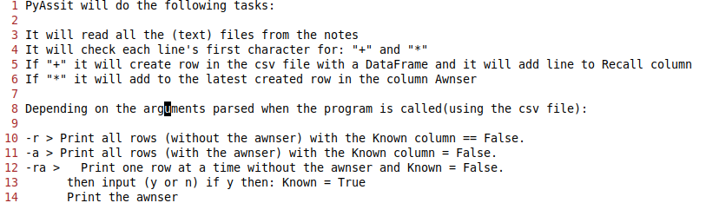
This version did not include question generation, instead the user was required to write a question himself inside of a text file followed by the corresponding answer. For this he had to manually include “*” or “+” at the beginning of the lines he defined as questions and answers. Here is the program’s code with some further explanation:
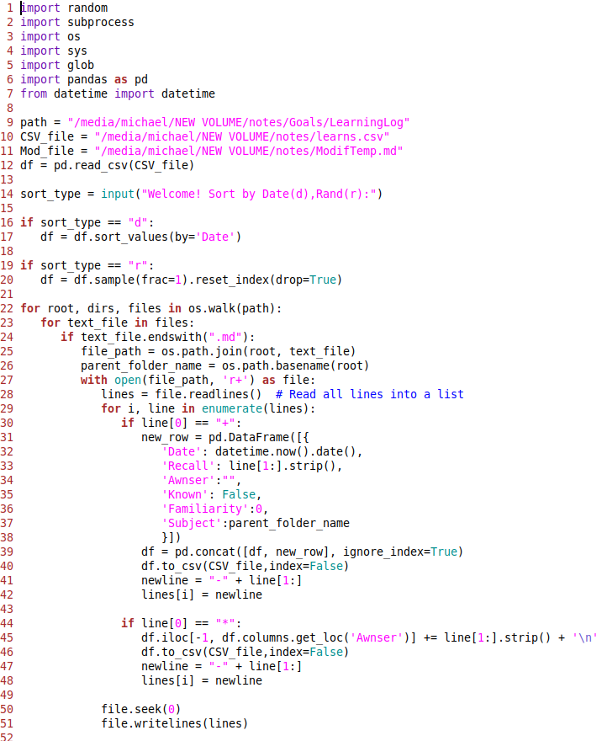
This first part the program assigns the paths to the files and notes folder. It then sorts the entries inside the csv file in a chosen specific order to be viewed in. It uses the os.walk() function to iterate through each text file in the notes folder. Inside the function it includes the two conditions: if line[0] == “+”: , if line[0] == “*”: and creates a new dataframe. The dataframe is added to the csv file as a new row with the to_csv() function.

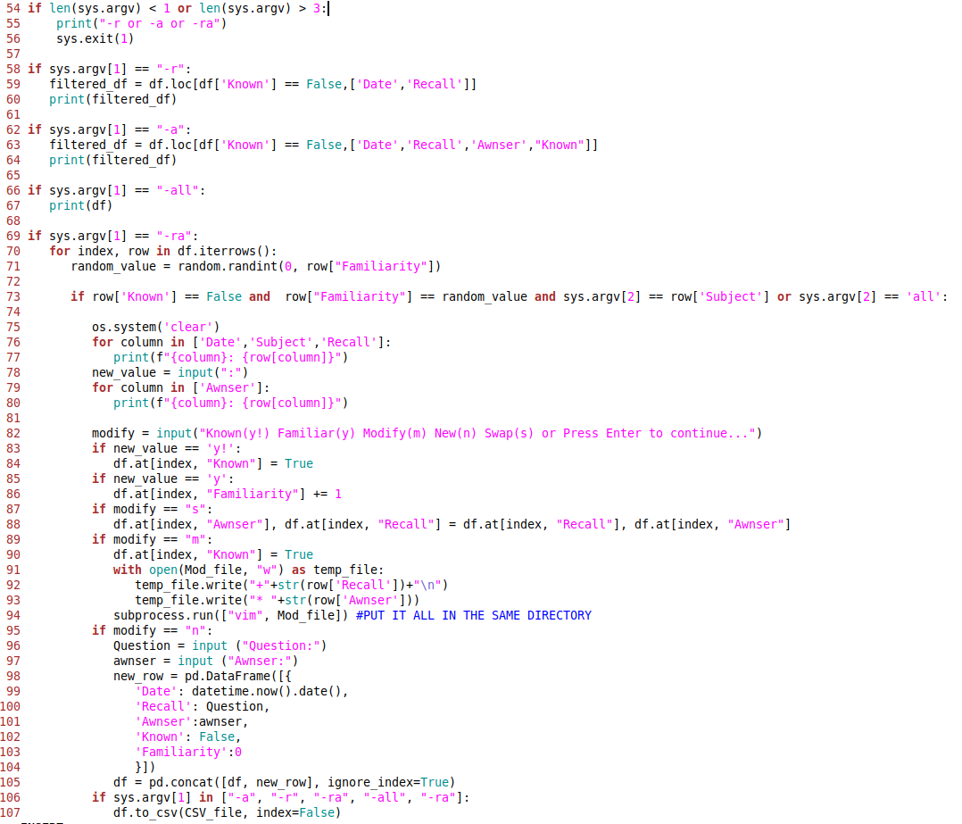
The second part of the program includes the user interface with different commands to interact with the csv file.

As previously mentioned the first program relies on the user to create a question everytime for the subject the desires to learn as such:
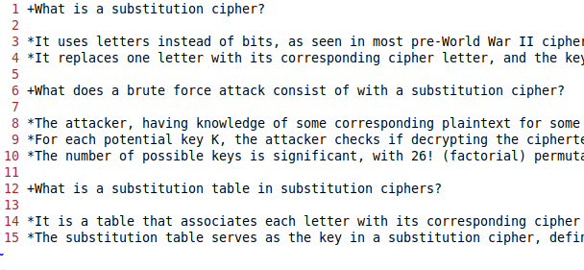
However this is very time consuming. The user who only wishes to write his notes and learn their content is forced to have to change the structure of his notes and formulate a question manually every time.
The revisited implementation of a learning app with question generation does not have to burden the user with the structure of his notes and more importantly the formulation of the questions. Instead he will only be required to structure his notes in a Markdown text format as such:
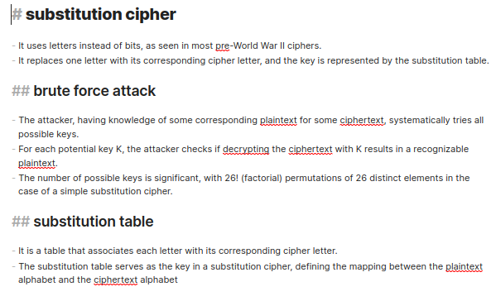

The Project’s structure:
The project is highly structured to enable high levels of modularity and simplicity. Here we can see its entire structure:
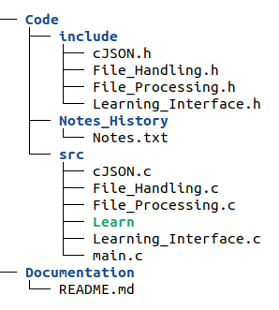
The entire app functionality is comprised of three main folders:
Include:
The include folder neatly houses each header file (*.h) with the identical name to its corresponding source file (*.c), additionally the names used ensure clarity and ease of understanding for users. This organization fosters modularity by distinctly defining the interface for each component of the program, allowing modifications or enhancements to be made to individual parts without disrupting the rest. Ultimately the modular design allows for the program to be more extensible to further development or any improvements.
Notes_History:
The notes History folder stores small text files relevant to the efficient execution of the program. Each text file corresponds specifically to a detected Markdown file. Currently it only contains a date value that corresponds to the program last modified date of the file. This functionality could be harnessed to implement extra metadata for each markdown file.
src:
This file contains all the complex code with all the computing logic. Each file contains specific functions that relate to the overall required functionality. Here is a comprehensive explanation of each file and its processes explained:
File_Handling.c:
This file contains functions that handle the file selection before they are processed. The file includes functions that use the Notes_History folder to update and compare date values so that the program knows which Markdown files have been modified or created recently.
cJSON.c:
This file contains code instructions specifically tailored for dealing with JSON data. It is a well known implementation for tasks such as reading, writing, and manipulating JSON data. It should not require any modifications.
File_Processing.c:
This file contains function that are fundamental to the processing of the Markdown and JSON files. It contains functions to extract the information from the Markown files, functions to create or append the extracted information into JSON files.
File_Interface.c:
This file contains the function that orchestrates the first part of the program, to extract from the users notes to create the JSON files. It also contains the function that orchestrates the learning environment that creates and displays the questions as well as the rest of the extracted information inside the JSON files.
main.c:
This file orchestrates the simple user interface that requires the user to run the program in the terminal and select the field he wants to learn from a drop down. It also calls all the main functions that show how the program operates.
Learn:
This is the direct compiled machine code resulting from the compilation of all the files mentioned above including the header files inside the include folder.

Problem:
Throughout this report I will consider the three aspects mentioned in the background to establish the usefulness of my solution. I will demonstrate the required use of the Markdown files, explain the detailed functionality of my current working solution. Finally I will explain some foreseeable extensions to my solution that will build upon the basis of my solution. At the same time I will explain how each detail contributes to the overall usefulness of my current solution.

Specification
In this section I will explain my current implementation of the working solution and how its meant to be used.

Setup:
Firstly the user will be required to install the source code. For this step the preferable method depends on wether the user is an programming enthusiast or is more focused on the simple usage of the program. If the user is simply interested in using the program, the most efficient way will be to download the source code directly from Git Hub as a zip file. However if the user is interested in how code code can be modified or made better he is recommended to Clone the repository onto his computer from Git Hub. Once the application is installed the user will be required to compile the application and produce the executable file. Finally the user can create an alias to the newly created program so that he can simply access the program’s execution from the terminal. All these steps are explained in the program’s README.md file.

Next the user will have to familiarise himself with Markdown and how to use the appropriate styling. Additionally the user will have to take the initiative to structure all his note folders and files with the appropriate naming and hierarchy. Here is an example of a file structure and instructions on the correct syntax styling:
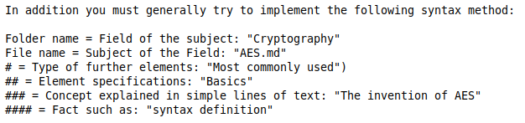
This is an extract of the README.md file that explains the required styling practices within the Markdown files for each heading.

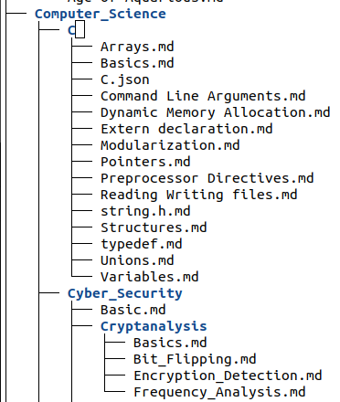
Here we have the demonstration of the ideal file structure needed for the correct implementation of the program. As previously stated it includes Folder names that correspond to the general Field concerned and file names that correspond to the various Subjects.

execution:
Once the environment is prepared the user can now run the program. To do this the user will simply type the name of the executable file and parse the path of the notes folder that contains all the structured markdown notes:
Then the user is shown the initial menu:

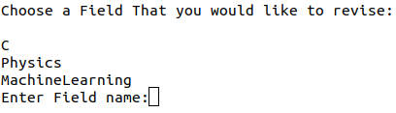
Once I select the subject I chose, in this case Physics I get the next menu:

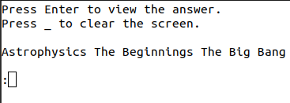

When I press enter to view the answer:

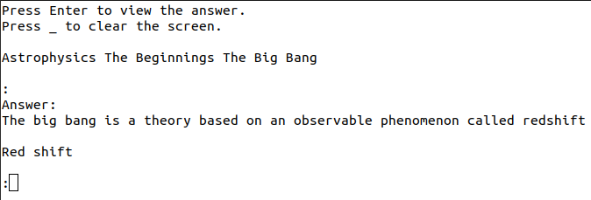

Here we can then see the entire output for this specific file:
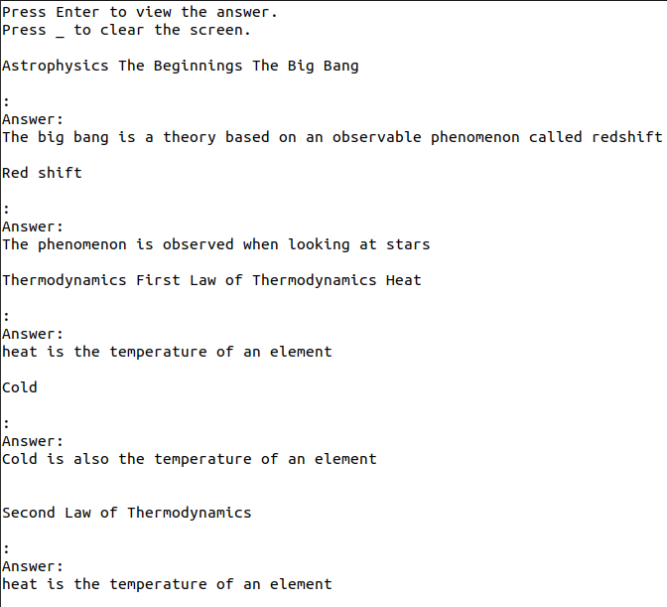
From looking at the output we can understand the functionality of the current program. The question is composed of the listing of each title and subtitle traversed until the answer is reached. For example the first question consists of: “Astrophysics The Beginnings The Big Bang”, by looking at the structure of the file we understand how the program functions. It finds the styling involved in the structure of the file and includes this information to directly produce the question.
This is the contents of the Astrophysics.md file:
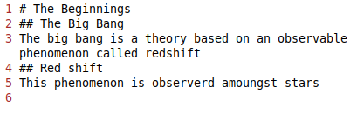
The program displays the file name Astrophysics, followed by the first heading and then the second heading to produce the first question: Astrophysics > The Beginnings > The Big Bang.
This is the contents of the Thermodynamics.md file:
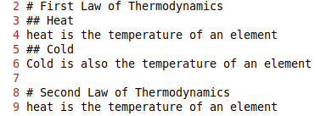

Design
Although the solution seems simple in appearance, there was considerable development required to allow the application to be highly efficient and extensible. In this section I will explain the current working design of the project. I will go through each main “.c” file that is included in the program and explain its various functionalities.

File_Handling.c
This file contains all the functionalities to handle the user’s note files efficiently. It contains 4 different functions:
Update_Vault_History()
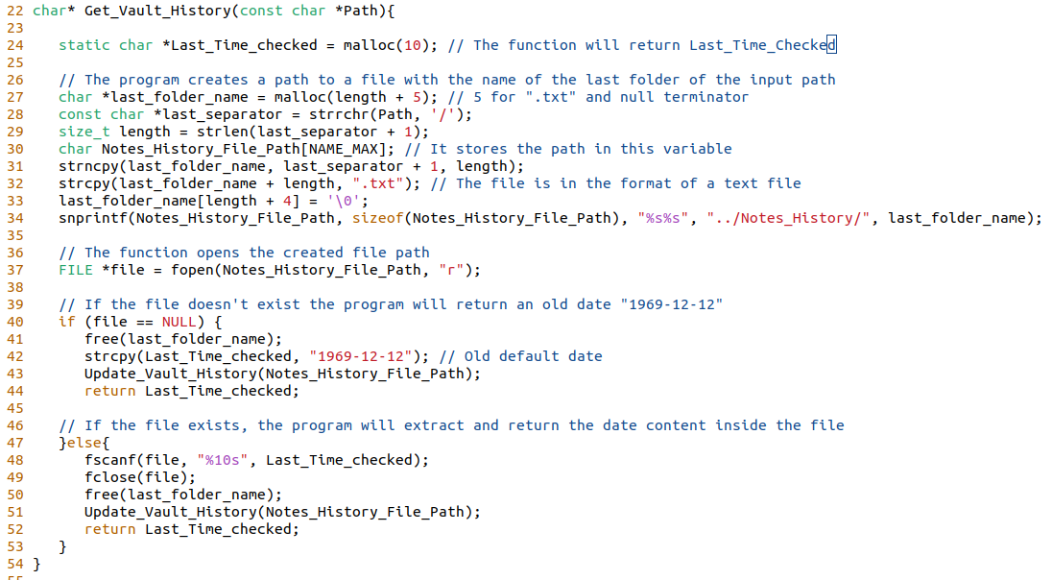
This function is associated with the use of the Notes_History Folder in the source code. It creates an entry with the name of the select Path to run the program.
For this following path an entry called Notes.txt will be created in the Notes_History Folder.
This function serves to store the date when the specific path selected to run the application was used. That way it will compare it with the date when each Markdown file was last opened, to select only the files that have been modified after the last time they where processed.

To achieve this efficient implementation the function also uses the following functions:
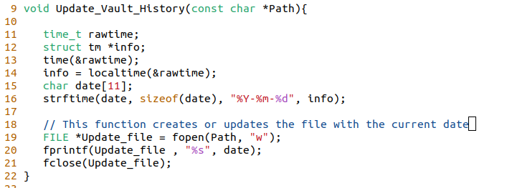
This function is called at the end of the Get_Vault_History function to update or create the entry with the file with the Notes_History_File_Path. It then inputs the current date into this history file.
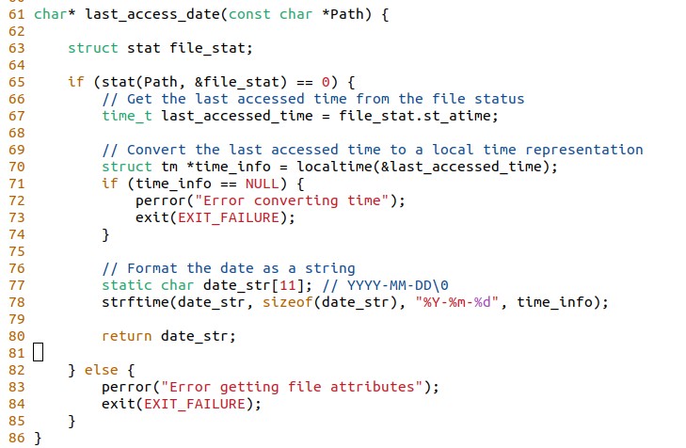
This function is used to get the date value of when each Markdown file was last edited. The program uses this value to compare it with the Last_Time_Checked variable returned by the Get_Vault_History function.

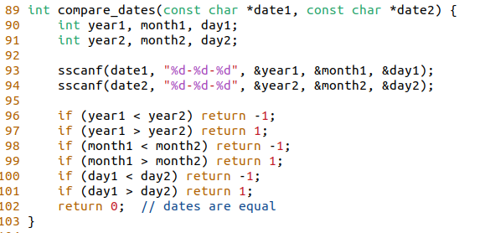
To compare the date values of when a Markdown file was last opened and when the Selected Notes folder was last executed with the program we run this fucntion. It interprets date values such as “2024-12-12” into meaningful data to compare with other date values.

The File_Handling.c is comprised of functions that help to make the program efficient by only processing the Markdown files that where recently modified. The methods of this file are primarily called in the Learning_Interface.c file that will be reviewed further on in this report.

File_Processing.c
This File processes the .md files and create the JSON files. Her is the first function Extract():
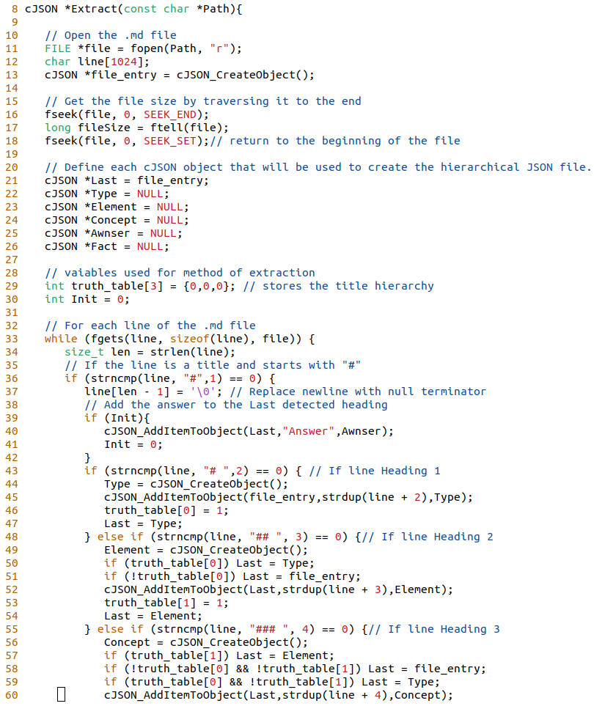
This Function will be given the path of the current .md file it needs to extract.
It will return a cJSON Object that will later be Stored in a file with the other function Store()
The cJSON structure is shown at the end of this section about the File_Processimg.c file.
Everytime the function is called it will start by opening the Markdown file and get its length value.
The function creates various cJSON objects that it will connect together to obtain the hierarchical structure of the .Markdown file.

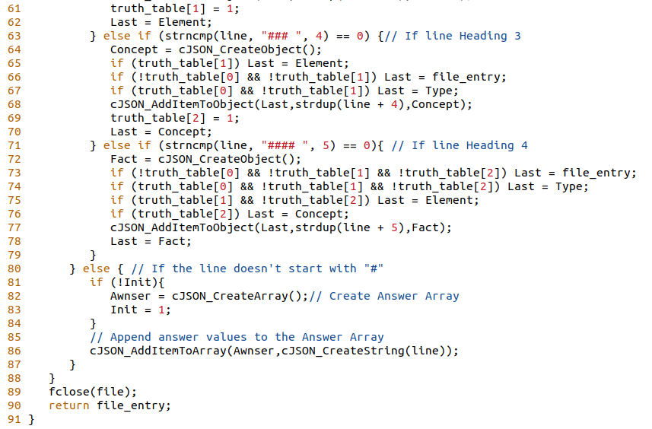
The function will then iterates through the file, it will create new cJSON objects for the newly detected titles starting with “#” and append to an answer cJSON Array the rest of the line detected.
Finally it will add each component inside their respectful cJSON objects that precedes them in its creation.

This is the Store() function, it takes for input the cJSON object that Extract() returns and the Path of the current Markdown file.
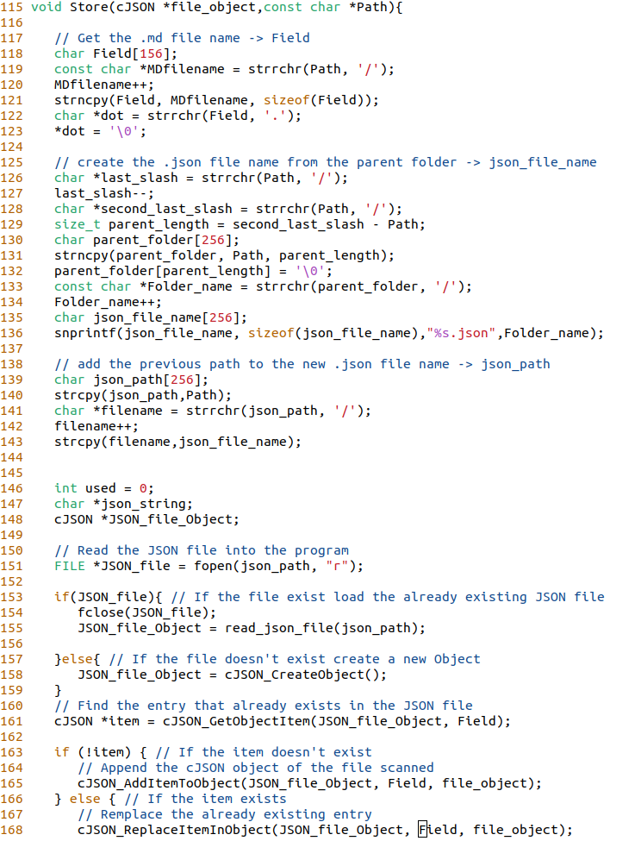
The function first derives 3 variables from the path:
- The Field, corresponds to the name of the Mardown file without the extention.
- The JSON file name, corresponds to the name of the folder that contains the Mardown file with the extention at the end “.json”.
- The JSON file path, is the intial Path with the JSON file name instead of the markdown file.
Then the function reads the JSON to create a cJSON object of it. Notice that if the JSON file doesn’t exist the fucntion create an empty cJSON object.
Using the Field variable the function searches the JSON file for the entry corresponding to the cJSON object taken as an input by the function.
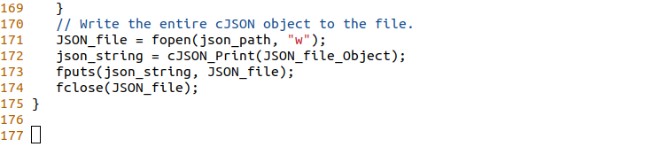
If the entry is found, then it is remplaced, otherwise it is appended. At then end the cJSON JSON file object is written to the file.

To better understand the functions in the File_Processing.c we have to understand the structure of the JSON files that the program creates and interprets. Here is an example of a JSON file Physics.json inside the Physics Folder with two other files: Astrophysics.md and Thermodynamics.md.
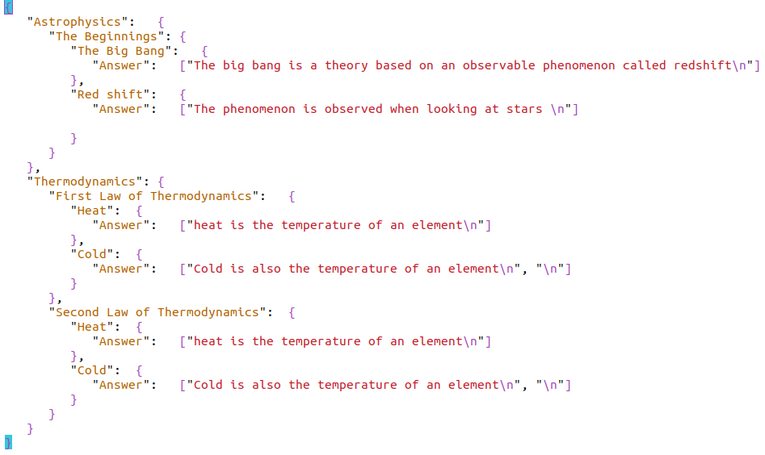
Here are the two files that correspond to the JSON file above. On the left the Astrophysics.md file and on the right the Thermodynamics.md file:

Learning_Interface.c
This file contains the functions that incorporate the Learning Interface with the various other funcions. These are the functions that are directly called in the main.c file, they incorporate the File_Processing.c and File_Handling.c functions as well as some of the cJSON library. First we shall see the Build() function:

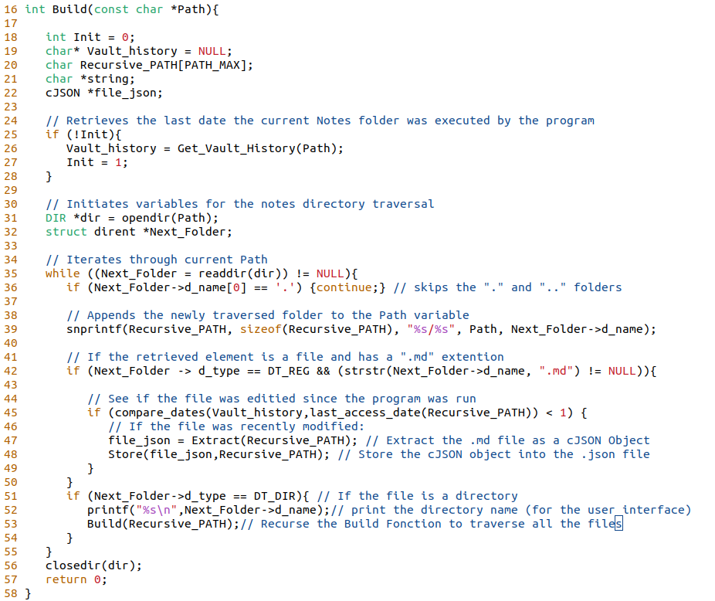
Before the notes folder is traversed this function retrieves the date of the last time the specific notes folder was executed. Then it includes the main part of the function that also includes the implementation of recursion (line 53). The function iterates recursively through all the files and folders: when it detects an Mardown file it extracts it to a cJSON object. Then it parses the cJSON object into the Store function. When it detects a folder the function prints the name of the folder to the screen for the User interface and then it Recurses until it has gone through all the folders.

The next main function in the Learning_Interface.c file is the Learn() function. This function is the function that includes the dynamic user interface for when the user selects a Field to learn. In other words this function is responsible for reading the JSON file and displaying it to the user interface:
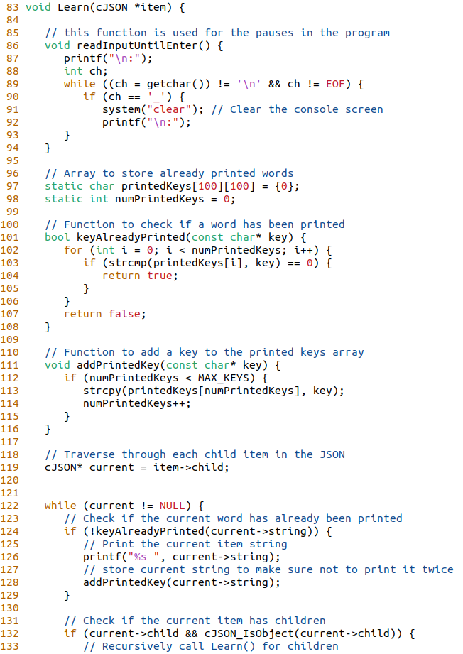
The function has 3 inner functions:
- readInputUntilEnter(), this function is called after the program displays the question so that the user can pause and press enter when he is ready to view the answer.
- KeyAlreadyPrinted(), this function serves to avoid questions with repetitive words.
- AddPrintKey(), this function is complementary with the previous KeyAlreadyPrinted().
The program then recursively processes the items inside cJSON object. Inside this loop it prints the name of the current item. By continuously printing the current item and updating the current item to its child it successfully prints the question.
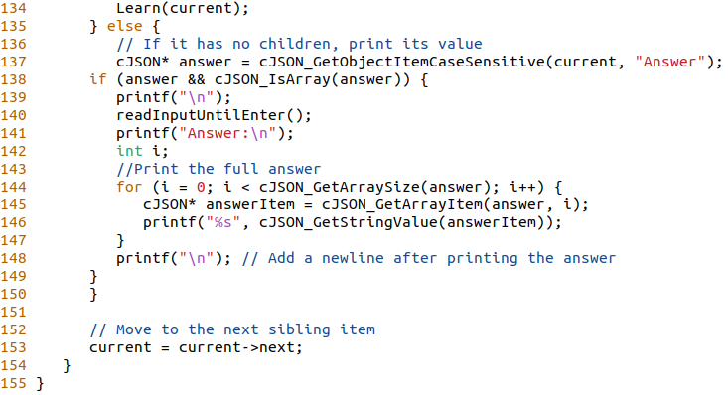
When the item has no child items the program retrieves the answer cJSON Array. Finally it prints all the contents of the Answer array with a for loop.

The last file included in this program is the main.c file:

main.c

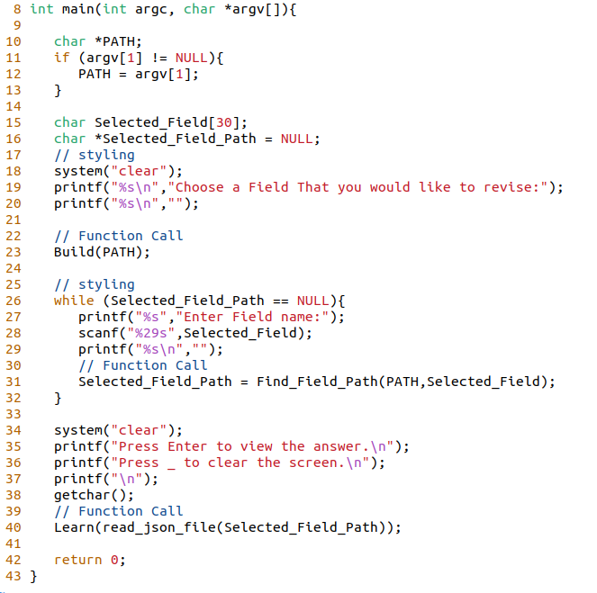
In the main.c file the program first calls the Build() function to update all the JSON data entries.

Then it finds the path of the selected chosen field “Physics”. For this it uses a small function called Find_Selected_Path() defined in the Learning_Interface.c file.

Finally it uses a function called read_json_file() defined in the File_Processing.c file, and inputs the cJSON object returned to the Learn() function.

CJSON.c
In the project design, cJSON was crucial for efficient JSON handling. It was easily implemented by only needing to install the files directly into the source code. With cJSON, data extraction and processing from Markdown files into structured JSON format were streamlined. Functions like Extract() and Store() ensured hierarchical organization, enabling easy retrieval and manipulation. cJSON's robust functionality sets a strong foundation for future enhancements of the project.

Implementation
The implementation of all the components was very gradual. I had already some experience with designing a learning app however it was all implemented into a single file of code. This project required using a lower level programming language and a more sophisticated implementation with extra modularity and structure.
In this section I will explain the gradual implementation process of all the functionality in a chronological order:

Learning C
Firstly I had to familiarise myself with the C programming language. I knew that in order to be able to develop a qualitative solution I was required to familiarise myself with all the aspects of the C programming language. I learnt about all the basic features that the C programming language offers. In the mean time I also benefited from a practical text editor to write notes on each subject that I learnt:
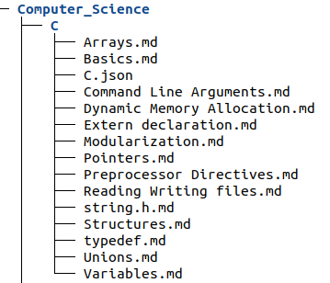

Initial Steps:
Once I had familiarised myself with the C programming language I was ready to start developing. After brainstorming and sketching my ideas I commenced with the implementation of the code that enabled me to search all the files and folders inside the notes folder. Rapidly I chose to implemented the recursive method using the Opendir() function and the DIR data structure type. After the implementation of the recursive function I was left with a program that could detect the files in the main folder through the recursive search.

CJSON:
Now I was required to understand how I could manipulated JSON files. By doing some research and comparing different libraries I selected the cJSON library. Its alternative library is the Jasson library, after deliberate comparison I concluded that cJSON was the best library for two reasons. Firstly the syntax required to manipulate the cJSON library was more simple and minimal, it remained very similar to the syntax I was used to be exposed while I learnt C. It has more detailed syntax for example it uses more pointers and other native C syntax. Secondly It has all the features I require, after doing some research I was confident that this library was well suited and there was no need for the more complex Library Jasson.

Efficient File Handling

This stage was more challenging then I expected. I implemented different solutions before discovering the final solution of using a simple text file that corresponds to the notes home folder. Once I had understood the best method I changed the structure of the program. Initially I was going to develop two files: File_Extraction, File_Analysis and Create_Learning_Material. However the implementation of an efficient method to handle the Markdown files in the notes folder made me reconsider the structure for the current one. I therefor complete this functionality first by incorporating all the working functions in the first file: File_Handling.c.

Efficient File Processing
After having implemented code for handling the files I was now required to think about the most technical aspect of the project. The program progressed as I set up the retrieval of the JSON file and created the cJSON object for proper structuring. However, structuring the program to read each line from the notes file posed some complexity, particularly due to variations in file structure using "#" markers. I considered adding a parent JSON structure each time, with the option to include some text, which seemed like a good approach. I decided on a hierarchical structure for the JSON files, aiming for simplicity and readability in the code. Despite encountering difficulties, I developed an Extract function that returned the desired cJSON object. Then, I focused on creating the Store function, which handled the JSON file creation and updating. This function iterated through each extracted cJSON object and incorporated it into a larger JSON file. Despite some setbacks, I documented each functionality to be implemented in the File Processing file. Initially considering text modification in C, I opted for a hierarchical question format for simplicity. This process, prioritized for convenience, culminated in an interface based on the file hierarchy's levels.

User Interface
he user interface presented several steps: 1) printing the JSON file names and asking the user to select one, 2) processing the selected file(s), and 3) implementing a function for handling the output as well as other potential metadata. However, while attempting to execute the process, I encountered difficulties. I decided to proceed with caution, taking baby steps forward. The build function initially worked, but encountered issues in the Store function. Upon investigation, it seemed that the problem actually originated in the Extract function. I was interrupted by overly complicated implementations. Throughout the implementation process, I realized the importance of focusing more energy on basic functionality before attempting to implement multiple features at once. Indeed My initial plan was to store various other data in the JSON files to refine the user interface. Here is an example of my initial implementation idea:
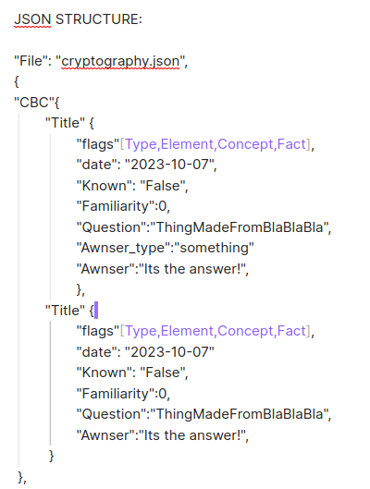

In the end I simplified the Learning interface by minimising the complexity of the JSON file structre. However this was still an interesting experience because I know how extensible this implementation can already be.

I am very pleased with this low-level implementation as it can allow for further development into a highly functional and stable version.

Conclusion

In the ever-evolving landscape of personal computing, applications designed to aid in learning are becoming increasingly prevalent. Among these, Anki stands out as a remarkable tool, offering users the ability to create organized playlists of flashcards to facilitate memorization and learning. However, Anki's manual flashcard creation process presents a significant hurdle for users seeking a more streamlined learning experience. To address this challenge, my project introduces a novel approach to question generation, aiming to automate the creation of flashcards from user-defined notes stored in Markdown format.

By prioritizing computational efficiency and leveraging the simplicity and accessibility of Markdown files, my implementation offers a practical solution accessible to anyone with basic knowledge of the C programming language. Although the current version of the application operates within a Linux terminal environment, its modular design and extensibility lay the groundwork for future enhancements and adaptations to various platforms.

Through the iterative development process, I encountered and overcame numerous challenges, from mastering C programming to efficiently handling Markdown and JSON files. While initial plans for a more complex user interface and additional features had to be scaled back due to technical constraints and complexity concerns, the resulting implementation remains functional and capable of fulfilling its core purpose: aiding users in learning through automated question generation.

Looking ahead, the project's simple yet efficient design provides a solid foundation for further development and refinement. By documenting the implementation on GitHub, I invite collaboration from the community to improve and expand upon the existing functionality. Ultimately, my goal is to create an assistive learning application that empowers users to effortlessly generate flashcards from their notes, enhancing their learning experience and knowledge retention. I hope this low level implementation will remain and allow for further development into a highly functional and stable version for everyone to use.

References:
(1) Official Anki App Website: https://apps.ankiweb.net/
(2) Daring Fireball is a website produced be the co-founder of Markdown John Gruber: https://daringfireball.net/projects/markdown/
(3) Tutorial website that provided the Basic Syntax info-graphic: https://www.markdownguide.org/cheat-sheet/

