BEARING
Product & Technical Overview

Prepared for Naum
MN&J Labs · 18 August 2026
Covers the system as deployed and verified on bearing.mnjlabs.com

Internal — contains architecture and API detail

1. Purpose and idea
Bearing answers one question for a person with a serious diagnosis: “Which treatments for my exact condition are approved, available and actually paid for in my country — and has that answer changed?”
A treatment can be approved in one country and unavailable in the next. Across Europe, the median gap between a cancer medicine being approved and a patient actually being able to receive it is 532 days — 128 days in Germany, 840 in Portugal. During that wait, nobody tells the patient where they stand. The information exists: it sits in government reimbursement registers and in commercial databases sold to pharmaceutical companies. It has never been turned to face the person it is actually about. That is the entire product idea.

What Bearing does
- The patient states their situation once — condition, stage, biomarkers, treatment line, country. Nothing else: no name, no ID number, no medical file.
- Bearing reads the official reimbursement register for that country (currently the Australian PBS) and shows, drug by drug, what is funded for that exact profile — quoting each restriction word for word from the register.
- It keeps watching. When an answer moves for that specific person — a drug becomes reachable, stops being reachable, or a requirement appears or disappears — Bearing tells them. Silence otherwise.
- It produces evidence the patient can act on: a one-page PDF for their doctor or payer, and a revocable share link a clinician can open without an account.

What Bearing deliberately is NOT
This boundary is the most important design decision in the product, because it keeps Bearing outside the regulatory category of a medical device (EU MDR) and outside high-risk classification under the AI Act:
- It never decides whether a patient qualifies for a treatment. Eligibility is a clinical judgement made by the prescriber and the payer.
- It never paraphrases a reimbursement restriction. Paraphrasing a restriction is how you accidentally give medical advice; the register's own wording is always quoted verbatim, in full.
- It never hides an option. The worst verdict a treatment card can carry is “cannot assess” — shown with an explanation of what is missing, never removed.
- AI is used to READ the register and the patient's own documents — never to form the access answer. The answer itself is computed by deterministic, auditable code (see section 5.2).

The asymmetry that shapes every decision
Missing a real change costs a patient months of not knowing a treatment was within reach — the product's only job, failed. Sending noise gets the product muted, after which the patient misses the real change anyway. Every matching and alerting rule in Bearing is written against this asymmetry: tell the person when something they could act on moved; stay silent otherwise; and when in doubt, show the option with an honest “we cannot assess this” rather than hiding it or overpromising.

2. Technology stack (brief)
Layer | Technology | Notes
Backend | Kotlin + Spring Boot 3 (Java 21) | Single service “bearing-core”; REST + server-rendered pages
Database | PostgreSQL 18 on AWS RDS | Flyway migrations (17 to date); append-only versioned facts; not publicly reachable
Frontend | Flutter (one codebase) | Web PWA + Android APK + iOS-ready; EN / RU / HE incl. RTL
Hosting | AWS ECS Fargate + ALB + ECR | Region us-east-1; TLS at the load balancer; rolling deploys
Secrets | AWS Secrets Manager | DB password, gate password, VAPID key, Anthropic key; IAM scoped per secret
Documents | S3 (SSE-KMS) / local in dev | Patient uploads; presigned URLs; never public
PDF | OpenPDF (LGPL) | Chosen over iText 7 to avoid AGPL obligations
Push | Web Push (VAPID) | No Firebase dependency; reaches desktop, Android, iOS 16.4+ via PWA
AI | Anthropic Claude API (Opus 5) | Register extraction, change summaries, document reading, questions
DB access (team) | Bastion + AWS SSM tunnel | No open ports; scripts/db-tunnel.ps1; access = IAM identity

The register data pipeline is deliberately boring: fetch → verbatim store → supersede-never-edit. Anything clever happens after the facts are safely on disk, and can be re-run at any time because nothing is ever destroyed.

3. External APIs (what Bearing consumes)

3.1 PBS Public Data API — the register source
https://data-api.health.gov.au/pbs/api/v3 — the Australian Pharmaceutical Benefits Scheme's public data service. This is the ground truth of the product: which medicines the Australian government funds, for which conditions, under which written restrictions.
- Three endpoints are joined locally: /restrictions (the legal wording), /items (drug, brand, form, PBS code), /item-restriction-relationships (which restriction applies to which item).
- Rate limit: one request per 20 seconds, shared across all public users. The ingest makes exactly four spaced calls per refresh, never per drug.
- Licence: Commonwealth of Australia copyright — redistribution permitted with the notice retained, modification not permitted. This aligns exactly with the product rule of quoting verbatim; the licence and the ethics point the same way.
- Current coverage: 64 live listings across 25 drugs for non-small cell lung cancer, refreshed via an admin endpoint (schedule pending).

3.2 Anthropic Claude API — reading, never deciding
https://api.anthropic.com/v1/messages, model claude-opus-5, key held in Secrets Manager. Four uses, all of them producing text or suggestions that a human or deterministic code acts on — never the access answer itself:
- Criteria extraction: reads each listing's restriction text into structured criteria (biomarker REQUIRED vs biomarker EXCLUDED), each citing the exact source sentence. Output lands unreviewed and is invisible to patients until a human signs it off. Measured against the hand-written regex it replaced: the regex missed 9 real requirements and could not represent the 13 listings that require the ABSENCE of a mutation.
- Change summaries: when a restriction's wording changes, a two-sentence plain-language note on what moved, stored next to (never instead of) both verbatim texts.
- Document reading: pulls biomarker results out of a patient's own uploaded pathology report — suggestions only, each with the exact quote it came from; the patient confirms before anything touches their profile. Requires its own separate consent.
- Appointment questions: turns the gaps the matcher already computed (“ROS1 not on your profile”) into questions to ask a doctor. Instructed never to suggest a treatment or state that anyone qualifies.
Model choice was measured, not assumed: on the same 61 listings, Haiku 4.5 agreed with Opus 5 on 95% of fields but misread crizotinib's ALK requirement as ROS1 and missed brigatinib's ALK clause entirely — wrong in precisely the way this product exists to prevent, to save ~$0.50 per full re-extraction. Opus 5 costs ~$0.71 for the entire register, once per listing, not per patient.

3.3 Web Push services (browser vendors)
Standard Web Push with VAPID keys. Each browser's push service (Google, Mozilla, Apple) delivers the notification; the payload is encrypted to the device and deliberately non-disclosing: “Something changed for you. Open Bearing to see it.” — never a drug or condition name, because a lock screen is read by whoever holds the phone.

3.4 Orphanet (dataset)
11,645 rare-disease names imported as a searchable dataset backing the rare-disease profile flow (/api/v1/rare-diseases/search). Not a live API dependency; refreshed from the published dataset.

4. Internal API (what Bearing exposes)
All endpoints are served by bearing-core behind the ALB. Everything under /api/v1/patients/{id}/… passes a servlet ownership interceptor that resolves the patient from the SESSION, not the URL — a signed-in account asking for another patient's data receives 404 (not 403, so patient IDs cannot be enumerated). Admin endpoints require the DEMO role held by MN&J team accounts.

4.1 Authentication & account
Endpoint | Purpose
GET /gate | Server-rendered sign-in page (EN/RU/HE). Shown to any unauthenticated browser request.
POST /login · /logout | Spring Security form login; JSESSIONID cookie; secure/HttpOnly behind TLS.
POST /api/v1/account/register | Create an account: email, password (BCrypt), optional birth year, country. No name field exists.
GET /api/v1/account/me | Who am I + my patient id. The app's session probe.
GET /api/v1/account/consent-text | The exact consent wording (versioned; its SHA-256 is stored with every consent row).
POST /api/v1/account/consent/withdraw | Append a withdrawal row — consent is a ledger, never an update.
DELETE /api/v1/account/me | GDPR Article 17 erasure: account, profiles, documents, alerts, shares — irreversibly.

4.2 The patient's data
Endpoint | Purpose
GET /api/v1/patients/{id}/cabinet | The core answer: every register listing evaluated against the CURRENT profile — available / cannot-assess / excluded, with verbatim text, gap notes and per-patient change count.
POST /api/v1/patients/{id}/profile | Save the profile as a NEW VERSION (append-only). Every answer ever shown stays attached to the version that produced it.
GET /api/v1/patients/{id}/profile/history | All profile versions, oldest first.
GET/POST/DELETE /api/v1/patients/{id}/documents | Upload (multipart, 20 MB), list, delete pathology reports and letters. Stored in S3 under KMS.
GET /api/v1/patients/{id}/alerts | Material changes for THIS patient, newest first — headline, reason we told them, verbatim detail.
GET /api/v1/patients/{id}/report.pdf | The one-page clinician PDF. No name, DOB or identifier anywhere, including the filename.

4.3 Sharing with a clinician
Endpoint | Purpose
POST /api/v1/patients/{id}/shares | Mint a share link: 256-bit token, stored only as SHA-256 (like a password). Plaintext exists once, in this response. Default expiry 14 days.
GET /api/v1/patients/{id}/shares | The patient's links with REAL open counts and expiry.
DELETE /api/v1/patients/{id}/shares/{shareId} | Immediate revocation.
GET /s/{token} | PUBLIC: server-rendered HTML summary for the clinician — no account, no JS needed; X-Robots-Tag noindex; counts one open per visit.
GET /s/{token}/report.pdf | PUBLIC: the PDF via the same token (does not double-count the visit). Revoked/expired links answer 404 exactly like unknown ones.

4.4 Search & reference
Endpoint | Purpose
GET /api/v1/register/search | Public-register search: drug, brand, ATC code or restriction words. Not tailored to the patient — “what the register says, for everyone”.
GET /api/v1/rare-diseases/search | Typeahead over 11,645 Orphanet conditions for the rare-disease profile.

4.5 Assist (AI helpers) & push
Endpoint | Purpose
GET /api/v1/patients/{id}/assist/status | Whether AI helpers are configured + whether this account granted document-reading consent. The UI hides features that cannot work.
POST /api/v1/patients/{id}/assist/document-consent | Separate, specific consent for sending a document to the AI processor (GDPR Art. 7).
POST /api/v1/patients/{id}/assist/read-document/{docId} | Suggest biomarkers found in an uploaded report — with quotes; nothing saved without the patient.
GET /api/v1/patients/{id}/assist/questions | Questions for the next appointment, generated from the matcher's own gap notes.
GET /api/v1/push/key | VAPID public key (or configured:false, hiding the feature).
POST/DELETE /api/v1/push/subscribe | Register/remove this device; doubles as the PUSH_ALERTS consent action.

4.6 Admin (MN&J only, role-gated)
Endpoint | Purpose
POST /api/v1/admin/refresh | Pull the live PBS schedule, supersede changed listings, then run per-patient change detection. Reports fetched/added/changed/withdrawn/unchanged. An empty fetch changes nothing — a network blip must never look like every drug being withdrawn.
POST /api/v1/admin/detect-changes | Re-run per-patient change detection alone. Idempotent — a second run produces zero.
POST /api/v1/admin/extract-criteria?limit=N | AI-extract structured criteria for listings not yet read; batched under the ALB's 60-second timeout; each batch its own transaction.
POST /api/v1/admin/notify | Send push notifications for undelivered material alerts. Deliberately a separate button from detection — one is re-runnable, the other reaches into a pocket.

Plus: Swagger UI at /swagger-ui.html, health at /actuator/health.

5. Business & functional components — in detail

5.1 Register ingestion (PbsIngestService)
Turns the PBS's three tables into our fact store. Three properties matter more than speed:
- Append-only. A changed listing is superseded, never edited. What we told a patient last month must remain reconstructable forever — fact_version rows carry valid_from / superseded_at and are never deleted.
- Verbatim. condition_text is stored exactly as published (HTML stripped).
- Quiet when nothing moved. Re-running against an unchanged schedule reports “64 fetched, 64 unchanged” and writes nothing. Getting this honest took two real fixes: normalisation once wrote ‘Authority required’ where the register held ‘Authority Required’ and churned 31 listings over a capital letter; and an NSCLC-only fetch once compared itself against the whole register and ‘withdrew’ melanoma listings it had never looked at. Both classes of error are now structurally prevented and covered by the diff scope.

5.2 The matching engine (CabinetService)
Deterministic code — no AI at match time, deliberately. The same patient must get the same answer on every page load, and every verdict must be explainable down to the clause that produced it. The pipeline:
- Group listings by drug. One drug can hold many listings (pembrolizumab has five for NSCLC alone); ungrouped, a drug could appear both available and unavailable at once.
- Relevance: does the listing's own text mention the patient's condition (with abbreviation handling, e.g. NSCLC)? Crude on purpose — a false positive costs the patient a glance; a false negative hides a real option.
- Exclusions first: if a reviewed criterion says the listing requires the ABSENCE of a biomarker the patient has, that listing is a dead end for them — the card flips to ‘not available’ with the note “this listing is funded only for patients without EGFR, and your profile records it”. This fixed a real defect: three immunotherapies were shown to an EGFR-positive patient with no warning at all.
- Requirements next, with negation awareness: ‘ALK negative’ on a profile is an ANSWER, not a missing value. A listing requiring ALK shows “your profile records ALK negative” (ruled out) — distinct from “ALK not on your profile” (a test worth asking about).
- Multi-listing choice: a drug is judged on the listing the patient can actually reach, preferring one they plainly meet, then one that states its requirement (so the gap note is honest), never on whichever row came first out of the database.
- Every card carries: verbatim restriction (truncated on screen, full in PDF/share), access route, gap note, days since the register was read.

5.3 AI criteria extraction + human review gate (CriteriaExtractionService)
The register states requirements in two directions — ‘must have evidence of X’ and ‘must NOT have evidence of X’ — in nearly identical language. Extraction reads each listing once into structured rows (fact_criterion): kind REQUIRED/EXCLUDED, short code (EGFR, ALK, PD-L1…), the register's phrase, and the exact source sentence. Three safety rules:
- Unverifiable = unusable: a criterion without its source sentence is dropped. Every stored row can be checked against the clause it claims.
- Ambiguity produces nothing: the prompt instructs omission over guessing — an omission shows as ‘cannot assess’; a reversal would tell a patient they need a mutation the listing rules out.
- Nothing reaches a patient unreviewed: rows land with reviewed_at NULL and the matcher ignores them until a human has signed each one off against its quote. Verified live: with 58 unreviewed criteria in production the cabinet was byte-identical to before.

5.4 Change detection & the material rule (AlertService + MaterialRule)
‘The register changed’ is not the product; ‘this changed for YOU’ is. There is no foreign key between a register row and a person — the link is a function: re-run each patient's cabinet and compare with what they last saw (patient_card_state). The rule that decides what is worth saying lives alone in one file (MaterialRule.kt) so changing the business decision is a one-file edit:
Event for this patient | Material?
Treatment becomes reachable | Yes
Treatment stops being reachable / delisted | Yes — urgent
A stated requirement appears or disappears | Yes (unless the patient has ruled it out)
New drug requiring a biomarker the patient tested NEGATIVE for | No — a closed door is not news
Same, but the patient was never tested | Yes — an actionable question for their doctor
Price, brand, pack size, rewording; drugs for other conditions | Never
The patient edited their own profile | Never — their cards move, but the register did not; the baseline rebuilds silently

The engine is idempotent (a second run produces zero — a retry must never frighten someone twice) and per-patient: the same register event was verified to be material for one profile, non-material for another, and invisible to a rare-disease patient. The cabinet's ‘changes’ banner shows this patient's own material alerts — each with the reason we judged it worth telling them, because a person interrupted about their cancer treatment is owed an explanation.

5.5 Notifications (PushService)
- Web Push to every subscribed device; payload never names a drug or condition — the news lives behind the sign-in.
- One notification per person per run, replaced not stacked — three buzzes about one piece of news is how notifications get switched off.
- Its own consent purpose (PUSH_ALERTS), checked at SEND time, not subscribe time — withdrawal between the two is honoured.
- Sending is a separate admin action from detecting, by design. Dead endpoints (404/410 from the push service) are pruned automatically.

5.6 Clinician outputs (ReportService, ShareService, SharedPageRenderer)
- PDF: one page a patient can print or email — every option for their profile (funded or not), each restriction quoted in FULL (the clause that decides a case is as likely to be the last one), profile labelled self-reported with its version, sources named (the PBS licence requires attribution), and no identifier anywhere including the filename.
- Share links: a link is a credential — whoever holds it can read a diagnosis. So: 256 random bits, only the SHA-256 stored (a database copy is not a set of live links), shown once, expires by default, revocable instantly, real open count (the page counts, its PDF doesn't).
- The clinician page: plain server-rendered HTML — no account, no service worker, no JavaScript, works on a locked-down hospital machine. States at the top what the reader is looking at. noindex/nofollow/noarchive. A revoked link 404s exactly like an unknown one, because ‘this used to work’ is itself information about a person.

5.7 Documents & AI document reading (DocumentService, AssistService)
- Uploads (PDF/image, 20 MB) stored in S3 under KMS; metadata in Postgres; content fetched only through our process — no third party ever receives a handle into the document store.
- Reading a document with AI requires its OWN consent (DOCUMENT_AI) — agreeing that Bearing may store a report is not agreeing that it may be sent out to be read. Enforced by a database CHECK constraint, not policy.
- Output is suggestions with mandatory quotes; negatives recorded as negatives (‘ALK negative’ is an answer); untested markers omitted. Verified against a synthetic pathology report: 4/4 correct, including the negatives, with BRAF correctly left out as ‘not tested’.

5.8 Accounts, consent ledger, privacy & isolation
- No names anywhere: the account is an email, a password hash, an optional birth year and a country. The strongest privacy control is not holding the data at all.
- Consent is an append-only ledger: every grant/withdrawal row stores the purpose, the consent-text version and the SHA-256 of the exact wording shown. Four purposes: HEALTH_DATA, EMAIL_ALERTS, PUSH_ALERTS, DOCUMENT_AI.
- Profiles are versioned, never overwritten — the History section of the Profile screen makes the rule visible to the patient.
- Per-patient isolation is one interceptor over the whole /api/v1/patients tree (verified: another signed-in account gets 404), so a future endpoint cannot forget it.
- GDPR Article 17 erasure is a real endpoint and has been exercised.

5.9 Data model (the load-bearing tables)
Table | What it holds
source / source_fetch | The registers we read, their licences, and every fetch we made.
intervention | A drug (name, brand, form, ATC).
fact_version | One register listing at one point in time. Append-only: superseded_at, never UPDATE/DELETE. Verbatim condition_text; change_summary on supersede.
fact_criterion | AI-extracted REQUIRED/EXCLUDED biomarkers with source sentence, extractor, and the human review stamp. Unreviewed rows are inert.
account / consent_record | Sign-in identity (no name) and the append-only consent ledger.
patient / profile_version | The clinical record: versioned profiles; biomarkers as text[].
patient_card_state | What each patient last saw per drug — the baseline change detection diffs against, stamped with the profile version that produced it.
patient_alert | Every detected change with kind, headline, the REASON it was/wasn't material, and notified_at.
patient_document | Upload metadata; bytes live in S3.
report_share | Share links: token hash, hint, expiry, revoked_at, open count.
push_subscription | Per-device Web Push endpoints with failure pruning.
rare_disease | 11,645 Orphanet conditions for search.

6. The screens — every one, with its responsibilities
All screenshots below were captured today from the production system at bearing.mnjlabs.com (desktop layout; the same Flutter codebase renders the phone layout and the Android app). The interface ships in English, Russian and Hebrew, including right-to-left layout.

6.1 Landing page
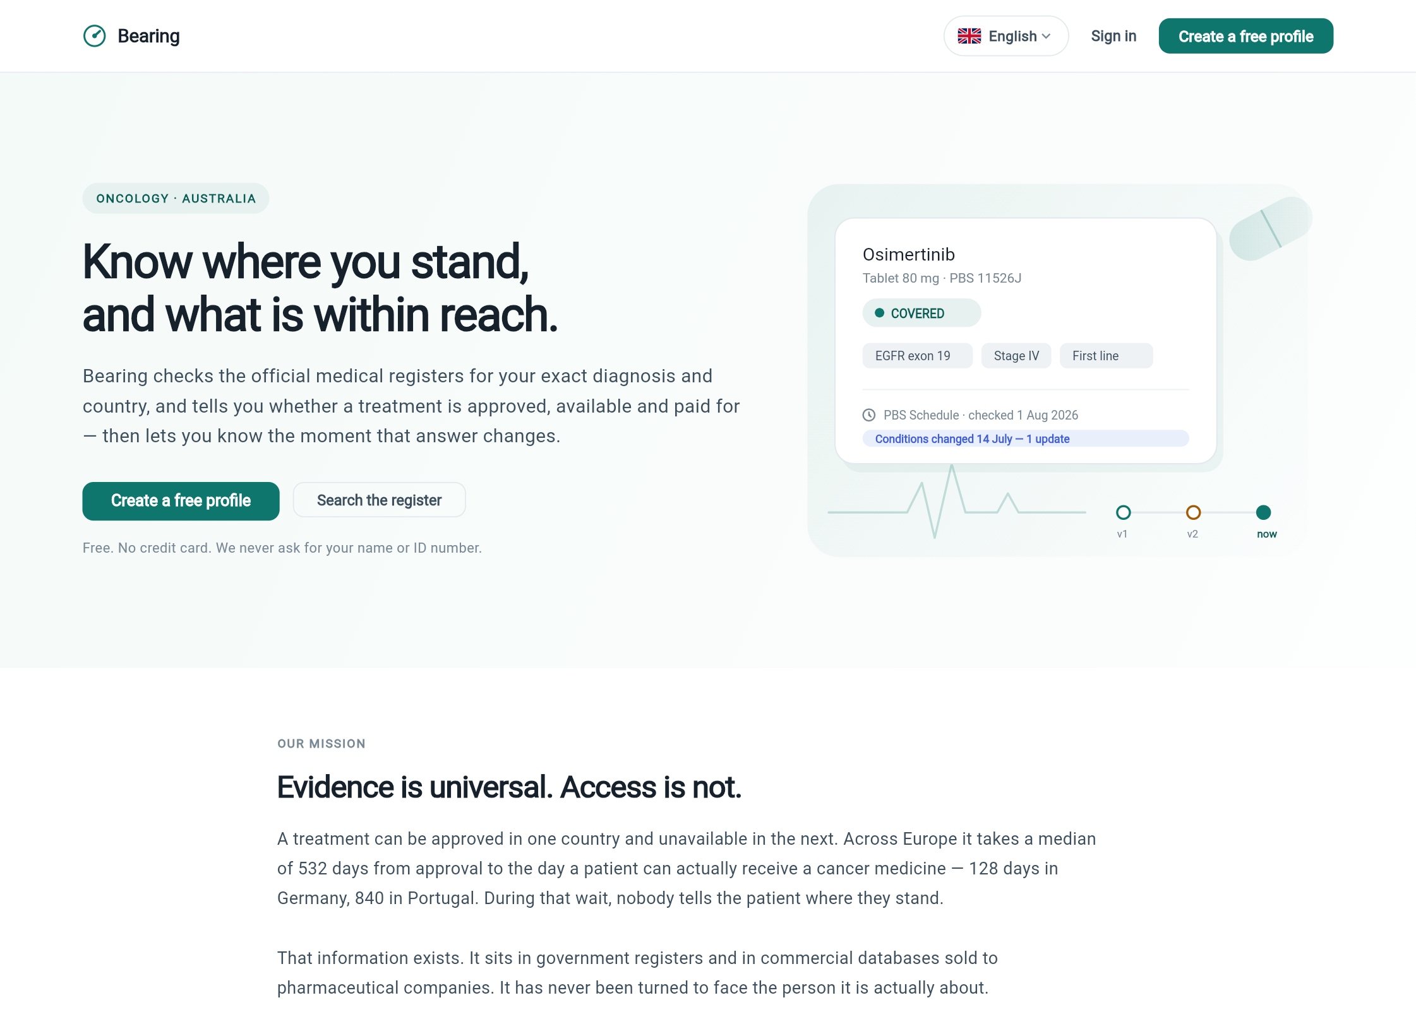
Landing — the promise, the mission, and a live-looking register card.
Responsibilities: state the product promise in one screen (“Know where you stand, and what is within reach”); explain the mission with the 532-day evidence; funnel to ‘Create a free profile’ or the public register search; set the privacy tone immediately (“Free. No credit card. We never ask for your name or ID number.”). Also carries the three-step ‘How it works’ section and language switcher (EN/RU/HE).

6.2 Sign-in (the gate)
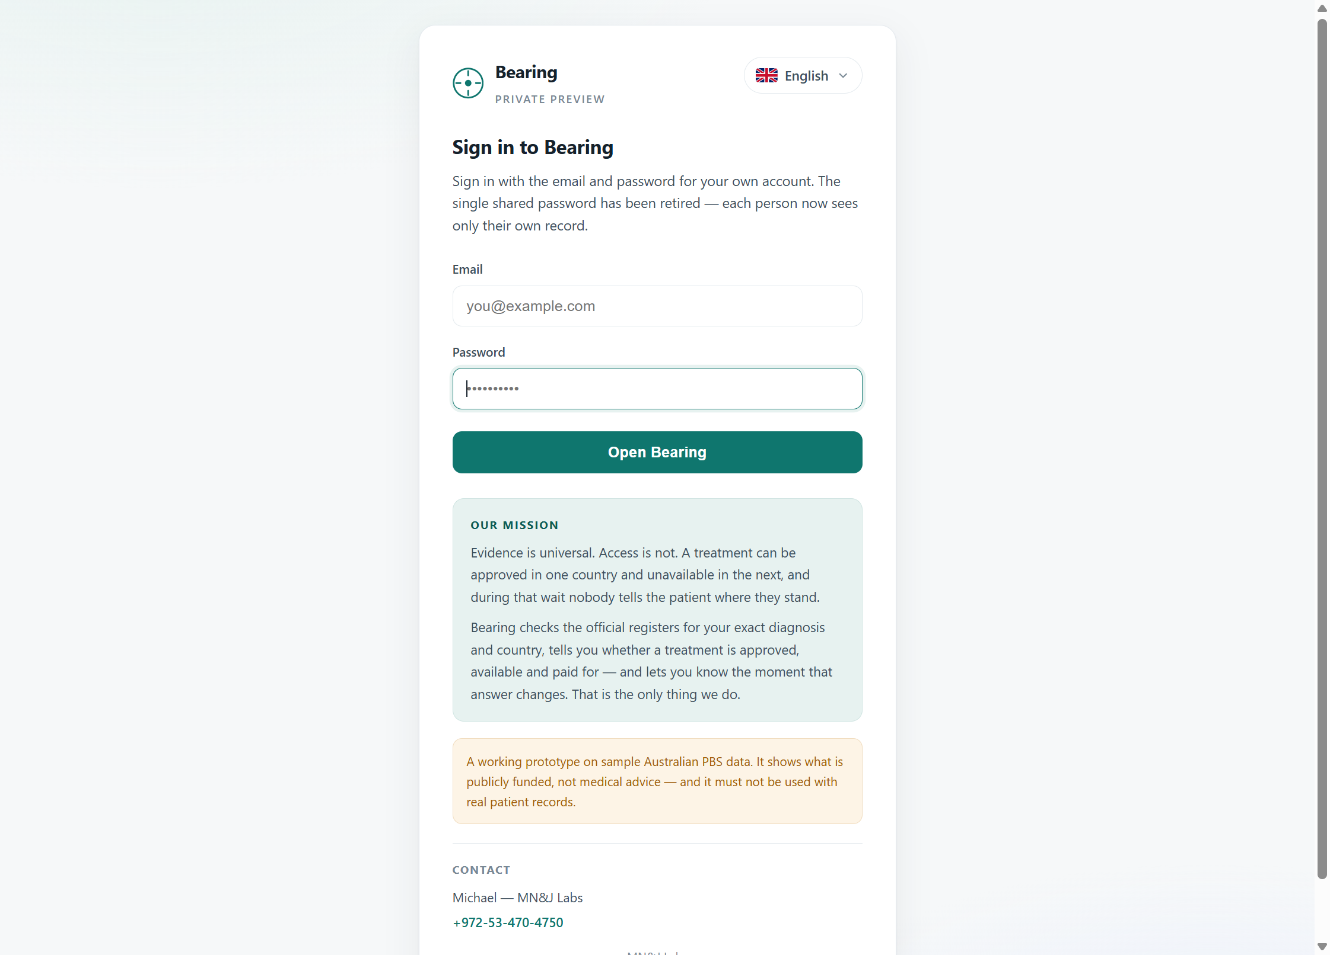
Server-rendered sign-in — shown before any application code loads.
Responsibilities: authenticate before the app is even served. Server-rendered (GateController) so an unauthenticated visitor never downloads patient-facing code; explains why an email is asked for (“so we can reach you when something changes — nothing else is required”); links to account creation; footer states plainly that this preview holds sample data only. Backed by Spring Security form login; passwords BCrypt-hashed; per-account sessions replaced the old shared password.

6.3 My cabinet — the core screen
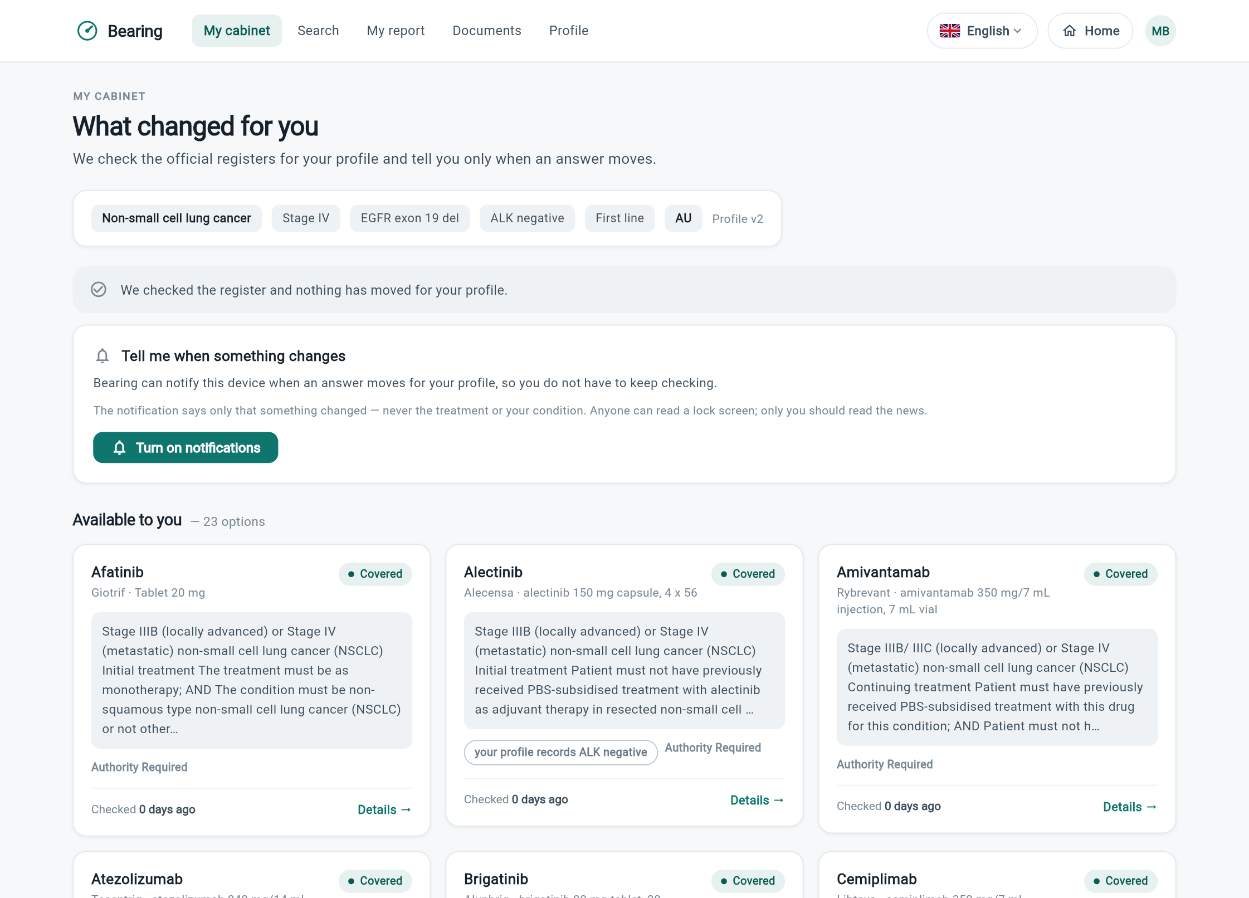
Cabinet top: profile chips, per-patient change feed, notification opt-in, available options.
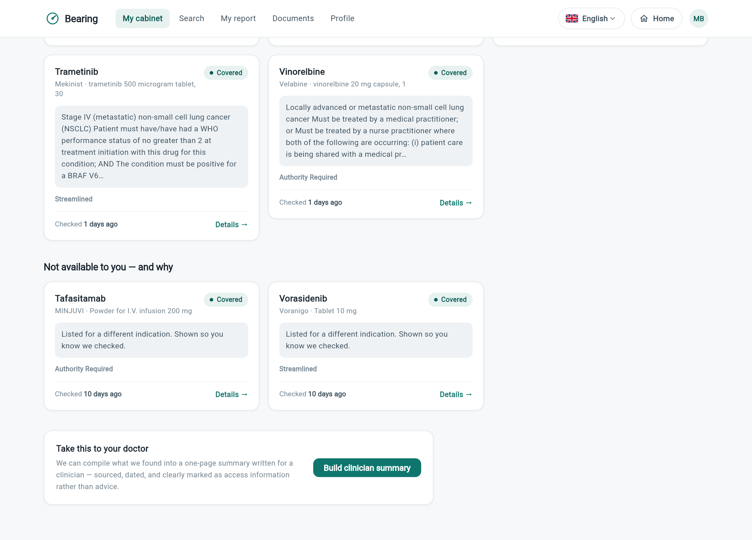
Cabinet bottom: ‘Not available to you — and why’, and the clinician-summary call to action.
This is the product's answer, rendered. Responsibilities:
- Show the profile the answer is computed from (chips: condition, stage, biomarkers, line, country, profile version) — the patient always sees what we based everything on.
- The change feed: this patient's material alerts with the reason we told them; when nothing moved, it says so explicitly (“We checked the register and nothing has moved for your profile”) because silence reading as breakage would erode the product's one promise.
- Notification opt-in, worded with its privacy property: the notification never names the treatment or condition.
- ‘Available to you’ cards: verbatim restriction, access route, honest gap notes (“your profile records ALK negative”), and ‘checked N days ago’ freshness on every card.
- ‘Not available to you — and why’: nothing is hidden; a drug listed for a different indication says exactly that (“shown so you know we checked”), and exclusion verdicts explain themselves.
Backing: GET /cabinet, GET /alerts, push subscribe. Every card links to a Details screen with the full clause, source register, and verification date.

6.4 Search the register
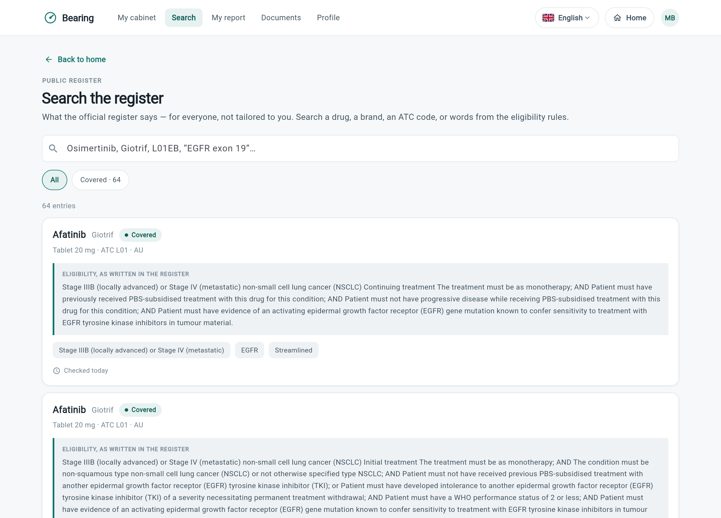
Public-register search — the untailored view.
Responsibilities: let anyone interrogate the register directly — by drug, brand, ATC code or words from the eligibility rules — with the explicit framing “for everyone, not tailored to you”. Each entry shows the eligibility exactly as written, stage/biomarker/route tags, and freshness. This screen is the natural candidate for the future public (pre-login) surface, since it contains no personal data. Backing: GET /register/search.

6.5 My report — sharing and the PDF
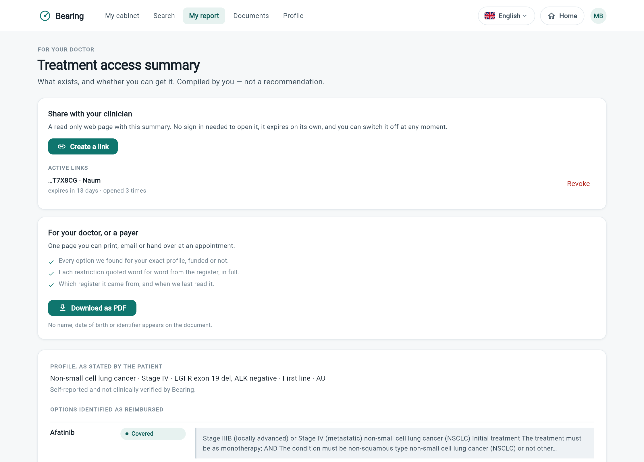
Report screen: real share links with live open counts, and the PDF download.
Responsibilities: turn the cabinet into evidence a patient can hand over. Two instruments:
- Share with your clinician: mints a revocable, expiring read-only link (shown once, copied to clipboard); lists active links with hint, label, REAL open count and expiry; one-click revoke. In the screenshot: an actual live link labelled ‘Naum’, opened 3 times.
- Download as PDF: the one-page summary — every option funded or not, every restriction quoted in full, register and read-date named, no identifier anywhere. On web the app fetches the bytes with its own session and hands the browser a blob (popup blockers silently killed the naive approach); on mobile it writes a temp file and opens the share sheet.
Below the panels, the summary itself is rendered on-screen with the same boxed verbatim quotes. Backing: /shares CRUD, /report.pdf.

6.6 Documents
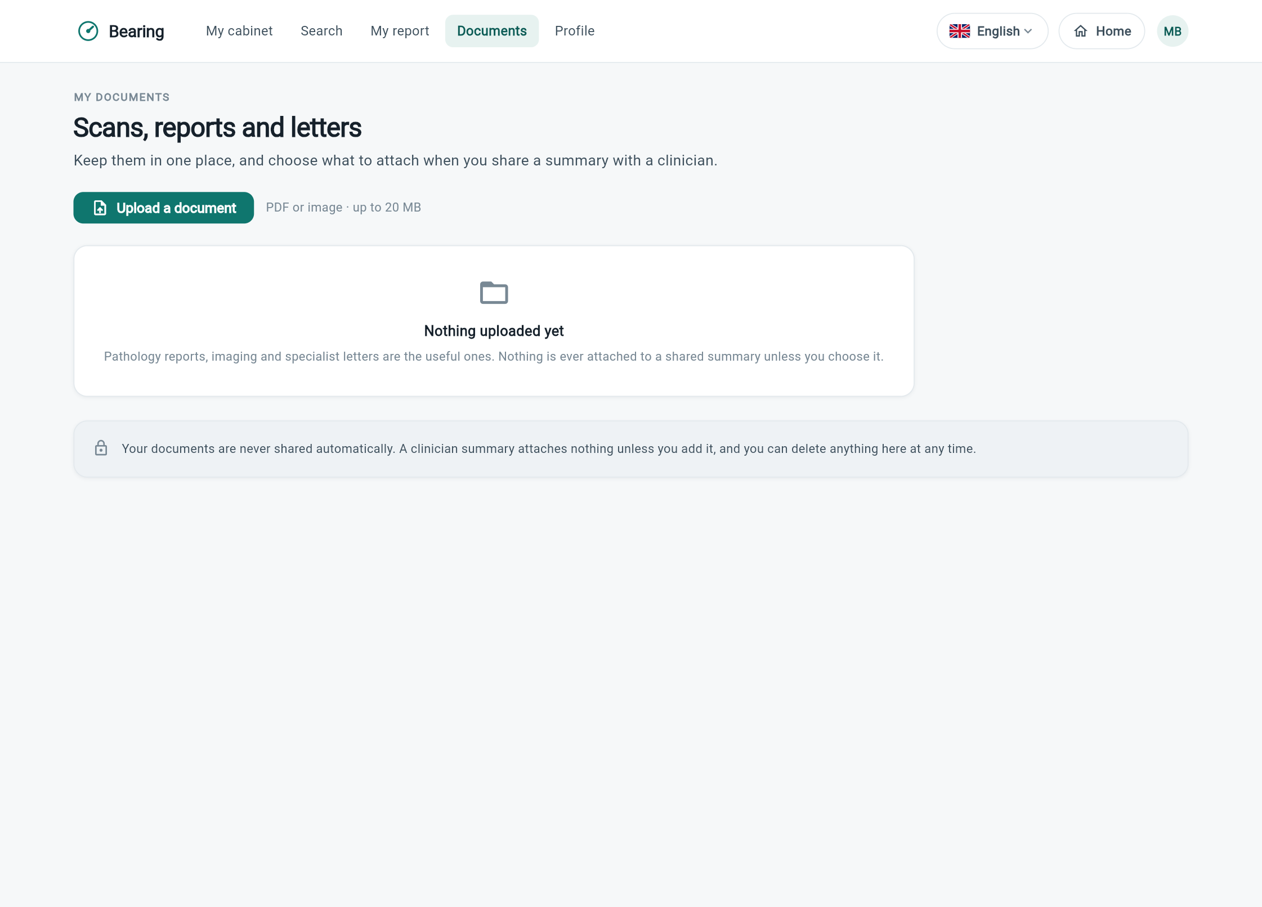
Documents — storage with an explicit never-shared-automatically contract.
Responsibilities: keep scans, pathology reports and letters in one place (PDF/image, up to 20 MB, S3 + KMS); state the sharing contract in the UI itself — nothing is ever attached to a shared summary unless the patient chooses it, and anything can be deleted at any time. This screen is also the entry point for AI document reading (with its separate consent), which suggests biomarkers with quotes for the patient to confirm into their profile. Backing: /documents CRUD, /assist/read-document, /assist/document-consent.

6.7 Profile
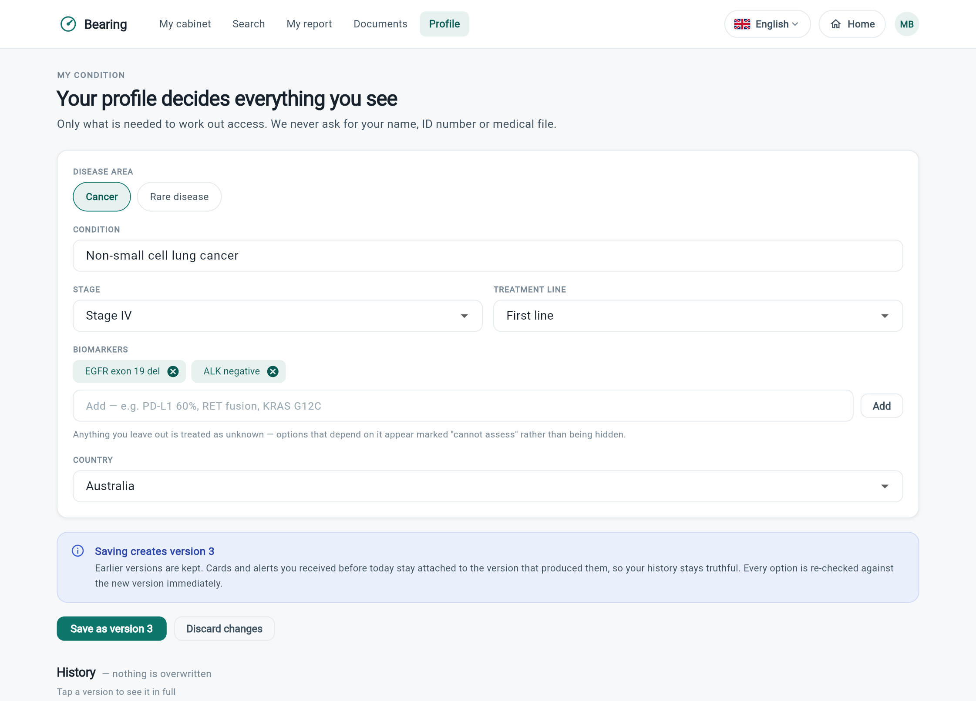
Profile — ‘decides everything you see’, with visible versioning.
Responsibilities: capture exactly the fields access depends on and nothing else — disease area (Cancer / Rare disease with Orphanet typeahead), condition, stage, treatment line, biomarker chips (free-text, with negatives like ‘ALK negative’ treated as answers), country. Two rules are made visible in the UI: anything left out is treated as unknown (options appear as ‘cannot assess’, never hidden), and saving creates a new version — the banner explains that earlier versions are kept and every option is re-checked immediately, and the History section lets the patient open any past version. Backing: POST /profile, GET /profile/history.

6.8 The clinician's view (shared link)
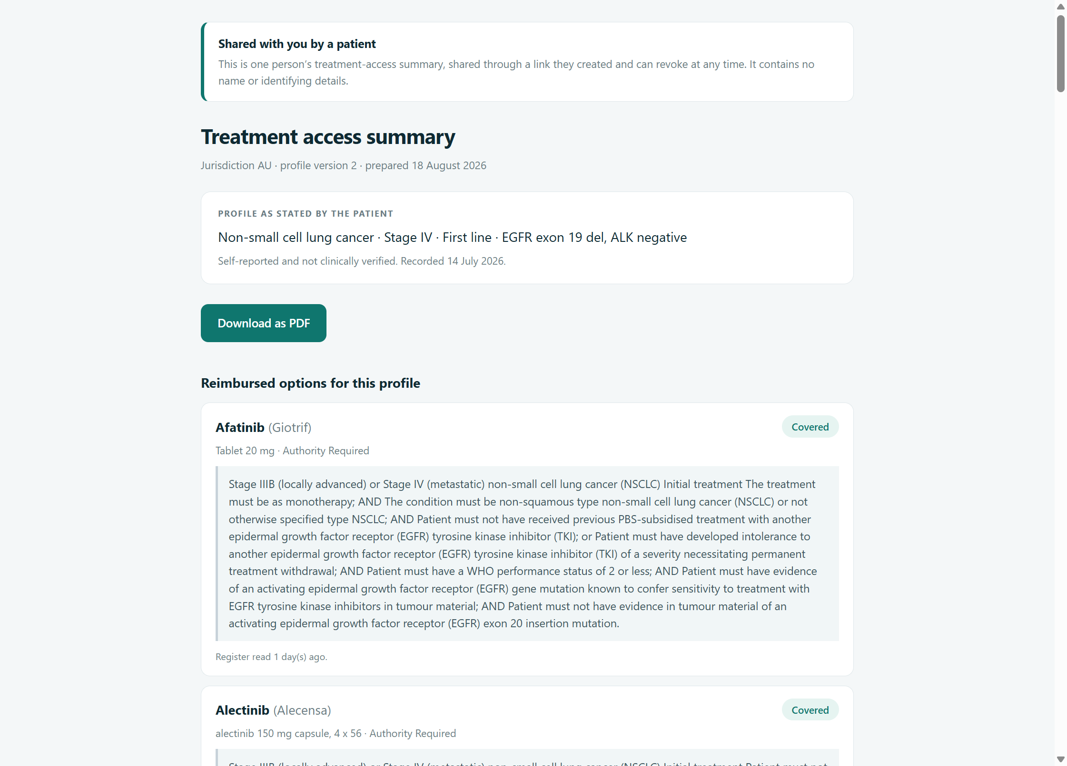
What a doctor sees when opening a patient's share link — no account, plain HTML.
Responsibilities: give the recipient everything and ask nothing — no sign-in, no app download, works without JavaScript on a hospital terminal. Opens with an honesty banner (“Shared with you by a patient… contains no name or identifying details”), then the self-reported profile, a PDF download, and every option with its full verbatim restriction. Never indexed by search engines; dead the instant the patient revokes it. Backing: GET /s/{token} and /s/{token}/report.pdf.

7. Where the system stands today

Live in production
- Accounts, per-patient isolation, consent ledger, GDPR erasure.
- Full NSCLC register (64 listings / 25 drugs) with verbatim text, append-only versioning, and a live PBS refresh endpoint.
- The matching engine with negation handling and exclusion support; per-patient change detection with the material rule; real per-patient change feed in the app.
- Web Push notifications (non-disclosing payloads, separate consent).
- Clinician PDF, share links with hashed tokens and real open counts, and the public clinician page.
- AI criteria extraction (58 criteria in production, awaiting human review), document reading with separate consent, appointment questions, change summaries.
- Android APK built and verified against production; iOS code-ready (needs a Mac to build/sign).

Deliberately not done yet
- Human review of the 58 extracted criteria — until each is signed off against its source sentence, the cabinet ignores them. This is the review gate working as designed, and the next concrete task.
- Email alerts: detection stores everything needed, but no email is sent — sending is the one irreversible step and waits for an explicit go decision (and the material rule is still to be confirmed with you).
- Scheduled register refresh (currently an admin button; a cron is a one-line change once the cadence is agreed).
- Second jurisdiction. The data model is register-agnostic by construction (source, jurisdiction fields everywhere); the PBS ingest is the template.

Prepared by Michael with Joseph (Claude) — 18 August 2026. Every claim in this document was verified against the running system on the day of writing; the screenshots are unretouched captures from production.

