1. 目前构建的框架是：

|  |  |  |  |  |  |  |  |  |  |  |  |  |  |
| --- | --- | --- | --- | --- | --- | --- | --- | --- | --- | --- | --- | --- | --- |
| 0 | GRF |  |  |  |  |  |  |  |  |  |  |  |  |
| 1 | I | I | I | I | **O** | **O** | **O** | **O** |  |  |  |  |  |
| 2 | mem | mem | mem | mem |  |  |  |  |  |  |  |  |  |
| 3 | BFU | BFU | BFU | BFU | BFU | BFU | BFU | BFU | SBOX | SBOX | SBOX | SBOX | BENES |
| 4 | mem | mem | mem | mem |  |  |  |  |  |  |  |  |  |
| 5 | BFU | BFU | BFU | BFU | BFU | BFU | BFU | BFU | SBOX | SBOX | SBOX | SBOX | BENES |
| 6 | mem | mem | mem | mem |  |  |  |  |  |  |  |  |  |
| 7 | BFU | BFU | BFU | BFU | BFU | BFU | BFU | BFU | SBOX | SBOX | SBOX | SBOX | BENES |
| 8 | mem | mem | mem | mem |  |  |  |  |  |  |  |  |  |
| 9 | BFU | BFU | BFU | BFU | BFU | BFU | BFU | BFU | SBOX | SBOX | SBOX | SBOX | BENES |
| 10 | I | I | I | I | **O** | **O** | **O** | **O** |  |  |  |  |  |
| 11 | mem | mem | mem | mem |  |  |  |  |  |  |  |  |  |
| 12 | BFU | BFU | BFU | BFU | BFU | BFU | BFU | BFU | SBOX | SBOX | SBOX | SBOX | BENES |
| 13 | mem | mem | mem | mem |  |  |  |  |  |  |  |  |  |
| 14 | BFU | BFU | BFU | BFU | BFU | BFU | BFU | BFU | SBOX | SBOX | SBOX | SBOX | BENES |
| 15 | mem | mem | mem | mem |  |  |  |  |  |  |  |  |  |
| 16 | BFU | BFU | BFU | BFU | BFU | BFU | BFU | BFU | SBOX | SBOX | SBOX | SBOX | BENES |
| 17 | mem | mem | mem | mem |  |  |  |  |  |  |  |  |  |
| 18 | BFU | BFU | BFU | BFU | BFU | BFU | BFU | BFU | SBOX | SBOX | SBOX | SBOX | BENES |
| 19 | I | I | I | I | **O** | **O** | **O** | **O** |  |  |  |  |  |
| 20 | mem | mem | mem | mem |  |  |  |  |  |  |  |  |  |
| 21 | BFU | BFU | BFU | BFU | BFU | BFU | BFU | BFU | SBOX | SBOX | SBOX | SBOX | BENES |
| 22 | mem | mem | mem | mem |  |  |  |  |  |  |  |  |  |
| 23 | BFU | BFU | BFU | BFU | BFU | BFU | BFU | BFU | SBOX | SBOX | SBOX | SBOX | BENES |
| 24 | mem | mem | mem | mem |  |  |  |  |  |  |  |  |  |
| 25 | BFU | BFU | BFU | BFU | BFU | BFU | BFU | BFU | SBOX | SBOX | SBOX | SBOX | BENES |
| 26 | mem | mem | mem | mem |  |  |  |  |  |  |  |  |  |
| 27 | BFU | BFU | BFU | BFU | BFU | BFU | BFU | BFU | SBOX | SBOX | SBOX | SBOX | BENES |
| 28 | I | I | I | I | **O** | **O** | **O** | **O** |  |  |  |  |  |
| 29 | mem | mem | mem | mem |  |  |  |  |  |  |  |  |  |
| 30 | BFU | BFU | BFU | BFU | BFU | BFU | BFU | BFU | SBOX | SBOX | SBOX | SBOX | BENES |
| 31 | mem | mem | mem | mem |  |  |  |  |  |  |  |  |  |
| 32 | BFU | BFU | BFU | BFU | BFU | BFU | BFU | BFU | SBOX | SBOX | SBOX | SBOX | BENES |
| 33 | mem | mem | mem | mem |  |  |  |  |  |  |  |  |  |
| 34 | BFU | BFU | BFU | BFU | BFU | BFU | BFU | BFU | SBOX | SBOX | SBOX | SBOX | BENES |
| 35 | mem | mem | mem | mem |  |  |  |  |  |  |  |  |  |
| 36 | BFU | BFU | BFU | BFU | BFU | BFU | BFU | BFU | SBOX | SBOX | SBOX | SBOX | BENES |

1. Mapping结果分为两部分：
2. Operation Mapping Result:：对应funcUnit的位置，参考架构图，例如block_3_8.sbox.fu对应BCU0-RCU0-SBOX0；I为InFIFO，对应（1/10/19/28行）col:0~3，O为OutFIFO，对应（1/10/19/28行）col:4~7（预留一行GRF），结果中input对应InFIFO，output对应OutFIFO，load/store对应mem，其他算子一一对应；

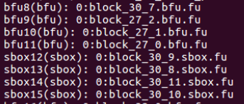

1. Connection Mapping Result：对应算子之间的的互联；

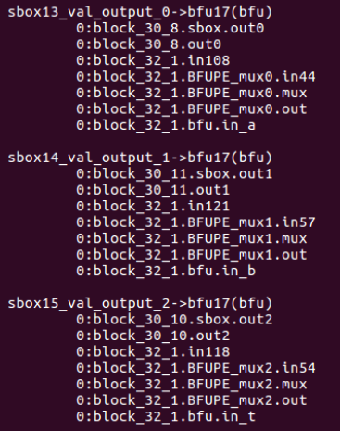

1. route结果解析：
2. “->”前面表示上一个算子的输出，后边表示到达的当前算子，使用的block与上述Operation结果是一致的；
3. *_Val_output_0：后面的数字表示输出number（与下面连线第一行的*.(func).out*的数字一致）：

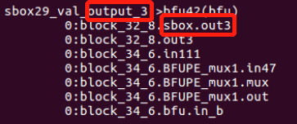

* BFU：0对应BFU-X，1对应BFU-Y；
* SBOX：0/1/2/3分别对应out0/out1/out2/out3；
* BENES：0/1/2/3分别对应BO0/BO1/BO2/BO3；
* 一个输出默认为0；

1. 每条连线最后一行的func.in*表示到达的当前算子的输入：

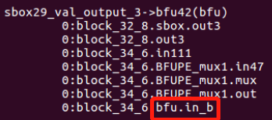

* BFU：算子的A/B/T输入对应bfu.in_a/bfu.in_b/bfu.in_t；
* SBOX：一个输入对应sbox.in；
* BENES：BI0/BI1/BI2/BI3对应benes.in_a/benes.in_b/benes.in_c/benes.in_d；