Hardware
- Windows Computer
- USB-C to USB Cable
- 24182 – Cable Assembly, Power, Focusing
- 24184 – Cable Assembly, Focusing Interface, 6X
- FLIR Boson VPC Adapter

Software/Firmware
- 6X-21214_Programming
- 6XT-21216_Programming
- FLIR Boson App

FLIR Boson App Install (21216 Only)

If not already installed, the following steps need to be completed to install the FLIR Boson App on the user’s PC.

- Copy to a local directory the installation file bosonAPP_v3.0.0_x64drivers.msi:

\\172.25.0.194\Data\Part Database (things we sell)\SW-xxxx-xxxx -- 6x Firmware\FLIR Boson\GUI

- Run the bosonAPP_v3.0.0_x64drivers.msi installation file.
- Follow the wizard instructions to complete the installation.

Sensor programming
This section covers the programming steps for both the thermal and multispectral variants of the 6X sensor. Files specific to a variant are includes in their applicable sub-folder:
- 6X: 6X-21214_Programming
- 6XT: 6XT-21216_Programming

Section 3.1 below pertains only to the thermal 6X and should be done before the sensor is installed into the lens mount.

Thermal Sensor Configuration (21216 Only)

- Connect the FLIR Boson VPC adapter to the back of the thermal sensor.
- Connect the USB cable between the PC and the VPC adapter.
- Open the FLIR Boson App.
- In the lower right corner of the window, click the “Port” dropdown and select the COM port for the thermal sensor.
  - If the thermal sensor is the only USB device used, there will only be one COM port.
  - The correct COM port can also be viewed in the device manager.
- The “Boson Link” status should show connected.
- Click the “Image Appearance” button on the left column of options.
- Click on the “Analog/CMOS” video controls section.
  - Under the video section, click the “CMOS” checkbox.
  - Under the configure section, set video source to “TLinear”. The Output should be “TLinear”.
  - Under the CMOS & USB telemetry section, turn “CMOS Enable” on.
  - Under the CMOS & USB telemetry section, set the “Mode” drop down to “Header”.
- Click on the “System” button on the column on the left column of options.
  - Under the “Configuration Controls” section, click “Save Power-On Defaults”.
- Disconnect the sensor and close the GUI.
- To verify that the correct changes were made, reconnect the sensor, reopen the FLIR Boson app, and ensure that all the settings changes remained.

Programming – Sensor Assembly

- Remove the microSD card from the camera and put it into the computer.
- Copy the contents of folder firmware - sdcard to the microSD card.
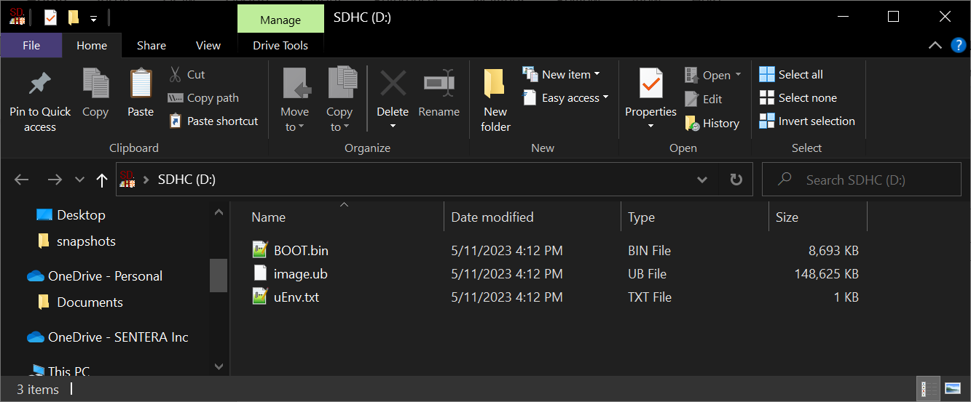

- Eject the microSD card from the computer and put it inside the camera.
- Remove the rear cover of the camera (if present).
- Set the dip switches present on the Imager Baseboard CCA to the following positions:

Dip Switch | Position
1 | ON
2 | OFF
3 | ON
4 | OFF

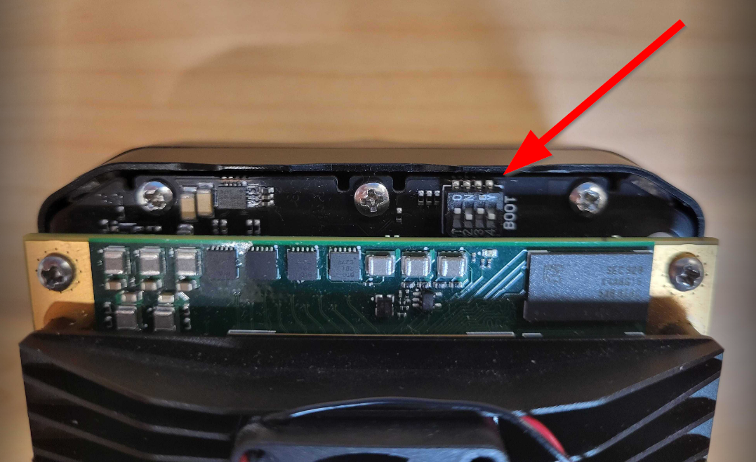

- Connect the Power cable (24182 & 24184) between an outlet and the camera.
- Connect the USB-C to USB cable between the PC and the camera.

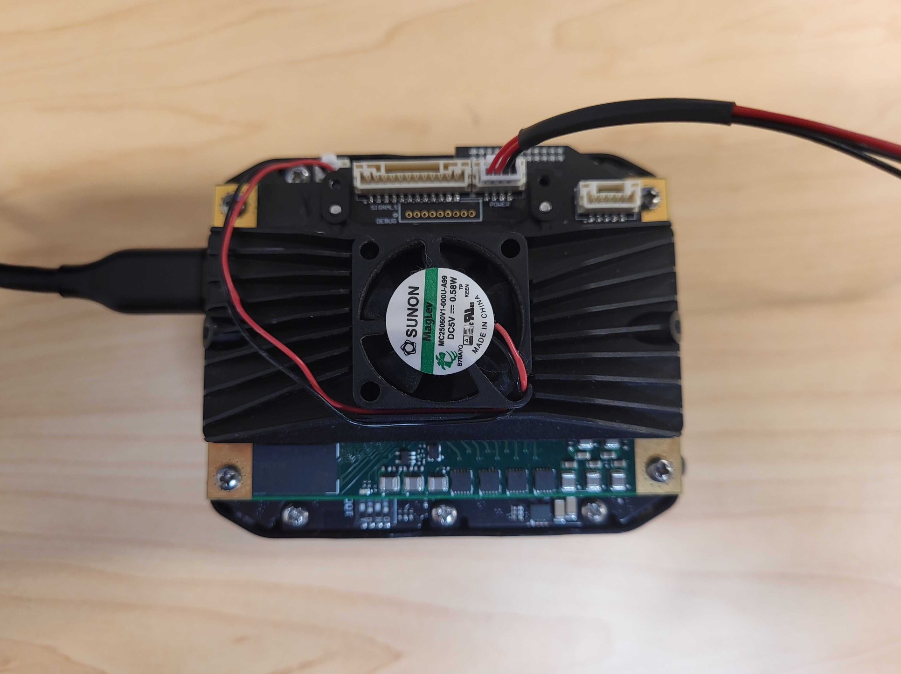

- Navigate to 192.168.42.1 on a web browser.
- Navigate to the “Update Firmware” tab on the left side of the webpage.
- Click in the “Firmware Update” field and select the firmware update file (where “X.X.X” is the release version) from the firmware – factory update folder:
  - 6X: 6x-factory-update_X.X.X-21214.swu
  - 6XT: 6x-thermal-factory-update_X.X.X-21216.swu
- Once the firmware update is completed (approx. 5 minutes) power down the camera.
- Remove the microSD card from the camera and place it in the computer.
- Delete all files from the microSD card.
- Copy folder configs/2121X-XX/firmware to the microSD card. Select the 2121X-XX folder based on what camera model is being programmed.
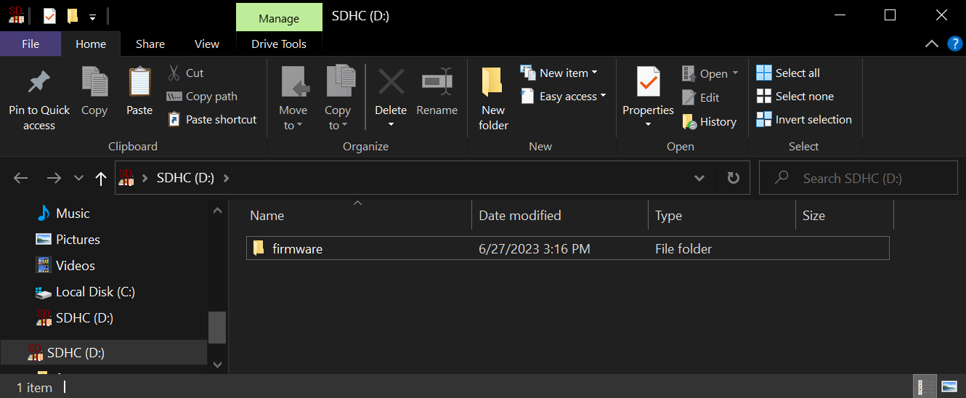
Note: The OEM – Sentera GPS configuration is applied as the initial configuration so that camera operation and focusing can be accomplished without being connected to a gimbal.
- On the microSD card, open file firmware/hw_config.yaml, and update the serial number to the serial number of the camera (surrounded by single quotes).
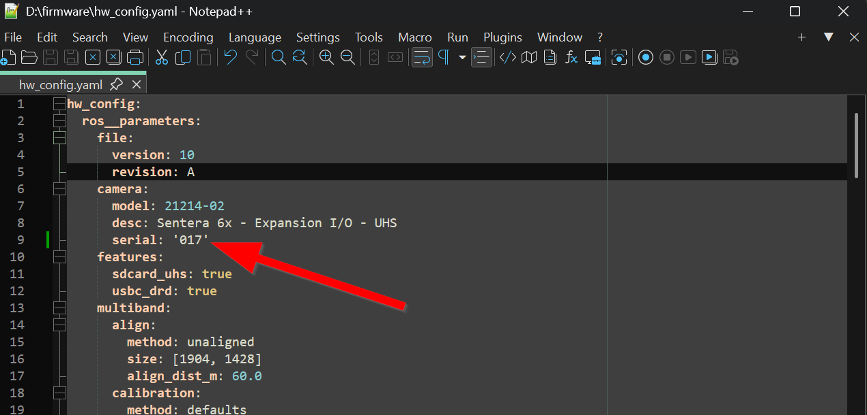

- Eject the microSD card from the computer and place it in the camera.
- Set the dip switches present on the Imager Baseboard CCA to the following positions:

Dip Switch | Position
1 | ON
2 | ON
3 | OFF
4 | ON

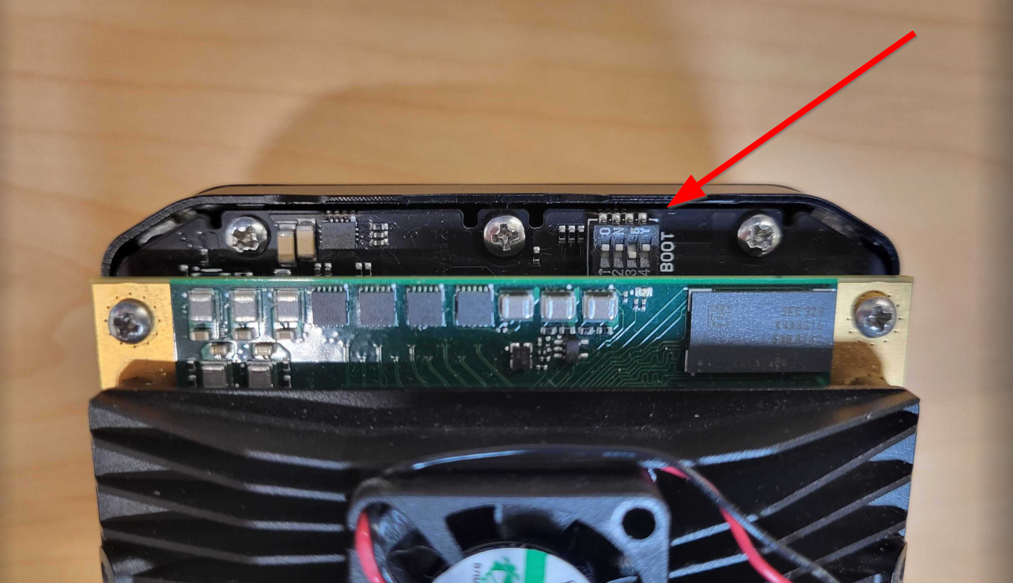

- Re-install the rear cover of the camera.
- Power on the camera.
- Navigate to 192.168.42.1 on a web browser.
- Navigate to the “Configuration” tab on the left side of the webpage.
- Verify that the “OEM – Sentera GPS” configuration is being used.

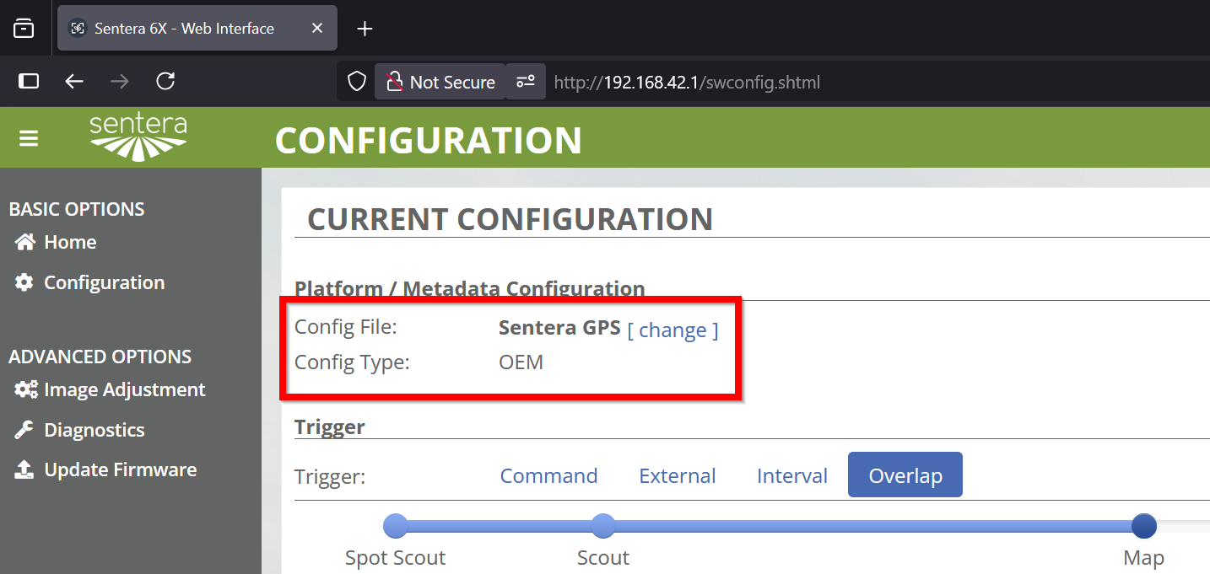

- Navigate to the “Diagnostics” tab on the left side of the webpage.
- Verify that the Part Number and Serial Number are what is expected for the camera.

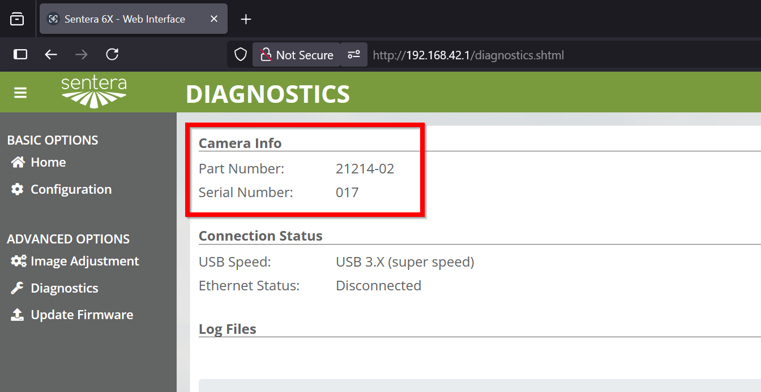

- Programming is complete!

