AI in the Curriculum: Challenges & Opportunities

Michael Borck, Curtin University

## Companion Website

[AI in the Curriculum](https://michael-borck.github.io/AI-in-the-Curriculum/)

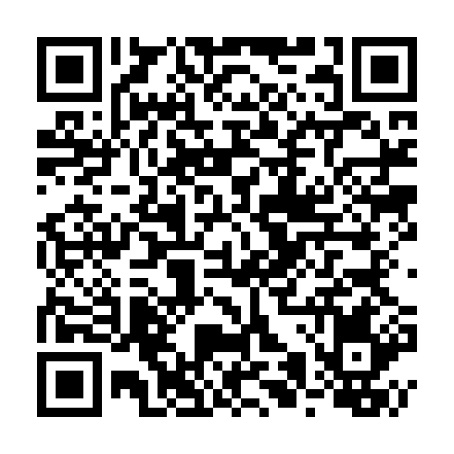

*AI Acknowledgment: AI tools were used in the initial drafting and development of this document. All content has been reviewed, refined, and validated through human expertise and professional judgment.*

## Today: 15 Minutes to Shift Perspective

**We’ll explore:** - Four challenges we’re all facing - One hidden barrier we don’t discuss - Three pathways forward - Your questions and experiences

**Not covering:** - How AI works - Which tools to use - Detection strategies - Policy development

*“Not about answers — just questions worth asking”*

I’m sharing observations from my own teaching and conversations with colleagues - you’ll likely recognize these patterns. * **Reality Check**: AI already in workflows; disciplines differ; no one-size-fits-all * **Today’s Goal**: Share challenges & spark reflection * *“Not about answers — just questions worth asking”*

* AI is already here - students using ChatGPT for assignments, staff for admin tasks
* Engineering will use it differently than Creative Writing - acknowledge this
* We’re exploring together, not prescribing solutions
* Set expectation: discussion starter, not definitive guide

**Elephant in the room**: We need to talk about AI shame - tease what’s coming

Some of you might be thinking ‘not another AI talk’ - but we need to talk about what’s actually happening in our classrooms

Let me share four challenges I’m seeing…

## Over-Trust: The “Fountain of Knowledge” Problem

* **Challenge**: Students over-trust AI
* **Impact**: Weakens critical thinking
* **Response**: Error-spotting, critique, reward questioning

I watched a student refuse to question an obviously wrong AI answer because ‘the AI said so’

* Students treat AI like authoritative source
* Hesitant to disagree even when they know better
* “But ChatGPT said…” becoming common refrain
* Give students an AI explanation with 2 deliberate errors
* Works across disciplines: wrong physics formula, incorrect historical date, buggy code, flawed diagnosis
* Students initially struggle to spot errors they’d normally catch

**Response strategies**: - Make error-hunting a regular exercise - Compare multiple AI responses to same prompt - Reward students who challenge AI answers - “Find three ways to improve this AI response”

**Key message**: Critical thinking matters MORE with AI, not less

But over-trust isn’t the only problem…

## Over-Use: Shortcuts vs. Scaffolds

* **Challenge**: AI as bypass, not support
* **Risks**: Shallow learning, plagiarism fears, lost skills
* **Response**: Frame AI as scaffold within pedagogy

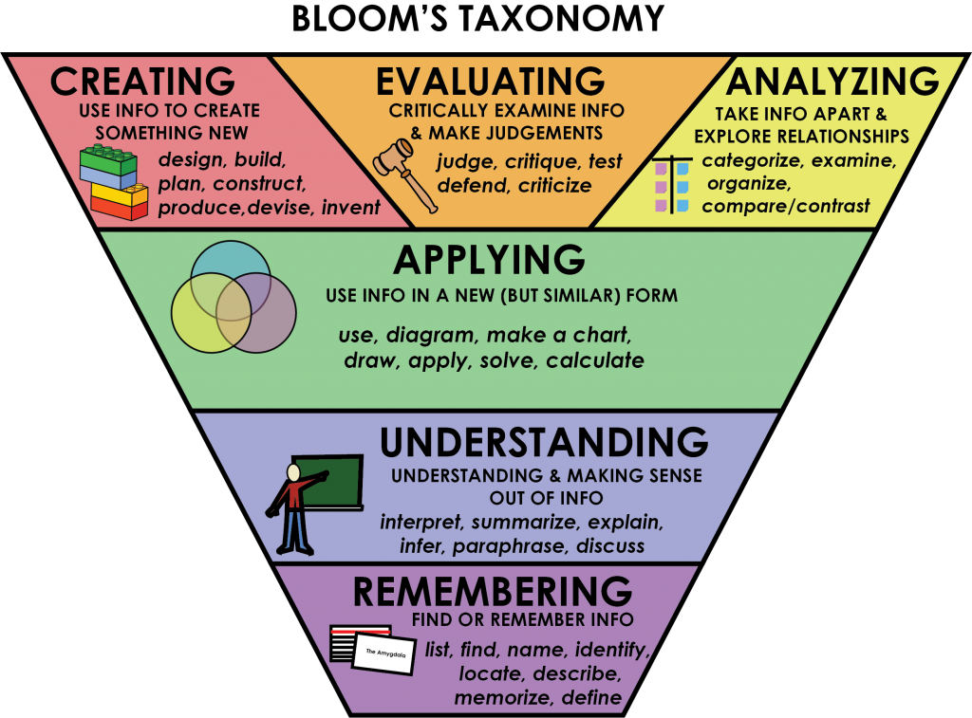

© Rawia Inaim. “Bloom’s Taxonomy.” Retrieved September 4, 2025, from https://opentextbc.ca/studentsuccess/chapter/effective-questions/. Licensed under a CC BY-SA (Attribution ShareAlike) license.

**The distinction**: “There’s a difference between using AI to skip learning and using it to enhance learning”

* Students jump straight to “give me the answer”
* Miss the learning that comes from struggle
* Can’t explain their “own” work
* Panic when asked to work without AI

**Bloom’s Flip explanation**: - Traditional: Start at Remember/Understand, work up to Create - AI Era: Start with Create/Evaluate WITH AI support - Then work backwards to build foundational understanding - Example: Create a marketing campaign (with AI) THEN learn marketing principles

**Practical example**: - Don’t use AI to write essay from scratch - DO use AI to generate counter-arguments to strengthen your thesis - Use it as sophisticated sparring partner, not ghostwriter

“This isn’t lowering standards - it’s changing the journey”

“Now, some staff see this as AI breaking education…”

## Misplaced Blame: It’s Not the Tool

* **Challenge**: Staff blame AI for integrity issues
* **Response**: Adapt assessment, don’t ban
  + Authentic, Personalised, Reflective
* *Past tools changed assessment, AI will too*

**Historical context**: - Calculators “ruined” mathematics → we adapted assessments - Wikipedia “destroyed” research → we taught evaluation - Google “killed” memorisation → we focused on application - Spell-check “weakened” writing → we emphasised ideas over mechanics

“AI doesn’t break assessments, it reveals what was already breakable”

**Assessment evolution examples**: - Authentic tasks: Real-world problems with no single answer - Personalised: Connect to student’s own experience/context - Reflective: “Explain your process” “What would you do differently?” - In-class components: Presentations, demonstrations, peer review

**For the skeptics**: - Banning won’t work - they’ll use it anyway - Better to teach proper use than pretend it doesn’t exist - “We don’t ban calculators, we teach when to use them”

But there’s a hidden challenge we rarely discuss…

## Fear of AI: The Root of Resistance

* **The Fear**: “AI will replace me” | “I’ll become obsolete” | “My expertise won’t matter”
* **The Reality**: Every new tool sparked fear
  + Printing press → scribes worried
  + Calculators → mathematicians concerned
  + Internet → everyone panicked
* **The Pattern**: Those who adapted thrived

Let’s name the real issue - fear. Not fear of technology, but fear of irrelevance. I feel it too. When I first saw ChatGPT write a decent lecture outline, my stomach dropped. ‘What’s my value now?’

But here’s what I learned: AI makes my expertise MORE valuable. It handles the routine so I can focus on what only humans do - connect, inspire, judge, create meaning. Students need us MORE to help them navigate this, not less.

The choice isn’t whether AI enters education - it’s already here. The choice is whether we guide its use or let students figure it out alone.

* Anchor story: “When I first saw ChatGPT write a lecture outline, my stomach dropped.”
* Reframe: “AI makes my expertise more valuable — because only I can judge, connect, inspire.”
* Takeaway: “Students don’t need us less, they need us more — to guide them through this shift.”

## AI Shame: The Hidden Barrier

* **Challenge**: Students & staff feel guilt/cheating
* **Impact**: Underground use, stress, lost learning
* **Response**: Normalise, Teach process, Share examples

*When I first used AI for teaching prep, I felt like I was cheating. Anyone else?*

**Student experiences**: - “I’m not really learning if I use AI” - Hide AI use from peers - worried about judgment - Imposter syndrome intensifies - Won’t ask for help with AI - too ashamed

**Staff experiences**: - “Real academics don’t need AI” - Secret experimentation - won’t share successes - Fear colleagues will think less of them - Worry about being “found out”

**Why this matters**: - Drives use underground → can’t develop best practices - Creates unnecessary stress for everyone - Prevents skill development in AI collaboration - Blocks innovation and sharing

**The reframe**: - Using AI well REQUIRES expertise - You need domain knowledge to evaluate outputs - Creativity to direct it effectively - We don’t say “spell-check wrote my paper”

* Share your own AI use openly: “I used Claude to help structure this presentation”
* Teach the process: prompting, evaluating, iterating
* Make it part of academic integrity discussions, not separate

So how do we move forward constructively?

Here’s the slide content with presenter notes based on the UNESCO framework:

## Moving Forward: AI as Learning Partner

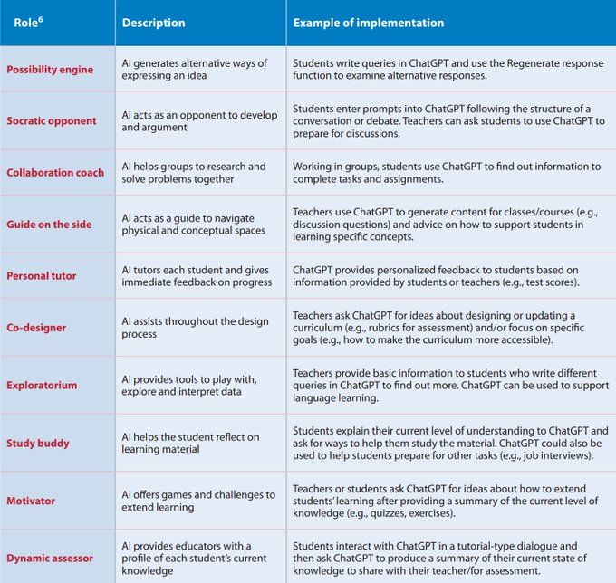

Adapted from UNESCO Quick Start Guide (2023)

So how do we move to productive use? UNESCO’s research identifies multiple roles AI can play in education - not as replacement, but as partner.”

**Walk through key roles** (pick 3-4 based on time):

**Possibility Engine example**: “Students use ChatGPT to brainstorm essay topics. One student was stuck on a history assignment until AI helped generate 10 different angles - they chose one they’d never considered.”

**Socratic Opponent**: “In my business ethics class, students argue one position while ChatGPT argues the opposite. Forces them to strengthen their reasoning - can’t just say ‘because I think so.’”

**Personal Tutor** (relate to shame): “This addresses the shame issue directly - students can ask AI ‘dumb questions’ they’re embarrassed to ask in class. No judgment, infinite patience.”

**Study Buddy**: “Perfect for exam prep. Students explain concepts TO the AI - if they can’t explain it clearly, they don’t understand it yet.”

**Key message**: “Notice none of these replace YOU. They augment learning. AI handles repetitive tasks so you can focus on what only humans do - inspire, connect, judge quality, provide wisdom.”

**Address elephant**: “Some of you might be thinking ‘but students will cheat.’ Remember - it’s not about the tool, it’s about the task design. If AI can complete your assignment alone, the assignment needs redesigning.”

**Practical takeaway**: “Pick ONE role from this table. Try it next week. Start small.”

“Let me show you how one colleague did exactly that…”

“These aren’t replacements - they’re enhancements”

**1. Learning Assistant examples**: - Brainstorming: “Give me 10 unconventional approaches to this problem” - Counter-arguments: “What would critics say about my thesis?” - Debugging: “Help me understand why this code/formula/logic isn’t working” - Socratic dialogue: AI as questioning partner

**2. Teaching Partner examples**: - Generate practice problems based on individual student errors - Create first-draft feedback (you refine and personalise) - Build adaptive quizzes that adjust to student level - Develop case studies relevant to your cohort

**3. Discipline-Specific examples**: - Engineering: Design validation, optimisation scenarios, failure analysis - Business: Market analysis, strategy simulation, competitor research - Health: Diagnostic reasoning practice, patient interaction scenarios - Arts: Concept iteration, style exploration, critique generation - Law: Case analysis, argument construction, precedent research - Education: Lesson plan variations, differentiation strategies

**Key message**: Every discipline can benefit - question is how, not if

“Start small - pick ONE thing that takes too much time”

“Let me share a real example from last week…”

## Quick Win: 30-Minute Experiment

* **What**: Worksheet → HTML in 30 min
* **Result**: Upload both verisons, more engagement
* **Key Insight**: Options, not replacements

**Set the scene**: - “After our last session, colleague went back to office…” - Not particularly tech-savvy - Had a PDF style worksheet they’d used for years

**The process**: 1. Took PDF of worksheet 2. Prompted AI: “Convert this to an interactive HTML exercise with instant feedback” 3. AI generated the code 4. Tested it quickly 5. Uploaded BOTH versions to Blackboard 6. Total time: Less than a coffee break

**The results**: - Students choose interactive version - Some will still preferred PDF - and that’s fine! - Interactive users engaged more, completed faster - PDF users had their familiar option

**Breaking through AI shame**: - They chose content, evaluated output, tested - AI was just the formatting tool

**The lesson**: - We’re adding options, not replacing what works - Students appreciate choice - No risk approach - can always revert

“There are tools to help with this…”

## Showcase: Curriculum Curator (FLX)

* **Tool**: Import → Restructure → Save 80% time
* **Value**: Supports staff, not replaces
* **Takeaway**: Efficiency

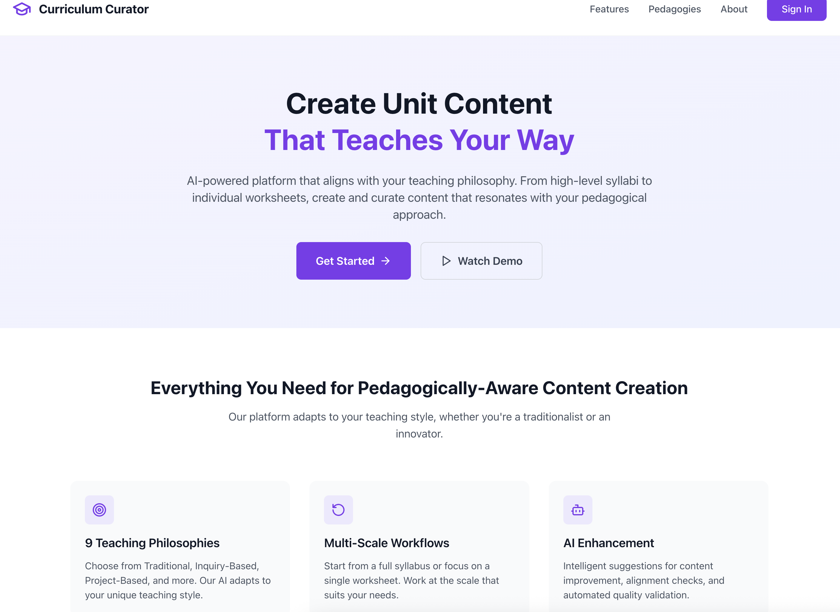

**Quick overview**: - FLX tool specifically designed for curriculum - Import existing materials - PDFs, slides, documents - Restructure into different formats - Extend with additional examples/exercises

**Specific example**: - 10 hours creating new module content → 2 hours curating/refining - Import last year’s content → Update with current examples - Generate practice questions from lecture notes

**Address the elephant**: - No shame in being efficient - Using tools for busywork = more time for students - You’re still the expert - tool just handles formatting/structure

**Key selling point**: - It’s not about replacing your expertise - It’s about amplifying it - Like having a teaching assistant who never sleeps

**Practical use cases**: - Quick quiz generation from lecture content - Converting static content to interactive - Creating multiple versions for different cohorts - Accessibility improvements (alt formats)

“Even if you never use it for creation, it’s great for reformatting”

“But the real questions are…”

## Questions to Guide Your Thinking

* Where can AI save time?
* How could students practice discipline-specific skills?
* What risks/barriers must we prepare for?
* How do we move past AI shame?

“I’m not expecting answers today - just want you thinking”

**Where can AI save time?** - Routine tasks: Grading rubrics, email responses, meeting summaries - Content creation: Quiz questions, worked examples, case studies - Administrative: Report writing, grant applications, reviews - Ask yourself: “What do I dread doing because it’s repetitive?”

**Discipline-specific skills practice**: - What would junior professionals in your field use AI for? - What simulations could AI enable that weren’t possible before? - How could students practice client/patient interactions? - What expensive/dangerous scenarios could AI simulate?

**Risks and barriers**: - Over-reliance - students who can’t work without it - Accuracy issues - hallucinations, outdated information - Equity - not all students have equal access - Industry expectations - what will employers expect?

**Moving past AI shame**: - How do we model healthy AI use? - What would transparent use look like in your course? - How do we separate tool use from academic integrity?

**Future consideration** - What skills become MORE important when AI handles routine tasks? - Critical thinking, creativity, ethical reasoning, human connection

## Let’s Discuss

* What’s one small thing you could try next week?
* What concerns need addressing?
* How might your discipline benefit/challenge?
* Have you felt AI shame?
* “These are conversation starters, not required answers”
* “Who wants to share a thought, concern, or experience?”

**Small experiment ideas**: - Use AI to generate discussion questions for one topic - Create alternative explanations for difficult concepts - Draft marking rubric with AI, then refine - Generate practice problems for next tutorial

**Common concerns**: - “This enables cheating” → Redirect to assessment design discussion - “My discipline doesn’t need AI” → Any repetitive tasks they hate - “This is moving too fast” → Acknowledge, suggest tiny experiments - “Students won’t learn properly” → Discuss scaffolding vs replacement

“These conversations are just beginning…”

## Thank You

* *“Not about answers — just questions worth asking… together, without shame”*
* **Next Step**: Try one small experiment, share results
* *“The best way to predict the future is to help create it”*

**Reinforce key messages**: - We’re all figuring this out together - Small experiments, not wholesale change - Share successes AND failures - both valuable - No shame in using tools to work smarter

**Resources available** - Example prompts for worksheet conversion - Access to Curriculum Curator for interested parties - Discipline-specific AI use cases document - “Moving Past AI Shame” discussion guide

**Call to action emphasis**: - “One small experiment” - lower the bar - “Share results” - build community of practice - “Be open” - break the shame cycle

**Final thought**: - “Remember - using AI well is a skill that requires your expertise” - “You’re not being replaced - you’re being amplified”

## Resources & References

* (Heaven, W. (2023, April 6). ChatGPT is going to change education, not destroy it. MIT Technology Review. Retrieved September 4 2025, from https://www.technologyreview.com/2023/04/06/1070216/chatgpt-is-going-to-change-education-not-destroy-it)[https://www.technologyreview.com/2023/04/06/1071059/chatgpt-change-not-destroy-education-openai/]
* (McNealis, R. Shame in the machine: affective accountability and the ethics of AI. AI & Soc (2025). https://doi.org/10.1007/s00146-025-02472-x)[https://link.springer.com/article/10.1007/s00146-025-02472-x]
* (Giray L. (2024). AI Shaming: The Silent Stigma among Academic Writers and Researchers. Annals of biomedical engineering, 52(9), 2319–2324. https://doi.org/10.1007/s10439-024-03582-1)[https://pubmed.ncbi.nlm.nih.gov/38977530/]
* (Sabzalieva, E., & Valentini, A. (2023). ChatGPT and artificial intelligence in higher education: Quick start guide. UNESCO International Institute for Higher Education in Latin America and the Caribbean (IESALC). https://unesdoc.unesco.org/ark:/48223/pf0000385146)[https://unesdoc.unesco.org/ark:/48223/pf0000385146]
* (WalkMe. (2025, August 27). Employees left behind in workplace AI boom, new WalkMe survey finds - WalkMe - Digital adoption Platform. WalkMe - Digital Adoption Platform. https://www.walkme.com/news-releases/employees-left-behind-in-workplace-ai-boom-new-walkme-survey-finds/?tabId=company-news)[https://www.walkme.com/news-releases/employees-left-behind-in-workplace-ai-boom-new-walkme-survey-finds/?tabId=company-news]
* (Russell Group. (2023). Russell Group principles on the use of generative AI tools in education. Russell Group. Retrieved September 4 2025, from https://www.russellgroup.ac.uk/policy/policy-briefings/principles-use-generative-ai-tools-education)[https://www.russellgroup.ac.uk/policy/policy-briefings/principles-use-generative-ai-tools-education]
* (Lichtenberg, N. (2025, August 29). “AI shame” is running rampant in the corporate sector—and C-suite leaders are most worried about getting caught, survey says. Fortune. https://fortune.com/2025/08/29/what-is-ai-shame-readiness-gap-training-artificial-intelligence/)[https://fortune.com/2025/08/29/what-is-ai-shame-readiness-gap-training-artificial-intelligence/]
* Canva Workplace Study on AI Adoption (2025)
* [TEQSA on Generative AI](https://www.teqsa.gov.au/guides-resources/higher-education-good-practice-hub/gen-ai-knowledge-hub)