Guidance:
- I use JavaScript to parse Excel, which is the easiest way to do it now. But we have to IE to do it. I use IE10 Compatibility View to do this now. It doesn't work well with IE11 now. So I highly recommend you to use IE10 Compatibility OR lower version. Besides, we need to set up a few things for IE. Open IE->tools->Internet Options->Advanced check use SSL 2.0, SSL3.0, TLS 1.0, TLS 1.1, TLS 1.2.
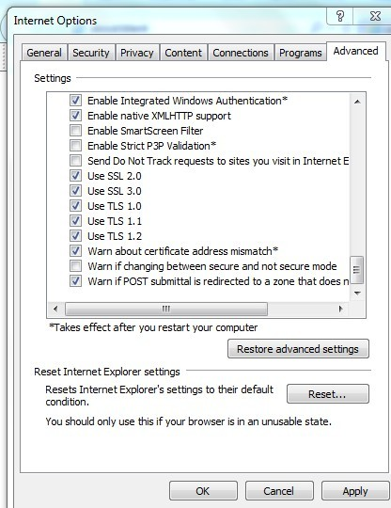
- All these documents must be in the same folder, considering that they are all related.

- Open mapUrlsDataGenerater.html in IE

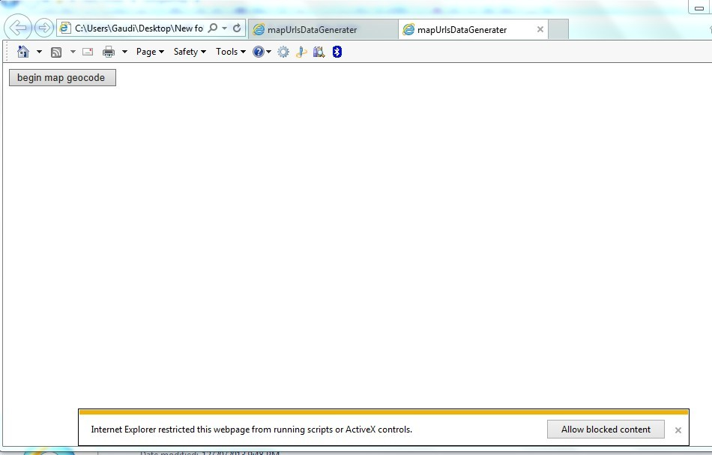
Hit the button”Allow blocked content”.
- It shows how many entries we already have so far.
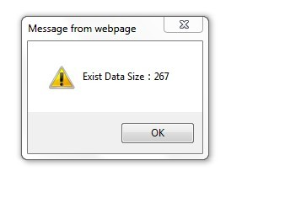

- Click “OK”. Then it will show the following dialog box:
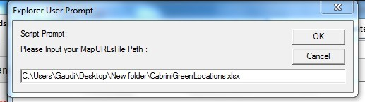
We’re supposed to input the route of the Excel with the new entries we will parse. And then hit “OK”.
- It comes:
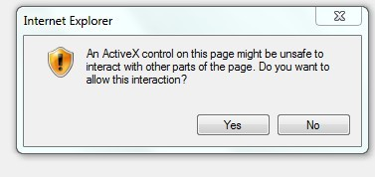
Hit “Yes”.
- It shows:
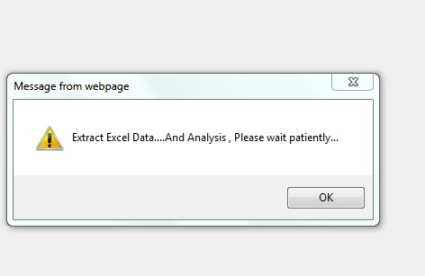
Hit “OK”.
- It shows:
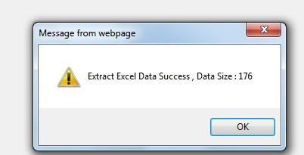
It shows the number of entries we extracted just now. And hit “ok”.
- It shows:
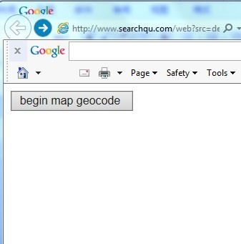
Click the button”begin map geocode”. It will take some time to do the parsing.(There is a limit of 2000 entries to parse every day for google map.)
- Here comes the parsed data:
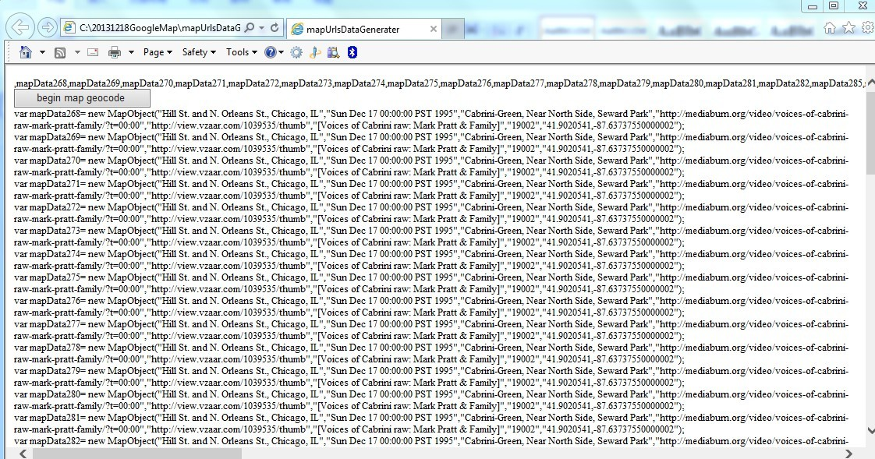

- After parsing all the data, open MediaBurnMapURLsData.js in the folder.

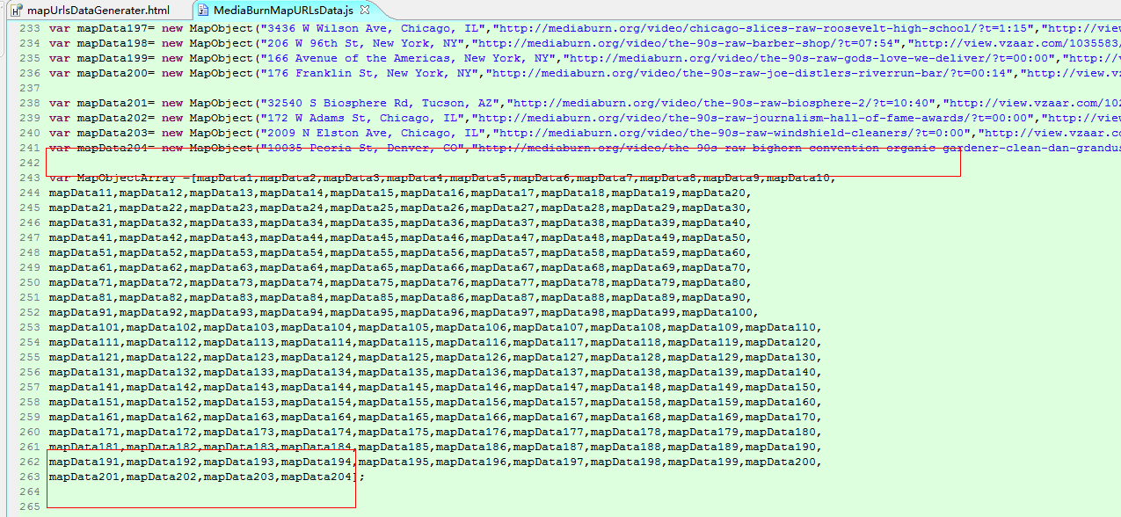

- Copy all the parsed data to this document. For example:
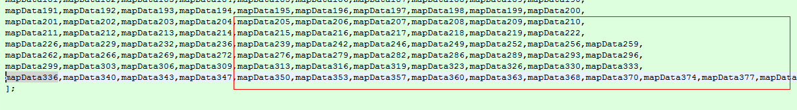
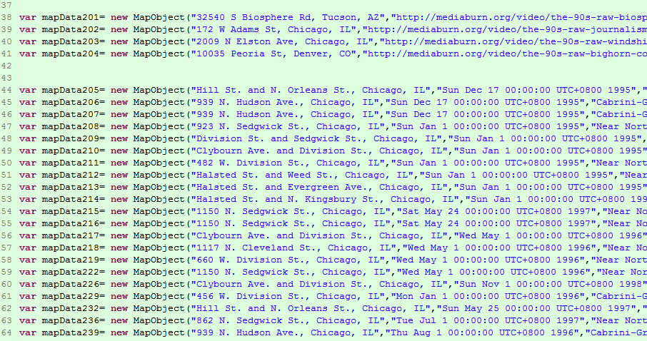
When copy the data, please pay attention to the coma and semicolon before and after each entries, especially the first entries and last entries just added.

DONE!
Now we finish the parsing for new entries.

