1. Starting at the top
   1. A world of crises

Economies go through cycles. They are long enough where one might not remember the severity and characteristics of the last one. Economic downturns can come from many different sources. As a retail lender, assume you cannot predict the future of the economy. Predict what you can, hedge against that which you cannot predict but can quantify.

* + 1. Countries in crisis

The context of this book will be the aftermath of the mortgage crisis. Global retail lending balances: $51 trillion.

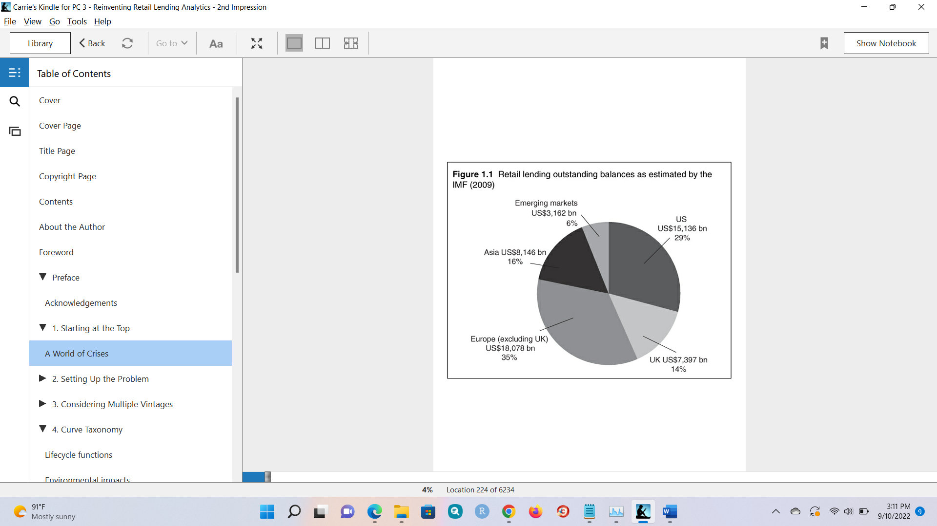

Early 90’s context re retail lending: (1) assumption that retail loans are naturally diversified, (2) no recent disasters, (3) few managers who remembered past crises. Result: overly aggressive mindset. This led to overly aggressive mortgage lending resulting in the financial crisis.

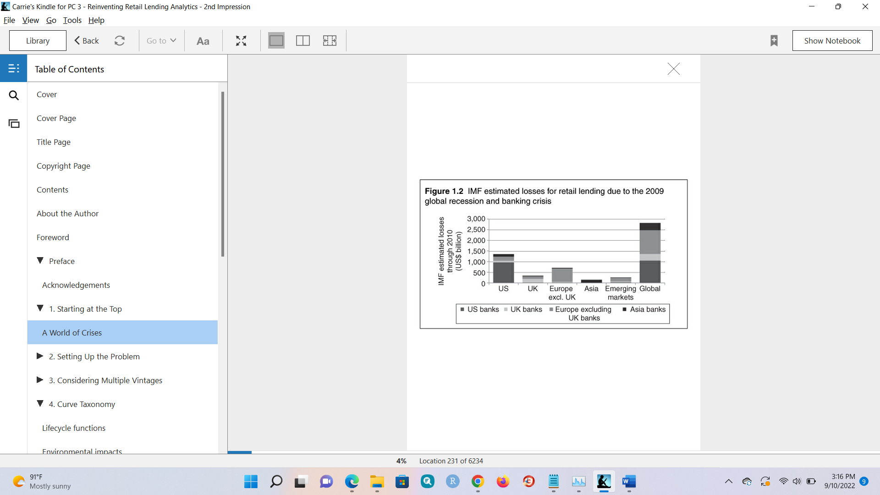

Losses from those loans absorbed bank capital, and banks had to rein in lending. Losses are estimated at $2.8 trillion on bank balance sheets and $4.1 trillion total (including securitized loans). That comes to 9.3% of all US loans and 8.8% of retail loans globally.

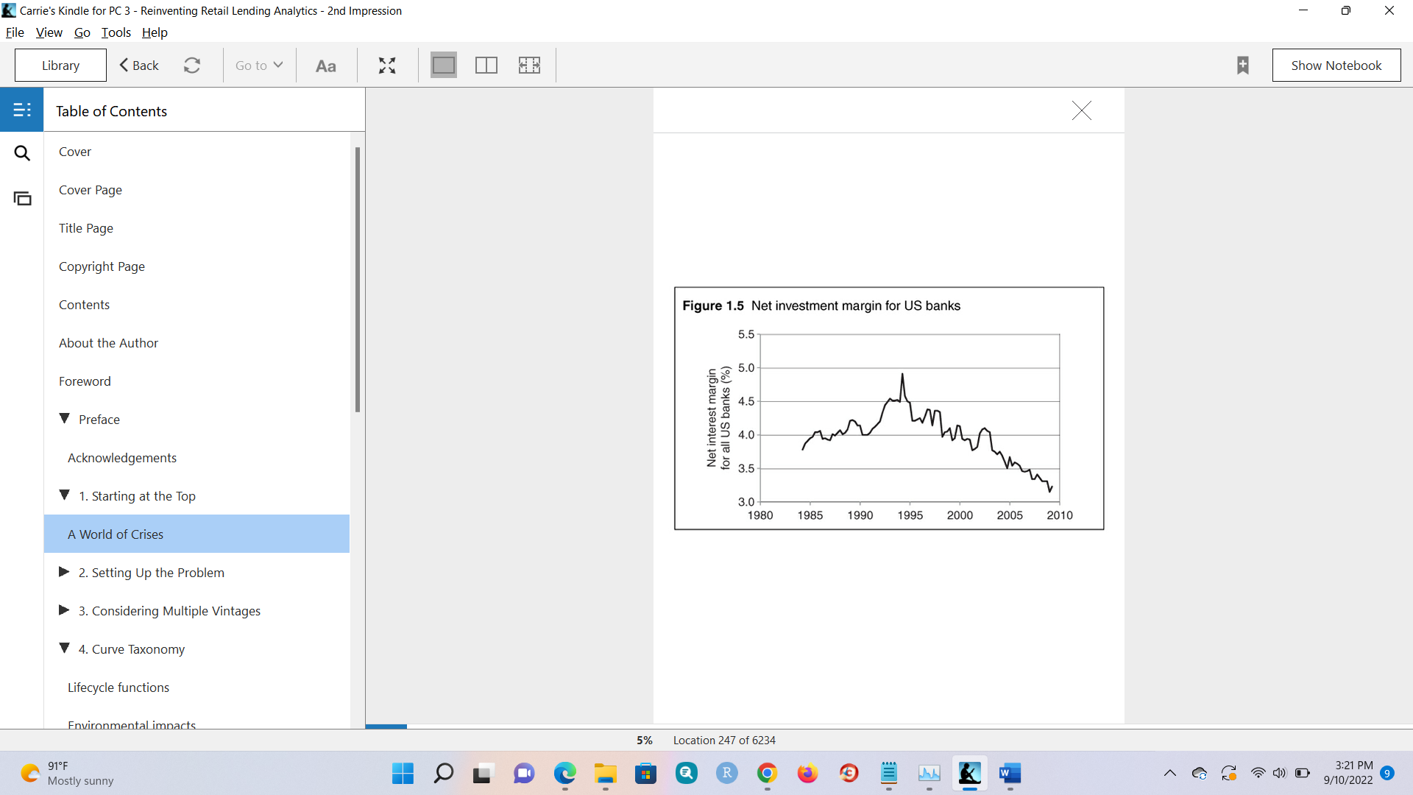

Banks were under pressure to hit very aggressive growth targets prior. Since 1994, NIM has been declining.

* + 1. Models in crisis

Roll-rate models, score-odds calibrations and simple econometric models, like the IMF’s, have been blamed as major contributing factors in the US mortgage crisis. Are all models broken? No.

Experienced practitioners had known for over a decade that the approaches listed were insufficient to accurately model retail loan portfolios, and relied on judgmental overlays to manage the model risk. But there are models that work, and that’s what this book is about.

* + 1. The key questions

Retailers use credit scores. “Scoring models typically predict cumulative behavior over a fixed horizon. As powerful as they are, they do not explain seasonality, the impact of the economy or the lifecycles that arise from consumer–product interactions.”

“When a long delay exists between our actions and the system’s response, we tend not to wait but rather keep making more changes. Consequently, we over-drive such systems, often leading to wide oscillations, exacerbating the problems we were trying to avoid.”

"In retail lending, it has been observed that portfolio managers typically double the magnitude of portfolio oscillations due to macroeconomic cycles."

" Thus, the business cycle is amplified by management: exactly the opposite of what was intended. This observation was made during the 1990s and it is exactly what we saw in the 2001 and 2008–9 recessions."

* + 1. Where to start

Most lenders use different models for account management and forecasting. " Certainly credit scoring was the first major success in retail lending analytics analytics. For a given product and price, being able to rank-order the applicants according to default risk revolutionised retail lending. Banks immediately became more profitable.

Unfortunately, “risk-based pricing” cannot be acclaimed as being the same success that scoring was. Risk-based pricing took scoring one step further by changing the price of the offering according to the individual score. To accomplish this, modellers had to cross the divide between ranking accounts and assigning probabilities of default to specific accounts. This seemed to succeed for a few years at a time, but in the wake of the US mortgage crisis it became clear that such successes were transient."

1. Setting Up the Problem
   1. Modelling opportunities
   2. Retail Lending
   3. Delinquency
   4. Securitized Products
   5. Revenue, Expenses, and Profitability
   6. Other Fields
      1. Utilities
      2. Web Services
      3. Manufacturers
      4. Publications and Media
      5. Collectables
      6. Poor Candidates
   7. Choose your variables
   8. Know your data
      1. Visualization
   9. Understanding Vintages
      1. Vintages
      2. Managing Vintages
      3. Lifecycle
      4. Vintage Quality
      5. Seasonality
      6. Management Actions
      7. Macro and competitive environment
   10. Summary
2. Considering multiple vintages
   1. Nonlinear decomposition
      1. M, e, and v
      2. Assumptions: independence (untrue, but it simplifies things, and the error due to that is small), lifecycle applies to all vintages (probably ok if you haven't changed the product),

Question for Brice: what does this mean? "For a rich data set such as is common in modelling credit card delinquency, the cumulative error in a one-year forecast due to this assumption is typically around 1–2%. 2%. From the perspective of the timing of peak losses due to the lifecycle function, the error could be expressed as ±1 month."

* + 1. Four ways to go about dealing with m, e, and v (non-linear decomposition methods):
       1. APC. Used for 100 years in demography.
       2. Survival and proportional hazard models. These two are effectively equivalent.
       3. Panel data methods.
       4. Dual-time dynamics. Commercially available in 2000.

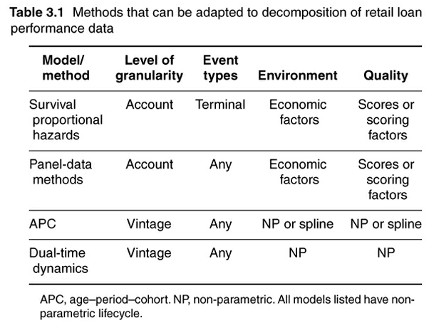

* 1. Model specification errors
  2. Estimation
  3. Minimum training data
  4. Validation
  5. Segmentation
  6. Environment clustering example
  7. Summary