Trial 1:

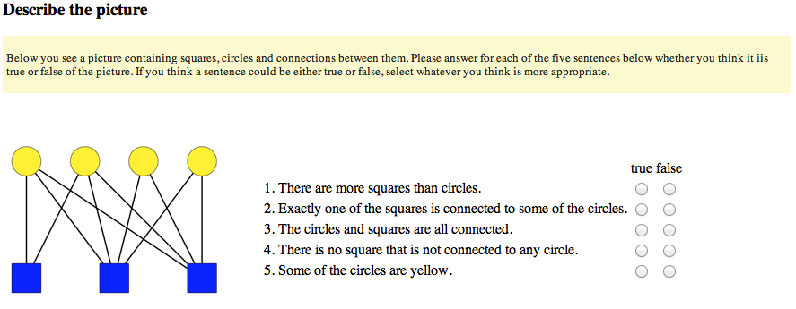
59 subjects were recruited via Amazon's Mechanical Turk to answer the following questions.

Sentences 1, 3, and 4 were intended as controls. Sentence 1 should be unambiguously false, sentence 3 ambiguous, and sentence 4 true.
Sentence 2 and 5 are the critical items. A 'true' answer for sentence 2 is indicative of a local reading, 'false' of a literal one. A 'true' answer for sentence 5 is indicative of a literal reading, 'false' of a pragmatic one.

The results were:

sentence | TRUE | FALSE
There are more squares than circles | 9 | 50
Exactly one of the squares is connected to some of the circles | 41 | 18
The circles and squares are connected | 48 | 11
There is no square that is not connected to any circle | 31 | 28
Some of the circles are yellow | 42 | 17

I was interested in whether there is a pattern in subjects' response patterns in sentences 2 and 5. Literalists should give 'false' answers for 2 and 'true' answers for 3. Pragmaticists, who read 'some' as 'some as not all', should show the opposite pattern.

But the result is:

 | Sentence 5
Sentence 2 | TRUE | FALSE
TRUE | 33 | 8
FALSE | 9 | 9

The majority of answers lies on the “other” diagonal. There is a marginally significant correlation between answers, but it goes the other way (X2 = 4.729, df=1, p = 0.03858).

Trial 2:

49 subjects were recruited via Amazon's Mechanical Turk to answer the following questions. Two sentences were different compared to trial 1, namely 2 and 4. The motivation is that sentence 4 previously seemed to difficult (double negation), and similarly the non-monotonic 'exactly one' could also have been to difficult, so that the answer pattern only reflects the judgment for the sentence “there is one”.
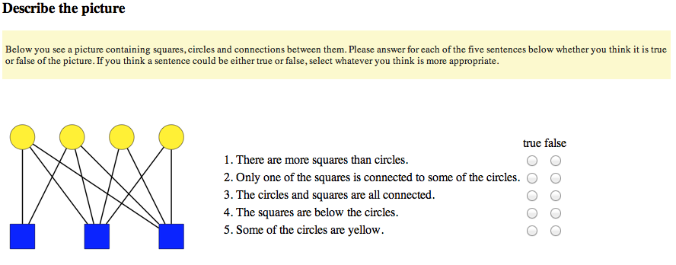

Sentences 1, 3, and 4 were intended as controls, as before.
Sentence 2 and 5 are the critical items, as before.

The results were:

sentence | TRUE | FALSE
There are more squares than circles | 3 | 46
Only one of the squares is connected to some of the circles | 10 | 39
The circles and squares are connected | 34 | 15
The squares are below the circles | 43 | 6
Some of the circles are yellow | 22 | 27

Looking for consistent literalists or pragmaticists:

 | Sentence 5
Sentence 2 | TRUE | FALSE
TRUE | 4 | 6
FALSE | 18 | 21

There is no interaction (X2 = 1e-4, df=1, p = 0.9942).

