**Main changes**

* Instead of talking about ‘bonus’ and ‘other’ card, we talk about ‘the card with a green/red border’ or just ‘green / red card’. (If prefer the latter.)
* We include instructions on the experiment screen (depending on condition type), e.g., like so for the competitive condition: “Remember that you need to describe the card with the **green** border. You win if L chooses the **red** card. L wins if L chooses the **green** card.”
* We use “some” instead of “most”. We therefore slightly change the pictures. For the example below, we have 3 or 4 pink objects in the green card, for instance. (A “typical number“ for “some As are Bs” is 3-5 when there are 10 As.)
* Instead of choosing a single word to complete a sentence, participants choose a full clause. Concretely, participants get the initial sentence fragment “The green card is the card where …” and what follows are subordinate clauses such as “some of the objects are green” vs “all of the objects are buckets.”
* The clauses to choose from fall into three categories: GREEN, RED, FALSE.
  + FALSE is a sentence that is false of both cards.
  + GREEN is a sentence that is either semantically true of the green card, but false of the red card (in control conditions ‘all’ and ‘none’) or which is semantically true of both cards but whose implicature is only true of the green card.
  + RED … same as for GREEN but reversed.
* Where previously we only used the word ‘clowns’, we will create a longer list of descriptions that do not apply to any picture (e.g., {clowns, soccer balls, black, insects, …}. We choose a random word from this list to instantiate the false sentence on the fly.

**Example trial for “some”**

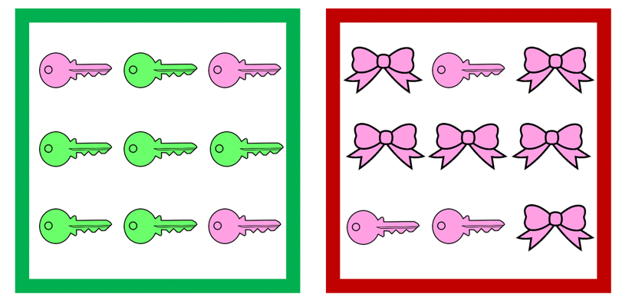

Remember that you need to describe the card with the **green** border. You win if L chooses the **red** card. L wins if L chooses the **green** card. How would you complete the sentence below to describe the green card?

The green card is the card where …

1. some of the objects are pink. [option GREEN]
2. some of the objects are keys. [option RED]
3. all of the objects are clowns. [option FALSE]