AI based Event Driven Algorithmic Engine & Machine Learning for Big Data
RAJ EZEKIEL, MICHAEL GIANSIRACUSA, ADAM LUTZ
Work Completed as of AUGUST 19, 2016
- Four camera ready papers published by SPIE (International Society for Optics and Photonics) as part of the proceedings of the Geospatial Informatics, Fusion, and Motion Video Analytics conference. Conference on April 17, 2016 Papers published May 31, 2016
  - Optimal Multi-focus Contourlet-based Image Fusion Algorithm Selection
  - Bandelet-Based Image Fusion: A Comparative Study for Multi-Focus, Multi-Modal Images
  - Multi-Focus and Multi-Modal Fusion: A Study of Multi-Resolution Transforms
  - A Comparative Study of Multi-Focus Image Fusion Validation Metrics
- Presented three posters at the Armed Forces Communications and Electronics Association (AFCEA) conference for the submitted SPIE papers on June 14, 2016
  - Bandelet-Based Image Fusion: A Comparative Study for Multi-Focus Images
  - Multi-Focus Contourlet-Based Image Fusion Algorithm Selection
  - Multi-Focus and Multi-Modal Fusion: A Study of Multi-Resolution Transforms
- Three abstracts accepted by NAECON - National Aerospace & Electronics Conference & Ohio Innovation Summit (NAECON-OIS), Dayton, OH, USA, July 26 - 29, 2016
  - Double-Density and Dual-Tree Based Methods for Image Super Resolution
  - Matrix Sketching For Big Data Reduction
  - Context-Driven Automated Data Relocation for Use in Data Transpositioning
- Three posters presented at the NAECON conference
  - Methods for Image Super Resolution
  - Context-Driven Automated Data Relocation for Use in Data Transpositioning
  - Matrix Sketching for Big Data Reduction
- Four abstracts submitted to Applied Imagery Pattern Recognition (AIPR)- Imaging and Artificial Intelligence: Intersection and Synergy, Washington DC, October 18-20, 2016
  - Multi-Scale Transformation Based Image Super-Resolution
  - User, Content, and Item - (CUI) based filtering for Big Data
  - Content-Based Information Retrieval Using Data Transpositioning
  - Seismic Signal Analysis using Multi-Scale/Multi-resolution Transformations
- Presented two posters at the Information Institute Summer Research Associate Poster Session and Technical Interchange, Urtz Conference, July 12, 2016
  - Matrix Sketching using Skylark
  - SmallK - Nonnegative Matrix Factorization
- Compiling and submitting image fusion code as well as contributing to Dr. Erik Blasch’s book, “Multispectral Image Fusion and Colorization”
- Journal Paper: A Comparative Study of Multi-Focus, Multi-Resolution Image Fusion Transforms and Methods in progress
  - Developed a collaboration with Dr. Larry Pearlstein on this paper and developed ideas for future work
  - Results from comparative study have motivated a novel fusion performance metric and a technique for reverse engineering a fusion algorithm to optimize performance
- SKYLARK:
  - Completed documentation for Skylark for a user to be able to begin working with it from start
  - Benchmarking performance for Skylark’s Randomized Singular Value Decomposition (RSVD) function
    - Computational time of calculating the Singular Value Decomposition (SVD) of large scale matrices (millions of rows and columns)
    - Error (Root Mean Square Error) when compared to the original matrix. Reconstruct the matrix by multiplying the decomposed matrix (USV*) into its original dimensions and calculate the Root Mean Square Error when compared to original matrix. The original matrix’s SVD is then calculated using MATLAB as well, which is then reconstructed and the Root-Mean-Square Error is then calculated compared to the original matrix
- SMALLK:
  - Completed documentation for SmallK for a user to be able to begin working with it from start
  - Benchmarking performance for SmallK’s Non-Negative Matrix Factorization (NMF) function
    - Time vs. Number of Elements for all NMF algorithms
  - Implemented SmallK through Collen Rollers AFRL Utility Manager
    - Successfully linked command line applications input and output for automation
    - Implemented clustering algorithm for Natural Language Processing (NLP)
- Presented SmallK and Skylark work in Collen Roller’s lightning talk in RIE-2 on July 13
- Benchmarking results of SmallK and Skylark for Adnan Bubalo’s Big Data Smart Analytics briefing
- Benchmarking ARL’s project Apollo
  - Twitter data clustering and ranking based on relevance
  - Benchmark against indexing with Solr and Carrot²’s clustering
  - Using K-Means Clustering, determine how Apollo can cluster Twitter data versus Carrot2
- SmallK clustering using LEAN (Lucene Tools for Text Analytics) is currently being tested on Twitter data. LEAN is used as a preprocessing step to allow SmallK to perform Non-Negative Matrix Factorization and clustering on the documents. The clusters were based on frequency and user specified parameters. This will be used in comparative benchmarking Apollo.
- Tweets that were clustered in Apollo have been ingested into Solr. The text of the tweets as well as the Twitter handle are the parameters that are being indexed but these can be expanded to include to user IDs, geolocation, and timestamps. Carrot² clustering is in preliminary testing using the Solr’s Carrot² interface. Carrot²’s clustering will also be used to comparatively benchmark Apollo.
- The following two proposals were provided to our mentors for funding to continue our research during the academic year:
  - Artificial Intelligence Based Algorithmic Engine, with Benchmarking and Functional GUI Interface for BIGDATA/XDATA Analytics
    - Collaboration with Dr. Larry Pearlstein and students from The College of New Jersey for our work with Deep Convolutional Neural Networks
  - Novel No-Reference Metric for Evaluating Multi-Focus Image Fusion Algorithms

Immediate Tasks
- NAECON papers
  - Context-Driven Automated Data Relocation for use in Data Transpositioning
  - Matrix Sketching for Big Data Reduction
  - Methods for Image Super Resolution
- Journal Paper for IEEE publication
  - A Comparative Study of Multi-Focus, Multi-Resolution Image Fusion Transforms and Methods
- Book Chapter
  - Beyond Wavelets – Multi-focus, Multi-modal Image Fusion with Bandelets and Contourlet based decomposition
- AIPR paper
  - Multi-Scale Transformation Based Image Super-Resolution
  - Content, User, and Item (CUI) based filtering for Big Data
  - Content-based Information Retrieval Using Data Transpositioning
  - Seismic Signal Analysis using Multi-Scale, Multi-Resolution Transformations
- SPIE Abstracts
  - Two abstracts for SPIE conference in April 2017

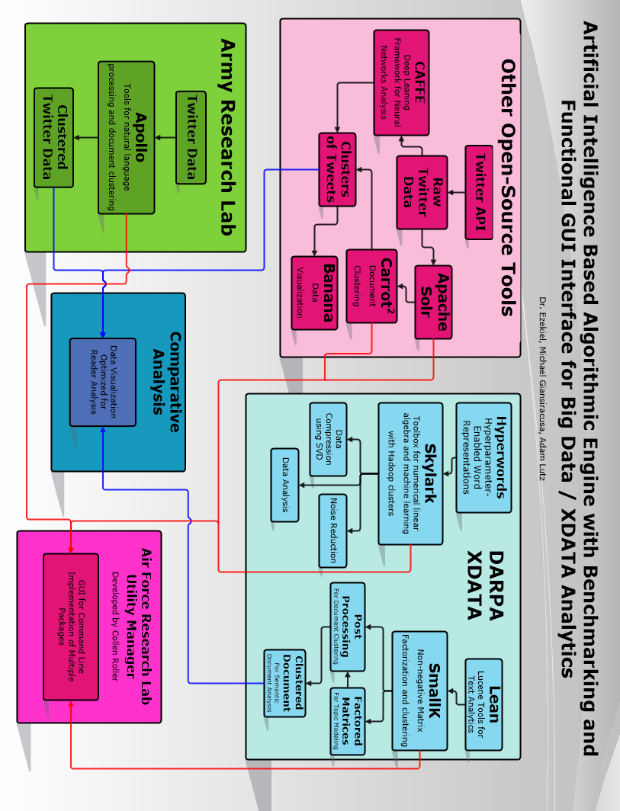

PROPOSED RESEARCH

Proposed research will be conducted in collaboration with Dr. Larry Pearlstein of The College of New Jersey.
- Continue documentation and practical testing of DARPA XDATA projects.
  - Initial benchmarking and documentation done for IBM’s Skylark and Georgia Tech’s SmallK.
- Perform benchmarking to evaluate resource requirements, data accuracy and usefulness.
- Assist in development of Collen Roller’s Command Line Utility Manager (AFRLUM) which includes debugging and suggestions for additional features.
- Integrate XDATA software into AFRLUM as exportable packages for end-user.
- Acquire labeled Twitter data which will be used to train a DCNN framework.
  - Explore the possibilities of generating synthetic training data.
- Conduct a pilot study for developing a DCNN framework to analyze Twitter data.
- Fully document the DCNN framework for publication and verification.
- Benchmark the DCNN’s performance using training time, resource requirements, and classification accuracy of training and testing data.
  - Explore options for standardized performance evaluation
- Develop a novel no-reference multi-focus image fusion metric based on the principles of closeness, sharpness, and simplicity.
  - Closeness –The fused image should be close to one or both of the input images.
  - Sharpness –The fused image should be as sharp as possible.
  - Simplicity – Good scores for simplicity relate to a minimum set of transitions.
- Compile a large test image data set of multi-focus imagery validation of the metric.
- Explore generating synthetic multi-focus imagery for further testing.
- Optimize an image fusion algorithm using the evaluated metric.
- Begin to compile findings for submission to a conference or refereed journal paper.

FUNDING PROFILE
The purpose of the funding will allow us to continue our research on Deep Convolutional Neural Networks and a novel multi-focus fusion performance metric. This work will require labeling of millions of tweets which is time intensive and this will require many hours to accomplish. The funding will support 3 students from each of two universities (TCNJ & IUP) for two semesters to accomplish this work. It will also build continuing, collaborative relationships with the AFRL and encourage graduate research work. So far we have raised $29,000 toward funding this program. We are looking more students at a cost of $5130 per student for 12 weeks and one student for 4 extra weeks at $215 per week.

TIME FRAME | SEP-APRIL
PER HOUR | $14.25
HOURS PER WEEK | 15
WEEKS PER SEMESTER | 12
TOTAL SEMESTERS | 2
TOTAL STUDENTS | 6
TOTAL STUDENT COST | $30,780.00
SECURED FUNDING | $29,000.00
FUNDS REQUESTING | $1,780.00
TOTAL STUDENT HOURS | 2160
Additional Student Cost | $5,130.00
Cost Per Week Per Student | $213.75

