Michael Garza

Professor Golovko

ITEC 1301

28 March 2018

Event Finder

The issue that would be solved by this application would be considered of medium importance. The solution is not lifesaving, but is life changing. This application is made for enjoyment and leisure, compared to something making a business run more efficiently. It does however, affect everyone. The problem is not finding something to do when your life gives you free time to enjoy some leisure activities. Personally, I find myself google searching places to go and things to do, but end up not going anywhere and just wasting my free time in my room or at home, because it is hard to find anything I want to do or it’s complicated to find anything. The objective behind this application is to help people find fun events and activities going on around them in their communities and end the waste of time of just sitting at home. This application will do this through posts created by users or organizations promoting their event or activity. Users will be able to see information regarding title, location, date, price, a description, and picture gallery of the event or activity. This simple application has the ability to change people’s lives due to the fact that they will no longer be wondering and wandering looking for something to do this Friday night.

The users that will be using this technology will be the people who have a hard time finding something to do in their spare time. Which could be anybody if not everybody, but most likely a younger group of people such as college students, they have a want and desire to have fun with the energy they have as young adults. In the initial period, I would expect a decent number of users. I would launch this application in a beta version exclusive to college students such as students at UH. This would create an automatic growing number of users, and when fully launched most other universities and students will pick up on the application. Overtime the number of users will grow exponentially, I would expect the app to be well known nationally within a month. The technology this application would be set in would be on mobile devices. As it is to be simple and used quickly. There is no need for a full website on computer systems. In order for the users to be happy while using this application they must be able to use it effectively. Effective use is looking for specific wants, such as how much they are willing to spend time, money and drive to their desired event or activity.

Users would need a login in order to save reoccurring events, and to provide the application with their location in order to find local events. The users will depend on geolocation in order for the application to work, otherwise there is no way to find the local events and activities around them. There is a need for integration with google maps in order to locate the user and the event. This will make the application much more effective and efficient than being separated from a map.

This application was created in order to help people with a desire to have fun that cannot find fun. The application includes filters, creating an ideal and specific search process including: expenses, distance, type of leisure, time, and a rating if the event is reoccurring. This app will be one of a kind and will change the way people look for fun.

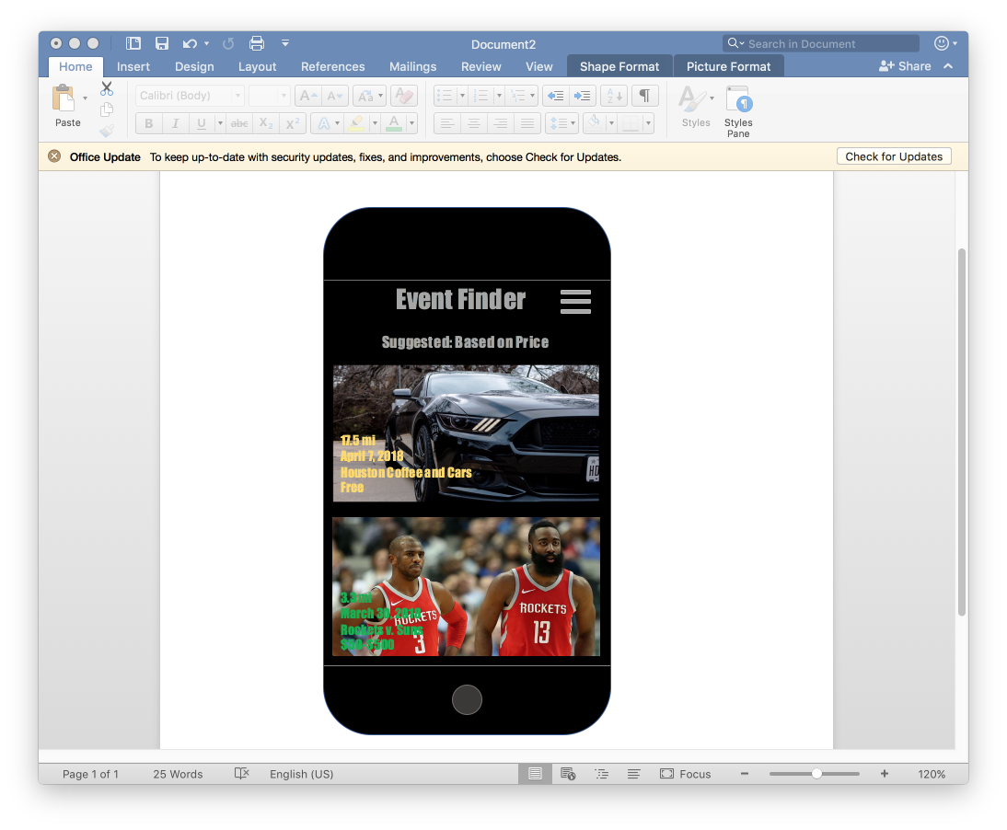

Screenshot of the created homepage of Event Finder