Michael Ghisilieri

CPE301 – SPRING 2016

Design Assignment 0

**DO NOT REMOVE THIS PAGE DURING SUBMISSION:**

The student understands that all required components should be submitted in complete for grading of this assignment.

|  |  |  |  |
| --- | --- | --- | --- |
| **NO** | **SUBMISSION ITEM** | **COMPLETED (Y/N)** | **MARKS**  **(/MAX)** |
| 0. | INITIAL CODE OF TASK 1/A |  |  |
| 1. | SCREENSHOTS OF EACH TASK OUTPUT |  |  |
| 2. | GITHUB LINK OF THE DA |  |  |
|  |  |  |  |
|  |  |  |  |

|  |  |  |  |
| --- | --- | --- | --- |
| 0. | INITIAL CODE OF TASK 1/A |  |  |

;

; DA0_Task1.asm

;

; Created: 2/13/2016 4:27:15 AM

; Author : Michael

;

.org 0 ; assemble code at 0x0000

sbi DDRB, 2 ; use PORT

ldi R20, 0 ; intialize register used as sum to zero

ldi R21, 37 ; load 37 into register R21 (first random number)

add R20, R21 ; R20 = R20 + R21 (add first number to sum)

ldi R21, 59 ; load 59 into register R21 (second random number)

add R20, R21 ; R20 = R20 + R21 (add second number to sum)

ldi R21, 52 ; load 42 into register R21 (third random number)

add R20, R21 ; R20 = R20 + R21 (add third number to sum)

ldi R21, 58 ; load 48 into register R21 (fourth random number)

add R20, R21 ; R20 = R20 + R21 (add fourth number to sum)

ldi R21, 55 ; load 35 into register R21 (fifth random number)

add R20, R21 ; R20 = R20 + R21 (add fifth number to sum)

brcs overflow ; if there is an overflow (carry flag set), branch to overflow label

ldi R21, 0 ; load 0 into register R21

out PORTB, R21 ; zero out PORTB so that pin 2 = LOW

jmp done ; if there wasn't an overflow, jump to done since PORTB has already been set

overflow:

ldi R21, 4 ; load 4 into register R21

out PORTB, R21 ; set PORTB to 4 so that pin 2 = HIGH

done:

jmp done ; infinite loop once program is finished running

|  |  |  |  |
| --- | --- | --- | --- |
| 1. | SCREENSHOTS OF EACH TASK OUTPUT |  |  |

TASK 1/A:

Beginning of debugging showing PORTB and registers used to be zeroed out.

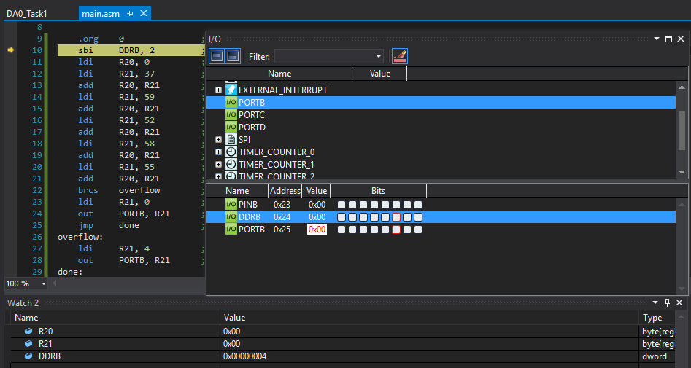

End of debugging showing overflow from 5 given numbers causing PIN2 of PORTB to go high (shown in red).

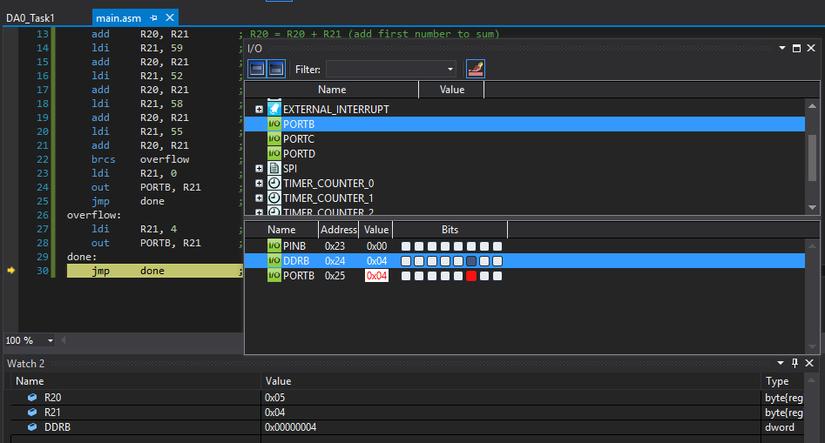

TASK 1/B:

During step through of the program, the carry bit ‘C’ goes high in the Status Register showing that the addition of the 5th number caused the sum to overflow.

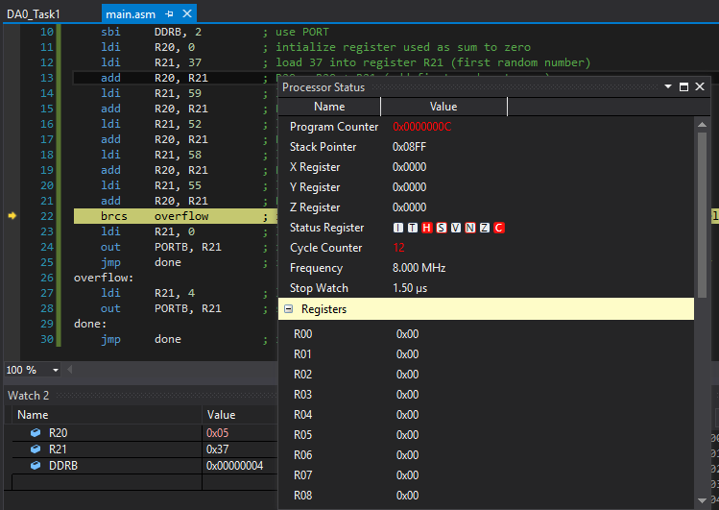

Execution Time = 2.00 $µs$, Number of Cycles = 16

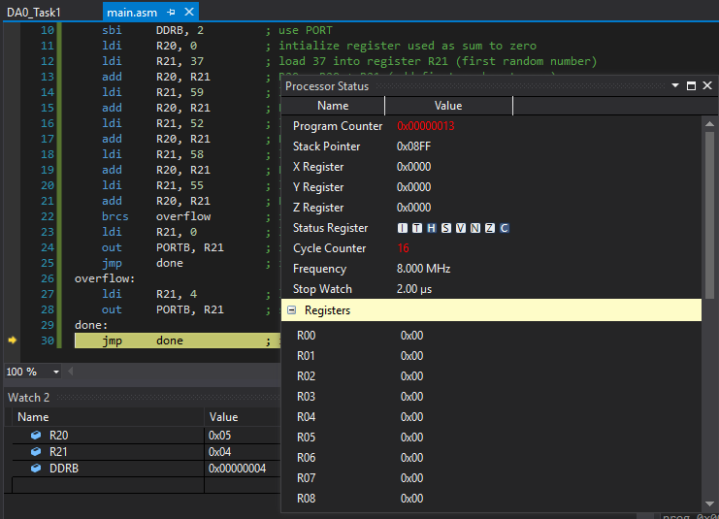

|  |  |  |  |
| --- | --- | --- | --- |
| 2. | GITHUB LINK OF THE DA |  |  |
| https://github.com/michael-ghisilieri/CpE301_DAs.git | | | |

**Student Academic Misconduct Policy**

<http://studentconduct.unlv.edu/misconduct/policy.html>

“This assignment submission is my own, original work”.

Michael Ghisilieri