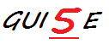

MySprite™
Sprite Editor and Animation Tool

User Manual

MySprite™ User Manual

Purpose of this User Manual
This user manual is designed to aid any MySprite™ user (you) with learning and performing common actions within the application. The manual begins with a concise, informative overview, and then is logically divided into basic tasks and grouped together by function. The three major functions of MySprite™, as they relate to most users, are Opening & Saving, Image Editing, and Animation. These three functions relate directly to the most common phases of sprite creation. This manual provides detailed instructions for completing these actions.

I. MySprite™ Overview: Concepts & Context
If you are new to the world of pixel art and sprites, don’t worry. This manual will briefly introduce the concept of sprites and provide a general overview of the MySprite™ user interface. Later on in the manual, if you are unsure where to locate a mentioned GUI item, you can quickly reference this section to find what you are looking for.
- What Is a MySprite™ File?..………...……………………………………………………………………………..page 4
- GUI Overview…..…………………………………………………………………………………………………………page 4

II. Opening & Saving: Methods & Procedures
Understanding the different methods for creating & saving a new sprite empowers you start and continue sprite projects more efficiently. This section of the manual describes the various methods for creating new sprites, importing existing sprite images, saving sprites, and exporting useful files along with simple, step-by-step procedures.
- Getting Started………………………………………………………………………………………………………….. page 6
  - Creating a New MySprite™ File………………………………….
  - Open Existing MySprite™ File…………………………………….
  - Import Images to Current MySprite™ File………………….
    - Overwrite Current…………………………………………
    - Add to Current………………………………………………
- Saving Your MySprite™ File…………………………………………………………………………………………page 8
  - Save…………………………………………………………………………..
  - Save As………………………………………………………………………
- Export Options……………………………………………………………………………………………………………page 8
  - Export Images…………………………………………………………..
  - Export Image Sheet…………………………………………………..
- Close and Exit……………………………………………………………………………………………………………..page 9

III. Image Editing: Tools & Transformations
With MySprite™, all the tools you need are a click away. This section details the use of built-in editing tools, and explains how to create your own tools to tailor MySprite™ to your specific needs.
- Built-in Image Tools..………………….……………………………………………………………………………….page 10
  - Pen Tool…………………………………………………………………….
  - Line Tool…………………………………………………………………….
  - Transformations…………………………………………………………
- Creating Custom Tools..…………………………………………………………………………….……………....page 11
- Transformations………………………………………………………………………………………………………….page 11

IV. Animation: Edit & Preview
In the past, once you finished drawing your masterpiece sprite, you still had to animate it with a separate application. There is no need for bulky additional software in order to animate your MySprite™ creation. Follow along in this section to bring your art to life.
- Insert & Deleting Frames..…………………………………………………………….……….…………………..page 12
- Duplicate Image………………………………………………………………………………………………………….page 12
- Arrangement………………………………………………….………………………….……………………………….page 12
- Animation Preview……………………….……..…………………………………………………..…………………page 13

MySprite™ Overview: Concepts & Context
- What is a sprite?
Sprites are typically animated, two-dimensional images. These animated images can be used in various ways; for instance, sprites are used extensively in video games. In MySprite, an animated sprite consists of a series of images that are composed of layers. MySprite™ presents all the tools you need to draw the first pixel on the first layer, to arranging finished frames in a complete animation.
- GUI Overview-
When you first open MySprite™, the simple layout opens in full screen. Below, the major GUI components are outlined, labeled, and described. Refer back to this section at anytime if you have trouble finding a particular tool or menu.
Figure 1.1 Initial Layout – Image Editing 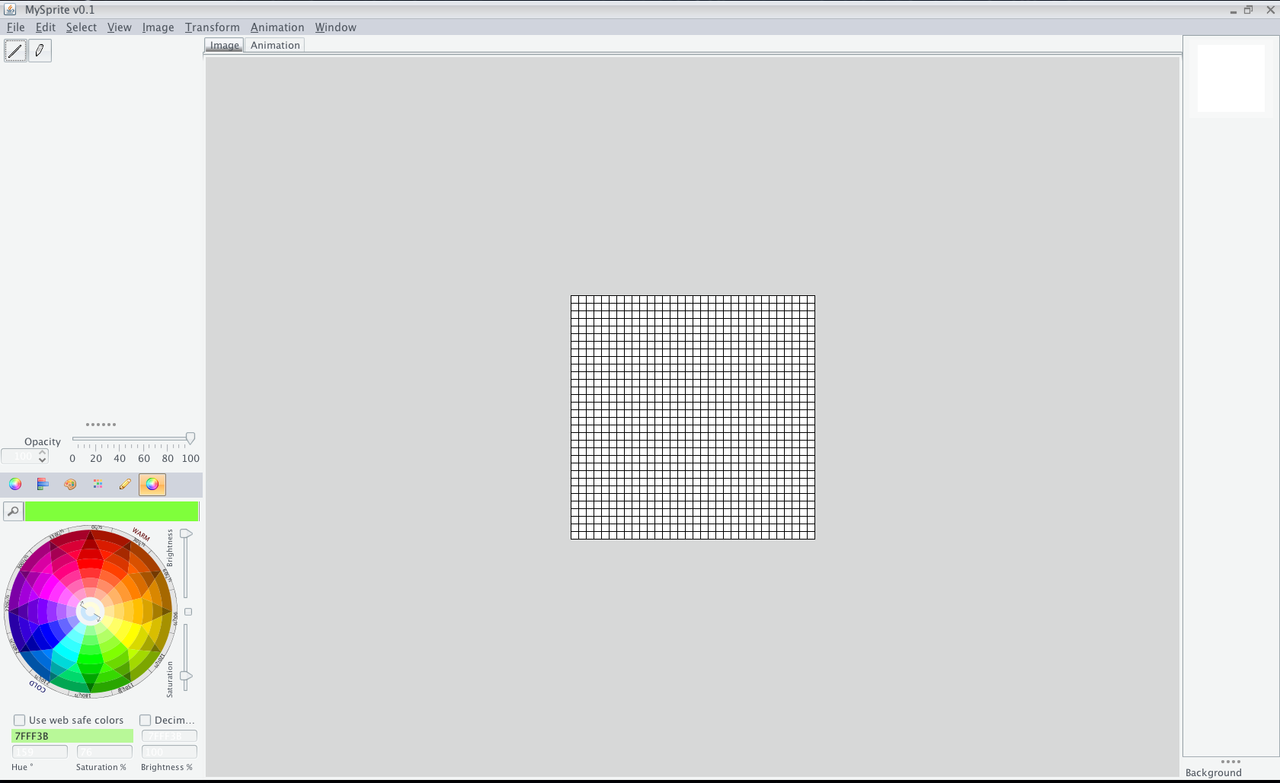
A
B
D
C
F
E
H
G

  - Menu Bar
Menu driven access to most functions and tools
  - Toolbar
Quick click access to common image editing mouse tools
  - Opacity Control Bar
Control the opacity of the current mouse tool
  - Color Picker
Multiple ways of choosing the desired color for the current tool
  - Image/Animation Switcher
Switch between image editing and animation arrangement with one click
  - Canvas Area
The general editing area that houses the canvas
  - Canvas
This is where mouse tools are applied to alter image layers’
  - Image Preview List
The sprite images are displayed here as previews, and to allow easy switching between different images
Figure 2.2 Image Editing 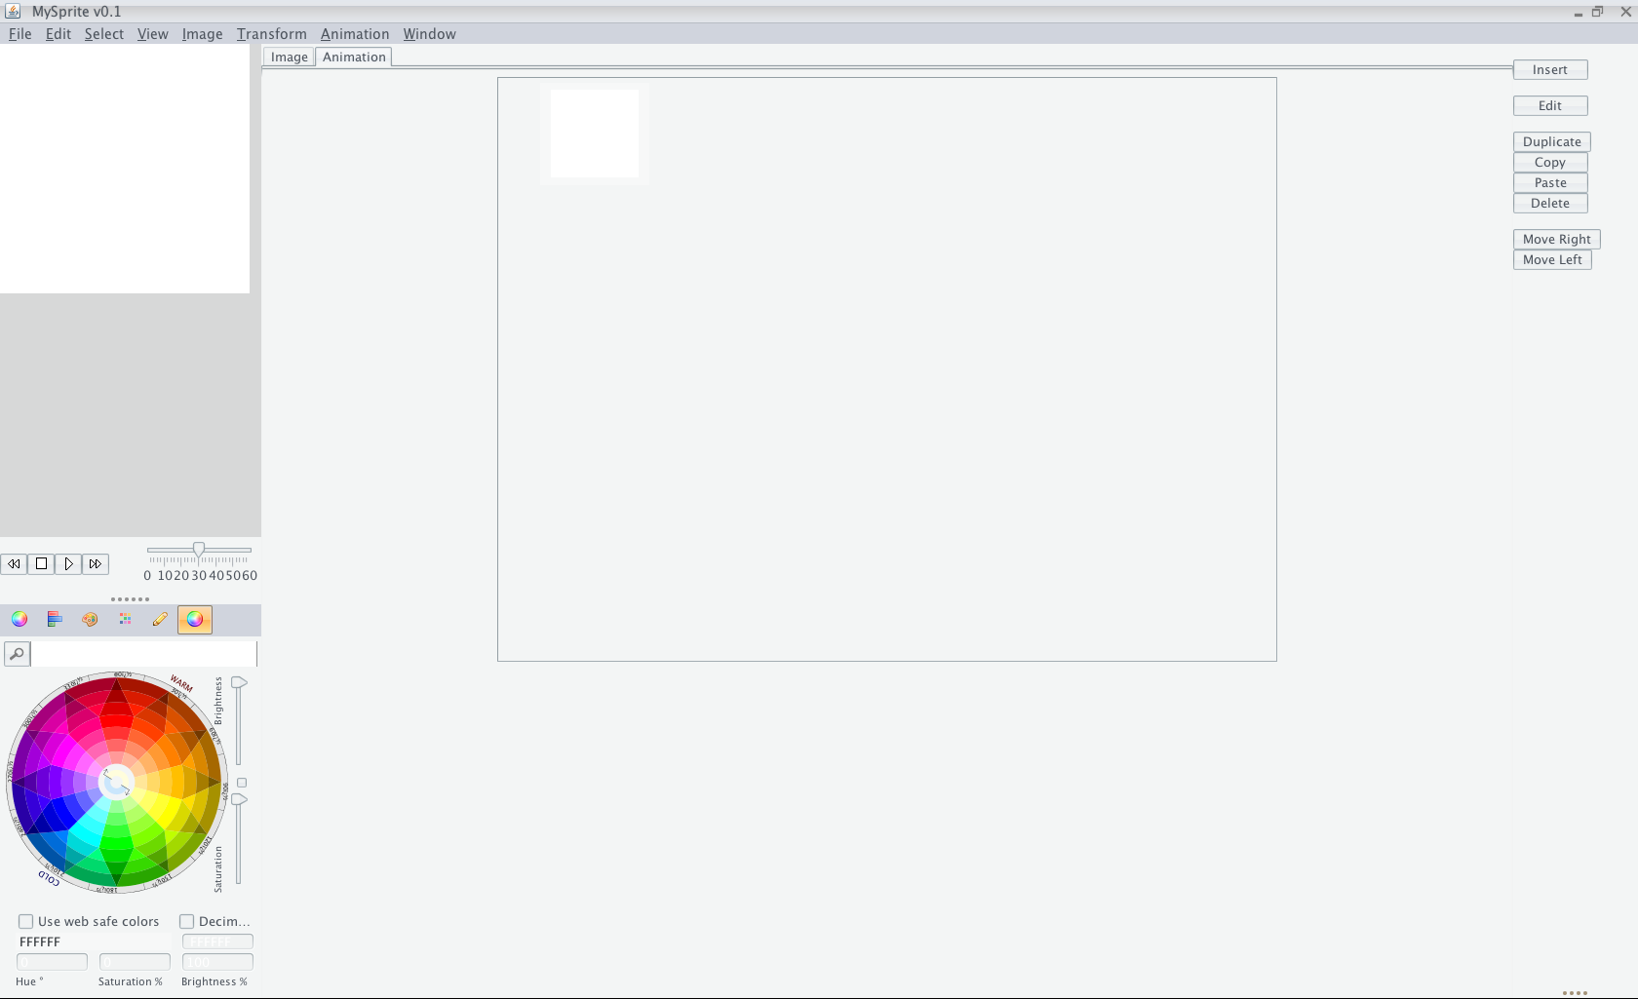
A
B
D
C
E
G
F

- Menu Bar
Menu driven access to most functions and tools
- Animation Preview
View your animated sprite in action
- Animation Control Bar
Contains animation play controls as well as a frame rate adjustment slider
- Color Picker
Multiple ways of choosing the desired color for the Animation Preview Background
- Image/Animation Switcher
Switch between image editing and animation arrangement with one click
- Frame Preview Area
View the frame images and their animation order that comprise your sprite
- Frame Tool Bar
Quick access to edit, reorder, or add/delete frame images

Opening & Saving: Methods & Procedures
- Getting Started
  - Creating a New MySprite™ File
    - From the Menu Bar, click File > New
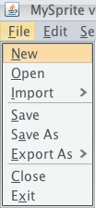
    - A dialog box will appear, allowing you to set the name & desired size of your new sprite
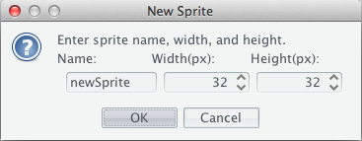
    - Click OK and you will be presented with a new, blank canvas
  - Open Existing MySprite™ File
    - From the Menu Bar, click File > Open
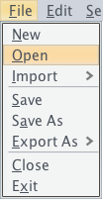
    - An open dialog box appears with a file browser. Use the browser to find your existing MySprite™ file.
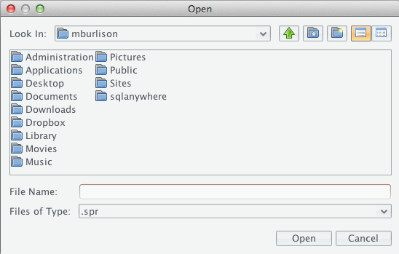
    - Click Open, and your chosen file is loaded into MySprite™ ready for editing.
  - Import Images to Current MySprite™ File
    - From the Menu Bar, click File > Import
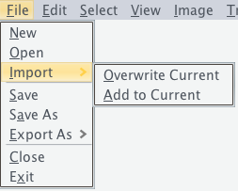
    - You have two options. Overwrite Current will remove all current images from the sprite, and replace them with images chosen via a file browser. Add to Current will simply append the images you choose to your sprite file without affecting the current images.
- Saving Your MySprite™ File
    - From the Menu Bar, click File > Save OR File > Save As
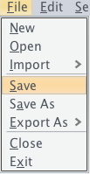
    - Choosing Save will save the sprite to the current MySprite™ file, or allow you to choose a location and file name if the sprite has not been saved before. Save As will allow you to choose a new name and location for your MySprite™ file, without altering the current MySprite™ file name and location.
- Export Options
    - From the Menu Bar, click File > Export As
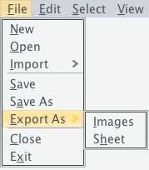
    - Choose Images to export all the current sprite images to separate files.
    - A dialog box will appear to allow you to choose the format of the exported images. After making your selection, click OK to choose the location of the exported images.
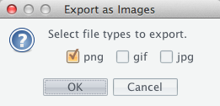
    - Exporting as Sheet is performed the same way, but will export all the current sprite images into a single image file that is useful for game engines and other applications.
- Close & Exit
    - To close the current working sprite, click File > Close from the Menu Bar.
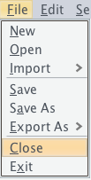
    - To exit MySprite™ completely, click File > Exit from the Menu Bar.
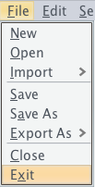

Image Editing: Tool & Transformations

- Built-in Image Tools
  - Color Picker
    - The Color Picker is used to set the color of the current tool.
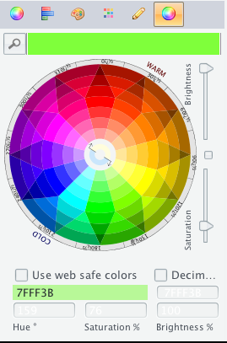
    - Using the icons in the bar above the Color Picker, you can change the method of choosing colors. Each method provides different options and controls such as Hue, Saturation, Brightness, etc.
    - Regardless of method, choosing a color can be as simple as clicking in the area with the desired color.

  - Pen Tool
    - Click the Pen Tool icon from the Tool Bar to set it as the current tool.
    - Click or drag anywhere on the canvas to draw with Pen Tool using the chosen color.
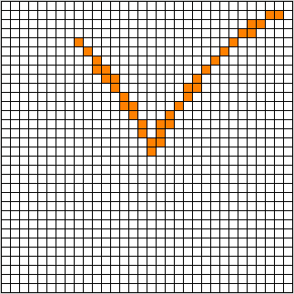

  - Line Tool
    - Click the Line Tool icon from the Tool Bar to set it as the current tool.
    - Click once on the Canvas where you would like your line to originate.
    - Click once more in a different area of the canvas where you would like your line to terminate, and a line will appear, connecting the two pixels inclusively.
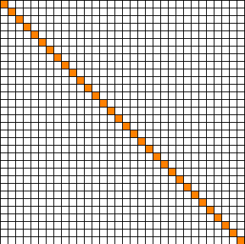
- Creating Custom Tools
    - If you have created or downloaded a custom tool file in XML format, simply copy the file and the tool’s icon image into the appropriate folders within the “assets” folder.
      - Tool XML Files: <MySprite™ Application Folder>/assets/tools/
      - Tool Icon Images: <MySprite™ Application Folder>/assets/image/
    - Relaunch MySprite™, and your new tool will appear in the Tool Bar ready to use.
- Transformations
    - From the Menu Bar, click one of the following to view and select transformation options for the current sprite, image, or layer respectively.
      - Transform > Sprite
      - Transform > Image
      - Transform > Layer
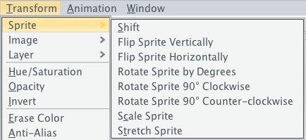

Animation: Edit & Preview
- Insert & Deleting Frame
  - Insert Frame
    - From the Frame Tool Bar, click the button.
    - A new blank frame will be added to the animation.
  - Delete Frame
    - Select a frame from the Frame Preview Area by clicking it.
    - Click the button to delete the selected frame and it’s image.
- Duplicate Image
  - Duplicate Frame
    - Select a frame from the Frame Preview Area by clicking it.
    - Click the button to insert a copy of the selected frame.
  - Copy/Paste Frame
    - Select a frame from the Frame Preview Area by clicking it.
    - Click the button to copy the selected frame’s image.
    - Select a frame who’s image you would like to replace with the previously copied image.
    - Click the button to replace the selected frame’s image with the previously copied image.
- Arrangement
  - Move Frame
    - Select a frame from the Frame Preview Area by clicking it.
    - Click the or button to shift the selected frame’s position either right or left respectively.
  - Cycle
    - From the Menu Bar, click Animation > Cycle Images
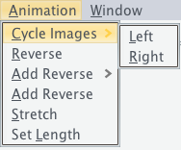
    - Then click Left or Right to cycle the frames by one to the left or right respectively.
  - Reverse
    - From the Menu Bar, click Animation > Reverse to reverse the order of the frames
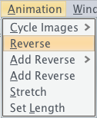
  - Add Reverse
    - From the Menu Bar, click Animation > Add Reverse
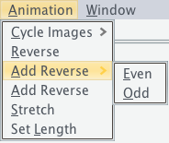
    - Then click Even to duplicate and append all the current frames in reverse order.
    - Alternatively, click Odd to duplicate all but the last frame and append them in reverse order.

Figure 4.1 Add Reverse Even/Odd
[Original]


[Add Reverse > Even]
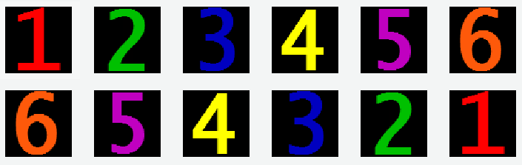

[Add Reverse > Odd]
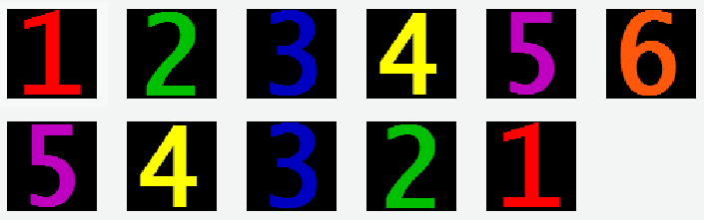

- Animation Preview
  - Play Controls & Frame Rate Adjustment
    - Using the Animation Control Bar, you can play, stop, step through, and adjust the frame rate of the Animation Preview.
