Tern Tangible Programming User Manual
http://hci.cs.tufts.edu/tern



Michael S. Horn

Version Beta 1, June 2009
Compatible with LEGO® MINDSTORMS® RCX
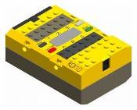

This project was developed at Tufts University in collaboration with Robert J.K. Jacob, Marina U. Bers, Jordan Crouser, Rachael Fein, Emily Lin, Mark Schnittman, and Erin Solovey. Much of this work was also done in collaboration with the Museum of Science, Boston with Taleen Agulian, Dan Noren, and Mary Murray. This project was funded in part by the National Science Foundation (Grant No. DRL-0735657). Any opinions, findings, and conclusions or recommendations expressed in this document are those of the authors and do not necessarily reflect the views of the National Science Foundation.



Table of Contents

Introduction 3
How It Works 3
What you’ll need to get started… 3
Installation Guide 4
Getting Started 5
Programming Guide 6
How to build tangible programming blocks 10
Tangible Block Checklist 12
Tangible Block Checklist 12
Appendix A: Tangible Block Faceplates 13
Appendix B: Optional Block Faceplates 19

Introduction
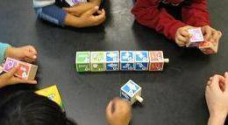
Tern is a tangible computer programming language. This means that, unlike other programming languages, you don’t use a mouse or a keyboard to create programs on a computer screen. Instead, you build physical programs using interlocking wooden blocks. These blocks represent actions for a robot to perform. With Tern there is no such thing as a syntax error. The shape of the interlocking blocks creates physical syntax that prevents the creation of invalid programs.

How It Works
Tern's wooden blocks contain no embedded electronics or power supplies. Instead Tern uses a standard webcam connected to a desktop or laptop computer to take a picture of your program, which it then converts into digital code using computer vision techniques.

What you’ll need to get started…
1. Windows Desktop or Laptop Computer with:
- Windows XP or better
- Two or more USB 2.0 ports
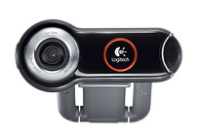
- 512 MB RAM or better
- 25 MB free hard drive space
2. Two Megapixel Web Camera (or better):
We recommend the Logitech QuickCam Pro 9000.
3. LEGO® MINDSTORMS® RCX Construction Kit with:
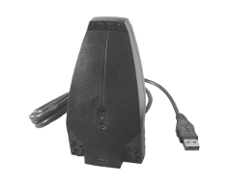
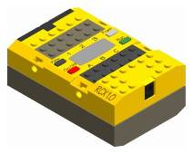
- LEGO Mindstorms RCX USB Tower
- LEGO Mindstorms RCX Brick
4. Other Software
- Java 6 Runtime Environment (http://download.java.net/jdk6)
- Webcam drivers
- LEGO Mindstorms RCX USB tower drivers (included with Tern)
5. Tangible Programming Blocks
See section on building Tern blocks below.

Installation Guide
- Download the latest Tern distribution (http://hci.cs.tufts.edu/tern) or use the enclosed CD.
- Run the Tern-Setup.exe installer.
- If this is your first time installing Tern, you may need the LEGO USB Tower drivers and the Java 6 runtime environment. Check the appropriate boxes in the installer.
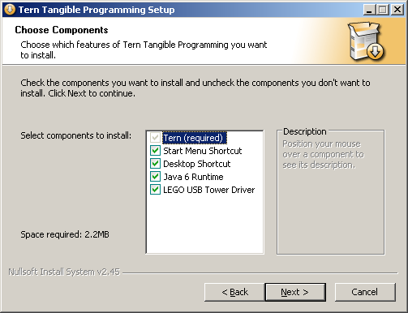
- Follow the steps in the installer wizard to complete the installation. If your system needs to install the Java 6 runtime environment, the wizard will attempt to connect to the Internet to download the necessary files.
- Finally, if you are using a Logitech QuickCam, download and install the appropriate drivers. The wizard will prompt you to download and install these drivers. Tern only needs the webcam drivers, not the optional software that comes with many cameras including the Logitech QuickCam.
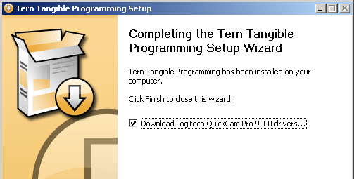

Getting Started
- Make sure your webcam is plugged in and working.
- Plug in the LEGO Mindstorms USB IR tower.
- Place the camera on a flat surface looking out parallel with the floor.
- Run Tern by clicking on the desktop or Start menu shortcut.

- If the camera icon on the lower right side of the screen has a red X, then Tern can’t connect to the camera. Try plugging the camera in again and restarting Tern.

- Create a program using the wooden blocks and place the program between two and three feet away from the webcam. Press the spacebar or the RUN button to compile. This will capture an image from the webcam.
- The tangible programming blocks should be placed at least 2 feet from the camera or the computer vision might fail to recognize all of the blocks.
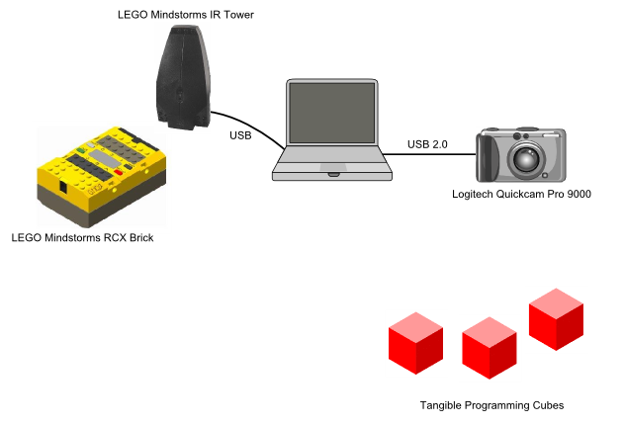

Programming Guide

Tern programs are created using chains of interlocking wooden blocks. Every Tern program starts with a BEGIN block and ends with an END block. When a program is compiled the robot will perform all of the actions between the BEGIN and the END. The robot will perform each action, one at a time, in order from left to right. This guide will explain what each different block tells the robot to do.
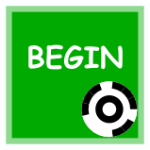

ACTION BLOCKS
Action blocks tell the robot to move or make a sound.

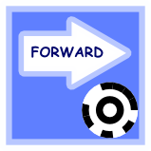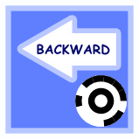 | FORWARD & REVERSE  These blocks tell the robot to move forward or backwards about one foot in a straight line. This is done by turning on motors A and C in the same direction for one second.
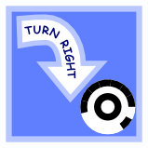 | LEFT & RIGHT  These blocks tell the robot to turn in place approximately 90 degrees to the left or right. This is done by turning on motors A and C in opposite directions for half a second.
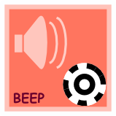   | SOUNDS  These blocks tell the robot to make different types of sounds—beep, sing, growl, and whistle.
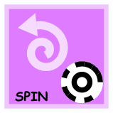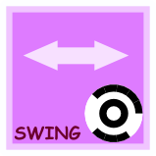 | DANCE MOVES  These blocks tell the robot to do one of its dance moves—shake, spin around, wiggle, or swing. These blocks use motors A and C on the RCX.
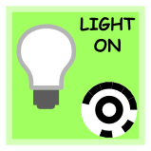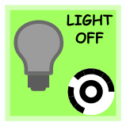 | LIGHT  These blocks turn on or off a light bulb attached to the RCX output B.
CONTROL BLOCKS
Control blocks alter the way a program itself behaves. In other words, they change the program’s flow-of-control. There are two types of control blocks in Tern: WAIT blocks and REPEAT blocks.
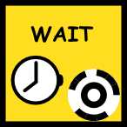 | WAIT  The WAIT block pauses a program. For example, the program below tells the robot to wait 1 second and then to drive forward.
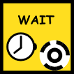

By adding a number block to this program, we can tell the robot to wait longer. For example, this program tells the robot to wait 3 seconds before driving forward.


Finally, a WAIT block can be used with a sensor block to tell the robot to wait for a sensor to be activated. For example, this program tells the robot to wait until the light sensor is activated. The sensor blocks are described in more detail below.
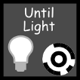

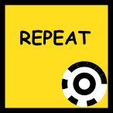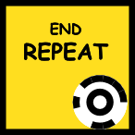 |  | REPEAT BLOCKS  Repeat blocks tell the robot to repeat a sequence of actions multiple times. This is called a loop. The simplest type of repeat loop is called an infinite loop. As the name suggests, it will repeat a sequence of actions over and over again forever—or at least until you turn off the robot. This program tells the robot to spin and beep in a loop. All of the blocks between the REPEAT block and the END REPEAT block are part of the loop.
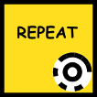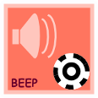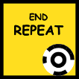

A counting loop tells the robot to repeat a sequence of actions a fixed number of times. For example, the program below drives the robot in a square, turning right and driving forward four times in a row. Notice that the number 4 block comes right after the REPEAT block. The number blocks tell the robot how many times to repeat the loop.

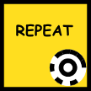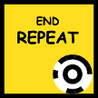

The last kind of loop is a sensor loop. This type of loop tells the robot to repeat a sequence of actions until a sensor is activated. The next section describes the different types of sensors that can be used with Tern. As an example, this program tells the robot to shake until the touch sensor is pressed.
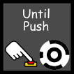

SENSOR BLOCKS
Sensor blocks can be used with both WAIT blocks and REPEAT blocks. With a REPEAT block, the sensor block controls how many times a loop repeats, and with a WAIT block, the sensor block controls how long a program remains paused. Tern supports two standard LEGO sensors, the touch sensor and the light sensor. The touch sensor should be plugged into output port 1 on the RCX brick, and the light sensor into port 3.

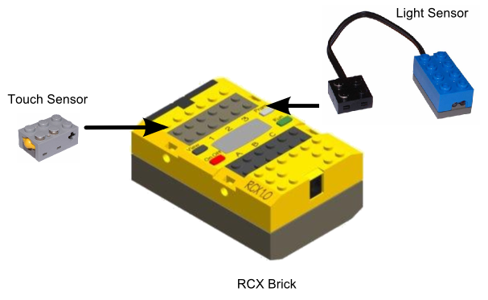
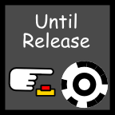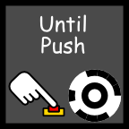 | TOUCH SENSORS  These blocks tell the robot to wait until the touch sensor is either pressed or released, depending on the block used.
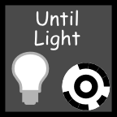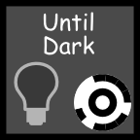 | LIGHT SENSORS  These blocks tell the robot to wait until the light sensor sees brightness or darkness, depending on the block used.
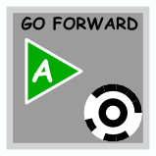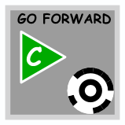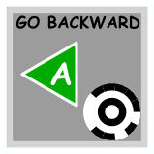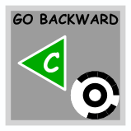 | MOTOR BLOCKS  These blocks tell the robot to turn on either motor A or motor C, depending on the block. Motors can be turned on in either the forward or the backward direction.
 | STOP BLOCKS  These blocks tell the robot to turn off either motor A or motor C.

How to build tangible programming blocks
The easiest way to build a set of tangible programming blocks is to purchase between 30 and 40 wooden cubes (1 ¾ inch) from an online supplier such as Barclay Woods (http://www.barclaywoods.com/craft_parts.htm). Use the checklist in the following section to determine how many cubes to buy. Then simply print out the templates in Appendix A. Cut out the labels and glue them onto the wooden cubes. At a minimum there should be one label on each cube. However, it is easier to program if you attach labels on four sides of the cubes, leaving two opposite sites blank. If you have more time and some woodworking tools, you can also build a set of interlocking wooden blocks using these instructions:
Materials:
- 1 3/4" wooden craft cubes (www.barclaywoods.com/craft_parts.htm)
- Yellow wood glue
- 1/2" hardwood dowel
- Rubber cement or 3M spray adhesive
- White card stock paper for printing labels
- Medium grade sandpaper
Tools:
- 10" drill press
- 1/2" drill bit
- Drill press vice
- Small hand saw (e.g. tenon saw or dovetail saw)
- C-clamp or vice
- Paper cutter
- Tern blocks are built out of 1 3/4" wooden craft cubes. These cube can be purchased from online vendors such as: http://www.barclaywoods.com/craft_parts.htm
- Each cube will need to have a 1/2" hole drilled through the cube. This is best done with a 10" drill press and a 1/2" drill bit. Each cube should be clamped down with a vice and the hole should be drilled with the grain (i.e. drill into one of the end grain sides of the cube). It's important that the holes be drilled exactly into the center of the cubes so that the blocks line up straight when connected together in a program.
- For the START and the END blocks holes should only be drilled half way through the cube.
- Next, test the hardwood dowel to make sure that it's the right size. Dowels vary greatly in thickness. So, you'll need to test the dowel make sure that it's the right thickness before cutting it into pegs. Do this by threading the dowel into the hole of one of the cubes and sliding the cube up and down along the length of the dowel. The cube should slide easily up and down the full length of the dowel. If not, use sand paper to reduce the thickness of the dowel until the cube slides easily. Better, bring a pre-drilled cube with you to the hardware store when you purchase the dowel. This way you can select a dowel that slides easily and save yourself a lot of sanding.
- Cut the dowel into 1 1/2" pegs. To do this clamp one of your cubes onto a work bench so that the hole of the cube runs parallel to the edge of the bench. Then use a pencil to mark the dowel at 1 1/2" intervals. These will show you where to cut. Next slide the dowel through the cube so that your first pencil mark sticks out about 1/2" inch. Holding the dowel firmly with one hand, use the hand saw to cut off a peg on your pencil mark. Repeat this process until you have as many pegs as you need.
- Use wood glue to glue the pegs into the cubes. Spread glue on the bottom 1/2" of the peg and twist it into the hole of the cube so as to distribute the glue evenly. The dowel should stick out 3/4" from the hole. You can use a penny (which has 3/4" diameter) to gauge the proper height.
- After the glue has dried sand the end of the pegs smooth.
- Print out labels on card stock using a color printer, and cut out each individual label with a paper cutter.
- Use rubber cement or 3M adhesive to glue the labels onto the four outside faces of the cubes.

Tangible Block Checklist
 | x 1 |  | x 1 | 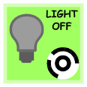 | x 2 | 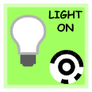 | x 2
 | x 2 |  | x 2 | 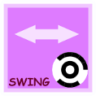 | x 2  optional |  | x 2  optional
 | x 3 | 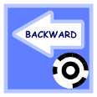 | x 2 |  | x 2 |  | x 2
 | x 2 |  | x 2 |  | x 2  optional |  | x 2  optional
 | x 2 |  | x 2 | 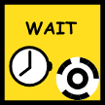 | x 2
 | x 2* | 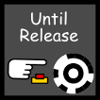 | x 2* |  | x 2* | 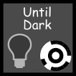 | x 2*
 | x 2* |  | x 2* |  | x 2* |  | x 2*
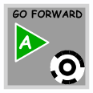 | x 2*  optional | 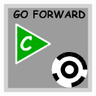 | x 2*  optional | 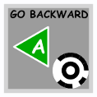 | x 2*  optional |  | x 2*  optional
 | x 2*  optional |  | x 2*  optional
* There are a total of two number blocks and two parameter blocks. Each number block has a different number value (2-5) on each face of the cube. Likewise, each parameter block has a different parameter value on each face of the cube. If you choose to include them, the Stop and Go blocks can be constructed the same way.

Appendix A: Tangible Block Faceplates






Appendix B: Optional Block Faceplates

