The Squad Institute Finance
- All amounts of “$5,000 to $20,000” need to be replaced with “up to $20,000”, and all references to “fortnightly instalments” to be replace with “weekly or fortnightly instalments”.
- If the website will display “0% interest”, a repayment breakdown example as outlined in the contract should also be included. Otherwise, all instances of “0% interest” should be replaced with “Interest Rate: Free”
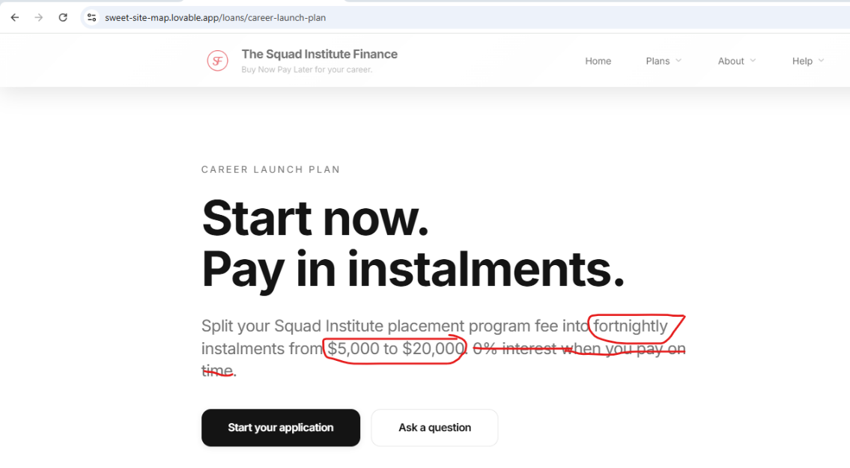
- The content does not make sense – all website content needs to be revised- Change this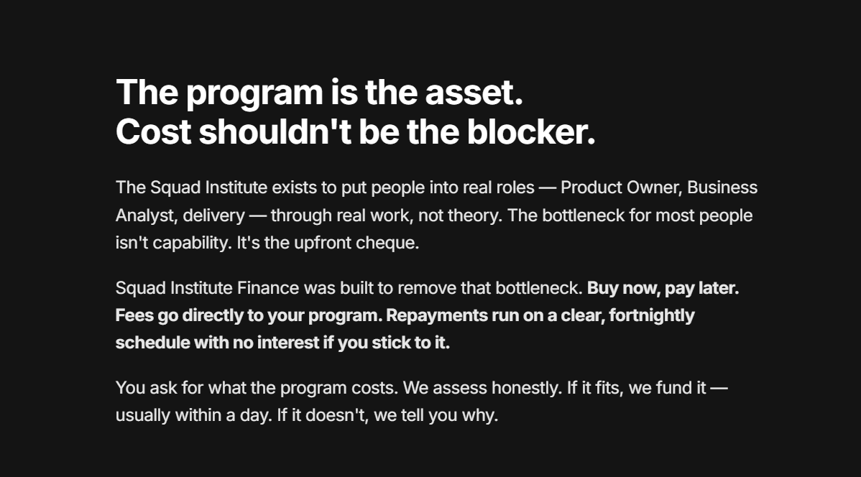
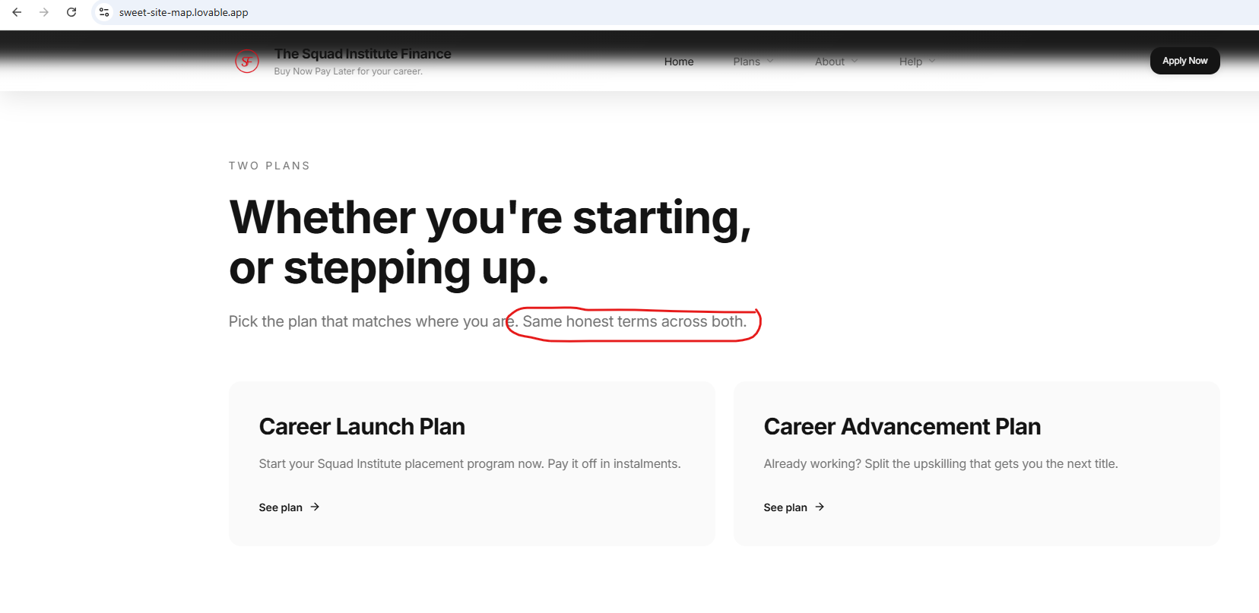

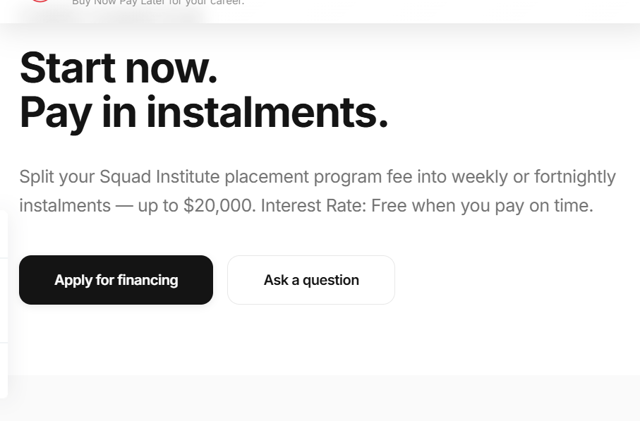
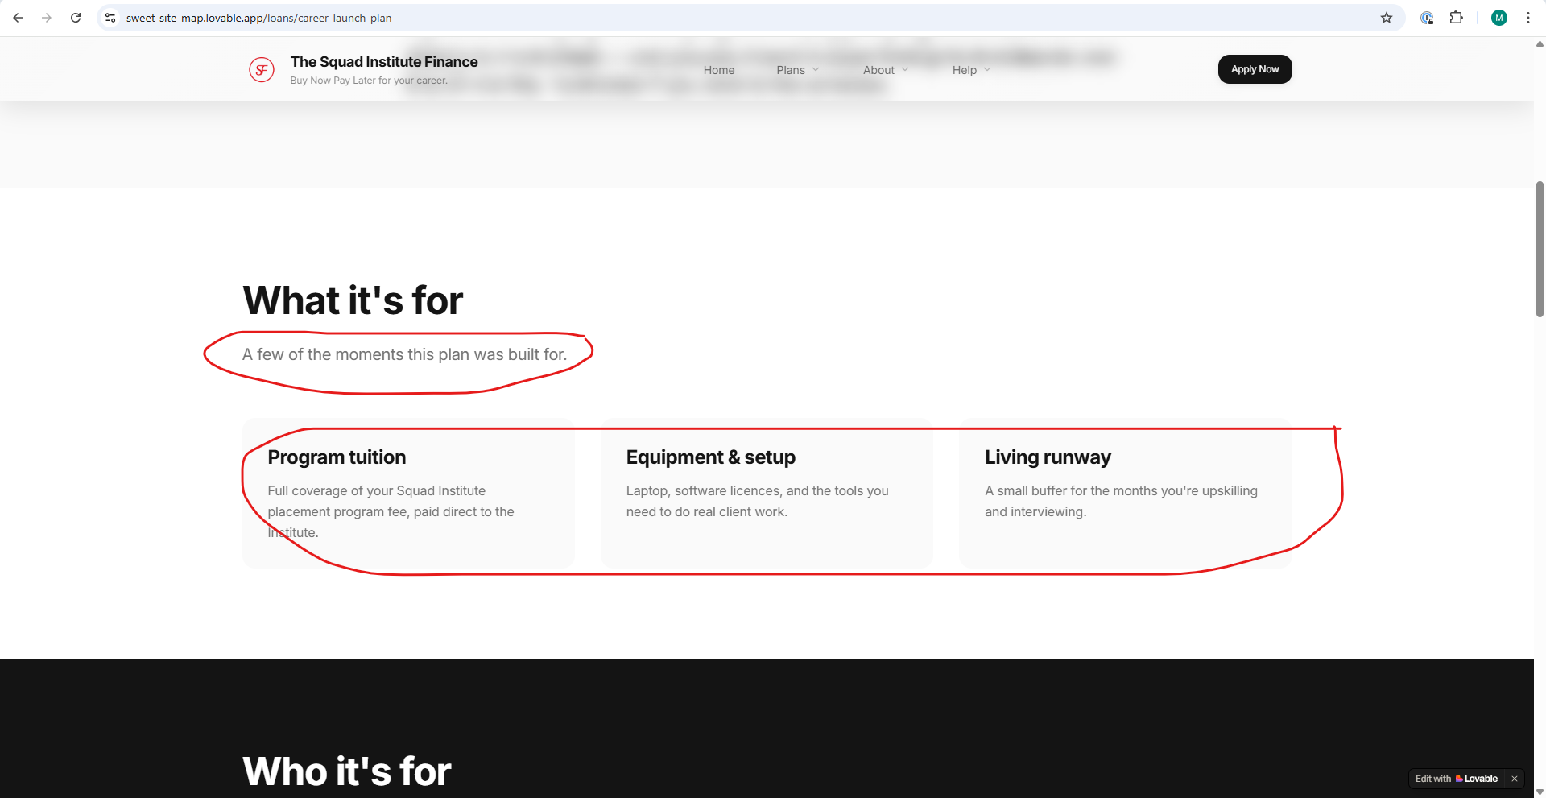
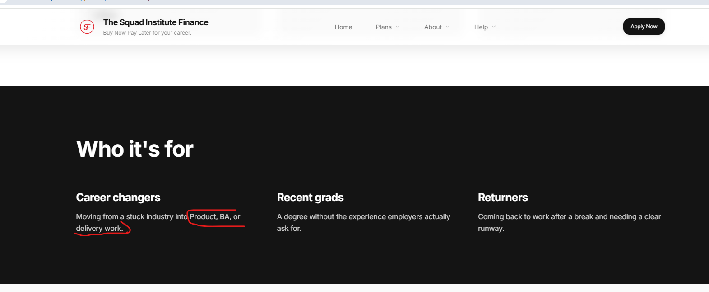

- Please fix the content- Refer to the contract , you may replace it with “ and you repay it in equal weekly or fortnightly instalments over 12 months. An admin fee will be charged if repayments extend beyond the 12-month period.)”

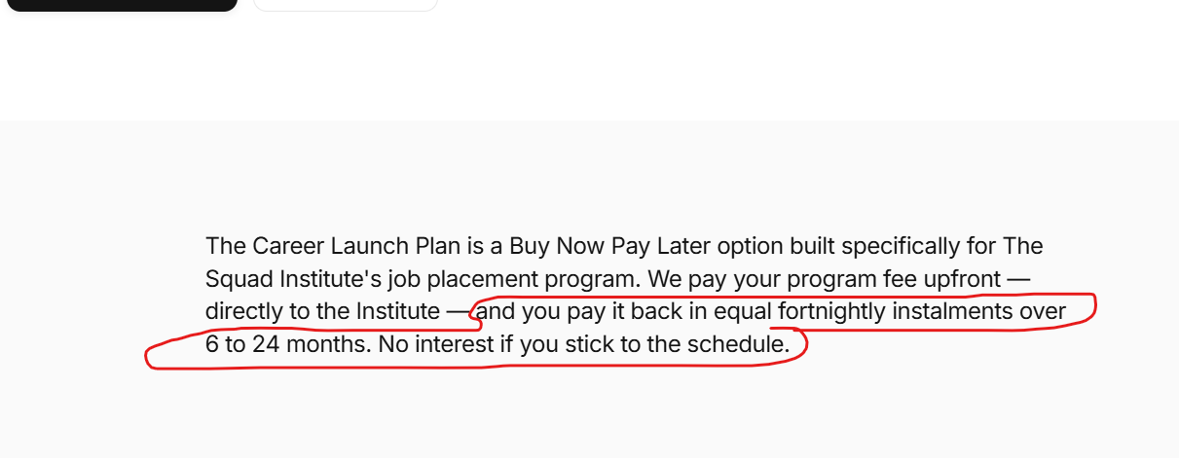

- include temporary visa holders with a valid visa

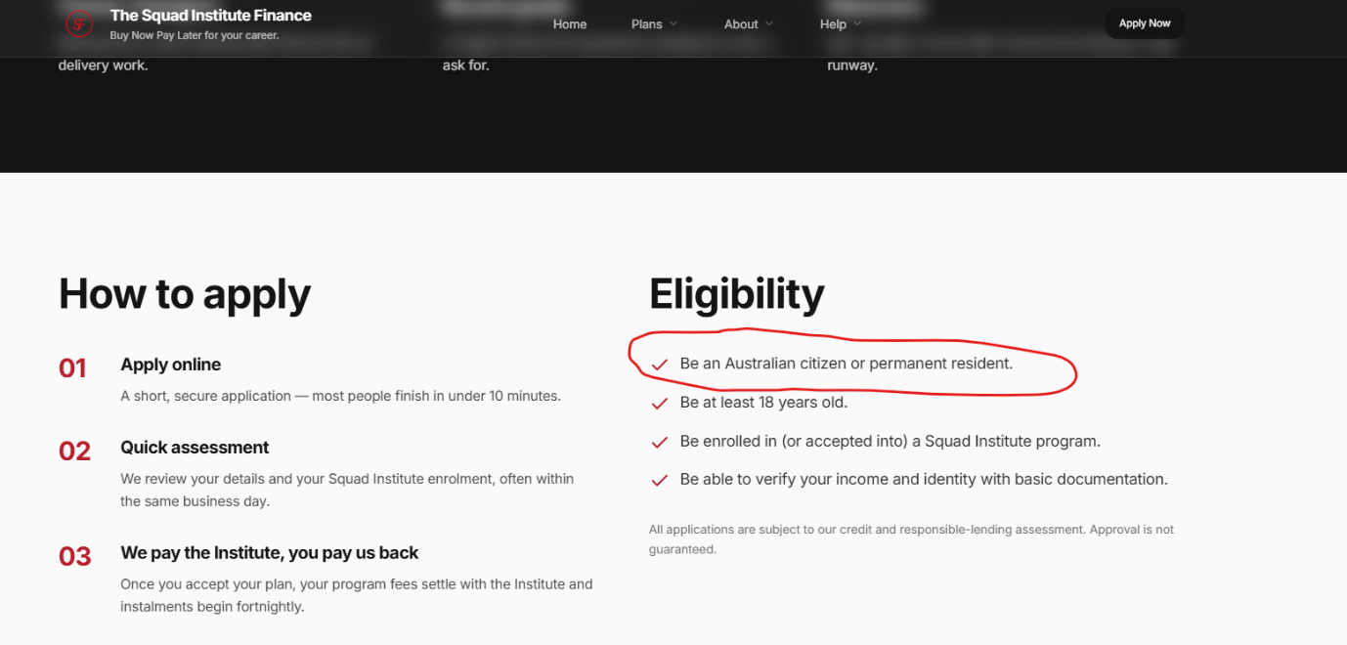

- Update the compliance documents as per the attached.
(Note: The Target Market Determination is to be reviewed and sent to Patrick for approval.)
- Update Contact details to sqif@newml.com.au, and phone (02) 7238 4196

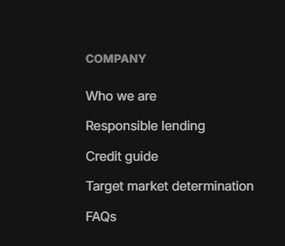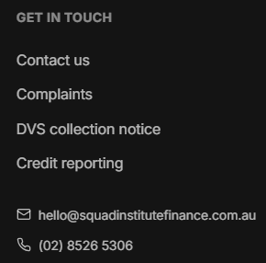

- The “Apply” and “Start Application” buttons are causing confusion regarding the customer journey and application process. The customer process needs to be clarified to ensure applicants understand the following:
• They do not need to be enrolled before applying.
• Applications can be pre-approved.
• Final loan approval is subject to graduation requirements being met.
• The website content must align with the official customer flowchart and repayment structure.

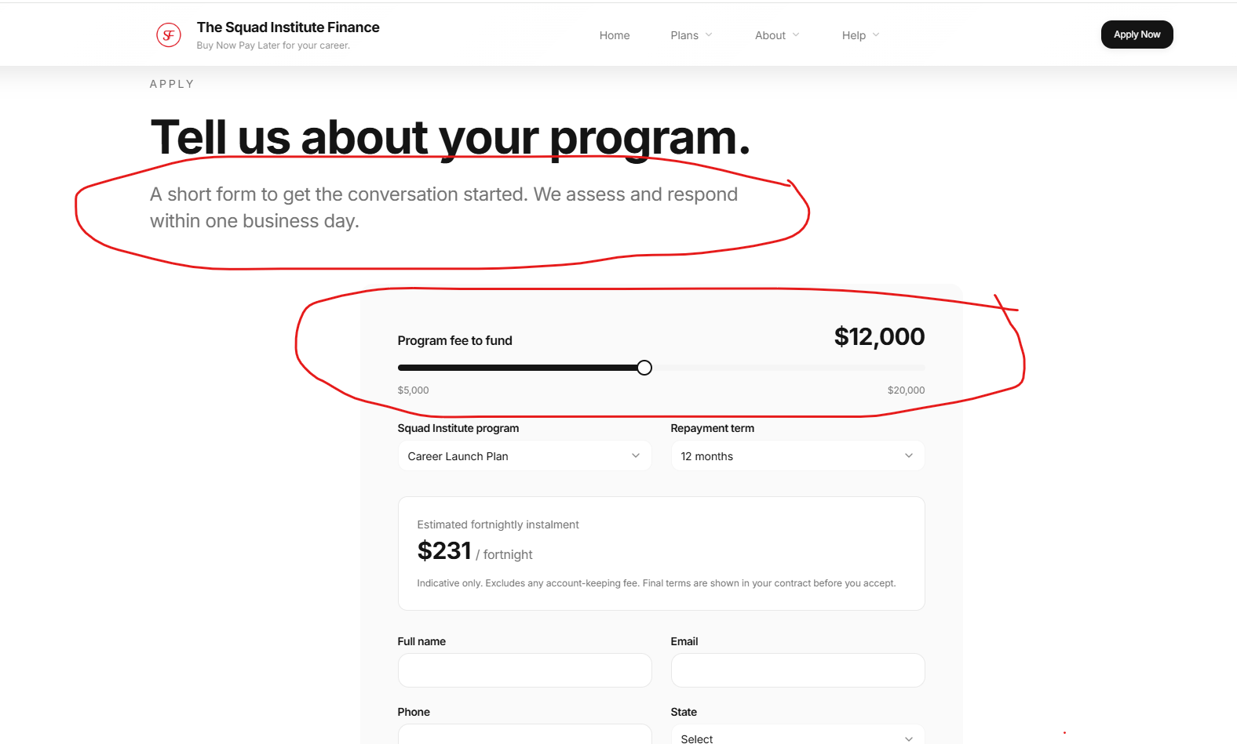

- We need to mention “New Money Lender Pty Ltd” in the footer – Please amend as follows:
New Money Lender Pty Ltd trading as The Squad Institute Finance ABN 19653 707 138, Australian Credit Licence 536096


