Introduction
This is my first markdown file. Here are some things I can do with my first markdown file:
- I can also convert this to docx
- I can also convert this to powerpoint
- I can also convert this to pdf

Math
This is the sample mean

Picture
Figure is Yaupon Holly ilex vomitoria. It is native to North America and it makes a highly caffeinated tea with lots of antioxidants. It also has less tannins than traditional tea so it is less bitter. Despite its pointed scientific name, I like it a whole lot.
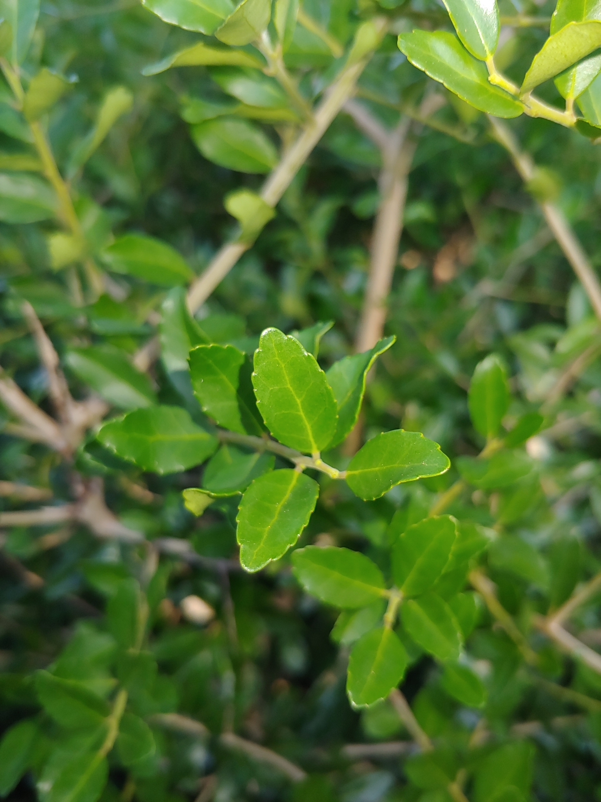
Ilex Vomitoria (a.k.a. Ilex-it-a-lot)

