Introduction
This is my first markdown file. Here are somethings I can do with my first markdown file:
- I can also convert this to docx
- I can also convert this to powerpoint
- I can also convert this to pdf

Math
This is the sample mean $\overset{‾}{y}=\sum_{i=1}^{n}{y_{i}}$

Picture
Figure is Yaupon Holy Ilex Vomitoria. It is native to North America and it makes a highly caffeinated tea with lots of antioxidants. IT also has less bitter tannins than traditional tea. Despite it’s pointed scientific name, I like it a whole lot.
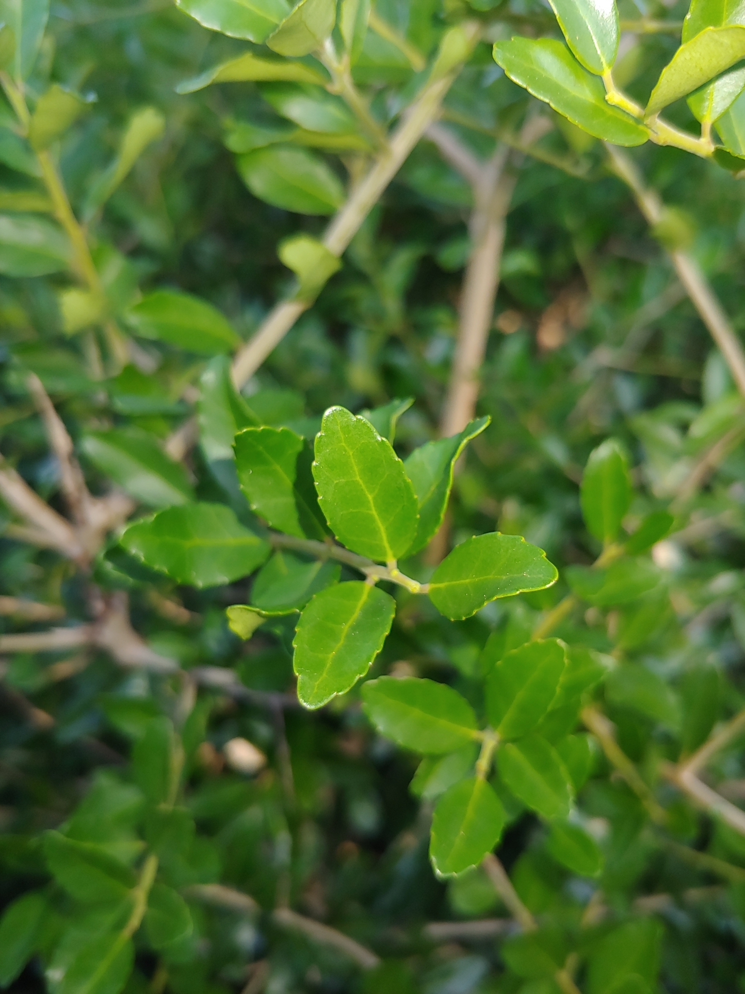
Ilex Vomitoria

