**SOURCE CODE**

import java.util.Scanner;  
  
public class Main {  
 String name;  
 int Id;  
 int voters;  
  
 Main (String n, int i) {  
 this.Id = i;  
 this.name = n;  
 }  
 Main ( int v) {  
 this.voters= v;  
 }  
 public void display1 () {  
 System.*out*.println("Id: " + this.Id);  
 System.*out*.println("Name: " + this.name);  
 }  
 public void display2 () {  
 System.*out*.println("votes: " + this.voters);  
 }  
 public static void main (String[] args) {  
 int votes = 0, totalVotes = 0;  
 Scanner scan = new Scanner(System.*in*);  
  
 Main cand1 = new Main("Juan Luna", 101 );  
 Main cand2 = new Main("Maria Clara", 102 );  
 Main cand3 = new Main("Jose Rizal", 103 );  
 Main cand4 = new Main("Andrei Boni", 104 );  
  
 cand1.display1();  
 System.*out*.println("Votes: " );  
 while (votes != -999){  
 votes = scan.nextInt();  
 if (votes == -999) {votes =0; break;}  
 totalVotes += votes;  
 }  
 Main cand1Votes = new Main(totalVotes);  
 totalVotes = 0;  
  
 cand2.display1();  
 System.*out*.println("Votes: " );  
 while (votes != -999){  
 votes = scan.nextInt();  
 if (votes == -999) {votes = 0; break;};  
 totalVotes += votes;  
 }  
 Main cand2Votes = new Main(totalVotes);  
 totalVotes = 0;  
  
 cand3.display1();  
 System.*out*.println("Votes: " );  
 while (votes != -999){  
 votes = scan.nextInt();  
 if (votes == -999) {votes = 0; break;}  
 totalVotes += votes;  
 }  
 Main cand3Votes = new Main(totalVotes);  
 totalVotes = 0;  
  
 cand4.display1();  
 System.*out*.println("Votes: " );  
 while (votes != -999){  
 votes = scan.nextInt();  
 if (votes == -999) { votes = 0; break;}  
 totalVotes += votes;  
 }  
 Main cand4Votes = new Main(totalVotes);  
 totalVotes = 0;  
  
 System.*out*.println("\n------TOTAL VOTES OF EACH CANDIDATE------");  
 cand1.display1();  
 cand1Votes.display2();  
 System.*out*.println("\n");  
 cand2.display1();  
 cand2Votes.display2();  
 System.*out*.println("\n");  
 cand3.display1();  
 cand3Votes.display2();  
 System.*out*.println("\n");  
 cand4.display1();  
 cand4Votes.display2();  
 }  
}

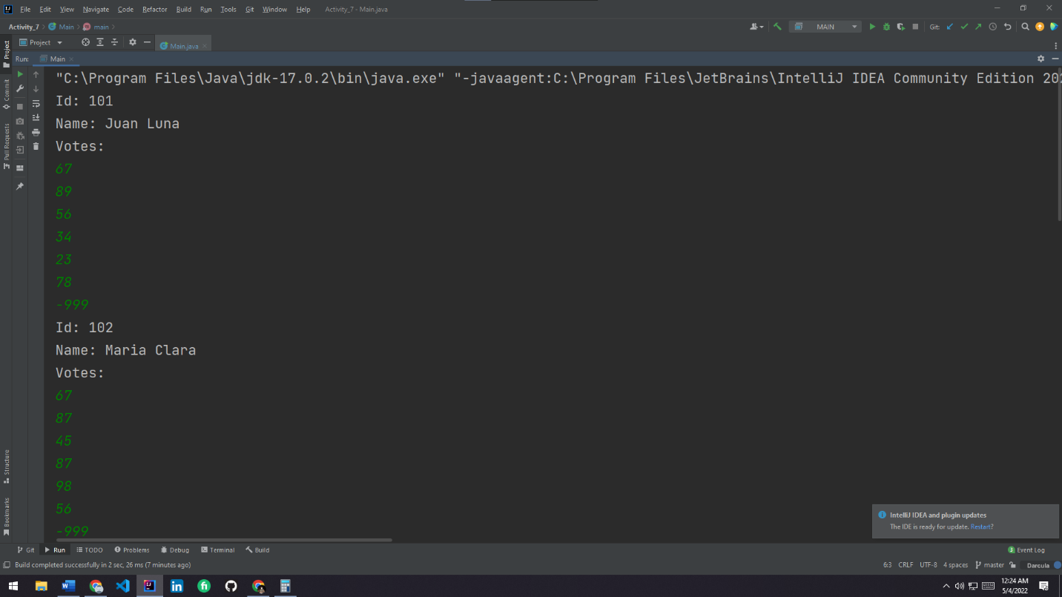**OUTPUT**

