
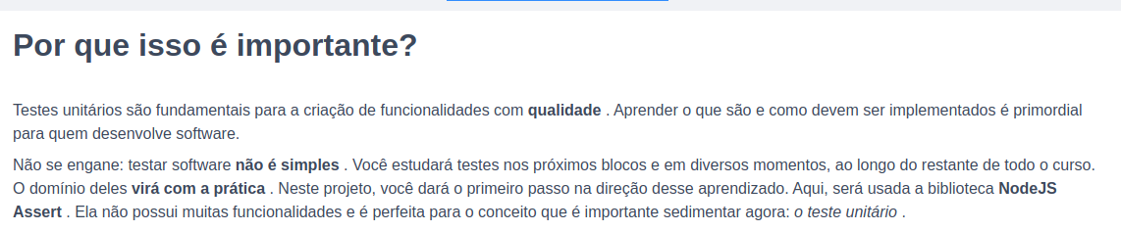
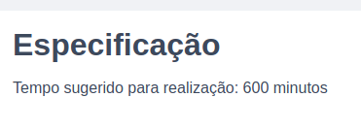

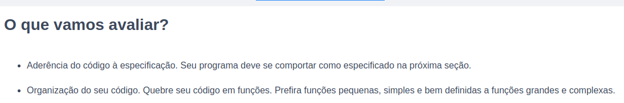

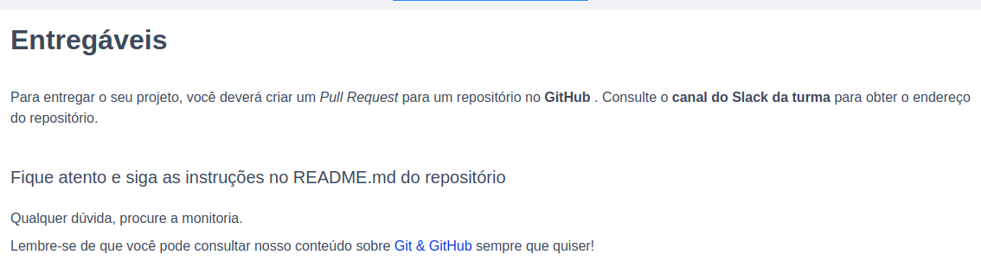

Git hub colega

tryber/sd-03-block8-project-js-unit-tests

