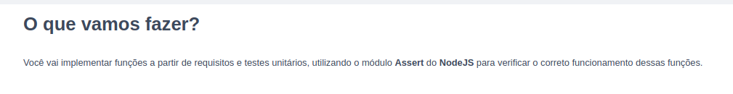
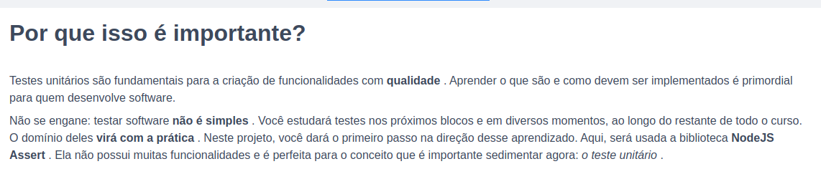
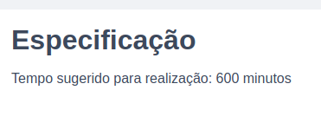

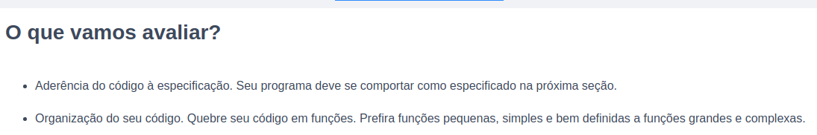

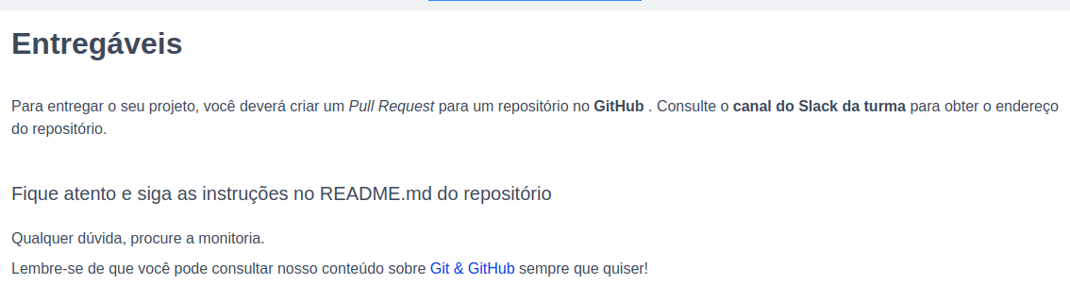

Git hub colega

tryber/sd-03-block8-project-js-unit-tests

https://github.com/tryber/sd-010-a-project-js-unit-tests

https://github.com/tryber/sd-010-a-project-js-unit-tests/pull/162

