

DESIGN AND DEVELOPMENT OF A PAYROLL SYSTEM WITH ROLE-BASED MONITORING AND APPOINTMENT SCHEDULING FOR GUIBONE ACCOUNTING SERVICES

RESEARCHER

Trisha Marie I. Lim
Michael I. Nacaya
Shahanie Y. Nanale
Victor E. Odarve
Rodge Kurt D. Rivera
Louie Cassandra Zapico

February 2026

DESIGN AND DEVELOPMENT OF A PAYROLL SYSTEM WITH ROLE-BASED MONITORING AND APPOINTMENT SCHEDULING FOR GUIBONE ACCOUNTING SERVICES
-------------------------------------------------------------------------------

A Capstone Project Presented to the
Faculty of the College of Information Technology

Cagayan de Oro College
Cagayan de Oro City

-------------------------------------------------------------------------------

In Partial Fulfillment
of the Requirements for the Degree
Bachelor of Science in Information Technologies

-------------------------------------------------------------------------------

Trisha Marie I. Lim
Michael I. Nacaya
Shahanie Y. Nanale
Victor E. Odarve
Rodge Kurt D. Rivera
Louie Cassandra Zapico

February 2026
APPROVAL SHEET

This Capstone Project, entitled “Design and Development of a Payroll System with Role-Based Monitoring and Appointment Scheduling for Guibone Accounting Services ” in partial fulfillment of the requirements for the degree Bachelor of Science in Information Technology, has been prepared and submitted by Lim, Trisha Marie, Nacaya, Micheal Igtos, Nanale, Shahanie, Odarve, Victor, Rivera, Rodge Kurt, and Zapico, Louie Cassandra, and has been examined, accepted, and recommended for Oral Examination.
Riel Jun E. Cainglet
Adviser

PANEL OF EXAMINERS
APPROVED in partial fulfillment of the requirements for the degree Bachelor of Science in Information Technology, by the Panel of Examiners with a grade of

MOSHEH CYRIL C. CAPAQUE. MMME
Chairperson

SHARON ROSE PATALINGHOG, MAED-ELT RYAN S. BASADRE
Panel Member Panel Member

ALEXIS V. LAROSA, PhD
Capstone/ Research Coordinator

Approved:
DARWIN M. GALUDO, MMME
Dean, College of Information Technology
CHAPTER 1
THE PROBLEM

Introduction
Guibone Accounting Services provides professional services such as audit, journal processing papers, tax filing, tax consultation, payroll management, appointment handling, and other related accounting processes. Among these, payroll processing is one of the most critical and time-sensitive functions, as it involves the accurate computation of employee salaries, statutory deductions, benefits, and the timely release of compensation. This process requires the management of multiple client records, employee data, scheduled payroll cycles, and assigned tasks that are handled by different staff members on a regular basis. As the number of clients and employees increases, payroll operations become more complex, making it more difficult to track the progress of payroll preparation, verify responsible personnel, and ensure that deadlines are consistently met. Studies indicate that increasing workflow complexity is a major operational challenge for accounting firms, particularly in managing payroll services alongside other accounting engagements (Aimeadow, 2025; The Accountant, 2025).
In the current payroll setup of the organization, employees receive a fixed salary rather than an hourly-based rate. Overtime work is compensated using an overtime premium rate of 1.50 (150%) of the employee’s computed regular rate. Employees are also entitled to paid vacation leave, during which their salary remains unchanged. In cases where an employee files a leave with a valid reason, no salary deduction is applied. Additionally, work rendered during holidays does not provide double pay, as the compensation is already incorporated into the fixed salary structure. These payroll policies require careful monitoring and accurate computation to ensure that employee compensation is processed consistently and in accordance with company rules. Managing these conditions manually increases the risk of errors in overtime computation, leave recording, and payroll preparation.
At present, payroll preparation, related tasks, and client appointments are monitored through manual tracking and informal communication. This approach makes it difficult to determine which staff member processed specific payroll records, the current status of payroll-related tasks, and whether scheduled client consultations regarding payroll concerns are properly handled. As a result, unprocessed payroll data, missed deadlines, duplicated work, and scheduling conflicts may occur. The absence of a structured and centralized system also limits transparency, weakens accountability, and reduces overall operational efficiency (LinkMyBooks, 2023). Professional reports emphasize that accounting firms require structured digital solutions to effectively manage payroll workflows, improve task visibility, and enhance coordination among staff (PwC Switzerland, 2024; Thomson Reuters, 2025). An organized system is essential not only for ensuring the accuracy and timeliness of payroll services but also for monitoring the progress of related tasks and managing client appointments associated with payroll concerns.
To address these challenges, this study proposes the development of a payroll monitoring system that provides a centralized platform for tracking payroll processes, task status, and scheduled client engagements. The system will allow authorized users to monitor the progress of payroll preparation, identify the personnel responsible for specific activities, and view the status of client records in real time. Rather than replacing existing accounting systems, the proposed system will serve as a support tool that enhances transparency, strengthens accountability, improves coordination, and ensures the efficient delivery of payroll services.

Statement of the Problem
Guibone Accounting Services currently manages payroll exclusively through the owner, ensuring the confidentiality and security of payroll data. While this setup prevents unauthorized access and maintains control over payroll processing, the firm does not have a structured role-based monitoring system for the preparatory tasks, supporting activities, and client appointments handled by the accounting staff. As the number of clients and transactions increases, it becomes more difficult to track task assignments, monitor work progress, and identify the personnel responsible for specific outputs. This lack of a centralized monitoring platform limits workflow visibility and makes coordination between the owner and staff less efficient.
At present, task updates, document preparation, and appointment scheduling are managed through manual recording and informal communication. Since accountants do not have a system where their responsibilities are defined and monitored based on their roles, there is no organized way to determine whether all required inputs for payroll and other accounting services have been completed and submitted on time. This situation leads to duplicated work, overlooked responsibilities, delays in the submission of required documents, and difficulty in monitoring overall task progress.
Furthermore, the absence of a role-based monitoring mechanism makes it difficult to identify which staff member performed specific activities and when these were completed. Without a centralized platform that provides real-time updates, the owner has limited visibility over the status of preparatory tasks, while the staff have no clear interface for viewing their assigned responsibilities and deadlines. This affects internal coordination, reduces accountability, and slows down the overall workflow of the organization.

Main Problem
Guibone Accounting Services experiences difficulty in task monitoring payroll preparatory activities, staff task assignments, and client engagements due to the absence of a centralized system that integrates payroll monitoring, appointment management, and scheduling. Although payroll computation is securely handled by the owner, there is no structured mechanism for tracking the status of payroll inputs, assigned responsibilities, and payroll timelines, as well as scheduled client consultations related to payroll concerns. This results in limited visibility, delayed preparation of required documents, possible scheduling conflicts, and reduced workflow coordination and accountability.
Specific Problem:
The first problem is the absence of a role-based platform for assigning and monitoring staff tasks. At present, accountants perform various preparatory activities and supporting processes; however, their responsibilities are not formally defined and monitored within a centralized system. Because of this, it is difficult to determine which staff member is assigned to a particular task and whether the task has already been completed, is still in progress, or has not yet been started. This lack of structured task ownership weakens accountability and makes performance evaluation challenging.
The second problem is the lack of real-time visibility of task progress for the owner. Although payroll processing is securely handled by the owner, there is no system that provides a consolidated and updated view of the status of documents and preparatory activities submitted by the staff. As a result, the owner must rely on manual follow-ups to verify whether all required inputs have been completed and submitted on time, which consumes valuable time and may cause delays in the overall workflow.
Another concern is the manual and unstructured monitoring of client appointments and engagements. Appointment scheduling and tracking are currently managed through informal communication and manual recording, which increases the possibility of scheduling conflicts, missed appointments, and poor coordination between staff and management. Without a centralized platform, it becomes difficult to ensure that all scheduled engagements are properly monitored and completed as planned.
Another specific problem in the payroll process is the manual consolidation and verification of payroll inputs, which makes salary computation dependent on scattered documents and increases the risk of incomplete or delayed data. There is no centralized tracking of each client’s payroll status, making it difficult to determine which payrolls are ready, pending, or completed. Additionally, payroll reports are prepared manually, consuming time and increasing the possibility of inconsistencies. The absence of automated deadline monitoring and secure digital storage also creates challenges in meeting payroll schedules and retrieving historical records, affecting the overall efficiency and reliability of payroll service delivery.
In addition, there is difficulty in identifying the staff responsible for specific outputs due to the absence of an activity log or audit trail. When tasks are completed, there is no reliable and automated record that shows who performed the activity and when it was accomplished. This limits transparency, weakens internal control, and makes it challenging to review completed work or address errors and client concerns efficiently.
Lastly, the current workflow is inefficient because task updates and progress monitoring are scattered across different files and communication channels. Staff members need to conduct manual follow-ups to determine the status of their assigned responsibilities, which slows down operations and increases the risk of duplicated work, overlooked tasks, and delayed submission of required documents. This lack of coordination affects the overall efficiency and organization of the firm’s service delivery.

Conceptual Framework (IPO Model)
The study is anchored on the Input–Process–Output (IPO) Model. 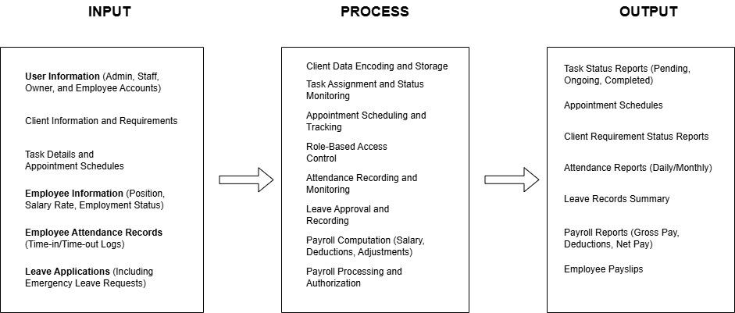
Figure 1.1 The IPO framework of the System

The Input–Process–Output (IPO) framework illustrates how the proposed payroll system with role-based monitoring features will operate at Guibone Accounting Services. It presents the flow of data from the required inputs, through system processing, up to the generated outputs. The payroll system serves as the core component of the proposed solution, while the task and appointment monitoring functions support the preparation, coordination, and timely completion of payroll and other accounting services.

1. Input
The inputs refer to the essential data and information needed for the payroll system to function effectively.
The system will store user information, including the details of the owner, administrators, accountants, secretaries, and other staff, which will be used for role assignment and access control. Since payroll processing is exclusive to the owner, access to payroll data and payroll operations will be restricted accordingly, while staff members will only be able to access the monitoring features based on their designated roles.
The system will also manage client and employee payroll information, such as employee profiles, salary rates, deductions, benefits, payroll schedules, and other relevant payroll details required for accurate payroll preparation and processing. In addition, client engagement details and supporting documents will be recorded to serve as references for payroll preparation and other accounting services.
Furthermore, task details and appointment schedules will be encoded in the system, including assigned personnel, deadlines, required documents, and status updates. Clearly defined user roles and responsibilities will also serve as inputs to establish a structured workflow, regulate access privileges, and promote accountability within the organization.

2. Process
The process refers to the system operations that transform the inputs into meaningful and organized information.
The system will facilitate payroll data management and payroll processing, where the owner can encode, update, compute, and generate payroll records accurately and securely. Access to these payroll functions will be restricted to the owner to maintain confidentiality and control.
To support payroll preparation and other services, the system will implement role-based access control, ensuring that users can only view and update information according to their assigned roles. The system will also enable task assignment and status monitoring, where preparatory activities such as document collection, data verification, and other supporting processes can be assigned to appropriate staff and tracked as pending, ongoing, or completed.
For coordination with clients, appointment scheduling and tracking will allow authorized users to set, update, and monitor meetings and deadlines related to payroll and other accounting services. The system will also provide client requirement progress monitoring, which will identify completed and pending requirements and the staff responsible for each activity.
In addition, deadline monitoring and automated notifications will help ensure that payroll preparation, task completion, and scheduled engagements are accomplished on time. Lastly, user activity logging and report generation will record system actions such as task updates, document submissions, and payroll processing, promoting transparency, accountability, and efficient supervision.
3. Output
The outputs are the results produced after the system processes the inputs.
The system will generate payroll reports and payroll summaries, which will provide accurate and organized records of employee compensation, deductions, and payroll transactions for the owner’s use. It will also produce a payroll status overview, allowing the owner to verify whether all required inputs for payroll processing have been completed.
For the monitoring feature, the system will provide a task monitoring dashboard that displays the status of assigned activities as pending, ongoing, or completed. An appointment calendar and schedule tracking interface will present a visual overview of client engagements, including upcoming, completed, and missed appointments.
In addition, client requirement status reports will show which documents and inputs have already been submitted and which are still lacking. The system will also generate user activity and accountability reports, identifying the personnel responsible for specific preparatory tasks and scheduled engagements.
Through a centralized payroll and monitoring interface, the owner will be able to oversee payroll processing and the progress of supporting activities, while staff members can view and update their assigned responsibilities based on their roles. Overall, the system will result in improved accuracy in payroll processing, enhanced transparency, better coordination, and more efficient workflow. It will also support informed decision-making by providing real-time insights into payroll preparation, task progress, appointments, and client data.
Objectives of the Study
General Objective
To design and develop a payroll system with role-based monitoring features for Guibone Accounting Services that will secure payroll processing for the owner while providing a centralized platform for tracking staff tasks and client appointments, thereby improving workflow coordination, accountability, transparency, and overall operational efficiency.
Specific Objectives
To assess the existing workflow of Guibone Accounting Services in terms of payroll preparation support activities, task monitoring, client appointment handling, and user accountability as a basis for identifying system requirements. This objective will involve gathering detailed information about current processes, determining operational gaps, and analyzing how tasks and client engagements are performed and monitored to serve as a foundation for the proposed system.
To design a payroll system architecture that includes secure and exclusive payroll access for the owner, role-based access for staff, structured task assignment and monitoring, and organized appointment management. This objective will focus on planning the overall system structure, database design, user interface, and access control mechanisms to ensure that payroll data remains confidential while staff members are able to perform and monitor their assigned responsibilities efficiently.
To develop a centralized system that will manage payroll records and generate payroll reports for the owner, allow staff to view and update assigned tasks based on their roles, provide real-time monitoring of task progress and client requirements, and maintain an updated appointment scheduling and tracking module. This objective will ensure that all necessary features are integrated into a single platform to improve coordination, accuracy, and workflow efficiency.
To implement user activity logging and reporting features that will identify the personnel responsible for specific tasks and scheduled engagements, thereby strengthening transparency and internal control. This objective will provide management with a clear and reliable basis for monitoring staff performance, verifying completed activities, and ensuring accountability within the organization.
To test and evaluate the functionality, usability, and performance of the system in terms of task visibility, workflow coordination, reduction of duplicated and overlooked activities, and improvement of monitoring and accountability. This objective will determine whether the developed system meets the operational needs of the firm and effectively supports the delivery of payroll and other accounting services.
To deploy the system to ensure its continuous reliability, accuracy, and alignment with the operational needs of Guibone Accounting Services. This objective will include the actual implementation of the system in the organization and the provision of necessary updates and improvements to sustain its efficiency over time.
Significance of Study
To the Organization
The proposed system provides a centralized platform to monitor tasks and client data, improving accountability, transparency, and workflow efficiency. It helps management track which tasks are pending or completed and identify who performed specific actions, reducing confusion and delays.

To Accountants and Staff
The system enables users to clearly see their responsibilities and task progress, ensuring that deadlines are met. Role-based access helps staff focus only on tasks relevant to their role, while monitoring features improve coordination and accountability.
To Clients
Clients benefit indirectly through more organized and efficient operations, ensuring that their tasks and data are processed accurately and on time. This leads to faster, more reliable service.
To Future Researchers
This study provides a model for designing role-based monitoring systems in accounting services, which can serve as a reference for future projects that aim to improve transparency, workflow monitoring, and user accountability.
To Government Agencies and Auditors
The monitoring system creates organized records of task completion and user activities, supporting internal control and compliance with auditing and regulatory requirements.
Scope and Limitations
Scope
This study focuses on the design and development of a payroll system with role-based monitoring features for Guibone Accounting Services. The system ensures that payroll processing is securely handled by the owner while providing staff with controlled access to monitor tasks and manage client appointments according to their assigned roles. Role-based access control is implemented, with privileges assigned to designated roles including owner, administrator, accountant, client, and secretary.
The system allows the owner to generate payroll reports and manage employee compensation securely. Meanwhile, staff members can perform supporting activities such as preparing required documents, updating task progress, and monitoring client requirements. Tasks can be tracked as pending, ongoing, or completed, and client appointments can be requested, scheduled, updated, and monitored by authorized personnel. A dashboard interface provides a centralized overview of task status, staff activity, client engagement progress, and upcoming appointments, thereby improving coordination, transparency, and accountability within the organization.
Limitation
The system is strictly designed as a payroll platform with monitoring features and does not perform other core accounting functions such as auditing, journal processing, tax filing, or tax consultation. Its primary purpose is to enhance workflow visibility and task accountability, rather than replace existing accounting software.
The study is limited to the internal operations of Guibone Accounting Services, and the design reflects the workflows and staffing structure of this particular firm. Therefore, its functionality and interface may not directly translate to larger organizations or firms with different operational setups.
Finally, to ensure data privacy and accuracy during system development and testing, all client information used in demonstrations or testing scenarios is either simulated or anonymized, preventing exposure of sensitive payroll and client data.

Definition of Terms:
Accounting Services – Processes involved in handling client financial records, tasks, and related operations.
Assets – Resources owned by a business that have economic value, such as cash, equipment, or inventory.
Attendance – A record of employee work hours, absences, and time entries used as a basis for payroll computation and monitoring of employee work schedules.
Audit – A systematic review or examination of financial records to ensure accuracy and compliance.
Bookkeeping – The routine recording of financial transactions in the books or system.
Client Data Monitoring – Observing and tracking which client records have been processed, by whom, and their current status.
Client Ledger – A record of transactions related to a specific client, including invoices, payments, and balances.
Journal – The initial record where transactions are first entered before posting to the ledger.
Monitoring System – A platform that tracks task progress, user activities, deadlines, and client data processing.
Payroll – The process of computing and managing employee compensation, including salaries, statutory deductions, benefits, and the generation of payroll reports within a specific pay period.
Remittance – Transfer of money from one party to another related to payroll or client transactions.
Role-Based Access – A security mechanism that assigns system permissions based on user roles.
Task Tracking – The process of recording and monitoring the status of tasks within the organization.
Workflow Efficiency – The effectiveness of task completion, task monitoring, and data organization within the organization.

CHAPTER 2
REVIEW OF RELATED LITERATURE AND STUDIES

This chapter reviews literature and studies that provide the theoretical and empirical foundation for a role-based monitoring system for accounting services. Research indicates that Accounting Information Systems (AIS), payroll automation, and workflow monitoring enhance efficiency, accuracy, and accountability in multi-user environments (Drew, 2022; Salsabila et al., 2025; Hussaini et al., 2025). Centralized task tracking and structured appointment scheduling reduce duplicated work, prevent delays, and improve client satisfaction (Martin-Navarro et al., 2023; Brown & Davis, 2022; Chatterjee, 2025). Role-Based Access Control (RBAC) and continuous monitoring mechanisms strengthen data integrity, traceability, and user accountability (Cai & Liu, 2006; Mann, 2025; Almasria, 2021). These studies collectively support the need for an integrated system combining task monitoring, payroll tracking, appointment scheduling, and role-based access to improve transparency and operational efficiency in accounting service firms.
Local Literature
Local literature highlights the increasing adoption of Accounting Information Systems and digital payroll technologies in improving organizational performance, operational efficiency, and internal control within Philippine institutions.
Canave et al. (2025) evaluated the efficiency of the payroll process system in the City Government of Naga, focusing on timeliness, accuracy, and employee satisfaction. The findings revealed that automated payroll systems significantly improved salary computation speed and reduced discrepancies in compensation records. However, the study also identified technical limitations and maintenance concerns, emphasizing the need for continuous system monitoring and updates to sustain operational efficiency.
Similarly, Nur’aida and Sasanti (2024) examined the impact of a Payroll Accounting Information System on internal control processes within a government manpower office. Their findings indicated that the implementation of payroll AIS strengthened verification procedures and minimized errors in salary processing. Nonetheless, they emphasized that continuous system refinement is necessary to maintain effective internal controls.
Hermawan et al. (2024) further confirmed that payroll AIS implementation significantly improves the effectiveness of internal controls over employee salary payments. Their study demonstrated that structured digital payroll systems enhance transparency and reduce irregularities in compensation management.
Castro et al. (2024) investigated the awareness and utilization of accounting information systems among accounting graduates. The study concluded that AIS tools are essential for managing financial activities, improving reporting accuracy, and preparing future accountants for technology-driven work environments. This reinforces the importance of digital systems in contemporary accounting practice.
Mapalo (2025) examined AIS utilization among small and medium-sized enterprises in Biñan City and found a positive relationship between effective AIS adoption and operational productivity. The findings demonstrated that digital accounting systems reduce operational costs, enhance decision-making capabilities, and streamline accounting procedures.
Flores et al. (2024) explored AIS usage in agri-related cooperatives in Davao del Norte and reported that while AIS supports data processing and financial management, environmental uncertainties may limit system effectiveness. The study recommended the incorporation of adaptive monitoring mechanisms to enhance system resilience.
Collectively, local literature underscores the benefits of digital accounting and payroll systems in improving efficiency and internal control. However, it also highlights the necessity of integrating structured monitoring and accountability features to address operational challenges.
Foreign Literature
Foreign literature provides comprehensive perspectives on payroll automation, workflow monitoring, appointment scheduling systems, and role-based access control mechanisms, which are relevant to improving organizational efficiency and accountability. These studies offer insights into global best practices and technology-driven approaches that can be adapted to professional service firms, including accounting organizations.
Salsabila et al. (2025) conducted a comprehensive review of payroll accounting information systems and concluded that digital payroll systems enhance accuracy, regulatory compliance, and overall organizational control. Their study highlighted that automation reduces manual errors, improves reporting consistency, and supports decision-making processes. However, the authors also noted implementation challenges, such as user resistance, technical limitations, and insufficient training, which may hinder system adoption and effectiveness. They recommended the inclusion of structured monitoring and feedback mechanisms to ensure the sustainability of payroll systems.
Hussaini et al. (2025) examined automated employee payroll systems and emphasized that these systems not only reduce human error but also improve compliance with labor regulations and streamline salary disbursement processes. The study found that automation improves operational reliability and enables managers to allocate resources more efficiently. These findings support the integration of automation features in accounting systems, particularly for handling high-volume payroll tasks with accuracy and consistency.
Cai and Liu (2006) provided foundational research on Role-Based Access Control (RBAC), arguing that grouping permissions into defined roles strengthens system security, accountability, and traceability. Their research showed that RBAC reduces unauthorized access and ensures that users can only perform actions aligned with their responsibilities. This mechanism is particularly critical in multi-user systems where sensitive financial data must be protected while maintaining operational transparency.
Martin-Navarro et al. (2023) conducted a systematic review of Business Process Management Systems (BPMS) and emphasized the role of workflow automation and task monitoring in improving organizational coordination. The study revealed that centralized platforms for tracking task status help prevent duplicated work, minimize delays, and support performance evaluation. The authors suggested that integrated monitoring dashboards enhance managerial oversight and ensure that all assigned tasks are completed efficiently.
Chatterjee (2025) examined structured appointment scheduling systems in service-based organizations and concluded that systematic scheduling significantly enhances operational efficiency. The study found that documenting staff assignments and engagement schedules reduces scheduling conflicts, increases client satisfaction, and provides clear accountability for all personnel involved. Florio (2024) further emphasized the importance of monitoring mechanisms for audit quality, arguing that oversight systems and activity tracking prevent inconsistencies and improve the reliability of financial reporting.
Mann (2025) highlighted that continuous monitoring and access control mechanisms serve as primary safeguards against breaches of data integrity in multi-user environments. The research demonstrated that documenting user actions through logs and audit trails ensures traceability and supports organizational accountability. Collectively, foreign literature strongly supports integrating workflow monitoring, structured scheduling, and role-based security frameworks to enhance operational transparency and staff accountability in organizations.
Local Studies
Local empirical studies demonstrate the practical application and benefits of AIS and monitoring systems within Philippine organizational settings. These studies provide evidence of how automation, structured monitoring, and workflow oversight improve efficiency, internal control, and decision-making.
Canave et al. (2025) reaffirmed that automated payroll systems improve efficiency and accuracy in government institutions, particularly in salary computation and employee satisfaction. However, the study emphasized that consistent monitoring, system maintenance, and timely updates are necessary to sustain optimal performance and prevent technical failures. Drew (2022) examined accounting automation and found that minimizing human intervention in routine tasks increases processing speed, reduces errors, and allows staff to focus on analytical and strategic responsibilities rather than repetitive operations.
Flores et al. (2024) highlighted the role of AIS in improving operational data management in cooperatives. While these systems support process standardization and better financial tracking, the study found that external factors such as environmental uncertainty can limit system effectiveness, necessitating stronger monitoring mechanisms. Aguinaldo et al. (2023) investigated the monitoring of outstanding audit findings in the Development Bank of the Philippines and concluded that systematic tracking mechanisms enhance resolution rates, improve oversight, and reinforce internal control processes.
Further studies conducted in academic institutions, including a State University in Pangasinan, revealed challenges in manual accounting systems, such as time-consuming data entry, high error rates, lack of real-time reporting, and limited analytical capacity. These findings highlight the importance of implementing structured, monitored digital systems to support decision-making, reduce operational errors, and promote transparency in organizational financial processes. Collectively, local studies provide a clear empirical foundation for integrating monitoring, automation, and accountability mechanisms in Philippine accounting service settings.
Foreign Studies
Foreign empirical studies provide additional evidence supporting the integration of monitoring, accountability, and workflow management mechanisms within AIS and other digital systems. These studies emphasize the importance of combining role-based access, real-time monitoring, and scheduling features to enhance efficiency and transparency across organizational contexts.
Almasria (2021) found that AIS improves audit quality by enhancing transaction traceability and providing structured documentation of user activities through audit trails. The study emphasized that activity logging increases transparency, strengthens internal control, and facilitates post-audit verification, ensuring that financial processes are properly documented and monitored. García et al. (2025) concluded that AIS with defined access levels and monitoring dashboards significantly improves data reliability and staff accountability. By combining role-based permissions with real-time monitoring, organizations can ensure that all tasks are traceable and verifiable, reducing the risk of unauthorized activity.
Brown and Davis (2022) examined appointment scheduling systems in professional service firms and found that centralized scheduling platforms improve coordination, reduce conflicts, and enhance operational efficiency. Structured scheduling allows managers to track assignments, optimize resource allocation, and ensure staff accountability. Xu et al. (2025) proposed an online monitoring and traceability optimization system, finding that real-time task tracking reduces delays, improves accuracy, and strengthens responsibility identification. Although conducted in a technical context, these findings underscore the importance of monitoring and traceability mechanisms in service-based organizations.
Collectively, foreign studies provide robust empirical support for integrating automation, workflow monitoring, appointment scheduling, and role-based access into organizational systems. These mechanisms not only improve operational efficiency but also strengthen transparency, internal control, and accountability, offering a strong evidence base for the proposed role-based monitoring system for accounting service firms.

Synthesis of Reviewed Literature and Studies
From both local and foreign literature and studies, the following themes surface:
- Digital Accounting Improves Efficiency: Local research indicates that Accounting Information Systems (AIS) enhance operational productivity, improve reporting accuracy, and support timely decision-making (Canave et al., 2025; Mapalo, 2025; Flores et al., 2024).
- Gaps in Monitoring Features: While AIS adoption improves basic accounting functions, most local studies report the absence of advanced monitoring tools, such as real-time task tracking, audit logs, and structured oversight (Drew, 2022; Aguinaldo et al., 2023).
- Role-Based Access Is Limited: Few studies examine how systems control access and visibility based on user roles, a key requirement for ensuring accountability in multi-user environments (Cai & Liu, 2006; Mann, 2025).
- Global Trends Support Technology Use: International literature confirms that digital systems facilitate better data management, workflow transparency, and operational coordination, highlighting the value of monitoring dashboards and real-time reporting (Hussaini et al., 2025; Salsabila et al., 2025; Martin-Navarro et al., 2023).
- Need for Accountability Mechanisms: Both local and global findings emphasize that while automation reduces errors and accelerates processes, accountability tools—such as user activity logs and task tracking—are necessary to maintain data integrity and efficient workflows (Almasria, 2021; García et al., 2025).
These synthesized themes support the development of a role-based monitoring system that integrates task tracking, user accountability, and operational transparency to enhance efficiency and control in accounting service processes.
Research Gap
Although local research addresses AIS awareness and basic adoption benefits, several gaps remain:
- Lack of Philippine Studies on Monitoring Tools: There is limited research on accounting systems that specifically address role‑based monitoring and task visibility in organizations.
- Insufficient Focus on Accountability Features: Most studies examine system adoption and performance outcomes, but not how systems track user actions or manage permissions based on roles.
- Absence of Usability Evaluations for Monitoring Interfaces: There is a lack of studies evaluating how monitoring interfaces affect user experience, accountability, and workflow transparency.
- Minimal Studies on Role-Based Task Monitoring: There is a lack of research on the effectiveness of role-based monitoring systems in improving accountability and transparency in small to medium accounting firms.

CHAPTER 3
METHODOLOGY

This chapter presents the methodology used in the design and development of a Payroll System with Role-Based Monitoring Features for Guibone Accounting Services. It includes the research design, respondents, research locale, data-gathering procedures, research instruments, system development life cycle, tools and technologies, and ethical considerations. The methodology ensures that the system is developed according to accurate data, user requirements, and industry standards while maintaining ethical research practices. It also aligns with the objectives of the study, which focus on secure payroll processing for the owner, task and appointment monitoring for staff, and improved workflow coordination and accountability.

Research Design
This study employed a developmental research design using a Modified Waterfall approach in the design and development of the payroll system with monitoring features. The Modified Waterfall methodology is a structured, sequential development model in which each phase is completed before moving to the next, but it allows limited feedback or minor adjustments between phases. This approach was selected because the system requirements such as secure payroll processing, role-based access control, task tracking, appointment management, and reporting benefit from a step-by-step process that ensures accuracy, reliability, and alignment with organizational needs.
The Modified Waterfall approach allowed the study to proceed through the following phases:
- Requirements Analysis – The researchers collected detailed information on the current workflow, payroll processes, supporting tasks, client engagement details, task monitoring challenges, and accountability issues. This phase involved interviews with staff and direct observation to understand the preparatory tasks that support payroll, the current system for tracking tasks and appointments, and areas needing improvement.
- System Design – Based on the requirements, the researchers designed the system architecture, including secure payroll processing for the owner, role-based monitoring features for staff, task tracking, appointment scheduling, user activity logging, and reporting mechanisms. The database structure, user interface, and access controls were carefully planned to ensure proper workflow, accountability, and data security.
- Implementation – The system was developed using PHP, MySQL, HTML, CSS, and Bootstrap. Core payroll functionalities were restricted to the owner, while staff modules included task monitoring, progress tracking, and appointment management. The implementation integrated real-time dashboards and reporting tools to provide centralized oversight of supporting tasks and client engagements.
- Testing – Verification and validation were conducted to ensure that payroll data remained secure, tasks and appointments were accurately monitored, and user roles were correctly enforced. Unit Testing, Integration Testing, and User Acceptance Testing (UAT) were conducted to ensure that the system met user requirements and enhanced workflow efficiency and accountability.
- Deployment – The system was operationalized at Guibone Accounting Services. User accounts were configured according to defined roles and access levels, and necessary organizational data, including client records, payroll tasks, and appointment schedules, were prepared for actual use. An orientation and hands-on training were conducted to familiarize the staff with the system’s features and workflow, ensuring the continuous monitoring of tasks and client appointments and supporting the organization’s operational requirements.
The study employed both qualitative and quantitative research methods. Qualitative data were gathered through interviews and direct observation to understand the existing workflow, preparatory tasks supporting payroll, monitoring challenges, and accountability gaps. Quantitative data were collected via structured survey questionnaires to measure workflow efficiency, clarity of role responsibilities, usability of monitoring features, and perceived improvements in accountability and task coordination.
By following the Modified Waterfall approach, the system was developed sequentially with verification at each stage, ensuring that the payroll system is secure, while the monitoring and appointment features effectively support staff workflow, transparency, and coordination at Guibone Accounting Services.
Respondents and Sampling Technique
The respondents of the study consisted of key personnel from Guibone Accounting Services, namely owner, administrators, accountants, and secretaries. These individuals were selected because they are directly involved in task processing and client data management within the organization. A total of three staff members participated in the study, representing the primary users of the proposed monitoring system.
The purposive sampling technique was employed to select respondents who possess direct experience in accounting tasks and system usage. This sampling method ensured that the data gathered were relevant, accurate, and grounded in firsthand knowledge of the organization’s workflow, task monitoring practices, and accountability challenges.
Research Locale
The study was conducted at Guibone Accounting Services, a private accounting firm located in Turno Bldg. Mabini, Tiano Brothers St, Cagayan De Oro City, 9000 Misamis Oriental. The organization provides services such as audit, tax filing, journal processing, and accounting consultations. This locale was chosen because it represents a typical medium-sized accounting firm in the Philippines, where multiple staff members process client records, and workflow monitoring is a critical operational need.
Data Gathering Procedure
The study followed these procedures:
- Permission and Coordination: Permission was obtained from the management of Guibone Accounting Services to conduct the study and gather relevant data.
- Observation of Workflow: The current accounting workflow was observed to identify how tasks are assigned, tracked, and monitored.
- Interviews: Structured interviews were conducted with administrators, accountants, and secretaries to understand current challenges, system limitations, and user requirements for a monitoring system.
- Surveys: A questionnaire was distributed to staff to quantify task completion efficiency, awareness of role responsibilities, and current issues with accountability.
- Documentation Review: Existing accounting records and systems were reviewed to analyze gaps in task tracking, user activity logs, and workflow transparency.
Data collected from these steps were used to design, develop, and evaluate the role-based monitoring system.
Research Instruments
The following instruments were utilized:
- Structured Interview Guide: To collect qualitative data on workflow processes, task monitoring issues, and user expectations.
- Survey Questionnaire: To gather quantitative data on system usability, task completion efficiency, and staff satisfaction with current accounting processes.
- Observation Checklist: To document current task tracking and monitoring practices.
- Document Analysis Form: To analyze existing accounting records and system usage.
All instruments were validated by the adviser and accounting experts to ensure accuracy, relevance, and reliability.

System Development Life Cycle (SDLC)
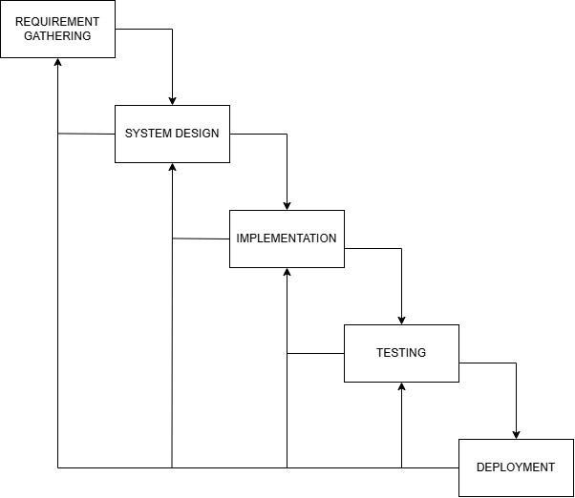
Figure 3.1 Modified Waterfall Development Model of SDLC
The development of the Payroll System with Role-Based Monitoring Features for Guibone Accounting Services followed the Modified Waterfall Model, a structured and sequential methodology that allows controlled feedback loops between phases. This approach ensures that the payroll system remains secure under the exclusive control of the owner, while staff can efficiently perform and monitor assigned tasks and client appointments according to their roles. The Modified Waterfall model was particularly suitable because it provides a step-by-step process while allowing minor adjustments and clarifications between phases, ensuring accuracy, accountability, and alignment with organizational needs.

Requirement Gathering
In this phase, the researchers collected detailed information about the existing workflow, staff responsibilities, task monitoring challenges, and client appointment handling. Emphasis was placed on understanding the preparatory tasks that support payroll processing and the current methods for tracking these tasks and client engagements. Both functional and non-functional requirements of the proposed system were documented and validated with the owner and staff. Whenever gaps, conflicts, or missing requirements were discovered in later phases, the researchers returned to this stage for clarification and refinement, ensuring that all system requirements accurately reflected organizational needs.

System Design
Based on the approved requirements, the system architecture was carefully planned. This included:
- Secure payroll processing exclusively for the owner
- Role-based access control for staff
- Task tracking and client appointment monitoring modules
- User interface layout and dashboard design
- Reporting and audit mechanisms
The design outputs were reviewed and revised to incorporate feedback from the client and stakeholders, ensuring that all components met the desired functionality before development. This phase ensured that tasks and appointments could be properly assigned, tracked, and monitored according to user roles while maintaining confidentiality of payroll data.
Implementation
During implementation, the system was developed following a 3-tier architecture consisting of the Presentation Layer, Application Layer, and Database Layer to ensure separation of concerns, scalability, and maintainability. The Presentation Layer was built using HTML, CSS, and Bootstrap to create a user-friendly interface for the owner and staff. The Application Layer was developed using PHP, which handled the system’s business logic, data processing, and access control. The Database Layer utilized MySQL to securely store and manage records such as payroll data, task assignments, client requirements, and appointment schedules.
Each module was built according to the system design specifications. The payroll module remained accessible only to the owner through controlled access in the application layer, while monitoring features allowed staff to view and update assigned tasks, track client requirements, and manage appointments through the presentation layer. When design inconsistencies or required modifications were identified during coding, controlled feedback loops allowed the researchers to return to the System Design phase to maintain consistency and accuracy.
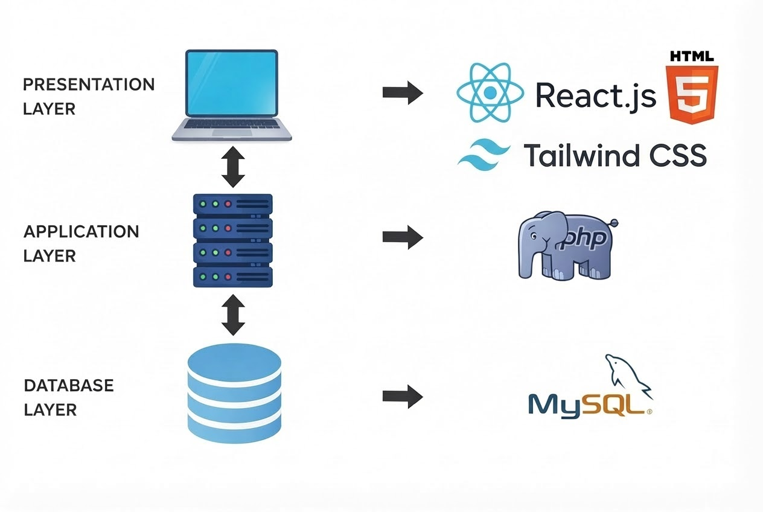

Testing
The system underwent Unit Testing, Integration Testing, and User Acceptance Testing (UAT) to verify that payroll processes, role-based monitoring, task tracking, and appointment scheduling were functioning correctly. Errors, unmet requirements, or inconsistencies discovered during testing prompted the researchers to revisit the Implementation or System Design phase for correction. This iterative feedback ensured that all system modules met the organization’s operational requirements and supported efficient task and appointment management.
Deployment
After successful system testing and validation, the developed system was formally deployed at Guibone Accounting Services. User accounts were configured based on designated roles and access levels. The owner retained exclusive authority over payroll processing and administrative controls, while staff members were granted access to the task monitoring and client appointment modules.
During the deployment phase, minor technical issues and user adjustments were addressed immediately to ensure smooth system operation. Necessary refinements were implemented based on user feedback. Upon final acceptance, the system, including its source code and documentation, was formally turned over to the organization. Future system maintenance and updates shall be managed by the organization or a designated technical personnel, as the project fulfills its academic requirement under the capstone program.
Tools, Technologies, and Technical Environment
The following tools and technologies were used:
- Programming Languages: JavaScript (React JSX), PHP
- Frameworks/Libraries: Axios, Tailwind CSS
- Database Management System: MySQL
- Development Tools: Visual Studio Code, XAMPP
- Operating System: Windows 11
- Web Browser: Google Chrome
These tools were chosen for their robustness, compatibility, and ease of deployment in a medium-sized accounting firm.

Ethical Considerations
The study adhered to ethical research practices:
- Informed Consent: All respondents were informed about the purpose of the study and voluntarily participated.
- Confidentiality: Data collected were kept confidential, and client data used for testing were anonymized.
- No Harm: Participation did not interfere with staff duties or work performance.
- Data Security: All data were securely stored and used solely for research purposes.
- Transparency: Findings and system evaluation results were shared with management to support decision-making.
These ethical considerations ensured the protection of participants, maintained trust, and complied with professional standards.

REFERENCES
Aguinaldo, C. M., Bautista, T. R. D., Primo, M.-J. C., & Tintero, A. J. P. (2023). The relevance of monitoring outstanding audit issues and findings in the Development Bank of the Philippines. International Journal of Advanced Engineering and Management Studies, 8(4). https://ijaems.com
Almasria, N. A. (2021). The role of accounting information systems in enhancing audit quality. International Journal of Accounting Information Systems, 41, 100512.
https://doi.org/10.1016/j.accinf.2021.100512
Brown, T., & Davis, R. (2022). The impact of centralized appointment scheduling systems on service efficiency in professional service firms. Journal of Service Management, 33(4), 615–632. https://doi.org/10.1108/JOSM-XX-XXXX-XXXX
Cai, Z., & Liu, J. (2006). Role-based access control model and its application in information systems security. Journal of Information & Computational Science, 3(3), 575–582. https://doi.org/10.1109/ICIAS.2006.305
Castro, R. M., et al. (2024). Awareness of accounting information systems and software among accounting graduates. Philippine Journal of Accountancy, 6(1), 45–60. https://philjournalsci.dost.gov.ph
Drew, J. (2022). Accounting automation and its impact on organizational performance. Journal of Accounting and Finance in Emerging Economies, 8(2), 233–248. https://doi.org/10.26710/jafee.v8i2.XXXX
Flores, J. P., et al. (2024). Accounting information systems and environmental uncertainty among agri-related cooperatives in Davao del Norte. Philippine Management Review, 31(1), 88–104. https://pmr.upd.edu.ph
Florio, C. (2024). Mandatory auditor rotation and audit quality: A systematic literature review. International Journal of Auditing, 28(1), 3–24. https://doi.org/10.1111/ijau.122XX
García, J., Pacheco-Mendoza, J., & Zula Cujano, F. (2025). Accounting information systems as internal control tools for organizational accountability. Journal of Applied Accounting Research. https://doi.org/10.1108/JAAR-XX-XXXX-XXXX
Mann, I. (2025). Continuous monitoring and access control in multi-user information environments. Computers & Security, 138, 103XXXX. https://doi.org/10.1016/j.cose.2024.103XXX
Mapalo, K. (2025). Accounting information system utilization and operational productivity of SMEs in Biñan City. Asia Pacific Journal of Management and Sustainable Development, 13(2). https://www.apjmsd.com
Martin-Navarro, A., Sancho, M. P. L., & Medina-Garrido, J. A. (2023). Business process management systems: A systematic literature review. Business Process Management Journal, 29(5), 1421–1445. https://doi.org/10.1108/BPMJ-XX-XXXX-XXXX
Nur’aida, & Sasanti, E. E. (2024). Payroll accounting information system and its impact on internal control of Manpower and Transmigration Office in Central Lombok Regency. International Journal of Business and Applied Economics, 3(2), 211–222. https://doi.org/10.55927/ijbae.v3i2.8125
Salsabila, S. N., Pratiwi, A., Handoko, S. N., & Kustiwi, I. A. (2025). Literature review: Analyzing the effectiveness of payroll accounting information systems in an effort to improve the company’s internal control. International Conference on Economics Business Management and Accounting (ICOEMA), 4(1), 1158–1169. https://conference.untag-sby.ac.id/index.php/icoema/article/view/5694
Wulansari, Y. Y., Nurromadhoni, D., & Azhari, M. (2024). Analysis of payroll accounting information systems at the Ministry of Religious Affairs Office in Surabaya City. Journal of Applied Management and Business, 5(2), 78–86. https://doi.org/10.37802/jamb.v5i2.881
Xu, X., et al. (2025). Online monitoring and traceability optimization system for real-time operations. IEEE Access, 13, 145233–145247. https://doi.org/10.1109/ACCESS.2025.XXXXXXX

Appendix A - Mockup Design
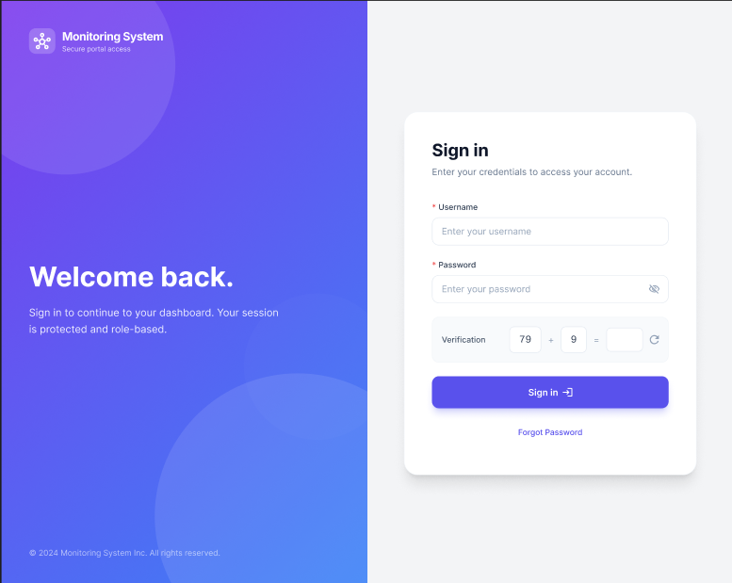
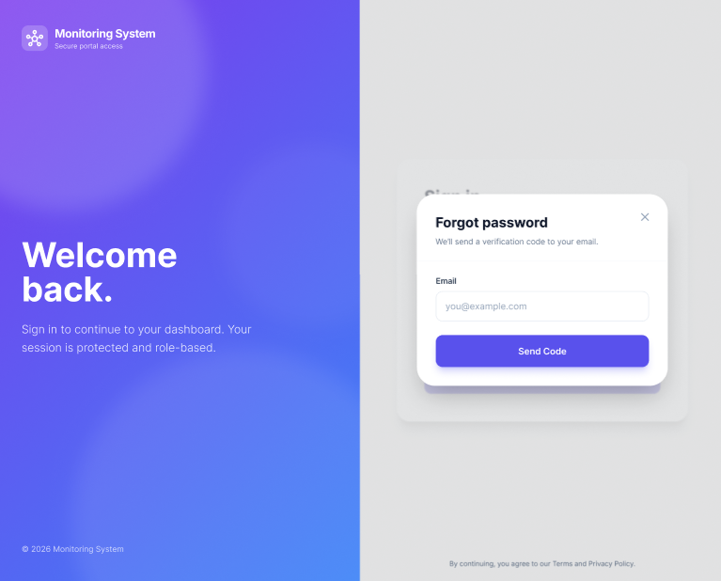

CLIENT DASHBOARD
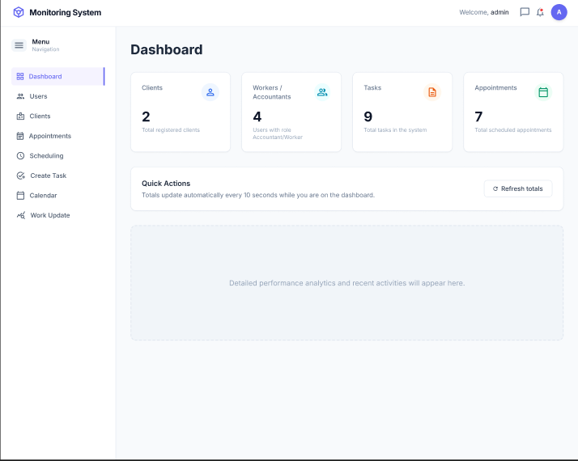
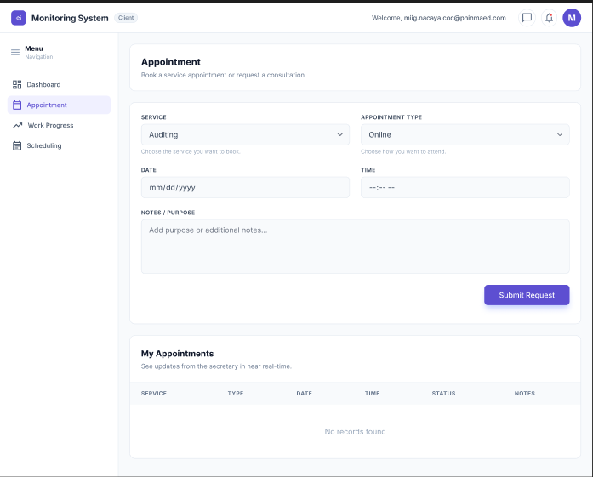

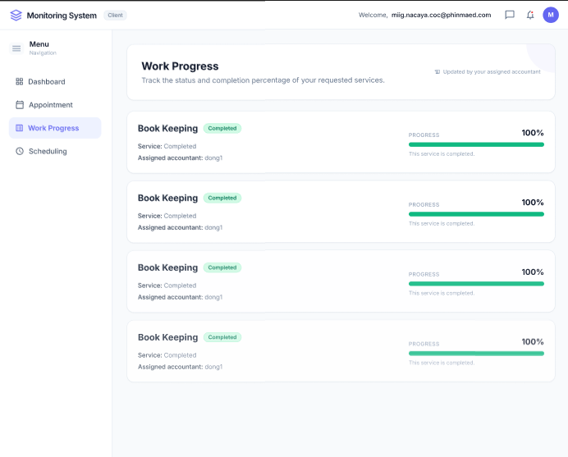
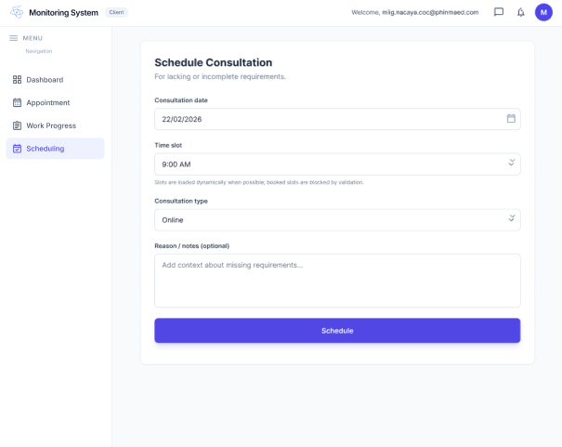

ACCOUNTANT DASHBOARD
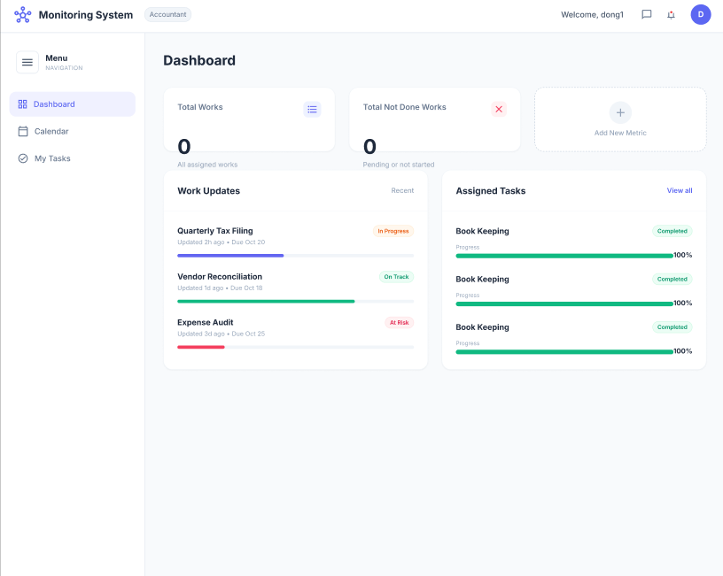
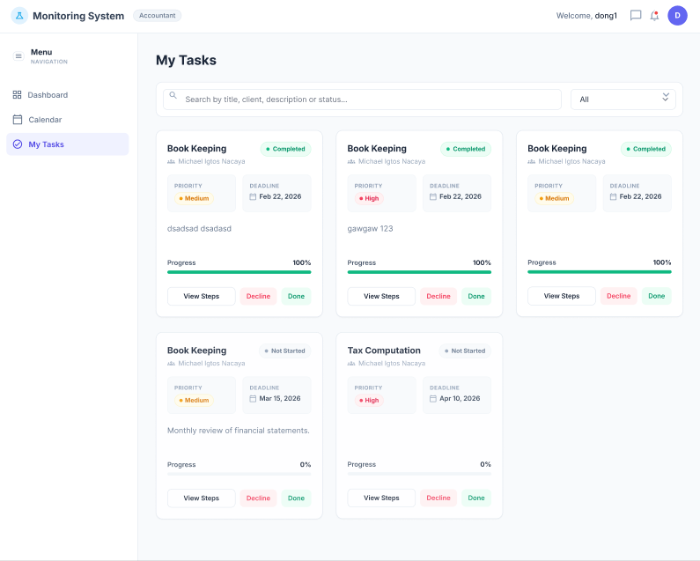
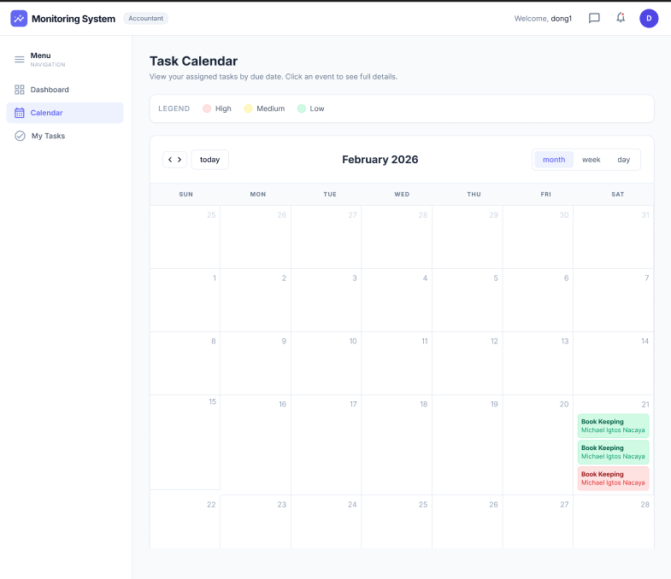
SECRETARY DASHBOARD
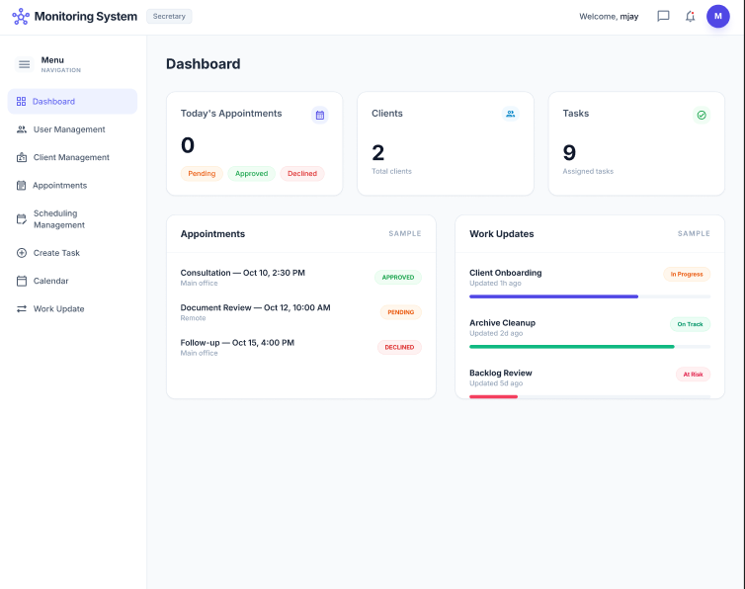
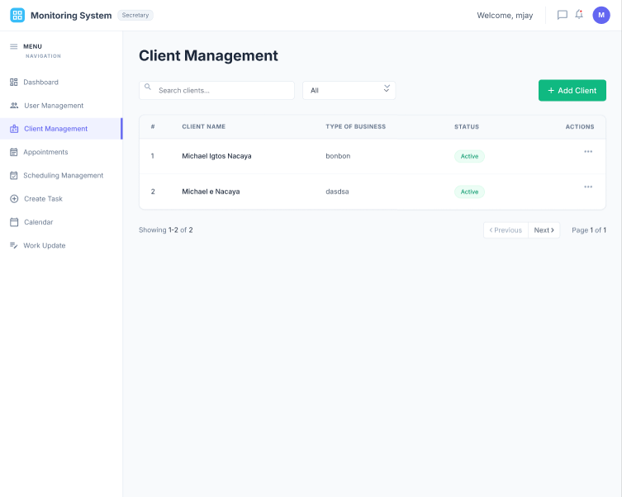
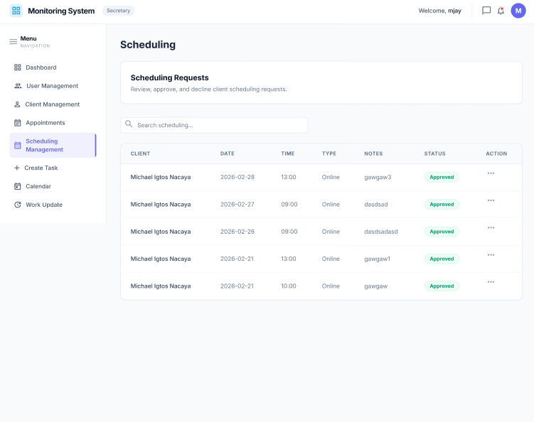

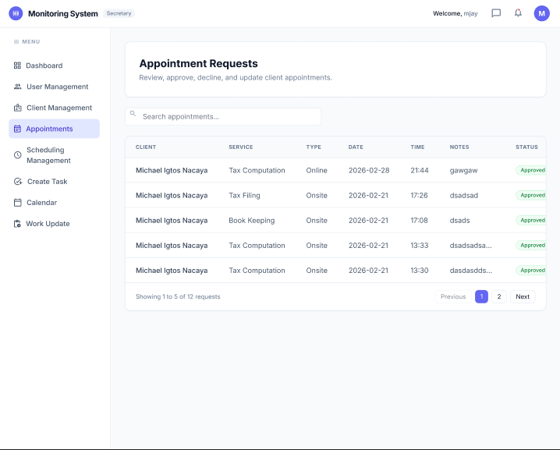
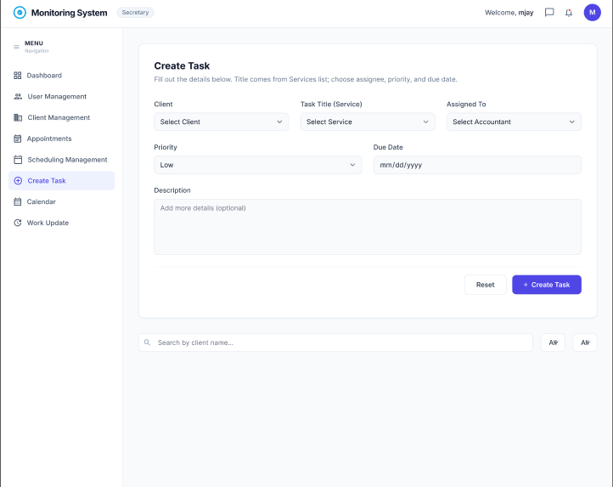
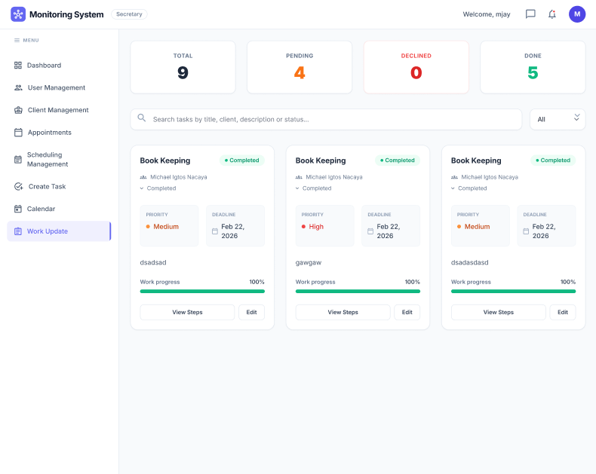
OWNER DASHBOARD
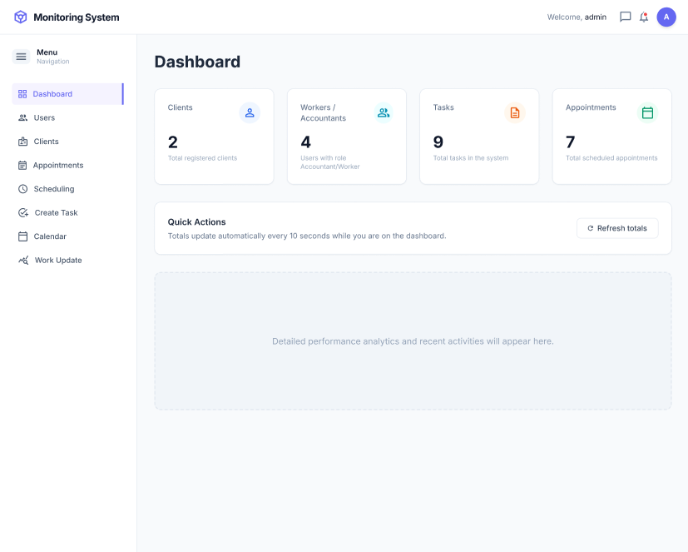

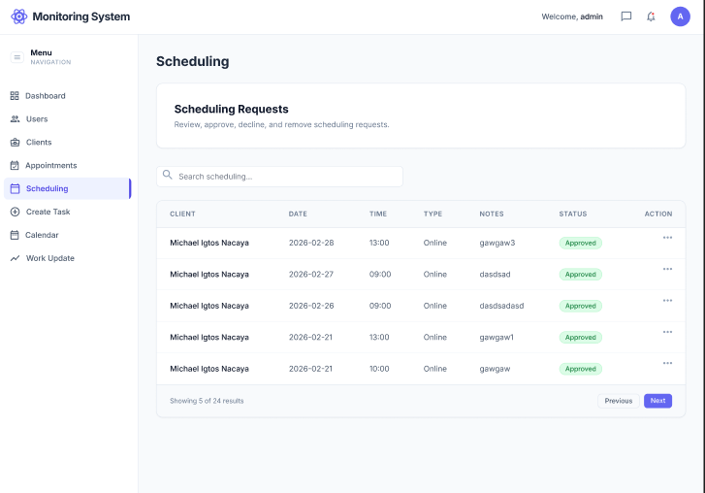
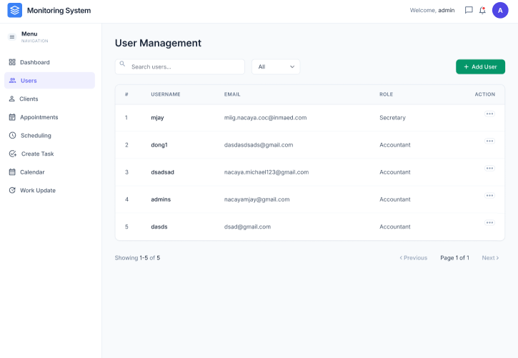

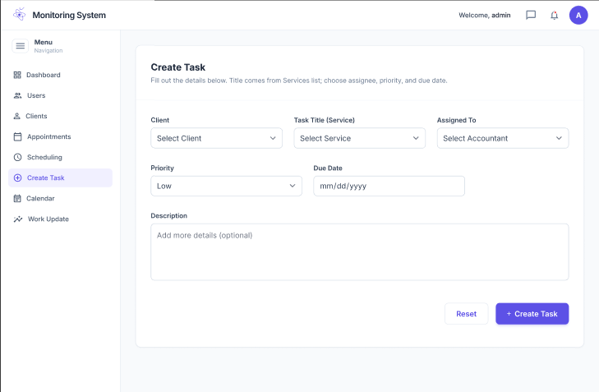
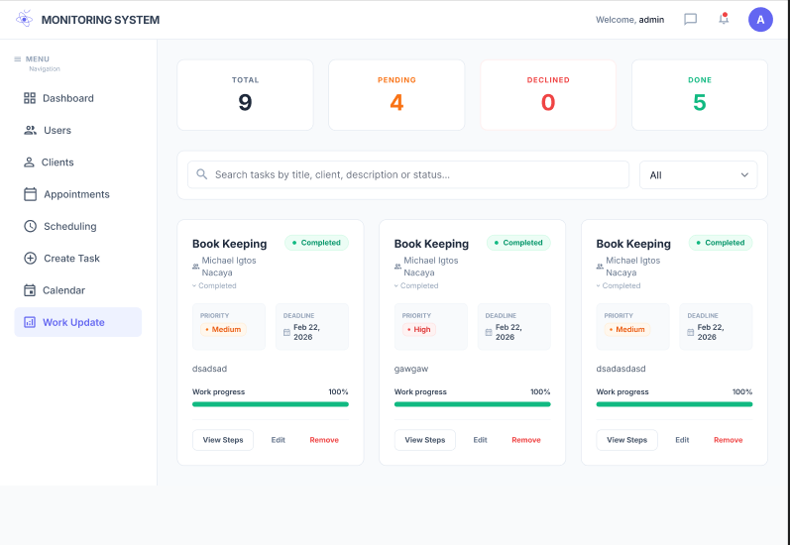
Appendix B - Letter of Intent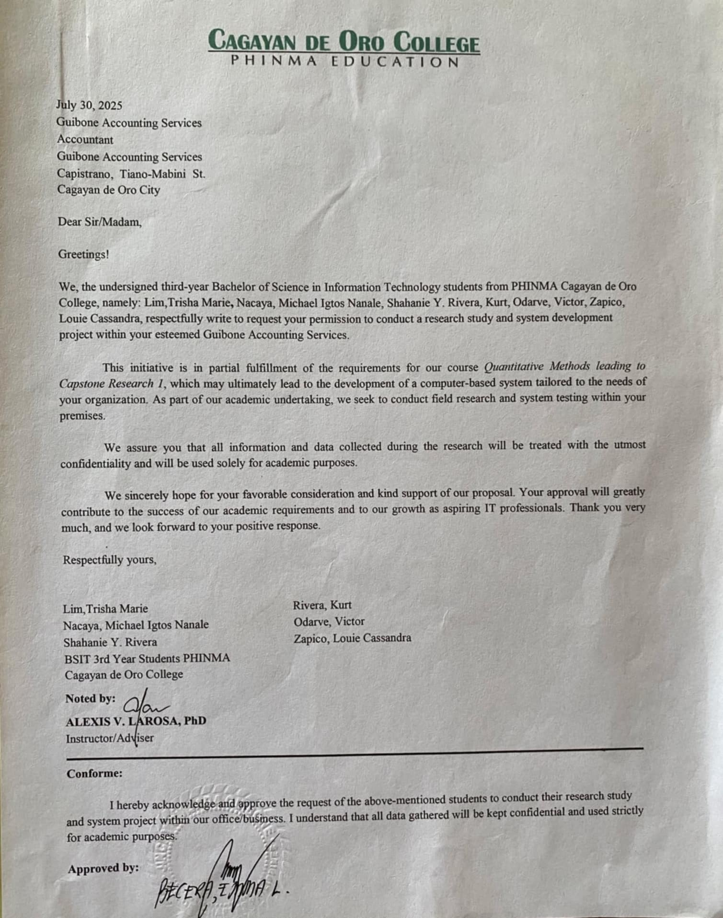

Appendix C - Gantt Chart of Activities
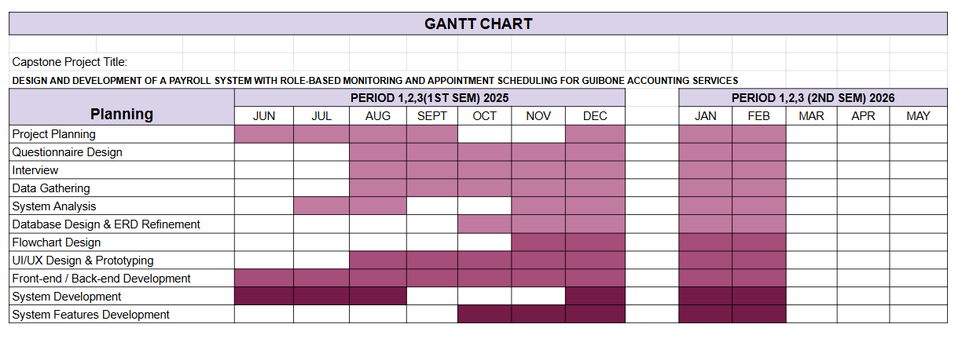

Appendix D - Use Case Diagram
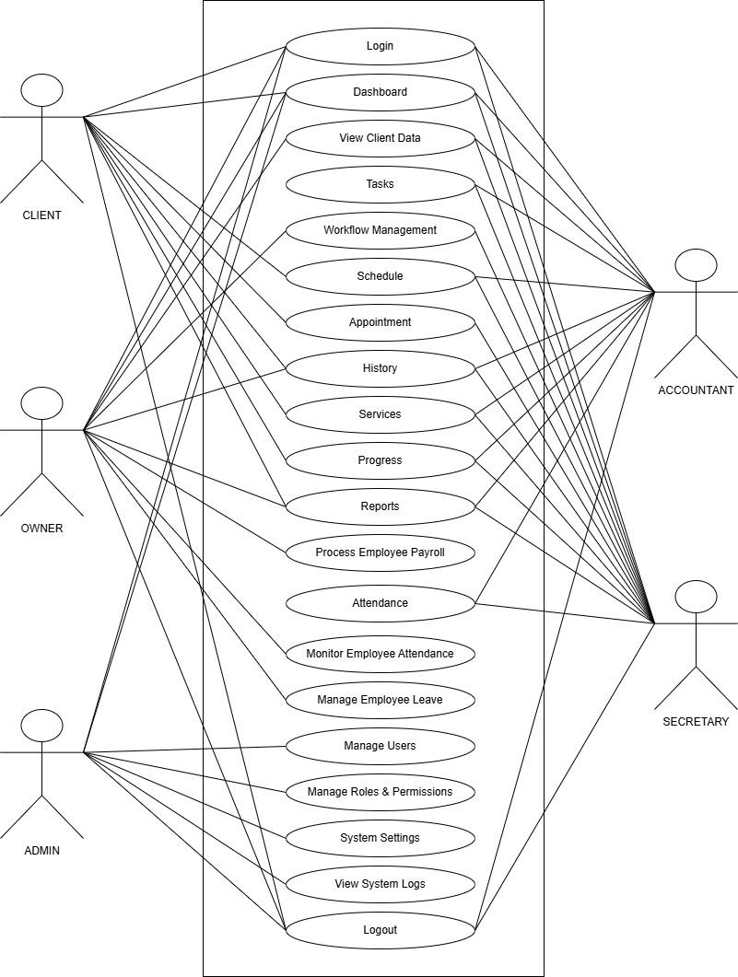

Appendix E - Logical Entity Relationship Diagram (ERD)
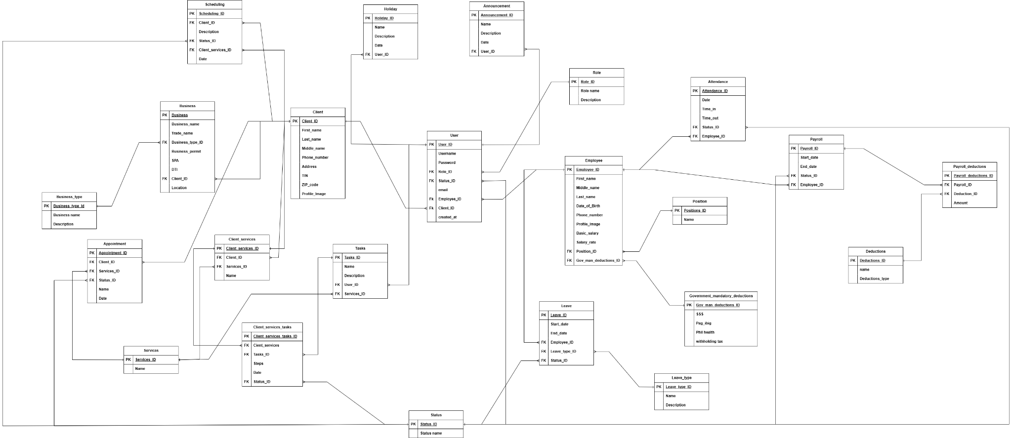

Appendix F - Data Flow Diagram

Appendix G - Context Diagram

Appendix H - Manual Process Flowchart

Appendix I - Proposed System Flowchart
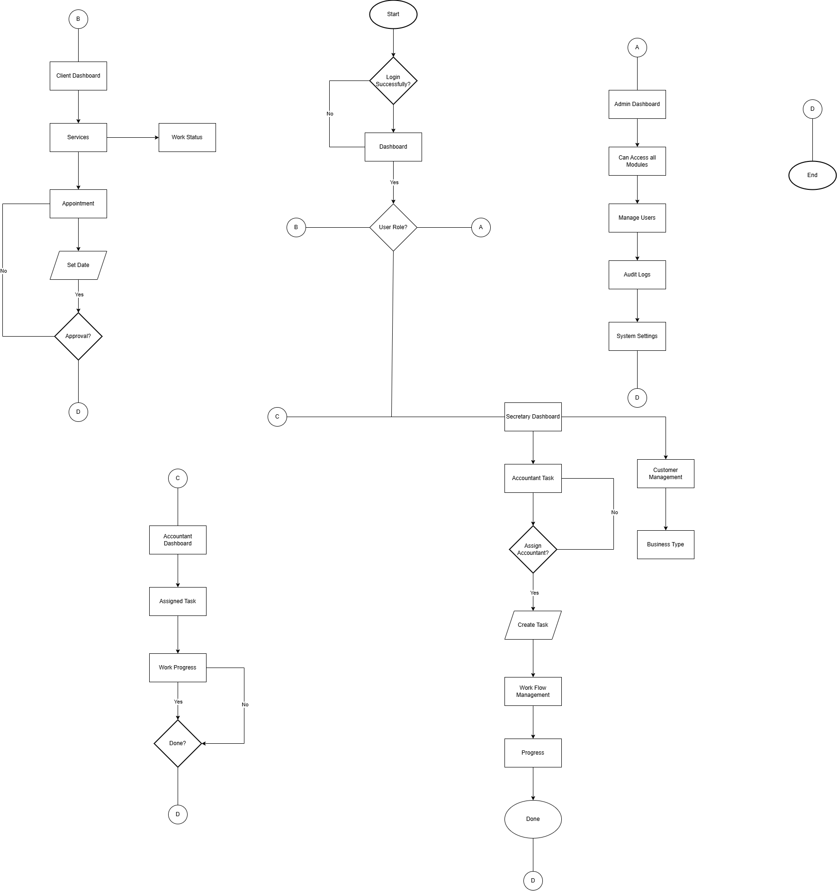

Appendix J - System Activity Diagram

Appendix K - Data Dictionary

Appendix L - UI/UX
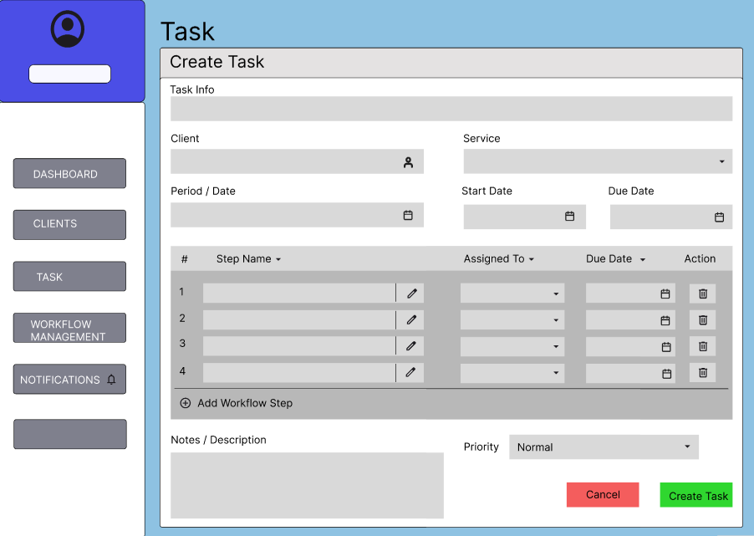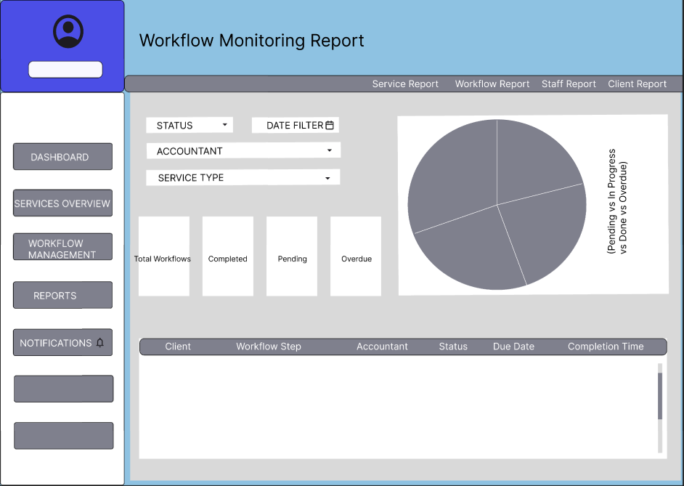
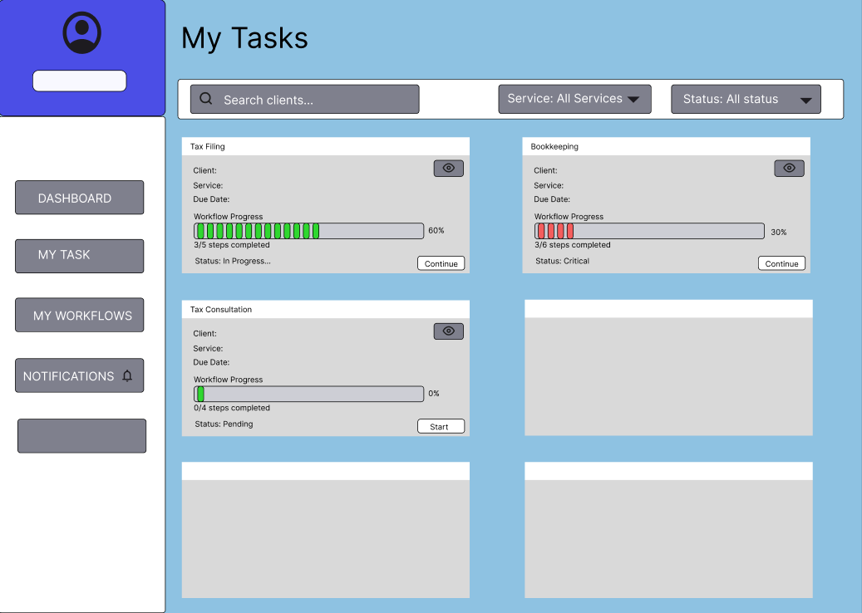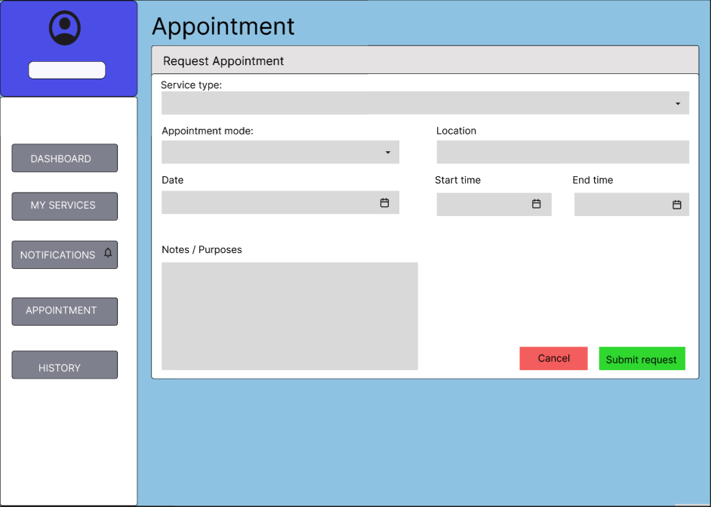

Appendix M - Code Snippets

Appendix N - Detailed SUS Test
System Usability Scale (SUS) Questionnaire
Users will rate the following statements on a scale of 1 (Strongly Disagree) to 5 (Strongly Agree)

System Usability Scale (SUS) Questionnaire | 1 | 2 | 3 | 4 | 5
1. I think that I would like to use this payroll and monitoring system frequently for my daily accounting and tracking tasks.
2. I found the system unnecessarily complex for its primary purpose of task monitoring and appointment tracking.
3. I thought the system was easy to use, especially in viewing real-time task statuses (Pending/Ongoing/Completed).
4. I think that I would need the support of a technical person to be able to use this system effectively.
5. I found the various functions (Task Tracking, Scheduling, User Logs) were well integrated.
6. I thought there was too much inconsistency in the way the dashboard and reports are presented.
7. I would imagine that most staff members would learn to use this monitoring system very quickly.
8. I found the system very cumbersome to use when updating client data or appointments.
9. I felt very confident using the system to identify who processed specific client records.
10. I needed to learn a lot of things before I could effectively manage roles and assignments.

Appendix O - Functional and Non-Functional Requirements

Appendix P - Physical Database

