China’s choice

Hong Kong names a new leader

But Carrie Lam is unlikely to heal the territory’s divisions

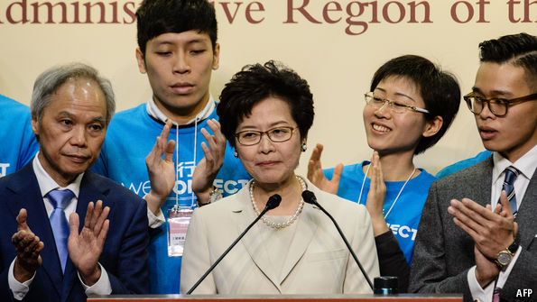

THERE was no doubt who would win the election in Hong Kong for the post of chief executive, as the territory’s leader is known. The choice was made on March 26th at Hong Kong’s harbour-front convention centre by nearly 1,200 members of a committee stacked with supporters of the Communist Party in Beijing. Carrie Lam, the party’s favourite, won 67% of their votes. As the outcome became clear, Mrs Lam’s supporters in the public gallery cheered and waved Chinese flags. Much more in doubt was whether Mrs Lam could command the support of the public. After she was declared the winner, protesters in front of the stage held up yellow umbrellas—a symbol of those who demand that the chief executive be chosen by the public. Mrs Lam will take over a bitterly divided society.

Pro-democracy members of the election committee (about a quarter of the total) mostly backed a rival candidate, John Tsang. Until last year Mr Tsang had served as Hong Kong’s financial secretary, one of the territory's most senior positions after the chief executive and that recently occupied by Mrs Lam, who stepped down as head of the civil service. He won 365 votes, less than half the number **garnered** by Mrs Lam. A third candidate, Woo Kwok-hing, who is a retired judge, got just 21.

With so few votes to count, it took only about two hours to calculate the result. The process might have been quicker still, but for the fact that any vote deemed invalid had to be presented for public **scrutiny**. On one was written a large Chinese character, meaning “fuck”. Those who found that amusing were equally thrilled when it was announced that Mrs Lam had won 777 votes; in Cantonese seven sounds like **slang** for **penis**. (**Puns** are common in Hong Kong’s street politics: its outgoing leader, Leung Chun-ying, is often depicted as a wolf by demonstrators, because his surname is similar to the word for one.)

Chinese officials describe the election committee as “broadly representative” of the territory’s 7.3m people (even though its members are mostly representatives of business and professional groups who tend to be pro-establishment). They insist that any problem with the election method is the fault of the pro-democracy camp. In 2014 the central government in Beijing offered to let the public vote in this election. But pro-democracy legislators opposed the change. They said that the kind of ballot that was being proposed would be a **sham** because candidates would still have to approved by a committee like the one that has just chosen Mrs Lam. Campaigners occupied the streets for 79 days, and in 2015 lawmakers voted down China’s plan.

Officials tried hard, however, to make this election appear more democratic than previous ones (when Mrs Lam takes over on July 1st she will be the territory’s fourth leader since the former colony was handed back to China by Britain in 1997). The three candidates ran campaigns aimed at the public, and took part in televised debates. On March 24th Mr Tsang toured the city on an open-top bus telling huge crowds of fans: “Most of you here don’t have votes, but still I yearn for your support.” Opinion polls showed that he did have more support than Mrs Lam, but not of the sort that counted in the election.

Old hipsters

A new way to classify dinosaurs

A challenge to the division between the Saurischia and the Ornithischia

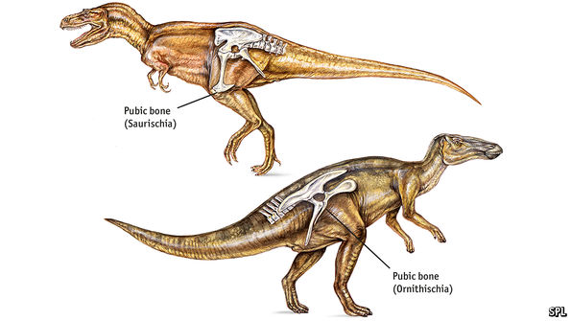

AS EVERY school-aged **aficionado** of dinosaurs knows, those terrible **reptiles** are divided into two groups: the **Saurischia** and the **Ornithischia**—or, to people for whom that is all Greek, the lizard-hipped and the bird-hipped. The names go back 130 years, to 1887, when they were invented and applied by Harry Seeley, a British **palaeontologist**.

Seeley determined that the arrangement of the bones in a dinosaur’s pelvis—specifically, whether the **pubic** bone points forwards (Saurischia) or backwards (Ornithischia)—could be used to assign that species to one of these two groups. In his view, and that of subsequent palaeontologists, the evolution of other features of dinosaur skeletons supported the idea that these two hip-defined groups were what are now referred to as clades, each having a single common ancestor. Seeley thereby thought he had overthrown the dinosaurs as a true clade themselves: he believed Saurischia and Ornithischia were descended separately from a group called the thecodonts.

Subsequent analysis suggests he was wrong about that. The dinosaurs do seem to be a proper clade, with a single **thecodont** ancestor. But the basic division Seeley made of them, into Saurischia and the Ornithischia, has not been challenged—until now.

The challengers are Matthew Baron, of Cambridge University, and his colleagues. Writing in Nature, they suggest dinosaur classification needs to be shaken up. Their system still has two groups, but it looks very different from Seeley’s.

Based on an analysis of 74 types of dinosaurs and close relatives of dinosaurs, which examined 457 skeletal characteristics, they propose that hip-structure is not the be-all and end-all that Seeley and his successors thought it was. Instead, they separate the two great subgroups of Saurischia, the sauropods (Brontosaurus, Diplodocus, etc) and the theropods (Tyrannosaurus, Allosaurus, etc) and reassign them. The sauropods are teamed up with a group called the Herrerasauridae, which are so primitive they are not easily fitted into the Saurischia-Ornithischia system, to form a reconstituted Saurischia. The rest of the Ornithischia and the theropods, meanwhile, are joined as a newly named group, the Ornithoscelida.

Whether Dr Baron’s classification will hold up remains to be seen. Any system based on comparative anatomy rather than DNA is vulnerable to the evolution of similar features on separate occasions—giving an illusion of relatedness that is actually untrue. Indeed, the problem with relying on anatomical features, such as hip-shape, to classify animals is well illustrated by dinosaurs themselves. It was not bird-hipped Ornithischia that gave rise to birds, but lizard-hipped theropods.

Hard driving

Uber is facing the biggest crisis in its short history

Can the ride-hailing giant stay in the fast lane?

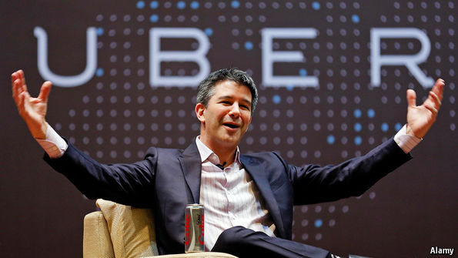

AS A teenager, Travis Kalanick’s first job was to knock on strangers’ doors and sell them knives. Now he is trying to **dodge** the **daggers** aimed at him and at Uber, a ride-hailing firm that is the world’s most valuable startup. On March 19th Jeff Jones, the company’s president, stepped down after six months, declaring that “the beliefs and approach to leadership that have guided my career are inconsistent with what I saw and experienced at Uber.” At least six key executives and high-ranking employees have left in the past nine weeks. They include Uber’s head of mapping, a former head of self-driving car technology, and an artificial-intelligence (AI) expert who had been put in charge of the firm’s AI research lab only three months ago.

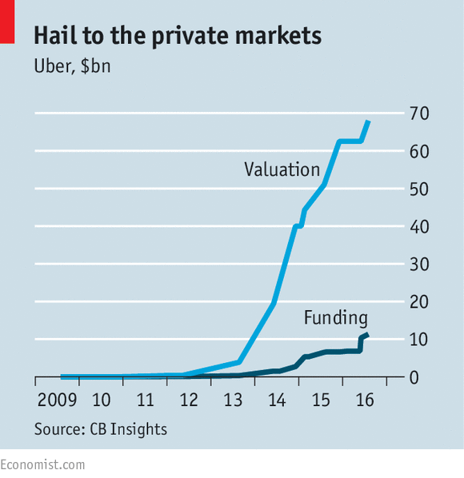Aggressive and **unrelentingly** ambitious, Mr Kalanick built his eight-year-old company into America’s largest privately owned technology firm by treading on the toes of different groups, including traditional taxi drivers, other tech companies and regulators. He pushed into new markets abroad and raised an unprecedented amount of capital, to the tune of around $12.5bn, including debt. The firm has a valuation of close to $70bn (see chart).

Yet a remarkable run of bad news for Mr Kalanick, combined with some setbacks for Uber itself, threatens to halt the firm’s **momentum**. “I have never seen someone have such a bad couple of months,” **commiserates** the boss of a large, public tech firm. Politics struck first: in January Mr Kalanick was widely criticised for serving on Donald Trump’s business advisory committee and for apparently intervening in a strike by taxi drivers opposed to Mr Trump’s ban on refugees. A campaign, called #DeleteUber, took off, encouraging users to stop using the Uber app.

Then worries about Uber’s culture mounted. A former employee wrote a blog post on how Uber’s human-resources department failed to act on her **sexual-harassment** complaint. Next, an Uber driver filmed Mr Kalanick arguing with him about fare cuts and uploaded the material, including the boss lamenting that “some people don’t like to take responsibility for their own shit”. The latest embarrassment was the revelation that Uber had secretly designed and used a software feature, called Greyball, to **evade** city officials attempting sting operations to catch Uber drivers violating local regulations.

Two questions face the company. One is whether Uber will continue prospering under Mr Kalanick’s leadership. Silicon Valley and its denizens may celebrate his type, but his public words and actions have made people close to the firm **squirm**. Bill Gurley, a venture capitalist and early Uber backer who sits on the board, is helping direct a search for a chief operating officer to keep Mr Kalanick in check and bring experience and discipline to the firm. It is certainly hard to keep on top of the firm’s growth: last year, its headcount doubled.

If Mr Gurley and the rest of the board cannot find an experienced candidate willing to work with Mr Kalanick, calls for him to step down may grow louder. But that is his decision to take. Uber is a prominent example of founders’ power at fast-growing tech firms. On its own, Uber’s board does not have the clout to change the CEO, because of his super-voting shares and those of his co-founder, Garrett Camp: together they control a majority of the voting stock.

The second question concerns Uber’s longer-term business prospects. One of the firm’s early-stage investors says that recent events have been a series of “body blows”, but he worries that there could be a “knockout blow” that would permanently damage Uber’s momentum. So far, he says, it looks as if Uber is merely bruised.

From the start of the year to the first week in March, Uber’s market share in America has fallen from around 80% to 74%, according to 7Park Data, which tracks the industry. Lyft, a smaller ride-hailing firm, seems to have been the chief beneficiary. The dip in market share for Uber could reverse, though the firm is unlikely to grow as effortlessly as in the past. There is, at least, still plenty of room to expand at home. Only around 6% of American mobile-phone users hail a ride through Uber and Lyft once a month or more.

Yet Uber’s enormous valuation also depends on the firm pulling off a harder task: dominating most markets for ride-hailing around the world. Fortunately, there is little evidence that Mr Kalanick’s antics have dented its prospects outside America. But the goal of worldwide dominion remains distant, even though no other private technology firm has ever spent so much money to gain a global foothold. It is competing against a strong competitor, Grab, in South-East Asia and was spending billions to compete against its Chinese **rival**, Didi, until it struck a deal last year to withdraw from the country in exchange for a 20% stake in that firm.

Investors particularly want to see the **ride-hailing** giant reach profitability in developed markets. Its sales, of around $5.5bn in 2016, are growing rapidly, but it has to spend a lot in American cities where there are rival local firms such as Lyft and (smaller) ones such as Juno and Via. For every dollar that Lyft spends in subsidising fares, it costs Uber four times the amount to hold onto customers and drivers, because of its far larger size. Foreign expansion adds still more expense, and it is unclear whether the competition at home and abroad, which hurts Uber’s chance of becoming profitable, will ever ease up.

There are other threats to watch out for. Uber’s performance depends on its software working smoothly and not being hit by outages, and this could suffer if more executives on the technical side leave. It may also struggle to hire talented engineers during this rough patch.

Corporate ambitions

Amazon, the world’s most remarkable firm, is just getting started

Amazon has the potential to meet the expectations of investors. But success will bring a big problem

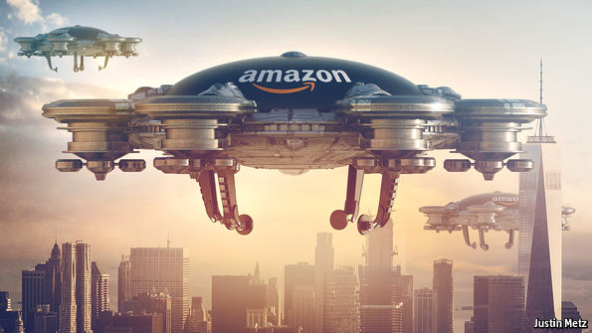

AMAZON is an extraordinary company. The former bookseller accounts for more than half of every new dollar spent online in America. It is the world’s leading provider of cloud computing. This year Amazon will probably spend twice as much on television as HBO, a cable channel. Its own-brand physical products include batteries, almonds, suits and speakers linked to a virtual voice-activated assistant that can control, among other things, your lamps and sprinkler.

Yet Amazon’s shareholders are working on the premise that it is just getting started. Since the beginning of 2015 its share price has jumped by 173%, seven times quicker than in the two previous years (and 12 times faster than the S&P 500 index). With a market capitalisation of some $400bn, it is the fifth-most-valuable firm in the world. Never before has a company been worth so much for so long while making so little money: 92% of its value is due to profits expected after 2020.

That is because investors anticipate both an extraordinary rise in revenue, from sales of $136bn last year to half a trillion over the next decade, and a jump in profits. The hopes invested in it imply that it will probably become more profitable than any other firm in America. Ground for scepticism does not come much more fertile than this: Amazon will have to grow faster than almost any big company in modern history to justify its valuation. Can it possibly do so?

It is easy to tick off some of the pitfalls. Rivals will not stand still. Microsoft has cloud-computing ambitions; Walmart already has revenues nudging $500bn and is beefing up online. If anything happened to Jeff Bezos, Amazon’s founder and boss, the gap would be exceptionally hard to fill. But the striking thing about the company is how much of a chance it has of achieving such unprecedented goals (see article).

A new sort of basket-case

This is largely due to the firm’s unusual approach to two dimensions of corporate life. The first of these is time. In an era when executives routinely whinge about pressure to produce short-term results, Amazon is resolutely focused on the distant horizon. Mr Bezos emphasises continual investment to propel its two principal businesses, e-commerce and Amazon Web Services (AWS), its cloud-computing arm.

In e-commerce, the more shoppers Amazon lures, the more retailers and manufacturers want to sell their goods on Amazon. That gives Amazon more cash for new services—such as two-hour shipping and streaming video and music—which entice more shoppers. Similarly, the more customers use AWS, the more Amazon can invest in new services, which attract more customers. A third virtuous circle is starting to whirl around Alexa, the firm’s voice-activated assistant: as developers build services for Alexa, it becomes more useful to consumers, giving developers reason to create yet more services.

So long as shareholders retain their faith in this model, Amazon’s heady valuation resembles a self-fulfilling prophecy. The company will be able to keep spending, and its spending will keep making it more powerful. Their faith is sustained by Amazon’s record. It has had its failures—its attempt to make a smartphone was a debacle. But the business is starting to crank out cash. Last year cashflow (before investment) was $16bn, more than quadruple the level five years ago.

If Amazon’s approach to time-frames is unusual, so too is the sheer breadth of its activities. The company’s list of current and possible competitors, as described in its annual filings, includes logistics firms, search engines, social networks, food manufacturers and producers of “physical, digital and interactive media of all types”. A wingspan this large is more reminiscent of a conglomerate than a retailer, which makes Amazon’s share price seem even more bloated: stockmarkets typically apply a “conglomerate discount” to reflect their inefficiencies.

Many of these services support Amazon’s own expansion and that of other companies. The obvious example is AWS, which powers Amazon’s operations as well as those of other firms. But Amazon also rents warehouse space to other sellers. It is building a $1.5bn air-freight hub in Kentucky. It is testing technology in stores to let consumers skip the cash register altogether, and experimenting with drone deliveries to the home. Such tools could presumably serve other customers, too. Some think that Amazon could become a new kind of utility: one that provides the infrastructure of commerce, from computing power to payments to logistics.

A giant cannot hide

And here lies the real problem with the expectations surrounding Amazon. If it gets anywhere close to fulfilling them, it will attract the attention of regulators. For now, Amazon is unlikely to trigger antitrust action. It is not yet the biggest retailer in America, its most mature market. America’s antitrust enforcers look mainly at a firm’s effect on consumers and pricing. Seen through this lens, Amazon appears **pristine**. Consumers applaud it; it is the most well-regarded company in America, according to a Harris poll. (AWS is a boon to startups, too.)

But as it grows, so will concerns about its power. Even on standard antitrust grounds, that may pose a problem: if it makes as much money as investors hope, a rough calculation suggests its earnings could be worth the equivalent of 25% of the combined profits of listed Western retail and media firms. But regulators are also changing the way they think about technology. In Europe, Google stands accused of using its clout as a search engine to extend its power to adjacent businesses. The comparative **immunity** from legal **liability** of digital platforms—for the posting of **inflammatory** content on Facebook, say, or the vetting of drivers on Uber—is being chipped away.

Amazon’s business model will also encourage regulators to think differently. Investors value Amazon’s growth over profits; that makes **predatory** pricing more **tempting**. In future, firms could increasingly depend on tools provided by their biggest rival. If Amazon does become a utility for commerce, the calls will grow for it to be regulated as one. Shareholders are right to believe in Amazon’s potential. But success will bring it into conflict with an even stronger beast: government.

The White House

The Trump presidency is in a hole

And that is bad for America—and the world

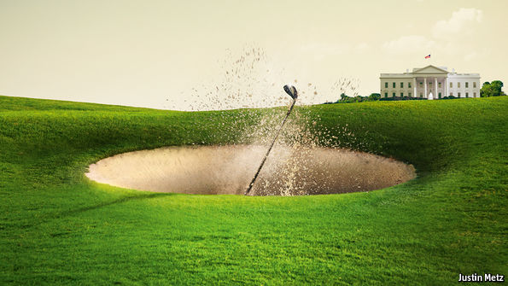

DONALD TRUMP won the White House on the promise that government is easy. Unlike his Democratic opponent, whose career had been devoted to politics, Mr Trump stood as a businessman who could Get Things Done. Enough voters decided that boasting, mocking, lying and grabbing women were secondary. Some Trump fans even saw them as the credentials of an authentic, swamp-draining saviour.

After 70 days in office, however, Mr Trump is stuck in the sand. A health-care bill promised as one of his “first acts” suffered a humiliating collapse in the—Republican-controlled—Congress (see Lexington). His repeated attempts to draft curbs on travel to America from some Muslim countries are being blocked by the courts. And suspicions that his campaign collaborated with Russia have cost him his national security adviser and look likely to dog his administration (see article). Voters are not impressed. No other president so early in his first term has suffered such low approval ratings.

It is tempting to feel relief that the Trump presidency is a mess. For those who doubt much of his agenda and worry about his lack of respect for institutions, perhaps the best hope is that he accomplishes little. That logic is beguiling, but wrong. After years of gridlock, Washington has work to do. The forthcoming summit with Xi Jinping, China’s president, shows how America is still the indispensable nation. A weak president can be dangerous—picture a trade war, a crisis in the Baltics or conflict on the Korean peninsula.

The business of government

Mr Trump is hardly the first tycoon to discover that business and politics work by different rules. If you fall out over a property deal, you can always find another sucker. In politics you cannot walk away so easily. Even if Mr Trump now despises the Republican factions that dared defy him over health care, Congress is the only place he can go to pass legislation.

The nature of political power is different, too. As owner and CEO of his business, Mr Trump had absolute control. The constitution sets out to block would-be autocrats. Where Mr Trump has acted appropriately—as with his nomination of a principled, conservative jurist to fill a Supreme Court vacancy—he deserves to prevail. But when the courts question the legality of his travel order they are only doing their job. Likewise, the Republican failure to muster a majority over health-care reflects not just divisions between the party’s moderates and hardliners, but also the defects of a bill that, by the end, would have led to worse protection, or none, for tens of millions of Americans without saving taxpayers much money.