Monkey business

An outbreak of yellow fever in Brazil

Yellow fever is bad for people. For wild primates, it can be catastrophic

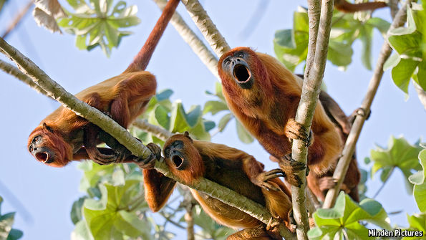

“ALL gone,” sighs Valmir Rossman as he scans the jungle surrounding his holding outside Santa Maria, a village in the state of Espírito Santo, north-east of Rio de Janeiro. Mr Rossman is a coffee farmer. Afternoons at his plantation used to echo to the calls of howler monkeys (pictured above) proclaiming their territories to potential **interlopers**. Since mid-February, however, he says he has neither heard nor seen a single one of them—except for two fresh carcasses he stumbled across where the coffee bushes give way to Atlantic rainforest, in the hills that mark the plantation’s edge.

Espírito Santo’s **howler-monkey** population is crashing. Mr Rossman’s **corpses** are two among 900 found this year by Sergio Mendes, a primatologist at the state’s federal university (UFES), and his team. In a typical year Dr Mendes would have expected his searchers to come across perhaps half a dozen such bodies during the same period. And something similar is happening in Minas Gerais, Espírito Santo’s inland neighbour. Analysis of the remains suggests the **culprit** is yellow fever.

It is easy to think of yellow fever, a mosquito-transmitted viral infection, as being just a human disease, but other primates can catch it, too—and New World monkeys suffer particularly badly. That is because, until the European discovery of the Americas, yellow fever was confined to the Old World. Animals there co-evolved with the virus that causes it, and thus developed a degree of inherited immunity. Their New World **brethren** had no such opportunity. The outbreak now raging in Espírito Santo, Minas Gerais and parts of other, adjoining states is affecting both monkeys and people. But it is monkeys who are, at least at the moment, suffering more.

Reality bites

The idea that wild animals are **reservoirs** of **pathogens** which go on to infect humans is well known, but not well studied. The Brazilian yellow-fever outbreak is an opportunity to put this right: to understand better the two-way pathogenic traffic involved, and also the fact that outbreaks can harm species other than **Homo sapiens**.

From a human point of view, Brazil has dealt well with yellow fever. It kills about half a dozen people a year. By comparison, **dengue** kills between 300 and 800. Crucially, after a big **vaccination** campaign in the 1930s, the last recorded case in the country of “urban-cycle” yellow fever was in 1942. The urban cycle is the usual mode of transmission in the Old World. It involves a mosquito called Aedes aegypti, which is also responsible for transmitting dengue, Zika and West Nile virus, and which arrived in the Americas at the same time as the virus itself. In urban-cycle yellow fever Aedes bites an infected human being and then carries the virus to another, possibly uninfected, human. In essence, this is human-to-human transmission.

As far as can be ascertained, all Brazilian cases since 1942 have been “wild-cycle” infections. These involve two other mosquito genera, Haemagogus and Sabethes, which are native to the Americas. Normally, these mosquitoes spend most of their time in tree **canopies**, supping on monkey blood. From time to time, though, they bite a human instead—for example, when loggers bring those canopies crashing to the forest floor. If the insects doing the biting are carrying the virus, such bites will pass it on to those who are unvaccinated. But, since Haemagogus and Sabethes do not live routinely in human habitats in the way that Aedes does, and vaccination programmes now concentrate on areas where wild-cycle infection is a risk, these canopy-dwelling mosquitoes rarely transmit yellow fever from person to person.

Those who are bitten and infected can, however, transmit it to other parts of the country which, because they have been free of the disease, may not have been heavily vaccinated. In 2000, for example, **strains** matching those from an outbreak in Pará, a state in northern Brazil, were found in areas as much as 2,000km (1,200 miles) away. That, **reckons** Pedro Vasconcelos of the Evandro Chagas Institute, a government laboratory in Pará, is too far for the virus to have moved without help from mechanised transport.

Occasionally, yellow fever alights in this way in an area with a large monkey population that has had no recent exposure to it, and has therefore acquired no immunity. The upshot can be **devastating**. Nine years ago 2,000 monkeys are thought to have perished close to Brazil’s border with Uruguay. In 2000 a similar number may have died in the centre-west of the country, one of the places to which people brought it from Pará.

The flare-up in Espírito Santo and Minas Gerais seems fiercer. According to Dr Mendes, yellow fever can wipe out 80-90% of a monkey population that lacks immunity—which the animals in these two states do lack, since the disease has previously been absent, and their immune systems have had no chance to learn how to respond. The body count, he reckons, could reach tens of thousands. And this time, people are dying as well. Since December, 371 human cases, a third of them fatal, have been recorded. The reason is similar to the cause of the toll in monkeys: lack of an appropriate immune response. The absence of urban-cycle disease means that local vaccination campaigns have wound down.

The health authorities are now on high alert, though. They have dispatched vaccine to the affected areas with commendable speed. That should stop the revival of urban-cycle transmission. Entomologists from UFES are also setting traps to catch mosquitoes, to try to find out which species are carrying the virus—forest insects or Aedes. The trapped mosquitoes are being sent to the Evandro Chagas Institute for identification—of both them and of any viruses they may be harbouring.

At the moment, researchers suspect that the virus causing this outbreak originated from monkeys in either Amazonia or the cerrado, Brazil’s savannah area. If that is confirmed, it will be a textbook example of disease in an animal reservoir spilling over to affect human beings. And it is a reservoir from which the disease is impossible to **eradicate**.

That leaves the authorities with two possible responses. The first is the one they have adopted: to react to outbreaks when they occur and accept the consequent **casualties**. The second is to return to mass, pre-emptive vaccination, which would be costly and run the risk of people dying, as a handful probably would, from reaction to the vaccine. That second approach is unlikely in the face of a lone outbreak, but if others follow as loggers push deeper into the rainforest, it might have to be considered. In the case of this particular outbreak, the authorities’ swift response means the chances are that it will be contained and then stamped out quickly—at least as far as people are concerned. How long it will be before Mr Rossman hears his howler monkeys again is anybody’s guess.