Daily chart

A new study tries to unpick what makes people happy and sad

Mental illness is a better predictor of **misery** than poverty is

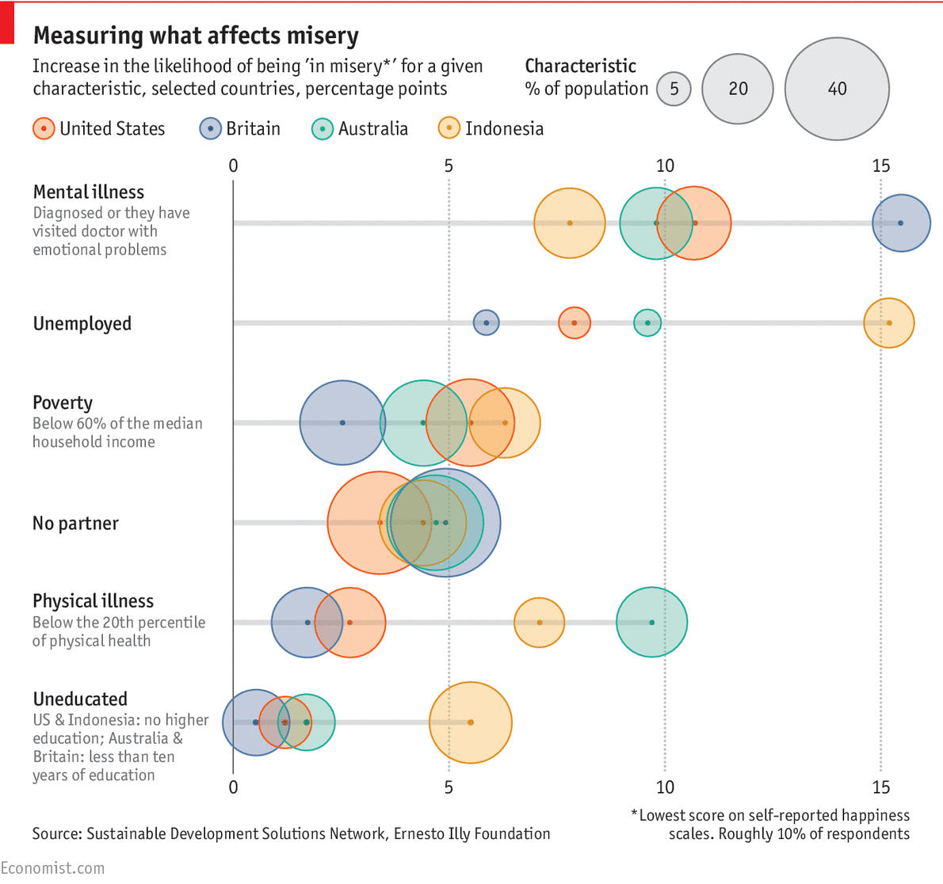

KEEPING voters happy is the lifeblood of any ambitious politician’s career. So they may want to pay attention to a report, released to mark “World Happiness Day” on March 20th, from the Sustainable Development Solutions Network, a UN body, and the Ernesto Illy Foundation, a non-profit. In addition to the usual rankings of countries from the happiest (Norway, for the usual reasons) to the least (Central African Republic, close to a failed state), the study also tries to unpick what makes people gleeful and—more unusually—what makes them **miserable**.

Reducing suffering, the authors argue, may be more important than boosting pleasure, because improving the life of an already-happy person probably yields a smaller gain in total **welfare** than freeing someone from misery does. They analysed large-scale surveys from four countries—Britain, Australia, America, Indonesia—to identify which factors are most closely associated with the population of the least happy decile of the sample.

The authors found that in the three rich countries mental illness was the strongest predictor of misery. With all other variables held constant, people who had visited a doctor recently with emotional-health problems were 10.7 percentage points more likely to be extremely unhappy than those who were not—roughly twice the impact of being poor. On one hand, this correlation should come as little surprise: people seeking treatment for depression are by definition unhappy. However, the study also included people suffering from stress or anxiety in this group. In Indonesia, mental health is also an important factor, though less so than employment.

The authors concluded that, in rich countries at least, investing in care for mental illness provided the best return (as measured by happiness gains) on public **expenditure**. They calculated that relieving one person of misery in Britain by reducing poverty would cost £180,000 ($222,500), whereas achieving the same goal by treating anxiety or depression would require just £10,000. That will make bean-counters happy, but is unlikely to cheer poiliticians.